Final Report:
Deep Learning for Social Analytics.

Students: Matrikel-Number.
Manoj Nethenahalli Dhanpal: 611794
Varad Santosh Kulkarni: 612254
Richard Seel: 598756

Introduction:
The goal of the project is to identify the “probability of the artist collaborations” based on the popularity, rank and genres.
The dataset used in the project is “Spotify Artist Feature Collaboration Network” from kaggle and the link to the dataset. “https://www.kaggle.com/datasets/jfreyberg/spotify-artist-feature-collaboration-network/data?select=nodes.csv”

Overview of the dataset:
- We have 2 datasets:
a)nodes which has spotify_id, artist_name, followers, popularity, chart_hits(country wise popularity) and genres.
b)edges which are uni-directed and only stored once, id_0<id_1 according to alphabetical order, that is a collaboration between artist A and artist B is stored in id_0:A, id_1:B

Related Work:
Manoj worked on pre-processing part of the data and cleaning the dataset, removing unwanted records and visualize the top artists and top collaborations and also worked in building GNN model etc…

Varad helped Manoj in pre-processing and also worked on Building the model using GNN---- need to add more.

Richard helped manoj in visualization, genres also worked on Building the model using GNN. --- Need to add more.

Both of there result are combined and validate the better results and all 3 of us worked and discussed regarding the steps and the tasks to build the model and reports etc...

Methods/Model:

We used GNN and Node2Vec techniques and for hyperparameters we used etc..

Data:
- nodes.csv shape(156422, 6)

The attributes are:
- spotify_id
- name
- followers
- popularity
- genres
- chart_hits

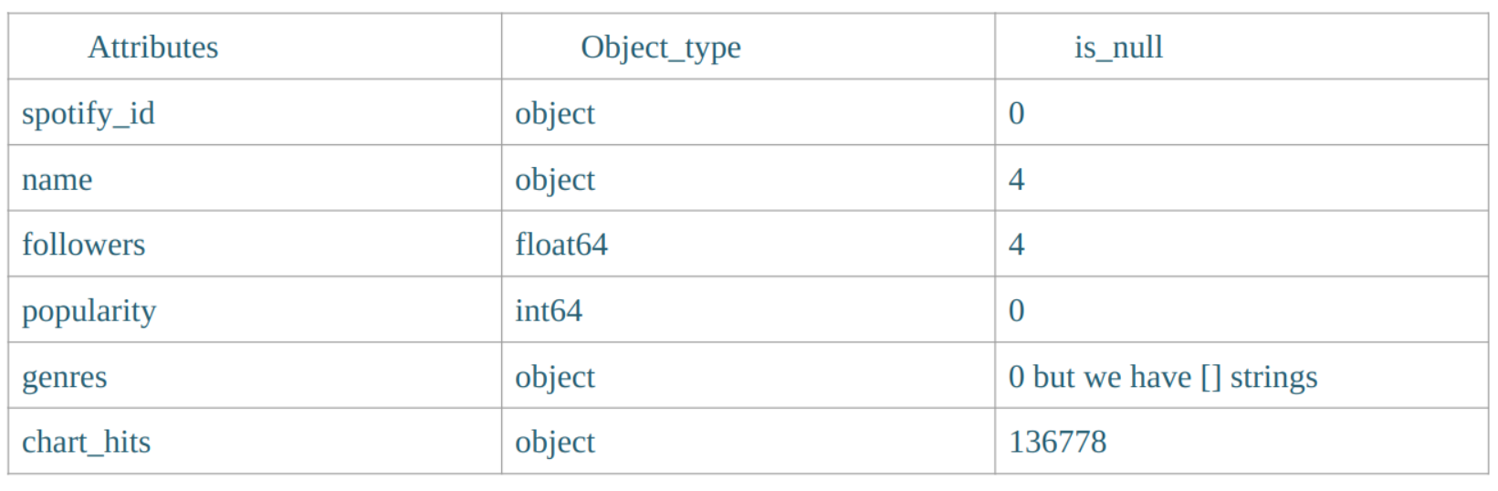
Data Pre-processing nodes:

2. edges.csv shape(300386,2)

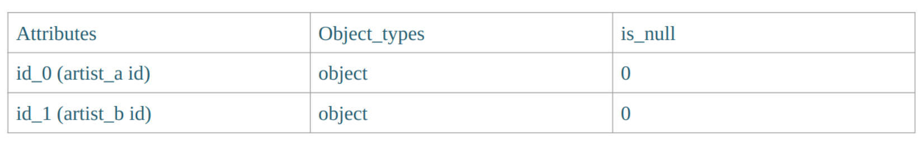
Data Pre-processing edges:
edges data set only contains 2 artist ids who have already collaborated.
- Using the “zip” function and “dict” constructor, we took the 2 columns from the nodes [‘spotifyid’] and [‘names’], we pair the elements from the list with ‘id_0’ and ‘id_1’and mapped them.
- Dropped the null rows and also removed the duplicate records.
- Filtered only the english names and finally we have id_0, id_1, artist_0 which is associated to id_0 and artist_1 which is associated to id_1
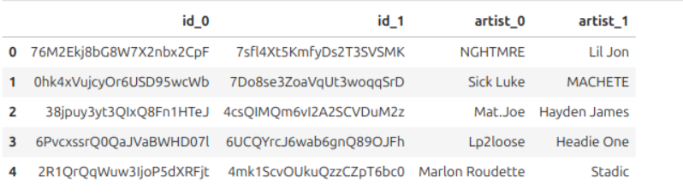

Results:

Discussion:

Conclusion:

References:

