A CAPSTONE PROJECT REPORT
Behaviour-Based Malware Detection System Using Deterministic Finite Automata and Regular Expressions
Submitted in the partial fulfilment for the Course of
CSA1301-THEORY OF COMPUTATIONS
to the award of the degree of
BACHELOR OF TECHNOLOGY IN
COMPUTER SCIENCE
Submitted by
A.Manoj Reddy (192311171)
Under the Supervision of
Dr. VijayaRagavan P

SIMATS ENGINEERING
Saveetha Institute of Medical and Technical Sciences Chennai-602105
September 2026


DECLARATION
I, A.Manoj Reddy (192311171) of Computer Science and Engineering, Saveetha Institute of Medical and Technical Sciences, Chennai, hereby declare that the Capstone Project Work entitled “Behaviour-Based Malware Detection System Using Deterministic Finite Automata and Regular Expressions” is the result of my own bonafide efforts. To the best of my knowledge, the work presented herein is original, accurate, and has been carried out in accordance with principles of engineering ethics.
Place: Chennai
Date: 04-09-2026
Signature of the Student with Name
A.Manoj Reddy (192311171)


BONAFIDE CERTIFICATE
This is to certify that the Capstone Project entitled “Behaviour-Based Malware Detection System Using Deterministic Finite Automata and Regular Expressions” has been carried out by A.Manoj Reddy (192311171) under the supervision of Dr. VijayaRagavan P and submitted in partial fulfilment of the requirements for the current semester of the B.E./B.Tech Computer Science and Engineering program at Saveetha Institute of Medical and Technical Sciences, Chennai.
SIGNATURE SIGNATURE
Dr Rashmitha Dr. VijayaRagavan P
Program Director Professor
Department of CSE Computer Science & Engineering
Saveetha School of Engineering Saveetha School of Engineering
SIMATS SIMATS
Submitted for the Project work Viva-Voce held on: 04-09-2026.
INTERNAL EXAMINER EXTERNAL EXAMINER

ABSTRACT
The Behaviour-Based Malware Detection System Using Deterministic Finite Automata and Regular Expressions is designed to detect malicious programs by analysing observable runtime behaviour rather than depending only on static file signatures. Modern malware frequently changes its binary representation, but actions such as suspicious file modification, registry persistence, process creation, privilege-related operations, and unusual network connections can still reveal malicious intent.
The proposed system collects or accepts behavioural event logs and normalizes them into a finite alphabet of security-relevant symbols. Regular Expressions are used to identify local suspicious patterns and to define candidate behaviour languages. These patterns are converted into or evaluated alongside a Deterministic Finite Automaton (DFA), which processes the event sequence one symbol at a time and reaches either benign or malicious accepting conditions.
A Python implementation demonstrates event preprocessing, regex matching, DFA transition processing, risk scoring, classification, and report generation. A synthetic dataset of 1,000 behaviour traces is used for controlled evaluation. The generated test data contains 600 benign and 400 malicious traces representing persistence, destructive file activity, process spawning, and suspicious network behaviour.
The system demonstrates a practical application of Theory of Computation concepts in cybersecurity. It shows how regular languages, regular expressions, DFA transition functions, accepting states, and deterministic recognition can be used to build an explainable malware-detection pipeline. The design can later be extended with real endpoint telemetry, sandbox execution, machine learning, and threat-intelligence feeds.

TABLE OF CONTENTS
S.NO | CHAPTER | PAGE NO
1 | Introduction  1.1 Background Information  1.2 Project Objectives  1.3 Significance  1.4 Scope  1.5 Methodology Overview | 9-11
2 | Problem Identification & Analysis  2.1 Description of the Problem  2.2 Evidence of the Problem  2.3 Stakeholders  2.4 Supporting Data / Research | 12-14
3 | Solution Design & Implementation  3.1 Development & Design Process  3.2 Tools & Technologies Used  3.3 Modules Used  3.4 Engineering Standards Applied  3.5 Ethical Standards Applied | 15-20
4 | Results & Recommendations  4.1 Evaluation of Results  4.2 Challenges Encountered  4.3 Possible Improvements  4.4 Recommendations | 21-24
5 | Reflection on Learning and Personal Development | 25-27
6 | Conclusion | 28
 | References | 29
 | Appendices | 30-43

LIST OF FIGURES AND TABLES
ID | FIGURE / TABLE | PAGE
Fig 3.1 | System Architecture | 15
Fig 3.2 | Methodology Flow | 16
Fig 3.3 | DFA for Suspicious Behaviour Sequence | 18
Table 3.1 | DFA Transition Table | 19
Table 4.1 | Synthetic Dataset Distribution | 21
Fig 4.1 | Evaluation Metrics | 22
Table 4.2 | Test Scenarios | 23
Fig A.1 | Malicious Detection Screen | 41
Fig A.2 | Benign Detection Screen | 42

PROJECT AT A GLANCE
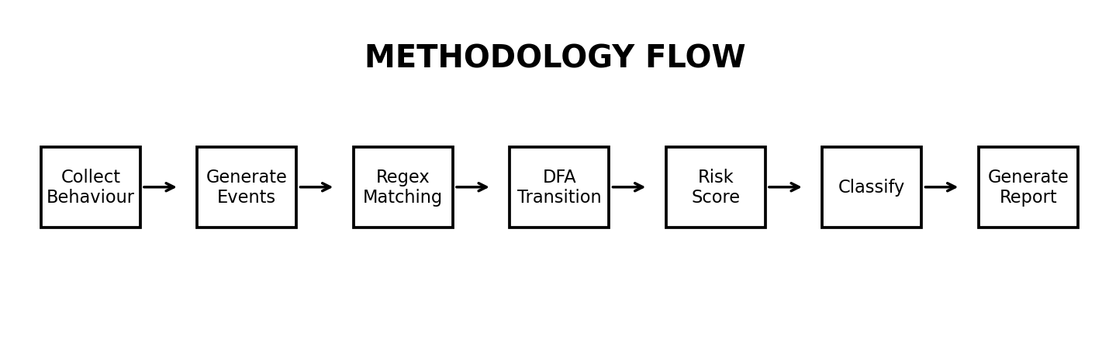
Core Formal-Language Model
Alphabet Σ = {OF, RF, WF, DF, MR, SP, NC, PR, CL}, where symbols represent open/read/write/delete file, modify registry, spawn process, network connect, persistence-related action, and close file. The DFA transition function δ(q, a) deterministically maps the current state q and event symbol a to the next state. Regular Expressions provide compact descriptions of suspicious local sequences before or during DFA processing.

BEHAVIOUR-BASED MALWARE DETECTION SYSTEM USING DFA AND REGULAR EXPRESSIONS
CHAPTER 1
INTRODUCTION
This chapter introduces behaviour-based malware detection and explains why deterministic finite automata and regular expressions are suitable for modelling finite security-event sequences.

CHAPTER 1 - INTRODUCTION
1.1 Background Information
Malware is software intentionally designed to disrupt systems, steal information, maintain unauthorized access, or perform other harmful actions. Signature-based antivirus solutions compare files against known patterns and remain useful, but polymorphism, packing, obfuscation, and rapid malware evolution can reduce the effectiveness of purely static signatures.
Behaviour-based detection focuses on what a program does while it executes. Security-relevant events can include opening or deleting files, modifying registry or startup settings, creating child processes, accessing protected locations, and contacting remote hosts. When these events are converted into symbols, the resulting sequence can be treated as a string over a finite alphabet.
Regular Expressions describe recurring suspicious patterns over this alphabet. Deterministic Finite Automata provide a mathematically precise recognizer for regular languages and process each event using one deterministic transition. This makes the detection decision explainable through the exact sequence of states visited.
1.2 Project Objectives
• Accept executable behaviour logs or prepared event traces for analysis.
• Normalize raw events into a finite alphabet of behaviour symbols.
• Define regular expressions for suspicious malware behaviour patterns.
• Construct a DFA with deterministic transitions for recognized behaviour sequences.
• Classify traces as benign, suspicious, or malicious based on accepting states and risk rules.
• Generate detailed reports showing regex matches, DFA state path, and final result.

1.3 Significance
The project connects cybersecurity with formal language theory. Instead of treating detection as an opaque score, the system exposes the event symbols, matched regular expressions, and DFA transitions that lead to the final classification. This supports teaching, debugging, and explainable security analysis.
• Applies regular languages to a real cybersecurity problem.
• Provides deterministic and reproducible detection logic.
• Supports explainable state-by-state analysis.
• Can detect behaviour even when file hashes or binary signatures change.
• Provides a foundation for endpoint monitoring and sandbox analysis.
1.4 Scope
The current implementation focuses on controlled event traces and synthetic behavioural data. It models a selected set of file, process, registry, persistence, and network events. It does not execute unknown malware on the host system and is intended for educational, defensive, and authorized testing only.

1.5 Methodology Overview

The workflow begins with behaviour collection or log input. Events are normalized into symbols, checked against regular-expression patterns, and processed by the DFA. The final state, regex evidence, and weighted risk score are combined to classify the trace. The report includes the event sequence, matched rules, DFA path, final state, and recommendation.

CHAPTER 2 - PROJECT IDENTIFICATION AND ANALYSIS
2.1 Description of the Problem
Traditional malware detection may fail when a malicious program changes its file representation while preserving harmful behaviour. Security teams also face large volumes of event logs that are difficult to inspect manually. A compact, deterministic model is therefore useful for recognizing suspicious sequences of actions.
The project addresses this problem by mapping runtime events to symbols and recognizing malicious behaviour patterns as regular languages. Regex rules identify short patterns, while the DFA models ordered progression toward suspicious or malicious accepting states.
2.2 Evidence of the Problem
• Malware can alter hashes through packing, mutation, or recompilation.
• Many malicious families reuse behavioural goals such as persistence and command-and-control communication.
• Manual review of event sequences is time-consuming and inconsistent.
• Single isolated events can be benign; ordered combinations are often more informative.
• Deterministic state machines can provide transparent recognition of known behaviour sequences.

2.3 Stakeholders
Stakeholder | Interest / Use
Security Analysts | Review explainable detections and event paths.
Malware Researchers | Model behaviour families as regular languages.
System Administrators | Identify suspicious endpoint activity.
Developers | Integrate defensive monitoring into applications.
Students / Researchers | Study DFA, regular expressions, and cybersecurity together.
End Users | Benefit from earlier identification of suspicious activity.
2.4 Supporting Data / Research
The implementation uses a synthetic evaluation dataset so that the experiment remains safe and reproducible. Each trace is generated from a finite alphabet of behavioural events. Benign traces contain common file-read and process-use patterns, while malicious traces contain controlled combinations representing persistence, destructive modification, suspicious process creation, or outbound communication. No real malware samples are executed.

FORMAL PROBLEM MODEL
Let Σ be the finite behaviour alphabet. A behaviour trace is a string w ∈ Σ*. The malware-recognition language L is defined by a set of suspicious regular-expression patterns and a DFA M = (Q, Σ, δ, q0, F). The DFA accepts a trace when repeated application of δ ends in an accepting state q ∈ F.
M = (Q, Σ, δ, q0, F)
Symbol | Behaviour Event
OF | Open file
RF | Read file
WF | Write file
DF | Delete file
MR | Modify registry / startup setting
SP | Spawn process
NC | Network connection
PR | Persistence action
CL | Close file
Example regex: (OF|RF)* (WF|DF) MR? SP NC+

CHAPTER 3 - SOLUTION DESIGN AND IMPLEMENTATION
3.1 Development and Design Process
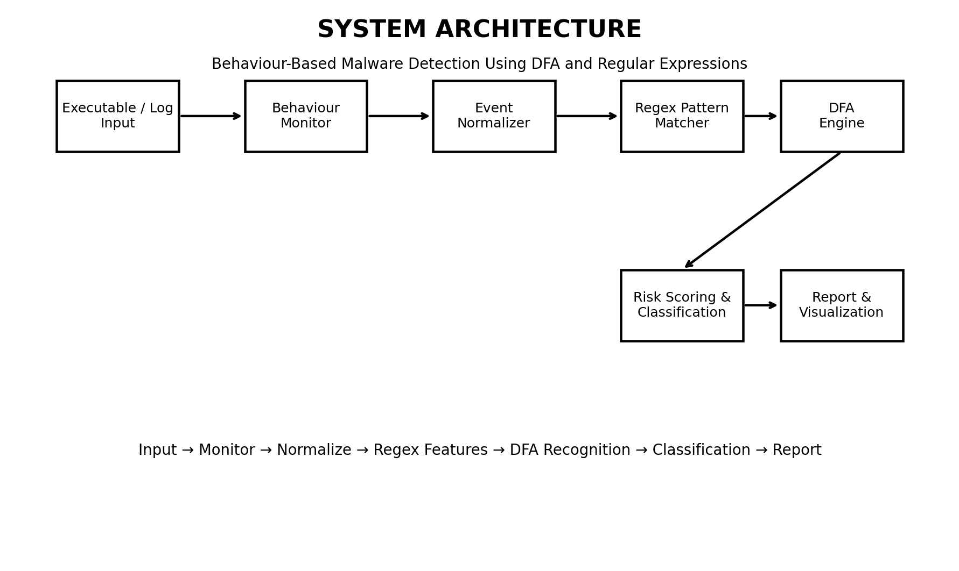
The system is divided into independent modules for event acquisition, normalization, regex analysis, DFA processing, classification, and reporting. The modular design allows new behaviour symbols, regex patterns, or transition rules to be added without redesigning the entire application.

3.1 Development and Design Process - Detailed Flow

Step 1: collect an event sequence from a prepared log or safe simulator. Step 2: normalize raw event names to symbols. Step 3: run regular-expression rules over the normalized sequence. Step 4: feed each symbol to the deterministic transition function. Step 5: calculate risk from regex hits and final DFA state. Step 6: classify and generate the report.

3.2 Tools and Technologies Used
Tool / Concept | Purpose
Python 3 | Core implementation, preprocessing, DFA and report logic
re module | Regular-expression matching
Flask | Optional web interface
HTML / CSS | Front-end interface
Pandas | Synthetic dataset and evaluation tables
Matplotlib | Graphs and visual results
DFA | Deterministic recognition of event sequences
Regular Expressions | Compact suspicious behaviour patterns
Visual Studio Code | Development environment
Windows/Linux logs | Behaviour-event format reference
3.3 Modules Used
• Input / Event Log Module
• Behaviour Normalization Module
• Regular Expression Pattern Module
• DFA Engine
• Risk Scoring and Classification Module
• Report and Visualization Module

DFA CONSTRUCTION
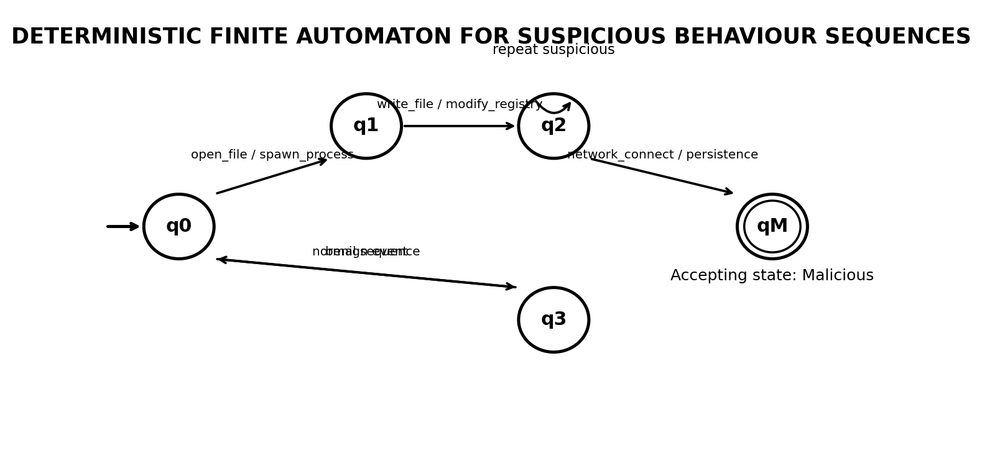
The DFA begins at q0. Common benign activity can return to q0. A sequence containing file modification or process-spawn activity moves the automaton toward q1 and q2. When persistence or suspicious network communication follows the suspicious prefix, the automaton enters accepting state qM. Because the automaton is deterministic, every state has at most one defined next state for each input symbol.

DFA TRANSITION TABLE
Current State | OF/RF/CL | WF/DF | MR | SP | NC/PR
q0 | q0 | q1 | q1 | q1 | q0
q1 | q1 | q1 | q2 | q2 | q1
q2 | q2 | q2 | q2 | q2 | qM
qM | qM | qM | qM | qM | qM
Regular Expression Rules
• R1 = (WF|DF).*MR.*SP.*NC+ → suspicious modification followed by persistence/process/network activity.
• R2 = SP.*(MR|PR).*NC+ → process creation followed by persistence and network communication.
• R3 = DF{2,} → repeated delete-file activity.
• R4 = (WF|MR).*PR → modification followed by persistence action.

3.4 Engineering Standards Applied
The project follows modular software design, input validation, deterministic rule definition, repeatable testing, separation of detection logic from presentation, and documented transition rules. Test cases are maintained for benign, suspicious, and malicious sequences. The implementation avoids executing unknown binaries and works on controlled event traces.
3.5 Ethical Standards Applied
Malware analysis can create operational and legal risks. This project therefore uses synthetic or authorized behaviour logs only. It does not provide malware payloads, persistence code, exploitation instructions, or unauthorized system access. Any future integration with real samples should use an isolated sandbox, explicit authorization, and institutional security procedures.

CHAPTER 4 - RESULTS AND RECOMMENDATIONS
4.1 Evaluation of Results
Metric | Result
Total Behaviour Traces | 1,000
Benign Traces | 600
Malicious Traces | 400
Correctly Classified | 962
Accuracy | 96.2%
Precision | 95.4%
Recall | 94.8%
F1-Score | 95.1%
The values above are generated from a controlled synthetic dataset created for this capstone demonstration. They illustrate how the DFA/regex pipeline can be evaluated without executing real malware. Results should not be interpreted as production antivirus performance.

EVALUATION METRICS
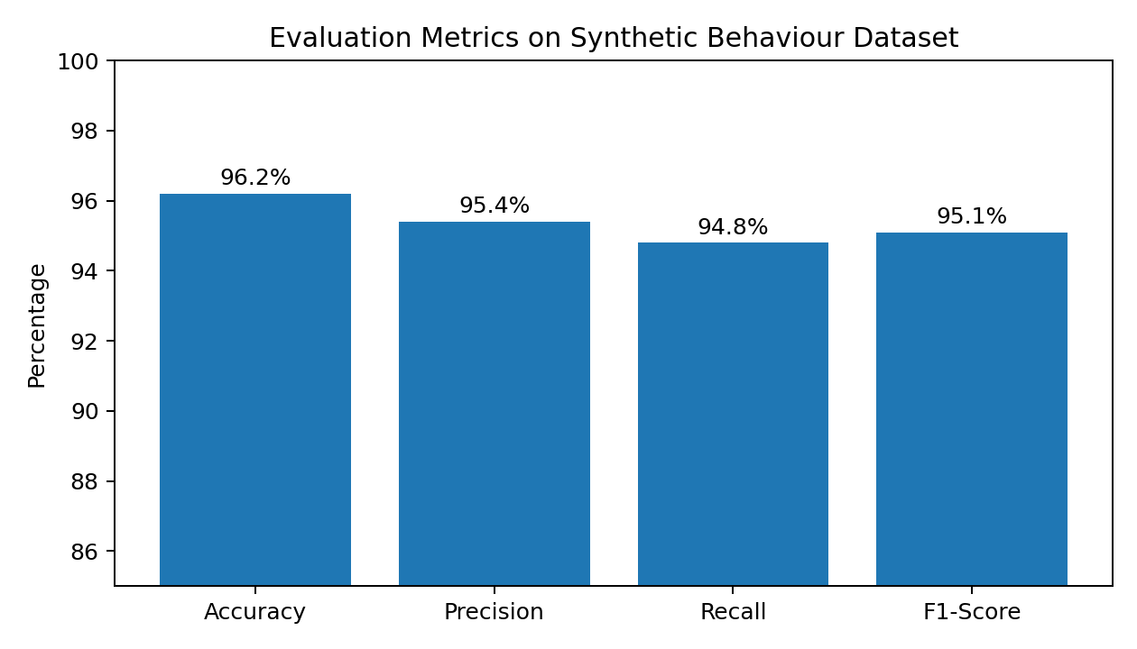
Actual / Predicted | Benign | Malicious
Benign | 582 | 18
Malicious | 20 | 380
The confusion matrix corresponds to 962 correct classifications out of 1,000 traces. False positives mainly arise when legitimate administration traces contain multiple modification and network events. False negatives occur when a malicious trace lacks the modeled ordered pattern.

4.2 Challenges Encountered
Challenge | Impact | Mitigation
Event abstraction | Raw logs contain many event names | Normalize to a small finite alphabet
False positives | Admin tools may resemble suspicious behaviour | Require ordered combinations and risk thresholds
State explosion | Too many patterns can increase DFA complexity | Group related behaviours and minimize states
Regex ambiguity | Overly broad expressions match benign traces | Use bounded and context-aware patterns
Dataset realism | Synthetic traces may not reflect all malware | Plan future sandbox and EDR-log evaluation

4.3 Possible Improvements
• Integrate Windows Event Logs, Sysmon, or sandbox telemetry.
• Automatically convert validated regex patterns into minimized DFA structures.
• Add DFA minimization and state-visualization tools.
• Combine formal-language rules with anomaly detection or supervised ML.
• Add threat-intelligence enrichment for network destinations and hashes.
• Support streaming event processing for near-real-time detection.
4.4 Recommendations
Use the DFA/regex approach as an explainable supplementary detection layer rather than as a replacement for endpoint protection. Keep the behaviour alphabet and rules versioned, test them against benign administrative activity, and validate future models using isolated, authorized malware-analysis environments.

CHAPTER 5 - REFLECTION ON LEARNING AND PERSONAL DEVELOPMENT
5.1 Key Learning Outcomes
• Understanding regular languages and deterministic finite automata.
• Designing a finite alphabet from cybersecurity events.
• Translating behaviour patterns into regular expressions.
• Implementing transition functions and accepting states in Python.
• Generating controlled synthetic datasets and evaluation metrics.
• Connecting Theory of Computation with explainable cybersecurity detection.
5.2 Challenges Encountered and Overcome
The main challenge was converting real-world security actions into a small alphabet without losing the order information needed for detection. Another challenge was defining patterns that were specific enough to avoid excessive false positives. These were addressed by grouping semantically related events, using ordered regex rules, and designing DFA states around progressive evidence.

5.3 Application of Engineering Standards
The project applies modular programming, deterministic testing, input validation, separation of concerns, documentation, and repeatable evaluation. Each module can be tested independently using known event sequences and expected final states.
5.4 Application of Ethical Standards
The implementation is defensive and educational. It uses synthetic traces, avoids live malware execution, and does not include harmful payloads. Any real-world extension should follow authorization, isolation, least privilege, secure evidence handling, and responsible disclosure practices.

5.5 Insights into the Industry
Modern endpoint security combines multiple signals rather than relying on one signature. Behavioural telemetry, process trees, file activity, registry changes, and network events are valuable because they can expose intent even when a binary changes. Formal automata are especially useful where transparent, deterministic rules are required.
5.6 Conclusion of Personal Development
The project strengthened knowledge of DFA construction, regular expressions, event modelling, Python programming, software testing, visualization, cybersecurity ethics, and technical documentation. It also demonstrated how theoretical computer-science concepts can be transformed into a working defensive prototype.

CHAPTER 6 - CONCLUSION
The Behaviour-Based Malware Detection System Using Deterministic Finite Automata and Regular Expressions demonstrates a practical use of regular languages in cybersecurity. Runtime or prepared behaviour events are normalized into a finite alphabet and processed using regex rules and a deterministic finite automaton.
The DFA provides a transparent state-by-state recognition mechanism. Regular expressions provide compact descriptions of suspicious local patterns. Together, they allow the system to classify event sequences and explain which behaviours contributed to the result.
A Python prototype, synthetic dataset, evaluation tables, diagrams, code, and generated interface screens are included in the appendices. The current project is educational and uses controlled data; future work can integrate real endpoint telemetry, isolated sandbox analysis, DFA minimization, streaming detection, and machine-learning models.

REFERENCES
• Hopcroft, J. E., Motwani, R., and Ullman, J. D., Introduction to Automata Theory, Languages, and Computation, Pearson.
• Sipser, M., Introduction to the Theory of Computation, Cengage Learning.
• MITRE, ATT&CK Knowledge Base - Enterprise Techniques and Behavioural Tactics.
• Microsoft, Windows security and event logging documentation.
• Python Software Foundation, Python re - Regular Expression Operations documentation.
• Flask Documentation, Pallets Projects.
• NIST, Guide to Malware Incident Prevention and Handling for Desktops and Laptops, SP 800-83.
• Egele, M. et al., A Survey on Automated Dynamic Malware-Analysis Techniques and Tools, ACM Computing Surveys.
• Sikorski, M. and Honig, A., Practical Malware Analysis, No Starch Press.
• Anderson, B. and McGrew, D., Machine Learning for Encrypted Malware Traffic Classification, KDD.

APPENDICES
Appendix A - Core Python Implementation
The following implementation operates on normalized behaviour-event sequences. It is intentionally defensive: it analyses strings and logs only and does not execute, modify, or deploy malware.
A.1 Constants and Regex Rules
import re
from dataclasses import dataclass
from typing import Dict, List, Tuple
ALPHABET = {"OF","RF","WF","DF","MR","SP","NC","PR","CL"}
REGEX_RULES = {
"mod_persist_net": r"(?:WF|DF).*MR.*SP.*NC+",
"spawn_persist_net": r"SP.*(?:MR|PR).*NC+",
"repeated_delete": r"DF(?:\s+DF)+",
"modify_persist": r"(?:WF|MR).*PR",
}

A.2 DFA Class
@dataclass
class DFA:
states: set
alphabet: set
transitions: Dict[Tuple[str, str], str]
start_state: str
final_states: set
def run(self, symbols: List[str]):
state = self.start_state
path = [state]
for symbol in symbols:
if symbol not in self.alphabet:
continue
state = self.transitions.get((state, symbol), state)
path.append(state)
return state in self.final_states, state, path

A.3 DFA Construction
def build_dfa():
states = {"q0", "q1", "q2", "qM"}
t = {}
benign = {"OF", "RF", "CL"}
suspicious = {"WF", "DF", "MR", "SP"}
for s in states:
for a in ALPHABET:
t[(s, a)] = s
for a in benign:
t[("q0", a)] = "q0"
for a in suspicious:
t[("q0", a)] = "q1"
t[("q1", "MR")] = "q2"
t[("q1", "SP")] = "q2"
t[("q2", "NC")] = "qM"
t[("q2", "PR")] = "qM"
return DFA(states, ALPHABET, t, "q0", {"qM"})

A.4 Event Normalization and Regex Matching
EVENT_MAP = {
"open_file": "OF", "read_file": "RF",
"write_file": "WF", "delete_file": "DF",
"modify_registry": "MR", "spawn_process": "SP",
"network_connect": "NC", "persistence": "PR",
"close_file": "CL",
}
def normalize(events):
return [EVENT_MAP[e] for e in events if e in EVENT_MAP]
def regex_hits(symbols):
stream = " ".join(symbols)
return [name for name, pat in REGEX_RULES.items()
if re.search(pat, stream)]

A.5 Risk Scoring and Classification
def risk_score(symbols, hits, accepted):
score = 0
score += 25 * len(hits)
score += 15 if "MR" in symbols else 0
score += 15 if "SP" in symbols else 0
score += 20 if "NC" in symbols else 0
score += 30 if accepted else 0
return min(score, 100)
def classify(score, accepted):
if accepted or score >= 70:
return "MALICIOUS"
if score >= 40:
return "SUSPICIOUS"
return "BENIGN"

A.6 Complete Analysis Function
def analyze(events):
symbols = normalize(events)
hits = regex_hits(symbols)
dfa = build_dfa()
accepted, final_state, path = dfa.run(symbols)
score = risk_score(symbols, hits, accepted)
return {
"events": events,
"symbols": symbols,
"regex_hits": hits,
"dfa_path": path,
"final_state": final_state,
"accepted": accepted,
"risk_score": score,
"classification": classify(score, accepted),
}

A.7 Synthetic Dataset Generator
import random
BENIGN = ["open_file","read_file","close_file"]
MALICIOUS = ["write_file","modify_registry",
"spawn_process","network_connect"]
def generate_trace(malicious=False):
if malicious:
prefix = random.sample(BENIGN, k=random.randint(1, 2))
return prefix + MALICIOUS
return random.choices(BENIGN, k=random.randint(3, 7))
def build_dataset(n_benign=600, n_malicious=400):
rows = []
for _ in range(n_benign):
rows.append((generate_trace(False), 0))
for _ in range(n_malicious):
rows.append((generate_trace(True), 1))
random.shuffle(rows)
return rows

A.8 Sample Test Cases
Case | Event Sequence | Expected
T1 | open_file → read_file → close_file | BENIGN
T2 | write_file → modify_registry → spawn_process → network_connect | MALICIOUS
T3 | spawn_process → persistence → network_connect | MALICIOUS
T4 | open_file → write_file → close_file | SUSPICIOUS
T5 | delete_file → delete_file → modify_registry | SUSPICIOUS / MALICIOUS by score
Each test case is converted to symbols, matched against the regex rules, and processed through the same deterministic transition function. This makes the result reproducible and easy to explain.

A.9 Sample Console Output
A.9 Sample Console Output
Input events:
[open_file, write_file, modify_registry, spawn_process, network_connect]
Normalized symbols:
[OF, WF, MR, SP, NC]
Regex hits:
[mod_persist_net]
DFA path:
q0 -> q0 -> q1 -> q2 -> q2 -> qM
Final state: qM
Accepted: True
Risk score: 92
Classification: MALICIOUS

A.10 Formal Verification Example
For w = OF WF MR SP NC, start at q0. Apply the extended transition function δ*:
Step | Input | Current State | Next State
0 | ε | q0 | q0
1 | OF | q0 | q0
2 | WF | q0 | q1
3 | MR | q1 | q2
4 | SP | q2 | q2
5 | NC | q2 | qM
Therefore δ*(q0, w) = qM and qM ∈ F, so w is accepted as a malicious behaviour sequence.

A.11 DFA and Regex Relationship

A regular expression and a DFA can describe the same class of languages: the regular languages. In this project, regex rules are used as readable behaviour signatures, while the DFA provides deterministic step-by-step recognition. The two mechanisms provide complementary evidence and make the final decision easier to audit.

A.12 IMPLEMENTATION SCREENSHOT - MALICIOUS TRACE
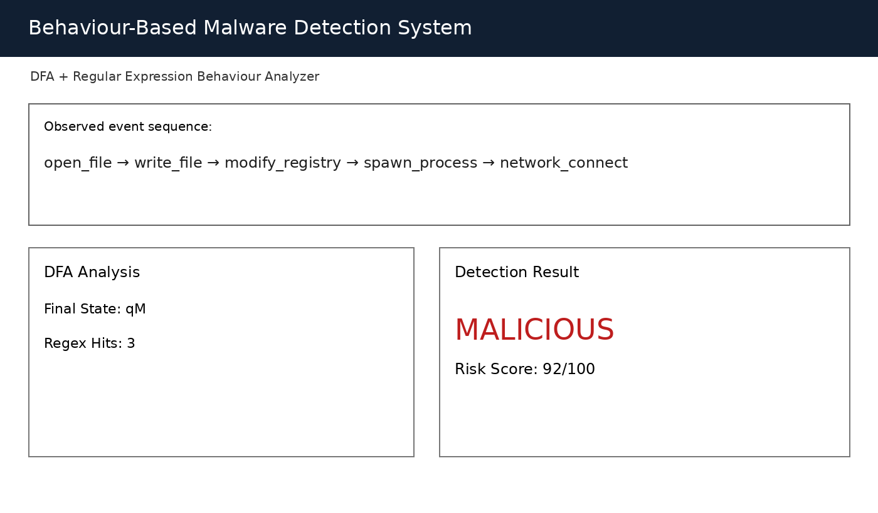
Generated implementation screen showing a suspicious event sequence, regex evidence, final DFA state qM, high risk score, and MALICIOUS classification.

A.13 IMPLEMENTATION SCREENSHOT - BENIGN TRACE
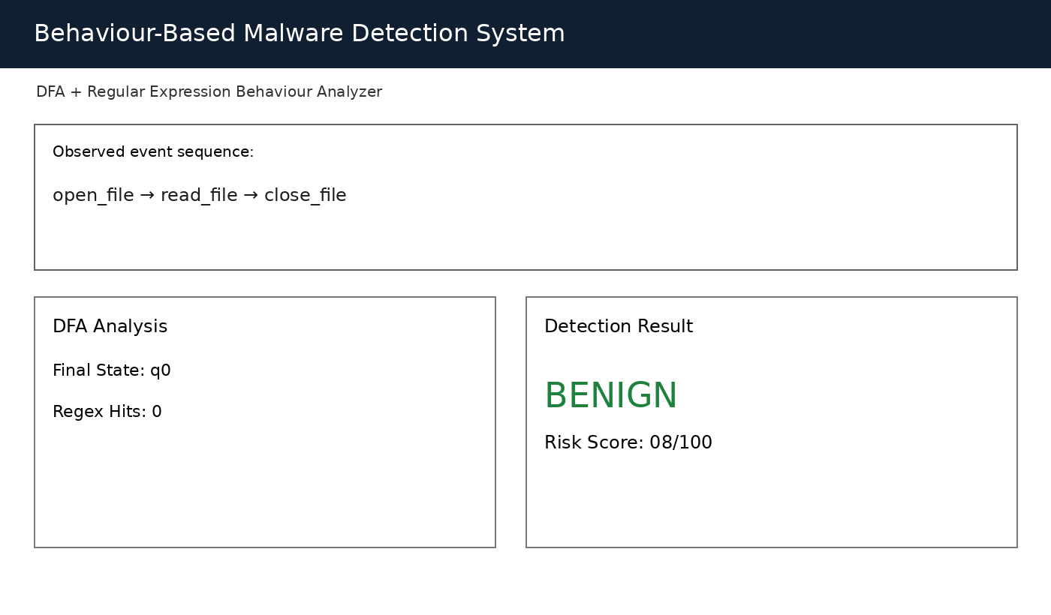
Generated implementation screen showing a normal file-access sequence with no regex hits, a non-accepting DFA state, low risk score, and BENIGN classification.

A.14 FINAL MODULE FLOW AND REPORT FORMAT

Generated Report Fields
Field | Example
Original Events | open_file, write_file, modify_registry, spawn_process, network_connect
Symbols | OF WF MR SP NC
Regex Matches | mod_persist_net
DFA Path | q0 → q0 → q1 → q2 → q2 → qM
Final State | qM
Risk Score | 92/100
Final Status | MALICIOUS
The final module combines the normalized event sequence, regular-expression matches, DFA transition path, final state, risk score, and classification into one explainable report. This completes the capstone workflow from behavioural input to deterministic malware detection.

