Impact of Frequency Reuse on Cellular Network Performance
Concept map and technical evaluation | Question 3

Overview and main finding
Frequency reuse allows cellular networks to serve many users with a limited spectrum allocation. The same frequencies are assigned to different cells so that spectrum can be used repeatedly across a geographical area. Its effectiveness depends on frequency planning and interference control. More aggressive reuse increases available resources per cell, but the resulting interference can reduce the amount of data successfully delivered.
The best design therefore maximizes usable network capacity while maintaining acceptable signal quality, coverage and reliability. Increasing reuse alone does not guarantee better performance. This report connects frequency planning, co-channel interference, adjacent channel interference and capacity, and evaluates techniques that balance these competing requirements.

Concept map
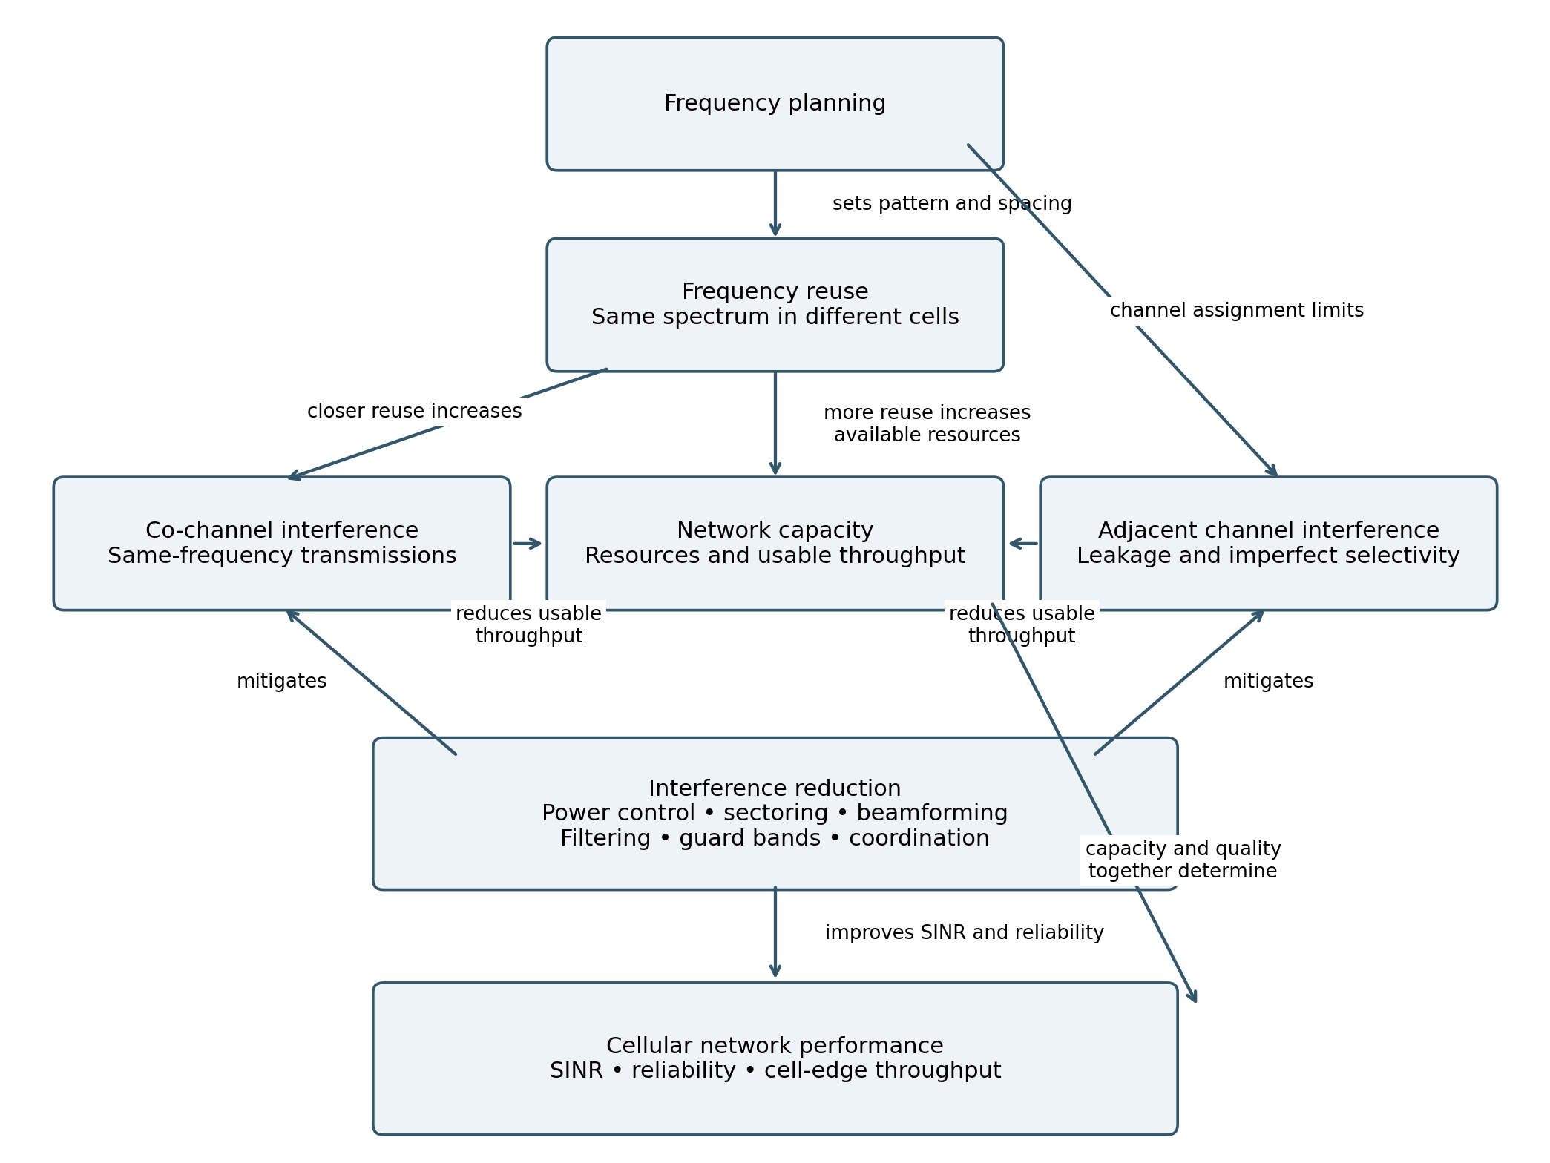
Figure 1. Read each arrow with its linking phrase. Frequency planning also specifies transmit power, antenna configuration and the separation of cells that share frequencies. The two interference types have different causes and require different remedies.

Frequency planning and reuse
A cellular network divides its coverage region into cells served by base stations. Frequency planning determines which frequencies or time-frequency resources each cell may use. It considers traffic demand, propagation, antenna patterns, transmit power and acceptable interference. In a traditional fixed-channel system, a cluster of N cells shares the available channels, and the cluster pattern is repeated across the network.

Core relationships
For a regular hexagonal model, the reuse distance D and cell radius R are related by D/R = √(3N). The cluster size follows N = i² + ij + j² for nonnegative integers i and j that define the lattice shift. This report calls 1/N the reuse fraction; some texts use “reuse factor” for N itself, so the convention must always be stated.
If S channels are divided equally among N cells, the nominal allocation per cell is S/N. Reducing N therefore increases the channels available to each cell, but it also reduces the separation between cells that share a frequency. Real deployments have irregular coverage, terrain, traffic and antenna patterns, so these equations are explanatory planning models rather than exact predictions.

Illustrative numerical comparison
Assume 420 channels, equal allocation, omnidirectional cells, a path-loss exponent n = 4 and six approximately equidistant first-tier co-channel interferers. In this simplified interference-limited model, SIR ≈ (D/R)ⁿ/6. Noise, shadowing, unequal distances, fading and higher interference tiers are excluded.
Cluster N | Reuse 1/N | Channels per cell | D/R | Approx SIR
3 | 1/3 | 140 | 3.00 | 11.3 dB
7 | 1/7 | 60 | 4.58 | 18.7 dB
12 | 1/12 | 35 | 6.00 | 23.3 dB
Moving from N = 7 to N = 3 increases nominal channels per cell from 60 to 140, but the estimated SIR falls from 18.7 dB to 11.3 dB. Moving to N = 12 improves estimated SIR to 23.3 dB while reducing channels per cell to 35. These calculations illustrate the trade-off; they are not measured throughput or recommended operating thresholds.

Modern reuse one networks
LTE and 5G commonly allow cells to use the same carrier bandwidth, described as reuse one. Scheduling, power control, directional antennas and interference management determine which resources can be used effectively. The fixed S/N channel model explains classical planning but does not fully describe modern packet-based capacity.

Interference and its effect on performance

Co-channel interference
Co-channel interference occurs when unwanted transmissions use the same frequency resources as the desired signal. It is closely related to spatial reuse: bringing cells that share resources closer together generally raises interference. Cell-edge users are especially vulnerable because their serving signal is weaker and neighboring signals can be relatively strong.
This interference lowers the signal-to-interference-plus-noise ratio, or SINR. Lower SINR can require a more robust modulation and coding scheme, increase retransmissions and reduce throughput. Severe interference can contribute to outages or unsuccessful connections. Raising every base station’s power together usually provides little improvement in an interference-limited network because desired and interfering signals both increase.

Adjacent channel interference
Adjacent channel interference comes from transmissions on nearby frequencies. It results from transmitter leakage into the wanted band and limited receiver selectivity. A strong nearby transmitter can overwhelm a weaker desired signal even when they use different channels. This near-far situation may arise between users, neighboring sites or co-located radio systems.
Adjacent channel interference is not simply another name for interference from a neighboring cell. “Co-channel” and “adjacent channel” describe the frequency relationship; either interferer can be physically nearby or distant. Increasing the distance between co-channel cells does not automatically solve leakage from an adjacent-frequency transmitter.
Aspect | Co-channel interference | Adjacent channel interference
Frequency relationship | Same frequency resources | Nearby frequency channels
Principal cause | Spatial reuse and overlapping transmissions | Leakage and imperfect receiver filtering
Main planning control | Reuse distance, antenna pattern and scheduling | Channel spacing, assignment and RF filtering
Practical effect | Lower SINR and usable throughput | Receiver impairment and lower usable throughput

Capacity must include successful delivery
Nominal capacity represents the resources available for transmission. Usable capacity represents successfully delivered traffic under actual radio and load conditions. A higher channel allocation can be offset by lower spectral efficiency, retransmissions or poor cell-edge coverage. A useful conceptual relationship is throughput ≈ allocated bandwidth × achievable spectral efficiency × successful delivery fraction; scheduling and protocol overhead further reduce the delivered rate.
Network evaluation should therefore examine aggregate throughput together with cell-edge throughput, outage probability, retransmission rate, connection reliability and fairness. A design that improves average throughput while leaving edge users unusable is not a balanced improvement.

Evaluation of interference reduction techniques
The following assessments are qualitative engineering judgments. Effectiveness depends on cell geometry, traffic load, radio equipment and the dominant source of interference; no universal percentage reduction is assumed.
Technique | Effectiveness and suitable use | Cost or limitation
Larger reuse distance | Strong classical control of co-channel interference; improves separation. | Reduces channels per cell; does not directly cure adjacent channel leakage.
Sectoring and antenna tilt | Reduces radiation toward unwanted directions and limits overshoot. | Requires antenna planning; sidelobes and sector boundaries still interfere.
Adaptive power control | Limits unnecessary transmit power and helps near-far problems. | Excessive reduction weakens coverage; equal power increases are not a solution.
Beamforming | Focuses energy toward users and can suppress interference directions. | Needs accurate channel information; mobility and sidelobes limit gains.
Fractional or soft reuse | Protects edge users through resource partitioning or power masks. | May reduce resources or power available in parts of a cell.
Inter-cell coordination | Coordinates time, frequency or power use; valuable at cell edges. | Consumes resources or introduces signaling and coordination overhead.
RF filtering and linearity | Directly reduces adjacent-band leakage and improves selectivity. | Hardware cost and filter limitations; same-channel interference remains.
Guard bands and channel spacing | Separates adjacent emissions from the desired channel. | Consumes spectrum and can reduce nominal capacity.

Which techniques are most effective
For co-channel interference, antenna optimization, controlled power and coordinated resource use often provide a better capacity trade-off than increasing cluster size alone. Fractional reuse assigns more protection to vulnerable cell-edge users while permitting greater reuse near the center. Soft reuse uses different power levels on resource subsets; its benefits depend on the chosen masks and traffic distribution.
For adjacent channel interference, filtering, transmitter linearity and appropriate channel separation target the actual cause. Power control and physical isolation can also reduce a strong nearby interferer. Guard bands work, but they should be sized to equipment and interference requirements because unused spectrum carries a capacity penalty.
In heterogeneous LTE networks, enhanced inter-cell interference coordination can use protected time intervals to help small-cell users exposed to strong macrocell interference. Protection improves those users’ conditions but limits some macrocell transmission opportunities. Coordinated multipoint operation may provide further gains, at the cost of tighter coordination and additional implementation demands.

Integrated evaluation and recommendation

Example planning decision
Consider a busy urban network with strong cell-center throughput but poor service at cell boundaries. If neighboring cells transmit simultaneously on the same resources, the likely problem is co-channel interference. First examine antenna overshoot and power settings, then coordinate scheduling or introduce edge-specific resource protection. Increasing frequency separation across all cells may improve isolation but unnecessarily reduce resources for users who already have good signal quality.
If problems instead occur near a strong transmitter operating on an adjacent carrier, inspect transmitter emissions, receiver selectivity and channel separation. Coordination on the shared carrier alone may not address that fault. Correct identification of the interference type determines which intervention is effective.

Appropriate linking phrases
Concept relationship | Linking phrase
Frequency planning → frequency reuse | determines the pattern and separation of
Smaller cluster size → resources per cell | increases the nominal allocation of
Closer co-channel cells → interference | generally increases
Co-channel interference → SINR | reduces
Adjacent channel interference → signal quality | degrades through leakage and limited selectivity
Interference reduction → usable capacity | can improve by enabling reliable transmissions
Guard bands → available spectrum | reduce while improving isolation
Planning and interference control → performance | jointly balance capacity and service quality

Conclusion
Frequency reuse is essential for serving many users within limited spectrum, but its benefit depends on managing interference. Frequency planning controls resource assignment and spatial separation. Co-channel interference constrains aggressive reuse, while adjacent channel interference requires attention to leakage, receiver selectivity and channel spacing. The most effective strategy combines suitable reuse, directional antennas, controlled power, coordination and RF protection, then verifies the result using both capacity and service-quality measurements.

References and further reading
1. ITU hosted CAICT presentation. Technology and Standard of 4G LTE, 2016. Discusses the trade-off between frequency reuse and spectral efficiency. https://www.itu.int/en/ITU-D/Regional-Presence/AsiaPacific/SiteAssets/Pages/Events/2016/Oct-CandI2016/CAICT2016/Session%206-1-Technology%20and%20Standard%20of%204G%20LTE-%E6%9D%A8%E6%80%9D%E8%BF%9C-final.pdf
2. Lindbom et al. Enhanced Inter-cell Interference Coordination for Heterogeneous Networks in LTE-Advanced A Survey, 2011. https://arxiv.org/abs/1112.1344
3. 3GPP. LTE Release 12 presentation, LTE Africa 2013. Includes enhanced interference coordination for overlaid deployments. https://www.3gpp.org/img/pdf/lte_africa_2013_3gpp_lte_release_12.pdf

