SAVEETHA SCHOOL OF ENGINEERING
Course Code: ITA1439 Course Name: Ethical Hacking Slot: A
CO1 – ASSIGNMENT_1
Nature of Assignment: Individual Duration: 1 Week Total Marks: 50
Student Name | Register No.
Manoj Reddy | 192311171

CO1: Apply the foundational concepts of ethical hacking, including the types of hackers, ethical principles, legal frameworks, and the role of responsible disclosure in cybersecurity.
Assignment Title: Design and Develop a Complete Ethical-Hacking Engagement Framework for a University’s Authorized Security-Assessment Programme.

Summary of the solution
This document solves all eleven tasks of the assignment with one integrated design, the University Ethical-Hacking Engagement Framework (UEHEF). The framework answers who authorizes a test, what is in scope, which laws apply, which attackers are modelled, what conduct is acceptable, how an isolated lab is used and how findings are disclosed. Every major decision is supported by a table, a figure or a test result. The tests were executed with small Python models of the decision rules (no live exploitation, no network scanning); the scalability results come from a seeded simulation whose assumptions are stated in Task 10. Legal and disclosure reference points were taken from public sources, including the Anthropic pages linked from claude.com, and are listed in the references.
Notes: the university is referred to as “the University”; engagement IDs, IP addresses (except the lab range 192.168.56.0/24), dates and names of roles are illustrative. This is a design exercise, not legal advice.
Task | Topic | Marks
1 | Enquiry questions, requirements, blueprint and design criteria | 4
2 | Hacker threat model and classification | 4
3 | Ethics and code-of-conduct module | 4
4 | Legal-compliance mapping (IT Act 2000, DPDP Act, CFAA) | 4
5 | Scope and rules-of-engagement document | 4
6 | Authorization and disclosure layer | 5
7 | Isolated ethical-hacking lab | 5
8 | Reusable document library | 5
9 | Integration, walkthrough, test and refinement | 5
10 | Scalability and governance evaluation | 5
11 | Defence under a changed requirement | 5
Total |  | 50

TASK 1 – Formulate the Enquiry and Framework Blueprint (4 Marks)
The scenario is converted below into formal engagement-governance requirements, a blueprint that shows how the components cooperate, a set of enquiry questions that the framework must answer, and a set of design criteria that are used as acceptance criteria in Task 11. The framework is named UEHEF (University Ethical-Hacking Engagement Framework). The word “University” refers to the institution in the scenario; all identifiers, addresses and dates used are illustrative.

1.1 Governance requirements derived from the scenario
ID | Requirement (the framework shall …) | Scenario source | Component
R1 | require a signed written authorization from the system owner and the CISO before any test action is performed | “unauthorized access” | C1
R2 | list every in-scope asset explicitly (ID, IP, owner); anything not listed is out of scope by default | “unclear scope” | C2
R3 | map each engagement activity to the applicable law (IT Act 2000, DPDP Act 2023, CERT-In directions) and compare with an international law (CFAA) | “legal exposure” | C3
R4 | apply a data-protection check whenever a target holds personal data | “systems that hold personal data” | C3, C1
R5 | protect live systems through testing windows, rate limits, prohibited techniques and a kill-switch | “damage to live systems” | C2, C5
R6 | accept requests from any department through one uniform intake process | “requested by different departments” | C1
R7 | vet external testers and bind them by NDA and a code of conduct | “internal staff or external testers” | C1, C5
R8 | provide an isolated lab for hands-on practice before live testing | “isolated-lab level” | C6
R9 | disclose findings only through a defined, timed, coordinated process | “uncoordinated disclosure” | C7
R10 | scale from 20 systems / 50 staff to the whole university and third-party assessors by configuration, not redesign | “remain usable as the programme grows” | All
R11 | record every approval, status change and decision in an auditable log | “governance decisions … justify” | C1, C8
R12 | separate the questions: authorized? legal? appropriate? | “clearly distinguish” | C1, C3, C5
R13 | model the attackers relevant to the university so that tests are realistic and relevant | “types of hackers” | C4
R14 | perform no live exploitation within this assignment (design, documentation and lab level only) | “No live exploitation is performed” | All

Systems in scope (initial programme: 20 systems)
Service group | Systems (register IDs) | Count | Hold personal data
Student portal | SYS-01 web front-end, SYS-02 application server, SYS-03 student-records database, SYS-04 single sign-on | 4 | 4 (all)
Learning-management system (LMS) | SYS-05 web front-end, SYS-06 application server, SYS-07 database, SYS-08 content store, SYS-09 plugin/integration server (vendor-hosted) | 5 | 4 (all except SYS-09)
E-mail service | SYS-10 mail gateway, SYS-11 mailbox server, SYS-12 webmail, SYS-13 mail archive | 4 | 4 (all)
Campus network | SYS-14 core switch, SYS-15 distribution switches, SYS-16 WLAN controller, SYS-17 perimeter firewall, SYS-18 DNS/DHCP, SYS-19 VPN gateway, SYS-20 RADIUS/802.1X | 7 | 1 (SYS-20)
Total |  | 20 | 13

Explicitly out of scope (named in the register so that requests touching them can be detected): payroll/finance ERP (10.30.1.0/24), health-centre records (10.30.2.0/24), research HPC cluster (10.30.3.0/24), student hostel/BYOD networks (10.40.0.0/16), the third-party payment gateway and library SaaS, and the personal devices of students and staff.

Stakeholders
Stakeholder | Role in the programme | Main interest
Vice-Chancellor / Registrar | Ultimate accountability; receives escalations | Reputation, legal exposure
CISO | Co-signs every authorization; chairs the Governance Board | Security posture, control over testing
Ethical-Hacking Governance Team (us) | Designs, runs and audits the framework | Consistent, defensible decisions
System owners (Deans, HoDs, IT heads) | Request tests, sign for their systems, fix findings | Service availability, timely fixes
Data Protection Officer (DPO) | Reviews tests that touch personal data; assesses incidents | DPDP compliance, data-subject protection
Internal testers / IT staff (about 50 staff) | Perform in-house tests, operate the lab | Clear rules, protection when acting in good faith
External assessors | Perform third-party tests under contract | Clear scope, safe harbour, payment
Students and staff (data subjects) | Their data sits in the portal, LMS and e-mail | Privacy and continuity of service
Legal counsel; CERT-In; software vendors | Legal advice; national incident coordination; patch owners | Lawful, coordinated handling

Expected activities and constraints
- Activities: passive reconnaissance, port and vulnerability scanning, configuration review, web-application testing with test accounts, wireless and network-segmentation review, password-policy audit, lab rehearsal, reporting, retesting, disclosure and closure.
- Constraints: (i) law – IT Act 2000, DPDP Act 2023, CERT-In directions; (ii) live-service availability, especially during admissions and examinations; (iii) personal data of students and staff; (iv) limited staff (about 50) and a single CISO office; (v) growth to external assessors; (vi) no live exploitation inside this assignment.

1.2 Framework blueprint
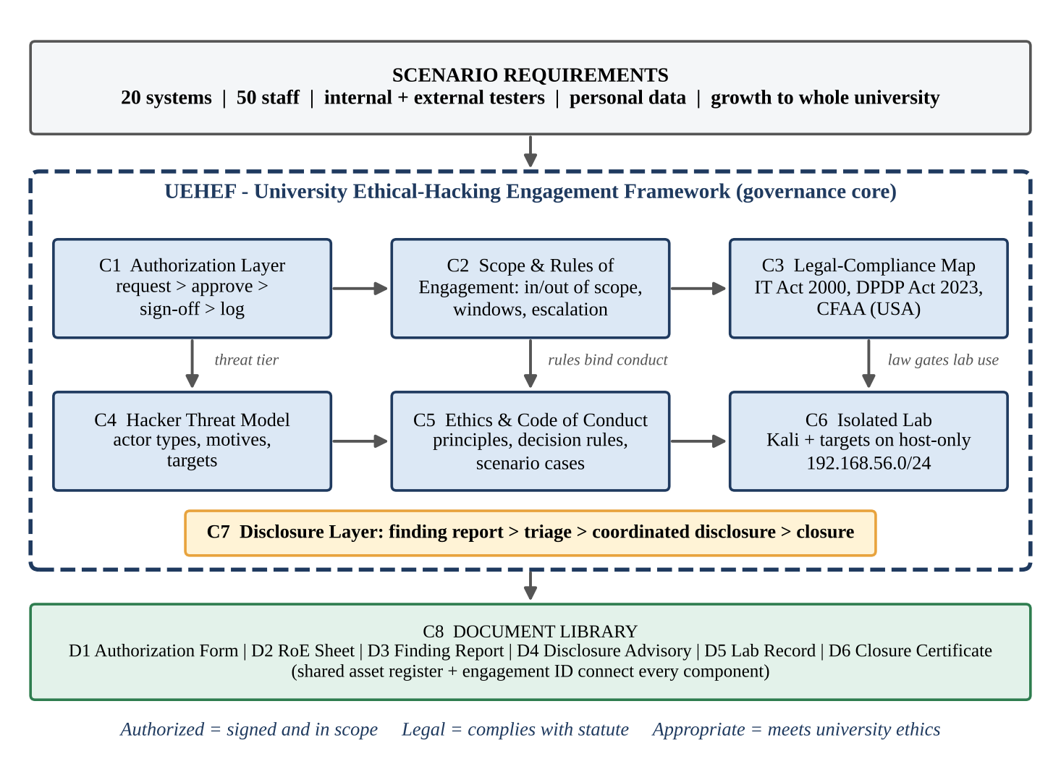
Figure 1: Requirements-to-governance blueprint of UEHEF (components C1–C8)
Figure 1 shows the cooperation. The engagement record (engagement ID, targets, window, signers, DPIA reference) is the spine that all components read and write. The interfaces between components are listed below; each is implemented and tested in Tasks 5–9.
From → To | What is passed | Effect
C4 Threat model → C1/C2 | Threat tier and likely attack paths | Decides the risk tier (low / high / external) and the permitted techniques
C3 Legal map → C1 | Personal-data flag and DPIA reference requirement | Authorization is put on HOLD if a PD system has no DPIA reference
C2 RoE → C1 | Targets, window, techniques | Authorization checks A5/A8/A10 reject out-of-scope or prohibited requests
C1 Authorization → C6 Lab | Lab authorization record | Only authorized testers receive lab access and the lab RoE
C5 Ethics → all | Decision rules and stop-and-ask checks | Every tester action is ACCEPTABLE, BORDERLINE or UNACCEPTABLE
C6 Lab → C7 Disclosure | Lab-validated finding (D3 JSON) | Starts the disclosure clock; severity routes the decision
C7 Disclosure → C3 Legal | Personal-data-exposed flag | Triggers DPO notification and the 72-hour breach clock where applicable
C8 Library → all | Documents D1–D6 with shared fields | Same engagement ID and asset IDs in every document

1.3 Enquiry questions the framework must answer
# | Enquiry question | Answered by
Q1 | Who authorizes a test, in what form, and how is the authorization proved and recorded? | C1, D1 (Tasks 5, 6)
Q2 | What exactly is in scope, and how is an out-of-scope request detected? | C2, D2 (Task 5)
Q3 | Which laws apply, what are the penalties, and which apply when personal data is touched? | C3 (Task 4)
Q4 | Which types of attackers are relevant, and how is an actor classified consistently? | C4 (Task 2)
Q5 | What conduct is acceptable, borderline or unacceptable during an engagement? | C5 (Task 3)
Q6 | How, when and by whom are findings disclosed, and when is full disclosure justified? | C7, D3, D4 (Task 6)
Q7 | Where is hands-on testing practised safely and how is containment shown? | C6, D5 (Task 7)
Q8 | Does the framework still work for the whole university and under changed requirements? | Tasks 10 and 11

1.4 Design criteria (used as acceptance criteria)
ID | Design criterion | Measurable acceptance test | Checked in
DC1 | Authorization completeness – no test action without a valid signed D1 | All authorization test cases give the expected decision (17 cases) | Tasks 8, 9
DC2 | Scope precision – no out-of-scope target accepted | All scope-boundary cases correct (7 cases) including boundary times | Tasks 5, 9
DC3 | Legal traceability – every legal requirement has at least one control | Each row of the legal table links to a control and a test | Task 4
DC4 | Containment – lab has no route to production or the Internet | Connectivity verification: negative tests all fail as expected | Task 7
DC5 | Timeliness – disclosure windows are defined and overdue findings are escalated | Overdue and 80 % cases trigger actions in the disclosure tests | Tasks 6, 9, 11
DC6 | Scalability – approval turnaround stays near one working day at university scale | Mean approval time of the refined design at large scale is no more than 1 working day | Task 10
DC7 | Reusability – at least four documents with defaults and validation | Document library tests pass for valid, boundary and invalid entries | Task 8
DC8 | Adaptability – a changed requirement is absorbed by modifying, not replacing, most components | Majority of components retained or modified in the revised design | Task 11

1.5 Rationale
Three governance options were compared: (a) leave each department to arrange its own tests (fast, but this is exactly the unstructured approach the team fears); (b) a single policy document (simple, but it gives no mechanism to check scope or to log decisions); and (c) a layered framework in which a small set of components share one engagement record and a document library. Option (c) is chosen because it is the only option that satisfies R10 and R11 together: new departments or external testers are added by creating new records, not by changing the rules. Its cost is more initial design effort and a small amount of administration per engagement, which Task 10 measures and Task 11 reduces further.

TASK 2 – Design a Hacker Threat Model and Classification (4 Marks)

2.1 Classification criteria and naming
An actor is described by four attributes: (A) authorization – is there written permission for the activity; (B) intent – benevolent, curiosity, ideological, financial, espionage/strategic, or grievance; (C) position – external, internal (holds a university account or privilege) or third-party; (D) capability – 1 (uses ready-made tools) to 5 (well-funded, custom tooling). The ordered rules below are applied top to bottom and the first rule that fits decides the class. This makes classification repeatable between reviewers.
Rule | Condition | Class
CR1 | Written authorization exists AND the conduct stays inside the authorized scope | White-hat (WH)
CR2 | Actor holds university-granted access or privilege AND misuses it with malicious or grossly negligent intent | Insider (IN)
CR3 | Actor is government-backed or equivalently resourced, with persistent strategic aims (espionage, research theft) | State-sponsored (SS)
CR4 | Motive is political or social, and publicity or disruption is the goal | Hacktivist (HK)
CR5 | No authorization AND no evidence of malicious intent AND the actor discloses the issue | Grey-hat (GH)
CR6 | No authorization, capability 1–2, uses tools or scripts without understanding them | Script kiddie (SK)
CR7 | No authorization AND financial gain, damage or theft is the intent (default for unauthorized and harmful) | Black-hat (BH)

Naming convention: CLASS-ORIGIN-CAPABILITY, for example GH-INT-2 means a grey-hat actor from inside the university community with capability 2; BH-EXT-4 is an external criminal with capability 4; WH-3P-3 is a third-party assessor. ORIGIN is EXT, INT or 3P. A tie between two rules is resolved by the rule with the lower number, and any override must be recorded with a reason.

2.2 Threat model and mapping table
Class (code) | Motivation | Typical capability | Likely university targets | Primary control
White-hat (WH) | Improve security; paid or assigned | 3–5 | Systems named in the signed D1/D2 | C1, C2, C5
Black-hat (BH) | Money, ransom, resale of student data and credentials | 3–5 | Student records DB (SYS-03), mail (SYS-10 to SYS-13), SSO (SYS-04) | Patching, MFA, monitoring
Grey-hat (GH) | Curiosity, reputation, “helping” without asking | 2–4 | Public web front-ends (SYS-01, SYS-05, SYS-12) | Disclosure channel, student-tester roster
Script kiddie (SK) | Fun, bragging, copying tutorials | 1–2 | Login pages, exposed services, WLAN | Rate limiting, hardening, WAF
Hacktivist (HK) | Political or social protest | 2–4 | Public web site, LMS front-end (defacement, DoS) | DDoS protection, incident plan
Malicious insider (IN) | Grievance, grade or fee manipulation, data sale | 2–4 (with valid access) | SYS-03, SYS-07 (marks, records), RADIUS, mail archive | Least privilege, logging, two-person rule
State-sponsored (SS) | Espionage, research and IP theft | 4–5 | Research data, staff mail, VPN gateway, SSO | Network segmentation, threat intelligence

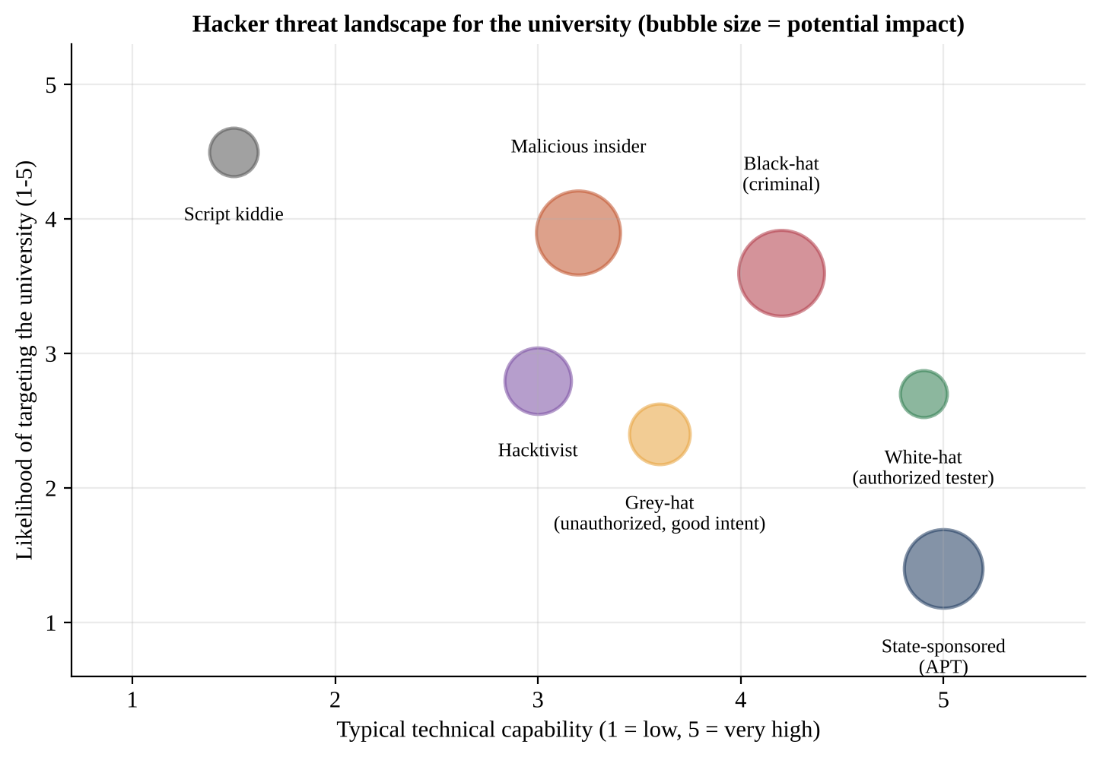
Figure 2: Threat landscape – capability against likelihood of targeting (scores are the team's qualitative judgement)
The scores in Figure 2 are qualitative (1–5) and reflect the team's judgement for a university with open-access services and a large population of students and staff. The most likely actors are script kiddies and malicious insiders; the highest-impact actors are black-hat criminals and insiders with privileged access. State-sponsored actors are unlikely but would have high impact on research data, so they are covered by general hardening rather than by specific tests in the initial 20 systems.

Consistency test of the criteria
Sample actor | Rule that fires | Class and code
Consultant with signed scope of SYS-05 to SYS-09 scans only those systems | CR1 | White-hat WH-3P-3
Same consultant scans the payroll network as well | CR1 fails (out of scope); CR2 not met; CR5 not met (no disclosure); CR7 if harmful intent is shown | Unauthorized actor – classified by intent; recorded as a conduct breach (Task 3)
Clerk with database access sells 300 student records | CR2 | Insider IN-INT-2
Group defaces the university site with a protest slogan | CR4 | Hacktivist HK-EXT-3
Teenager runs a downloaded exploit script against the login page | CR6 | Script kiddie SK-EXT-1
Persistent intrusion into research server, nothing monetised, advanced tooling | CR3 | State-sponsored SS-EXT-5

2.3 Borderline actor: two alternative classifications
Case. A final-year student runs a port scan and a simple SQL-injection test on the LMS out of curiosity, reads five records to confirm that the flaw is real, deletes them, and the next day e-mails the Dean a description and offers to help. No payment is asked and no data is published. There is no written authorization.
Alternative | Criteria for | Criteria against | Decision
Alt-1: Black-hat (BH-INT-2) | Unauthorized access to a system with personal data; records were read (IT Act s.43/s.66 conduct) | No intent to harm or profit (CR7 requires it); data deleted and the flaw disclosed | Rejected
Alt-2: White-hat (WH-INT-2) | Good intent; responsible disclosure; no harm | CR1 requires prior written authorization; permission cannot be given afterwards, so the first rule fails | Rejected
Alt-3: Insider (IN-INT-2) | Holds a student account of the university | CR2 needs malicious or grossly negligent misuse of granted privilege; intent here was not malicious | Rejected
Alt-4: Grey-hat (GH-INT-2) | No authorization AND no malicious intent AND discloses (all three parts of CR5) | Legal exposure remains (access was unauthorized) | Selected

Justified final classification: GH-INT-2 (grey-hat, internal community, capability 2). Classification describes the actor, not the legal outcome: the access was still unauthorized, so the incident is recorded and the university may take disciplinary action, but the response is proportionate (acknowledge the report, fix the flaw, brief the student, offer an invitation to the authorized student-tester roster). Treating the student as a black-hat would discourage future reports and push curious people towards silence; treating the student as a white-hat would suggest that permission is optional. This is the main reason for putting authorization first (CR1) in the rule order.

TASK 3 – Create an Ethics and Code-of-Conduct Module (4 Marks)

3.1 Ethical principles
Principle | Rule of behaviour | Evidence produced
P1 Written authorization | No scan, login or test without a signed D1 that covers the action | Engagement ID in every log and report
P2 Agreed scope | Touch only listed assets, inside the window, using permitted techniques | Scope allow-list check (S1–S5)
P3 Confidentiality | Findings, credentials and data are shared only with named recipients (need to know) | NDA, restricted evidence store
P4 Integrity | Never alter or delete logs, evidence or data; report results as they are | Hash-chained log, tool output kept
P5 Avoid harm | Use the least intrusive method that proves the point; stop if service degrades | Rate limits, kill-switch, HALT message
P6 Honest reporting | Report all findings including own mistakes; no exaggeration or hiding | D3 report, incident note for mistakes
P7 Privacy by minimisation | See, copy and keep as little personal data as possible; redact evidence | Evidence redaction rule F5
P8 Lawfulness and professionalism | Follow the law, the contract and the code; no payment demands or threats; declare conflicts of interest | Signed code acknowledgement

3.2 Rules and checks that prevent or detect unethical action
Stop-and-ask check. Before each phase and whenever something unexpected happens, the tester must answer five questions: (1) Is there a signed D1 for this? (2) Is the target on the allow-list? (3) Is it inside the window? (4) Is the technique permitted and the impact the smallest needed? (5) Will any personal data be seen or kept? Any “No” or “Not sure” means stop and escalate – never “try and see”.
Type | Control | What it catches
Preventive | Dual sign-off (system owner + CISO); scope allow-list; signed code acknowledgement; tool profiles with rate limits; two-person rule for exploitation steps; kill-switch word HALT | Unauthorized, out-of-scope or damaging actions
Preventive | Evidence redaction and no-copy rule for personal data; no payment or threats clause | Privacy breaches, extortion
Detective | Hash-chained engagement log; command history captured; Governance Team reviews logs within 48 hours; alert on traffic to any address outside the allow-list | Tampering, scope drift, hidden probes
Corrective | Immediate stop; incident note within 1 hour; owner and DPO informed; disciplinary or contractual action | Repeat breaches

Decision rule. Each action is evaluated by a rule that returns ACCEPTABLE, BORDERLINE or UNACCEPTABLE:
UNACCEPTABLE if no written authorization OR target out of scope OR prohibited technique
OR personal data copied/retained OR logs/evidence tampered OR payment/threat demanded
BORDERLINE if scope unclear OR window overrun OR personal data seen incidentally
OR written permission needed (for example publishing a finding)
ACCEPTABLE otherwise
Response: ACCEPTABLE -> proceed and log | BORDERLINE -> pause, record, ask owner/CISO | UNACCEPTABLE -> stop, report within 1 hour

3.3 Scenario cases
Twelve cases (four acceptable, four borderline, four unacceptable) were encoded as inputs to the decision rule and run (conduct.py). The result column is the output of that run.
ID | Case | Expected | Rule output | Response of the code of conduct
A1 | Rate-limited vulnerability scan of SYS-09 at 01:00, inside window | ACCEPTABLE | ACCEPTABLE | Proceed; entry written to the log – reason: all checks pass
A2 | Logs in once with a default password on an in-scope switch, screenshots the prompt only, logs it | ACCEPTABLE | ACCEPTABLE | Proceed; entry written to the log – reason: all checks pass
A3 | Reports a critical flaw to the CISO the same day instead of waiting for the final report | ACCEPTABLE | ACCEPTABLE | Proceed; entry written to the log – reason: all checks pass
A4 | Asks the Governance Team before touching a newly discovered in-scope sub-service | ACCEPTABLE | ACCEPTABLE | Proceed; entry written to the log – reason: all checks pass
B1 | Scan shows host 10.20.2.15, same subnet but not in the register; tester wants to continue | BORDERLINE | BORDERLINE | Pause; record; ask owner / CISO / DPO before continuing – reason: scope unclear
B2 | Error page displays a student's name and roll number during an authorized test | BORDERLINE | BORDERLINE | Pause; record; ask owner / CISO / DPO before continuing – reason: personal data seen incidentally
B3 | Slow scan overruns the window by 40 minutes | BORDERLINE | BORDERLINE | Pause; record; ask owner / CISO / DPO before continuing – reason: window overrun
B4 | External tester wants to use the anonymised finding in a conference talk | BORDERLINE | BORDERLINE | Pause; record; ask owner / CISO / DPO before continuing – reason: needs written permission
U1 | Pivots from SYS-09 into the payroll ERP because the credentials also work | UNACCEPTABLE | UNACCEPTABLE | Stop; report within 1 hour; review for disciplinary or legal action – reason: target out of scope
U2 | Downloads 2,000 student records 'as proof' | UNACCEPTABLE | UNACCEPTABLE | Stop; report within 1 hour; review for disciplinary or legal action – reason: prohibited technique; personal data copied/retained
U3 | Offers not to publish a finding if paid | UNACCEPTABLE | UNACCEPTABLE | Stop; report within 1 hour; review for disciplinary or legal action – reason: payment/threat demanded
U4 | Deletes log lines showing an out-of-scope probe | UNACCEPTABLE | UNACCEPTABLE | Stop; report within 1 hour; review for disciplinary or legal action – reason: logs/evidence tampered

Evidence that the rules separate acceptable from unacceptable actions: all 12 of 12 cases returned the expected class. The cases differ by a single input, which shows that the boundary is sharp: for example B2 (personal data seen) is BORDERLINE, whereas U2 (personal data copied) is UNACCEPTABLE.

3.4 How the module preserves trust and keeps engagements lawful and professional
- Trust of the university community: students and staff are told that tests are authorized, logged and bounded by a code of conduct; personal data is minimised and redacted.
- Trust of testers: a tester who stays inside the signed scope is protected by the university’s written authorization; a tester who is unsure is told to stop and ask, not blamed for asking.
- Lawfulness: the rule “no written authorization means unacceptable” mirrors the legal position that unauthorized access is an offence (Task 4), and the ban on copying personal data supports the data-protection duties.
- Professionalism: honest reporting, no threats or payment demands (this matches the industry practice in Anthropic’s responsible-disclosure policy, which also forbids demanding payment and retaining data), and a documented response for every outcome.

TASK 4 – Construct a Legal-Compliance Mapping (4 Marks)

4.1 Legal landscape
Three layers of law apply to an engagement in India. (1) The Information Technology Act, 2000 (as amended in 2008) creates civil liability and criminal offences for unauthorized access and damage, and gives CERT-In (Section 70B) its role. (2) The Digital Personal Data Protection Act, 2023 and the DPDP Rules, 2025 (notified in November 2025) regulate the processing of digital personal data; secondary sources report that the main obligations, penalties and the omission of Section 43A of the IT Act commence about 18 months after notification, i.e. around May 2027, so on the date of this assignment (1 November 2026) Section 43A and the older security rules are still the operating regime and DPDP duties are being prepared for. (3) The CERT-In Directions of 28 April 2022 require specified cyber incidents to be reported within 6 hours of noticing them. For comparison, the Computer Fraud and Abuse Act (CFAA, 18 U.S.C. §1030) of the United States is used as the international benchmark; it matters directly if an external assessor, a cloud host or an affected person has a United States connection.
Key legal insight for the framework: neither statute contains a general safe harbour for ethical hackers. The only thing that makes security testing lawful is authorization from the person entitled to give it. This is why authorization (C1) is the first and strictest control of the framework. This mapping is a design aid and not legal advice; it must be confirmed by the university’s legal counsel.

4.2 Offences, obligations and penalties – India (IT Act, DPDP Act, CERT-In)
Provision | Offence / obligation | Penalty or consequence | Relevance to an engagement
IT Act s.43(a)–(j) | Access, download, copy, introduce virus, damage, disrupt, deny access, alter or destroy data, without permission of the owner or person in charge | Civil: compensation to the person affected (adjudicating officer handles claims up to ₹5 crore; larger claims go to a civil court) | Core risk for testers: any act outside the signed scope
s.43A | Body corporate possessing sensitive personal data fails to keep reasonable security practices | Compensation to the affected person; no fixed upper limit. To be omitted when DPDP provisions commence (about May 2027) | University is the body corporate for student data; a careless test that leaks data can trigger it
s.66 | Dishonest or fraudulent act covered by s.43 | Imprisonment up to 3 years, or fine up to ₹5 lakh, or both | Criminal liability if intent is dishonest or fraudulent
s.66B / 66C / 66D | Receiving stolen computer resource; identity theft (using another’s password); cheating by personation | Up to 3 years and/or fine up to ₹1 lakh each | Using real student or staff credentials in a test
s.66F | Cyber-terrorism | Imprisonment which may extend to life | Not expected; shows why attacks on critical systems are never in scope
s.70 | Access to a notified “protected system” | Up to 10 years and fine | Check that no register asset has been notified; if so, NCIIPC clearance is needed
s.72 | Breach of confidentiality and privacy by a person empowered under the Act who secures access to records and discloses them without consent | Up to 2 years, or fine up to ₹1 lakh, or both | Disclosure of records seen during a test
s.72A | Disclosure of personal information obtained under a lawful contract, in breach of that contract or without consent | Up to 3 years, or fine up to ₹5 lakh, or both | External assessors who pass on data obtained under contract
s.70B and CERT-In Directions 2022 | Report listed cyber incidents to CERT-In within 6 hours of noticing; keep logs (180 days) and synchronise clocks; keep a point of contact | Failure to comply: punishable under s.70B(7) (imprisonment up to 1 year or fine up to ₹1 lakh, or both) | Decides whether a test event is a mere finding or a reportable incident
s.85 | Offences by companies: persons in charge are liable unless they show lack of knowledge or due diligence | Persons responsible are deemed guilty | Board-level sign-off and due-diligence records protect officers
DPDP Act 2023, s.8(5)–(6) and Rules | Data fiduciary must take reasonable security safeguards; must inform the Data Protection Board and each affected person of a personal-data breach (detailed report to the Board within 72 hours under the Rules) | Penalty Schedule: up to ₹250 crore for failure to take reasonable security safeguards; up to ₹200 crore for failure to give breach notice | University = data fiduciary; external tester = data processor, needs a contract (s.8(2))

4.3 International comparison – CFAA (United States)
Provision | Offence | Maximum penalty (first offence) | Comment
§1030(a)(2) | Intentionally accessing a computer without authorization or exceeding authorized access and obtaining information | Up to 1 year; up to 5 years if for commercial gain, in furtherance of another crime or value above US$5,000; up to 10 years for repeat offences | Closest to IT Act s.43(a)/(b) and s.66
§1030(a)(5)(A) | Knowingly causing transmission of a program or command that intentionally damages a protected computer | Up to 10 years | Closest to s.43(c)–(e) (virus, damage, disruption)
§1030(a)(5)(B)/(C) | Reckless damage / damage and loss through unauthorized access | Up to 5 years / up to 1 year | Damage without intent is still punishable
§1030(a)(7) | Threatening to damage or reveal data to extort money or value | Up to 5 years | Maps to the code-of-conduct rule against threats and payment demands
§1030(g) | Civil action by a person suffering damage or loss (generally at least US$5,000 loss) | Compensatory damages, injunctive relief | Comparable to compensation under s.43

Aspect | IT Act 2000 (India) | CFAA (USA)
Trigger term | “Without permission of the owner or any other person who is in charge” | “Without authorization” or “exceeds authorized access”
Civil + criminal | Civil compensation (s.43) and criminal punishment (s.66) | Criminal (§1030(a)–(c)) and civil action (§1030(g))
Safe harbour for researchers | None in the statute; authorization is the only defence in practice | None in the statute; since May 2022 the DOJ charging policy tells prosecutors not to charge good-faith security research, but this is policy and does not bind civil plaintiffs or other prosecutors
Contract-only limits | Permission may be limited by the owner’s terms | After Van Buren v. United States (2021) and the DOJ policy, breach of a policy or contract alone is generally not “exceeding authorized access”, unless access to the area is barred in all circumstances
Reach beyond the country | s.75 applies to offences outside India that involve a computer in India | Applies to any “protected computer”, including computers outside the US that affect US commerce
Data protection | s.43A / DPDP Act 2023 (separate statute) | No general privacy rule; sector laws and state laws apply

4.4 Legal requirement → framework control
ID | Legal requirement | Control in the framework | Evidence
L1 | Access only with permission of the owner (s.43(a), s.66; CFAA (a)(2)) | C1 dual-signed D1 with check A1–A6; C2 allow-list and runtime check S1–S5 | Auth tests I1–I3; scope tests S-invalid
L2 | No copying, altering, destroying or introducing malicious code (s.43(b),(c),(i)) | Prohibited techniques: data exfiltration, persistence, real-account use; malware only inside the lab | Auth test I5; conduct case U2
L3 | No disruption or denial of access (s.43(e),(f); CFAA (a)(5)) | DoS prohibited; rate limits; testing window 23:00–05:00; exam blackout; kill-switch | Auth tests I5, R2, R3; scope test 05:00
L4 | Reasonable security safeguards for personal data (s.43A; DPDP s.8(5)) | DPIA reference for PD targets (A7); evidence redaction (F5); restricted evidence store | Auth test I6; finding test I3
L5 | Breach intimation (DPDP s.8(6); 72-hour detailed report) | Breach lane in disclosure: DPO informed at once, 72-hour clock when data is actually compromised | Disclosure test F6
L6 | Report listed incidents to CERT-In within 6 hours | Triage step separates a “finding” from an “incident”; incident triggers CERT-In contact within 6 hours | Task 9 walkthrough, day 13
L7 | Confidentiality of data obtained (s.72, s.72A) | NDA for every tester (A6); need-to-know distribution of D3 | Auth test I4
L8 | Corporate accountability (s.85) | CISO and system-owner signatures; Board approval for high-risk and full disclosure | Auth test I1; disclosure rule D5
L9 | CFAA exposure for US-linked assets or assessors | Third-party and cloud systems are out of scope unless written consent is attached (A9); assessor agreement D7 | Auth test R1
L10 | No extortion (CFAA (a)(7); Indian criminal law) | Code of conduct: payment demand or threat is UNACCEPTABLE | Conduct case U3
L11 | Protected systems (s.70) | Register check before approval: any notified asset needs NCIIPC clearance | Intake check (step 2)

4.5 Decision: which laws apply when a test touches personal data
Law | Applies? | Reason | Decision for the framework
IT Act 2000 (s.43, 66, 72, 70B) | Yes, always | Computers are in India and owned by an Indian institution | Authorization + scope + logging are mandatory for every engagement
CERT-In Directions 2022 | Yes, if a listed incident is noticed | Applies to service providers and bodies corporate | Incident triage step with a 6-hour reporting clock
s.43A and the older security rules | Yes, until DPDP commencement | Still in force on 1 Nov 2026 | Treat PD systems as requiring reasonable security practices during testing
DPDP Act 2023 and Rules 2025 | Yes in design; legally binding on the main duties from about May 2027 | University is a data fiduciary for 13 of 20 systems; testers handle data as processors | Adopt DPDP-grade controls now (DPIA reference, minimisation, processor clause, 72-hour breach lane). Cheaper than redesign later
CFAA (USA) | Not automatically; conditional | Applies only where an asset, assessor or affected person has a US nexus | Use as a benchmark; exclude US-hosted or third-party systems unless consent is attached; add a CFAA clause to D7

Conclusion. For a test that touches personal data the university must satisfy the IT Act (authorization, no damage, confidentiality), the CERT-In incident rules, and the data-protection regime (s.43A today, DPDP from its commencement). The CFAA is not binding on a purely Indian test, but it justifies the third-party consent rule and gives a model of good-faith research that the university can copy in its own safe-harbour wording. The framework therefore places the legal gate (step 4 of the workflow) before sign-off: no authorization is approved for a personal-data system without a DPIA reference.

TASK 5 – Create a Scope and Rules-of-Engagement Document (4 Marks)

5.1 Rules-of-Engagement document (D2) – template filled for ENG-2026-007
Section | Content
1 Identity | Engagement ID ENG-2026-007; title “Pre-upgrade assessment of the LMS”; requester: Dean, School of Computing; system owner: LMS service owner; version 1.1
2 Objective | Identify exploitable weaknesses in the LMS before the planned upgrade; no exploitation beyond proof of existence
3 In scope | SYS-05 (10.20.2.10), SYS-06 (10.20.2.11), SYS-09 (10.20.2.14, vendor-hosted; written consent VENDOR-CONSENT-117)
4 Out of scope | SYS-07 and SYS-08 (databases and content store, tested only through the web tier), payroll ERP 10.30.1.0/24, health centre 10.30.2.0/24, HPC 10.30.3.0/24, hostel/BYOD 10.40.0.0/16, payment gateway, any address not in the register, personal devices, social engineering, physical access
5 Testing window | 9 Nov 2026 to 22 Nov 2026, daily 23:00–05:00 IST; no testing on days in the examination blackout (14–30 Dec 2026) or during admission-result days
6 Permitted techniques | Passive reconnaissance; port scan (max 100 packets per second); authenticated and unauthenticated vulnerability scan; web testing with the two supplied test accounts; configuration review; minimal proof-of-concept that stops at proof of existence
7 Prohibited techniques | Denial of service; social engineering; physical intrusion; data exfiltration; persistence or backdoors; lateral movement outside scope; use of real student or staff accounts; password cracking outside the lab
8 Data handling | Personal data must not be copied. Screenshots are redacted. Evidence is kept in the encrypted evidence store for 12 months and then destroyed. DPIA reference DPIA-2026-003
9 Communication | Daily start and end message to the Governance Team; findings of Critical or High severity reported to the CISO within 4 hours of validation
10 Incident during test | Service slowdown, unexpected data, scope doubt: send HALT, stop, record, call the escalation contact below
11 Reporting | D3 finding report (JSON and PDF) within 3 working days of the end of testing
12 Sign-off | System owner, CISO, DPO (for PD systems), tester lead. Each signature carries name, role, date and the SHA-256 of this document

Escalation paths
Level | Trigger | Contact | Response time
L1 | Scope doubt, window overrun, tool error | Tester lead → Governance Team on-call | 15 minutes
L2 | Service degradation; personal data seen; Critical or High finding | CISO (and DPO for personal data) | 30 minutes (4 hours for reporting a finding)
L3 | Outage of a live service; suspected real attack in progress; reportable incident | CISO → Registrar / Vice-Chancellor’s office; CERT-In contact | Immediate; CERT-In report within 6 hours
Emergency | Anyone sends HALT | All testing stops at once | Immediate

5.2 Rules for recording and verifying written authorization
Rule | Statement
AV1 | Every engagement receives a unique ID in the form ENG-YYYY-NNN; verbal or e-mail-only approval is invalid.
AV2 | Two signatures are mandatory: the system owner and the CISO; a third signature (DPO) is mandatory if any target holds personal data.
AV3 | Signatory authority follows the matrix below; a signature by a person who is not on the matrix is invalid.
AV4 | The signed PDF is hashed (SHA-256) and the hash is stored in the engagement register; any later change shows as a hash mismatch.
AV5 | For external requesters, the CISO office verifies the request by a call-back to a known number (guards against forged requests).
AV6 | Authorization is valid only for the stated dates (maximum 30 days; longer needs Board approval) and cannot be back-dated.
AV7 | Authorization can be revoked at once by the CISO; the register status becomes REVOKED and testers are told by phone and e-mail.
AV8 | Testers carry (or can display) the authorization ID; the SOC and network team receive the target list and window in advance.

System class | System owner who signs | Second signature | Third signature
Student portal, student records (SYS-01 to 04) | Controller of Examinations / Registrar’s nominee | CISO | DPO
LMS (SYS-05 to 09) | Dean (Academic Technology) | CISO | DPO (SYS-05 to 08)
E-mail (SYS-10 to 13) | Head, IT Services | CISO | DPO
Campus network (SYS-14 to 20) | Head, Network Operations | CISO | DPO (SYS-20 only)

5.3 Naming and boundaries so that out-of-scope requests are detected
Scope is expressed as an allow-list: if a target is not named, it is out of scope (default deny). Each asset is identified by three attributes that must agree – register ID (SYS-nn), IP address and host name. Wildcards (such as *.example.edu) and whole subnets are never accepted unless a CIDR is written out and signed. Findings use FND-NNN-NN names that include the engagement number, so that a finding can be traced to its authorization. The runtime check has five tests:
Check | Test | Result on failure
S1 | Address lies inside a named out-of-scope network | Reject: out-of-scope network
S2 | Address is not in the asset register | Reject: unknown asset
S3 | Asset is registered but not authorized for this engagement | Reject: not authorized
S4 | Current date is outside the authorized dates | Reject: outside dates
S5 | Current time is outside 23:00–05:00 IST | Reject: outside window

The check was implemented and run on seven test requests (engagement ENG-2026-007 with only SYS-09 authorized). Every result matched the expectation:
Test request | Expected | Actual | Reason returned
S-valid: SYS-09 inside window | In scope | In scope ✔ | in scope
S-boundary: 04:59 (last minute) | In scope | In scope ✔ | in scope
S-boundary: 05:00 (window closed) | Rejected | Rejected ✔ | S5 outside 23:00-05:00 testing window
S-invalid: registered but not authorized | Rejected | Rejected ✔ | S3 SYS-07 is registered but not authorized for this engagement
S-invalid: payroll ERP network | Rejected | Rejected ✔ | S1 address is inside a named out-of-scope network
S-invalid: unregistered address | Rejected | Rejected ✔ | S2 address not in asset register
S-invalid: outside dates | Rejected | Rejected ✔ | S4 outside authorized dates

5.4 Transformation of the RoE into a pre-engagement checklist
Each RoE section is converted into a yes/no check that must be completed and signed by the Governance Team before the tester receives the “go” message. Twelve RoE sections produce sixteen checks.
# | Checklist item (answer Yes / No) | From RoE section | Verified by
1 | Engagement ID exists in the register and status is APPROVED | 1 | Governance Team
2 | D1 has the system-owner and CISO signatures; DPO signature if personal data | 12 | Governance Team
3 | SHA-256 of D1/D2 equals the hash in the register | 12 | Governance Team
4 | DPIA reference present for every personal-data target | 8 | DPO
5 | Every target has register ID + IP + host name that agree | 3 | Governance Team
6 | No target lies in an out-of-scope network; vendor consent attached for vendor-hosted systems | 3, 4 | Governance Team
7 | Window is 30 days or less, in the future, and outside blackout dates | 5 | Governance Team
8 | SOC and network team informed of IPs, window and tester IPs | 5, 9 | CISO office
9 | Permitted tools are configured with the agreed rate limits | 6 | Tester lead
10 | Prohibited techniques list read and acknowledged by each tester | 7 | Tester lead
11 | Test accounts issued; no real accounts used | 6, 7 | System owner
12 | Each tester has signed the code of conduct; external testers have an NDA | 12 | Governance Team
13 | Escalation contacts and the HALT word confirmed by phone | 9, 10 | Tester lead
14 | Backup or snapshot of the target exists (or rollback plan agreed) | 10 | System owner
15 | Lab rehearsal completed and D5 lab record signed | 6 | Tester lead
16 | Evidence store ready; redaction and retention rules explained | 8, 11 | Governance Team

TASK 6 – Build an Authorization and Disclosure Layer (5 Marks)

6.1 Authorization workflow
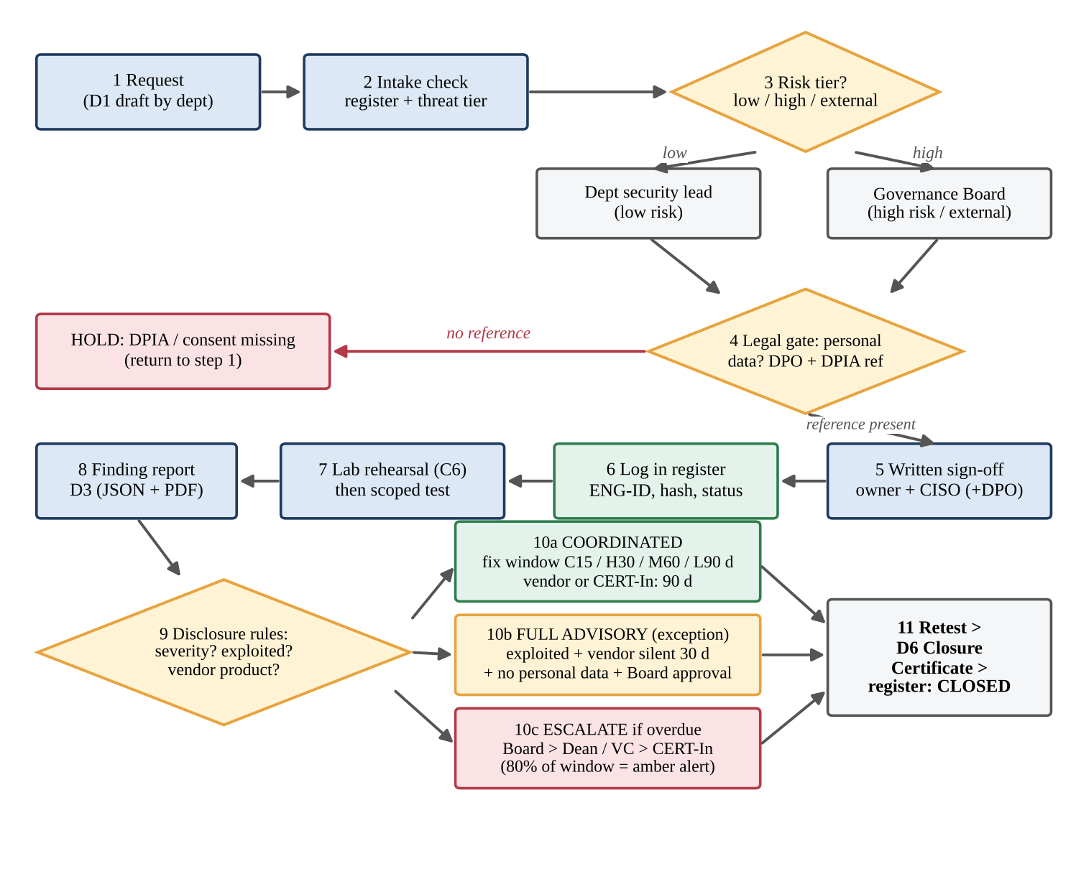
Figure 3: Authorization workflow (steps 1–6), testing (7–8) and disclosure (9–11)
Step | Actor | Input → output | Target time | Log entry
1 Request | Requesting department | D1 draft → submitted request | — | SUBMITTED
2 Intake check | Governance Team | Register, threat tier, vendor-hosting check → INTAKE_OK or return | 4 working hours | INTAKE_OK
3 Risk tier | Governance Team | Low → department security lead; high or external → Board | — | TIER_SET
4 Legal gate | DPO | PD present → DPIA reference required; otherwise HOLD | 1 working day | LEGAL_OK or LEGAL_HOLD
5 Sign-off | System owner, CISO (+DPO) | Dual signature → APPROVED | 1 working day | APPROVED + hash
6 Record | Governance Team | Register entry, SOC notice, RoE issued | 2 working hours | ACTIVE when window opens

Status model: DRAFT → SUBMITTED → INTAKE_OK → LEGAL_OK (or LEGAL_HOLD → back to SUBMITTED) → APPROVED → ACTIVE → TESTING_DONE → REPORTED → DISCLOSING → CLOSED. Terminal alternative states are REJECTED, EXPIRED (window ended without testing) and REVOKED. Only the listed transitions are allowed; any other change is refused and logged.

6.2 Responsible (coordinated) disclosure process
Coordinated disclosure means that the finder first tells the party that can fix the problem, gives it a fair time to do so, and publishes details only afterwards or when the time has expired. The university process adopts the industry reference points that were read from Anthropic’s public pages linked from claude.com: the Anthropic Responsible Disclosure Policy (reports through a HackerOne form; one vulnerability per report with summary, severity, steps to reproduce, impact and suggested fix; acknowledgement within three business days; no access to or retention of data beyond what is needed; no payment demands; safe harbour for good-faith research) and the Anthropic Coordinated Vulnerability Disclosure process (a standard 90-day deadline, a 14-day extension if the vendor is making progress, a 7-day target for actively exploited critical flaws, escalation after 30 days of silence, and withholding of full technical details for 45 days after a patch).

Reporting format (D3) – minimum content
Finding ID, engagement ID, title, affected asset (register ID), date discovered and date validated (T0), severity and CVSS score, description, steps to reproduce (without personal data), evidence (redacted), impact, recommended fix, whether the asset is third-party, whether the flaw is exploited in the wild, whether personal data is exposed, tester name and status.

Remediation windows and timeline
Event | Day (T0 = validation date) | Rule
Owner notified | T0 + 1 day (Critical: within 4 hours) | CISO informs the system owner; DPO if personal data is involved
Owner acknowledges and gives a plan | T0 + 3 working days | Same as the 3-business-day acknowledgement of the industry reference
Fix window by severity | Critical 15 / High 30 / Medium 60 / Low 90 days | Actively exploited: 7 days, whatever the severity
Vendor or CERT-In notified (third-party product) | T0 + 1 day | Vendor deadline 90 days; 14-day extension if the vendor shows progress
Amber alert | 80 % of the window used | Reminder to owner and Dean
Overdue | Window exceeded | Escalate to Board, then Dean/VC; inform CERT-In for third-party products
Retest and closure | Within 5 working days of the fix | D6 Closure Certificate

Comparison with full disclosure and bug bounty
Aspect | Coordinated disclosure | Full (immediate public) disclosure | Bug-bounty programme
Idea | Tell the owner first; publish after a fixed period or after the fix | Publish details immediately to everyone | Open invitation to outside researchers with rewards under published rules
Benefit | Fix before attackers learn the details; fair to the owner | Forces quick action; warns users when a vendor is silent | Wide testing; pay only for valid finds
Risk | Owner may delay; needs deadlines and escalation | Attackers get a free exploit; personal data at risk | Needs staff to triage; scope abuse; payment and tax handling
Control of timeline | High (deadline set in advance) | None | Medium (programme rules)
Fit for the university | Default for all findings | Exception only (see 6.4) | Later stage: public safe-harbour and bounty after the programme matures

6.3 Operations for logging approvals, status updates and disclosure decisions
Three operations implement the layer. They are implemented in the model (framework.py) so that they can be run and tested.
Operation | Definition | Output
op1 log_event(eng_id, actor, action, status) | Appends a record with timestamp, actor, action, new status and the hash of the previous record (hash chain). Records are never edited; a correction is a new record. | Tamper-evident audit trail
op2 authorize(form, today) | Runs checks A1–A10 (ID format, dual signature, window length, back-dating, targets in register, tester NDA, DPIA reference, prohibited techniques, vendor consent, blackout calendar). | APPROVED / HOLD / REJECTED + reasons
op3 disclosure(finding) | Chooses the route and deadline; adds actions (DPO, 80 % amber, overdue escalation). | Route, deadline in days, actions

Sample hash-chained log for ENG-2026-007 (hash values shortened):
seq time (IST) actor action status prev-hash this-hash
001 02-Nov 10:05 Dean submit D1 SUBMITTED 0000 a3f1
002 03-Nov 09:20 Gov. Team intake check passed INTAKE_OK a3f1 7c2e
003 04-Nov 11:00 DPO DPIA-2026-003 added LEGAL_OK 7c2e 19bd
004 05-Nov 15:30 CISO+Owner sign-off, hash stored APPROVED 19bd e04a
005 09-Nov 23:00 Gov. Team window opens ACTIVE e04a 5d8c
Deciding when disclosure may proceed. Disclosure of a finding to anyone outside the owner group may proceed only when all of the following are true: (1) the finding is validated and T0 is recorded; (2) the owner has been notified and acknowledged; (3) the fix is verified by retest or the fix window has expired with the Board’s decision recorded; (4) the advisory contains no personal data, credentials or exploit code; (5) legal counsel has reviewed it; (6) for full disclosure, the Board has approved in writing.

6.4 Rules for choosing coordinated or full disclosure
Rule | Condition | Route
D1 | Personal data is exposed (any severity) | Coordinated only, internal; DPO informed at once; full disclosure forbidden
D2 | Flaw is in a university-owned system | Coordinated (owner fixes first; an advisory is internal only)
D3 | Flaw is in a third-party product, not exploited | Coordinated with the vendor or CERT-In; 90 days (+14 if progress)
D4 | Flaw is exploited in the wild | Deadline 7 days; mitigation advice to users may be issued early
D5 | Exploited in the wild AND vendor silent for 30 days or more AND no personal data AND Board approves | Full advisory (mitigations only; no exploit code)
D6 | Anything else | Coordinated

The six rules were run on six sample findings. Results (baseline timeline):
Finding | Route chosen | Deadline (days) | Actions produced
F1 High, owner-fixable, day 10 | COORDINATED (internal owner, then advisory) | 30 | track
F2 High, day 25 (80% rule) | COORDINATED (internal owner, then advisory) | 30 | amber: 80% of window used - reminder to owner
F3 Critical, day 20 (delayed) | COORDINATED (internal owner, then advisory) | 15 | OVERDUE by 5 d: escalate to Governance Board; owner's Dean/VC
F4 Medium in vendor product, day 5 | COORDINATED (vendor/CERT-In) | 90 | track
F5 Exploited bug, vendor silent 35d | FULL ADVISORY (needs Board approval) | 7 | OVERDUE by 28 d: escalate to Governance Board; inform CERT-In
F6 Same but personal data exposed | COORDINATED (vendor/CERT-In) | 7 | notify DPO immediately; 72-hour data-breach clock starts if data was actually compromised; OVERDUE by 28 d: escalate to Governance Board; inform CERT-In

6.5 Interaction with the RoE and legal-compliance components
Interaction | How the layer uses the other component | Test that demonstrates it | Result
Authorization ↔ Legal | A personal-data target without a DPIA reference puts the request on HOLD | I6 (SYS-03, no DPIA) | HOLD
Authorization ↔ RoE (scope) | Targets must exist in the register; unknown target is refused | I3 (SYS-99) | REJECTED
Authorization ↔ RoE (techniques) | Prohibited technique list from the RoE is checked in the form | I5 (DoS listed) | REJECTED
Authorization ↔ RoE (calendar) | Blackout and 30-day limit from the RoE are enforced | B2, R2 | REJECTED
Disclosure ↔ Legal | Personal data exposure forces coordinated route and DPO action | F6 | Coordinated + DPO + 72-hour note
Disclosure ↔ Authorization | A finding can be reported only against an engagement and target that were authorized | Finding test I2 (Task 8) | REJECTED
Disclosure ↔ Ethics | Payment demand or threat makes disclosure unacceptable | Conduct case U3 | UNACCEPTABLE

TASK 7 – Design an Isolated Ethical-Hacking Lab (5 Marks)

7.1 Lab design
The lab is a set of virtual machines on one host computer, connected only by a host-only network (192.168.56.0/24). It has one tester machine (Kali Linux) and several deliberately vulnerable or synthetic-data targets. No virtual adapter connects the lab to the campus LAN or the Internet, so a mistaken command cannot reach a production system.
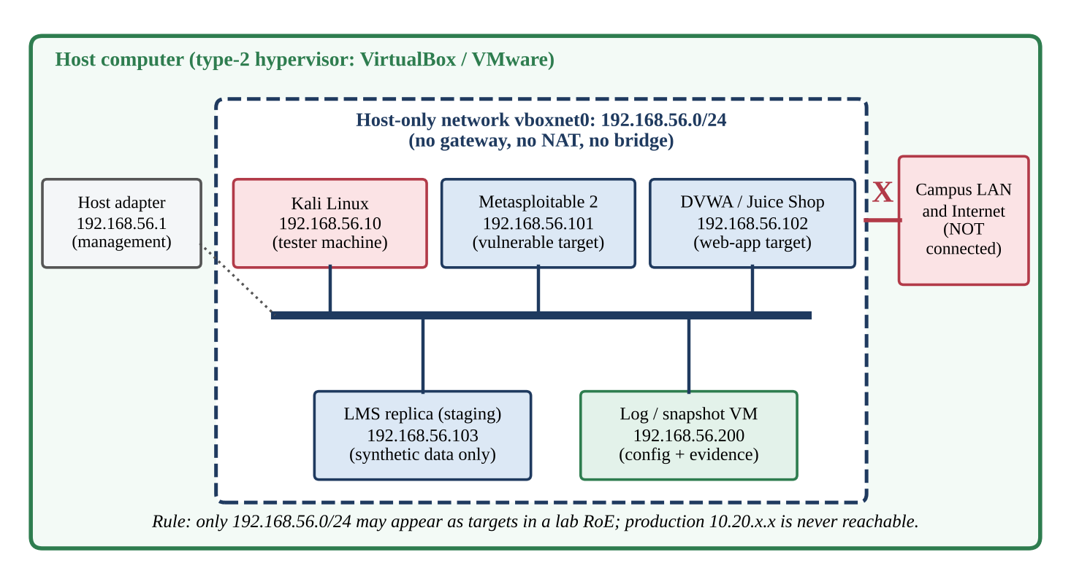
Figure 4: Isolated lab – Kali Linux and authorized targets on a host-only network

Components, roles and addressing
VM / component | Role | Address | Resources | Notes
Host computer | Runs the hypervisor (VirtualBox or VMware Workstation) | 192.168.56.1 (host adapter) | 16 GB RAM, 4+ cores, 100 GB disk | Management only; IP forwarding disabled; not a target
Kali Linux (current rolling release) | Tester machine – attacker role | 192.168.56.10 | 4 GB RAM, 2 vCPU, 40 GB | Tools: nmap, Nikto, Burp Community, sqlmap, Metasploit (lab use only)
Metasploitable 2 | Intentionally vulnerable Linux target for network-service practice | 192.168.56.101 | 1 GB RAM, 1 vCPU | Never given real data
DVWA or OWASP Juice Shop | Intentionally vulnerable web-application target | 192.168.56.102 | 2 GB RAM, 1 vCPU | Practise injection, XSS, access control
LMS replica (staging) | Rehearsal copy of the LMS (same version and plugins) for ENG-2026-007 | 192.168.56.103 | 4 GB RAM, 2 vCPU | Synthetic data only – no production data is ever copied
Log / snapshot VM | Stores D5 lab record, command logs, evidence hashes | 192.168.56.200 | 1 GB RAM, 1 vCPU | Write-once folder for evidence

Address plan: .1 host; .10–.19 tester machines; .100–.199 targets; .200–.209 infrastructure. DHCP is switched off, so every address is static and recorded. Connectivity rules: Kali → targets: allowed on all ports; targets → Kali: replies and lab exercises (such as reverse connections) allowed inside the subnet; any VM → campus LAN or Internet: no route; host → VMs: management only (SSH, console). Shared folders, shared clipboard, drag-and-drop and USB pass-through are disabled.

Creating the isolated network (VirtualBox commands)
VBoxManage hostonlyif create # creates vboxnet0
VBoxManage hostonlyif ipconfig vboxnet0 --ip 192.168.56.1 --netmask 255.255.255.0
VBoxManage dhcpserver remove --ifname vboxnet0 # static addressing only
VBoxManage modifyvm "Kali" --nic1 hostonly --hostonlyadapter1 vboxnet0 --nic2 none
VBoxManage modifyvm "Metasploitable2" --nic1 hostonly --hostonlyadapter1 vboxnet0 --nic2 none
VBoxManage snapshot "Kali" take clean-baseline # repeat for every VM
Command names and options can differ slightly between VirtualBox versions; the commands above document the intended configuration and are recorded in D5. The lab was not executed in this assignment (no live testing is performed); the verification operations below give the expected results and the address-guard logic was executed in the model.

7.2 Recording the lab configuration
Step | Action | Record (stored in D5)
1 | Export the hypervisor view: VBoxManage list vms; VBoxManage showvminfo <vm> --machinereadable; VBoxManage list hostonlyifs | Adapter type, MAC, network name per VM
2 | Inside each VM: ip -br addr; ip route; uname -r; dpkg -l | sha256sum (or rpm -qa) | Address, routes, kernel and package-list hash
3 | Take a snapshot called clean-baseline; export OVA files and compute sha256sum of each | Snapshot name, OVA hash
4 | Compare LMS replica version and plugin list with production (read-only inventory) | Fidelity statement: identical / differences listed
5 | Tester lead and Governance Team sign D5; D5 hash is added to the engagement log | Signatures, date, hash

7.3 Operations on the lab

Operation 1 – Verify connectivity and isolation
Check (run on Kali) | Command | Expected result | Proves
Own address | ip -br addr | eth0 UP 192.168.56.10/24 | Correct address
Routing table | ip route | Only 192.168.56.0/24 and no default gateway | No path out
Reach target 1 | ping -c 3 192.168.56.101 | 3 replies, 0 % loss | Kali ↔ target works
Reach target 2 and 3 | ping -c 3 192.168.56.102 ; ping -c 3 192.168.56.103 | Replies from both | All targets up
Host discovery | nmap -sn 192.168.56.0/24 | Hosts .1 .10 .101 .102 .103 .200 only | No unknown host
Internet test (negative) | ping -c 2 8.8.8.8 | “Network is unreachable” / 100 % loss | No Internet route
Production test (negative) | ping -c 2 10.20.1.10 | “Network is unreachable” / 100 % loss | No route to campus systems

Operation 2 – Record the lab set-up (lab_record)
for vm in Kali Metasploitable2 DVWA LMS-replica Logger; do
VBoxManage showvminfo "$vm" --machinereadable | grep -E 'nic|hostonly|VMState' >> d5_record.txt
done
ip -br addr >> d5_record.txt ; ip route >> d5_record.txt ; date -Is >> d5_record.txt
sha256sum d5_record.txt | tee -a engagement_log.txt # hash goes into the hash-chained log

Operation 3 – Lab address guard (target check before any command)
Every lab command is run through a guard that accepts only IP addresses inside 192.168.56.0/24, excluding the host adapter. Host names and wildcards are refused. The guard was implemented and run on seven inputs:
Target given | Expected | Actual | Reason
192.168.56.101 | Accept | Accept ✔ | inside lab CIDR
192.168.56.254 | Accept | Accept ✔ | inside lab CIDR
192.168.56.1 | Refuse | Refuse ✔ | host adapter is not a target
192.168.57.5 | Refuse | Refuse ✔ | outside lab CIDR
10.20.1.10 | Refuse | Refuse ✔ | outside lab CIDR
8.8.8.8 | Refuse | Refuse ✔ | outside lab CIDR
*.example.edu | Refuse | Refuse ✔ | not an IP literal (hostnames/wildcards refused)

Operation 4 – Restore to baseline
After each exercise the target VMs are restored with VBoxManage snapshot <vm> restore clean-baseline, so that every rehearsal starts from the recorded state and no malware or changed configuration is carried to the next engagement.

7.4 Host-only versus NAT (and other options)
Criterion | Host-only (chosen) | NAT | Bridged | Internal network
Access to the Internet | None | Outbound yes | Yes (through the campus LAN) | None
Access to campus systems | None | Outbound possible (through host NAT) | Yes – dangerous | None
Host can manage VMs | Yes | Yes (port forwarding needed) | Yes | No (only inside the VMs)
VMs can reach each other | Yes | No by default (each VM alone behind NAT) | Yes | Yes
Risk of scanning a real system by typing error | Very low | High (Internet addresses reachable) | Very high | Very low
Software updates | Not possible while connected (done offline in update mode) | Possible | Possible | Not possible
Suitability for Kali + targets lab | Best | Not suitable for testing; allowed only for update mode | Not allowed | Possible but hard to manage

Justification. The legal risk in a lab is a scan or exploit that leaves the lab: under IT Act s.43/s.66 and CFAA §1030(a)(2) that would be unauthorized access to someone else’s system. Host-only networking gives the strongest guarantee that is still convenient, because it still allows the host to manage the VMs and lets all VMs talk to each other. NAT gives outbound Internet access, so a mistyped address or a wrongly configured tool could reach real hosts. The compromise is an update mode: when Kali needs updates, the targets are powered off, a NAT adapter is attached to Kali only for the update, and it is removed again before the verification checks of Operation 1 are repeated and D5 is re-signed.

7.5 How the lab keeps testing authorized and contained
- Authorized: a lab engagement has its own authorization (a short D1) that lists the lab addresses as the only targets; lab access is given only to testers named in D1 who have signed the code of conduct.
- Contained by network: no gateway, no NAT, no bridge, DHCP off; negative tests in Operation 1 prove that 8.8.8.8 and 10.20.1.10 cannot be reached.
- Contained by software guard: the address guard refuses any target outside 192.168.56.0/24 (7 of 7 test inputs correct).
- Safe content: only intentionally vulnerable machines and synthetic data are used; the LMS replica never contains production records, so a lab mistake cannot expose personal data.
- Recoverable and auditable: snapshots restore a clean state; D5 and command logs are hashed into the engagement log.

TASK 8 – Develop a Reusable Document Library (5 Marks)
The library has six reusable documents. All share three keys – engagement ID, asset IDs and the date format (YYYY-MM-DD) – so that a document produced by one component can be consumed by another.
Doc | Name | Used by | Output
D1 | Authorization Form | C1 | Signed PDF + register entry (status APPROVED)
D2 | Scope and Rules-of-Engagement Sheet | C2 | Allow-list, window, technique lists (Task 5)
D3 | Finding Report | C6, C7 | Structured JSON + PDF; feeds disclosure decisions
D4 | Disclosure Advisory / Notice | C7 | Owner notice and, if allowed, advisory text
D5 | Lab Configuration Record | C6 | Signed lab record with hashes
D6 | Closure and Retest Certificate | C1, C7 | Register status CLOSED

8.1 D1 – Authorization Form (fields and defaults)
Field | Type / format | Default | Validation rule (check)
Engagement ID | ENG-YYYY-NNN | Next free number | Must match pattern (A1)
Title and objective | Text (max 200 characters) | — | Not empty
Requester and system owner | Name, role | — | Role on authority matrix
Signatures | System owner, CISO (+DPO) | — | Owner AND CISO present (A2)
Start and end date | YYYY-MM-DD | Start = approval date + 5 days; end = start + 13 days | End not before start; at most 30 days unless extension; not in the past (A3, A4)
Testing hours | Time range | 23:00–05:00 IST | Must lie inside the standard window
Targets | List of SYS-nn | — | All in register; none out-of-scope (A5)
Hosting | Own / vendor | Own | If vendor: consent reference required (A9)
Testers | Name, internal/external, NDA | Internal | At least one; external → NDA = yes (A6)
Techniques | From list in D2 | port_scan, vuln_scan | No prohibited technique (A8)
Personal data involved | Yes/No (auto-filled from register) | Auto | If yes: DPIA reference required (A7)
Lab rehearsal required | Yes/No | Yes for any PD target | —
Extension approved | Board reference | None | Required if window above 30 days
Document hash | SHA-256 | Computed on signing | Stored in register (AV4)

8.2 D3 – Finding Report (fields) and structured output
Field | Content / default | Rule
id | FND-<eng>-<nn> | Unique, generated
engagement | ENG-YYYY-NNN | Must be an APPROVED engagement
title | Short description | 1–120 characters
target | Register ID | Must be one of the authorized targets
severity, cvss | Critical 9.0–10.0, High 7.0–8.9, Medium 4.0–6.9, Low 0.1–3.9 | CVSS must lie in the band of the severity
description, steps, impact | Free text | No personal data
evidence | Redacted output or screenshot description | No e-mail address or 12-digit number pattern (PD check)
remediation | Recommended fix | Required
third_party_product, exploited, personal_data_exposed | false (default) | Boolean flags that drive the disclosure route
validated_on (T0) | Date | Starts the disclosure clock

Structured output. On acceptance, D3 is written as a JSON object. The disclosure component (C7) reads this object directly; no re-typing is needed. The example below is the finding of the walkthrough (Task 9):
{ "id": "FND-007-01", "engagement": "ENG-2026-007", "target": "SYS-09",
"title": "SQL injection in quiz-export endpoint of vendor plugin",
"severity": "High", "cvss": 8.1, "validated_on": "2026-11-14",
"third_party_product": true, "exploited": false, "personal_data_exposed": true,
"remediation": "Disable endpoint; apply vendor patch; use parameterised queries" }
↓ disclosure(finding) ↓
route: COORDINATED (vendor/CERT-In) | deadline: 90 d vendor, 30 d for university deployment
actions: notify DPO immediately; track amber at 80 % of window

8.3 D4, D5, D6 – content
Doc | Fields | Defaults and rules
D4 Disclosure Advisory / Notice | Advisory ID, finding ID, affected product and versions, summary (no exploit code), severity, workaround, fix status, timeline (T0, notice, fix, publication), contacts, credit line (with permission) | Audience default = owner group; public publication needs Board approval (rule D5) and legal review; personal data is never included
D5 Lab Configuration Record | Lab ID, host details, VM list with role and IP, adapter mode, snapshot names, OVA hashes, fidelity statement, signatures, date | Adapter mode default = host-only; any other mode makes the record INVALID
D6 Closure and Retest Certificate | Finding ID, fix date, retest date and result (Pass/Fail), residual risk, evidence hash, signatures of owner and Governance Team | Register status becomes CLOSED only on Pass; on Fail the finding returns to DISCLOSING

8.4 Test entries: valid, boundary and invalid inputs
The document rules were encoded and executed. The first table tests D1 (authorization checks, today’s date in the model = 2 Nov 2026); the second tests D3.

D1 Authorization Form – 17 entries
Entry | Expected | Actual | Reason(s) returned
V1 valid: 14-day window, non-PD system | APPROVED | APPROVED ✔ | all checks A1-A8 passed
V2 valid: PD system with DPIA reference | APPROVED | APPROVED ✔ | all checks A1-A8 passed
B1 boundary: window exactly 30 days | APPROVED | APPROVED ✔ | all checks A1-A8 passed
B2 boundary: window 31 days, no extension | REJECTED | REJECTED ✔ | A3 window longer than 30 days without Board extension
B3 boundary: starts today (same-day) | APPROVED | APPROVED ✔ | all checks A1-A8 passed
B4 boundary: 31 days WITH Board extension | APPROVED | APPROVED ✔ | all checks A1-A8 passed
I1 invalid: CISO signature missing | REJECTED | REJECTED ✔ | A2 dual sign-off (system owner + CISO) missing
I2 invalid: back-dated start (1 Nov) | REJECTED | REJECTED ✔ | A4 back-dated authorization (start before approval date)
I3 invalid: target not in register | REJECTED | REJECTED ✔ | A5 target SYS-99 not in asset register (out of scope)
I4 invalid: external tester without NDA | REJECTED | REJECTED ✔ | A6 external tester X Ltd has no signed NDA
I5 invalid: DoS listed as technique | REJECTED | REJECTED ✔ | A8 prohibited technique(s): dos
I6 hold: PD system, no DPIA reference | HOLD | HOLD ✔ | A7 targets hold personal data but no data-protection impact reference (DPO sign-off)
I7 invalid: malformed ID 'ENG-26-7' | REJECTED | REJECTED ✔ | A1 invalid engagement ID format
I8 invalid: empty form (no authorization at all) | REJECTED | REJECTED ✔ | A1 invalid engagement ID format; A2 dual sign-off (system owner + CISO) missing; A3 testing window missing; A5 no targets listed; A6 no named tester
R1 refinement P1: vendor-hosted SYS-09, no consent | HOLD | HOLD ✔ | A9 target is vendor-hosted but no written third-party consent attached
R2 refinement P2: window 10-20 Dec overlaps blackout | REJECTED | REJECTED ✔ | A10 testing window overlaps examination blackout calendar
R3 refinement P2: window ends 13 Dec (boundary, ok) | APPROVED | APPROVED ✔ | all checks A1-A8 passed

D3 Finding Report – 10 entries
Entry | Expected | Actual | Reason(s) returned
V1 valid High 8.1 | ACCEPTED | ACCEPTED ✔ | all checks passed
B1 CVSS 7.0 labelled High (lower bound) | ACCEPTED | ACCEPTED ✔ | all checks passed
B2 CVSS 8.9 labelled High (upper bound) | ACCEPTED | ACCEPTED ✔ | all checks passed
B3 CVSS 9.0 labelled High (band mismatch) | REJECTED | REJECTED ✔ | F2 CVSS does not match severity band
B4 title exactly 120 characters | ACCEPTED | ACCEPTED ✔ | all checks passed
B5 title 121 characters | REJECTED | REJECTED ✔ | F3 title longer than 120 characters
I1 CVSS 10.1 | REJECTED | REJECTED ✔ | F2 CVSS outside 0.0-10.0
I2 target SYS-12 not in engagement | REJECTED | REJECTED ✔ | F4 target not authorized for this engagement
I3 evidence contains e-mail address | REJECTED | REJECTED ✔ | F5 evidence contains personal data - redact and resubmit
I4 missing remediation | REJECTED | REJECTED ✔ | F1 missing field remediation

Result: 17 of 17 D1 entries and 10 of 10 D3 entries gave the expected result. Boundary entries (30 days v 31 days; CVSS 8.9 v 9.0; 120 v 121 characters; 04:59 v 05:00) show exactly where each rule changes.

8.5 Evidence of integration with the framework
Document | Produced by | Consumed by | Integration evidence
D1 → register | C1 | C2, C6, C7 | Engagement ID, targets and window are read by the scope check (S3, S4) and by D3 validation (F4)
D2 → checklist | C2 | Governance Team | 16 checklist items derived from the 12 RoE sections
D3 JSON → disclosure() | C6 | C7 | Flags third_party_product, exploited, personal_data_exposed decide route and deadline (F1–F6)
D3 → legal | C7 | C3 | personal_data_exposed starts the DPO and 72-hour process
D5 → D1 | C6 | C1 | A PD engagement requires a signed D5 (checklist item 15)
D6 → register | C7 | C1 | Status CLOSED only after Pass

TASK 9 – Integrate, Test and Refine the Framework (5 Marks)

9.1 Integration of Tasks 2–8
The components are connected through one engagement record and a fixed lifecycle. Table below shows the lifecycle phases, which components act in each phase, which document is produced and which gate must be passed.
Phase | Components used | Document | Gate (pass condition)
0 Prepare | C4 threat model, C3 legal map, C5 code | Reference documents | Annual review by the Board
1 Request and intake | C1, C2, C4 | D1 draft | Targets in register; tier set
2 Legal gate | C3, DPO | DPIA reference | Reference present for PD targets
3 Authorization | C1, C8 | D1 signed, D2, register entry | Dual signature; hash stored; checks A1–A10 pass
4 Lab rehearsal | C6, C5 | D5 | Isolation checks pass; D5 signed
5 Scoped testing | C2, C5, C6 | Logs, D3 draft | Runtime scope check S1–S5; stop-and-ask rule
6 Reporting and triage | C7, C3 | D3 JSON | Validation F1–F5 pass; route and deadline set
7 Disclosure and closure | C7, C1 | D4, D6 | Fix verified by retest; status CLOSED

9.2 Walkthrough of an authorized assessment (ENG-2026-007)
Situation. Before the LMS upgrade, the Dean of the School of Computing asks for an assessment of the LMS web tier and its vendor-hosted plugin server (SYS-05, SYS-06, SYS-09). The dates are illustrative.
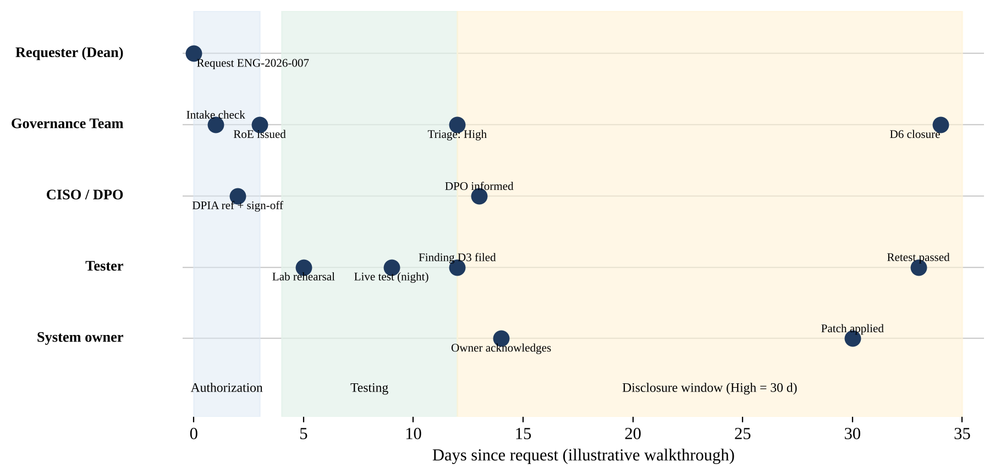
Figure 5: Timeline of the walkthrough (authorization, testing, disclosure)
Day (date) | Step | What happens | Component / document
0 (2 Nov) | Request | Dean submits the D1 draft with targets SYS-05, SYS-06, SYS-09, window 10–20 Dec, two internal testers | C1, D1
1 (3 Nov) | Intake | Register check passes. The team notices that SYS-09 runs on the vendor’s hosting (problem P1). Request returned for vendor consent | C1, C2
2 (4 Nov) | Legal gate | LMS holds personal data; DPO supplies DPIA-2026-003; vendor consent VENDOR-CONSENT-117 attached | C3
3 (5 Nov) | Sign-off and record | Owner and CISO sign; PDF hash stored; RoE issued; SOC informed. Checklist items 1–14 are ticked. Calendar check shows that the requested window of 10–20 Dec overlaps the end-semester examination blackout starting 14 Dec (problem P2); the window is moved to 9–22 Nov | C1, C2, D2
5 (7 Nov) | Lab rehearsal | Testers rehearse on the LMS replica 192.168.56.103 (synthetic data). The plugin version differs by one minor release between lab and production (problem P5); the lab record states the difference | C6, D5
9 (11 Nov, 23:30) | Scoped live test | Rate-limited scan of SYS-09 inside the window. A suspected SQL injection in the quiz-export endpoint is confirmed with one harmless request. The error page shows one student’s name and roll number (problem P3). The tester stops, does not copy it, records the incident and informs the DPO (case B2: BORDERLINE) | C2, C5
12 (14 Nov) | Finding report | D3 accepted: severity High, CVSS 8.1. The first draft contained the name in a screenshot and was rejected by rule F5; redacted version accepted. T0 is set to the validation date (problem P4: when does the clock start?) | D3, C7
12–13 | Triage | disclosure(): third-party product, not exploited, personal data exposed → COORDINATED; DPO informed; DPO records that an authorized tester saw the item incidentally and no data left the university’s control, so no breach notice is required (design assumption to be confirmed by the DPO); no listed incident, so no CERT-In report | C7, C3
13 | Notification | Owner and vendor notified; vendor deadline 90 days; university deployment must be fixed within the High window of 30 days (until day 42) | C7, D4
14–30 | Remediation | Owner acknowledges on day 14, disables the endpoint on day 15 (mitigation), applies the vendor patch on day 30 (amber alert not reached) | C7
33–34 | Retest and closure | Retest passes on day 33; D6 issued on day 34; register status CLOSED; log chain verified | D6, C1

9.3 Systematic test cases
Twelve test cases cover the four risk categories. They were executed against the model of the final (refined) framework; expected results were written before the run.
ID | Category | Test | Expected | Actual
M1 | Missing authorization | CISO signature missing | REJECTED | REJECTED ✔
M2 | Missing authorization | Empty form submitted | REJECTED | REJECTED ✔
M3 | Missing authorization | Start date earlier than approval date (back-dating) | REJECTED | REJECTED ✔
O1 | Out-of-scope request | Target SYS-99 not in register | REJECTED | REJECTED ✔
O2 | Out-of-scope request | Runtime request to payroll ERP 10.30.1.25 | Rejected | Rejected ✔
O3 | Out-of-scope request | Registered system SYS-07 not authorized for this engagement | Rejected | Rejected ✔
L1 | Legal conflict | PD system SYS-03, no DPIA reference | HOLD | HOLD ✔
L2 | Legal conflict | External tester without NDA | REJECTED | REJECTED ✔
L3 | Legal conflict | Denial-of-service listed (s.43(e)/(f), CFAA (a)(5)) | REJECTED | REJECTED ✔
D1 | Delayed disclosure | High finding, day 25 of 30 (baseline) | Amber alert | Amber alert ✔
D2 | Delayed disclosure | Critical finding, day 20 of 15 | Overdue → escalate | Overdue → escalate ✔
D3 | Delayed disclosure | Exploited bug, vendor silent 35 days, no personal data | Full advisory (Board) | Full advisory (Board) ✔

All twelve cases gave the expected result. Together with the earlier suites, the final framework passed 58 of 58 executed checks (D1 forms, scope requests, conduct cases, lab guard, D3 reports, standing-authorization states).

9.4 Problems found in the walkthrough and refinements
# | Problem encountered | Refinement made | Component changed | Evidence after refinement
P1 | SYS-09 turned out to be vendor-hosted; the draft D1 had no way to show consent from the vendor | New D1 field “Hosting” and rule A9: vendor-hosted target needs written consent, otherwise HOLD | C1, D1, C3 (L9) | Test R1 → HOLD
P2 | Requested window overlapped an examination week | Blackout calendar added to D2; rule A10 rejects overlapping windows; checklist item 7 | C2, C1 | Tests R2 → REJECTED, R3 (boundary) → APPROVED
P3 | A screenshot in the first D3 draft showed a student’s name | Evidence rule F5 (pattern check) and redaction step; conduct case B2 added | D3, C5 | Finding test I3 → REJECTED
P4 | Unclear when the disclosure clock starts (discovery, report or fix) | Clock fixed at T0 = validation date, recorded in D3 and in the log | C7 | days_since_validation used in tests F1–F6
P5 | Lab replica differed from production by one plugin version | D5 “fidelity statement” field; checklist item 15 requires it | C6, D5 | D5 content (Task 8.3)
P6 | Every request waited for the same Board secretariat; suspected bottleneck at scale | Tiered approval by risk (department lead for low risk) and register-linked scope check | C1, C2 | Task 10 results

Final corrected framework (v1.1). v1.1 differs from the first draft by: two new authorization checks (A9 vendor consent, A10 blackout), one new finding rule (F5 personal-data pattern), a fixed disclosure clock, the D5 fidelity statement, one new conduct case, and tiered approval. All suites were re-run after the changes and passed.

TASK 10 – Create a Scalability and Governance Evaluation (5 Marks)

10.1 Evaluation setup
A small seeded simulation (sim.py, listed in Appendix B) compares two programme sizes under two governance designs. Baseline governance is the first version of the framework: every request, every scope check and every disclosure decision goes through one Governance Board secretariat. Refined governance is v1.1 after the walkthrough (P6): tiered approval, register-linked scope checking and severity-routed disclosure triage. The model is an estimate based on stated assumptions, not field data from a real university, and the results are read in that light.
Parameter | Small programme (one department) | Large programme (whole university + external assessors)
Systems in programme | 5 | 400
Testers | 3 internal | 40 (including external assessors)
Engagements per month | 3 | 30
Share of requests from external assessors | 0 % | 40 %
Share of high-risk requests | 30 % | 30 %
Systems per engagement | 2 | 4
Findings per month | 6 | 120 (5 % Critical, 15 % High, 40 % Medium, 40 % Low)
Department security leads (refined design) | 1 | 8
Service times (working hours) | Approval 2.0 mean (+4.0 vetting for external in baseline); lead approval 0.75; Board triage 0.75; rule-based triage 0.25 | Same
Fixed latency | 4 working hours for signatures per request; 2 working hours for finding validation and owner notice | Same
Method | FCFS queue in working hours (8 h × 22 days a month); Poisson arrivals; 200 runs, seeds 2026–2225; 12 simulated months | Same

10.2 Processes tested and measures recorded
Process | Measure | How it is obtained
A Engagement approval | Mean and 90th-percentile turnaround (working days); share approved within 5 working days; number of steps | Queue simulation; steps counted from the workflow (baseline 7, external 10; refined low-risk 5, high 8, external 9)
B Scope verification | Checks per engagement | Baseline: 6 manual checks per target + 4 engagement-level; refined: 6 register-linked checks once + 1 exception check per target + 4
C Disclosure triage | Mean days from validated finding to routed decision | Queue simulation; baseline all findings to the Board; refined: Critical/High to Board, Medium/Low to two disclosure officers by rule
Coverage | Share of systems with an approved engagement in a quarter | Limited by approvals on time and tester capacity (1.5 engagements per tester per quarter)

10.3 Results
Measure | Small – baseline | Small – refined | Large – baseline | Large – refined
A1 Approval turnaround, mean (working days) | 0.76 | 0.64 | 1.69 | 0.88
A2 Approval turnaround, 90th percentile (working days) | 1.08 | 0.83 | 3.33 | 1.5
A3 Approved within 5 working days (%) | 100 | 100 | 97.5 | 100
A4 Procedural steps per engagement (mean) | 7 | 5.9 | 8.2 | 7.1
B1 Scope-verification checks per engagement | 16 | 12 | 28 | 14
C1 Disclosure triage, mean (working days) | 0.35 | 0.29 | 0.44 | 0.3
C2 Disclosure triage, Critical findings (working days) | 0.35 | 0.34 | 0.44 | 0.35
D1 Quarterly scope coverage (% of systems) | 100 | 100 | 60 | 60

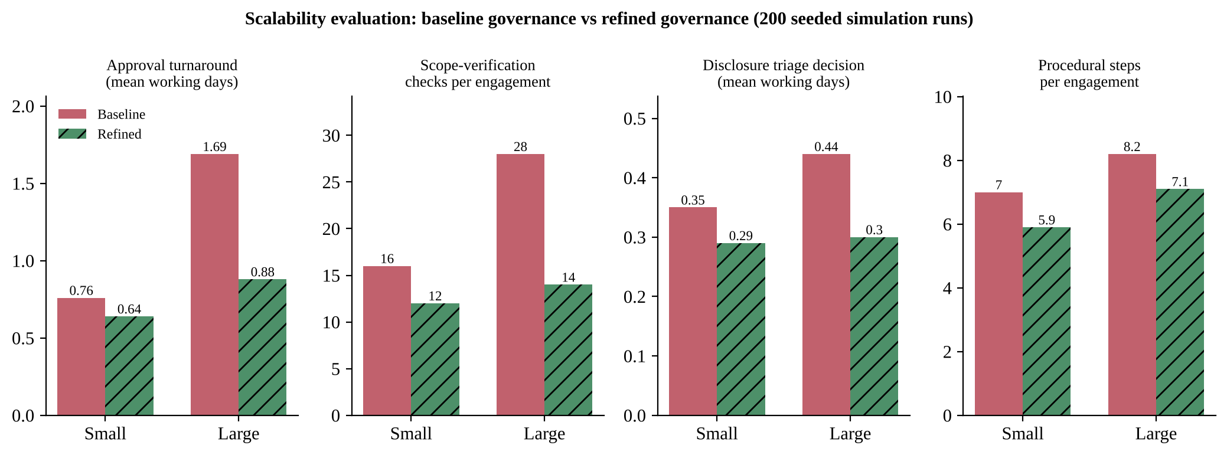
Figure 6: Baseline against refined governance for three processes at small and large scale

10.4 Interpretation
- Baseline does not scale well. Moving from one department to the whole university raises mean approval time from 0.76 to 1.69 working days (+122%) and the 90th percentile to 3.33 days, because all requests (and the external-assessor vetting) share one queue. Scope checks per engagement rise from 16 to 28. DC6 (no more than 1 working day) is not met by the baseline at large scale.
- Refined governance meets DC6. At large scale the mean approval time falls to 0.88 days (48% lower), the 90th percentile to 1.5 days (55% lower), approvals within 5 working days reach 100%, scope checks fall by 50%, and disclosure triage falls from 0.44 to 0.3 days. Critical findings stay with the Board, so their speed (0.35 days) is deliberately not “optimised away”.
- At small scale the gain is small (0.76 to 0.64 days). The tiered design is therefore justified by growth, not by the current 20 systems; it costs nothing extra to run it from the start because with one lead it behaves like the baseline.
- Coverage is limited by tester capacity, not by governance. Quarterly coverage is 60% for both designs at large scale: faster approvals cannot test more systems if there are not enough testers. This finding changes the governance decision: it points to risk-based prioritisation and standing authorizations (Task 11) rather than to further tuning of approvals.

10.5 Governance refinements adopted because of the evidence
# | Evidence | Refinement to governance | Trigger / KPI
G1 | Single approval queue gives 3.33-day 90th percentile at large scale | Tiered approval: department security lead for low-risk internal requests; Board only for high-risk and external requests | Review tier threshold if 90th-percentile approval time exceeds 2 working days
G2 | Scope checks double from 16 to 28 per engagement when systems per engagement rise | Register-linked scope check: one check against the asset register plus exceptions | Checks per engagement not above 14 at large scale
G3 | All findings sent to the Board even though 80 % are Medium or Low | Severity-routed triage: Critical and High to Board, others to disclosure officers by rule | Board workload share of findings not above 20 %
G4 | Coverage is capped at 60 % by tester capacity | Risk-based coverage target: all personal-data systems each year, others by risk; use external assessors when coverage falls below target | Coverage per quarter reported to the Board
G5 | Approval waiting time depends on one secretariat | Utilisation alarm: add an approver when the queue utilisation exceeds 70 % | Monthly queue report

TASK 11 – Defend the Framework Under a Changed Requirement (5 Marks)

11.1 Impact of the changed requirement
Changed requirement | Why v1.1 is not enough | Components affected
Continuous assessments | v1.1 authorizes one engagement of at most 30 days. Weekly or daily automated scans would need a new approval each time (about 5,200 approvals per quarter for 400 systems scanned weekly) | C1, C2, C6
Third-party assessors | Vetting and contract terms were handled case by case in A6 (NDA only); no safe-harbour, data-processor or insurance clauses | C1, C3, C5, C8
Stricter data-protection rules | Personal-data handling was a check (A7, F5), not a gate with minimisation, redaction and a 72-hour clock; DPDP duties begin around May 2027 | C3, C7
Shorter disclosure timeline | Windows of 15/30/60/90 days and 90-day vendor deadline are too long for the new policy | C7
Easy to govern and extend | New components must plug into the same engagement record and register | All

11.2 Retain, modify, replace or redesign
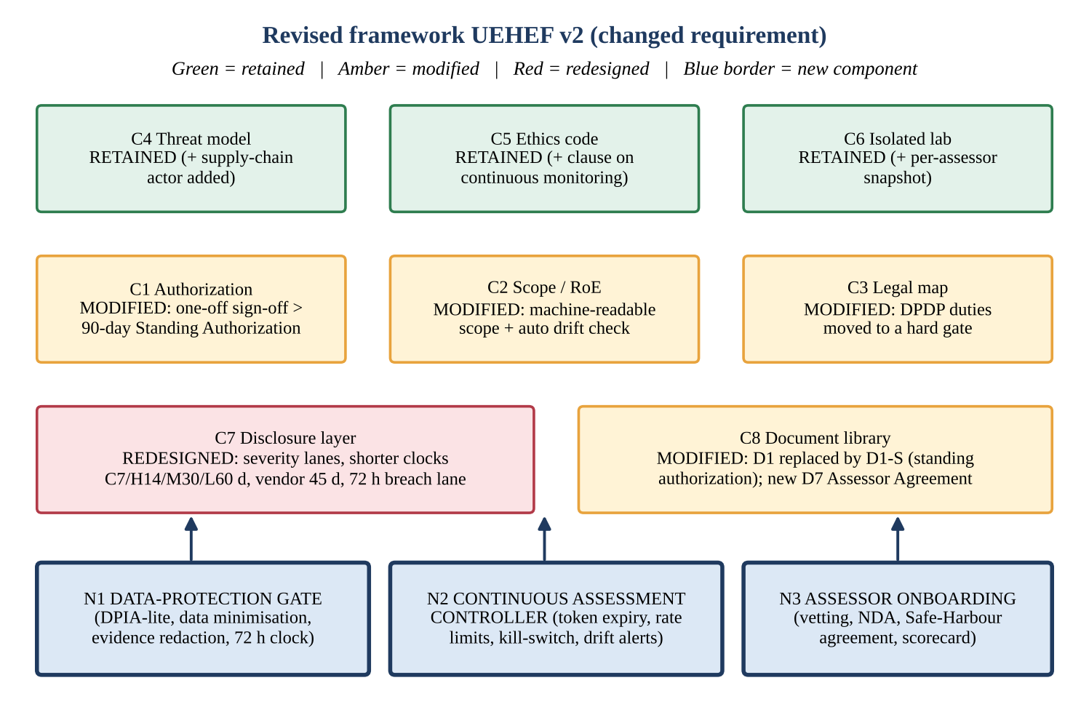
Figure 7: Revised framework UEHEF v2 – decisions on each component and the three new components
Component | Decision | What changes and why
C4 Threat model | Retain (+ one actor) | Add “supply-chain / third-party assessor” as an actor type; the classification rules stay
C5 Ethics and code of conduct | Retain (+ one clause) | Add continuous-monitoring rules (no widening of a standing scope without approval); the decision rule is unchanged
C6 Isolated lab | Retain (+ snapshot per assessor) | Each external assessor rehearses in their own lab snapshot; design and isolation proof unchanged
C1 Authorization | Modify | Add Standing Authorization (D1-S): valid for 90 days, repeated scans in a defined scope; one-off D1 stays for intrusive tests
C2 Scope / RoE | Modify | Scope becomes machine-readable (list of IDs + register hash) so that drift can be detected automatically
C3 Legal map | Modify | Data-protection duties become a hard gate (N1) instead of a single field; add CERT-In and DPDP rows for external assessors
C8 Document library | Modify | D1 gets a standing variant; new D7 Third-Party Assessor Agreement; D3 gets a “data-protection” section
C7 Disclosure layer | Redesign | Shorter, severity-based clocks, a fast lane for exploited flaws and a 72-hour breach lane; the first design allowed too much time and had no formal link to breach duties
No component | None replaced entirely | The engagement record, the register and the document keys are kept, so everything built so far is reused

11.3 New and modified components and their integration

N1 – Data-Protection Gate (new, called by C1 and C7)
- Before testing: a short data-protection impact check (DPIA-lite) for every PD target; data-minimisation plan (test accounts, masked data, read-only access); processor clause signed by assessors.
- During testing: evidence redaction rule (pattern check F5 becomes mandatory); no copying of personal data; any sight of personal data is logged as an incidental exposure.
- After testing: the DPO classifies the event; where personal data was actually compromised, the 72-hour clock for the detailed report to the Data Protection Board starts at once, and where it is a listed incident the 6-hour CERT-In clock applies.

N2 – Continuous Assessment Controller with Standing Authorization (new, modifies C1/C2)
A standing authorization token carries: engagement ID, list of asset IDs, the register hash at signing time, permitted tools and rate limit (for example 2 scans per day), expiry (90 days), signers, and a kill-switch flag. Four rules apply: the token expires after 90 days; it is suspended if the asset register changes (a new system or owner appears – drift review); scans above the rate limit are throttled; and the CISO can revoke it at once. It was implemented and run on five states:
State tested | Expected | Actual
Day 1 (9 Nov 2026), same register | ACTIVE | ACTIVE ✔
Day 90 (7 Feb 2027) boundary | ACTIVE | ACTIVE ✔
Day 91 (8 Feb 2027) | EXPIRED | EXPIRED ✔
New system added to register (hash changed) | SUSPENDED (asset register changed - drift review) | SUSPENDED (asset register changed - drift review) ✔
3rd scan in one day (limit 2) | THROTTLED (rate limit exceeded) | THROTTLED (rate limit exceeded) ✔

Effect on workload: with weekly scans of 400 systems, per-scan approvals would be 400 × 13 = 5,200 per quarter. With one standing token per 10 systems the number is 40 per quarter, which is 99.2 % fewer approvals. Intrusive testing (exploitation proofs, new tools) still requires a normal D1.

N3 – Third-Party Assessor Onboarding (new, modifies C8)
Steps: due-diligence check (identity, references, insurance); signed D7 agreement; NDA; code-of-conduct acknowledgement; data-processor clause (DPDP s.8(2)); rule that third-party and US-hosted systems stay out of scope without written consent (CFAA L9); a university safe-harbour statement for good-faith work inside the signed scope (modelled on the commitments in Anthropic’s Responsible Disclosure Policy); rule that no payment may be demanded and no data retained; and a scorecard (on-time reports, scope violations, quality) that decides renewal.

C7 – Redesigned disclosure timeline
The same disclosure function was run with the revised windows (Critical 7, High 14, Medium 30, Low 60 days; vendor 45 days; actively exploited 7 days). The table shows how the six test findings behave under the old and new clocks.
Finding | Baseline deadline (days) and action | Revised deadline (days) and action
F1 High, owner-fixable, day 10 | 30 – track | 14 – track
F2 High, day 25 (80% rule) | 30 – amber: 80% of window used - reminder to owner | 14 – OVERDUE by 11 d: escalate to Governance Board; owner's Dean/VC
F3 Critical, day 20 (delayed) | 15 – OVERDUE by 5 d: escalate to Governance Board; owner's Dean/VC | 7 – OVERDUE by 13 d: escalate to Governance Board; owner's Dean/VC
F4 Medium in vendor product, day 5 | 90 – track | 45 – track
F5 Exploited bug, vendor silent 35d | 7 – OVERDUE by 28 d: escalate to Governance Board; inform CERT-In | 7 – OVERDUE by 28 d: escalate to Governance Board; inform CERT-In
F6 Same but personal data exposed | 7 – notify DPO immediately; 72-hour data-breach clock starts if data was actually compromised | 7 – notify DPO immediately; 72-hour data-breach clock starts if data was actually compromised

Finding F2 (High, day 25) was only an amber warning under the baseline but is overdue by 11 days under the revised 14-day window, which shows that the shorter timeline is enforced by the same code with a changed configuration. F4 (Medium finding in a vendor product) moves from a 90-day to a 45-day vendor deadline.

How the new parts connect
New / modified part | Connects to | Mechanism
N1 Data-Protection Gate | C1, C3, C7, D3 | A7 becomes mandatory for standing tokens; F5 redaction; DPO flag drives the 72-hour lane
N2 Controller | C1, C2, register | Token stored in register; register hash compared on each scan; log entries per scan batch
N3 Onboarding | C1, C5, C8 | Assessor must be ACTIVE in the roster before A6 passes; D7 attached to D1
Revised C7 | C3, N1, register | Windows read from configuration (baseline/revised); personal-data flag unchanged

11.4 Defence of the final framework using the evidence
Claim | Evidence
The framework prevents unauthorized or out-of-scope action | Walkthrough: vendor-hosting (P1) and blackout (P2) problems were caught before testing. Tests: all 17 authorization and 7 scope cases correct; conduct rule separates 12 of 12 cases.
It is legally defensible | Legal map (Task 4) links 11 legal requirements to controls and tests; the personal-data conclusion adopts DPDP-grade controls before they become binding (about May 2027); CFAA exposure is handled by consent and out-of-scope rules.
It protects personal data in practice | Walkthrough day 9: the tester stopped at the first sight of a student’s name; rule F5 rejected the unredacted screenshot; DPO was informed; the finding report passed after redaction.
It scales | Task 10: at large scale refined approval is 0.88 working days (baseline 1.69) and scope checks halve (28 → 14); standing authorization reduces continuous-scan approvals by 99.2 %.
Disclosure is timely and coordinated | Disclosure tests F1–F6 give the correct route, deadline and escalation under both clocks; the revised clock is a configuration change.
It remains easy to govern and extend | Of eight components, three are retained, four modified and one redesigned; none is replaced. The three new parts attach to the existing engagement record and register.

11.5 Acceptance check against the design criteria of Task 1
Criterion | Result | Evidence
DC1 Authorization completeness | Met | 17 of 17 D1 cases correct
DC2 Scope precision | Met | 7 of 7 scope cases correct, including 04:59 / 05:00 boundary
DC3 Legal traceability | Met | 11 legal requirements each linked to a control and a test (Task 4.4)
DC4 Containment | Met (design level) | Host-only network; negative checks specified; address guard 7 of 7 correct. Not yet verified on a built lab
DC5 Timeliness | Met | Amber and overdue actions in disclosure tests; revised clocks
DC6 Scalability | Met only after refinement | Refined large-scale mean approval 0.88 days; baseline 1.69 days failed
DC7 Reusability | Met | Six documents; 10 of 10 D3 cases correct
DC8 Adaptability | Met | No component replaced; three retained, four modified, one redesigned

11.6 Remaining trade-offs and limitations, and future improvements
# | Trade-off or limitation | Why it remains | Proposed future improvement
1 | Standing authorization trades per-scan control for speed; a stolen or misused token could be abused for 90 days | Continuous scanning is impossible without it | Shorter tokens for sensitive systems; cryptographically signed tokens bound to tester and source IP; weekly automatic digest to the CISO
2 | Shorter disclosure clocks raise the load on system owners and may cause rushed or poor fixes and many escalations | The changed requirement demands it | Owner capacity plan; service-criticality-based windows; temporary mitigations (disable feature) accepted as interim closure
3 | The Board secretariat and the CISO are still human single points of failure | Signatures and risk decisions need accountable people | Deputy roster; policy-as-code to approve routine low-risk requests automatically with sampling audits
4 | The scalability results come from a simulation with assumed service times, not from real measurements | No real programme data exists yet | Run a one-department pilot for one semester; replace assumptions with measured approval and fix times
5 | The legal mapping depends on law that is changing (DPDP commencement, CERT-In directions) and was prepared from public sources, not legal advice | Law is outside the team’s control | Quarterly review by counsel; version stamp on every legal row; add state-law and sector-regulator (for example UGC) requirements
6 | Everything depends on an accurate asset register | Scope, tokens and checks all use it | Automated discovery to detect unregistered assets; owner attestation each semester

11.7 Conclusion
The UEHEF framework turns an unstructured ethical-hacking activity into a governed programme in which every test is authorized, scoped, lawful, ethical, recorded and disclosed on a clock. The walkthrough showed six practical problems, all of which were fixed and re-tested; the evaluation showed that the first design would not scale and the refined design does; and the changed requirement was met by adding three components and redesigning one, without discarding the engagement record, the register or the document library. The remaining limitations are stated openly and have concrete next steps.

Appendix A – Reproducing the evidence
All tests in this document were produced by small Python programs that contain only decision logic and no network or exploitation code: framework.py (authorization checks A1–A10, scope checks S1–S5, disclosure rules for the baseline and revised clocks), conduct.py (conduct decision rule, lab address guard, finding validator, standing-authorization check) and sim.py (scalability simulation). Running python3 conduct.py regenerates the test results and python3 sim.py regenerates the evaluation table (seed 2026 + run number, 200 runs). The figures were drawn with matplotlib.

Summary of executed checks
Suite | Cases | Passed
D1 authorization checks | 17 | 17
Scope requests (S1–S5) | 7 | 7
Conduct decision rule | 12 | 12
Lab address guard | 7 | 7
D3 finding validator | 10 | 10
Standing authorization states | 5 | 5
Total | 58 | 58

Appendix B – Simulation code (sim.py, core parts)
"""Reproducible scalability model (seeded). Queueing simulation in WORKING HOURS (8 h/day, 5 days/week).
Processes: (A) engagement approval, (B) scope verification effort, (C) disclosure triage decision."""
import numpy as np, heapq, json
SEED = 2026
H_PER_MONTH = 8 * 22 # working hours per month
def multi_server(arrivals, service, servers):
"""FCFS multi-server queue; returns waiting+service time for each job (hours)."""
free = [0.0] * servers
heapq.heapify(free)
out = []
for a, s in zip(arrivals, service):
t = heapq.heappop(free)
start = max(a, t)
heapq.heappush(free, start + s)
out.append(start + s - a)
return np.array(out)
def approval(scn, mode, rng, months=12):
n = rng.poisson(scn["eng_per_month"] * months)
arr = np.sort(rng.uniform(0, months * H_PER_MONTH, n))
ext = rng.random(n) < scn["ext_share"]
high = rng.random(n) < scn["high_risk_share"]
if mode == "baseline": # every request -> one Governance Board secretariat queue (+ vetting for externals)
svc = rng.exponential(2.0, n) + ext * rng.exponential(4.0, n)
t = multi_server(arr, svc, 1)
steps = np.where(ext, 10, 7)
else: # tiered: low-risk -> dept security leads (parallel); high-risk / external -> Board
lowq = ~(high | ext)
t = np.zeros(n)
svc_low = rng.exponential(0.75, lowq.sum())
t[lowq] = multi_server(arr[lowq], svc_low, scn["dept_leads"])
hi = ~lowq
svc_hi = rng.exponential(2.0, hi.sum()) + ext[hi] * rng.exponential(2.0, hi.sum()) # vetting pre-done by roster
t[hi] = multi_server(arr[hi], svc_hi, 1)
steps = np.where(lowq, 5, np.where(ext, 9, 8))
# fixed human latency per request (collecting signatures) added identically to both modes: 4 working hours
t = t + 4.0
return dict(n=int(n), mean_days=float(t.mean() / 8), p90_days=float(np.percentile(t, 90) / 8),
steps=float(steps.mean()), approved_in_5d=float((t <= 40).mean() * 100))
def scope_effort(scn, mode):
"""Checklist checks needed per engagement (analytic)."""
k = scn["sys_per_eng"]
if mode == "baseline": # 6 manual checks per target system + 4 engagement-level checks
return 6 * k + 4
return 6 + 1 * k + 4 # 6 register-linked checks once + 1 exception check per system + 4 engagement-level
def coverage(scn, mode, rng, ap):
"""% of in-scope systems with an approved engagement inside a quarter (tester-capacity bound)."""
per_q = ap["n"] / 4.0
cap_testers = scn["testers"] * 1.5 # each tester completes ~1.5 engagements / quarter
ok_frac = ap["approved_in_5d"] / 100 # engagements approved quickly enough to start in window
done = min(per_q * ok_frac, cap_testers)
return float(min(100.0, done * scn["sys_per_eng"] / scn["systems"] * 100))
def disclosure_triage(scn, mode, rng, months=12):
n = rng.poisson(scn["findings_per_month"] * months)
arr = np.sort(rng.uniform(0, months * H_PER_MONTH, n))
sev = rng.choice(["Critical", "High", "Medium", "Low"], n, p=[.05, .15, .40, .40])
if mode == "baseline": # Board decides every finding
svc = rng.exponential(0.75, n)
t = multi_server(arr, svc, 1)
else: # severity routed: C/H -> Board, M/L -> disclosure officer (rule-based, 2 officers)
ch = np.isin(sev, ["Critical", "High"])
t = np.zeros(n)
t[ch] = multi_server(arr[ch], rng.exponential(0.75, ch.sum()), 1)
t[~ch] = multi_server(arr[~ch], rng.exponential(0.25, (~ch).sum()), 2)
t = t + 2.0 # fixed: validation + owner notification
crit = np.isin(sev, ["Critical"])
return dict(n=int(n), mean_days=float(t.mean() / 8), p90_days=float(np.percentile(t, 90) / 8),
crit_mean_days=float(t[crit].mean() / 8) if crit.any() else float("nan"))
SCEN = {
"Small (1 department)": dict(systems=5, testers=3, eng_per_month=3, ext_share=0.0, high_risk_share=0.3,
sys_per_eng=2, dept_leads=1, findings_per_month=6),
"Large (whole university + external)": dict(systems=400, testers=40, eng_per_month=30, ext_share=0.4, high_risk_share=0.3,
sys_per_eng=4, dept_leads=8, findings_per_month=120),
}
def run(runs=200):
res = {}
for name, scn in SCEN.items():
for mode in ("baseline", "refined"):
acc = []
for r in range(runs):
rng = np.random.default_rng(SEED + r)
ap = approval(scn, mode, rng)
cov = coverage(scn, mode, rng, ap)
dt_ = disclosure_triage(scn, mode, rng)
acc.append((ap["mean_days"], ap["p90_days"], ap["steps"], ap["approved_in_5d"], cov,
dt_["mean_days"], dt_["crit_mean_days"]))
a = np.nanmean(np.array(acc), axis=0)
res[f"{name}|{mode}"] = dict(
approval_mean_days=round(a[0], 2), approval_p90_days=round(a[1], 2), steps=round(a[2], 1),
approved_within_5d=round(a[3], 1), coverage_pct=round(a[4], 1),
scope_checks=scope_effort(scn, mode), disclosure_mean_days=round(a[5], 2),
disclosure_crit_days=round(a[6], 2))
return res
if __name__ == "__main__":
r = run()
json.dump(r, open("sim.json", "w"), indent=1)
for k, v in r.items():
print(k, v)

References and sources
All web pages were opened on 1 November 2026. Secondary legal summaries were used only for dates and to cross-check statutory figures and should be verified against the official Gazette and statute text before any legal reliance.
- Anthropic – Claude (claude.com): home page and links to security, trust centre, privacy and responsible-disclosure pages. https://claude.com/
- Anthropic – Responsible Disclosure Policy (scope, rules for researchers, safe harbour, three-business-day acknowledgement). https://www.anthropic.com/responsible-disclosure-policy
- Anthropic – Coordinated Vulnerability Disclosure (90-day deadline, 14-day extension, 7-day exploited-bug target, 30-day escalation, 45-day detail embargo after patch; as of 6 March 2026). https://www.anthropic.com/coordinated-vulnerability-disclosure
- Information Technology Act, 2000 – text (PRS India copy). https://PRSINDIA.org/files/bills_acts/bills_parliament/2021/IT Act, 2000.pdf ; overview of offences and penalties: https://www.gktoday.in/it-act-2000-key-provisions/
- Digital Personal Data Protection Act, 2023 and DPDP Rules, 2025 – implementation timeline and penalties (secondary summary). https://www.dpdpa.com/blogs/DPDPA_Implementation_Timeline.html ; Khaitan & Co. ERGO note of 15 November 2025 (search result); Hogan Lovells note on the Act being brought into force (search result).
- CERT-In Directions of 28 April 2022 (6-hour incident reporting) – Trilegal and other law-firm notes (search results). https://trilegal.com/knowledge-repository/2022-cert-in-directions-on-reporting-cyber-incidents/
- Computer Fraud and Abuse Act, 18 U.S.C. §1030, and the U.S. Department of Justice charging policy of May 2022 – Jones Day: “Department of Justice Significantly Revises Policy on Charging CFAA Violations”. https://www.jonesday.com/en/insights/2022/06/department-of-justice-significantly-revises-policy-on-charging-cfaa-violations
- Penalty figures for IT Act sections 66, 66B–66F, 70, 72, 72A and CFAA subsection maxima are taken from the statute texts as summarised in the sources above and from standard references; they should be re-checked with counsel.

