Classification: Internal

BUSINESS REQUIREMENTS DOCUMENT
Employee Onboarding | Agentic HR Operations (AHRO)

Attribute | Detail
Document Title | BRD - Employee Onboarding (AHRO)
Version | 2.0
Status | Draft for Review
Date of Issue | 13-Aug-2026
Classification | Internal
Source Document | As-Is Process Narrative: Employee Onboarding; Onboarding Process -  Draft PDD

Reading Convention
Sections with grayed table rows contain forward-looking content pending To-Be design confirmation. They are retained so the developer and tester have the reference material they need to build and test against, but they do not require SME validation in this version. Full-colour sections are validated As-Is content.
Classification: Internal

BUSINESS REQUIREMENTS DOCUMENT
Employee Onboarding | Agentic HR Operations (AHRO)
Includes Appendix A (Blue-Collar / Frontline) and Appendix B (M&A / TUPE-Transfer)

Attribute | Detail
Document Title | BRD - Employee Onboarding (AHRO)
Version | 1.0 & 1.1
Status | Draft for Review
Date of Issue | 13-Aug-206 & 21-Aug-2026
Classification | Internal
Source Document | As-Is Process Narrative: Employee Onboarding; Onboarding Process Draft

Reading Convention
Sections with grayed table rows contain forward-looking content pending To-Be design confirmation. They are retained so developers and testers have reference material to build and test against, but do not require SME validation in this version. Full-colour sections are validated As-Is content.

Table of Contents
Table of Contents 2
1. Document Control 4
1.1 Version History 4
1.2 Reviewers & Sign-Off 4
2. Executive Summary 5
3. Business Context 5
3.1 Problem Statement 5
3.2 Scope 5
3.3 Stakeholders 5
3.4 Trigger Events 6
4. Current State (As-Is) 7
4.1 As-Is Process Map 7
4.2 End-to-End Process | Step by Step 7
4.4 Exception Scenarios 8
4.5 Onboarding Types and Their As-Is Handling 9
4.6 Onboarding Readiness & SLA Model - Summary 9
4.7 Pain Points 10
5. Future State (To-Be) 11
5.1 To-Be Process Map 11
5.2 To-Be Process Description 11
6. Roles & Responsibilities (RACI) 12
7. Business Objectives & Success Criteria 13
7.1 Business Objectives 13
7.2 Success KPIs 13
8. Business Requirements 14
9. System & Application Enablement 15
9.1 Application Landscape 15
10. Business Rules & Governance Controls 16
11. Glossary 17
Appendix A - Blue-Collar / Frontline Employee Onboarding 18
A.1 Overview & Rationale 18
A.2 Key Differences vs White-Collar Onboarding 18
A.3 Blue-Collar Onboarding Process Map 18
A.4 Additional / Modified Steps 19
A.5 Additional Data & Document Requirements 19
A.6 Provisioning Differences 20
A.7 Readiness Model Addition - Safety & Medical Fitness 20
A.8 RACI Adjustments 20
A.9 Statutory & Compliance Considerations 21
A.10 Exceptions & KPIs 21
Appendix B - M&A / TUPE-Transfer Onboarding 22
B.1 Overview & Transfer Basis 22
B.2 Key Differences vs Standard Onboarding 22
B.3 M&A / TUPE-Transfer Process Map 22
B.4 Step Definitions 23
B.5 Data & Due-Diligence Requirements 24
B.6 RACI (Transfer-Specific) 24
B.7 Compliance, Exceptions & KPIs 24

1. Document Control

1.1 Version History
Version | Date | Author | Summary
1.0 | 13-Aug-2026 | Sabrina Rajiv | Initial draft based on the As-Is Onboarding Narrative and Draft PDD, aligned to the AHRO agentic operating model.
1.1 | 21-Aug-2026 | Sabrina Rajiv | Added Appendix A (Blue-Collar / Frontline), Section 4.5.6 and Appendix B (M&A / TUPE-Transfer).

1.2 Reviewers & Sign-Off
By signing below, each reviewer confirms they have read this document and agree to its contents.
Name | Role | Department | Action
[Name] | HR Process Owner | Human Resources | Approver
[Name] | Program Manager | HR Transformation | Approver
[Name] | Project Manager | HR Operations | Approver
[Name] | AI Governance Lead | Risk & Compliance | Approver

2. Executive Summary
Employee Onboarding is the end-to-end journey that converts an accepted offer into a productive, Day-1-ready employee. It spans documentation collection, background verification (BGV), HRIS record creation, IT and asset provisioning, payroll and benefits enrolment, induction, and early-tenure engagement. In the current As-Is state it is executed across the HRIS (Oracle HCM), a case-management layer (ServiceNow HRSD), an external BGV vendor, IT/asset provisioning tools, and payroll — coordinated largely through email, checklists, and manual handoffs.
Key pain points include fragmented handoffs; manual document chasing; delayed BGV turnaround; inconsistent Day-1 readiness; and limited real-time visibility. This document captures the current state and the requirements to move toward an automated, agent-assisted onboarding framework with clear human-in-the-loop checkpoints, governance, and Day-1 readiness assurance. It also covers specialised onboarding types: blue-collar / frontline (Appendix A) and M&A / TUPE-transfer (Section 4.5.6 and Appendix B).

3. Business Context

3.1 Problem Statement
Today's onboarding workflow suffers from fragmented ownership across TA, HR Operations, IT, and Payroll; manual, email-based document collection; and reactive follow-up on missing information or BGV discrepancies. The result is inconsistent Day-1 readiness, delayed access to systems and assets, a variable new-hire experience, avoidable early attrition, and limited auditability.

3.2 Scope

In Scope
- New-hire onboarding from offer acceptance through probation confirmation (30-60-90).
- Documentation collection, completeness validation, and deficiency follow-up.
- Background verification (BGV) initiation, tracking, and discrepancy handling.
- Employee record creation in the HRIS and organisation/role assignment.
- IT and asset provisioning, and system access requests.
- Payroll and benefits enrolment setup.
- Day-1 readiness checkpoint, induction, buddy assignment, and manager connect.
- Specialised populations: blue-collar / frontline (Appendix A) and M&A / TUPE transfers (Appendix B).
- Onboarding status monitoring, notifications, and exception escalation.

Out of Scope
- Recruitment, sourcing, interviewing, and offer generation (covered in the Talent Acquisition BRD).
- Ongoing payroll processing and monthly pay runs beyond initial enrolment.
- Learning & development beyond Day-1 induction and mandatory compliance training enrolment.
- Performance management, internal transfers, and offboarding (covered separately).

3.3 Stakeholders
Stakeholder | Primary Role
Talent Acquisition (TA) | Hands off accepted offer; validates candidate details at onboarding start.
HR Operations / Onboarding Analyst | Owns intake, document validation, BGV coordination, and HRIS record creation.
Hiring Manager | Confirms role readiness, workspace, buddy, and Day-1 plan.
HRBP | Oversees new-hire experience and early-tenure engagement.
IT / Asset Management | Provisions accounts, hardware, and system access.
Payroll & Benefits | Enrols the employee in payroll and benefits.
Background Verification Vendor | Executes education, employment, identity, and criminal checks.
AI Governance / Compliance | Reviews agent boundaries, data minimisation, and responsible-AI controls.
New Hire (Employee) | Submits documents; completes pre-boarding and induction tasks.

3.4 Trigger Events
The onboarding process is initiated by any of the following trigger events:
- Offer Accepted: the candidate accepts the offer and the record is handed from TA to HR Operations.
- Pre-Boarding Start Date Reached: a scheduled pre-boarding window opens ahead of the joining date.
- Re-Onboarding / Rehire: a former employee or contractor converts to a new role requiring a fresh onboarding cycle.
- Bulk / Campus Intake: a cohort of new hires joins on a common start date (campus or lateral batch).
- M&A / TUPE Transfer: a workforce is inherited via a merger, acquisition or business/service transfer and onboarded in bulk with continuity of service (see Section 4.5.6 and Appendix B).

4. Current State (As-Is)

4.1 As-Is Process Map
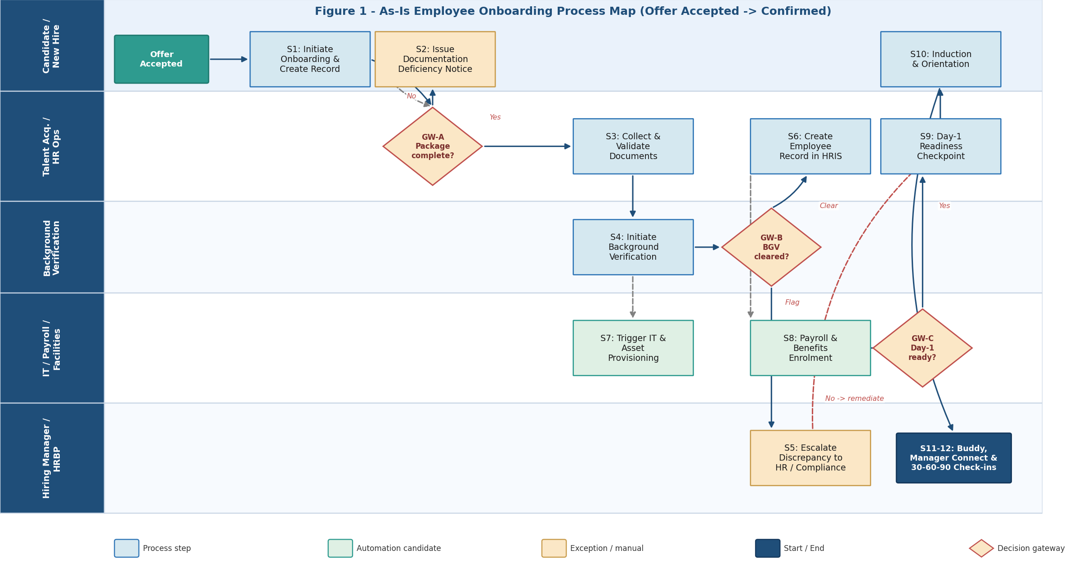
Figure 1 — As-Is Employee Onboarding Process Map.

4.2 End-to-End Process — Step by Step
The process comprises twelve sequential activities and three decision points (Gateways A–C).
Trigger Event
The process starts when an offer is accepted and TA hands the record to HR Operations, or when a scheduled pre-boarding window opens.
Step 01 - Initiate Onboarding & Create Candidate Record
The Onboarding Analyst logs the new hire in the tracker (ServiceNow HRSD) with legal name, role, business unit, joining date, hiring manager, and location. A pre-boarding checklist is instantiated and a welcome communication issued.
DECISION POINT - Gateway A: Is the offer-acceptance package complete?
The Analyst checks the mandatory intake checklist. If ANY item is missing → Step 02. If ALL present → Step 03.
Step 02 - Issue Documentation Deficiency Notice
The Analyst issues a deficiency notice listing each missing document. On response the case returns to Step 01; if no response within SLA, it is escalated.
Step 03 - Collect & Validate Documents
The Analyst collects and validates all documents for authenticity and consistency and confirms statutory forms are complete.
Step 04 - Initiate Background Verification (BGV)
The Analyst initiates BGV with the external vendor, records the reference number, and tracks turnaround against SLA. Provisioning pre-work (Step 07) can begin for confirmed joiners.
DECISION POINT - Gateway B: Is BGV cleared?
If CLEAR → Step 06. If a discrepancy or adverse result → Step 05.
Step 05 - Escalate Discrepancy to HR / Compliance
The Analyst routes the case to HR/Compliance for disposition: clarify/re-check, proceed with conditions, or rescind.
Step 06 - Create Employee Record in HRIS
The Analyst creates the employee master in Oracle HCM. The record is the system of reference for downstream provisioning.
Step 07 - Trigger IT & Asset Provisioning
The Analyst raises IT and asset requests via the service catalogue, tracked to completion before Day-1, following least-privilege templates.
Step 08 - Configure Payroll & Benefits Enrolment
The Analyst sets up payroll and enrols the employee in benefits, validated against the HRIS record.
DECISION POINT - Gateway C: Is Day-1 readiness confirmed?
If YES → Step 09/10. If NO → remediate outstanding item(s) before Day-1.
Step 09 - Day-1 Readiness Checkpoint
A consolidated readiness review 2–3 business days before start date.
Step 10 - Conduct Induction & Orientation
On Day-1 the new hire completes induction, collects assets, and activates access.
Step 11 - Assign Buddy & Manager Connect
A buddy is assigned and the manager holds a structured connect.
Step 12 - 30-60-90 Day Check-ins & Probation Confirmation
Scheduled check-ins capture engagement; at end of probation the employee is confirmed.

4.3 Possible Paths Through the Process
Path 1 - Happy Path
Complete package; BGV clear; Day-1 ready.
Path 2 - Deficiency Loop
Package incomplete at Gateway A; deficiency notice at Step 02; returns to Step 01.
Path 3 - BGV Discrepancy
Gateway B discrepancy routes to Step 05 for disposition.
Path 4 - Day-1 Not Ready
Gateway C = NO; outstanding items remediated before start.
Path 5 - Rehire / Re-Onboarding
Expedited cycle with reduced re-collection where prior records are valid.

4.4 Exception Scenarios
Exception | When | Current Handling
Candidate never responds to deficiency notice | After Step 02 | Case lapses after SLA; escalated; joining date may be re-planned.
BGV delayed beyond acceptable window | Step 04 | Conditional-join where permitted, or defer start date.
BGV discrepancy or adverse result | GW-B | Escalate to HR/Compliance (Step 05).
IT/assets not provisioned before Day-1 | GW-C | Manual expedite; interim access; contingency Day-1 plan.
Payroll cut-off missed | Step 08 | Off-cycle payment or next-cycle correction.
Start date changes after setup | Any step | Update HRIS effective date; re-sequence provisioning.
Duplicate or rehire record | Step 06 | Master-data check prevents duplicate; prior record reactivated.
Bulk/campus intake volume spike | Trigger / Step 01 | Cohort batch checklist; additional analysts assigned.

4.5 Onboarding Types and Their As-Is Handling

4.5.1 Lateral / Experienced Hire
Full end-to-end assessment (Steps 01-12). Requires complete documentation, standard BGV, and role-based access. Owner: Onboarding Analyst; Manager confirms Day-1 readiness.

4.5.2 Campus / Fresher Batch
Cohort onboarding on a common start date. Emphasis on batch document collection, standardised induction, and bulk provisioning. Higher volume; readiness consistency is the main risk.

4.5.3 Rehire / Conversion (Contractor to FTE)
Expedited cycle with reduced re-collection where prior records are valid; BGV and access refreshed per policy. Owner: Onboarding Analyst; HRBP confirms eligibility.

4.5.4 Cross-Border / Relocation Hire
Additional steps for visa/work-authorisation, jurisdiction-specific statutory forms, and localisation of payroll/benefits. Longer lead time; Legal/Mobility involvement.

4.5.5 Executive / Senior Hire
Enhanced due diligence, confidentiality handling, tailored induction, and executive-asset provisioning. Owner: HRBP with Onboarding Analyst support.

4.5.6 M&A / TUPE-Transfer (Acquired-Population Onboarding)
Bulk onboarding of a workforce inherited through a merger, acquisition or business/service transfer. Where an automatic-transfer regime applies (e.g., TUPE in the UK, the EU Acquired Rights Directive, or comparable local law), employees transfer on their existing terms with continuity of service preserved — an inherited-population migration, not a fresh hire. Emphasis shifts from BGV/offer to HR due diligence, inform-and-consult with employee representatives/works councils, bulk record creation with preserved service dates, and payroll/benefits/access cutover on legal Day-1, followed by post-transfer harmonisation. In asset deals where auto-transfer does not apply, terms are mapped and offers/rehire may be required. Owner: HR Integration Lead with Legal and Payroll; see Appendix B for the detailed flow.

4.6 Onboarding Readiness & SLA Model | Summary
The As-Is model tracks readiness across five workstreams. Each has an owner, an SLA relative to the joining date (J), and a Day-1 readiness weight used at Gateway C.
Workstream | Owner | SLA (relative to J) | Day-1 Weight
Documentation & Validation | Onboarding Analyst | Complete by J-7 | 20%
Background Verification | Analyst + Vendor | Initiated J-10; result by J-2 | 25%
HRIS Record & Org Assignment | Onboarding Analyst | Active by J-5 | 15%
IT & Asset Provisioning | IT / Assets | Ready by J-2 | 20%
Payroll & Benefits Enrolment | Payroll | Setup by payroll cut-off | 20%

Readiness Tiers
Tier | Score | Status | Action
Green | 100% | Day-1 ready | Proceed to induction
Amber | 80–99% | Minor gaps | Expedite; contingency plan for residual items
Red | < 80% | Not ready | Escalate; consider start-date re-plan

4.7 Pain Points
ID | Pain Point | Impact
PP-01 | Manual, email-based document collection and chasing | Delays, rework, inconsistent completeness
PP-02 | Fragmented handoffs across TA, HR, IT, and Payroll | Missed steps and unclear ownership
PP-03 | BGV turnaround variability with limited status visibility | Late clearance; Day-1 risk
PP-04 | No single real-time view of onboarding readiness | Reactive firefighting near joining date
PP-05 | Provisioning not synchronised to start date | Access/asset delays; poor first-day experience
PP-06 | Checklist discipline depends on individual analysts | Inconsistent readiness and auditability gaps

5. Future State (To-Be)
Forward-looking content — pending To-Be design confirmation.

5.1 To-Be Process Map
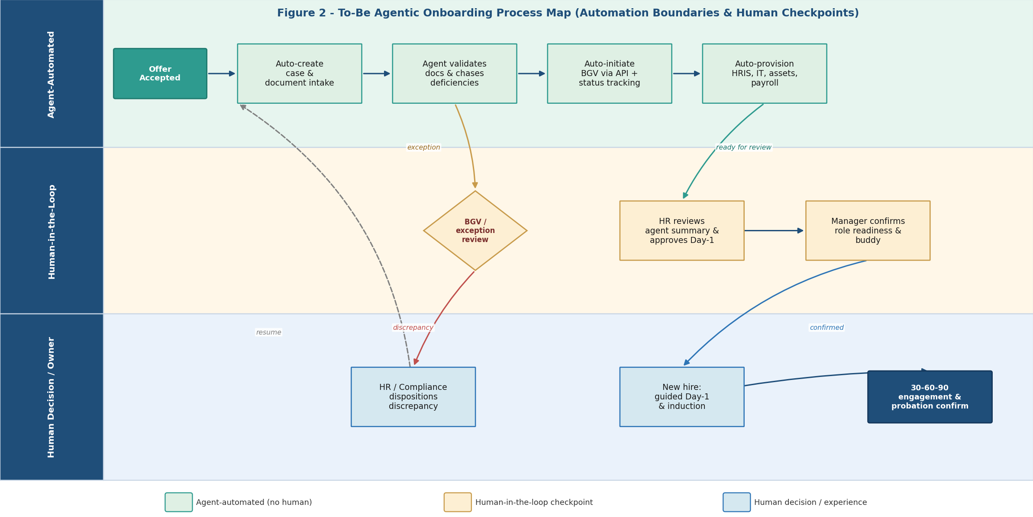
Figure 2 — To-Be Agentic Onboarding Process Map.

5.2 To-Be Process Description
In the future state, an onboarding agent auto-creates the case on offer acceptance, ingests and validates documents, chases deficiencies, initiates and tracks BGV via API, and auto-provisions HRIS, IT/assets, and payroll against role templates. Human-in-the-loop checkpoints are retained for BGV/exception review, HR approval of Day-1, and the Hiring Manager's role-readiness confirmation. Human-only steps preserve the new-hire experience and compliance disposition of discrepancies.

6. Roles & Responsibilities (RACI)
R = Responsible, A = Accountable, C = Consulted, I = Informed.
Step | Activity | Analyst | HRBP | Manager | IT | Payroll | BGV | New Hire
01 | Initiate & Create Record | R/A | I | I | — | — | — | R
02 | Deficiency Notice | R/A | I | — | — | — | — | R
03 | Collect & Validate Docs | R/A | C | — | — | — | — | R
04 | Initiate BGV | R/A | I | — | — | — | R | C
05 | Escalate Discrepancy | R | A | I | — | — | C | —
06 | Create HRIS Record | R/A | C | I | — | — | — | —
07 | IT & Asset Provisioning | R | I | C | R | — | — | I
08 | Payroll & Benefits | R | I | — | — | R | — | C
09 | Day-1 Readiness Checkpoint | R/A | C | C | I | I | I | I
10 | Induction & Orientation | R | C | C | — | — | — | R
11 | Buddy & Manager Connect | C | A | R | — | — | — | R
12 | 30-60-90 & Probation | C | A | R | — | — | — | R

7. Business Objectives & Success Criteria

7.1 Business Objectives
ID | Objective
BO-01 | Reduce onboarding cycle time from offer acceptance to Day-1 readiness.
BO-02 | Standardise the onboarding process and checklists across all business units.
BO-03 | Improve Day-1 readiness (HRIS, access, assets, payroll) to a consistent standard.
BO-04 | Reduce manual effort in document collection, BGV coordination, and provisioning.
BO-05 | Enforce compliance, data minimisation, and responsible-AI controls with human accountability.
BO-06 | Improve new-hire experience and reduce early-tenure (0–90 day) attrition.
BO-07 | Provide a complete, auditable trail of onboarding decisions and completions.

7.2 Success KPIs
KPI definitions are established; targets remain pending To-Be design and discovery.
KPI | Definition | Baseline | Target
Onboarding Cycle Time | Days from offer acceptance to Day-1 readiness | TBD | ≤ 7 days
Day-1 Readiness Rate | % of joiners fully ready on Day-1 | TBD | ≥ 98%
Document Completeness at Intake | % of packages complete at first submission | TBD | ≥ 90%
BGV Turnaround | Days from BGV initiation to result | TBD | ≤ 5 days
Provisioning On-Time Rate | % of IT/asset requests ready by J-2 | TBD | ≥ 95%
New-Hire Experience (eNPS) | 30-day onboarding experience score | TBD | ≥ +40
0–90 Day Attrition | % of new hires exiting within 90 days | TBD | ≤ 3%

8. Business Requirements
Priority: M = Must, S = Should, C = Could. Mapped to Business Objectives (BO-) in Section 7.
ID | Requirement | Priority | Objective
REQ-01 | Auto-create the onboarding case on offer acceptance and instantiate the pre-boarding checklist. | M | BO-01, BO-07
REQ-02 | Ingest and validate new-hire documents against the mandatory checklist; flag and chase deficiencies. | M | BO-01, BO-04
REQ-03 | Initiate BGV via vendor API and track status against SLA with automated reminders. | M | BO-03, BO-04
REQ-04 | Route BGV discrepancies to HR/Compliance with the vendor report for disposition. | M | BO-05
REQ-05 | Create the employee record in Oracle HCM with position, org, manager, and start date on clearance. | M | BO-01, BO-07
REQ-06 | Auto-raise IT/asset and role-based access requests via the service catalogue. | M | BO-03
REQ-07 | Configure payroll and benefits enrolment with validation against the HRIS record. | M | BO-03
REQ-08 | Maintain a live onboarding readiness score across the five workstreams. | M | BO-03
REQ-09 | Enforce a Day-1 readiness checkpoint with BGV clearance as a hard prerequisite. | M | BO-03, BO-05
REQ-10 | Provide guided Day-1 induction and mandatory compliance-training enrolment. | S | BO-06
REQ-11 | Assign a buddy and schedule the structured manager connect. | S | BO-06
REQ-12 | Schedule 30-60-90 check-ins and capture probation confirmation. | S | BO-06, BO-07
REQ-13 | Generate real-time alerts when any workstream breaches its SLA relative to the joining date. | M | BO-03
REQ-14 | Support rehire/conversion with reduced re-collection where prior records are valid. | S | BO-04
REQ-15 | Enforce data minimisation and role-based access to sensitive new-hire data. | M | BO-05
REQ-16 | Maintain an immutable audit trail of steps, approvals, owners, and timestamps. | M | BO-07

9. System & Application Enablement

9.1 Application Landscape
Application | Function
Oracle HCM | Employee master, position/org assignment, start date, onboarding status (system of reference).
ServiceNow HRSD (with NowAssist) | Onboarding case management, checklists, tasks, and agent-assisted actions.
Background Verification Vendor (Portal/API) | Identity, education, employment, address, and criminal/database checks.
IT Service Catalogue / ITSM | Account, email, hardware, and role-based access provisioning.
Payroll & Benefits System | Payroll setup, tax/statutory registration, and benefits enrolment.
Microsoft Outlook / Teams | Pre-boarding comms, notifications, approvals, and manager connect.
Power BI | Onboarding readiness dashboards and SLA analytics.

10. Business Rules & Governance Controls
ID | Rule
BR-01 | No system access or asset is granted before BGV clearance (or an approved conditional-join per policy) and an active HRIS record.
BR-02 | Onboarding checklists and role-based access templates are version-controlled; only HR Operations/IT owners may modify them.
BR-03 | Sensitive new-hire data is collected on a minimisation basis and accessible only on a role-based need-to-know.
BR-04 | Day-1 readiness requires all mandatory workstreams complete or an approved contingency, with BGV as a hard prerequisite.
BR-05 | BGV discrepancies are dispositioned only by HR/Compliance; analysts cannot self-approve adverse results.
BR-06 | Every onboarding decision, approval, and provisioning action is logged with owner and timestamp for audit.
BR-07 | Agent actions are bounded and reversible; defined checkpoints require human approval before proceeding.
BR-08 | Records are retained per statutory policy; documents are not shared externally.

11. Glossary
Term | Definition
AHRO | Agentic HR Operations — the agent-assisted HR operating model.
BRD | Business Requirements Document — this document.
BGV | Background Verification — identity, education, employment, and related checks.
HRIS / HCM | Human Resource Information System / Human Capital Management (Oracle HCM).
HRSD | HR Service Delivery (ServiceNow), with NowAssist agentic capabilities.
Day-1 Readiness | State in which HRIS, access, assets, and payroll are ready for the joining date.
Gateway | A decision point in the process (A–C).
J | The joining (start) date, used as the reference for SLAs (e.g., J-7).
TUPE / ARD | Transfer of Undertakings (Protection of Employment) / EU Acquired Rights Directive.
Continuity of Service | Preservation of an employee's original service date through a transfer.

Appendix A - Blue-Collar / Frontline Employee Onboarding
This appendix extends Section 4.5 to cover blue-collar, frontline, shop-floor and field workers (e.g., manufacturing operators, warehouse, logistics, facilities, security and construction). While the core 12-step backbone applies, blue-collar onboarding is high-volume, site-based and safety-critical: it adds mandatory medical-fitness and safety-clearance hard gates, physical provisioning (PPE, uniform, tools, badge), wage/timesheet payroll, and heightened statutory-labour compliance.

A.1 Overview & Rationale
Blue-collar hiring typically occurs in bulk or on a continuous walk-in basis against site manpower demand. Documentation is frequently collected with assistance at a kiosk or site HR desk; identity and age verification are critical; and prior-employment BGV is often supplemented with police verification. Crucially, a worker cannot be deployed to the floor or site until certified medically fit and safety-inducted - these are non-negotiable hard gates. Provisioning shifts to badge, PPE, uniform, tools and locker; and payroll shifts to wage/hourly, timesheet-driven pay with statutory registrations (e.g., PF/UAN, ESIC, minimum-wage and overtime compliance).

A.2 Key Differences vs White-Collar Onboarding
Dimension | White-Collar (Main BRD) | Blue-Collar / Frontline
Hiring pattern | Individual / lateral offer acceptance | Bulk / batch / continuous walk-in against manpower demand
Document intake | Digital self-upload | Assisted kiosk / paper at site HR; low-literacy support
Identity & eligibility | Standard ID + education | ID + age proof + trade/skill certification + right-to-work
Verification | Education / employment / criminal BGV | BGV + police verification + medical fitness + drug test
Deployment gate | BGV clearance | Medical fitness AND safety sign-off (dual hard gates)
Provisioning | Laptop, email, system access | Access badge, PPE, uniform, tools, locker
Payroll | Monthly salary | Wage/hourly, timesheet-driven; PF/UAN, ESIC, minimum wage, overtime
First-line owner | Hiring Manager | Supervisor / Foreman / Shift-in-charge
Induction | Policies, security, systems | HSE/safety, site orientation, machine/equipment SOPs
Training gate | Role-based (post Day-1) | Mandatory safety competency before floor/site access
Volume & cadence | Steady | Peaks with shifts/seasons; surge staffing

A.3 Blue-Collar Onboarding Process Map
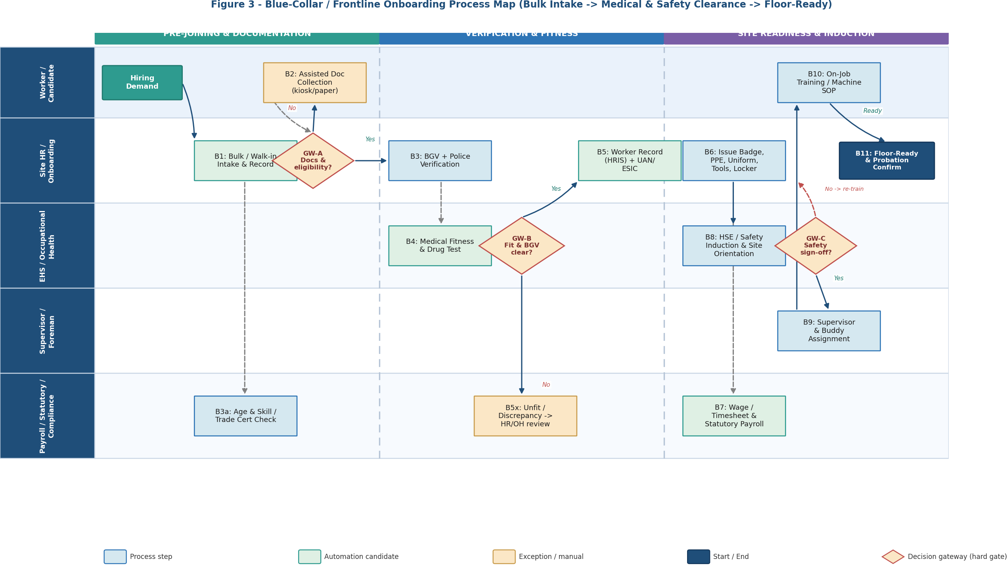
Figure 3 - Blue-Collar / Frontline Onboarding Process Map. Two hard gates (GW-B medical fitness & BGV, GW-C safety sign-off) must pass before floor-ready.

A.4 Additional / Modified Steps
Step | Description | Owner
B1 | Bulk / walk-in intake and worker record creation with role, site, shift and skill category. | Site HR
GW-A | Documents & eligibility complete (ID, age proof, skill/trade certificate)? If no, assisted collection (B2). | Site HR
B3 | BGV plus police verification (address / antecedents) per policy. | Site HR + Vendor
B4 | Medical fitness examination and drug test via Occupational Health. | EHS / Occ. Health
GW-B | HARD GATE: Medically fit AND BGV clear? If no, route to HR/OH review. | EHS + HR
B5 | Create worker record in HRIS and generate statutory IDs (e.g., UAN/ESIC). | Site HR
B6 | Issue access badge, PPE, uniform, tools and locker; record issuance. | Site HR + Stores
B7 | Wage/timesheet setup and statutory payroll registration. | Payroll / Compliance
B8 | HSE / safety induction and site orientation. | EHS / Safety
GW-C | HARD GATE: Safety competency signed off? If no, re-train before floor access. | EHS + Supervisor
B9-B11 | Supervisor & buddy assignment, on-job / machine-SOP training, and probation confirmation. | Supervisor

A.5 Additional Data & Document Requirements
Field / Document | Type | Mandatory | Purpose
Age Proof | File | Yes | Prevent under-age deployment; statutory compliance
Trade / Skill Certificate | File | Conditional | Competency for regulated tasks (forklift, welding, electrical)
Medical Fitness Certificate | File | Yes | Fitness-to-work hard gate (GW-B)
Drug-Test Result | File | Conditional | Safety-critical roles / policy
Police Verification | File | Conditional | Antecedent check for site security
PPE Size Details | Structured | Yes | Correct PPE / uniform issuance
Next of Kin / Emergency Contact | Structured | Yes | Site safety & emergency response
Bank / UAN / ESIC | Structured | Yes | Wage payment and statutory contributions

A.6 Provisioning Differences
Item | Purpose
Access Badge / Gate Pass | Site and zone access control; time-and-attendance capture
PPE (helmet, boots, gloves, hi-vis) | Mandatory safety equipment issued before floor access
Uniform | Identification and role/zone differentiation
Tools / Instruments | Role-specific equipment with issuance record
Locker / Storage | Personal storage and shift changeover
Transport / Canteen enrolment | Shift logistics and welfare (where provided)

A.7 Readiness Model Addition - Safety & Medical Fitness
The Day-1 readiness model is extended with a Safety & Medical Fitness workstream that acts as a hard prerequisite: a worker is not floor-ready unless medically fit and safety-signed-off, regardless of the weighted readiness score.
Workstream | Owner | Gate | Floor-Ready Weight
Documentation & Eligibility | Site HR | GW-A | 15%
BGV + Police Verification | Site HR + Vendor | GW-B | 15%
Medical Fitness & Drug Test | Occupational Health | GW-B (hard) | 20%
Provisioning (Badge/PPE/Uniform/Tools) | Site HR + Stores | - | 15%
Wage/Timesheet & Statutory Payroll | Payroll | - | 15%
Safety / HSE Induction | EHS | GW-C (hard) | 20%

A.8 RACI Adjustments
Step | Activity | Site HR | EHS/OH | Supervisor | Payroll | BGV | Worker
B1 | Intake & Worker Record | R/A | I | I | - | - | R
B3 | BGV + Police Verification | R/A | - | - | - | R | C
B4 | Medical Fitness & Drug Test | C | R/A | - | - | - | R
GW-B | Fitness & BGV Clearance | C | A | I | - | C | -
B6 | Badge / PPE / Uniform / Tools | R/A | C | C | - | - | R
B7 | Wage & Statutory Payroll | C | - | - | R/A | - | C
B8 | HSE / Safety Induction | I | R/A | C | - | - | R
GW-C | Safety Sign-off | I | A | R | - | - | C
B9-B11 | OJT & Probation Confirm | C | C | R/A | - | - | R

A.9 Statutory & Compliance Considerations
Area | Requirement
Age & child-labour | Verify minimum working age; block under-age deployment (hard).
Occupational health & safety | Fitness-to-work and safety induction mandatory before floor access.
Wages & hours | Minimum-wage, overtime and working-hour limits applied in payroll setup.
Social security | Statutory registrations (e.g., PF/UAN, ESIC) completed before first wage run.
Contract labour | Principal-employer obligations and licence checks apply where contractor-engaged.
Records & audit | PPE issuance, safety sign-off, fitness certificates and IDs retained as auditable evidence.

A.10 Exceptions & KPIs
Exception | When | Handling
Medically unfit / restricted | GW-B | Route to Occupational Health; role reassignment or hold per policy.
Safety competency not achieved | GW-C | Re-train and re-assess; no floor access until signed off.
PPE stock-out | B6 | Interim PPE / defer floor access; expedite stores replenishment.
Missing age / skill certificate | GW-A | Assisted collection; block deployment for regulated tasks until verified.
Bulk-intake surge | B1 | Batch checklist and surge staffing; risk of inconsistent readiness.

KPI | Definition | Target
Floor-Ready Cycle Time | Days from intake to floor-ready | 3-5 days
Medical Fitness Turnaround | Days from exam to result | = 2 days
Safety Induction Completion | % inducted before floor access | 100%
PPE Issuance Compliance | % issued & recorded before deployment | 100%
Statutory Registration Timeliness | % registered before first wage run | = 99%
Early (0-30 day) Attrition | % exiting within 30 days | = 8%

Appendix B - M&A / TUPE-Transfer Onboarding
This appendix extends Section 4.5.6 to detail the onboarding of a workforce inherited through a merger, acquisition, or business/service transfer. Where an automatic-transfer regime applies, employees are migrated with continuity of service rather than hired afresh, and controls shift to due diligence, legally required consultation, bulk data migration, and a payroll/access cutover timed to legal Day-1.

B.1 Overview & Transfer Basis
The transfer basis determines the onboarding pathway. Under an automatic-transfer regime (TUPE / Acquired Rights Directive / comparable local law), affected employees transfer to the buyer on their existing terms with continuity of service preserved; dismissals connected to the transfer are generally prohibited, and inform-and-consult obligations apply. In a pure asset deal without auto-transfer, employees do not transfer automatically - terms are mapped and offers (rehire) may be extended. Obligations, consultation timelines and objection/opt-out rights vary by country and must be confirmed with Legal.
Transfer Basis | Onboarding Implication
Automatic transfer (TUPE / ARD) | Migrate on existing terms; preserve service; no re-BGV by default; consult reps; harmonise later.
Share purchase | Employer entity unchanged; primarily system/branding integration; minimal term change.
Asset purchase (no auto-transfer) | No automatic transfer; map terms; extend offers / rehire; treat closer to new-hire.
Cross-border transfer | Localise per each jurisdiction; separate consultation and payroll setup per country.

B.2 Key Differences vs Standard Onboarding
Dimension | Standard New-Hire | M&A / TUPE Transfer
Population | Individual joiner | Inherited group / whole business unit
Basis | Offer acceptance | Legal transfer (auto-transfer or asset deal)
Terms & service | New terms; service starts at hire | Existing terms preserved; continuity of service
BGV | Full BGV before access | Typically no re-BGV for transferring staff; access re-provisioned
Employee choice | Accept / decline offer | Inform & consult; possible objection / opt-out
Key gate | Day-1 readiness (BGV + provisioning) | Legal Day-1 cutover (payroll/benefits/access) with no pay disruption
Primary owners | Onboarding Analyst + Hiring Manager | HR Integration Lead + Legal + Payroll
Post-join | 30-60-90 & probation | Policy/terms harmonisation over an agreed period

B.3 M&A / TUPE-Transfer Process Map
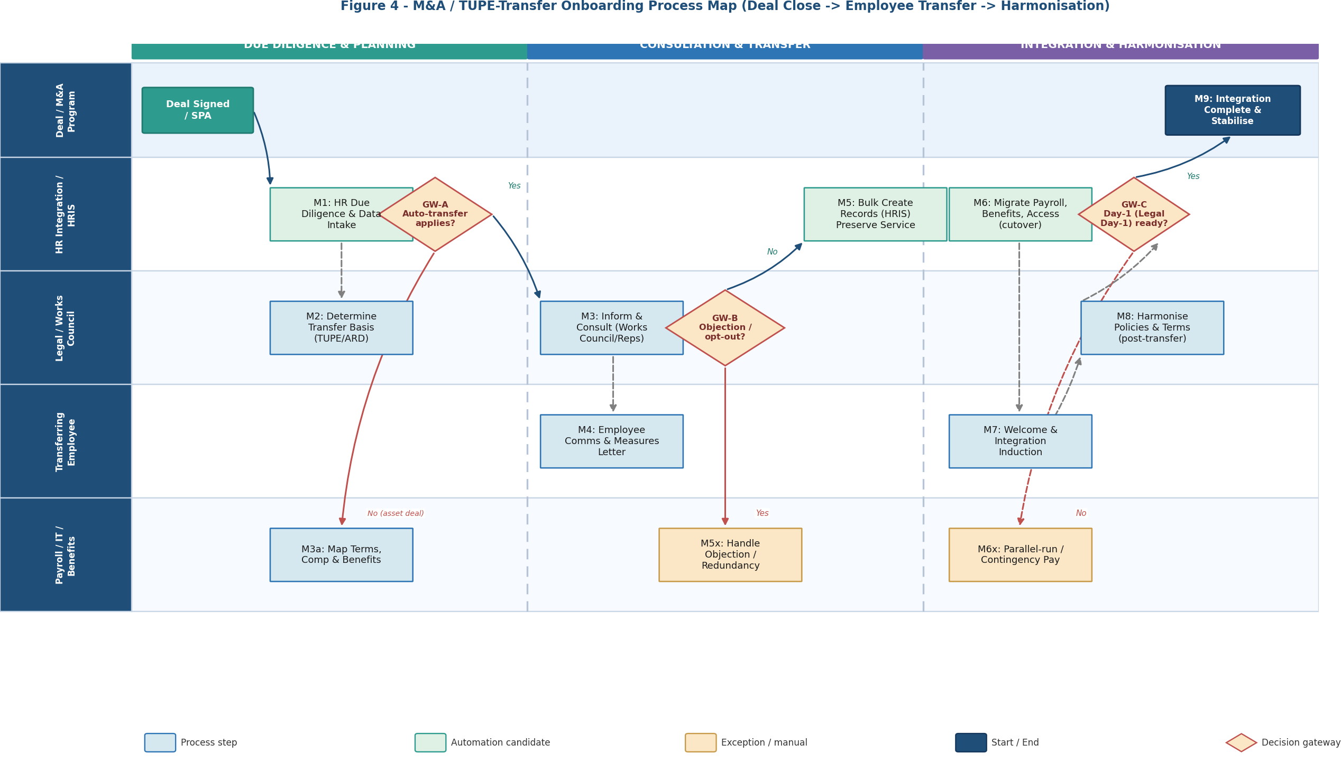
Figure 4 - M&A / TUPE-Transfer Onboarding Process Map, across Due Diligence & Planning, Consultation & Transfer, and Integration & Harmonisation.

B.4 Step Definitions
Step | Description | Owner
M1 | HR due diligence and secure intake of employee data (headcount, terms, service, liabilities). | HR Integration
M2 | Determine transfer basis and applicable law (TUPE/ARD vs asset deal). | Legal
GW-A | Does automatic transfer apply? If no, map terms and prepare offers (M3a). | Legal + HR
M3 | Inform and consult recognised representatives / works council per statutory timeline. | HR + Legal
M4 | Individual employee communications and measures letter (terms, changes, Day-1 info). | HR Integration
GW-B | Any objection / opt-out? If yes, handle per policy (M5x). | HR + Legal
M5 | Bulk-create worker records in HRIS preserving original hire/service dates. | HR Integration
M6 | Cutover of payroll, benefits and system access, timed to legal Day-1. | Payroll / IT / Benefits
GW-C | Legal Day-1 ready (no pay disruption)? If no, parallel-run / contingency pay (M6x). | HR + Payroll
M7 | Welcome and integration induction (culture, policies, tooling). | HR Integration
M8 | Post-transfer harmonisation of policies and terms over the agreed period. | HR + Legal
M9 | Integration complete and workforce stabilised. | HR Integration

B.5 Data & Due-Diligence Requirements
Data Item | Source | Purpose
Headcount & org structure | Seller / DD data room | Scope and integration planning
Original hire / service dates | Seller HR records | Preserve continuity of service
Terms & conditions / contracts | Seller HR records | Term mapping and harmonisation
Compensation & benefits | Seller HR / payroll | Payroll and benefits cutover
Collective agreements / reps | Seller / Legal | Consultation obligations
Pending liabilities (claims, LOA) | Seller / Legal | Risk and provisioning
Payroll & bank data | Seller payroll | Day-1 pay continuity

B.6 RACI (Transfer-Specific)
R = Responsible, A = Accountable, C = Consulted, I = Informed.
Step | Activity | HR Integ. | Legal | Payroll | IT | Employee
M1 | HR Due Diligence & Data Intake | R/A | C | C | - | I
M2 | Determine Transfer Basis | C | R/A | - | - | I
M3 | Inform & Consult Reps | R | A | - | - | C
M4 | Employee Comms & Measures | R/A | C | - | - | R
GW-B | Objection / Opt-out Handling | R | A | - | - | R
M5 | Bulk Create Records (preserve service) | R/A | C | C | C | I
M6 | Payroll/Benefits/Access Cutover | C | I | R | R | I
GW-C | Legal Day-1 Readiness | A | C | R | C | I
M7-M8 | Induction & Harmonisation | R/A | C | C | - | R

B.7 Compliance, Exceptions & KPIs
Area | Requirement
Inform & consult | Complete statutory consultation with reps/works council before transfer.
No transfer-connected dismissal | Avoid dismissals tied to the transfer; changes to terms constrained by law.
Continuity of service | Preserve original service dates for benefits, notice and entitlements.
Data protection | Lawful transfer of employee data from seller; minimise and secure.
Pension / benefits | Address pension and benefit obligations per applicable rules.
Objection / opt-out | Handle objections and any redundancy per jurisdiction and policy.

KPI | Definition | Target
Day-1 Pay Continuity | % of transferring staff paid correctly on first cycle | 100%
Record Migration Accuracy | % of records migrated with correct service dates | = 99%
Consultation Compliance | Statutory consultation completed on time | 100%
Access Cutover On-Time | % with access ready by legal Day-1 | = 98%
Transfer-Related Attrition (0-90d) | % of transferred staff exiting within 90 days | = 10%
Harmonisation Completion | % of planned term/policy harmonisation done on schedule | = 95%

Confidential — Internal | Employee Onboarding (AHRO) BRD v1.2
