FHIR API Data Ingestion
& Analytics Pipeline
Manoj Ramamurthy

1. Project Overview

This document describes the end-to-end data pipeline built on Microsoft Fabric to ingest, transform, and model FHIR (Fast Healthcare Interoperability Resources) API data using a Medallion Lakehouse Architecture.

The pipeline ingests 4 FHIR resources — Patient, Encounter, Observation, and Condition — across a rolling 3-day window, stores them in layered Delta tables, and produces analytics-ready Gold views.

1.1 Key Objectives
- Incrementally ingest FHIR API data for 2-3 days with pagination
- Build a 4-layer Medallion Architecture: Raw, Bronze, Silver, Gold
- Apply SCD Type 2 versioning to track historical changes
- Orchestrate the full pipeline using Fabric Data Pipeline
- Produce clean, analytics-ready Gold tables for reporting

1.2 Technology Stack
Component | Technology
Platform | Microsoft Fabric
Storage | OneLake Lakehouse — FHIR_Lakehouse (Delta / Parquet)
Processing | Apache Spark (PySpark Notebooks)
Transformation | Spark Notebooks
Orchestration | Fabric Data Pipeline
Version Control | GitHub (Git Integration)
Source API | HAPI FHIR R4 (hapi.fhir.org)

2. Lakehouse Architecture

The FHIR_Lakehouse on Microsoft Fabric is organised into a Medallion Architecture with four layers. Below is the actual Lakehouse Explorer view showing the implemented table and file structure.

2.1 Actual Lakehouse Structure (FHIR_Lakehouse)
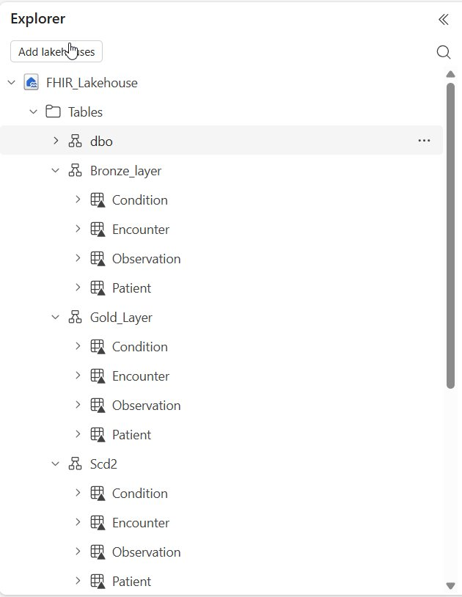 | 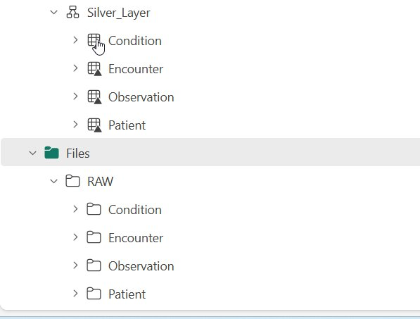
Figure 1: FHIR_Lakehouse Explorer — Tables (Bronze, Gold, SCD2, Silver) and Files (RAW) as implemented in Microsoft Fabric

The Lakehouse contains the following schema groups under Tables, and the RAW folder under Files:

Schema / Folder | Tables / Subfolders | Description
Bronze_layer | Patient, Encounter, Observation, Condition | Raw ingested Delta tables with metadata columns
Scd2 | Patient, Encounter, Observation, Condition | SCD Type 2 versioned tables tracking historical changes
Silver_Layer | Patient, Encounter, Observation, Condition | Cleaned, flattened, deduplicated Delta tables
Gold_Layer | Patient, Encounter, Observation, Condition | Joined analytical views for reporting
Files / RAW | Patient, Encounter, Observation, Condition | Raw JSON API responses stored as-is, partitioned by date

2.2 RAW Layer — Incremental Partitioning (3 Days)
The RAW folder under Files stores the original JSON API responses partitioned by resource and date. As shown below, data was successfully ingested for 3 consecutive days (2026-03-23, 2026-03-24, 2026-03-25) for all 4 resources — satisfying the 2-3 day incremental ingestion requirement.

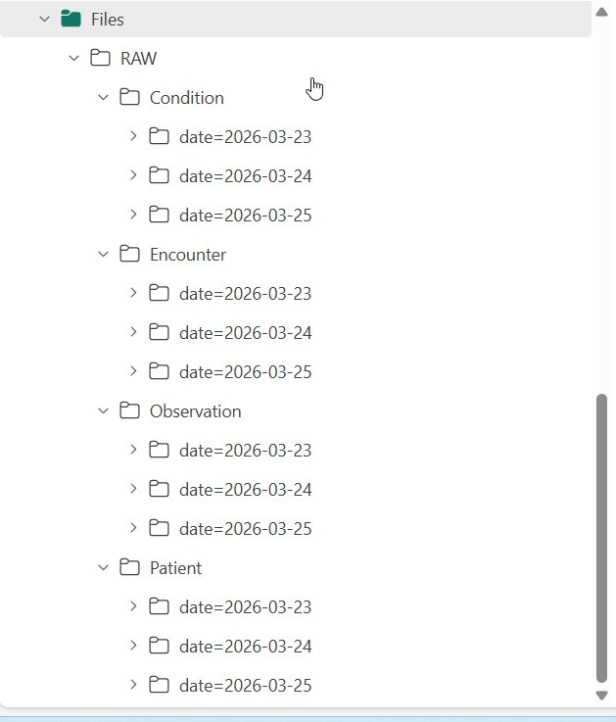
Figure 2: RAW layer showing 3-day date partitions for all 4 FHIR resources — Condition, Encounter, Observation, Patient

2.3 Architecture Flow Diagram
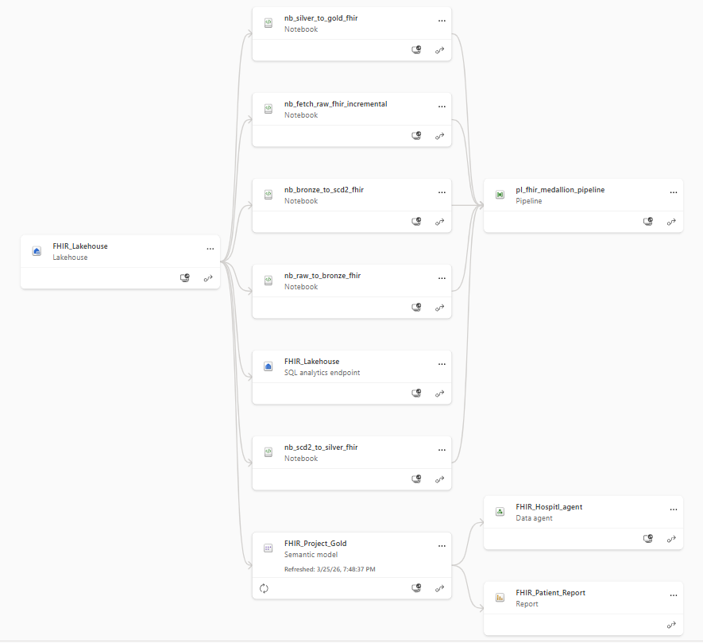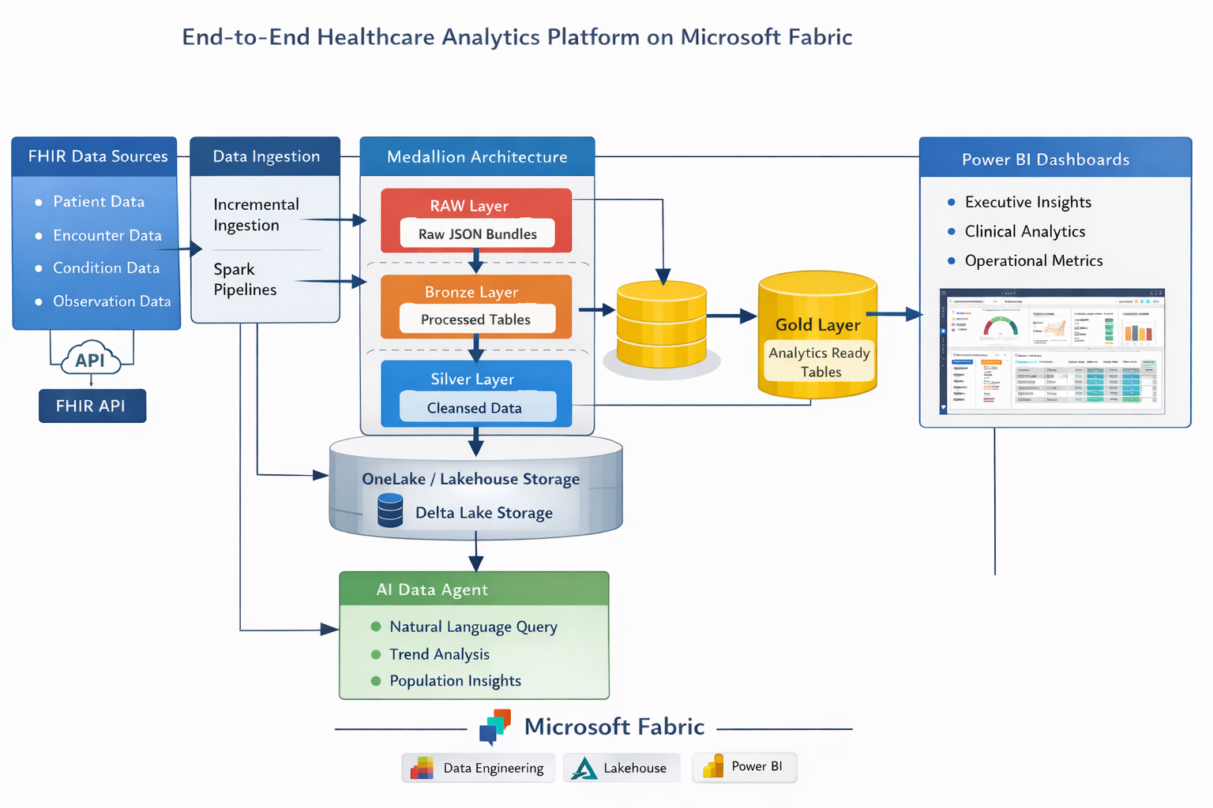
Figure 2: current architecture

2.3 Lakehouse Folder Structure
FHIR_Lakehouse/
Tables/
Bronze_layer/ -> Patient, Encounter, Observation, Condition
Scd2/ -> Patient, Encounter, Observation, Condition
Silver_Layer/ -> Patient, Encounter, Observation, Condition
Gold_Layer/ -> Patient, Encounter, Observation, Condition
Files/
RAW/
Patient/date=YYYY-MM-DD/page_1.json ...
Encounter/date=YYYY-MM-DD/page_1.json ...
Observation/date=YYYY-MM-DD/page_1.json ...
Condition/date=YYYY-MM-DD/page_1.json ...

3. Data Ingestion — Bronze Layer

3.1 FHIR API Details
Property | Value
Base URL | https://hapi.fhir.org/baseR4
Format | JSON (application/fhir+json)
Resources | Patient, Encounter, Observation, Condition
Pagination | _count=50 with next link traversal
Date Filter | _lastUpdated=ge{YYYY-MM-DD}
Date Range | Rolling 3-day window (today minus 2 days)

3.2 Ingestion Flow

- Calls the FHIR API with date filter and page size parameter
- Loops through all paginated results using the next link in the bundle
- Saves each page as raw JSON under Files/RAW/{Resource}/date={date}/
- Converts entries to Delta format and appends to the Bronze_layer table
- Adds extraction_timestamp and api_url_or_params metadata columns

3.3 SCD Type 2 Versioning
Each Bronze table has a corresponding Scd2 table that tracks historical changes across daily loads.

Column | Description
valid_from | Date when this version of the record became active
valid_to | Date when superseded — 9999-12-31 if still current
is_current | Boolean TRUE for the latest version of a record
row_hash | SHA-256 hash of all fields used to detect changes

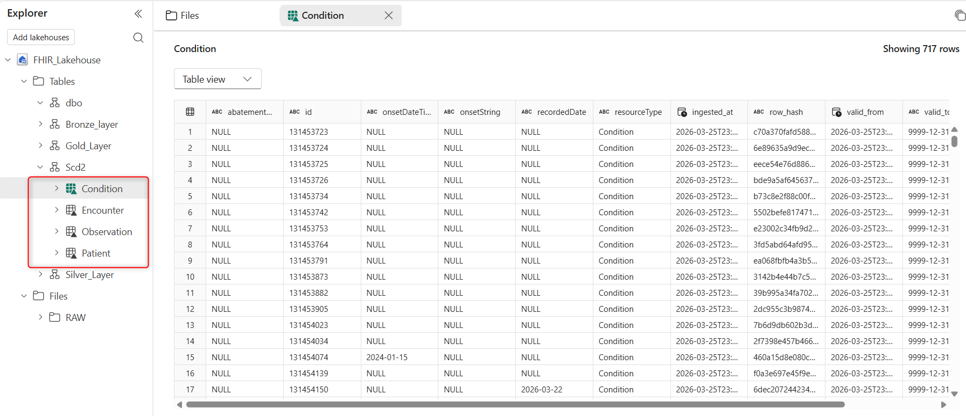

4. Data Transformation — Silver Layer

The Silver_Layer cleans and flattens the nested FHIR JSON structure into queryable, typed columns. Transformations are applied using Spark Notebooks for JSON flattening and Dataflow Gen2 for further cleaning.

4.1 Transformations Applied
- Flatten nested arrays and structs (e.g. name[0].family, code.coding[0].display)
- Extract patient/encounter references using regex on FHIR reference strings
- Cast date strings to proper date types
- Deduplicate records on resource ID
- Filter out rows with null primary keys

4.2 Silver Table Schema
Table | Primary Key | Key Columns
Silver_Layer.Patient | patient_id | gender, birth_date, family_name, given_name, city, state, country
Silver_Layer.Encounter | encounter_id | patient_id, status, encounter_class, period_start, period_end
Silver_Layer.Observation | observation_id | patient_id, encounter_id, observation_code, value_quantity, effective_date
Silver_Layer.Condition | condition_id | patient_id, encounter_id, condition_code, clinical_status, onset_date

5. Analytics Layer — Gold

The Gold_Layer contains joined, aggregated views built from Silver tables, optimised for reporting and Power BI consumption.

5.1 Gold Tables
Table | Description
Gold_Layer.Patient | Patient demographics enriched with summary metrics
Gold_Layer.Encounter | Patient joined with Encounter — one row per encounter with demographics
Gold_Layer.Observation | Patient joined with Observation — all readings with values and units
Gold_Layer.Condition | Patient joined with Condition — latest clinical status per condition

6. Pipeline Orchestration

All ingestion, transformation and loading steps are orchestrated using a Fabric Data Pipeline named pl_fhir_ingestion. The pipeline runs daily and is fully parameterised.

6.1 Pipeline Flow
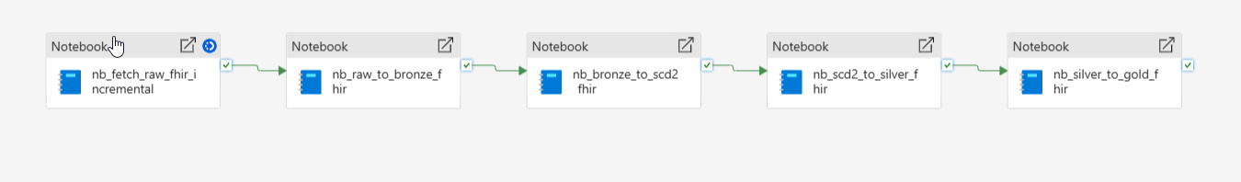
Figure 5: Insert your Fabric Data Pipeline screenshot here

6.2 Pipeline Activities
# | Activity | Description
1 | Set Variable: run_date | Sets the pipeline run date — no hardcoding
2 | Notebook: Ingest Patient | Fetches Patient data, saves raw JSON, writes Bronze Delta
3 | Notebook: Ingest Encounter | Fetches Encounter data (depends on Patient completing first)
4 | Notebook: Ingest Observation | Fetches Observation data
5 | Notebook: Ingest Condition | Fetches Condition data
6 | Dataflow Gen2: Silver | Cleans and transforms all Bronze tables into Silver_Layer
7 | Notebook: Gold Build | Creates Gold_Layer analytical views from Silver tables
8 | Notebook: Metadata Log | Logs run stats to pipeline_run_log Delta table

7. Table Relationships

All FHIR resources link back to the Patient resource via a shared patient_id. This forms the central dimension of the analytical model.

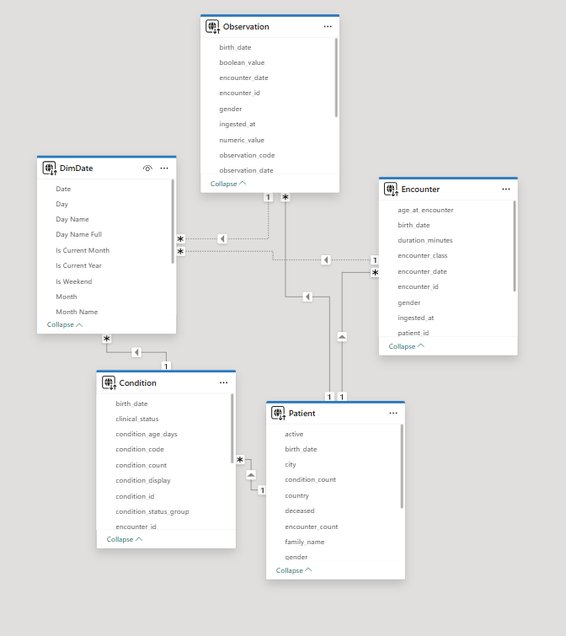
Figure 6: Insert your full data model / ER diagram here
## Entity Relationship Diagram

```mermaid
erDiagram
Patient ||--o{ Encounter : "patient_id"
Patient ||--o{ Condition : "patient_id"
Patient ||--o{ Observation : "patient_id"
Encounter ||--o{ Observation : "encounter_id"
DimDate ||--o{ Encounter : "Date - encounter_date"
DimDate ||--o{ Observation : "Date - observation_date"
DimDate ||--o{ Condition : "Date - onset_date"

Table | Description
Gold_Layer.Patient | Patient demographics enriched with summary metrics
Gold_Layer.Encounter | Patient joined with Encounter — one row per encounter with demographics
Gold_Layer.Observation | Patient joined with Observation — all readings with values and units
Gold_Layer.Condition | Patient joined with Condition — latest clinical status per condition

8. Notebooks & Code Structure

8.1 Notebook List
Notebook | Purpose
nb_raw_to_bronze_fhir | Incremental FHIR API ingestion, raw JSON save, Bronze Delta write,
nb_bronze_to_scd2_fhir | Broze to scd2 – date with timestamp
nb_scd2_to_silver_fhir | Flatten and clean Bronze tables into typed Silver Delta tables
nb_silver_to_gold_fhir | Build Gold analytical views joining silver tables

8.2 Design Principles
- No hardcoded dates — run_date passed as pipeline parameter
- All resources handled by reusable functions (no code duplication)
- Modular cells — each function is independently testable
- mergeSchema enabled on all Delta writes for schema evolution
- Error handling on API calls with raise_for_status()

8.3 GitHub Repository Structure
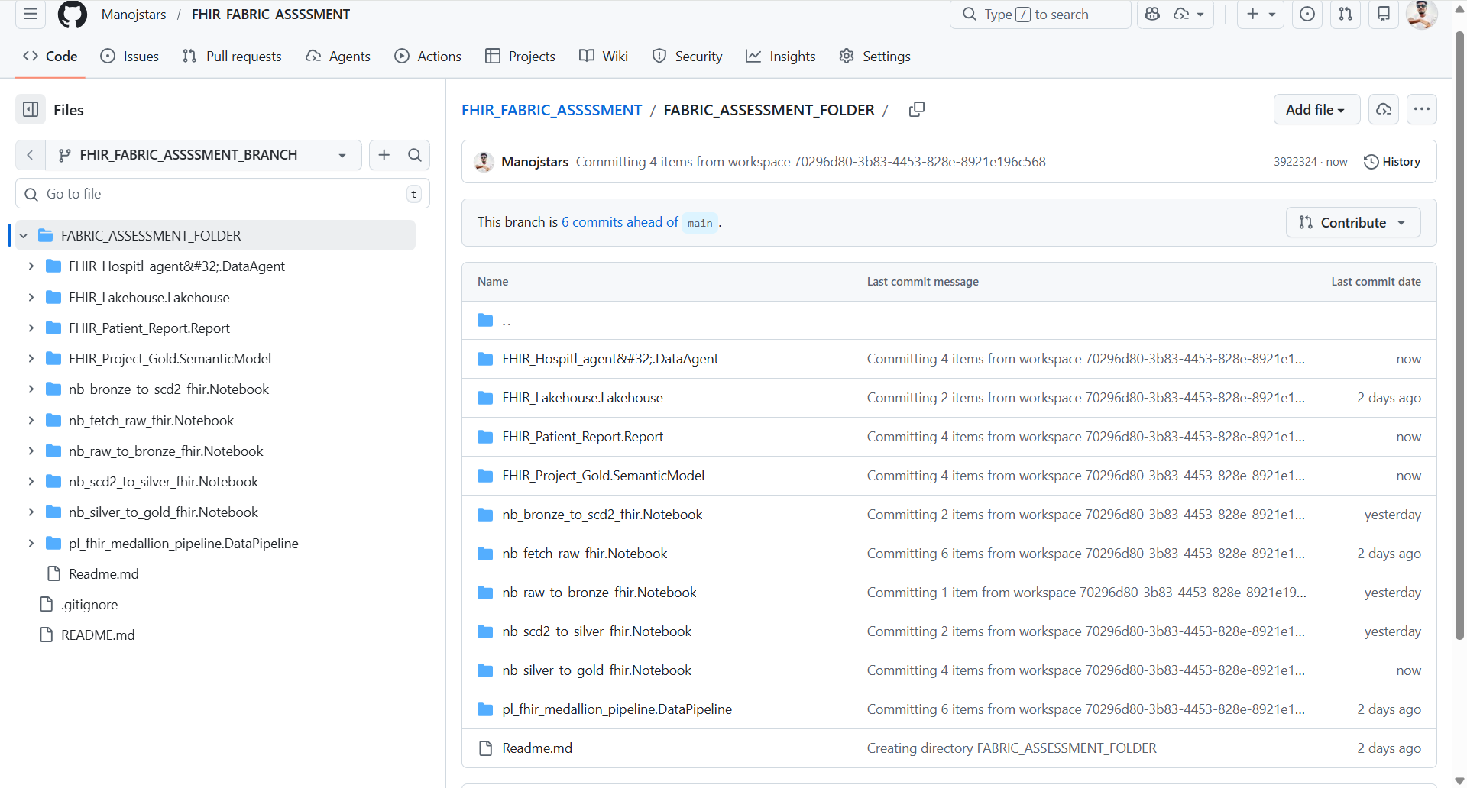

9. Power BI Visuals

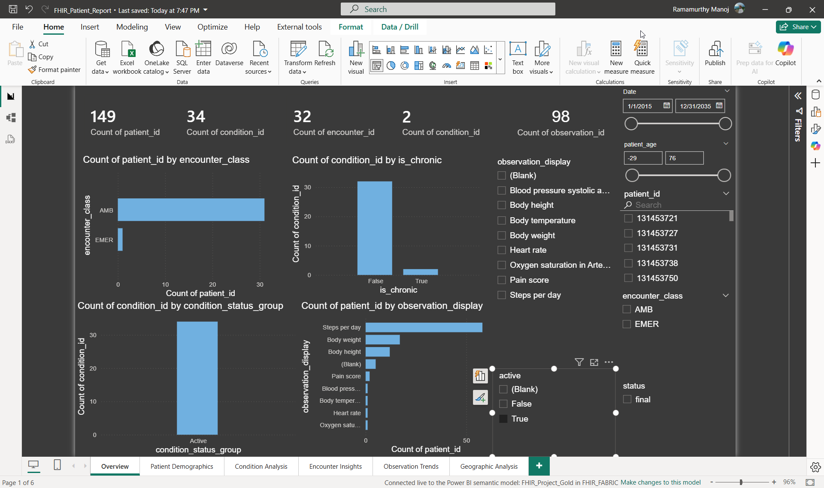
Figure overview

Patient Demographics

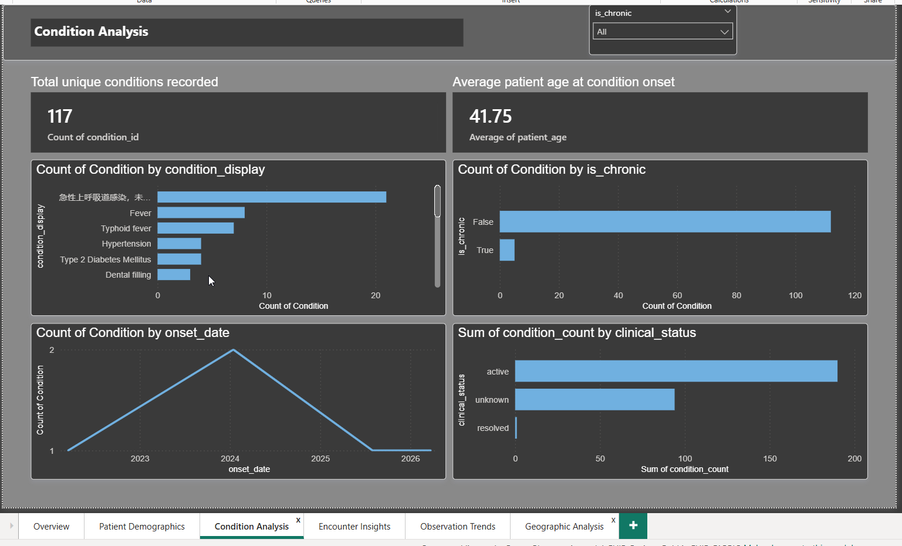
conditional Analysis
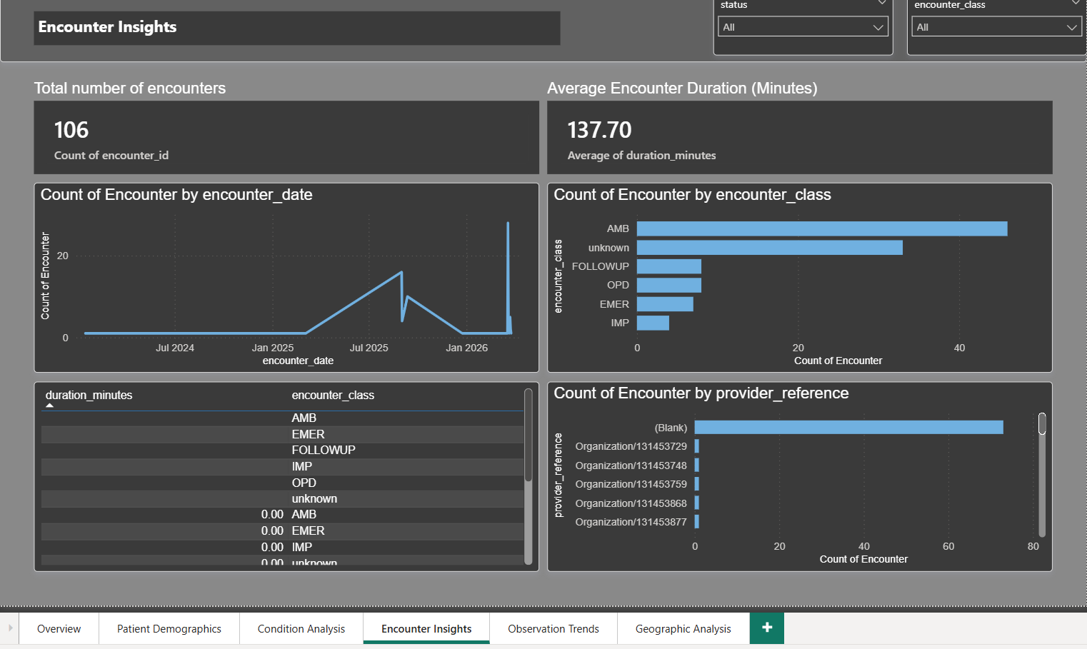
Encounter Analysis

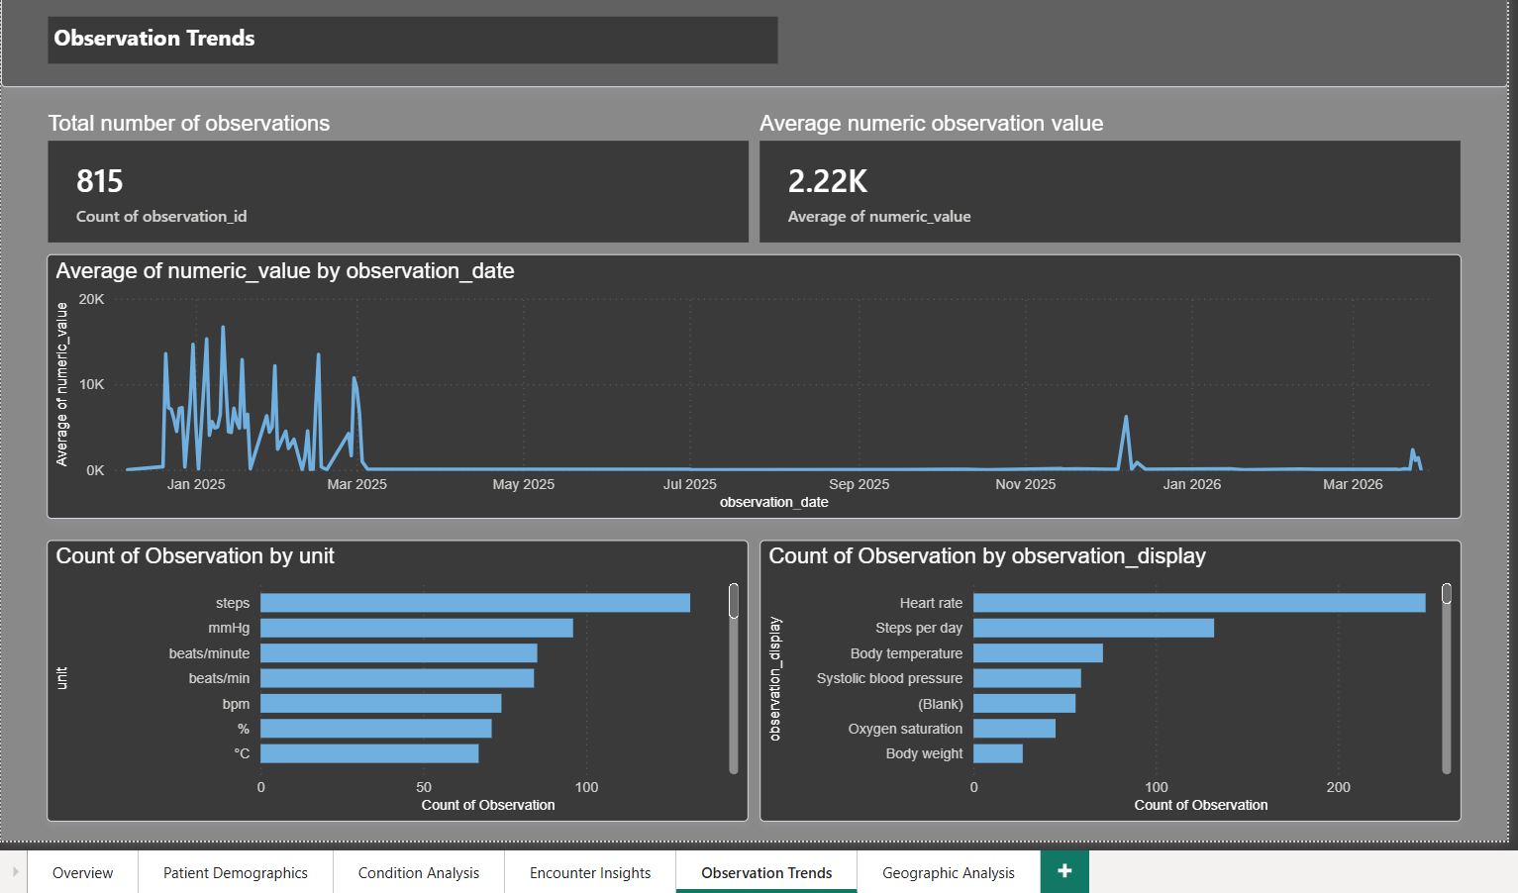
Observation Analysis

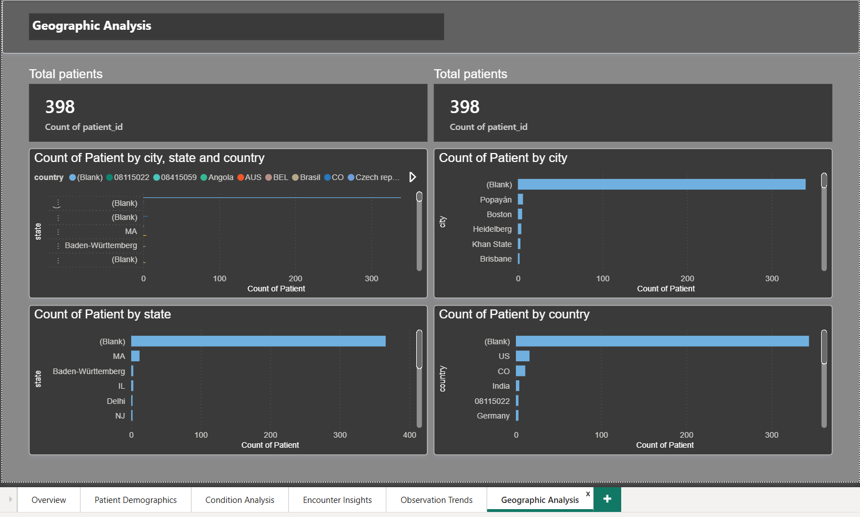
Geography Analysis

10. Data Agents

 | Requirement
[ ] | Ingest and transform 2-3 days of data with pagination
[x] | Medallion Architecture implemented (Raw, Bronze, Silver, Gold) in FHIR_Lakehouse
[ ] | Metadata columns added to all tables (extraction_timestamp, api_url_or_params)
[x] | SCD Type 2 tables created (Scd2 schema in Lakehouse)
[ ] | Modular, parameterised code — no hardcoding
[ ] | Fabric Data Pipeline orchestrating all resources in correct order
[ ] | GitHub repo connected and all notebooks committed
[ ] | Documentation complete with architecture and table diagrams
[ ] | (Optional) Power BI report built on Gold layer

FHIR Analytics Pipeline | Microsoft Fabric | v1.1 | March 2026

