PROJECT REPORT
As a Field work for Course

SOFT COMPUTING TECHNIQUES
(INT246)
On Topic
Understanding the stress level of students using Neuro fuzzy system

By
Name : Manoj Suthar
Reg. No : 11803111
Roll No. : RKM106A07

Submitted To

Usha Mittal

Lovely Professional University
Jalandhar, Punjab, India.


Abstract:
Stress is a condition of mental pressure for particular individual facing problems from environmental and social well-being which leads to so many diseases. Young age is the critical period because at this time youth faces lots of changes in his/her life. They are expected to be the elites in the society. The researcher found that the stress mainly comes from academic tests, interpersonal relations, relationship problems, life changes, and career exploration. Such stress may usually cause psychological, physical, and behavioral problems. In this paper, a hybrid neuro-fuzzy based adaptive system has been proposed which can take intelligent decisions depending upon the data from devices such as fitness trackers. The data consist signals for ECG, EMG, GSR measures from the foot, GSR measures from the hand, HR and Respiration. Using this signal reading, we can train a Neuro-fuzzy system that can provide us an accurate student stress level.
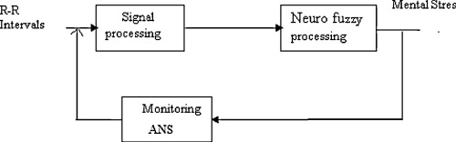
Keywords: ANFIS, GSR, HR, HRV

Introduction:
In the present competitive age it is reported that young generation are found to be more in stress. We got the information related to depression, attempt to suicide and some psychological symptoms among the youth. Adolescence is a dangerous period of time where young people experience self organization and role confusion. For them, stress mainly comes from academic tests, interpersonal relations, relationship problems, financial, and career exploration. Such stress may usually cause psychological, physical, and behavioral problems. Taking all these factors into account an effort is made to understand the stress and emotional adjustments of today’s youth. The inference of this study may lead to better adjustment and academic performance of the students.
In this paper, stress can be predicted based on adaptive neuro-fuzzy inference system (ANFIS) using dataset containing HRV data e.g. ECG, EMG, GSR measures from the foot, GSR measures from the hand, HR and Respiration etc. ANFIS is a fusion system using neural network and fuzzy logic which has the ability of self-learning and performs the reasoning that is easy for human to understand. A neural network is a mathematical model which learns from the previous experiences. Fuzzy system has the ability of human reasoning which deals efficiently with uncertain data.

Literature Review:
Segal (2013): This is imperative to the amount of stress involvement they encounter when stressed. This can be influenced by individual’s ability to effectively cope with stressful events and situations.

Presnall (2008): conducted the Student Stress Survey that showed the stress affects their emotional and mental health. Furthermore, the survey polled 2,253 undergraduate students aged 18 to 24 randomly selected from schools nationwide and revealed that the primary sources of stress were financial problems, relationship, family problems, and extracurricular activities.

MacGeorge, Samter&Gillihanand Sasaki & Yamasaki (2007): said that depression is a major problem. Intrapersonal and interpersonal factors were also traced by the psychologists that exacerbate college stress and depression.

Proposed methodology:

- Data information:
The original data comes from a project conducted at MIT by Healey as a part of her PhD thesis, and consist of body measurements conducted on various young people driving in stressing environments, e.g. rush hour, highways, red lights, as well as a relaxation period to create a non-stressed base reading. The data consists signals for ECG, EMG, GSR measures from the foot, GSR measures from the hand, HR and Respiration. All values are float values, with a sampling frequency of 15.5 samples per second. The header names are manually cleaned and then the data is stored in a Pandas dataframe.

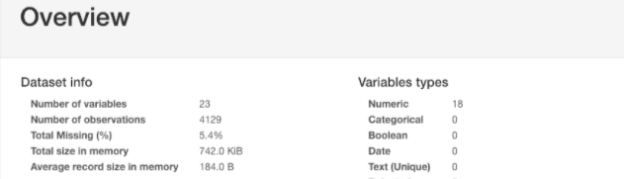

Important variables take part in stress calculation:
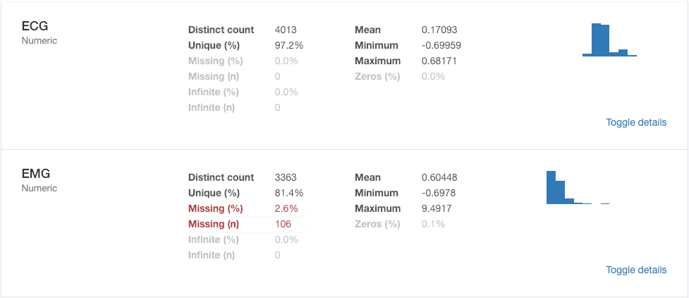
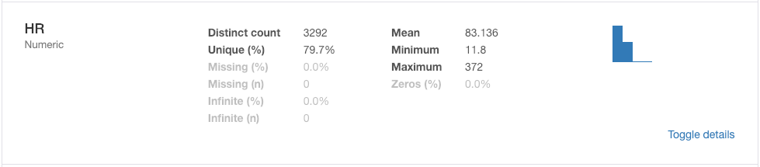
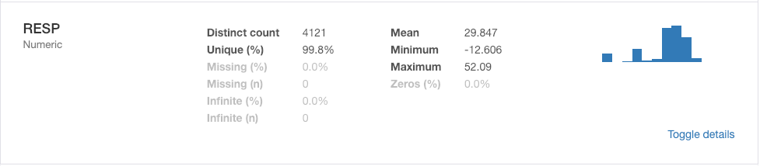
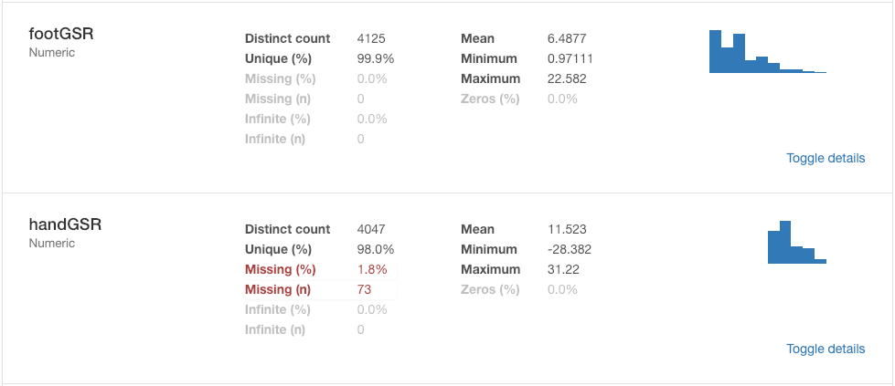
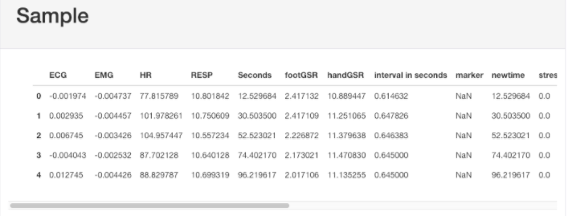

- Proposed system:
In proposed system, the data had been manipulated to get the variables on which the stress level is more dependent and also to decrease the size of dataset. As the original dataset contain 4129 rows and 23 columns out of which only 329 rows contain distinct stress level value. If we clearly see all out of 23 columns only 6 columns are most important i.e. ECG, EMG, HR, RESP, footGSR and handGSR.
After making a better dataset, I taken HR, RESP and handGSR as an input variables because ANFIS model takes a lot of time to run using all six variables; and output as ‘stress’ columns. Then, I use the adaptive neuro-fuzzy inference system (ANFIS) in order to train my system because ANFIS is adaptive in nature.
I have taken three membership function of guassmf for each variable. All this three MF cover the whole space equally as you can see below all three figures of membership functions:
- Membership function for HR(heart rate)
- Membership function for RESP(Respiration rate)
- Membership function for handGSR(Galvanic Skin Response for the hands)

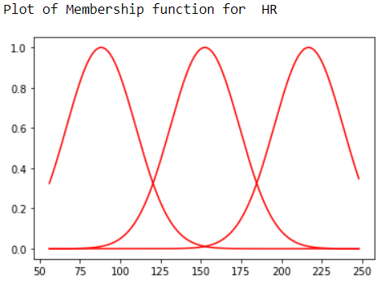

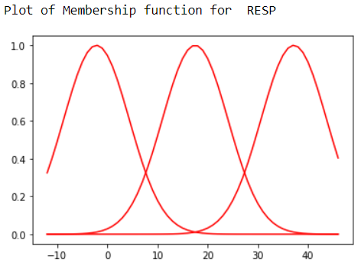
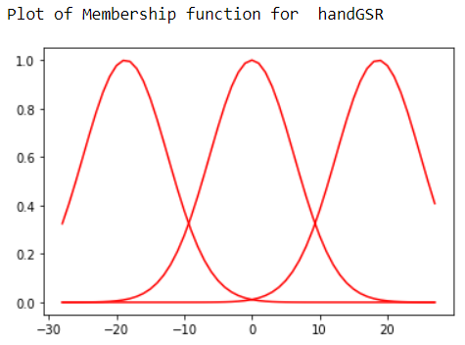

- ANFIS Model:
An integrating technique comprising of neural network and fuzzy logic called adaptive neuro-fuzzy inference system is used as a principal tool in the proposed method. Using this technique, first fuzzy system is built using the fuzzy rules extracted from the training data. Then ANFIS model is designed by tuning the rules of fuzzy system using neural network. Here, Sugeno based ANFIS system is implemented to compute the results.
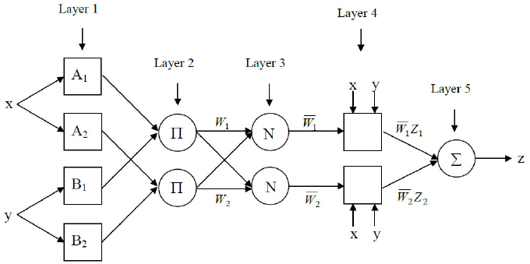
The different layers of this structure are discussed below:
Layer 1: The number of neurons at this layer is equal to the number of input variables i.e. 3 correspond to HR, RESP and handGSR.
Layer 2: In the proposed model, three membership functions are assigned to each input variable. Thus, total number of neurons is 3+3+3=9.
Layer 3: It consists of fuzzy rules which change with training of the model.
Layer 4: The number of neurons in this layer is equal to the number of membership functions used for output variable.
Layer 5: This layer consists of only one fixed node that computes the overall output as the summation of all incoming signals i.e. stress level between 0 to 1.

Results and Discussion:

If I take number of rows in modified dataset above 50 then training of ANFIS model will be correct. I have taken the rows which are distinct out of 4129 rows due to which ANFIS model is not fully training when I take it below 329 distinct rows. For example, when number of rows is equal to 200, the training of the model going right and you also can see graphs of error and result. From the figure, we can found out that as number of epoch’s increases, the decreasing error rate also increases.

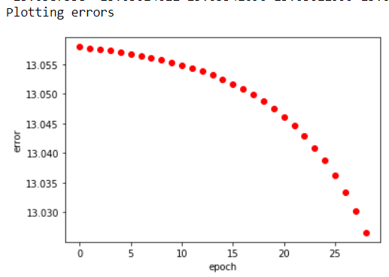
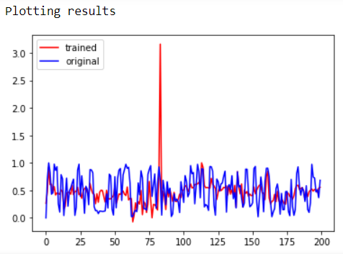

Conclusion:

From the findings, the results clearly show that youth are stressed toward high level. The symptoms identified are being eating, depression and headaches are more among students. It is identified that among all factors, the main causes of stress among youth is relationship stress, financial and psychological stress. They want to maintain the social network and they are increasing the networking with the use of technology. The next stress they are feeling is career related. They have fear of job opportunity and how they survive in the competitive environment. Young respondents were able to identify some strategies to cope with stress such as meditation, enough sleeping, going out with the friends and counseling.

References:

- Article: A Study of Causes of Stress and Stress Management among Youth July 2018 IRA-International Journal of Management & Social Sciences (ISSN 2455-2267)
- A project at MIT by Healey as a part of her PhD thesis
- chriotte/Stress_classifier_with_AutoML_and_wearable_devices github

