Advanced Stats - Bank Swallow Movement

2023-04-24

## BIO8940 Final Project

### Bank swallow movements to roosting habitat

### By: Manon Veselovsky - 8259387

## Introduction:

##### Various animals across taxa are known to form aggregate groups during their lifecycle ((**Bednekoff2003?**)). This phenomenon can become problematic when faced with habitat modification if this alters the suitable habitat where this clustering behaviour is centered. For example, during the winter, the eastern migratory monarch butterfly population forms a single roosting colony of millions of individuals in a very small region of oyamel forest in Mexico. While many factors contribute to declining monarch butterfly populations, one of the most concerning is the illegal logging of the oyamel forests which provide this rare roosting habitat for monarchs ((**Flores-Martinez2019?**)). Unfortunately, habitat alteration and loss is only projected to increase as human infrastructure expands, which will likely continue to threaten certain habitats. For conservation of species to be effective, it is important to understand the degree to which threatened habitats are being used by threatened species.

##### One highly threatened species whose aggregation ecology requires greater study is the bank swallow (*Riparia riparia*). Bank swallow populations in Canada are estimated to have declined by 98% since the 1980s ((**Saldanha2019?**)). Currently, the threatened status of these birds in Ontario means that 50 m surrounding their breeding colonies must be protected from alteration (Bank Swallow General Habitat Description | Ontario.Ca, n.d.). However, it has been discovered that bank swallows not only form aggregate groups in breeding colonies, but also congregate at night to roost in wetlands around their colonies ((**Falconer2016?**)). Unfortunately, the use of wetlands at night by these birds has not been taken into consideration in their habitat protection plan due to the recent discovery of this phenomenon. Much remains unknown about the movement ecology of these birds, and studies must be conducted to evaluate their use of wetlands to inform recovery strategies. Currently, we have limited data on the proportion of nights bank swallows use wetland roosts during the breeding period. Preliminary studies indicate that bank swallow roosting behaviour is negatively associated with night time light availability, and that males utilize wetland roosts more than females during the early breeding period ((**Falconer2016?**); (**Saldanha2019?**)). Unfortunately, these evaluations have only been conducted on a small number of individuals, limiting the conclusions that can be drawn on overall patterns. For recovery plans to be effective it is important to identify the degree to which bank swallows are roosting in wetlands and determine what conditions may modify this roosting behaviour.

##### In this paper, I will use a database of 52 bank swallows observed on 49 nights to explore bank swallow roosting behaviour. The results of this paper will show how often bank swallows are using major wetlands to roost and what factors affect their use of wetlands for roosting. If bank swallow individuals have a high probability of using wetland roosts each night, then wetlands are likely an important habitat for these birds. Additionally, if bank swallows show significant drop offs in use of wetlands with increasing distance from their colony, then wetlands in close proximity to colonies may need to be prioritized for protection in order to help the recovery of bank swallow populations.

##### While a hypothesis cannot be tested with this data and our current state of knowledge, predictions can be made. Firstly, based on the tentative results of previous studies, I predict that nighttime light availibility will negatively affect roosting probability. Secondly, I predict that males will use wetland roosts proportionately more in the early breeding period than females. Apart from this, I will explore new variables as predictors of the probability of using wetland roosts.

## Methods:

##### In summer 2015, 52 bank swallows were captured, sexed, and tagged at breeding colonies along the shore of Lake Erie and in sand and gravel pits near Long Point, Ontario. Automated radio telemetry systems were also installed at each colony and throughout the Long Point wetland complex. Between June 2nd and July 21st, 2015, tagged birds were tracked for movement between their colony and the main wetland complex. These data were then visually analyzed and a “roost” success value was assigned to each bird’s evening movement. Birds that were detected in the wetland complex in the late evening and early the following morning were assigned a roost value of 1 as they stayed at the wetland overnight (roosted). Birds that were detected at their colony in the late evening and early the following morning were assigned a roosting value of 0 as they did not leave the colony (did not roost). Any nights where birds were not detected in the same location both in the morning and the evening were removed from the dataset (*from my understanding). The distance and ordinal date of the roosting movement were also recorded. Distance was calculated as the distance from the colony to the mean location of the wetland complex at Long Point.

##### I also collected environmental variables using the package RNCEP. The time and location of birds in the evening were used with this package to determine the evening’s wind component vectors (N/S and E/W), the illumated proportion of the moon (1 being full moon, 0 being new moon), and the percentage cloud cover. A study in New Brunswick indicated that light availability (a combination of moon illumination and cloud cover) affected the roosting movement behaviour of bank swallows ((**Saldanha2019?**)). Consequently, I multiplied the proportion of moon illumination with the proportion of open sky (1 - proportion of cloud cover) to get the light availability at the time of bird detection. Finally, the degree of flow assistance (tailwind) was determined using the RNCEP function NCEP.Tailwind(). Using the north-south and east-west wind components on the evening of observation, and the direction from the bird’s colony to the mean wetland location, the airflow assistance for that direction of travel was determined. The resulting tailwind variable takes into account wind speed in the direction of the bird’s travel but yields a unitless value. Negative values represent airflow against the animal’s direction of travel and positive values represent airflow in the animal’s direction of travel.

### Statistical Methods:

##### I fit a generalized linear mixed effects model using a binomial distribution to determine which factors affect the probability of a bank swallow roosting overnight at the wetland (1), or whether it stays at the colony (0). I included distance, nighttime illumination, tailwind, ordinal date, sex of the individual, and the interaction of sex and ordinal date as fixed predictors. I also included the random variable of individual ID nested within colony, as individuals were only part of one breeding colony for the duration of monitoring, and roosting observations on different nights were on the same 52 individuals.

################### SECTION 1.4 MODEL BUILDING AND DIAGNOSTIC PLOTS ####################  
# Model of roost probability, using the scaled and centered values for distance,   
m = glmer(roost ~ distance + sex + ordinal_date + sex:ordinal_date + illum + tailwind + (1|colony/id), data=df.scale, family="binomial")

## Results:

### Diagnostic plots

##### First, I will examine the normality of the residuals from the random variables and the collinearity of fixed predictors (VIF values) using the performance package check_model() function.

##### Unfortunately, the display of the check_model() results do not seem to knit to documents properly outside R. Results show all VIF values are all below 3 indicating my fixed effects do not suffer from collinearity. Normality of the random effects also appears fine with no significant deviations from the plotted line (I will double check this with another plot below).

##### Next, I will examine the dispersion of the residuals for the overall model. This will be done using the DHARMa package.

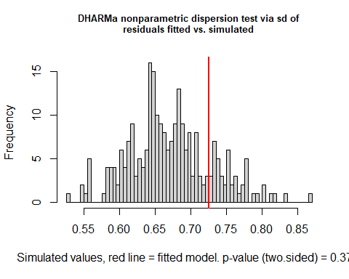

##   
## DHARMa nonparametric dispersion test via sd of residuals fitted vs.  
## simulated  
##   
## data: simulationOutput  
## dispersion = 1.0819, p-value = 0.376  
## alternative hypothesis: two.sided

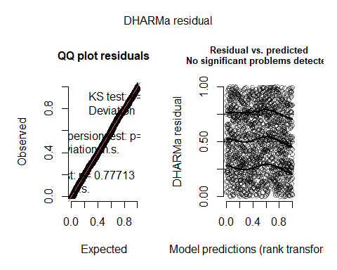 ##### There do not appear to be any problems in the overall model residuals. There are no significant deviations from the QQ line, no significant patterns in the residuals vs predicted plot, and the distribution of the simulated residuals versus fitted residuals does not show any issues. However, the overall residuals do not provide a full assessment for binomial models. I will assess model fit and check for under or overdispersion of residuals for each predictor.

plotResiduals(dharm_output, form=df.scale$distance) #some problem with model fit due to pattern in the residuals but not terrible, indicates possible non-linear relationship with distance

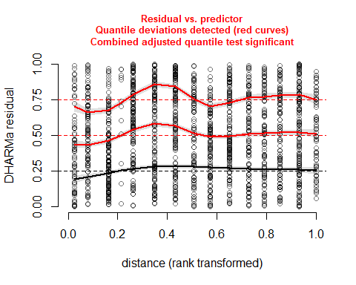 ##### There appear to be some issues in the residuals here, but it is not too problematic. A pattern would indicate a non-linear relationship with distance (and require a transformation), but I am not sure a particular pattern is evident. For good measure, I did try some transformations but none increased the suitability of the model fit, and many failed to converge. Overall, I believe the fit is not overly concerning.

##### I will continue with the evaluations of the residuals for the other predictors below.

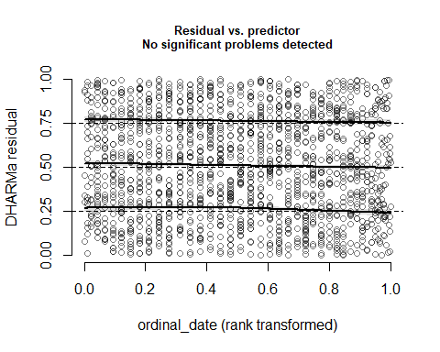 ##### Ordinal date appears to be fine, with no patterns or evidence of over or under dispersion.

## Warning in ensurePredictor(simulationOutput, form): DHARMa:::ensurePredictor:  
## character string was provided as predictor. DHARMa has converted to factor  
## automatically. To remove this warning, please convert to factor before  
## attempting to plot with DHARMa.

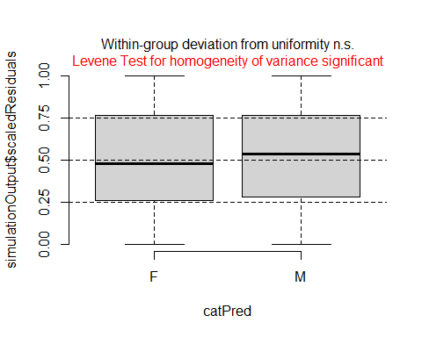 ##### Sex also appears to be fine.

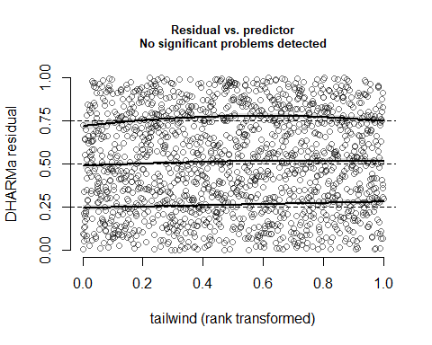 ##### Tailwind also appears to be fine.

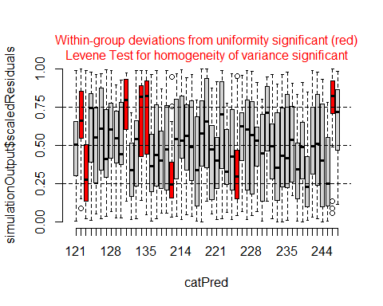

## Warning in ensurePredictor(simulationOutput, form): DHARMa:::ensurePredictor:  
## character string was provided as predictor. DHARMa has converted to factor  
## automatically. To remove this warning, please convert to factor before  
## attempting to plot with DHARMa.

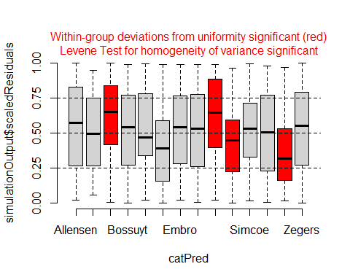 ##### There are some issues in the random effects here but they do not appear too bad. Documentation on how to evaluate these issues is scarce. I will check the QQ plot for normality of the random effects more closely.

r5 = as.data.frame(ranef(m))  
ggplot(data = r5, aes(sample = condval)) +  
 geom_qq() + geom_qq_line() +  
 facet_wrap(~ grpvar) +  
 theme_classic()

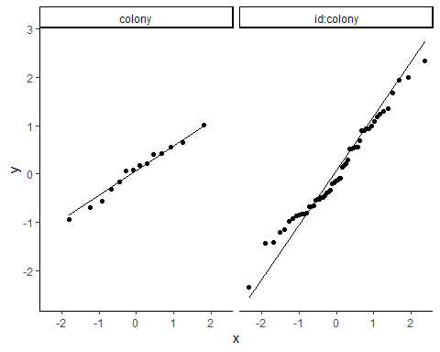 ##### Normality of the random effects here looks good as the points roughly follow the QQ line. Overall, I believe the assumption of normality of residuals for each variable has been met. This, coupled with the fact that there is no collinearity between my predictors and no significant differences between simulated and observed residuals, allow me to feel confident in evaluating the effects of my model.

### Model effects

## Generalized linear mixed model fit by maximum likelihood (Laplace  
## Approximation) [glmerMod]  
## Family: binomial ( logit )  
## Formula: roost ~ distance + sex + ordinal_date + sex:ordinal_date + illum +   
## tailwind + (1 | colony/id)  
## Data: df.scale  
##   
## AIC BIC logLik deviance df.resid   
## 1062.4 1110.6 -522.2 1044.4 1570   
##   
## Scaled residuals:   
## Min 1Q Median 3Q Max   
## -12.0398 -0.3228 -0.1198 0.1719 16.8109   
##   
## Random effects:  
## Groups Name Variance Std.Dev.  
## id:colony (Intercept) 1.670 1.2921   
## colony (Intercept) 0.615 0.7842   
## Number of obs: 1579, groups: id:colony, 54; colony, 14  
##   
## Fixed effects:  
## Estimate Std. Error z value Pr(>|z|)   
## (Intercept) -2.498347 0.385736 -6.477 9.37e-11 ***  
## distance -2.044346 0.316968 -6.450 1.12e-10 ***  
## sexM 0.725066 0.431201 1.682 0.09266 .   
## ordinal_date 1.646245 0.161120 10.217 < 2e-16 ***  
## illum -0.003349 0.003224 -1.039 0.29896   
## tailwind 0.243765 0.085270 2.859 0.00425 **   
## sexM:ordinal_date -0.456073 0.207821 -2.195 0.02820 *   
## ---  
## Signif. codes: 0 '***' 0.001 '**' 0.01 '*' 0.05 '.' 0.1 ' ' 1  
##   
## Correlation of Fixed Effects:  
## (Intr) distnc sexM ordnl_ illum talwnd  
## distance 0.216   
## sexM -0.518 -0.068   
## ordinal_dat -0.165 -0.174 0.119   
## illum -0.205 -0.022 -0.014 -0.130   
## tailwind -0.029 -0.047 0.007 0.071 -0.023   
## sxM:rdnl_dt 0.106 0.058 -0.127 -0.724 0.005 -0.010

##### There is a significant relationship with each variable except for the nighttime illumination % (illum). Because of the log link function for binomial variables, interpretation of these raw estimates is not clear. Thus, I will focus on the back-transformed effects plots on the observed scale.

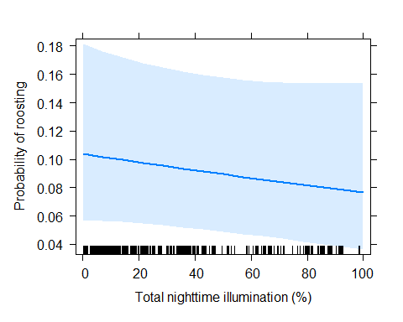 ##### Looking at the effect plot for illum, there is only a slight negative relationship between illumination and the probability of roosting at a wetland. Indeed, 0% illumination estimated to have a mean estimate of ~10.5% of birds roosting, and 100% illumination having a mean estimate of 8% of birds roosting. However, the confidence interval does contain potential effects which could be biologically significant - anywhere from a decreasing relationship of 18% to 4% roosting rate with illumination, or an increasing relationship of 6% to 16% with illumination. Because of this I cannot definitively conclude that there is no relationship between roosting rate/probability and nighttime illumination (as these differences would be biologically significant). However, it is unlikely that this is an overall important relationship given the sample size here. ##### Now I call my plot showing the relationship between distance to the wetland roost and the probability of roosting.

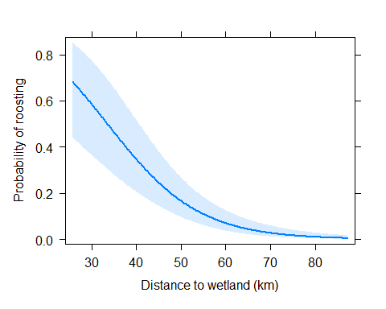

##### Here, we can see that the distance from the colony to the wetland site has a significant effect on whether the wetland roost will be used. If the wetland habitat is within 30 km (25.62 km being the closest in my dataset), bank swallows are estimated to roost anywhere from ~45%-85% (mean estimate ~60%) of the time. There is a significant drop in roosting probability with distance to the wetland (p=1.12*10-e). At 50 km, only 15% of bank swallows will travel to the wetland to roost (with 95% confidence interval maximum being ~25%). Beyond this distance, the wetland starts to be used <20% of the time, or less than half the probability of close wetlands.

##### I will continue with my exploration of effects with the interaction of sex and the ordinal date.

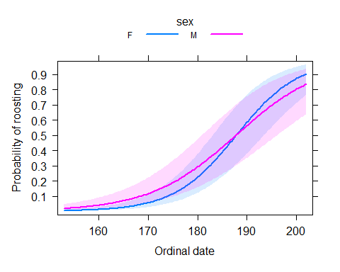

##### Here we can see the effect of the interaction sex and ordinal date. During the early breeding season period, males are estimated to use wetlands to roost proportionately more than females. For example, at ordinal date 170, males appear to be using wetlands about twice as much as females (mean estimate of ~10% males roosting versus ~5% of females).

##### Later in the season it appears that the relationship to ordinal date changes for males and females. Around ordinal date 188, we begin to see females utilizing wetland roosts more than males. By ordinal date 200, females are ~8% more likely to roost than males, although the rate for males is already quite high at ~83%. While the overall interaction between sex and ordinal date is significant (p = 0.028), it should be noted that there are no clear points of separation between the 95% CIs of the two sexes. More individuals would likely be needed to get clear separation of these CIs.

##### Overall, for both males and females, there is a positive relationship between ordinal date and the probability of roosting. The early breeding season, ordinal date 160 to 170, sees very low use of roosting sites (<10% probability). At ordinal date 180 we begin to see a sharp increase in overall roost use by both sexes, going from ~20% probability at ordinal date 180 to ~60% at ordinal date 190. By ordinal date 200, the probability of using wetland roosts increases to 80%-90%.

### Next, I will look at the effect of tailwind.

#get predicted y values for tailwind on the scaled tailwind values  
predict_tw = predictorEffect("tailwind",m, focal.levels=100,xlevels=1)  
  
#convert tailwind values back to the un-scaled, un-centered form  
predict_tw$x$tailwind = predict_tw$x$tailwind*scaleList_tw$scale + scaleList_tw$center  
  
#plot the data (rescale.axis = F prevents it from changing the spacing between the y-tick marks to make the relationship appear linear)  
plot(predict_tw,rescale.axis=F,main="", ylab="Probability of roosting",xlab="Tailwind flow assistance",xlim=c(-3,3))

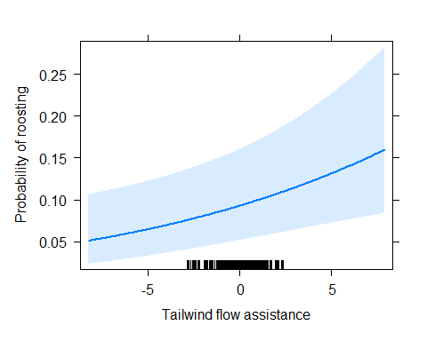 ##### Here it can be seen that the degree of tailwind has a positive effect on the probability of roosting for the bank swallow. From lowest tailwind (-ve flow assistance) to high tailwind (+ve flow assistance), the mean probability of using wetland roost goes from ~5% to ~16%, increasing to more than 3x the original probability. However, it is important to note that the CI for this estimate is quite wide. ##### Finally, I will look at variation in the random effects.

## Generalized linear mixed model fit by maximum likelihood (Laplace  
## Approximation) [glmerMod]  
## Family: binomial ( logit )  
## Formula: roost ~ distance + sex + ordinal_date + sex:ordinal_date + illum +   
## tailwind + (1 | colony/id)  
## Data: df.scale  
##   
## AIC BIC logLik deviance df.resid   
## 1062.4 1110.6 -522.2 1044.4 1570   
##   
## Scaled residuals:   
## Min 1Q Median 3Q Max   
## -12.0398 -0.3228 -0.1198 0.1719 16.8109   
##   
## Random effects:  
## Groups Name Variance Std.Dev.  
## id:colony (Intercept) 1.670 1.2921   
## colony (Intercept) 0.615 0.7842   
## Number of obs: 1579, groups: id:colony, 54; colony, 14  
##   
## Fixed effects:  
## Estimate Std. Error z value Pr(>|z|)   
## (Intercept) -2.498347 0.385736 -6.477 9.37e-11 ***  
## distance -2.044346 0.316968 -6.450 1.12e-10 ***  
## sexM 0.725066 0.431201 1.682 0.09266 .   
## ordinal_date 1.646245 0.161120 10.217 < 2e-16 ***  
## illum -0.003349 0.003224 -1.039 0.29896   
## tailwind 0.243765 0.085270 2.859 0.00425 **   
## sexM:ordinal_date -0.456073 0.207821 -2.195 0.02820 *   
## ---  
## Signif. codes: 0 '***' 0.001 '**' 0.01 '*' 0.05 '.' 0.1 ' ' 1  
##   
## Correlation of Fixed Effects:  
## (Intr) distnc sexM ordnl_ illum talwnd  
## distance 0.216   
## sexM -0.518 -0.068   
## ordinal_dat -0.165 -0.174 0.119   
## illum -0.205 -0.022 -0.014 -0.130   
## tailwind -0.029 -0.047 0.007 0.071 -0.023   
## sxM:rdnl_dt 0.106 0.058 -0.127 -0.724 0.005 -0.010

## grpvar term grp condval   
## Length:68 (Intercept):68 123:Allensen : 1 Min. :-2.34709   
## Class :character 223:Simcoe : 1 1st Qu.:-0.59104   
## Mode :character 129:Crosby : 1 Median :-0.08522   
## 212:Waterford: 1 Mean : 0.04814   
## 239:Cultus : 1 3rd Qu.: 0.57996   
## 237:Kingswood: 1 Max. : 2.34602   
## (Other) :62   
## condsd   
## Min. :0.4743   
## 1st Qu.:0.6105   
## Median :0.6594   
## Mean :0.7376   
## 3rd Qu.:0.8515   
## Max. :1.2216   
##

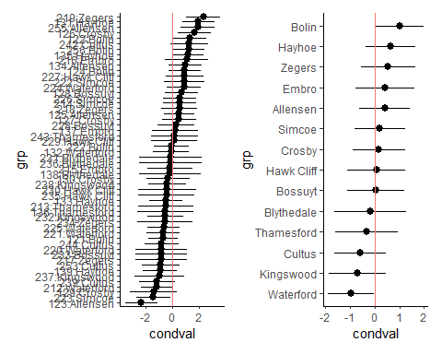 ##### Here we can see that individuals do vary in their use of wetlands for overnight roosting. Colonies do not show as strong a variation in roosting behaviour.

## Discussion:

##### Overall, my results yield some new insight into bank swallow roosting behaviour and confirm some patterns of smaller studies. Firstly, the probability of roosting at the main wetland complex in Long Point did vary significantly with distance from the colony. Birds in colonies close to the wetland complex (25 km) had a mean probability of roosting at the Long Point wetland of 70%, while colonies 50 km away had an estimated probability of ~15% use. If there are positive fitness effects for birds that roost at night, then proximity of suitable roosting habitat could be an important consideration for conservation of these birds. The hypothesis that wetland roosts positively affect fitness of adults by reducing predation risk would be an important next step for conservation assessment. However, it is important to note that my data does not evaluate birds that did not stay at the colony or go to the main wetland complex at Long Point. If a bird left the colony for the night but was not detected at Long Point, my understanding is that it was discarded from this dataset. Unfortunately, as of the time of submission I was unable to confirm with the individual that performed this process if my understanding is correct. If correct, then it is possible these birds were utilizing roosts other than the main wetland complex around the 50 km range. This would lower the confidence in the estimate for how little birds are using wetland roosts at higher distances, as they could just have more habitats available along the 50km radius surrounding their colony than wetlands within a 25 km radius for those close to Long Point. While I am sure there is a relationship between distance to wetland from the colony and roosting probability, it may not be as strong as the one I found here. This would reduce the need to preserve wetland habitat close to the colony.

##### I also found that tailwind to roost site has a significant effect on the probability of roosting for bank swallows. A direct headwind is associated with a mean probability estimate of roosting at 5%, while a direct tailwind increases the mean probability estimate of roosting 3x to 16%. Future observational studies on roosting probability should take into account the wind vector to control for noise in the observed data.

##### Finally, my study both confirmed and failed to confirm predictors of roosting found by previous studies. For total nighttime illumination, I did not find a significant effect on probability of roosting. Illumination in my study did show a negative effect but it was estimated to be only a 2.5% mean difference across the entire range of illumination, from 100% cloud cover and new moon to no cloud cover full moon. In contrast, I did confirm differential roosting probabilities between males and females. Males had an estimated 2x the probability of females to roost in the early breeding period. Additionally, I found that males and females seem to swap relative roost probability in the late breeding period, with females becoming more likely to roost than males. However, this phenomenon of female roosting probability exceeding male roosting probability was dwarfed by the overall trend across both sexes. In the late season, both sexes exhibited 80%-90% probability of roosting in wetlands. This high use of wetlands in the late season indicates that wetlands could be extremely important to the ecology of bank swallows. Again, if the hypothesis that wetlands provide safety from predation is proven, this high use of wetlands by these birds would mean they are of critical importance for bank swallows, especially considering that less than 10% of total wetland habitats in southern Ontario remain of those pre-industrial revolution. The evidence that individuals vary significantly in their use of wetlands as roosts indicates that a test of the predation hypothesis is possible. I suggest this as the next step in evaluating the roosting behaviour of bank swallows.