Supporting Information
Article title: Phenotypic plasticity and genetic adaptation of functional traits influences intra-specific variation in hydrological efficiency and safety
Authors: Carola Pritzkow*, Virginia Williamson, Christopher Szota, Raphaël Trouvé, Stefan K. Arndt
Figure S1 Relationship between climate parameters and elevation along the precipitation gradient.
Figure S2: Leaf hydraulic vulnerability for all E. obliqua populations grown in the field and nursery.
Figure S3: Relationship between P₅₀ and maximum leaf conductivity and for all five E. obliqua populations in the field and nursery.
Table S1 Trait means (± standard error) of 8-months old seedlings grown from Eucalyptus obliqua populations
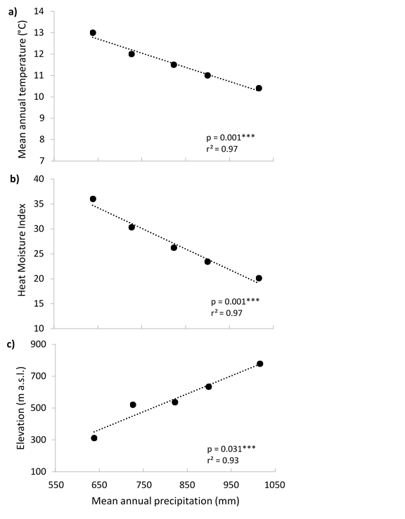
Figure S1 Relationship between climate parameters and elevation along the precipitation gradient. High correlation of (a) mean annual temperature, (b) heat moisture index and (c) elevation (meters above sea level) with mean annual precipitation at origin. Significance levels are derived from one-way ANOVA.
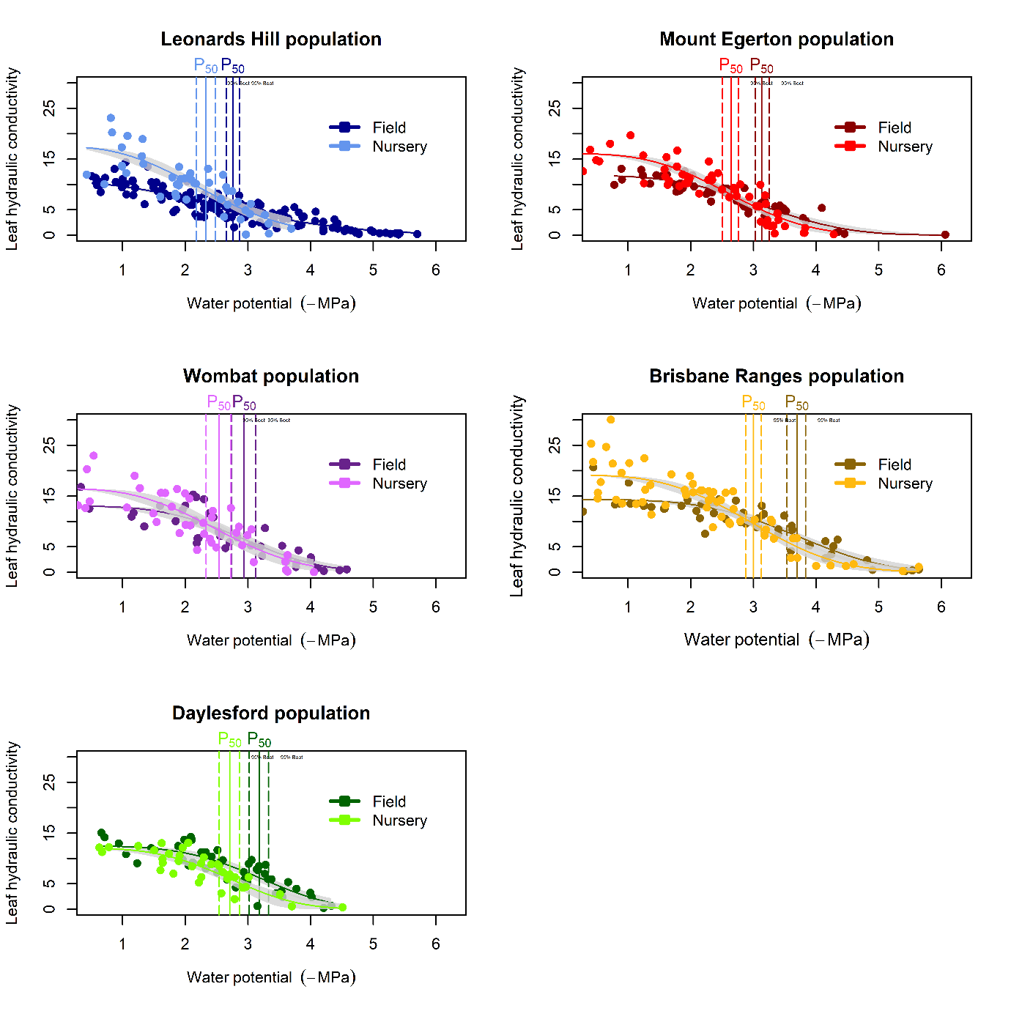
Figure S2: Leaf hydraulic vulnerability for all E. obliqua populations grown in the field and nursery. The darker colour in each subfigure represents the leaf vulnerability of the mature field population and the lighter colour represents the leaf vulnerability of the 8-months old seedlings grown in the nursery. Here, Leonards Hill is the wettest population (1016 mm MAP), followed by Wombat (899 mm MAP), Daylesford (822 mm MAP), Mount Egerton (726 mm MAP) and Brisbane Ranges (638 mm MAP). Individual measurements (circles), Weibull fit (line) with confidence interval (shaded area) and P₅₀ (vertical solid line) with bootstrapped confidence interval (vertical dotted lines) are given for each leaf hydraulic vulnerability curve.

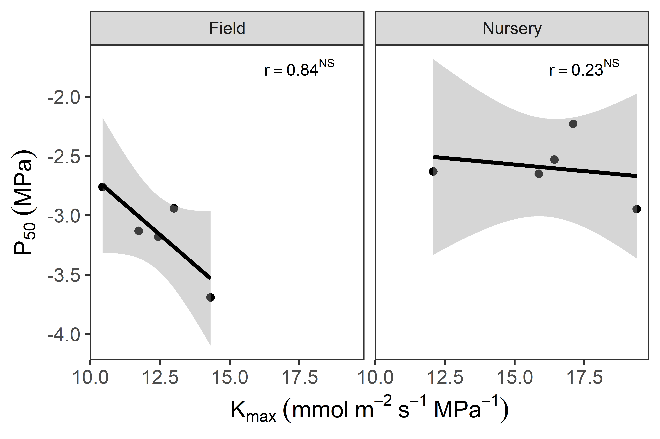
Figure S3: Relationship between P₅₀ and maximum leaf conductivity and for all five E. obliqua populations in the field and nursery. Population mean trait values (circles), linear regressions (black line) with 95% confidence interval (shaded area), correlation coefficients (r), with significance level indicated as *** P < 0.001; ** P < 0.01; * P < 0.05; ns P > 0.05 are given.

Table S1: Physiological, morphological and leaf anatomical functional trait means (± standard error) of 8-months old seedlings grown from five Eucalyptus obliqua populations from seed along a rainfall gradient. Letters indicate significant difference between populations (Tukey post hoc test, n=18-41).

Population | Ψ_{TLP} | P₅₀ | P₈₈ | LA | SLA | HV | K_{max} | Wall | D_{h}
BR | -1.70 (0.04) a | -2.95 (0.21) a | -4.19 (0.25) a | 29.39 (0.78) a | 56.99 (1.14) a | 2.09 (0.14) a | 2.76 (0.04) a | 2.44 (0.03) a | 2.50 (0.04) a
ME | -1.69 (0.04) a | -2.65 (0.06) ab | -3.69 (0.18) ab | 35.31 (0.87) bc | 70.27 (1.53) b | 1.90 (0.15) a | 2.68 (0.09) ab | 2.23 (0.03) b | 2.64 (0.06) ab
DF | -1.50 (0.07) a | -2.63 (0.08) ab | -3.59 (0.18) ab | 32.37 (0.96) ac | 78.98 (2.58) b | 2.77 (0.26) a | 3.01 (0.09) b | 2.06 (0.03) c | 2.65 (0.06) b
WO | -1.68 (0.05) a | -2.53 (0.12) ab | -3.58 (0.26) ab | 37.68 (0.86) bd | 62.64 (1.05) a | 2.10 (0.22) a | 2.70 (0.09) ab | 2.19 (0.03) bc | 2.67 (0.06) a
LH | -1.62 (0.11) a | -2.23 (0.14) b | -3.14 (0.19) b | 39.46 (1.04) d | 76.60 (3.57) b | 2.53 (0.21) a | 2.58 (0.09) ab | 2.19 (0.03) b | 2.58 (0.06) ab
Traits: Ψ_{TLP}: water potential at turgor loss point, P₅₀: loss of 50% hydraulic conductivity, P₈₈: loss of 88% hydraulic conductivity, LA: leaf area, SLA: specific leaf area, HV: Huber Value, K_{max}: maximum hydraulic conductivity, Wall: double wall thickness, D_{h}: hydraulic weighted vessel diameter

