NectarExperiment_SummaryRMarkdown

2023-01-19

## R Markdown Nectar Experiment Analysis Script

### Writen by Manon Veselovsky

#### create separate working databases for greenhouse and field experiments

GH_data = subset(summarydat, summarydat$ExpLoc == "GH")  
Field_data = subset(summarydat,summarydat$ExpLoc == "Field")

## Data Analysis

### Greenhouse

#### Check the weights on day 7 of trial for normality

## `stat_bin()` using `bins = 30`. Pick better value with `binwidth`.

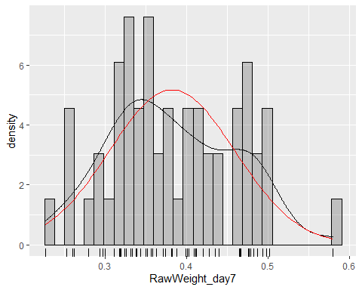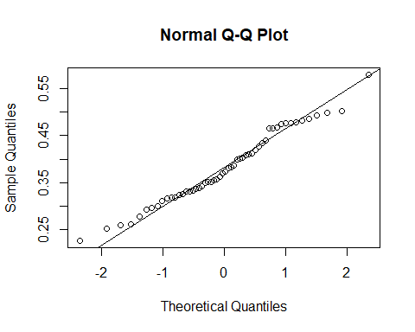

##   
## Shapiro-Wilk normality test  
##   
## data: GH_data$RawWeight_day7  
## W = 0.97657, p-value = 0.3677

#### Create full model for the raw weight of greenhouse butterflies on day 7 of trial as a function of experimental variables

lmer.model = lmer(RawWeight_day7~ Plant + Sex + ForewingLength + EmergDate + Cohort + EnclCol + (1|Couple), data=GH_data)  
Anova(lmer.model, type=3)

## Analysis of Deviance Table (Type III Wald chisquare tests)  
##   
## Response: RawWeight_day7  
## Chisq Df Pr(>Chisq)   
## (Intercept) 1.7318 1 0.188176   
## Plant 17.1591 5 0.004208 **   
## Sex 3.4454 1 0.063427 .   
## ForewingLength 33.9783 1 5.573e-09 ***  
## EmergDate 0.7616 1 0.382839   
## Cohort 0.5777 1 0.447216   
## EnclCol 5.8144 1 0.015895 *   
## ---  
## Signif. codes: 0 '***' 0.001 '**' 0.01 '*' 0.05 '.' 0.1 ' ' 1

#### Check for collinearity between variables and check model assumptions

##### Reduce model, removing least significant terms

#test to see if more complex model is significantly better  
anova(reduced_1, lmer.model) #more complex not significantly better, leave cohort out

## refitting model(s) with ML (instead of REML)

## Data: GH_data  
## Models:  
## reduced_1: RawWeight_day7 ~ Plant + Sex + ForewingLength + EmergDate + EnclCol + (1 | Couple)  
## lmer.model: RawWeight_day7 ~ Plant + Sex + ForewingLength + EmergDate + Cohort + EnclCol + (1 | Couple)  
## npar AIC BIC logLik deviance Chisq Df Pr(>Chisq)  
## reduced_1 12 -115.44 -94.874 69.718 -139.44   
## lmer.model 13 -114.59 -92.315 70.296 -140.59 1.1552 1 0.2825

Anova(reduced_1, type=3) #next least significant term is EmergDate

## Analysis of Deviance Table (Type III Wald chisquare tests)  
##   
## Response: RawWeight_day7  
## Chisq Df Pr(>Chisq)   
## (Intercept) 0.8066 1 0.369137   
## Plant 19.4625 5 0.001576 **   
## Sex 4.6995 1 0.030172 *   
## ForewingLength 38.7226 1 4.885e-10 ***  
## EmergDate 0.0812 1 0.775678   
## EnclCol 6.2134 1 0.012679 *   
## ---  
## Signif. codes: 0 '***' 0.001 '**' 0.01 '*' 0.05 '.' 0.1 ' ' 1

#test to see if more complex is significantly better  
anova(reduced_2, reduced_1) #more complex not significantly better, leave EmergDate out

## refitting model(s) with ML (instead of REML)

## Data: GH_data  
## Models:  
## reduced_2: RawWeight_day7 ~ Plant + Sex + ForewingLength + EnclCol + (1 | Couple)  
## reduced_1: RawWeight_day7 ~ Plant + Sex + ForewingLength + EmergDate + EnclCol + (1 | Couple)  
## npar AIC BIC logLik deviance Chisq Df Pr(>Chisq)  
## reduced_2 11 -117.20 -98.355 69.602 -139.21   
## reduced_1 12 -115.44 -94.874 69.718 -139.44 0.232 1 0.63

Anova(reduced_2, type=3) #next least significant is EnclCol

## Analysis of Deviance Table (Type III Wald chisquare tests)  
##   
## Response: RawWeight_day7  
## Chisq Df Pr(>Chisq)   
## (Intercept) 20.5259 1 5.883e-06 ***  
## Plant 22.1797 5 0.000484 ***  
## Sex 6.6974 1 0.009656 **   
## ForewingLength 43.0838 1 5.244e-11 ***  
## EnclCol 6.1585 1 0.013078 *   
## ---  
## Signif. codes: 0 '***' 0.001 '**' 0.01 '*' 0.05 '.' 0.1 ' ' 1

#test to see if reduced is significantly better  
anova(reduced_3, reduced_2) #more complex is significantly better, keep reduced_2

## refitting model(s) with ML (instead of REML)

## Data: GH_data  
## Models:  
## reduced_3: RawWeight_day7 ~ Plant + Sex + ForewingLength + (1 | Couple)  
## reduced_2: RawWeight_day7 ~ Plant + Sex + ForewingLength + EnclCol + (1 | Couple)  
## npar AIC BIC logLik deviance Chisq Df Pr(>Chisq)   
## reduced_3 10 -112.02 -94.887 66.011 -132.02   
## reduced_2 11 -117.20 -98.355 69.602 -139.21 7.1822 1 0.007363 **  
## ---  
## Signif. codes: 0 '***' 0.001 '**' 0.01 '*' 0.05 '.' 0.1 ' ' 1

bestmodel = reduced_2 #assign best model and display its effects plot

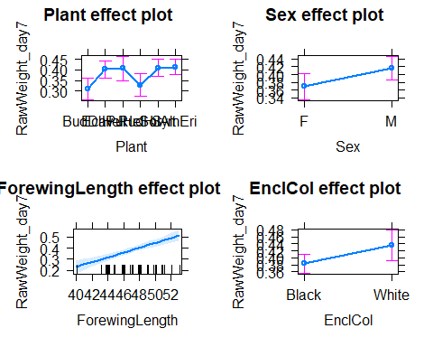

Effects plot of the best model

#### Multiple comparisons test to detect differences between plant treatment groups

m1<-bestmodel  
library(multcomp)  
#WHICH groups are different from each other  
g<-glht(m1, mcp(Plant="Tukey")); confint(g)

##   
## Simultaneous Confidence Intervals  
##   
## Multiple Comparisons of Means: Tukey Contrasts  
##   
##   
## Fit: lmer(formula = RawWeight_day7 ~ Plant + Sex + ForewingLength +   
## EnclCol + (1 | Couple), data = GH_data)  
##   
## Quantile = 2.8348  
## 95% family-wise confidence level  
##   
##   
## Linear Hypotheses:  
## Estimate lwr upr   
## EchPur - BudDav == 0 0.091831 0.012530 0.171133  
## HelHel - BudDav == 0 0.094803 -0.010163 0.199770  
## RudHir - BudDav == 0 0.017550 -0.077880 0.112980  
## SolAlt - BudDav == 0 0.097580 0.014803 0.180357  
## SymEri - BudDav == 0 0.101267 0.025284 0.177249  
## HelHel - EchPur == 0 0.002972 -0.088770 0.094714  
## RudHir - EchPur == 0 -0.074281 -0.161262 0.012700  
## SolAlt - EchPur == 0 0.005749 -0.063632 0.075129  
## SymEri - EchPur == 0 0.009435 -0.054211 0.073082  
## RudHir - HelHel == 0 -0.077254 -0.176101 0.021593  
## SolAlt - HelHel == 0 0.002777 -0.083821 0.089375  
## SymEri - HelHel == 0 0.006463 -0.077835 0.090761  
## SolAlt - RudHir == 0 0.080030 -0.005205 0.165265  
## SymEri - RudHir == 0 0.083717 0.001583 0.165850  
## SymEri - SolAlt == 0 0.003687 -0.061057 0.068431

#OR  
# library(emmeans)  
# emmeans(m1, list(pairwise~Plant), adjust="tukey")

### Comparing greenhouse and field goldenrod

### Check flower surface area and if it significantly differs between species

SA_comparison = lm(TotalSA ~ Plant + ExpLoc + Plant:ExpLoc, data=data)  
emmeans(SA_comparison, list(pairwise~Plant), adjust="tukey")

## NOTE: Results may be misleading due to involvement in interactions

## $`emmeans of Plant`  
## Plant emmean SE df lower.CL upper.CL  
## BudDav nonEst NA NA NA NA  
## EchPur nonEst NA NA NA NA  
## EutMac nonEst NA NA NA NA  
## HelHel nonEst NA NA NA NA  
## RudHir nonEst NA NA NA NA  
## SolAlt 3e+06 722035 68 1556453 4438049  
## SymEri nonEst NA NA NA NA  
##   
## Results are averaged over the levels of: ExpLoc   
## Confidence level used: 0.95   
##   
## $`pairwise differences of Plant`  
## 1 estimate SE df z.ratio p.value  
## BudDav - EchPur nonEst NA NA NA NA  
## BudDav - EutMac nonEst NA NA NA NA  
## BudDav - HelHel nonEst NA NA NA NA  
## BudDav - RudHir nonEst NA NA NA NA  
## BudDav - SolAlt nonEst NA NA NA NA  
## BudDav - SymEri nonEst NA NA NA NA  
## EchPur - EutMac nonEst NA NA NA NA  
## EchPur - HelHel nonEst NA NA NA NA  
## EchPur - RudHir nonEst NA NA NA NA  
## EchPur - SolAlt nonEst NA NA NA NA  
## EchPur - SymEri nonEst NA NA NA NA  
## EutMac - HelHel nonEst NA NA NA NA  
## EutMac - RudHir nonEst NA NA NA NA  
## EutMac - SolAlt nonEst NA NA NA NA  
## EutMac - SymEri nonEst NA NA NA NA  
## HelHel - RudHir nonEst NA NA NA NA  
## HelHel - SolAlt nonEst NA NA NA NA  
## HelHel - SymEri nonEst NA NA NA NA  
## RudHir - SolAlt nonEst NA NA NA NA  
## RudHir - SymEri nonEst NA NA NA NA  
## SolAlt - SymEri nonEst NA NA NA NA  
##   
## Results are averaged over the levels of: ExpLoc   
## P value adjustment: tukey method for comparing a family of 7 estimates

plot(allEffects(SA_comparison))

## Note:  
## 6 values in the Plant*ExpLoc effect are not estimable

