

A Project

Report On

**Restaurant Management System**

By

Manonmani P

B.sc

Batch: 2020 – 5351

Center: Chennai-Chrompet

Under the Guidance of,

Jayant V.

Technical Trainer

EduBridge

(School of coding)

Introduction:

Our project explains about the Restaurant Management System. This project mainly explains the various actions related to Food Ordering . You can buy various foods in the category. Our Project Include Modules:-

* Home
* About us
* Items
* Contact US
* Admin Login
* Customer Page
* Cook page

I have developed this Application in Java, JSP, Servlets, and MySQL. It’s a web-based projects so I have used CSS, JavaScript and Bootstrap also.

The main feature of the project is to make food order easier. You can access this website from anywhere and everywhere.

In Admin module, admin can view the table and bill for all tables who are ordered foods.

In Home module, you can view the welcome page for the restaurant management system.

In About us, I have mentioned about our company and then I have specified various kind of foods, drinks , ice cream and pizza with price.

In Items Module, you can see various kind of foods and drinks, ice creams, pizza and burger

In Contact us Module, we have given phone Number, gmail id ,location, Address and one thanks message.

In Customer Page Module, you can book table and then you can order food with various kind of category.

In Cook page module, you can add category of item,items to update, bill for tables

Data Dictionary:

Database name is hotel_orders;

I have various kind of tables in hotel_orders that are category, item, login, order_details, order_master and with AdminLogin page.

Screenshots:

Home Page:

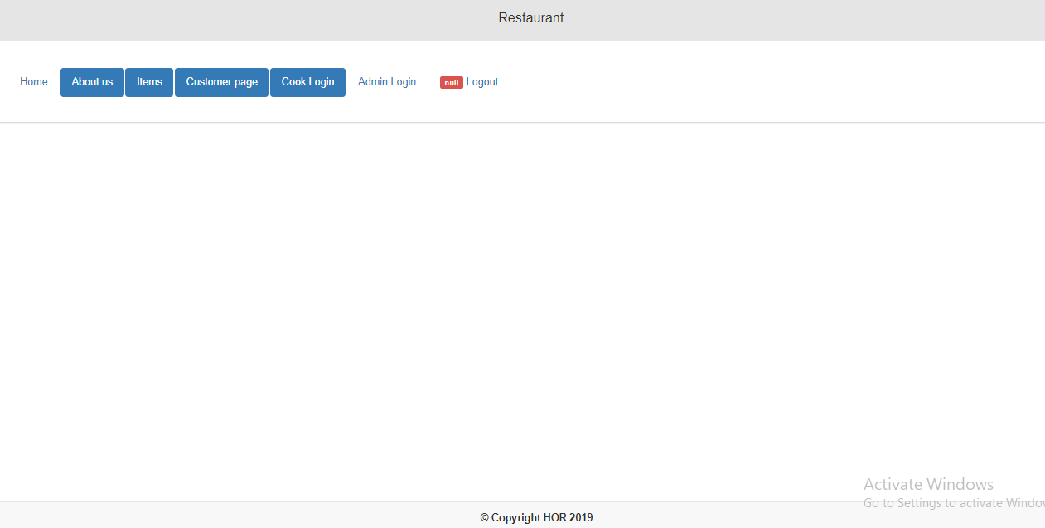

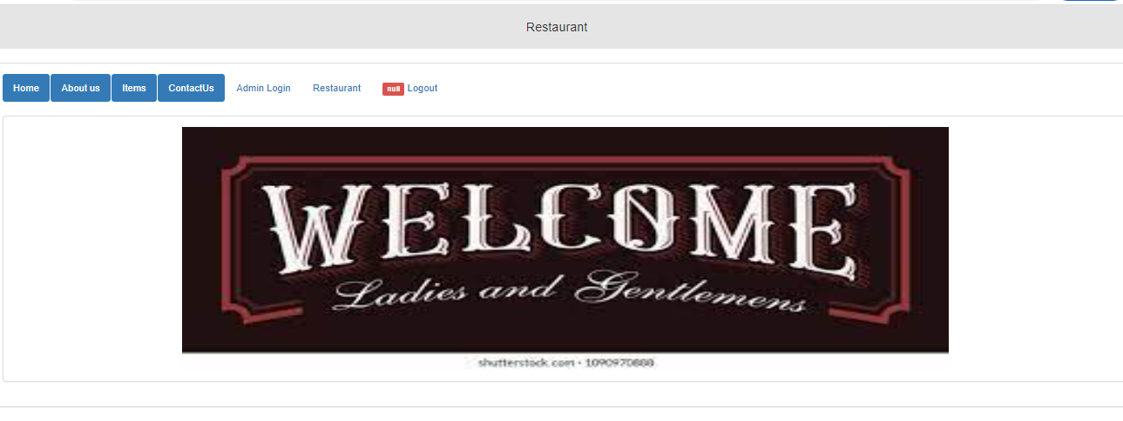

About Us:

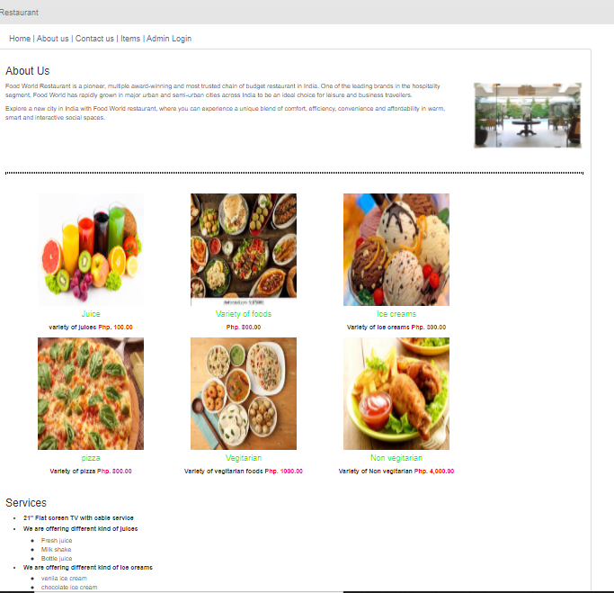

Contact Us:

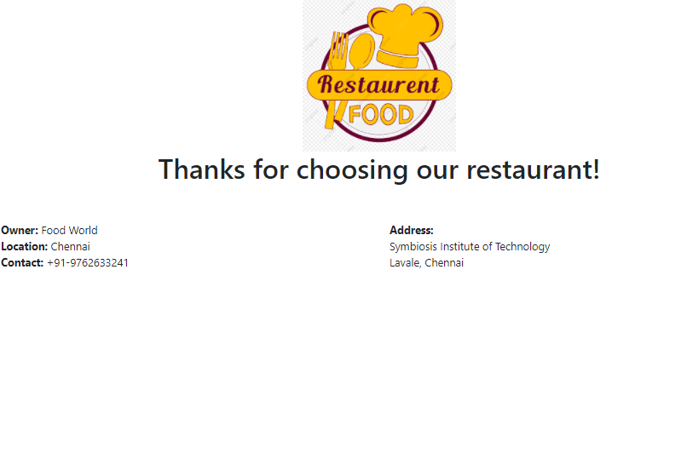

Items:

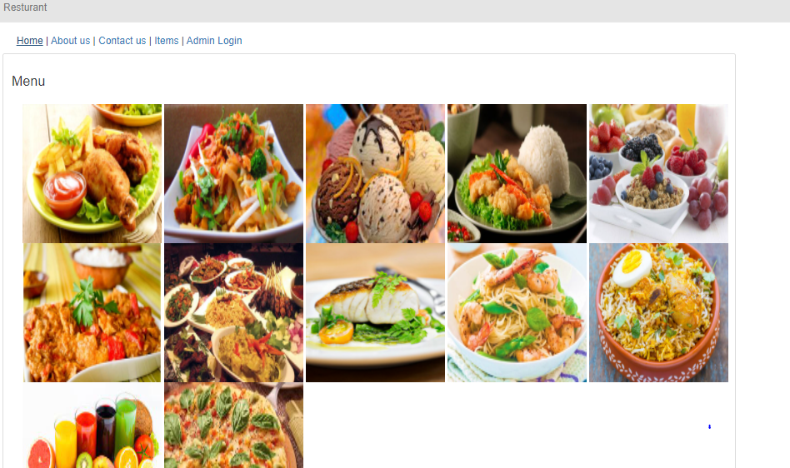

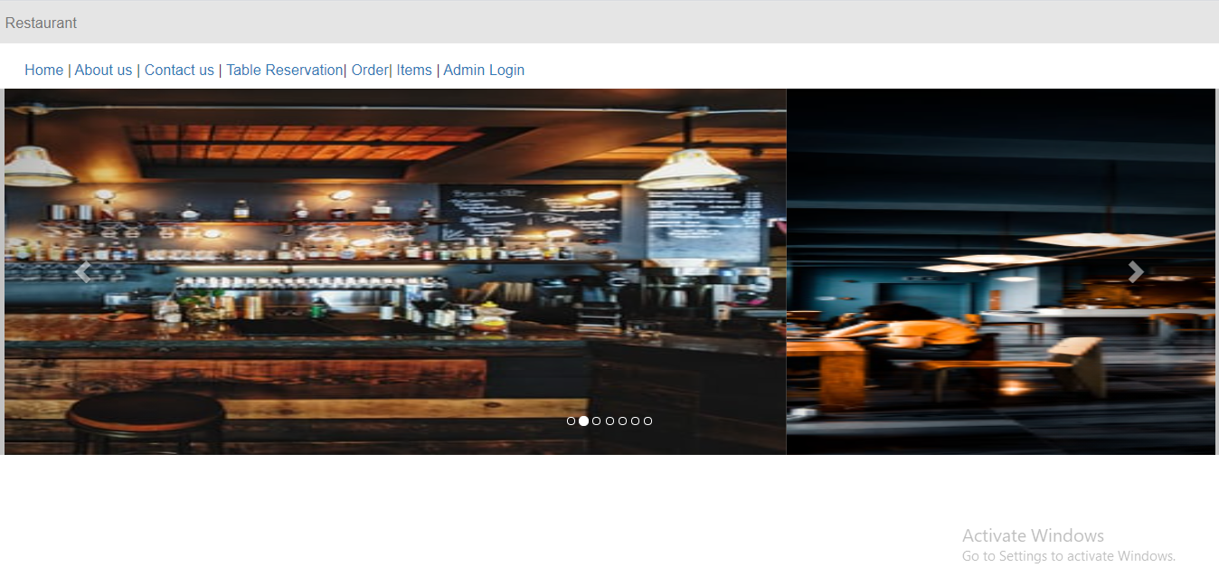

Admin Login:

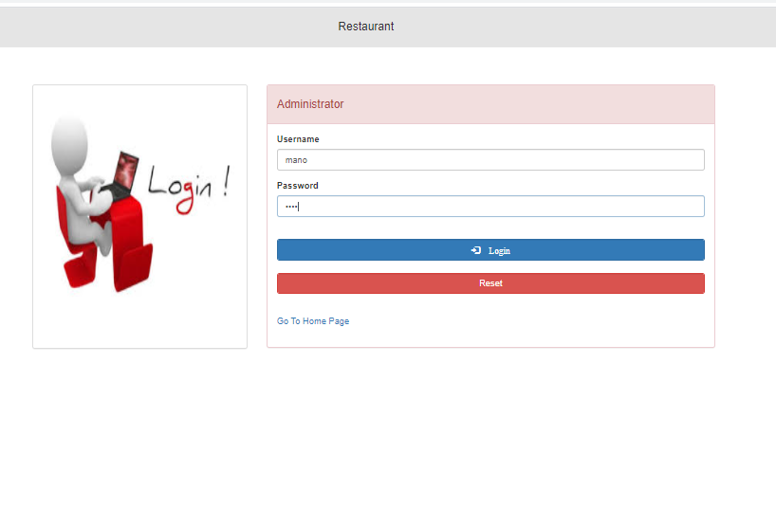

Customer Page:

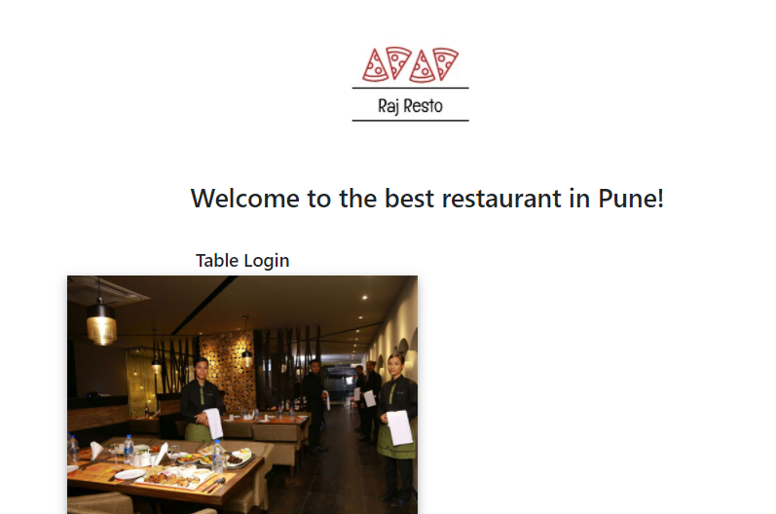

Table Login:

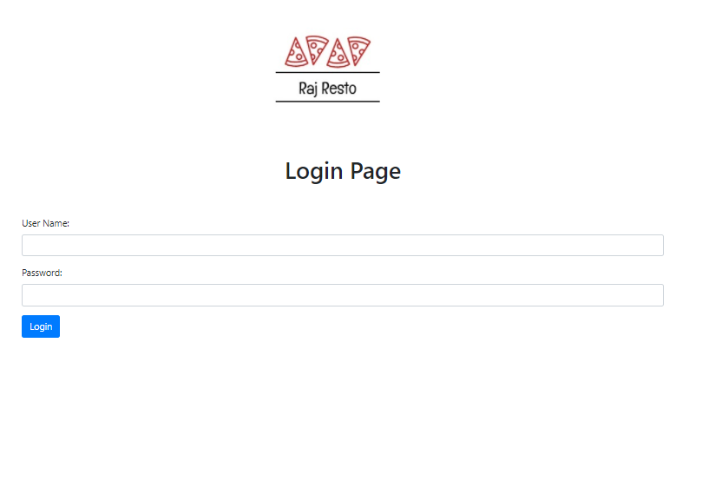

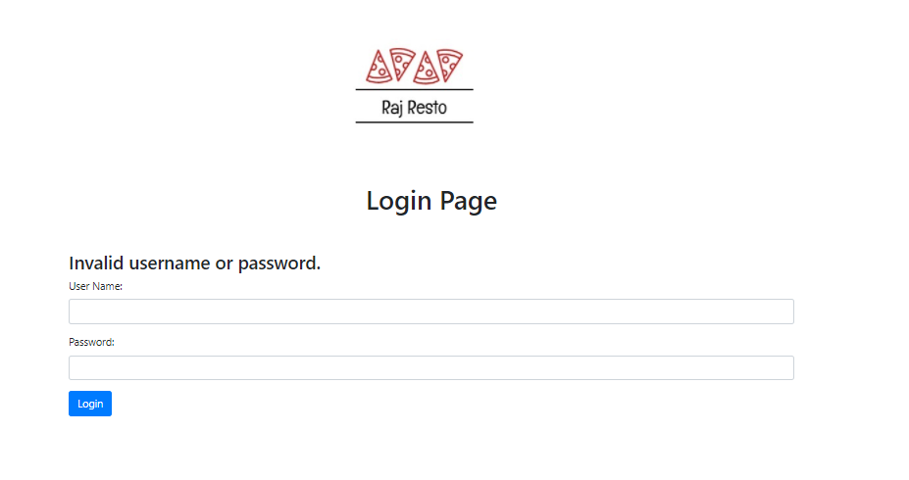

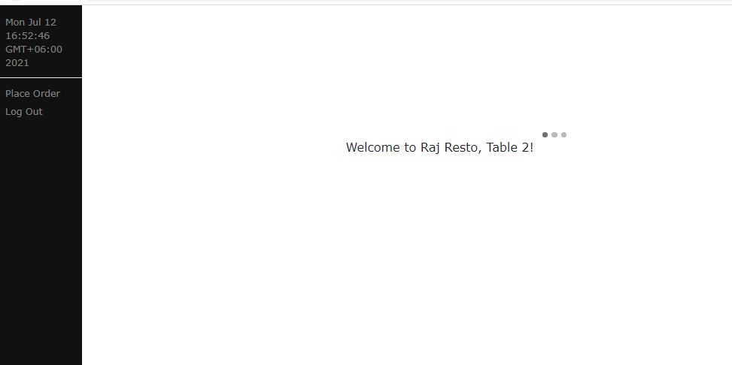

Order :

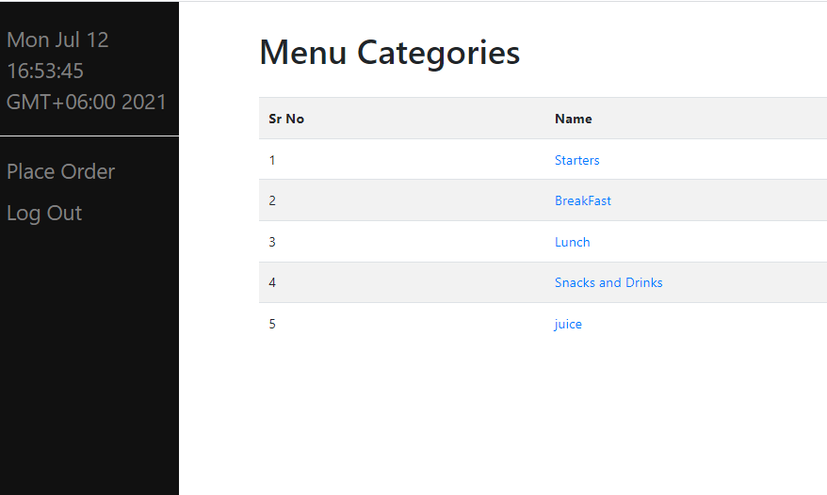

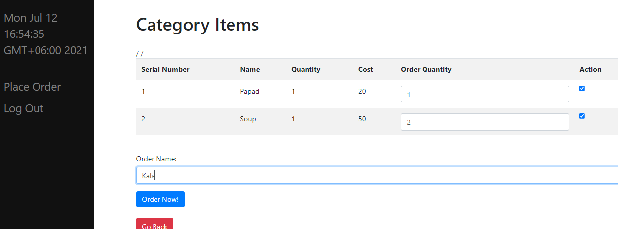

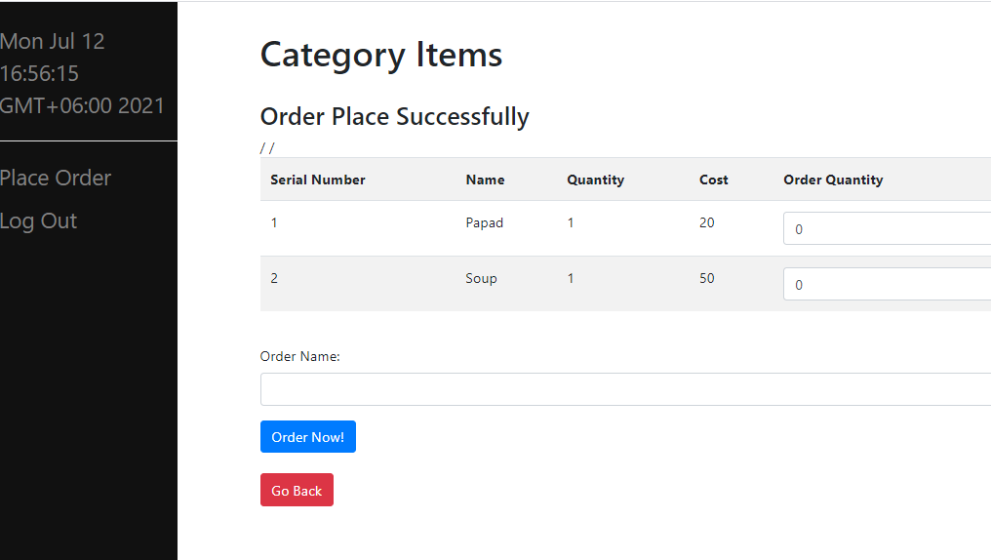

Cook Login:

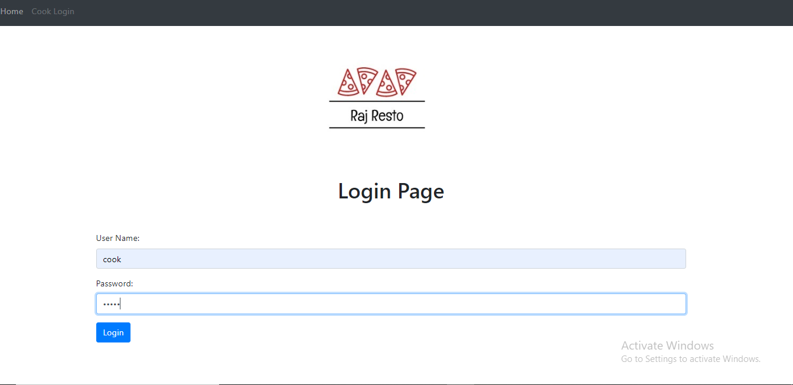

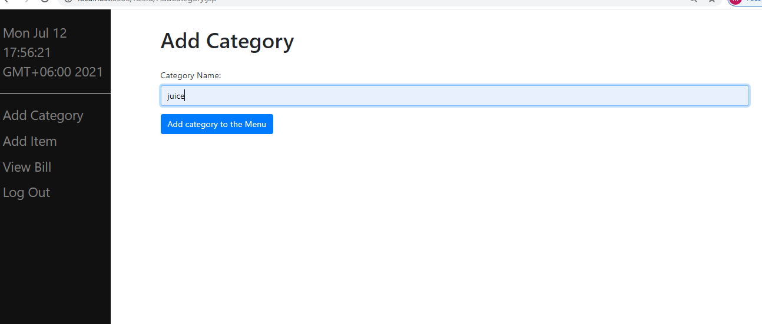

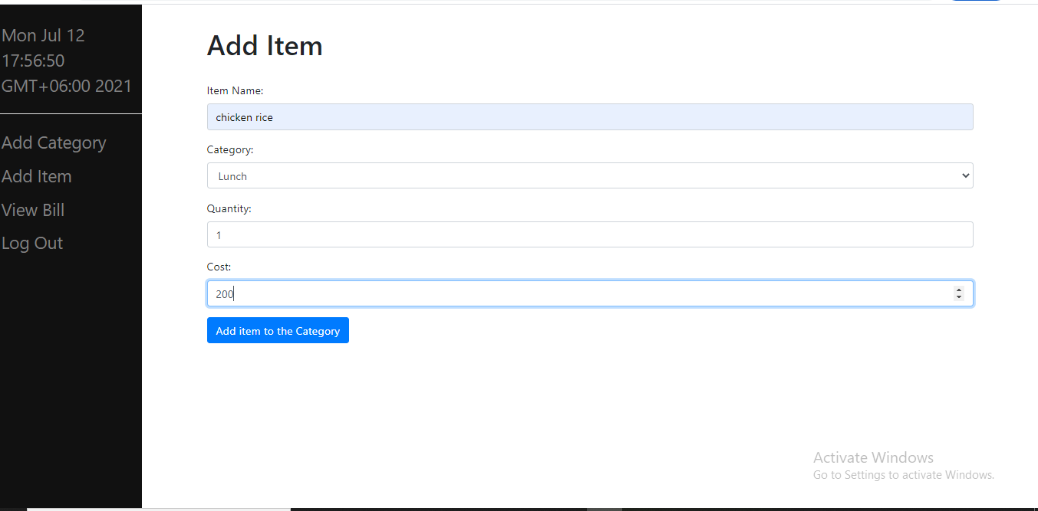

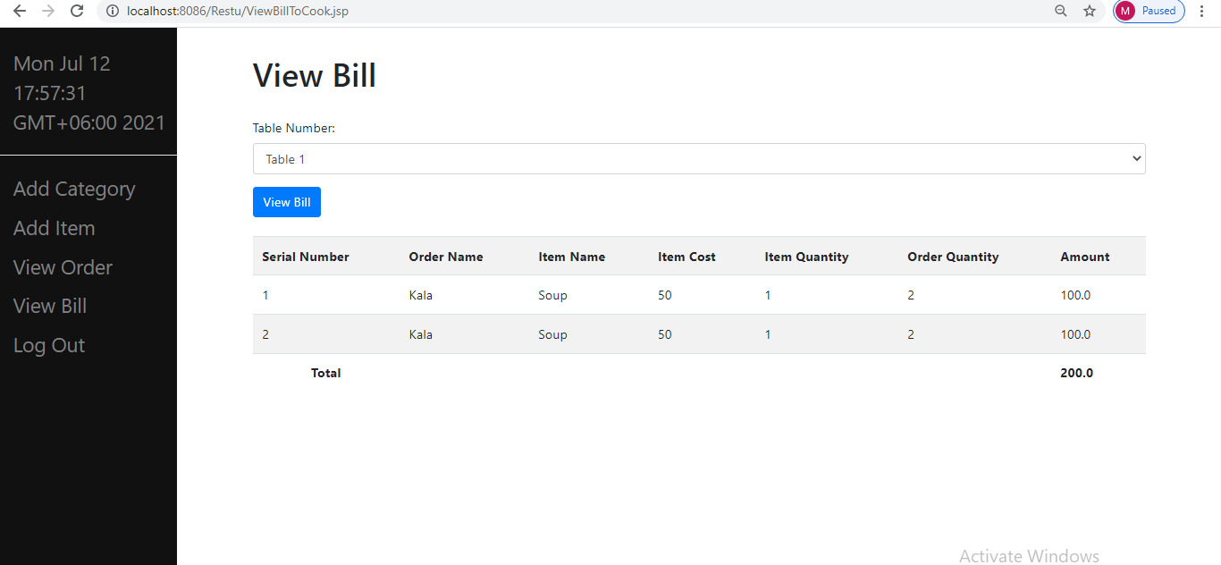

ViewBill:

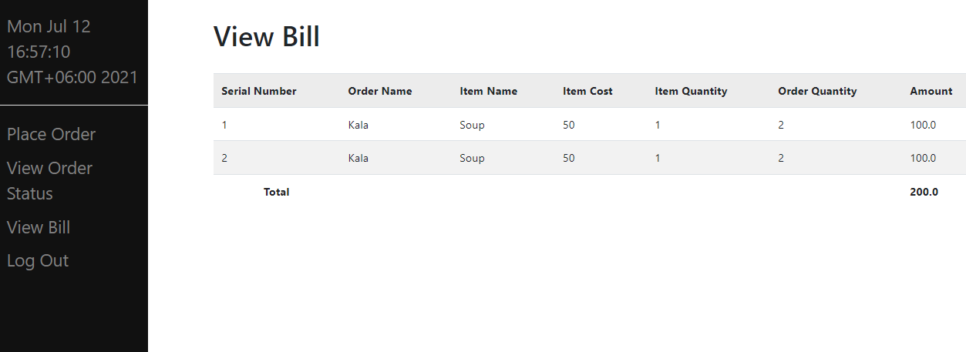

View Order Status:

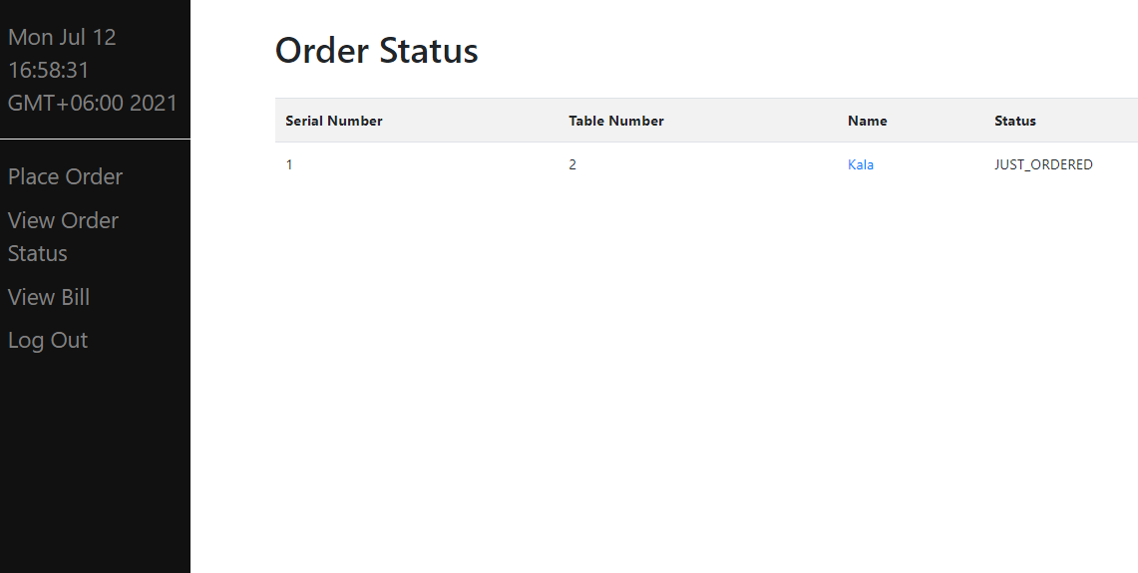

Logout :

