JENKINS
1. Continuous Integration (CI)
Developers frequently merge (integrate) their code changes into a shared repository.
Each merge triggers automated processes such as:
- Building the application
- Running tests
- Checking code quality
Goal: Catch bugs early, ensure new code works well with existing code, and reduce integration problems.
2. Continuous Delivery (CD)
Once the code passes all CI checks, it’s automatically packaged and prepared for release to staging or production—but a human typically approves the final deployment.
Goal: Make releases reliable, predictable, and easy.

Jenkins
******
popular CI/CD automation servers
it is platform independent -> it can run anywhere os system
it is opensource
integration tool
written in java
Automating the repeated tasks
Automates build, test, deployment
Works with GitHub, Docker, Kubernetes, AWS, etc.

Advantages of Jenkins
- Continuous Integration
- Continuous Delivery
- Open-Source & Community
- Automation
- Plugin Architecture
- Easy to Use
- Supports Multiple Platforms
- Distributed Builds
- Customizable
- Robust Security
- Comprehensive Testing
- Scalability
- Web Interface

Jenkins Master & Agent Architecture
******************************
it uses distributed architecture
handle the large workload efficiently
This architecture is made of two main components:
- Jenkins Master (now called Controller)
- Jenkins Agents (also called Nodes/Workers)
- Jobs / Pipelines
- Plugins
- External Integrations (SCM, Docker, Cloud, K8s, Artifact Repos)
Jenkins Master
*************
it is brain of jenkins
✔ Orchestrating the builds
- Decides what task to run
- Decides where (which agent) to run it
- Schedules jobs
- Monitors agent status
✔ Hosting the Web UI
- Includes dashboards
- Job configuration screens
- Pipeline visualization
✔ Storing system configuration
- Plugins
- Jenkins settings
- Credentials
- Security configurations
- Global environment variables
✔ Handling job management
- Job creation
- Job triggers
- Build history logs
- Artifact storage
✔ Triggering builds
- Based on webhooks (GitHub/GitLab)
- Manual triggers
- Scheduled (cron) triggers
✔ Distributing tasks to agents
The Controller does not run heavy tasks like building, testing, or deploying.
Its job is coordination, not execution.

Jenkins Agent / Worker / Node
***************************
Agents are machines that execute the build jobs.
This communication must be secure to prevent unauthorized access or malicious code execution.

An agent can be:
- A physical server
- A virtual machine
- A Docker container
- A Kubernetes pod (ephemeral agents)
- A cloud instance (AWS, Azure, GCP)
Agents perform:
✔ Build execution
- Compile code
- Run unit/integration tests
- Build Docker images
- Run security scans
✔ Environment-specific tasks
Agents may have:
- Different OS types
- Different toolchains (Java, Python, .NET)
- Different resource capacities
This allows Jenkins to run the right job on the right machine.
✔ Parallel execution
Each agent can have multiple executors, enabling multiple builds at once.
✔ Types of Jenkins Agents
- Static Agents
  - Pre-configured, always available
  - Installed on VMs or physical servers
- Dynamic Agents
  - Auto-created and destroyed based on workload
  - Provided by:
    - Docker
    - Kubernetes
    - Cloud providers (AWS EC2, Azure VM, GCP Compute)
- Inbound Agents
  - Agent connects to Jenkins controller
  - Useful in firewalled environments
- Outbound (SSH) Agents
  - Controller connects to the agent via SSH
3. Jenkins Controller — Agent Communication
Jenkins uses the Remoting protocol for communication.
Communication can happen through:
- SSH
- Java Web Start (deprecated)
- Jenkins Tunnel
- Kubernetes API (for K8s agents)
- Cloud APIs
4. Distributed Jenkins Architecture
A common scalable architecture:
+------------------------+
| Jenkins Controller |
| - UI |
| - Scheduling |
| - Job mgmt |
+-----------+------------+
|
------------------------------------
| | |
+--------+--------+ +------+--------+ +------+--------+
| Static Linux | | Docker Agent | | Windows Agent |
| Build Agent | | (Ephemeral) | | (for .NET) |
+-----------------+ +---------------+ +---------------+
5. Jenkins Pipeline Architecture
Pipelines are defined in Jenkinsfile and executed on agents.
Two types:
- Declarative Pipeline
- Scripted Pipeline
Pipeline Flow:
Jenkinsfile -> Controller -> Agent -> Execute Steps -> Report Results
Pipeline execution only happens on agents, but the controller orchestrates everything.

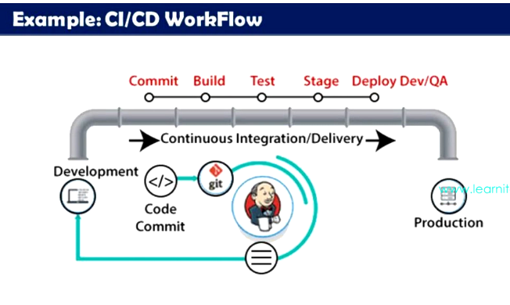
sudo systemctl start jenkins
sudo systemctl enable jenkins -> used to run
sudo systemctl status jenkins
$ ip a
for the first time they provide a screen, on the screen => we should give command “cat and path”
to get password
9f9e5e7f947c4a9cbecc98346407d129 -password of mine

once you login jenkins portal:
you can see “PEOPLE” option ->view the users who are using jenkins

Security
********
Dashboard -> Manage Jenkins -> Security
1.Security Realm -> there will be different options
(Delegate to Servlet container,
Jenkins own user database
LDAP -> we have to give server configuration
Unix User/group database -> if the user belongs to group shadow they can access the jenkins
None)
1. Create a user through the Jenkins UI (recommended)
If Jenkins is using its own user database (Jenkins internal security realm):
- Go to:
Manage Jenkins → Security → Configure Global Security
- Under “Security Realm,” select:
Jenkins’ own user database
- Enable:
Allow users to sign up (optional)
- Save.
- Then go to:
Manage Jenkins → Manage Users → Create User
- Fill in:
  - Username
  - Password
  - Full name
  - E-mail

Authorization
- anyone can do anything - which is not feassible
- legacy mode
- logged in user can do anything
- maxtrix based security – used approach
- project based matrix strategy – this also

Role based strategy -> it is one of the authorization style if you want this to be there .
You need to go “Plugins” then search “role” and install

Once you install -> click the “Security” -> authorization ->”Role based “ -> save and apply

Manage Jenkins ->in Security module -> Manage Roles -> create roles whatever you want and give permission for the created user

Roles you need to create :
ReadOnly_users
Immedia_users
Build_users
Admin

if you want to create pattern you can create in “Iteam”
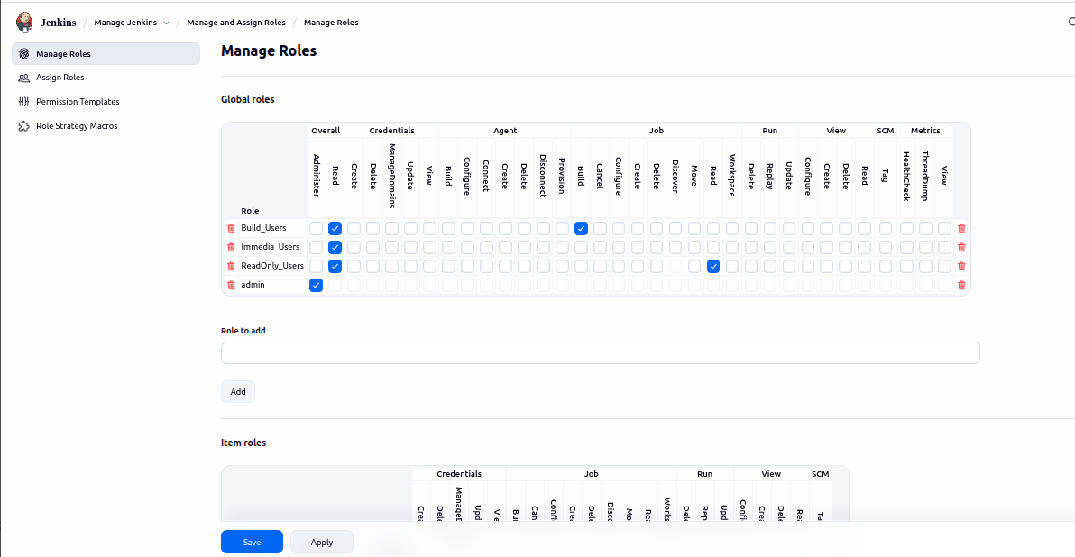
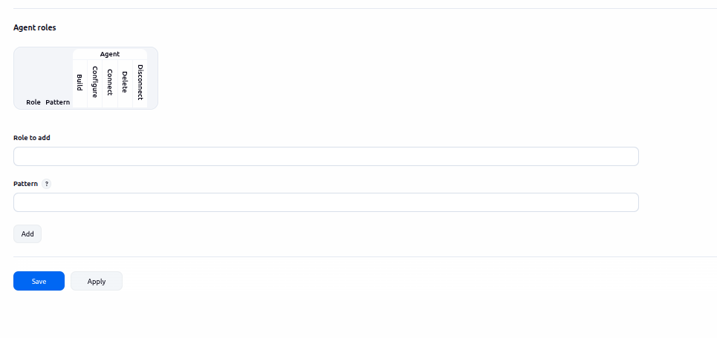

Configuration
***********
if you want to create job
give name ->free style ->

1.Discard old builds
***************
It is a Jenkins feature that automatically deletes old build history so your Jenkins server doesn’t get full or slow.
Why is it useful?
- Saves disk space
- Keeps your Jenkins fast
- Prevents clutter
2. GitHub project
Meaning: Links your Jenkins job to a GitHub repository.
Use case:
“I used the GitHub project field to connect Jenkins to our repository so developers can easily navigate from Jenkins to GitHub directly.”
3. This project is parameterised
Meaning: Allows you to pass inputs before triggering a build.
Use case:
“I parameterized our deployment job with environment options like dev/test/prod so the same job could be reused for multiple environments.”
4. Throttle builds
Meaning: Limits how many builds run at the same time.
Use case:
“We had heavy jobs that consumed a lot of CPU. I used Throttle builds to ensure only one build ran at a time, preventing server overload.”
5. Execute concurrent builds if necessary
Meaning: Allows the same job to run multiple builds simultaneously.
Use case:
“When multiple developers pushed code at the same time, I enabled concurrent builds so their builds could run in parallel and reduce wait times.”
6. Source Code Management (SCM)
None
No code is required (script-only jobs).
Git
Pull code from GitHub, GitLab, Bitbucket, etc.
Use case:
“I configured SCM with Git so Jenkins automatically pulled the latest code for every build.”
7. Triggers
Defines when the job should start automatically.
a. Trigger builds remotely
Meaning: Start a job using an external call (URL or API).
Use case:
“We integrated Jenkins with a custom tool, so the tool triggered Jenkins builds using the remote trigger URL.”
b. Build after other projects are built
Meaning: Runs the job after a different job completes.
Use case:
“I set up a pipeline chain: Build → Test → Deploy. The Test job triggered automatically after the Build job finished.”
c. Build periodically
Meaning: Runs based on a schedule (like cron).
Use case:
“We ran cleanup scripts every midnight using the Build periodically option.”
d. GitHub hook trigger for GITScm polling
Meaning: Build triggers instantly when GitHub detects a push.
Use case:
“To enable true CI, I used GitHub webhooks so Jenkins builds started immediately after code was pushed.”
e. Poll SCM
Meaning: Jenkins checks the Git repo at intervals for changes.
Use case:
“For repositories where webhooks were not allowed, I used Poll SCM to check for changes every 5 minutes.”
8. Environment Section
What is Build Environment in Jenkins?
The Build Environment section in a Jenkins job defines the environment or context in which the job runs.
It controls settings before the build starts or during the build, such as:
- Environment variables
- File system cleanup
- Wrappers for special behavior (like running with credentials, timeouts, or virtual environments)
Where to find it
- Go to Jenkins Dashboard → Your Job → Configure
- Scroll down to Build Environment section

a. Delete workspace before build starts
Meaning: Cleans the job directory before each build.
Use case:
“Some builds were failing due to leftover files. I cleaned the workspace before builds to ensure a fresh start.”
b. Use secret text(s) or file(s)
Meaning: Inject passwords, tokens, or secret files securely.
Use case:
“I stored API keys here so they wouldn’t appear in the console logs.”
c. Add timestamps to the Console Output
Meaning: Shows time next to each log line.
Use case:
“This helped us measure exactly how long each step took during performance debugging.”
d. Inspect build log for published build scans
Meaning: Detects build scan links (e.g., Gradle).
Use case:
“We used Gradle build scans, and Jenkins highlighted scan URLs automatically.”
e. Terminate a build if it’s stuck
Meaning: Kills jobs that hang for too long.
Use case:
“Sometimes our test jobs hung due to environment issues. I set a timeout so Jenkins automatically terminated them.”
9. With Ant
Meaning: Allows running Apache Ant build scripts (common for older Java projects).
Use case:
“I used this option to build legacy Java applications that still used Ant instead of Maven or Gradle.”

Jenkins Build Steps
Build Steps are the actual actions Jenkins performs when the job runs.
This is where Jenkins does the real work like compiling code, running tests, deploying, etc.

1. Execute Shell / Execute Windows Batch Command
Meaning: Runs shell or command-line scripts.
Interview answer:
“I used Execute Shell to run build scripts, compile code, run tests, or trigger deployments.”
Use case:
- Run a .sh script
- Execute Python or Maven commands
- Clean directories
Example command:
mvn clean install
2. Invoke Ant
Meaning: Runs Ant build scripts like build.xml for older Java projects.
Interview answer:
“I worked on a legacy Java project that used Ant. I used the Invoke Ant build step to compile and package the application.”
Use case:
- Build Java using Ant
- Run Ant targets
3. Invoke Gradle Script
Meaning: Runs a Gradle build, similar to:
./gradlew build
Interview answer:
“I used Invoke Gradle to run build tasks like compile, test, and publish artifacts.”
Use case:
- Java Spring Boot apps
- Mobile (Android) builds
4. Invoke Maven
Meaning: Run Maven goals like:
mvn clean install
Interview answer:
“My main build step was Invoke Maven to compile the project, run tests, and generate artifacts.”
Use case:
- Build Java applications
- Run unit tests
- Create .jar or .war files
5. Execute Groovy Script
Meaning: Runs Groovy code.
Interview answer:
“I used Execute Groovy Script to automate small tasks like reading files or manipulating build metadata.”
Use case:
- Custom logic
- Parsing build info
- Automation tasks
6. Copy Artifacts
Meaning: Copy files from another job.
Interview answer:
“I used Copy Artifacts to take build output (like .jar files) from one job and use them in another.”
Use case:
- Build job produces artifact → Deploy job uses it
- Shared artifacts across jobs
7. Publish Over SSH
Meaning: Send files or run commands on remote servers.
Interview answer:
“I used Publish Over SSH to deploy artifacts to our Linux servers.”
Use case:
- Upload files to servers
- Deploy to staging/production
- Restart services remotely
8. Send Files or Execute Scripts via SSH (Using SSH plugin)
Meaning: Automate remote execution.
Interview answer:
“I used the SSH plugin to run deployment scripts on remote machines.”
Use case:
- Start/stop services
- Trigger remote builds
- Copy config files
9. Build with Docker
Meaning: Builds Docker images or runs containers.
Interview answer:
“I used Docker build steps to create images and push them to Docker Hub or ECR.”
Use case:
- Docker image build
- Run containerized tests
- Push images to registry
10. Build with SonarQube (Quality Scan)
Meaning: Perform static code analysis.
Interview answer:
“I added a SonarQube scan as a build step to ensure code quality, check vulnerabilities, and maintain standards.”
Use case:
- Code quality checks
- Security checks
- Technical debt analysis

What are Jenkins Plugins?
Definition:
A Jenkins plugin is an add-on or extension that enhances Jenkins’ capabilities. Jenkins itself is lightweight and modular; plugins allow it to integrate with tools, services, and platforms.
Key Points:
- Jenkins core has basic features (jobs, pipelines, etc.), but most functionality comes from plugins.
- Plugins can provide SCM integration, build tools, reporting, notifications, security, cloud support, and much more.
- Jenkins has over 1,800 plugins available in the official Plugin Index.
Updates Tab
What it is:
The Updates tab shows all the plugins that are already installed in your Jenkins but have newer versions available.
Use / Why it’s important:
- Keeps Jenkins plugins up-to-date with bug fixes, security patches, and new features.
- Helps prevent compatibility issues with other plugins or Jenkins core updates.
- Allows you to update plugins immediately or schedule update after restart.
Available Plugins Tab
What it is:
The Available tab lists all plugins that can be installed on Jenkins, but are not yet installed. This comes from the Jenkins update center.
Use / Why it’s important:
- Lets you add new capabilities to Jenkins, such as integrating with GitHub, Slack, Docker, Maven, SonarQube, etc.
- Makes Jenkins extensible and adaptable to different CI/CD workflows.
- Helps you search, read descriptions, and select plugins to enhance Jenkins.
Installed Plugins Tab
What it is:
The Installed tab shows all plugins that are already installed in your Jenkins, along with their version, status, and dependencies.
Use / Why it’s important:
- Lets you see what’s currently running in Jenkins.
- Allows you to disable, uninstall, or troubleshoot plugins.
- Helps manage plugin dependencies, ensuring Jenkins stays stable.
Advanced Tab
What it is:
The Advanced tab provides manual and advanced configuration options for plugin management.
Use / Why it’s important:
- Manual plugin installation: Upload .hpi or .jpi files (useful for offline Jenkins servers).
- Update center configuration: Use custom or internal plugin repositories.
- Proxy configuration: If Jenkins is behind a firewall, configure access to download plugins.
- Force plugin updates: Refresh update site metadata.

Parameter in Jenkins?
Definition:
A parameter in Jenkins is a variable value that you can pass to a build at runtime.
Purpose / Use:
- Make Jenkins jobs dynamic and reusable.
- Allow users to provide input before starting the build.
- Control build behavior without changing job configuration.
Common Parameter Types
A. String Parameter
- What it is: A single-line text input.
- Use Case: Pass a branch name, version number, or file path.
- Example:
  - Name: BRANCH
  - Default Value: main
  - Description: Enter the Git branch to build
B. Boolean Parameter
- What it is: True/False checkbox.
- Use Case: Toggle options like run tests, enable debug mode, or skip steps.
- Example:
  - Name: RUN_TESTS
  - Default: true
C. Choice Parameter
- What it is: Dropdown menu with predefined choices.
- Use Case: Select environment, build type, or deployment target.
- Example:
  - Name: ENV
  - Choices: DEV, QA, PROD
  - Description: Select deployment environment
D. Multi-line String Parameter
- What it is: Text box for multiple lines.
- Use Case: Pass scripts, commands, or configuration.
- Example:
  - Name: CONFIG
  - Default Value: Multiple environment variables or commands
E. Password Parameter
- What it is: Hidden input (masked in UI).
- Use Case: Pass API keys, passwords, or tokens securely.
- Example:
  - Name: SECRET_KEY
  - Description: Enter API secret key
F. File Parameter
- What it is: Allows uploading a file to the job.
- Use Case: Upload config files, scripts, or deployment packages.
- Example:
  - Upload .zip or .tar files to deploy
G. Run Parameter
- What it is: Allows selecting a build of another job.
- Use Case: Use artifacts from a previous build in this job.
- Example:
  - Name: UPSTREAM_BUILD
  - Select last successful build of a job
H. Credentials Parameter (with Credentials Binding Plugin)
- What it is: Select stored Jenkins credentials securely.
- Use Case: Pass username/password, SSH key, or token to a job.
- Example:
  - Name: AWS_CREDENTIALS
  - Type: AWS credential
I. Choice Parameter from Script / Active Choice Parameter (with Active Choices Plugin)
- What it is: Dynamic choices generated from a script (Groovy, shell).
- Use Case: Populate options based on current repository branches or external API.
- Example:
  - Name: BRANCH
  - Script fetches branches from GitHub

Upstream Job:
- A job that triggers another job.
- It runs first in a sequence.
Downstream Job:
- A job that is triggered by another job.
- It runs after the upstream job completes.
Purpose:
- To chain jobs together in a workflow.
- Automate sequential CI/CD processes.
Example Use Case:
- Job A: Build the application (upstream)
- Job B: Run tests (downstream)
- Job C: Deploy to staging (downstream of B)
Sequential Execution in Jenkins
Sequential execution means one job starts only after the previous job finishes successfully.
If you want to sent the parameter of the values to another job
then you should download the plugin “parameterize trigger”

Pipeline Syntax
Scripted
- first syntax
- Groovy engine
- advanced scripting capabilities, high flexibility
- difficult to start
Declarative
- more recent addition
- easier to get started, but not that powerful
- pre-defined structure
Declarative
pipeline {
agent any
stages {
stage('Build') {
steps {
sh 'make'
}
}
stage('Test') {
steps {
sh 'make test'
}
}
stage('Deploy') {
steps {
sh 'make deploy'
}
}
}
}
Scripted
node {
stage('Build') {
sh 'make'
}
stage('Test') {
sh 'make test'
}
stage('Deploy') {
sh 'make deploy'
}
}

pipeline {
agent any

stages {
stage('Build') {
steps {
sh 'echo "Building the project..."'
sh 'python setup.py build' // Example build command for Python
}
}
stage('Test') {
steps {
sh 'echo "Running tests..."'
sh 'python -m unittest discover' // Example test command for Python
}
}
stage('Deploy') {
steps {
sh 'echo "Deploying the application..."'
// Example deploy command could vary greatly depending on the target environment
sh 'scp -r build/ [user]@[server]:[path]' // Example deployment command using scp
}
}
}
}
Jenkins Pipeline?
- Definition:
A Jenkins Pipeline is a suite of plugins that supports implementing and integrating continuous delivery pipelines into Jenkins.
- Purpose:
It allows you to define build, test, and deployment workflows as code (using a Jenkinsfile), making automation reliable, repeatable, and version-controlled.
- Why Pipelines?
Before pipelines, Jenkins jobs were often configured manually or via freestyle jobs, which were:
  - pipeline {
  - agent any
  - stages {
  - stage("First Stage") {
  - steps {
  - sh """
  - echo "fisrt stage"
  - """
  - }
  - }
  - stage("Second Stage") {
  - steps {
  - sh """
  - echo "second stage"
  - """
  - }
  - }
  - }
  - }

  - pipeline {
  - agent any
  - stages {
  - stage('one') {
  - parallel {
  - stage('two') {
  - sh """
  - echo "Executing parallel job two."
  - """
  - }
  - stage('three') {
  - sh """
  - echo "Executing parallel job three."
  - """
  - }
  - stage('four') {
  - sh """
  - echo "Executing parallel job four."
  - """
  - }
  - }
  - }
  - }
  - }

  - pipeline {
  - agent any

  - stages {
  - stage('Parallel Jobs') {
  - parallel {
  - stage('Job 1') {
  - steps {
  - echo 'Running Job 1'
  - // Add your job 1 steps here
  - }
  - }
  - stage('Job 2') {
  - steps {
  - echo 'Running Job 2'
  - // Add your job 2 steps here
  - }
  - }
  - stage('Job 3') {
  - steps {
  - echo 'Running Job 3'
  - // Add your job 3 steps here
  - }
  - }
  - }
  - }
  - }
  - }

  - pipeline {
  - agent any

  - environment {
  - DOCKERHUB_CREDENTIALS=credentials("dockerhub")
  - }

  - stages {
  - stage("Docker Login") {
  - steps {
  - withCredentials([usernamePassword(credentialsId: 'dockerhub', passwordVariable: 'DOCKERHUB_CREDENTIALS_PSW', usernameVariable: 'DOCKERHUB_CREDENTIALS_USR')])
  - {
  - sh """
  - echo "------------ Login to DockerHub ------------"
  - sudo docker login -u $DOCKERHUB_CREDENTIALS_USR --password-stdin
  - echo "------------ Successfully Logedin ------------"
  - """
  - }
  - }
  - }
  - }
  - }

  - pipeline {
  - agent any
  - stages {
  - stage("Parallel Stage") {
  - parallel {
  - stage("One") {
  - steps {
  - sh """
  - echo "One"
  - """
  - }
  - }
  - stage("Two") {
  - steps {
  - sh """
  - echo "One"
  - """
  - }
  - }
  - stage("Three") {
  - steps {
  - sh """
  - echo "One"
  - """
  - }
  - }
  - }
  - }
  - stage("Sequential") {
  - steps {
  - sh """
  - echo "Sequential"
  - """
  - }
  - }
  - }
  - }Hard to maintain
  - Not version-controlled
  - Limited in complex workflows
Pipelines fix that by scripting the entire process.
Types of Jenkins Pipelines
A. Declarative Pipeline (recommended)
- Uses a structured, simpler syntax
- Easier to write and maintain
- Example: your uploaded script is declarative pipeline
B. Scripted Pipeline
- Uses full Groovy scripting language
- More powerful and flexible but complex
- Gives more control for advanced workflows
Jenkinsfile
- The pipeline code is stored in a file called Jenkinsfile in your source repository.
- This allows pipeline definitions to be versioned alongside the application code.
JENKINS SLAVE (AGENT)?
A Jenkins Slave (now called Agent) is a machine that Jenkins uses to run jobs.
The Master/Controller sends tasks to slaves so you can:
- Distribute builds
- Run parallel jobs
- Use different environments (e.g., Python, Node.js, Java, Docker)
- Offload heavy builds from the controller
HOW TO SET UP A TRADITIONAL JENKINS SLAVE (NODE)
This is when you use a physical server, VM, or machine as a Jenkins agent.
STEP 1: Go to Configure Nodes
- Open Jenkins UI
- Select Manage Jenkins
- Click Manage Nodes and Clouds
- Click New Node
STEP 2: Create a New Node
- Name: slave-1
- Type: Permanent Agent
- Click OK
A. Launch agent via SSH (Most Common)
Jenkins connects to the agent using SSH.
Requirements:
- SSH installed on the agent
- Java installed on the agent
- Agent user created (example: jenkins)
Steps:
- Enter hostname / IP
- Add SSH credentials
- Jenkins will connect → download agent.jar → agent online ✔
B. Launch agent via Java Web Start (JNLP)
Used when Jenkins cannot SSH to the agent.
Steps:
- On agent machine, download agent.jar
- Run command:
java -jar agent.jar -jnlpUrl <URL> -secret <secret-key>
HOW TO USE DOCKER AS JENKINS SLAVES (BEST PRACTICE)
This creates ephemeral agents—Docker containers that start when needed and delete automatically.
METHOD 1: Using Docker Plugin (Simple)
STEP 1: Install Required Plugins
Go to:
Manage Jenkins → Manage Plugins → Available
Install:
- Docker
- Docker Pipeline
- Docker API
STEP 2: Configure Docker Cloud
- Go to Manage Jenkins → Manage Nodes and Clouds → Configure Clouds
- Add a Docker Cloud
- Enter Docker Host:
If Docker is installed on the Jenkins server:
unix:///var/run/docker.sock
STEP 3: Add Docker Templates (Agents)
Configure:
- Docker Image (example: jenkins/inbound-agent:latest)
- Remote FS root: /home/jenkins
- Labels: docker-agent
- Launch method: Inbound Agent
- Remove container after build ✔
STEP 4: Use It in a Jenkinsfile
Example:
pipeline {
agent {
docker {
image 'python:3.10'
args '-u root' // optional
}
}

stages {
stage('Build') {
steps {
sh 'python --version'
}
}
}
}
💡 Jenkins automatically pulls the Docker image → runs steps inside container → destroys it.
METHOD 2: Docker-Based Jenkins Slave (Standalone Container)
Start a slave container that registers with Jenkins:
1. Pull the inbound agent image
docker pull jenkins/inbound-agent
2. Run it:
docker run -d \
-v /var/run/docker.sock:/var/run/docker.sock \
jenkins/inbound-agent \
-url http://<jenkins-server>:8080 <secret> <agent-name>
This will register as a permanent agent inside Jenkins.
METHOD 3: Kubernetes Agents (Most Modern)
If you are deploying Jenkins on Kubernetes → use Kubernetes plugin → agents are created as pods.
We will create a Multibranch Pipeline that:
- Connects to GitHub repo
- Automatically detects branches + PRs
- Uses a Jenkinsfile stored in each branch
- Builds code inside a Docker container
- Optionally builds & pushes a Docker image
🚀 PART 1 — Jenkins Setup (Multibranch Pipeline)
✔ Step 1: Install Required Plugins
Go to:
Manage Jenkins → Manage Plugins
Install:
- GitHub Branch Source
- Docker
- Docker Pipeline
- Pipeline
- Blue Ocean (optional, for nice UI)
Step 2: Create a Multibranch Pipeline
- Go to Jenkins Dashboard
- Click New Item
- Choose Multibranch Pipeline
- Name it:
multi-docker-github-pipeline
- Click OK
Step 3: Configure Branch Sources
Inside the job:
Under Branch Sources → Add Source → GitHub
Set:
Field | Value
Credentials | Add GitHub token
Repository URL | https://github.com/<user>/<repo>
Next:
✔ Choose “Build all branches”
✔ Choose “Discover pull requests”
Step 4: Add Scan Triggers
Inside Scan Multibranch Pipeline Triggers:
Enable:
✔ Periodically if not otherwise run
Set: 1 minute or 5 minutes
Jenkins will automatically:
- Detect new branches
- Detect deleted branches
- Build PRs
- Build feature branches
PART 2 — Create Jenkinsfile With Docker Build
This Jenkinsfile should be included in the root of your GitHub repo.
JENKINSFILE EXAMPLE (Modern Multibranch + Docker)
This pipeline does:
✔ Build using Docker agent
✔ Build Docker image
✔ Test
✔ Push to DockerHub (optional)
pipeline {
agent {
docker {
image 'python:3.10' // Build container
}
}

environment {
DOCKERHUB_CREDENTIALS = credentials('dockerhub-id') // Jenkins credentials ID
IMAGE_NAME = "yourdockerhubuser/myapp"
}

stages {

stage('Checkout') {
steps {
checkout scm
}
}

stage('Build') {
steps {
sh 'echo "Building application..."'
sh 'python setup.py build' // example build command
}
}

stage('Test') {
steps {
sh 'echo "Running tests..."'
sh 'python -m unittest discover'
}
}

stage('Docker Build') {
steps {
sh """
docker build -t ${IMAGE_NAME}:${BRANCH_NAME} .
"""
}
}

stage('Docker Login & Push') {
when {
branch 'main' // push only from master/main branch
}
steps {
sh """
echo "$DOCKERHUB_CREDENTIALS_PSW" | docker login -u "$DOCKERHUB_CREDENTIALS_USR" --password-stdin
docker push ${IMAGE_NAME}:${BRANCH_NAME}
"""
}
}
}
}

FROM python:3.10-slim

WORKDIR /app

COPY . .

RUN pip install -r requirements.txt

CMD ["python", "app.py"]
pipeline {
agent any
stages {
stage("First Stage") {
steps {
sh """
echo "fisrt stage"
"""
}
}
stage("Second Stage") {
steps {
sh """
echo "second stage"
"""
}
}
}
}

pipeline {
agent any
stages {
stage('one') {
parallel {
stage('two') {
sh """
echo "Executing parallel job two."
"""
}
stage('three') {
sh """
echo "Executing parallel job three."
"""
}
stage('four') {
sh """
echo "Executing parallel job four."
"""
}
}
}
}
}

pipeline {
agent any

stages {
stage('Parallel Jobs') {
parallel {
stage('Job 1') {
steps {
echo 'Running Job 1'
// Add your job 1 steps here
}
}
stage('Job 2') {
steps {
echo 'Running Job 2'
// Add your job 2 steps here
}
}
stage('Job 3') {
steps {
echo 'Running Job 3'
// Add your job 3 steps here
}
}
}
}
}
}

pipeline {
agent any

environment {
DOCKERHUB_CREDENTIALS=credentials("dockerhub")
}

stages {
stage("Docker Login") {
steps {
withCredentials([usernamePassword(credentialsId: 'dockerhub', passwordVariable: 'DOCKERHUB_CREDENTIALS_PSW', usernameVariable: 'DOCKERHUB_CREDENTIALS_USR')])
{
sh """
echo "------------ Login to DockerHub ------------"
sudo docker login -u $DOCKERHUB_CREDENTIALS_USR --password-stdin
echo "------------ Successfully Logedin ------------"
"""
}
}
}
}
}

pipeline {
agent any
stages {
stage("Parallel Stage") {
parallel {
stage("One") {
steps {
sh """
echo "One"
"""
}
}
stage("Two") {
steps {
sh """
echo "One"
"""
}
}
stage("Three") {
steps {
sh """
echo "One"
"""
}
}
}
}
stage("Sequential") {
steps {
sh """
echo "Sequential"
"""
}
}
}
}

pipeline {
agent any

environment {
DOCKERHUB_CREDENTIALS=credentials("dockerhub")
}

parameters {
string(name: "Environment", defaultValue: "dev", description: "provide environment on which you want to deploy")
choice(name: "Selection", choices: ["build","tests","sta"], description: "select the action you want to perform" )
booleanParam(name: "Continue", defaultValue: false, description: "weather you want to continue or not")
file(name: "State file", description: "upload state file")
}

stages {
stage("first-stage") {
steps {
script {
if( params.Environment == "dev" ) {
println("Executing first-stage")
}
println(test())
}
}
}
stage("second-stage") {
steps {
sh """
echo "Second Stage"
"""
}
}
stage("docker-login") {
steps {
sh """
echo "-------- Loggingin to DockerHub ---------"
docker login -u $DOCKERHUB_CREDENTIALS_USR -p $DOCKERHUB_CREDENTIALS_PSW
echo "-------- Successfully Loggedin to DockerHub --------"
"""
}
}
}
}
def test() {
return "---test---"
}

@Library('my-shared-library') _
pipeline {
agent any

environment {
DOCKERHUB_CREDENTIALS=credentials("dockerhub")
}

parameters {
string(name: "Environment", defaultValue: "dev", description: "provide environment on which you want to deploy")
choice(name: "Selection", choices: ["build","tests","sta"], description: "select the action you want to perform" )
booleanParam(name: "Continue", defaultValue: false, description: "weather you want to continue or not")
file(name: "State file", description: "upload state file")
}

stages {
stage("first-stage") {
steps {
script {
if( params.Environment == "dev" ) {
println("Executing first-stage")
}
println(test())
}
}
}
stage("second-stage") {
steps {
sh """
echo "Second Stage"
"""
}
}
stage("docker-login") {
steps {
sh """
echo "-------- Loggingin to DockerHub ---------"
docker login -u $DOCKERHUB_CREDENTIALS_USR -p $DOCKERHUB_CREDENTIALS_PSW
echo "-------- Successfully Loggedin to DockerHub --------"
"""
// script {
// dockerHubLogin("$DOCKERHUB_CREDENTIALS_USR","$DOCKERHUB_CREDENTIALS_PSW")
// }
}
}
}
}
def test() {
return "---test---"
}

pipeline {
agent any

stages {
stage("parallel stage") {
parallel {
stage("one") {
steps {
sh """
echo "one"
"""
}
}
stage("two") {
steps {
sh """
echo "two"
"""
}
}
stage("three") {
steps {
sh """
echo "three"
"""
}
}
}
}
stage("sequential") {
steps {
sh """
echo "sequential stage"
"""
}
}
}
}
---------------
pipeline {
agent any
environment {
GITHUB_TOKEN=credentials("github-token")
}
parameters {
string(name: "App_Name", description: "application name that need to be deployed")
string(name: "App_Version", description: "version of the application that need to be deployed")
}
stages {
stage("cloning repo") {
steps {
checkout scmGit(branches: [[name: '*/main']], extensions: [], userRemoteConfigs: [[url: 'https://github.com/shivagande26/Kubernetes-ArgoCD.git']])
}
}
stage("updating image version in a file") {
steps {
sh """
echo "-------- Updating File Content --------"
cd "${params.App_Name}"
sed -i 's/image:.*/image: 8072388539\\/datastore:${params.App_Version}/g' "${params.App_Name}".yaml
echo "-------- File Content Updated Successfully --------"
"""
}
}
stage("pushing code to github") {
steps {
sh """
echo "-------- Pushing Changes To GitHub --------"
git add .
git commit -am "docket image updated"
git push https://$GITHUB_TOKEN@github.com/shivagande26/Kubernetes-ArgoCD.git HEAD:main
echo "-------- Pushed Changes Successfully --------"
"""
}
}
}
}

