Microservice

- it completes the disability of monolithic application
- no single point of failure
- scalability -> if multiple users use at same time (it will load balance
- devops
- performance will be good

Disadvantage
===========
- every call goes out of vm or container which leads to failures

Service in monolithic
================
- client ->load balacer -> service
- it leads to performance issue
- microservice calls the service directly
- single point failure

Service discovery
=============
- service discovery app->client inside that we have (load balancer)->service
- service discovery app has all urls for all service
- high performance
- we wont call service discovery everytime instead of that it has cache urls and call
- it helps to decouple client and service
- Ex: it is like phone book with help of this we can find that url easliy and dynamically

to define server we need eureka server dependency
to define client we need eureka client dependency

in spring boot Eureka server acts as service discovery
to define application is discovery -> @EnableEurekaServer

Ex:
we have two client
1.home
2.product

with help of the rest template we can call product in home applciation

server :
main

Spring cloud config server
=========================
- how to manage properties file in 100 microservice?
- Difficult to mannage properties files

to create config server -we need config server dependency
we need to use @EnableConfigServer annotation
then we need use the “Spring.cloud.config.server.git.url = your url” should be in application property file

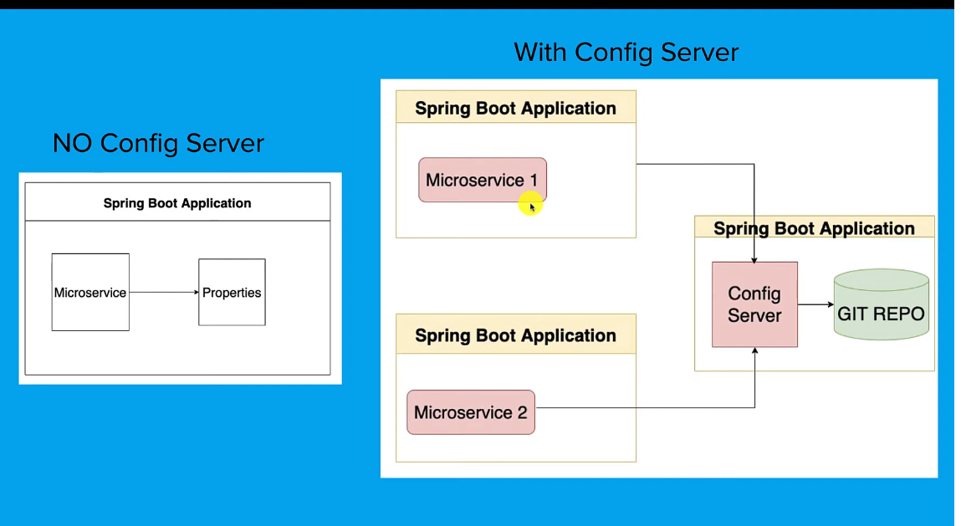

Circuit breaker
===============

while calling different microservice from one service to another we may face network failures.

While calling one microservice to another microservice there may be change to get network failures or down time
to handle this issue we have ciruit breaker
keep calling will execeed to thread pool will busy

for this we need to use “resilience4j dependency”

Spring cloud resilience4j framework
=============================
there will circuit breaker factory and circuit breaker interface
circuit breaker ->open cirucuit to stop calling service
rate limiter ->limit number of calls
bulk head ->maximum concurrent calls
retry

spring boot app ->circuit breaker interface <- resilence4j implementation <- hystrix implementation (netflix framework) <- sentinel implementation

circuite braker heps us to reduce the unwanted call if we face any network failures.

Api Gateway
==========
without using api gateway
->hardcoded url
->cross cutting concerns (common function like login logout)
->correlation id (used for tracking perpose)
->Authentication
->authorization

with gateway
-----------------
- service discovery finds the url and give url back to api gateway will call that service.
- Service discovery -> gives the host and port of the service
- which helps to route any urls

Advantages
--------------
->no hardcoded url
->cross cutting concerns (common function like login logout)
->correlation id (used for tracking perpose)
->Authentication
->static /dynamic routing
->metrics (limitation handle)

common api gateways in market
---------------------------------------
spring cloud zuul - open source
apigee api managment – google
aws api gateway -amazon
azure api gateway – microsoft

zuul api gateway

to perform gateway (spring cloud zuul dependency, service discovery client)

@EnableZuulPRoxy
@EnableDiscoveryClient

sample :https://github.com/Manonmani13/EverySiteProgramPractice/tree/main/Microservice

