Kafka
Introduction
In today’s world, data is the main ingredient of internet applications and typically encompasses the following:
- Page visits and clicks
- User activities
- Logs Monitoring
- Events corresponding to logins
- Social networking activities such as likes, shares and comments
What is Event Stream?
- Event streaming is the practice of capturing data in real-time from event sources.
- Sources can be databases, sensors, mobile devices, cloud services, and software applications.
- Storing these event streams durably for later retrieval; manipulating, processing, and reacting to the event streams in real-time as well as retrospectively; and routing the event streams to different destination technologies as needed.
- Using Event streams we can keep right information at right place at right time
Uses of Data
Application data can be used to run analytics in real time serving various purposes, some of which are:
- Delivering advertisements
- Tracking abnormal user behaviors
- Displaying search based on relevance
- Showing recommendations based on previous activities
What is Apache Kafka?
- Apache Kafka is a distributed streaming platform.
- Apache Kafka is used to process real-time data feeds with high throughput and low latency.
Examples: flights data, sensors data, stocks data, news data, user activities, etc.
- Kafka works based on the Publisher and Subscriber model.
- Kafka was originally developed at LinkedIn in 2011.
Ex: WhatsApp group
One person sends message → many people receive it

How Kafka Works?
- Apache Kafka is a distributed streaming platform.
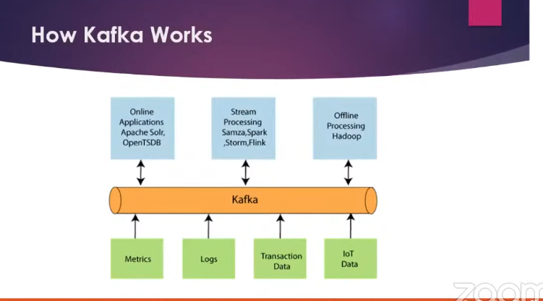
- At its core, it allows systems that generate data (called Producers) to persist their data in real-time in an Apache Kafka Topic.Any topic can then be read by any number of systems who need that data in real-time (called Consumers).Kafka is a Pub/Sub system. Behind the scenes, Kafka is distributed, scales well, replicates data across brokers (servers), can survive broker downtime, and much more.
Spring Boot + Apache Kafka Application
========================================
Step-1 : Download Zookeeper from below URL
URL :
http://mirrors.estointernet.in/apache/zookeeper/stable/

Step-2 : Download Apache Kafka from below URL
URL :
http://mirrors.estointernet.in/apache/kafka/

Step-3 : Set Path to ZOOKEEPER in Environment variables upto bin folder

Step-4 : Start Zookeeper server using below command from Kafka folder
Command :
zookeeper-server-start.bat zookeeper.properties
Note :
Above command will be available in kafka/bin/windows folder.
Note: zookeeper.properties file will be available in kafka/config folder. You can copy zookeeper.properties and server.properties files from kafka/config folder to kafka/bin/windows folder.
Step-5: Start Kafka Server using below command from Kafka folder
Command :
kafka-server-start.bat server.properties
Note: server.properties file will be available in config folder (Copied to windows folder)
Step-6: Create Kafka Topic using below command
Command :
kafka-topics.bat --create --zookeeper localhost:2181 --replication-factor 1 --partitions 1 --topic demo-sbms-topic
Step-7: View created Topics using below command
Command :
kafka-topics.bat --list --zookeeper localhost:2181

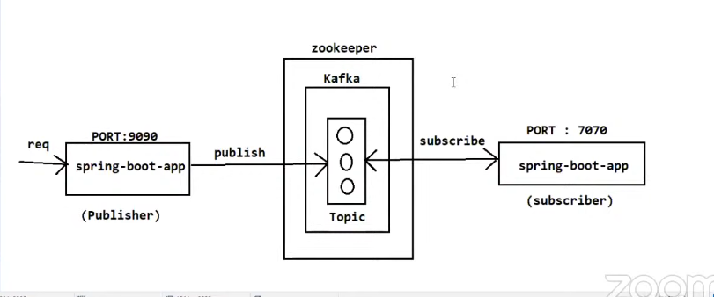
Topic & Partition
**************
- A Topic is a logical category where messages are stored.
- Internally, a topic is divided into Partitions.
- Each partition is an append-only log.
- Messages inside a partition are ordered.
- Kafka achieves parallelism & scalability using partitions.
- One topic → multiple partitions → distributed across brokers
- Like folder name.

Example:
- order-topic
- payment-topic
Use Case
Separate order events from payment events.

Producer
**********
- Producer sends data to Kafka topics.
- Producer decides:
- Topic
- Partition (optional)
- Key (optional)
- Messages are asynchronous by default.

Use Case
- Microservice publishes events
- Decouple services
- High throughput

Ex:
{
"orderId": 101,
"status": "CREATED"
}

Consumer
***********
- Consumer reads messages from Kafka
- Consumers belong to a Consumer Group
- In one group:
- One partition → one consumer only
- Offset remembers where consumer stopped

Real-life Example
***************
Inventory Service → reduces stock
Email Service → sends mail
Both consume the same order event, independently.

Consumer Group
**************
- Consumer Group = load balancing unit
- Same group → share partitions
- Different group → read full data independently

Why Kafka exists?
Benefits:
- Order service sends message once
- Kafka stores it safely
- Other services read independently
- If one service is down → no data loss

👉 THIS is why Kafka exists

Partition
*********
Topic is divided into partitions.
Why?
- Parallel processing
- High performance
Use Case
If you get 10,000 orders per second:
- One partition = slow
- Three partitions = process in parallel

OFFSET MANAGEMENT
***********************
Offset = number assigned to each message in a partition
It tells Kafka which messages are already read
Offset is maintained per consumer group
Stored inside Kafka (__consumer_offsets)

👉 Offset decides data loss or duplicate data

Use Case
Why offset is needed?
Application crashes
Restarts
Kafka should know where to continue
Without offset → Kafka doesn’t know what you processed.

Real-time Example
**********************
Order processing service:
Order 101 processed
Order 102 processed
Crash happens before commit

👉 After restart:

If offset committed → start from 103
If not committed → 102 will be processed again

REPLICATION & FAULT TOLERANCE
*********************************
Kafka copies data across brokers
Each partition has:
Leader (handles read/write)
Followers (backup)
If leader fails → follower becomes leader

Use Case
Why replication?
Server crash
Network failure
Hardware issues
Kafka must not lose data

Real-time Example

Bank transaction events:
Broker-1 goes down
Broker-2 takes over
No transaction lost

DELIVERY GUARANTEES
**************************
Kafka provides 3 delivery guarantees:
Type | Meaning
At-most-once | Message may be lost
At-least-once | Message may be duplicated
Exactly-once | No loss, no duplicate

Use Case
******

Scenario | Guarantee
Logs | At-least-once
Email | At-least-once
Payments | Exactly-once

Real-time Example
***************
Payment service:

Duplicate message → duplicate payment ❌
So Exactly-once is required

ERROR HANDLING & RETRY
******************************
Consumer can fail due to:
DB down
Bad data
Network issue

Kafka allows:
Retry
Backoff
Dead Letter Topic (DLT)

Use Case
********
Why retry?

Temporary failures should not lose data
Bad messages should be isolated

Real-time Example

Order has invalid productId:

Retry 3 times
Still fails
Send to order-events-DLT

SERIALIZATION & DESERIALIZATION
**********************************
Kafka sends bytes
Objects must be converted to bytes
This is done using:
Serializer (Producer)
Deserializer (Consumer)

Use Case

Java object → JSON → Kafka
Kafka → JSON → Java object

KAFKA ARCHITECTURE
************************
Kafka is not a single server. It is a CLUSTER of servers.

Important Components

• Broker – One Kafka server
• Cluster – Group of brokers
• Controller Broker – Manages leader election
• Topic – Logical message category
• Partition – Physical log file
• Leader Partition – Handles reads/writes
• Follower Partition – Backup
• ISR (In-Sync Replicas) – Replicas fully synced with leader

Zookeeper vs KRaft

• Old Kafka → Uses Zookeeper
• New Kafka (2.8+) → Uses KRaft (Kafka Raft)
• KRaft removes Zookeeper dependency

Use Case (Why needed?)
-------------------------
Why architecture matters?
• Server crash
• Network failure
• Horizontal scaling
• Zero data loss

Kafka must elect new leader automatically.

Real-time Example

Bank transaction topic:
• Partition-0 leader = Broker-1
• Broker-1 crashes
• Broker-2 (follower) becomes leader
• Transactions continue
👉 No downtime, no data loss
PRODUCER INTERNALS
**********************
Producer controls how messages are sent.

Important configs:
• acks – when Kafka confirms write
• batching – multiple messages together
• linger.ms – wait time before sending
• compression – gzip, snappy
• idempotence – avoid duplicates

Kafka Consumer Internals
**********************
Consumer internals explain HOW Kafka consumers actually work behind the scenes:
- How they join a group
- How partitions are assigned
- How offsets are managed
- How rebalancing happens
- How consumers poll and commit
Consumer Group
******************
A consumer group = multiple consumers working together to read a topic.
Rules:
- One partition → consumed by only ONE consumer in a group
- Multiple groups → each group gets full data
Why needed?
- Parallel processing
- Scalability
- Fault tolerance

ISR (In-Sync Replicas) & min.insync.replicas
*************************************
When a partition is replicated:
- 1 Leader
- Multiple Followers
ISR = List of replicas that are fully caught up with the leader.
If a follower is slow or not synced → it is removed from ISR.
min.insync.replicas
Ex: acks=all

Then Kafka requires minimum ISR count to confirm write.
If ISR < min.insync.replicas → Producer gets error.
Use Case
-------------
Why needed?
To prevent data loss when brokers are failing.

Log Structure Internals
*******************
Kafka is basically a distributed commit log system.
Everything in Kafka is stored in logs.

Each partition is stored as:
log segments
index file
time index file
Kafka does NOT store all data in one file.
It breaks into segment files.
Each segment:
- 1GB default
- Sequential write
- Very fast
High Watermark (HW)
Consumer can only read committed messages below HW.
Use Case
-----------------
Why segment?
- Fast disk writes
- Easy cleanup
- Easy retention
Real-Time Example
Order topic retention = 7 days
After 7 days → old segment deleted automatically.

Log Compaction
**************
Log compaction keeps only latest value per key.
Old records removed.
Example:
Key=101 Status=CREATED
Key=101 Status=SHIPPED
Key=101 Status=DELIVERED
After compaction:
Key=101 Status=DELIVERED
Use Case
********
Used when:
- Maintaining latest state
- User profile data
- Configuration storage

Real-Time Example
****************
User profile updates.
You don’t need old name changes.
You only need latest profile.

Rebalancing
**********
Rebalancing happens when Kafka redistributes partitions among consumers in the same consumer group.
Rebalance happens when:
- New consumer joins
- Consumer leaves
- Consumer crashes
- Partition count changes
- Consumer doesn’t poll in time
During rebalance:
- Partitions revoked
- Reassigned
- Processing stops temporarily
Real-Time Example
3 partitions
2 consumers
Consumer-1 → P0, P1
Consumer-2 → P2
Now 3rd consumer joins → Rebalance happens.

Consumer Internals
****************
Consumer works using:
poll()
Poll does:
- Fetch data
- Send heartbeat
- Join group
- Trigger rebalance
- Commit offset
Important configs:
- max.poll.records
- max.poll.interval.ms
- session.timeout.ms
- heartbeat.interval.ms
If consumer doesn’t poll in time → removed from group.

Use Case
-------------
Long processing jobs must adjust max.poll.interval.

Real-Time Example
--------------------
Consumer takes 10 minutes to process one record.
Default max.poll.interval = 5 min
→ Kafka kicks consumer out
→ Rebalance happens
→ Duplicate processing

Exactly Once Semantics
*********************
To prevent duplicates:
Kafka provides:
- Idempotent Producer
- Transactions
Idempotent Producer
Prevents duplicate writes during retries.
enable.idempotence=true
Transactions
Multiple topic writes become atomic.
transactional.id=my-tx

Use Case
Payment system
Bank transfers
Inventory deduction

Real-Time Example
Payment service:
Debit amount
Send confirmation
If crash happens in middle → transaction rollback.
No duplicate charge.

Kafka Streams
***************
Kafka Streams = Stream processing library.
Allows:
- Filtering
- Aggregation
- Join
- Windowing
Works inside Java app.

Use Case
Real-time analytics.

Real-Time Example
Count number of orders per minute.
Stream:
groupBy()
windowedBy()
count()

Schema Registry
*************
Instead of JSON, use:
- Avro
- Protobuf
Schema stored in central registry.
Supports schema evolution.

Use Case
------------------
Microservices must agree on message structure.

Performance Tuning
*****************
Important tuning:
Producer:
- batch.size
- linger.ms
- compression
Broker:
- num.network.threads
- num.io.threads
Consumer:
- fetch.min.bytes
- max.poll.records

Use Case
**************
Handle 1 million messages per second.
Real-Time Example
E-commerce during Big Billion Day sale.
High throughput required.

