Why string is immuntable?
-------------------------------------------
String s2=new String(“MAno”) -> store in heap memory
String s=”mano”->String pool
s=”Manonmani”-> if you change like this .it will create new Space (point) and point to Manonmani

Memory
----------
stack area -> which store primitve data types and refernece of non primitive data type.
->organized with first in first out.
->used for static memory allocation
->this inculdes function call,local variable,and control flow.
->it allocate and deallocate memory by system.
->smaller size compare to heap
->we can access it very fast.
Heaparea-> memory is used to store objects like(array,functions)
->organized in complex manner
->use dynakic memory allocation
->creates memory at runtime for new in c++ or malloc in C
->memory allocation or decallocation is done by programmer or by garbage collector.
->larger than stack. It can grow and shrink for needed memory
->it slower compare to stack

String Pool
->string pool is inside the heap area
->string literal will store in string pool
->string object will store in heap area
-> it will point out same reference if string name is same

Multi Thread
--------------------
->process of exuecting multiple task at same time.
->light weight process
->share memory area
-> does not allocate memory so save space
->ex:animation ,games
->save times
->doesnot lock user and it doesnot affect another thread if any exception raised becasue thread is independent
->smallest unit of execution with in process
->thread class extends Object class and implement runnable interface
->thread methods:start(),run(),sleep(),currentThread(),join(),getpriority(),setPriority(),getName(),getID(),isAlive(),yield() ,stop(),suspend(),resume(),destory(),interupt(),isinterrupted(),interrupted(),activeCount(),checkAccess(),holdLock(),getState(),getThreadGroup(),toString(),notify(),notifyAll()
->start() used to start execution of thread
->run() used to do an action
->sleep() sleep thread for specific time
->currentThread() return reference to current executing thread object
->join() -> waits for thread to die
->getPriority() returns the priority of thread
-> setPriority() change the priority
->yield() used to pause thread and execute other thread for tempory
->notify() used to give notification for sepecific thread which is waiting for object.
->notifyAll() used to give notification for all waiting threads

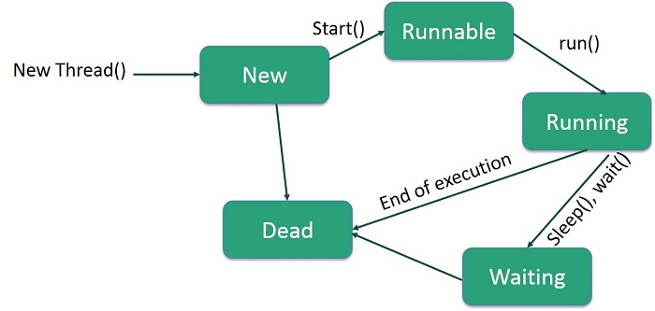

Thread Life Cycle
-------------------------
new -> new thread is created, it is always in new state
start->when this method means it is in active state.
Runnable->thread ready to run state
running -> thread gets the cpu it moves to running state
sleep-> sleep for some times
dead->terminate whenever action finish
abnormal termination->whenever exception raised

How to create Thread
---------------------------------
-> 1.extending thread class
->2.by implementing runnable interface
->Thread constructor 1.Thread(),2.Thread(String),Thread(Runnable),Thread(Runnable,String)
->Runnable thread have only one method that is run()

Thread Scheduler
----------------------
-> that decides which thread to run or execute and which thread to wait is called a thread scheduler.
->if more than one thread in the runnable state it is up to the thread scheduler to pick one of the threads and ignore the another thread.
-> it decides to run thread which thread execute first
->two factor for scheduling thread (priority, time of arrival)
->priority of thread between 1 to 10
->if two thread have same priority then it will check arrival time.

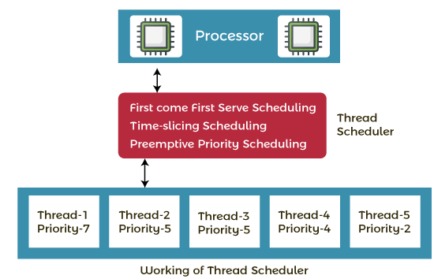

Process
----------
->process is independent program
-> each process has its own memory
->process not share memory directly to another process
->inter process communication is need for exchange data between process
->process managed by os
->handles scheduling,resource allocation,and isolation
->it is heavey
->process is isolated because it is does not affect it any crash it happend

Join()
--------
->it is from java.lang package
->permits the developer to mention waiting period
-> it dependent on os for timing
->waits equal time to the execute

Priority
-------------
Min_Priority -10
Max_priority -1
Norm_priority -5

Daemon Thread
---------------------
-> it is serivce provider thread and provide service to user thread.
->ex: when all the threads dies ,jvm thread thread automatically.
->low priority thread
-> it life depends on user thread

Thread Pool
--------------------
-> it represent group of worker thread that waiting for the job and resused many times.
->group of fixed size threads is created
->thread is pulled out and assigned job by service provider.
->methods newFixedThreadPool(int s) create thread pool with fixed size,
newCachedThreadPool() create new thread pool
->better performance,save times there is no need to create new thread.
-> used in servlet ,jsp

DeadLock
-----------------
-> it comes from any program which involves multithreading
->All thread are executing are waiting for result from thread that are blocked and waiting stage
-> it is called non avaliability of thread for the execution

Thread Leakage
----------------------------
-> when thread remove from the pool to execute task but it is not returning to it after the completion of the task.
-> example: if any thread throws exception and it is not handle by the program then the thread exit and reduce thread pool size by 1.

Thread Group
------------------------
->group thread in single object
->we can suspend,resume or interrupt a group of threads by single call
->implements by java.lang package
->Constructor ThreadGroup(String name) -> group with name
-> ThreadGroup(ThreadGroup,String) -> group with given parent group and name
->methods checkAccess(),activeCount(),activeGroupCount(),destory(),enumerate(),getMAxPriority(),getName(),getParent(),interrupt(),isDeamon(),setDaemon(),isDestory(),list(),stop(),resume(),toString(),suspend(),setmaxPriority().

Gargebage Collector
------------------------------
-> process of collecting unused memory
->it is automatically performed by java
->removes unreferenced ojects from heap area
->it makes memory efficient
->unreference object -> nulling referece ,assigning reference to another ,anonymous object
->finalize() method is invoked by garbage collector used for clean up process.
->gc() used to perform clean up procesing
-> gc() from system and runtime classes

Shutdown Hopk
-------------------------
-> developer wrote code to when the jvm studown is know as shutdown hook.
-> need to perform cleanup work
-> kill request generated by os or reource allocation because of lack of memory then studown hook slove the problem
->java.lang package
invoke method from Runtime.getRuntime().addShutdownHook(Thread)

Aspect | Processes | Threads
Definition | Independent units of execution with their own memory space. | Smaller units of execution within a process.
Memory | Each process has its own separate memory space. | Threads within the same process share the same memory space.
Creation Overhead | Higher overhead due to memory and resource duplication. | Lower overhead as threads share resources and memory.
Communication | Requires Inter-Process Communication (IPC) like pipes, message queues, or shared memory. | Easier communication as threads share the same memory space.
Resource Management | Managed by the operating system, which handles scheduling and resource allocation. | Managed within the process; requires synchronization mechanisms.
Isolation | Strong isolation; faults or crashes in one process do not affect others. | Less isolation; faults in one thread can affect the entire process.
Scheduling | Scheduled independently by the operating system. | Scheduled by the operating system within the context of the parent process.
Synchronization | Not typically required for IPC, but may need synchronization for shared resources. | Requires synchronization to manage shared resources and avoid race conditions.
Context Switching | Context switching between processes involves saving and loading process states, which is costly. | Context switching between threads is less costly as they share the same memory space.
Fault Tolerance | More fault-tolerant; crashes or issues in one process are contained within that process. | Less fault-tolerant; issues in one thread can potentially affect the entire process.
Resource Sharing | Limited to IPC mechanisms for sharing resources. | Direct access to shared resources within the same process.

Exception Handling
-------------------------
->exception means is abnormal condition
-> exception is an event that distrupts the normal flow of the program.
->handles runtime errors such as classNotFoundException,IOException,SQLException,RemoteException
->there are two type exception checked exception and unchecked exception, error

checked exception
----------------------
-> inherit the throwable class except RuntimeException and error are know as checked exception
->ex:IOException,SQLException, etc
->checked exception checed at compile time

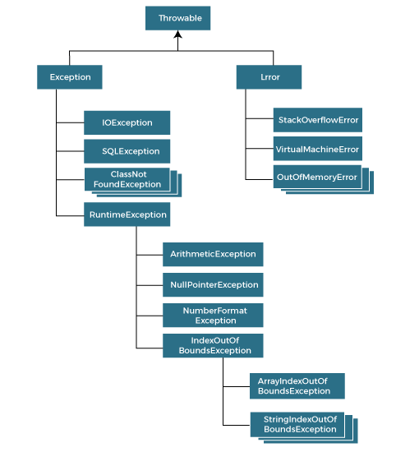
Unchecked Exception
-------------------------------
-> inherit the runtime exception know as uncked exception
->ex : arithmeticException,NullPointerException,ArrayIndexOutOFBoundException etc.
-> exception is not checked at compile time

Error
---------
-> error is irrecoverable
->errors are outofmemoryError,VirtualMachineError, AssertionError etc.

Exception Keyword
---------------------------
try,catch,finally,throw,throws
-> try we have to place exception code . We cant use try block alone,
-> try block followed by catch or finally block
catch-> used to andle exception .
-> we cannot use catch block without try
finally->execute the necessary code
->it will execute whether an exception is handle or not
throw -> used to throw exception

throws->used to declare exception
->exception may occur in method
-> doesnt throw exception
->used with method signature

Throw
------------
-> we can create customize exception
->used to thrwo exception

Serialization
------------------
->writing the state of object into byte stream.
->used in hibernate ,jpa
-> it is platform independent
-> it means serialize on one platform and deserizlize on different platform
-> implements serizlizable interface
-> travvel object state on the network
-> it is frim java.io package
->it is marker interface
-> must be implemented by the class whose object needs to be persisted
->deseriakuze means convert byte stream to object.
-> it is associate with serialable class which is known as serialVersionID
->serialVersionId verify sender and receiver of serialze object

Transient
-------------
-> if you dont want serialize any data member of class you can use it
-> ex: user login details with password but we dont wont to store original data in file
->so we can use transient key
->jvm reads transient key it ignores the original values instead of the that store default value

FileOutputStream
---------------------------
->is an ouput stream used to writing data to a file.
-> if youu want to write primitive values into a file
->you can write byte - oriented as well as character oriented
-> it is from java.io
methods finalize(),write(byte arr[]),write(byte [] arr,int off,int len),write(int ),getChannel(),getFD(),close()

FileInputSteam
------------------------
->class contains input bytes from file
->used to read byte data ,image,audi ,video etc.
-> it is from java.io package
->avaiable(),read(),read(byte[] b),read(byte [] arr,int off,int len),read(int ),getChannel(),getFD(),close()

BufferedOutputStream
---------------------------------
->used for buffering output stream
->uses buffer to store data.
->more effiency than to write in stream
-> bufferedOutputStream(OuputStream os),bufferedOutputStream(OuputStream os,int size)
->write(int b),write(byte [] b,int off,int len)

BufferInputStream
----------------------------
->it is used to read information from stream.
->performance fast
->internal buffer array is created
->from java.io package
->constructors ->BufferInputStream(inputStream is),BufferedInputStream(InputStream IS, int size)
->avaiable(),read(),read(byte [] arr,int off,int len),close(),reset(),mark()

SequenceInputStream
-------------------------------
->it is used to read data from multiple streams.
-> it is from java.io. Package
-> SequenceInputStream(inputStream s1,inputStream s2),SequenceInputSream(Enumeration e)
-> methods read(),avaliable(),close()

ByteArrayOutputStream
------------------------------
-> it is used to write common data in multiple files
->data written int byte array which can be writen multiple times in stream.
->it has copy of data and forwards to multiple streams.
->automatically grow according to the data
-> it is from java.io package
->constructors ByteArrayOutputStream() -> creates new byte array output stream with capacity 32,
ByteArrayOutputStream(int size) > creates new byte array output stream with specified size
-> methods size(),toByteArray(),toSTring(),toString(String charsetNAme), write(int b), reset(),close()

ByteArrayInputStream
----------------------------------
-> it is componation of ByteArray and inputStream
-> used to read byte array as input stream
->it has interanal buffer which is used to read byte array as stream
->it grow according of data
-> java.io package
-> constructor ByteArrayInputStream(byte),ByteArrayInputStream(byte[] ar,int of,int len)
->read(),markSupport(),close(),reset(),mark()

DataOutputStream
-------------------------
->allows application to write primitive data type
-> use data output stream to write data that can be read by a data input
-> from java .io package
-> size(),write(),writeBoolean(),writeChar(),flush()
DataInputStream
-----------------------
-> used to read primitive data type
->uses data output stream to write data can be read by data input stream
-> java.io package
->read(),readInt(),readByte(),readChar()

FileOutputStream
--------------------------
->implements OutputStream class
-> provides different subclass bufferedOutputStream and DataOutputStream
->java .io pacjage
-> methods : write(int b)flush(),close().

FileInputStream
-------------------
-> implements inptStream class
-> provides different subclass bufferedInputStream and DataInputStream
->java .io pacjage
-> methods : read(),reset(),close().

ObjectStream
---------------------
->class act as a serialization descriptor for class.
-> class contains SerialVersionUID and name of the class.
->getField(),getNAme(),getSerialVersionUID().

ObjectStreamField
-------------------------
-> used to declare the serializable field of the class
->from java.io
->constructor ObjectStreamField(String name,class type),ObjectStreamField(String name,Class type, boolean unshared)
->compareTo(),getName(),GetOffset(),getType(),toSTring().

FileWriter
---------------
->used to write character oriented data to file
->which is used for file handling
->package from java.io
->fileWriter(String name),FileWriter(File)
->write(char c[]),flush(),close()
FileReader
---------------
->used to read data from the file
-> returns byte format like FileInputStream class
-> used for file handling
-> from java.io package
->if the file is not there it will throw file not found exception
->FileReader(String) ,FileReader(File)
->methods read(),close().

BufferedWriter
-----------------------
->used to provide buffering for writer instance
->makes performance faster
->inherts the writer class
->java.io package
->BufferedWriter(Writer),BufferedWriter(Writer,int)
->newLine(),write(int c),flush(),close()

BufferedReader
-------------------
->used to read the text from a character based input stream
->used to read data line by line by readLine()
->make perfromance faster
->inherit reader class
->BufferedReader(Reader),BufferedReader(REader,size)
->read(),readLine(),ready(),reset(),close()
CharArrayReader
-------------------------
->composed of charArray and Reader
->used to read character array as reader
->inherts reader class
-> it is from java.io package

CharArrayWriter
------------------------
->class can be used to write common data to multiple files
->it inherits writer class
-> buffer automatically grows when data is written in this stream
->java.io package
->size(),toCharArray(),write(),flush(),rest(),close()
PrintStream
-------------------
->class provide method to write data to another stream
->automatically flush
->this method does not thrwo IOEXception
-> it is from java.io package
->print() ->every primitive type,println(),fomrat()

PrintWriter
----------------
->implementations of writer class
->it prints formatted representation of objects
->java.io package
->println(),append(CharSequence ),checkError(),setError(),clearError(),flush(),close()

OutputStreamWriter
------------------------
-> it is class
->convert character stream to byte stream
->character are encoded into byte using specified charset
->optimize the performance of outputStreamWriter by using it with in BufferWriter
->OutputStreamWriter(OutputStream) ,OuputStreamWriter(OuputStream,Charset)
->cllose(),flush(),getEconding(),write(cha[],int off,int len)

InputStreamReader
------------------------
-> it is bridge from byte stream to character stream
->it reads bytes and decodes them into character
->close(),read(),ready(),getEncoding()

PushbackInputStream
------------------------------
-> it is class overrides inputStream
-> provide functionality to another input stream
->it can unread because if already read and push back one byte.
->java.io package
->avaiable(),read(),mark(),skip(),reset(),close().

PushbackReader
----------------------
->class is character stream reader
->it is used to pushes back a character into stream overrides the fileReader
->java.io package
->read(),mark(),ready(),reset(),close()

StringWriter
-----------------
->inherits the writer class
->character stream collects output from string buffer.
->can be used to construct a string
->from java.io package
->writer(int c),toString(),getBuffer()flush(),close()

StringWriter
-------------------
->character stream with string as a source
->it takes input string and changes it into character stream
->inherits reader class
->system resource like network,sockets and files are not used
-> java.io package
->read(),ready(),skip(),reset(),close()

PipedWriter
--------------
-> it is used to write java pipe as stream of characters.
-> it is used generally for writer text
->connected to a PipedReader and used different threads.
->close(),connect(),flush()
PipedReader
--------------------
-> it is used to read content of pipe as stream of characters.
->class is used generally to read text.
->class must be connected to the same pipeWriter
->used by different threads.
->close(),connect(PipedWriter),read(),ready()

FileWriter
----------------
->abstract class
->used to write filtered character stream
->override some of its methods and provide additional methods and fields also
->close(),flush(),write(int c)
FilterReader
-------------------
-> used to filtering operation on reader stream
->it is an abstract class for reading filtered character straeam
->provides default method
->close(),mark(),ready(),read(),reset().

File
-------------
->it is an abstract representation of file directory
->pathname can be either absolute or relative
->file class have several methods for working with directory
->pathSeparator represents as a string for conveniences.
->constructors File(File,String),File(String),File(String,String),File(URL)
->createTempFile(String,String),createNEwFile(),canWrite()

Synchornized
--------------------
->control the access of multiple threads to any shared resource
->when we want touse only one thread to access shread resource
->prevent consistency problem
-> two types of synchronized: process,thread

Thread Synchronized
-----------------------------
->two types of thread synchornized
-> mutual exclusive 1.syncrhonized method,2.syncronized block, static synchronized
->cooperation

Mutal Exclusive
-------------------
->helps keep threads from interfering one with another while sharing data
->three way we can do
* synchronize method
* synchronize block
* static synchornize
-> it is used to lock object for any share resource
-> it is lock for object an release it when the thread completes its task.
->synchornized block is smaller than method
->it does not allow more than one jvm ,provide access control to a share resource.
->synchronize block is more efficient than java synchrinzied block

static synchronization
-----------------------------------
->static method a synchronized
-> lock will be on class not on object

InterThread Communication
----------------------------------
->allow syncrhonized thread to communicate with each other
->cooperation is one thread is paused running in its critical section and another thread is allowed to enter same critial section.
->it is implements by wait(),notify(),notifyAll()
Wait()
-------------
->current thread to release the lock and wait unitil another thread invoke notify method
->wait until object notify
->wait(),wait(long tiime)

notify()
------------
->wakes up single thread waiting on this object’s monitor.
->if any thread is waiting on object then one of them choosen to awaken.

NotifyAll()
------------------
->wakes up all threads waiting in object’s montior
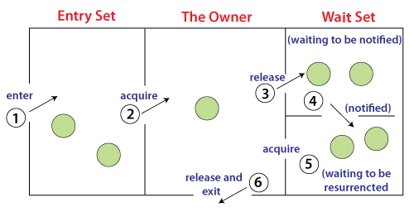

wait() | sleep()
The wait() method releases the lock. | The sleep() method doesn't release the lock.
It is a method of Object class | It is a method of Thread class
It is the non-static method | It is the static method
It should be notified by notify() or notifyAll() methods | After the specified amount of time, sleep is completed.

Interrupting thread
------------------------
->thread is in sleeping or waiting state call method interrupt() it breaks that state.
->interrupt(),interrupted(),isInterupted()
Collection
------------------
-> it is framework that prvoide architecture
->to store andmanipulate group of objects.
->you can perform serachig,sorting,insertions,manipulation and deletion.
->it is single units of object.
->it provide many interfaces
->set,list,queue and classes are ArrayList,vector,linkedList,PriorityQueue,Hashset and etc.
->represent set of classes and interface.
-> from java.util package
->add(),addAll(),remove(),removeAll(),removeIF(),size(),contains(),clear()
List
-----------
->it is child interface of collection interface
->which can store the ordered collection of objects
->list interface is implemented by classess ArrayList,LinkedList,Vector and stack.
->java.util package
->duplicate elements also

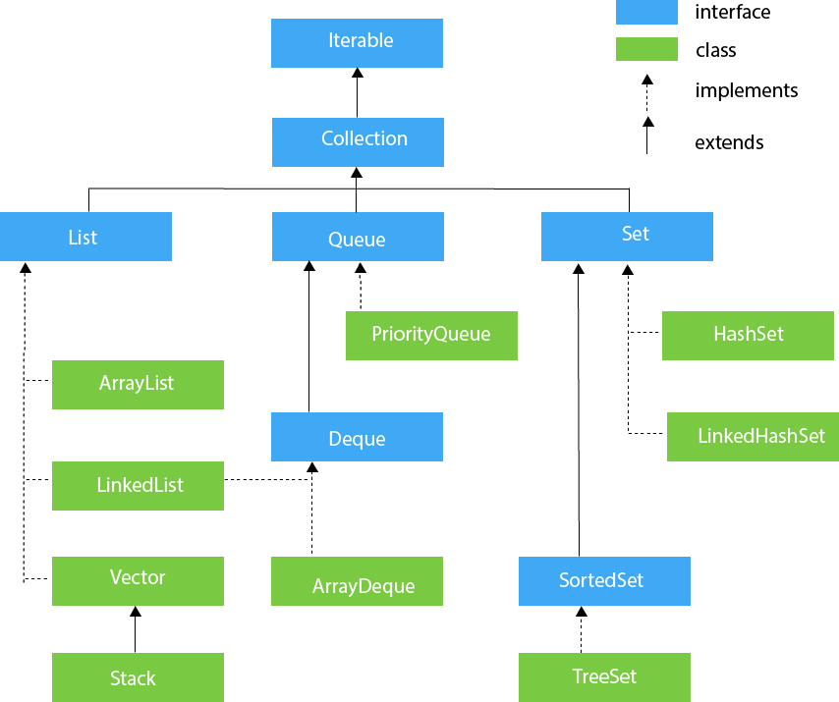
ArrayList
-------------------
->it is implements the list.
->it uses dynamic array to store the duplicate elements of different data types.
-> it maintains insertion order
-> it is non synchronized
->class can be randomly accessed.
-> there is no size limit
->from java.util package
->manipulation it is slower than linkedlist because of lot of shifting needs to occur if any elemeent removed
->we cannot create list of primitve data types
->add(),addAll(),clear(),get(),sort(),size()
->better for access data
-> it is contiguous

LinkedList
----------------
->it is implements the list.
->it uses a doubly linked list
->store the duplicate elements
-> it maintains insertion order
-> it is non synchronized
->manipulation is fast
->Add(),addAll(),clear,get(),getFirst(),getLAst(),pop()
->better for manipulation data
-> it is not contiguous
Vector
------------
-> it uses dynamic array to store the data elements
-> it is synchronized
-> it contains many methods
->found in 1.2 java
->java.util package
->add(),addAll()clear(),clone(),size(),get(),set()
Statck
------------
->statck is subclass of vector
->implements last in first out data structure.
->stack contains all the methods of vector class
->provides methods like push(),pop() etc.
->java.util package
Queue
-----------
->it is interface
->maintains the first in first out order.
->ordered list
->various class like priorityQueue ,Deque and ArrayDeque implements Queue.
->it is from java.util package
->follows first in first out
->add(),offer(),remove(),poll(),element(),
PriorityQueue
---------------
-> it implements queue
-> hold the elements or object which are to be processed by priorities
->doesnt allow null values.
->from java.util package
Deque
---------
->deque interface extends the queue interface
->remove and add elements from both side
->deque stands for double ended queue
->from java.util package
->first in first out supported
->add(),offer(),remove(),offerFirst(),offerLAst()
ArrayDeque
----------------
->arrayDeque class implements queue
->unlike queue, we can add or delete the elements from both side.
->it is faster
-> null element are not allowed
-> not thread safe
-> from java.util package
Set
-----
->it is present in java.util package
->extends the collection interface
->it is unordered set of elements
-> does not allow duplicate
-> we can store atmost one null value in set
->it implements by hashSet,LinkedHashSet and treeSet.
HashSet
------------
->implements set interface
->uses hash table for storage
->hashing is used to store element in hashset
->unique elements
->inherits abstractSet class implements set interface
->allows null values
-> non synchronized
-> doesnt maintain insertion order
->elements are inserted based on hashcode
->add(),clear(),size(),contains(),remove()
LinkedHashSet
-------------------
->non synchornied
->extends hashset and implements set
->unique elements
->maintains insertion order
->permits null value
->java.util package
SortedSet
--------------------
->it is alternate of set total ordering on its elements
->are arranged in the increasing (ascending) order
->provide addtional method for orderings elements
TreeSet
------------
->implements set interface
->inherits AbstractClass and implements navigable set
->unique elements
->access and retrieval time of treeset is quite fast.
->stored in ascending order.
->non synchronized
->doesnt allow null values
->java.util package
->add(),addAll(),isEmpty(),first(),last(),size()
Map
---------
->contains values on the basis of key and value pair
->key and value known as entry.
->map contains unique key
->have to search,update or delete eleements basis of key.
-> two interface for implementing map and sortedmap
->three classes hashmap,linkedhashmap and treemap
->doesnt allow duplicate keys
->you can have duplicate values
->put(),putIfAbsent(),remove(),clear(),forEach(),get(),size().
HashMap
---------------
->it implements map interface
->it store key and value pair
->key should be unique
->if we give same key again it will replace values.
->java.util package
->not synchronized
->only one null key and may contains multiple null values
->maintain insertion order
->used hashing technique
->clear(),isEmpty(),clone(),put(),putAll(),remove(),forEach(),size().
Hashing
-------------
->process of converting an object into integer values
->used for indexing and faster seraches.

LinkedHashMap
----------------------------
->class is hashtable and linkedlist implementation of map interface
->inherits hashmap class and implements map interface
->values based on the key
->contains unique key
->have one null key and multiple null values.
-> non synchronized
->maintains insertion order
->class is 16 with loader factor 0.75
->java.util packages
->get(),clear(),containsValue(),forEach(),getOrDefault()
TreeMap
------------------
->used to store key value pair
->implements the navigablemap interface and extends AbstractMap class.
->unique elements
->cannot have null key and can have multiple null values
-> it is non synchronized
->maintains ascending order
->java.util package
->clear(),clone(),comparator(),forEach(),putAll(),replace(),firstKey(),remove(),size().

HashMap | TreeMap
1) HashMap can contain one null key. | TreeMap cannot contain any null key.
2) HashMap maintains no order. | TreeMap maintains ascending order.
Hashtable
--------------
->hashtable implements hashtable
->maps key to values
->inherits Dictory class
->it is array of list
->contains values based on key
->doesnt allow null key or value
-> it is synchronized
-> it is from java.util package
->clear(),equals(),forEach(),getOrDefault(),put(),putAll(),toString(),size(), get().

HashMap | Hashtable
1) HashMap is non synchronized. It is not-thread safe and can't be shared between many threads without proper synchronization code. | Hashtable is synchronized. It is thread-safe and can be shared with many threads.
2) HashMap allows one null key and multiple null values. | Hashtable doesn't allow any null key or value.
3) HashMap is a new class introduced in JDK 1.2. | Hashtable is a legacy class.
4) HashMap is fast. | Hashtable is slow.
5) We can make the HashMap as synchronized by calling this code  Map m = Collections.synchronizedMap(hashMap); | Hashtable is internally synchronized and can't be unsynchronized.
6) HashMap is traversed by Iterator. | Hashtable is traversed by Enumerator and Iterator.
7) Iterator in HashMap is fail-fast. | Enumerator in Hashtable is not fail-fast.
8) HashMap inherits AbstractMap class. | Hashtable inherits Dictionary class.

EnumSet
-------------
->inherits AbstractClass and implements set interface
-> it is from java.util package
->it is special set for enum types.
->allOf(),copyOf(),noneOF(),range()
->java.util package
EnumMap
-----------
->implemented for enum keys
->inherits enum and abstractMap classes.
-> from java.util package
->clear(),clone(),containKey(),containsValue(),entrySet(),get(),hashCode(),size(),put(),putAll(),
remove()
Collection Class
-------------------------
->it is used with static methods that operate on the collection.
->inherits object class.
->throw null pointer exceptions if the collection object is null
->java.util package
->addAll(),asLifoQueue(),binarySearch(),checkedCollection(),checkedMap(),checkedQueue(),chekedSet(),copy(),fill()list(),max(),min(),rotate(),suffle(),sort()
Sorting in collection
-------------------------------
->can sort the element of String Objects, wrapper class,user defined class
->provides static method for sorting element
->java.util package
Comparable Interface
-------------------------------
->it is used to order the object.
->it is from java.lang package
-> it conatains only one method compareTo(Object)
->provide single sorting sequence only
->used to comapre current object with specified object.
->it will return +1,- 1, 0 .
->you can sort String,Wrapper class, user -defined class
Comparator Interface
------------------------------
->is used the objects of user – defined object.
-> from java.util package contains two method compare(object,object) and equals(object)
-> provide multiple sorting sequence
->reverse(),thenComparing()
Properites
------------
->contains key and value pair both as string
->java.util package
->subclass of hashtable
->class provide methods to get data from the properiteis file
->load(),getProperty(),list(),setProperty(),store()

ArrayList | Vector
1) ArrayList is not synchronized. | Vector is synchronized.
2) ArrayList increments 50% of current array size if the number of elements exceeds from its capacity. | Vector increments 100% means doubles the array size if the total number of elements exceeds than its capacity.
3) ArrayList is not a legacy class. It is introduced in JDK 1.2. | Vector is a legacy class.
4) ArrayList is fast because it is non-synchronized. | Vector is slow because it is synchronized, i.e., in a multithreading environment, it holds the other threads in runnable or non-runnable state until current thread releases the lock of the object.
5) ArrayList uses the Iterator interface to traverse the elements. | A Vector can use the Iterator interface or Enumeration interface to traverse the elements.
Iterator
------------------
->it is one of the cursor
->it is interface
->iterate over the collection of object
-> java util package from 1.2 version
->next(),hashNExt(),remove(),forEach
ConcurrentHashMap
-----------------------------
->hash table supports full concurrency of reterivals
->it obeys same functional specification as hashtable
->thread safe
->no support locking entire table
->clear(),entrySet()
ConcurrentLinkedQueue
--------------------------------
->it is unbounded
->thread safe
->arrange the eleement FIFO
-> it is iterator implements all opetional method queue and iterator method
->add(),addAll(),forEach(),contains(),size().
Java 8 Features
--------------------------
Lamda Expression
-------------------------
->help us to write code functional style.
->it is very useful in collection library.
->helps to iterate,filter and extract data.
->used to provide implementations of a interface which is functional interface
->saves lot of code
->syntax (argument – list) -> {body}
Functional Interface
--------------------------
->provide implementation of functional interface.
->which has only one abstract method is called functional interface
-> provide annotation @FunctionalInterface
Method Reference
-------------------------
->it is new fetature called method reference
->it is used to refer method of functional interface
->types of method reference * Reference to static method * Reference to an instance method *Reference to a constrctor
-> you can refer to static method defined
-> syntax : ClassName::staticMethodName
->can refer instance method
->syntax ClassName::instanceMethodName
->you can refer constructor by new keyword
syntax ClassName :: new
->java.util package
Stream API
---------
->new additional package in java 8 in java.util package
->package consists of classes,interfaces and enum to allow functional style
->it does not store any elements
->conveys elements from a source such as data structure, an array or an I/o channel
->stream does not modify its source
->it is lasy
->elements of the stream are visited only life time of stream
->you can use steam to fileter,collect,print,convert from one datastructure to another etc
->anyMatch(),allMatch(),builder(),collect(),count(),distinct(),filter()
Stream Filter
---------------------
->provide method to filter() to filter the elements
Base64 Encode and Decode
------------------------------------
->base64 deal with encryption
->can encrpty and decrypt your data
->java.util package
->decoder() ,encoder()
forEach
-----------
->new method forEach() to iterate the elements.
->default method define in iterate interface
->forEachOrder() method iterate element with specified order
Collectors
-------------------
->collectors class extends Object class
->provide reduction,acculating elements in collections,summarizing elements according to various critica
StringJoiner
----------------
->from java.util
->construct sequence of characters
->you can create string by passing delimiters like comma(,),hypen( - )
->add(),merge(),length()
optional class
--------------------
->used to deal with NullPointerExceptio
->java.util package
->used to check presence of value for particular variable
->empty(),of(),ofNullable(),get(),isPresent(),map(),flatMap(),orElse(),orElseGet(),orElseThrow()
Parallel Array
--------------
->new feature added in arrays class
-> use can sort array parallel
-> from java.util pacage
->parallelSort()
Wrapper Class
------------------------
->whose wraps or contains primitive data type
->we can wrap a primitive data type into wrapper class.
->types char,int,short,long,byte,boolean,float,double
Autoboxing
------------------
->convert primitive data type to wrapper class
Unboxing
-------------
->convert wrapper class to primitive data

Java 11 Features
------------------------------
1.Running Java file with single java command
-------------------------------------------------------------
-> from java11 version onwards, we can execute java file directly without performing compilation separatly.
-> with help of this command “Java Test.java”.
->if we provide more than one class with main() methods in single java file and if we execute that java file then jvm will search for the main() method class in the order in which we provide from starting point of the file to ending point, in which class jvm identitfies main() method first time then jvm will treat class as the actual main class and jvm will execute that mainclass.
Note: java11 version is providing backward compatibility, that is , in java 11 version ,we can follow the old convention like compilation of java file with javac and execution of the java program with java command.
2.New Utility Methods from String class
-------------------------------------------------------
->isBlank() check whether the string is blank or not
->lines() splits line terminators and return a stream.(“\n”)
->repeat(int count) used to duplicate or repeat string
->stripTraling()used to remove all leading white spaces from a string
3.Local variable syntax for lamda Expressions Parameter
------------------------------------------------------------------------------
->complier infers the type of variable at compile time
->allows to use var in lamda experssion and it can be used to apply modifiers to local variables
4.Collection to Array
--------------------------
->uses to convert a collection into a array
-> toArray() method is overloaded method
5.File API
-----------------
->readString(PAth, Charset),writeString(Path,CharSequence,OpenOption)
Not Predicate
----------------------
->negate an existing predicate similar to negate method
Optional Class
---------------------
->isEmpty() to check if value is present
->isPresent() check value is present or not

HttpClient
-----------------
->it is recommanded to use instead of other httpCleint api
->can make http request without using external dependency.
Nested Base Access Controll
-----------------------------------------
->private access with nest members directly no more auto generated bridge method
-> new classes apis: NestHost,NestMember,Nestmates
->getNestHost() is used to get the name of the nest host
->isNestmateOf() used to check whether a class is a nest mate
->getNestMembers() returns an array of nest members including classes and interface

Spring boot
----------------------
what is spring boot?
Spring boot is nothing but exsiting framework+some embeded http servers.(tomcat/jetty etc)
Xml or annotations configurations
why?
----
-> to ease the java based applications developement,unit test and integration test process
->to reduce development,unit test and integration test time by providing some defaults
->to increase productivity
why spring
----------------pg
-> the core features of the spring freamework can be used in developing any java application,but there are extensions for building web applications on top of the java EE platform
->spring framework target to make j2ee development easier to use and promotes good programming practices by enabling aPOJO based programming model.
3.Can we disable the default web server in the spring boot application?
-----------------------------------------------------------------------------------
spring.main.web-application-type=none
4.can we override or replace the embeded tomcat
----------------------------------------------------------------
yes you can do that with help of starter dependencies(spring boot starter.jetty) as depencendy
How to disable a specific auto configuration class?
-------------------------------------------------------------------
can use exclude attribute of @EnableAutoConfiguration
if you find any autoconfiguration classes that you do not want are being applied
@EnableAutoConfiguration(exclude=SecurityAutoConfiguration.class)
6.what does the @SpringBootApplication annonation do?
---------------------------------------------------------------------------
->it enables these features
@EnableAutoConfiguration : enable spring boot’s auto-configuration machanism
@CompoonentScan : enable @Component scan on the package where application is located
@Configuration: allow to register extra beans in the context or import additionalconfiguration class
7.@RestController
-----------------------
-> for creating restful controllers
->specialization of @Component and is autodetected through class path scanning
->it adds the @Controller and @ResponseBody annotations . It converts the response to JSON or XML.
8.Can we have multiple application properties in spring boot?
----------------------------------------------------------------------------------------
->using multiple application.properites files you can tell spring boot with which environment the application should start
->example is to configure two databases. One for dev and one for productive
9.difference between mvn clean package and mvn clean install
clean: deletes the target floder. So the same result for both commands
Package : converts your .java source code into a .jar/.war file and puts it into the target floder
install :first it does a packages.then it takes the jar/.war files and puts it into your local maven repository, which lives m2/repository.
Actuator
-------------------
actuator endpoints let you monitor and interact with your application
spring boot includes a number of built-in endpoints and less you add you own
for example , the health endpoint provides basic application health information
What is Api
-------------------
application programming interface.
-> it is set of protocols and tool building application software.
->sepecifies how the components should be interact
->apis are used when programming GUIcomponent
->there are many different types of apis for operating system,applications or websites .example:youtube apis,google apis.

Rest API
-----------
Representation state transfer api.
Rest api is http protocols which is used to send and receive data.
methods are get,post,put,delete.
ORM
------------
->object relational mapping
->it is programming technique.
->used to connect object code to a relational database.
->advantage we no need to write sql queries
->it will do CRUD Operation
-> different ORM tools are IBATS,Eclipse Link,Ebean,EJB,JPA and Java data object.

Hibernate Framework
-----------------------------------
->simplifies teh development of java application to interact with database
->open source, light weight , orm tools.
->simplifies data creations, data manipulation and data access.
Benenfict of Hibernate
-------------------------------
->it will work for all database ex:oracle,mysql
->easy mapping of domain object to relational databse
->ability to work with jpa provier
->provide database independence
->maintance is easy-to-use
Core interface of Hibernate
----------------------------------------
Session
->single threaded
->short lived object representating a conversation between application and persistence store
Session Factory
->obtains session instance
->there must be single sessionFactory for whole application
Configuration interface
->used to configure and boostrap hiberanate
Transaction Interface
->interface abstracts the code from any kind of transaction implementation such as JDBC transaction,JTA trasaction
Query and critiera interface
--------------------------------
->user to perform queries and also control the flow of query execution
JPA
----------
->java persistence architecture specify for accessing ,persisting and managing data between java objects/classes and relational database
->developing interface for certain standard
ORM1 (inset,delete,update,get)
ORM2 (insertObject,deleteObject,updateObject,getObject)
volatile
-----
-> it is a keyword modifier
->used to modify the value of variable by different thread.
->make class thread safe.
->thread always update the value of an attribute in main memory.
-->we cannot used with classes or method
->used with variable
marker interface
-------------------------
->empty interface
->Ex:serializable,Clonable and remote interface
->it shows runtime type information about the object
->it is the reason that jvm and complier have additional information about an object.

Design Pattern
------------------------
->well proved solution for sloving problem/task
->represent idea to slove particular problem
->reusablity of the code
-> categories 1. core java design patter 2. jee design pattern
Core Java Design Pattern
--------------------------------------
Creational Desgin Pattern
------------------------------------
->it is concern with the way of creating objects.
->thses design are used when design must be made at the time instantiation
Factory Method Pattern
==================
->define an interface or abstract class for creating an object but decide with help of subclass
->other words subclass are responsible to create the instance of the class.

Structural Design Pattern
Behavior Design Pattern

