

STOCK PRICE PREDICTION

- Introduction

- Stock market is an aggregation stockbrokers and traders who can buy and sell shares of stocks.

- Stock data is non-stationary, chaotic, random and depends on several technical parameters.

- Since statistical approaches are linear in nature, it hampere prediction performances in case of sudden rise or fall of prices of or fall of stock .

- Combine multiple models and sources of information to improve prediction accuracy.

- In modern days of artificial intelligence, machine learning plays a important role in time series predictions.

- Objectives

- To predict stock prices using both statistical and machine learning approaches.

- To make comparison between statistical and machine learning approach predictions.
- To find a better approach, which predicts prices of the stocks more accurately.

- Linear Regression

- Linear regression is a type of supervised machine learning algorithm that computes the linear relationship between a dependent variable and one or more independent features.

- The goal of the algorithm is to find the best linear equation that can predict the value of the dependent variable based on the independent variable.

Machine Leaning MethodS

Random Forest

Support Vector Machine (Support Vector Regression)

Random Forest

- Random Forest algorithm is one of the ensemble learning algorithms.

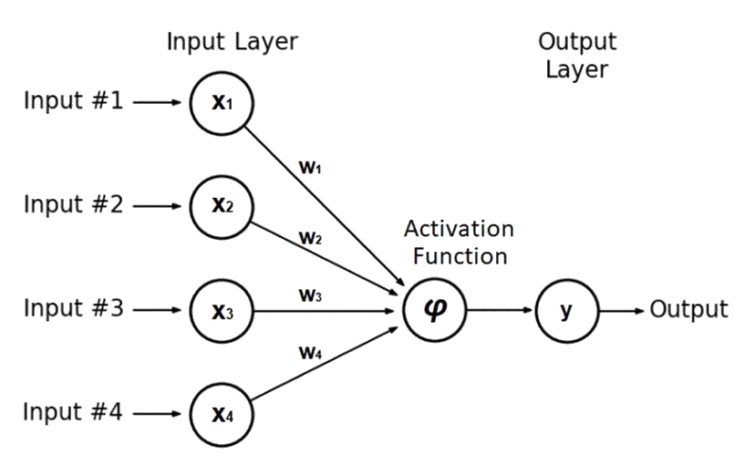

Support Vector Machine (Support Vector Regression)

- SVM can be used as regression method.
- Support Vector Regression uses the same principles as the SVM for classification, with only a few minor differences.
- A margin of tolerance (ϵ) is set in approximation to the SVM.

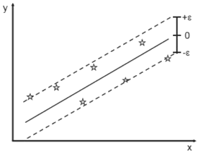

PROGRAM:

import pandas as pd
import numpy as np

import matplotlib.pyplot as plt
import seaborn as sns
sns.set_style('whitegrid')
plt.style.use("fivethirtyeight")
%matplotlib inline

# For reading stock data from yahoo
from pandas_datareader.data import DataReader
import yfinance as yf
from pandas_datareader import data as pdr

yf.pdr_override()

# For time stamps
from datetime import datetime

# The tech stocks we'll use for this analysis
tech_list = ['AAPL', 'GOOG', 'MSFT', 'AMZN']

# Set up End and Start times for data grab
tech_list = ['AAPL', 'GOOG', 'MSFT', 'AMZN']

end = datetime.now()
start = datetime(end.year - 1, end.month, end.day)

for stock in tech_list:
globals()[stock] = yf.download(stock, start, end)

company_list = [AAPL, GOOG, MSFT, AMZN]
company_name = ["APPLE", "GOOGLE", "MICROSOFT", "AMAZON"]

for company, com_name in zip(company_list, company_name):
company["company_name"] = com_name

df = pd.concat(company_list, axis=0)
df.tail(10)

OUTPUT;

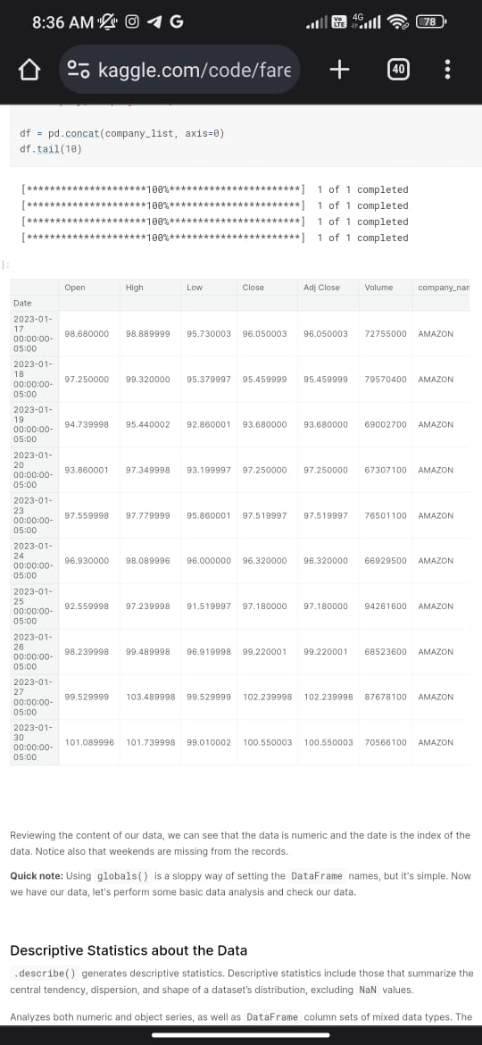

Prediction
- As statistical methods, predictions have been performed using 10-day, 15-day, 30-day Simple Moving Average and Weighted Moving Average, Exponential Smoothing with α = 0.3, 0.5, 0.75 and naïve approach.
- As Machine Learning methods, predictions have been performed using Simple Linear Regression, Lasso Regression and Ridge Regression, K-Nearest Neighbor, Random Forest with different number of estimators, Support Vector Machine and Neural Network Models like SLP, MLP and LSTM.

Current stock price prediction

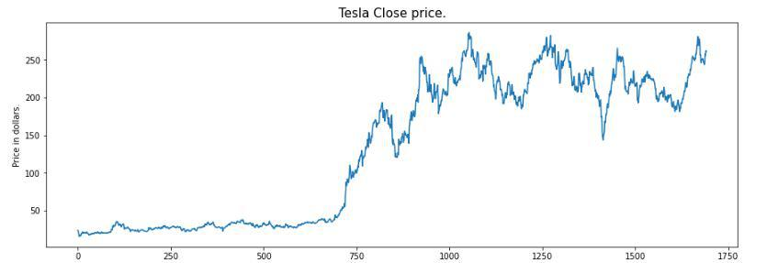

- Feature Selection

- For time series prediction, selection of features is an important task.
- Because selection of worst features can direct the prediction to a wrong way.
- In this system, three features have been selected.
i. The opening price
ii. The highest price
iii. The lowest price.

Conclusion

- A comparative study between statistical approaches and machine learning approaches has been done in terms of prediction performances.

- Machine learning methods, especially, MLP and LSTM are found to be the most accurate to predict stock prices.

THANK YOU

