- Exit Method:
This exit method is used to stop the JVM running which terminates the execution of the program that running currently.
we can use this method to stop the program execution once all the code run completed, to stop the execution. we can also use this to terminate the program incase of any exception or error occurs.
parameter- int
Exit(0) – for successful termination, once code run complete
exit (-1)- used for abnormal termination , incase of any exception occurs during the code run.
exit(1) - used for abnormal termination , incase of any errors occurs during the code run.

- Log4j2:
Log4j2 is logging framework for java app by appache, for logging the info during execution of program as per user need for programmer analysis.
difference between classpath and buildpath in springboot project
Builpath is the properties of the java which is used by the compiler to build the project and resolve dependencies. we can manually configure the buildpath like updating the JRE configurations and so on for based on requirement of project.
Classpath is path inside our project where we keep all the resource,JARs and project sources.
Mostly the properties files will be placed under src/java/resource, as like LOG4J2 properties will be placed under this.
Log4j2:
Property file should created with same name, xml is preferable to use and should be placed under under src/java/resource or seperate config folder. If we are placing under seperate config folder we need to point this property file in the project property file as below.
log4j.configurationFile=log4j2.xml
Dependencies in POM file
- <groupId>log4j</groupId>
<artifactId>log4j</artifactId>
- <groupId>org.apache.logging.log4j</groupId>
<artifactId>log4j-api</artifactId>
- <groupId>org.apache.logging.log4j</groupId>
<artifactId>log4j-core</artifactId>
Refer utility doc for xml data and example

- StringTokenizer
String Tokenizer is class in java which used to split the group of string values based on the given delimiter.
NextToken(), nextelement() both returns the same which retrieve the each tokens(string values) one by one.
hasmoretoken(), hasmoreelement() both returns the same boolean value by checking whether we have more tokens( string) in queue for retrieval.
counttoken() method used to retreive total no of token available.
import java.util.*
String Tokenizer has limitations, eg it cannot handle multiple delimiter at the same time & different type of tokens ( string,number ). to handle this we have Stream tokenizer in java.
Real time Example – Reading data from CSV File.
- File Read,Write operation
For Creating a new file to specific location we use File class in java with its respective method. and for writting the data to it we need to use File writter class and it’s respective method.
It’s always mandatory to use flush() or close() method after writting the data into the file using file writter else the changes will not available in the file.
import java.io.*;

File wr = new File("C:\\EBT Web\\Java\\Log\\WriteFile.txt");
wr.createNewFile();

FileWriter txt = new FileWriter(wr);
txt.write("Writting data into new file created by fileReader");

txt.flush();
txt.close();

Without calling the flush() or close () method the data will not write to the file. Filewriter does not automatically write the data to the file (it buffers it - ( temporary memory stored on the internal disk)). Calling flush() tells FileWriter to write the data to the file.
The close() method closes an open file. You should always close your files, in some cases, due to buffering, changes made to a file may not show until you close the file.

File Reader class is used to read the data from the given file, it will read the data in the form of character from the file. we have few methods which can be used for reading.
FileReader fl = new FileReader("C:\\EBT Web\\Java\\Log\\JavaLogfile.log");
char[] ch = new char[200];
fl.read(ch);
read method in file reader will read and store the characters from file into the array.
BufferReader class is used to read the data as as line by line as well single character whereas in filereader we can ready only by characters. Also it’s preformance is higher than filereader.
Hence bufferReader is preferrable to use for file IO operation
FileReader fr = new FileReader("C:\\EBT Web\\Java\\Log\\log4j2.xml");
BufferedReader br = new BufferedReader(fr);
String sr = br.readLine();
while(sr!=null) {
System.out.println(sr);
sr =br.readLine();
}
br.close();
Stream in Java
Java I/O (Input and Output) is used to process the input and produce the output. Java uses the concept of a stream to make I/O operation fast. The java.io package contains all the classes required for input and output operations.
InputStream in java is used to read the data from the File, keyboard,audio, image and so on as a ordered sequence of bytes. Outstream in java is used to write the data to the destination.
Difference between InputStream and fileReader
FileInputStream is Byte Based, it can be used to read bytes. FileReader is Character Based, it can be used to read characters.
InputStream is used for reading binary files. FileReader is used for reading text files in platform default encoding.This means you should use this class if you are reading from a text file that has the same character encoding as the default one. If you happen to read a text file encoded in different character encoding then you should use Input StreamReader with specified character encoding.
InputStream input = new FileInputStream("input.txt");

- Properties class and to load the properties file
Properties class is used to get the property values based on its key from the properties file. The Properties class provides methods to get data from the properties file and store data into the properties file. Moreover, it can be used to get the properties of a system.

Import - java.util
The below code is used to get the URI (path) of the given property file.
InputStream stream = Thread.currentThread().getContextClassLoader()
.getResourceAsStream("System.properties")

The getResourceAsStream method returns null with type as InputStream.
Output - file:/C:/EBT%20Web/Java/Java/target/classes/System.properties
property load() helps to read a property list (key and element pairs) from the input byte stream.
properties.load(inputStream);
Enumeration names = property.propertyNames();
Enumeration is used when we use list of constant values in the code.
In the above line the propertyNames method returns enumeration type of all keys in this property list, including distinct keys in the default property list (A property list can contain another property list as its "defaults"; this second property list is searched if the property key is not found in the original property list), if a key of the same name has not already been found from the main properties list.
System.setproperty(key,value);
This System.setproperty is used to set the system properties with the user defined key and values for the runtime current code execution
Complete code as below
Properties property = new Properties;
InputStream stream = Thread.currentThread().getContextClassLoader()
.getResourceAsStream("System.properties")
property.load(inputStream);
Enumeration names = property.propertyNames();
while(names.hasMoreElement)
{
String key = ((String)names.nextElement).trim();
String value = property.getProperty(key).trim()
System.setproperty(key,value);
}
using list(System.out) we can print all the keys and values that loaded into properties class variable from the property files. property.list(System.out);
- HikariDataSource

Dependency for POM

<dependency>
<groupId>com.zaxxer</groupId>
<artifactId>HikariCP</artifactId>
</dependency>

Dependency for Jdbc Template
<dependency>
<groupId>org.springframework</groupId>
<artifactId>spring-jdbc</artifactId>
</dependency>

Dependency for oracle driver class
<dependency>
<groupId>com.oracle.database.jdbc</groupId>
<artifactId>ojdbc8</artifactId>
<version>19.8.0.0</version>
</dependency>

Import for Datasource data type - import javax.sql.DataSource;
JDBC in Java:
JDBC ( Java Database connectivity) is the Java API that helps the programmer to connect, interact and fetch the data from DB without any extra code. Java program that uses the JDBC API can connect to any database management system (DBMS), as long as a driver exists for that particular DBMS.
HikariDataSource - Hikari is a JDBC DataSource implementation that provides a connection pooling mechanism. Compared to other implementations, it promises to be lightweight and better performing.
HikariDataSource ds = dwConfig.getHikariDataSource();
In above code, we created the class called dwConfig with above method that has code for datasource creation and DB realted configurations. we are storing the return type with type as Hikardatasource for connection pool.

JDBCTemplate Class
The JDBC template is the main API through which we’ll access most of the functionality with DB:
    - creation and closing of connections
    - running statements and stored procedure calls
    - iterating over the ResultSet and returning results
JdbcTemplate jdbc = new JdbcTemplate(ds);
//we are passing the created datasource to this jdbctemplate class
Complete Code
HikariDataSource ds = dwConfig.getHikariDataSource();
JdbcTemplate jdbc = new JdbcTemplate(ds);
dbspClass class = new dbspClass (jdbc);
The above dbspclass class is the programmer developed class in which we have DB query and SP for the execution and to fetch the resultset from it.
Refer utility development doc for the DB Configuration code.

- ArrayList
Import - java.util package
The main advantages of Java ArrayList are, if we declare an array then it’s needed to mention the size but in ArrayList, it is not needed to mention the size of ArrayList if you want to mention the size then you can do it.
It has many other feature than Array.
List<String> successUpdate = new ArrayList<String>();
Here we defined the Data types as List, but the original syntax is
ArrayList arraylist = new ArrayList<String>(), The ArrayList is the implementation class of interface List. The best approach to create an object is the 1st statement because of later point of time you can assign any other class object which implements List interface like LinkedList and Vector , also we can use all the methods that related to List. but as per 2nd statement, you can not assign any other object except ArrayList.This is one type of hardcoding of object creation, as a result, we are losing the flexibility of object creation.

One of the important design principle in java is “ Always program to Interface rather than its implementation class”.

- List
The List interface in Java provides a way to store the ordered collection. It is a child interface of Collection. It contains the index-based methods to insert, update, delete and search the elements. It can have the duplicate elements also. We can also store the null elements in the list. The implementation classes of List interface are ArrayList, LinkedList, Stack and Vector. The ArrayList and LinkedList are widely used in Java programming
Import - java.util package
- Difference between Array and List
List is used to collect items that usually consist of elements of different data types. An array is also a vital component that collects several items of the same data type.
- ListIterator
List Iterator method is java is used to iterate over the elements of arraylist using its index or without it. it has methods like hasNext(), next() , previous() and many more method to iterate inside the list.
ListIterator<String> iterator = arrlist.listIterator(2);
while (iterator.hasNext())
{
String i = iterator.next();
System.out.println(i);
}
}

- Map
The Map is the interface in java from collection framework, it stores the data in keys and value pair , where we can access the data using its keys, The map cannot have duplicate Keys and each key should have one respective values.
The Map interface maintains three sets: keys, values, and key/values maps (mapping). It is possible to access all these sets individually. The pair of key and value is called as entry in map.
Import - java.util package

This map has different method that help us to perfrom the operations like --> add, delete, change the element and iterate through it.

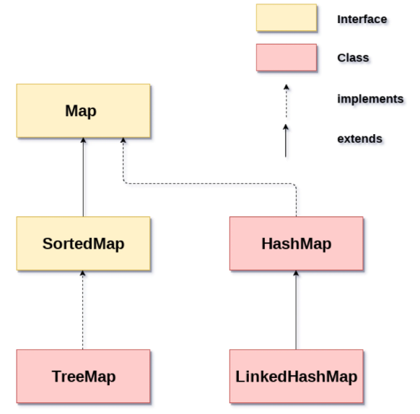

Map<K,V> hm = new HashMap<K,V> ();
Map<String, String> map = new HashMap<String, String>();

Since Map is an interface, objects of the type map cannot be created. To create an object, we always need a class that extends this map.

HashMap
- HashMap has complexity of O(1) for insertion and lookup.
- HashMap allows one null key and multiple null values.
- HashMap does not maintain any order.
TreeMap
- TreeMap has complexity of O(logN) for insertion and lookup.
- TreeMap does not allow null key but allow multiple null values.
- TreeMap maintains order. It stores keys in sorted and ascending order.
Map<Integer, String> tm=new TreeMap<Integer, String>();
LinkedHashMap
- LinkedHashMap has complexity of O(1) for insertion and lookup.
- LinkedHashMap allows one null key and multiple null values.
- LinkedHashMap maintains order in which key-value pairs are inserted.
Map<Integer, String> tm=new LinkedHashMap<Integer, String>();
- Mail related code and imports in java
  - Import – import java.net.InetAddress;

InetAddress inetAddress = InetAddress.getLocalHost();;

The InetAddress class provides methods to get the IP address of any hostname for example www.javatpoint.com, www.google.com, www.facebook.com, etc. An IP address is represented by 32-bit or 128-bit unsigned number. Inet Address can handle both IPv4 and IPv6 addresses.

The IPV4 is the primary internet protocal. where IPV6 is the latest version of internet protocol which aims at fulfilling the need of more internet addresses. also it provides problem present in IPV4.

e.g.
Host Name: www.javatpoint.com
IP Address: 172.67.196.82

  - Ternary operator
Syntax :
variable = Expression1 ? Expression2: Expression3

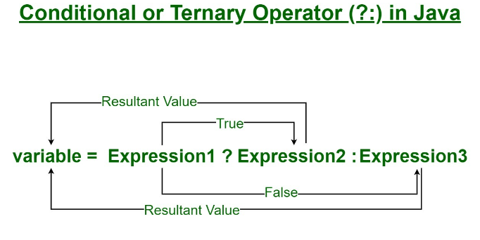

String hostName = null != inetAddress ? inetAddress.getHostName() : "";
here we used ternary operator. which works as if ,inet address is not equals to null then it will get the hostname else return "" (empty).

  - how to get the currenttime in java

String startTime = new Timestamp(System.currentTimeMillis()).toString().
substring(0, 19);

output - 2023-11-20 18:39:07.027

System.currentTimeMillis() – this method in java returns the current time in milliseconds
E.g. Current Time in milliseconds = 1349333576093
In above code we used new timestamp () which takes long as an argument, so we are giving system.currenttimemillis() method that returns long, to get the current date and time in java. And based on our usage we converted the value to string here.

To get the current date in user defined format
Calendar cal = Calendar.getInstance();
SimpleDateFormat dateFormat = new SimpleDateFormat("yyyy-MM-dd");
SimpleDateFormat timeFormat = new SimpleDateFormat("HH:mm:ss:SSSSSS");
String date = dateFormat.format(cal.getTime());
String ti = timeFormat.format(cal.getTime());
String currentTS = date + ":" + ti;
System.out.println(currentTS);

import java.sql.Timestamp;
import java.text.ParseException;
import java.text.SimpleDateFormat;
import java.util.Calendar;
import java.util.Date;

- String, String Builder & String buffer

String is immutuable class, which mean once string is created it can’t be modified if we modify the existing string it will create the new object in memory which is the memory consumptions.
String can be created in two ways, using literal and using new keyword
String s1 = “literals”;
String s1 = new String (“keywords”);

All the string class objects are stored in special part heap area called “String pool”, it has two segment in that
- Constant pool //string created as literal store here
- non constant pool // string created using new keyword store here
In constant pool duplicate values are not allowed even if we create duplicate value it will get stored point to same address in memory, whereas in non constant pool duplicate values are allowed

String buffer & String Builder – String buffer is the mutuable class, using which we can modify and change the string which we created without creating new object. it will also provide various method to do operations on string objects.
Compared to buffer , string builder is more faster , not thread safe and not synchronized.

E.g.

StringBuffer msgBuffer = new StringBuffer("Hello,\n\n");
msgBuffer.append("This is the Startup notification of Ani Update Utility \n\n");

- iterator
Iterator is an interface in java which used to loop through the collection of values like arraylist, hashmap and so on. It has different method for accessing element through iteration.
- hasNext() // Returns true if the iteration has more elements.
- next() // Returns the next element in the iteration. It throws NoSuchElementException if no more element is present.
- remove() // Removes the next element in the iteration. This method can be called only once per call to next().
E.g.
Map<String, String> mapvar;
Iterator<Entry<String, String>> iter = mapvar.entrySet().iterator();
while (iter.hasNext()) {
Entry<String, String> entry = iter.next();
sb.append(entry.getKey());
sb.append('=').append('"');
sb.append(entry.getValue().trim());
sb.append('"');
sb.append("\n");

Import - import java.util.Iterator;

- parameterized constructor
Java class creates a default constructor if the programmer hasn't defined any type of constructor in the class. The parameterized constructor has to be defined explicitly by the programmer. The main aim to create parameterized constructor is to initialize the objects with programmer-defined states or values. The values of members can be assigned during the process of initializing the object with the help of parameterized constructors.

- session
In application we should know which / who is the client sending the request to send them the response back. In order to attain that we are using the session management in java, the way to maintain this session is to make the unique id for each session.

In JavaMail If you want to interact with the same mail host in different ways then the session is the object that holds this information.

getDefaultInstance - Get the default Session object. if a default has not yet been setup, a new Session object is created and installed as the default.Therefore, if one does not already exist, it call getInstance()
getInstance - Get a new Session object.So, a new session object is created, regardless of whether one already exists.

Import - import javax.mail.Session;
Session session = Session.getDefaultInstance(props);
session.setDebug(debug);

Refer utility dev Doc for more details on creating email trigger in java

- Reference variable , lambda,supplier<>,callablestatement,struct

