- java.lang.ArrayIndexOutOfBoundsException8 - Thrown to indicate that an array has been accessed with an illegal index.
- Log4j2:ERROR in 11028347
- without property or xml file log4j2 will not work
- we need to exclude the existing spring-boot-starter-logging in POM.xml to enable the log4j2 logging else it won’t work.
- xml is more preferable than .propery file
- StringTokenizer error:
for data retrieval we need to store the values into the variable, then only we can retrieve the exact values else we will retrieve only the address of the value.
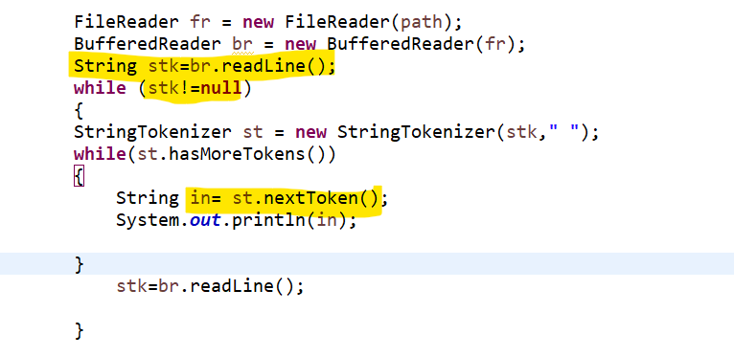
- ClassNotFoundException:
Incase no proper dependency added in POM.xml file it will throw classNotFoundException

