Sri Lanka Institute of Information Technology

Lab Submission

<Worksheet 04>

**<IT24100579>**

**<Basuru K.H.M>**

**Fundamentals of Computing | IT1140**

B.Sc. (Hons) in Information Technology

**Activity 01:**

|  |  |  |  |
| --- | --- | --- | --- |
| **A** | **B** | **SUM** | **CARRYBIT** |
| **0** | **0** | **0** | **0** |
| **0** | **1** | **1** | **0** |
| **1** | **0** | **1** | **0** |
| **1** | **1** | **1** | **1** |

|  |  |  |
| --- | --- | --- |
| **P** | **Q** | **P XOR Q** |
| **0** | **0** | **0** |
| **0** | **1** | **1** |
| **1** | **0** | **1** |
| **1** | **1** | **0** |

1. **Both the XOR circuit and the circuit in part (a) produce the SUM output that follows the XOR logic.**

**Activity 02:**

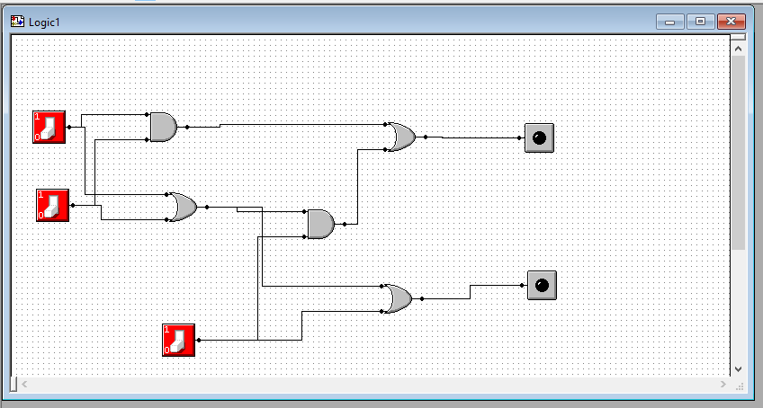

**Figure 4.2 – Half Adder;**

**A half-adder is a basic digital circuit that adds two single-bit binary numbers, producing a sum and a carry output. It is used in the construction of more complex arithmetic circuits.**

**Figure 4.3 – Full Adder;**

**A full-adder extends the functionality of the half-adder by allowing for the addition of three single-bit binary numbers, which include a carry bit from a previous addition, making it essential for performing multi-bit binary addition in arithmetic operations.**

**Activity 03:**

