Below is the solution for the azure assessment:

1. **Create a Resource Group in West Europe:**

* **Select Resource Group from the menu in home screen and click on add to create new resource group with required details.**

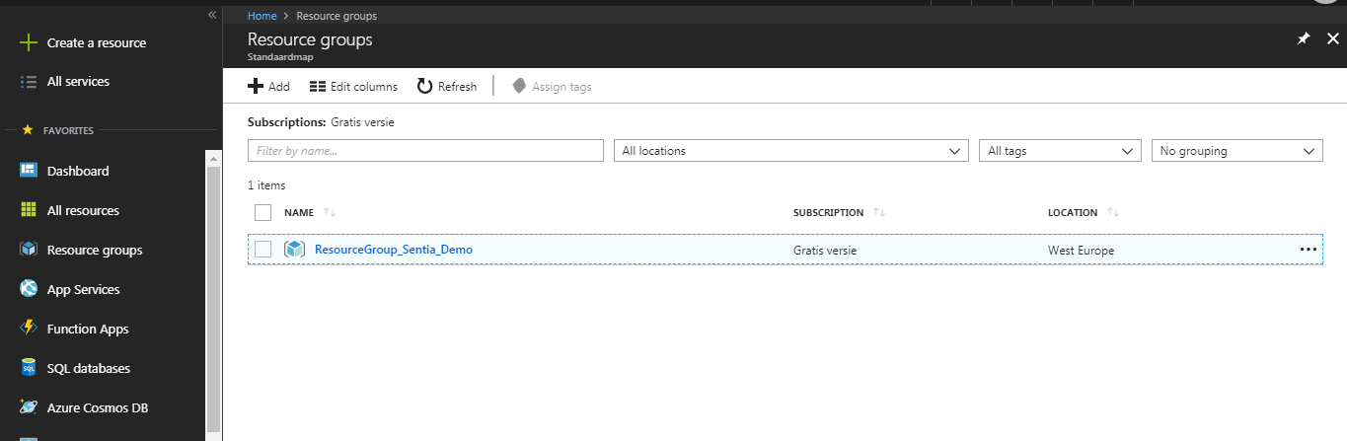

Time log: 5 min to create a resource group with the required details

1. **Create a Storage Account in the above created Resource Group, using encryption and an unique name, starting with the prefix 'sentia'**

* **Select StoreAccount from the menu and click on add to create new.**

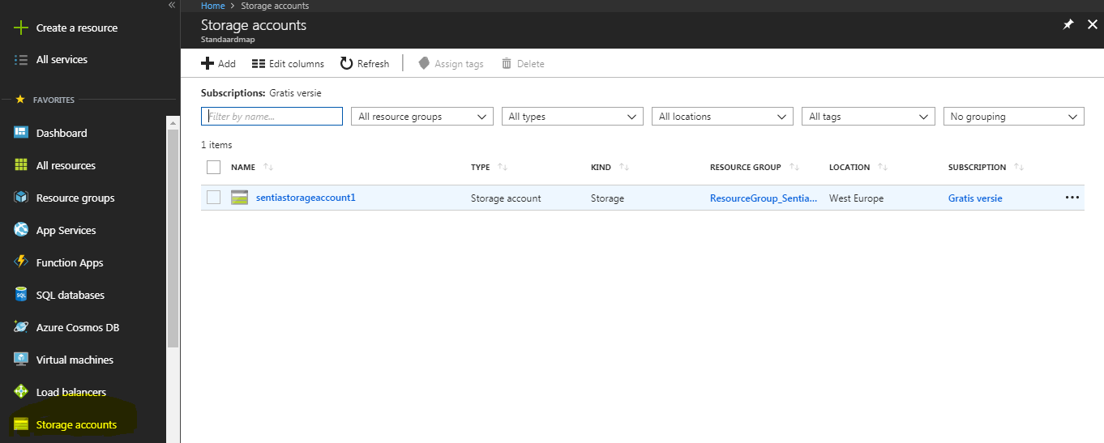

**To add encryption to your StorageAccount , select the storageaccount and select encryption.**

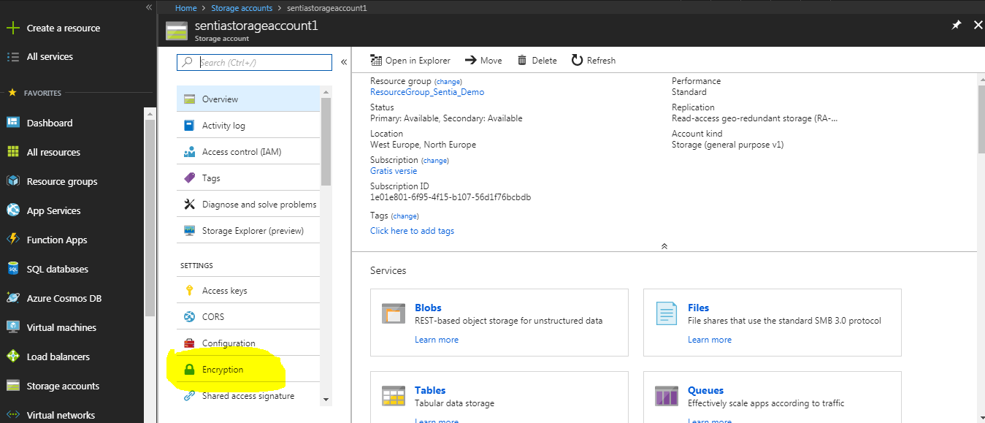

**Select the check box use your own key and create your own key vault.**

**This is how the resource group would look like once the storage account with encryption is added for the resource group**

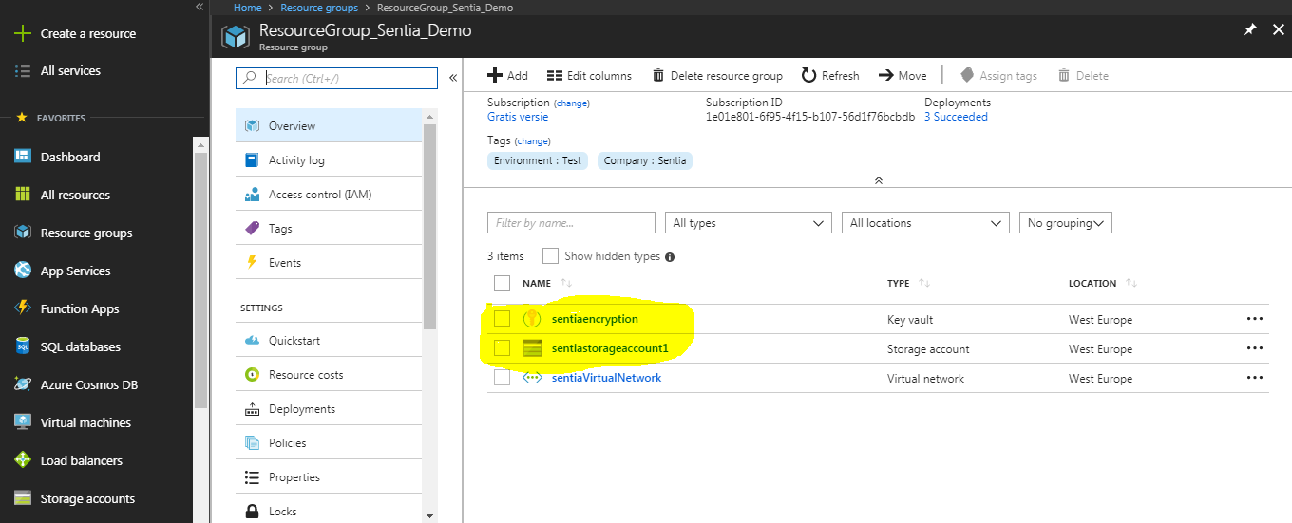

Time Log: Approximate 10 min to create the storage account and add encryption on the resource group.

1. **Create a Virtual Network in the above created Resource Group with three subnets, using 172.16.0.0/12 as the address prefix**

* Select virtual networks from the menu and add new with required details.

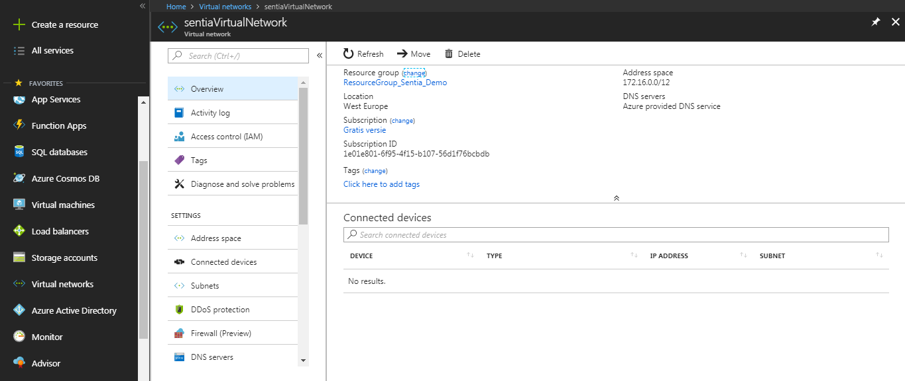

To create subnets for the above Virtual network, select subnet from the options and add new.

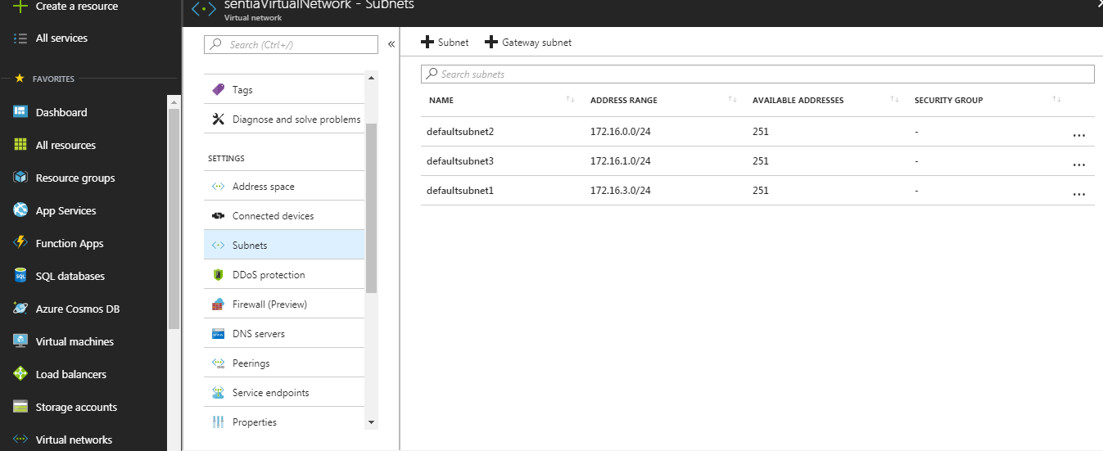

Once added to the resource group, it will be reflected in the resource group as shown below.

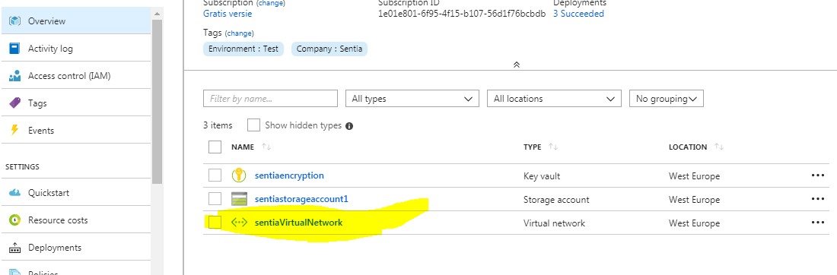

Time Log: Approximate 15 min to create the virtual network and add subnets.

(5-10 min to figure out the address space for the 3 subnets ☺)

1. **Apply the following tags to the resource group: Environment='Test', Company='Sentia'**

Select tags from the selected resource group and add the 2 tags as shown below.

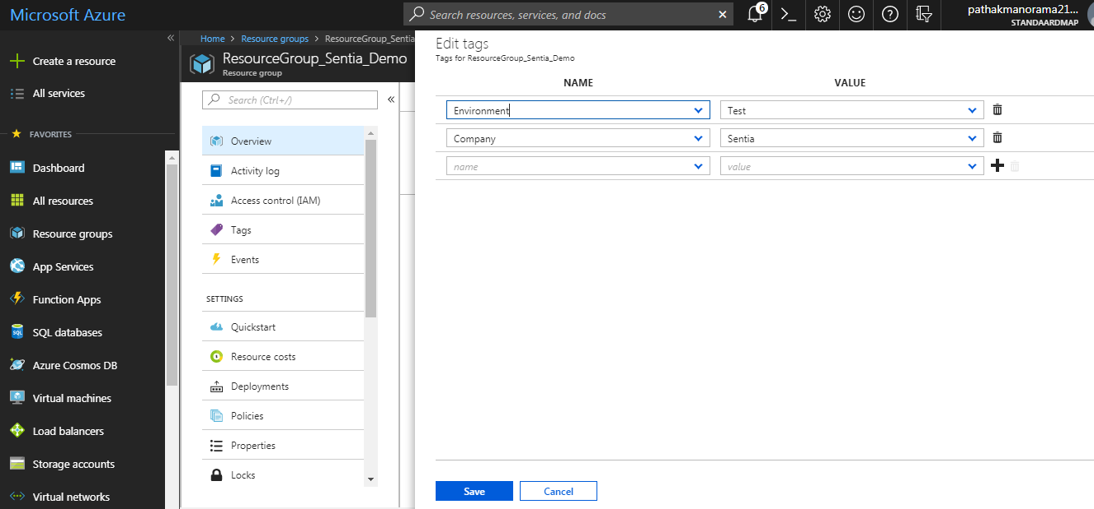

Time Log: Approximate 2 min to create the tags.

1. **Create a policy definition using the REST API to restrict the resourcetypes to only allow: compute, network and storage resourcetypes .**

**Note: I have created a custom definition but can alos re-use the built in policy “Allow resource types”.**

* To create policy definition navigate to

Home > Resource group > Policies > Policy Definition and add new definition.

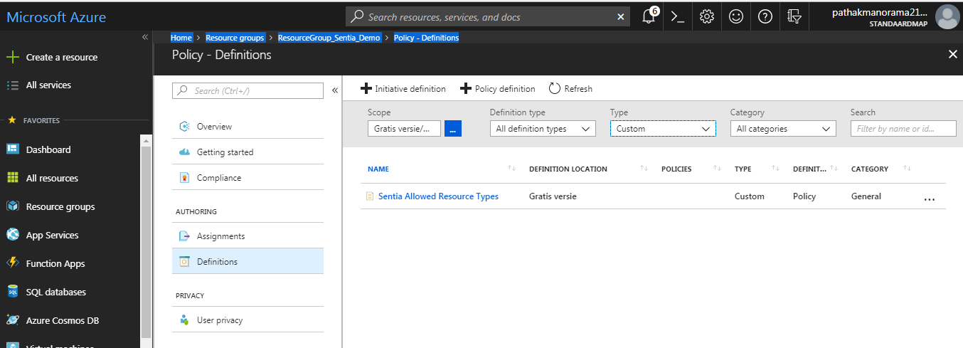

Below is the json script:

(Reused the existing script from “Allow resourcetype” built in policy)

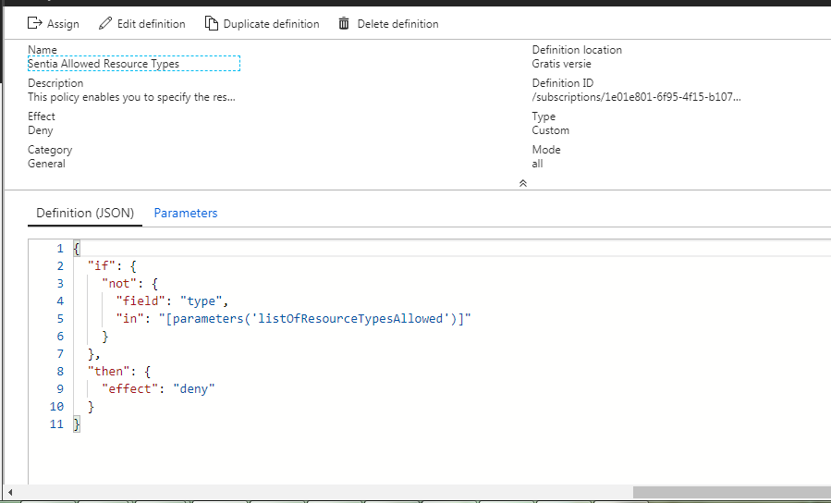

**To assign the policy definition using the REST API to the subscription and resource group:**

**Click on assign policy and add the resource group to which you want the custom policy definition to be added.**

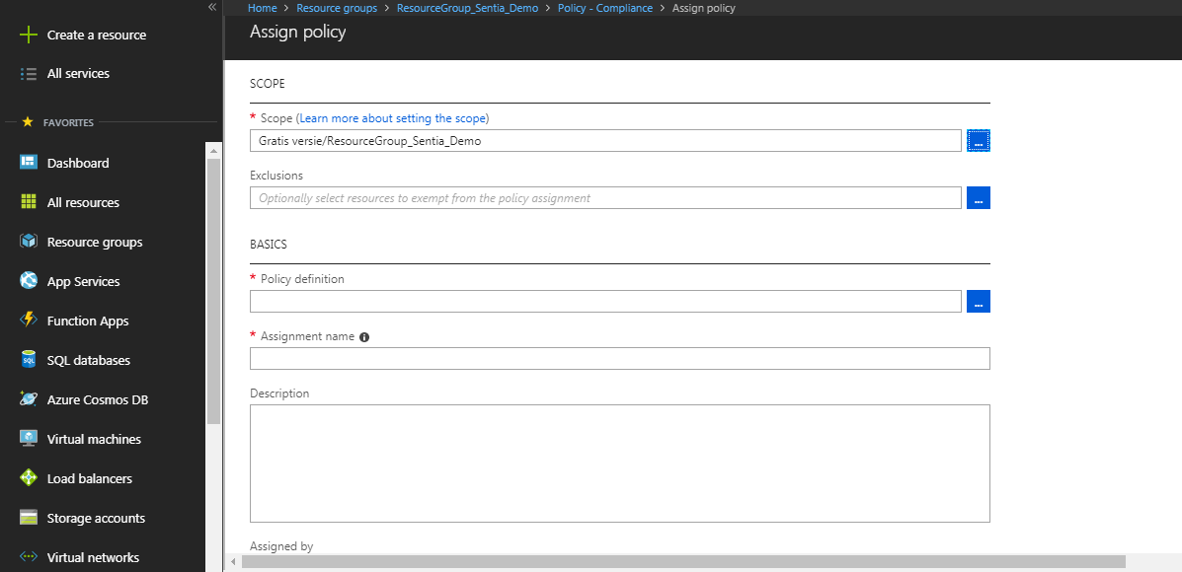

**In the allowed resource types select the resource types that you want the resource group to access**

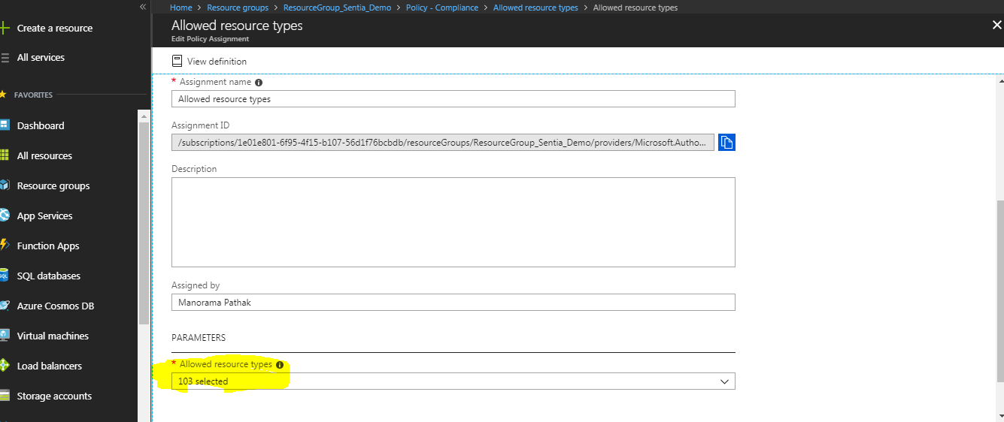

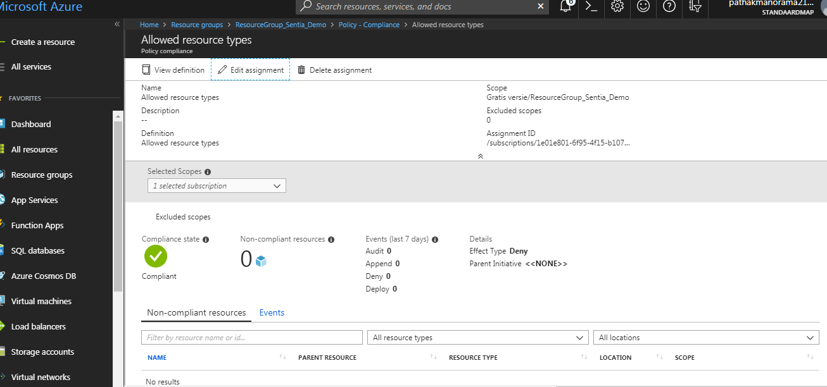

Time Log: Approximate 20 min to create the policy definition and assign the policy definition with the resource types to the resource group.

1. **Create a deployment script, using template and parameter files, to deploy below-listed items, in a secure manner, to the Azure subscription.**

**The deployment template has been added in the repository.**