Μάνος Αραπίδης
el16071
8o εξάμηνο

1)

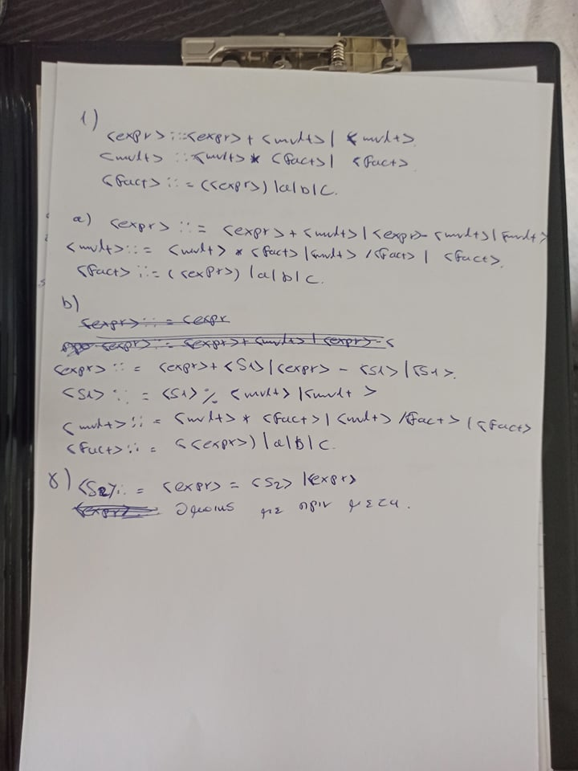
3)


s

2)

a)
def f(a):
a = list(a)
s = sum(a)
return [x / s for x in a]
b)
fun check k n = k * k > n orelse n mod k <> 0 andalso check (k+2) n

fun prime 2 = true
| prime n = n mod 2 <> 0 andalso check 3 n
γ)

γ1)
7 17 42 1 7 17
γ2)
7 17 42 1 42 1

δ)

δ1)7 1 1 17
δ2) 1 1 17 7

5)

α)
max_data(n(A, L), M) :-
max_data(L, M1),
(M1 > A -> M is M1; M is A).

max_data([], 0).
max_data([T|Ts],M) :-
max_data(T,MT),
max_data(Ts,MTs),
(MT > MTs -> M is MT; M is MTs).

4)

fun reverse ls =
let
fun help (nil,xs) = xs
| help (y::ys,xs) = help (ys,y::xs)
in help (ls,nil)
end

fun reconstruct [] = []
| reconstruct [x] = [[x]]
| reconstruct (z::zs) =
let fun walk ([], _, _, acc) = acc
(*| walk ((x::xs), sofar, i, ([]::ys)) = walk (xs, sofar, (i+1), [x]::ys)*)
| walk ((x::xs), sofar, i, ((y::ys)::acc)) =
if sofar > i then walk (xs, sofar, (i+1), (x::y::ys)::acc)
else walk (xs, x, 0, ([x]::(y::ys)::acc))
in reverse (map reverse (walk (zs, z, 0, [[z]])))
end

6)
import numpy as np

def adjacency_list_to_incidence_matrix(adj_list):
node_count = len(adj_list)
edge_count = sum(map(len, adj_list))
dimensions_of_matrix = (node_count,node_count)
inc_matrix = np.zeros(dimensions_of_matrix)
for node_index in range(0, node_count):
for neighbor_index in adj_list[node_index]:
inc_matrix[node_index][neighbor_index] = 1
return inc_matrix

def out_degree(M, u):
l = len(M)
count = 0
for i in range (0,l):
if M[u][i]==1:
count=count+1
return count

def in_degree(M, u):
l = len(M)
count = 0
for i in range (0,l):
if M[i][u]==1:
count=count+1
return count

