
Call 2024 Round 1 KA2
KA220-HED - Cooperation partnerships in higher education (KA220-HED)



.
Visual Interactive System for Teaching and Assessment of
Sign Languages (VISTA-SL)
R3.2a - Large Language Model integrating best practices on SL teaching
R3.2b: LLM-powered Virtual Instructor
Ref. Project: 2024-1-EL01-KA220-HED-000257847

Περιεχόμενα
1 Introduction and Scope 3
1.1 Purpose of the Document 3
1.2 Project Context and Objectives 3
1.3 Design Goals and Requirements 3
2 Architectural Principles and Design 4
2.1 Overarching Architecture Model 4
2.2 Principle of Modularity 4
2.3 Technology Stack 5
3 Core Platform Infrastructure Integration 7
3.1 User Management and Thread Resolution 7
3.2 Pedagogical Context Injection (RAG) 7
4 Operational Logic and Data Flow 8
4.1 Phase 1: Session Initialization and Thread Resolution 8
4.2 Phase 2: Dynamic Context Retrieval (The "Coach" Protocol) 8
4.3 Phase 3: Knowledge Base Ingestion (Static Context) 9
4.4 Phase 4: Prompt Synthesis and Streaming Delivery 9
5 Data Lifecycle and GDPR Compliance Interfaces 10
5.1 The "Right to be Forgotten" Protocols 10
5.2 Deletion Endpoints and Logic 10
6 Deployment and Containerization Strategy 11
6.1 Containerization Rationale 11
6.2 Docker Architecture 11
6.3 Deployment Configuration 11
7 Module Specification 12

Contents

Introduction and Scope

Purpose of the Document
This document presents the Technical Architecture for the VISTA-SL LLM Virtual Instructor, developed as part of Activity 3.2a and 3.2b in Work Package 3 of the VISTA-SL Erasmus+ project. The architecture serves as the technical blueprint for integrating Generative Artificial Intelligence into the core learning platform, ensuring that the system meets the project’s requirements for personalized, adaptive learning.
The purpose of this specification is to define the structural components, data interfaces, and operational logic required to transform a standard Large Language Model (LLM) into a context-aware pedagogical agent. It details how the system bridges the gap between static curriculum content and dynamic student needs, providing a comprehensive reference for the technical partners responsible for implementation, testing, and deployment.

Project Context and Objectives
The VISTA-SL project aims to modernize Sign Language education through interactive digital tools. Within this ecosystem, the LLM Virtual Instructor acts as an intelligent middleware layer. Its primary objective is to move beyond generic automated responses by implementing a Retrieval-Augmented Generation (RAG) pipeline that is deeply integrated with the learner's academic progress.
The system is designed to achieve three specific pedagogical goals. First, it must provide immediate, natural language explanations of complex linguistic concepts found in the VISTA-SL curriculum. Second, it must deliver a highly personalized learning experience by leveraging the learner's comprehensive historical context, by retaining memory of previous interactions and tracking real-time academic milestones, the system adapts to the learner’s journey than offering static answers. Third, the system must maintain strict data privacy standards through rigorous Data Lifecycle Management. Rather than relying on permanent anonymization which prevents personalized history tracking, the architecture implements a robust "Right to be Forgotten" protocol. While the system maintains a secure link between the student and the AI during active learning periods to ensure continuity, it includes specific mechanisms to permanently expunge this data. Upon account deletion or request, the system executes a hard-delete sequence that removes the user’s history from both the middleware database and the AI engine, ensuring no residual data remains.

Design Goals and Requirements
The architectural design is driven by the need for scalability, modularity, and compliance with European data protection standards (GDPR). The system is built as a standalone microservice that interacts with the Core Platform via secure APIs, ensuring that updates to the AI logic do not disrupt the stability of the main Learning Management System (LMS).
Key functional requirements include Dynamic Context Injection, where the system autonomously queries the user’s learning history before generating a response, and Real-Time Streaming, which utilizes Server-Sent Events (SSE) to minimize perceived latency during interactions. Non-functional requirements emphasize the use of open-source components specifically Python FastAPI and PostgreSQL to ensure sustainability and replicability by partner institutions.

Architectural Principles and Design

Overarching Architecture Model
The VISTA-SL LLM module operates on a microservices-based architecture, functioning as an intelligent orchestration layer between the Frontend Client and the Cognitive Backend. This design isolates the decision-making logic from the user interface, allowing for independent scaling and maintenance.
The architecture is defined by the interaction between two primary containerized components:
- The FastAPI Orchestrator (Middleware): This is the central Python-based application that serves as the system's "nervous system." Internally, it encapsulates the logic for user authentication, state management, and external API integration. It acts as the secure bridge, retrieving learner telemetry from the VISTA-SL Platform and constructing the context-aware prompts required for the RAG pipeline.

- The Cognitive Engine (AnythingLLM): This component functions as the isolated "brain" of the system. It manages the Vector Database for semantic retrieval of curriculum documents and generates the natural language responses based on the prompts received from the Orchestrator.
By co-locating the integration logic and persistence handling within the FastAPI Orchestrator, the system minimizes network latency and ensures that the pedagogical context is securely injected into every AI interaction before it reaches the generation phase.

Principle of Modularity
Adhering to the project's modularity principles, the LLM Virtual Instructor is designed to be agnostic regarding the underlying Artificial Intelligence model. The system architecture effectively decouples the orchestration logic from the specific inference engine.
This design choice ensures that the underlying Large Language Model (LLM) can be swapped or upgraded with minimal configuration changes, preventing vendor lock-in. For instance, while the current implementation utilizes the cloud-based Grok model to leverage high-performance inference during the pilot phase, the system supports a seamless transition to local execution using frameworks such as Ollama. This flexibility allows the consortium to migrate from third-party cloud solutions to privacy-centric, locally hosted models (e.g., running Llama-3 directly on local hardware) without requiring any modifications to the core application code or the student database structure. A list of the providers and the selected LLM is shown in the Figure below.

Figure 1: List of the cloud based LLMs available.
= 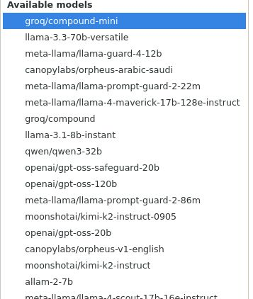 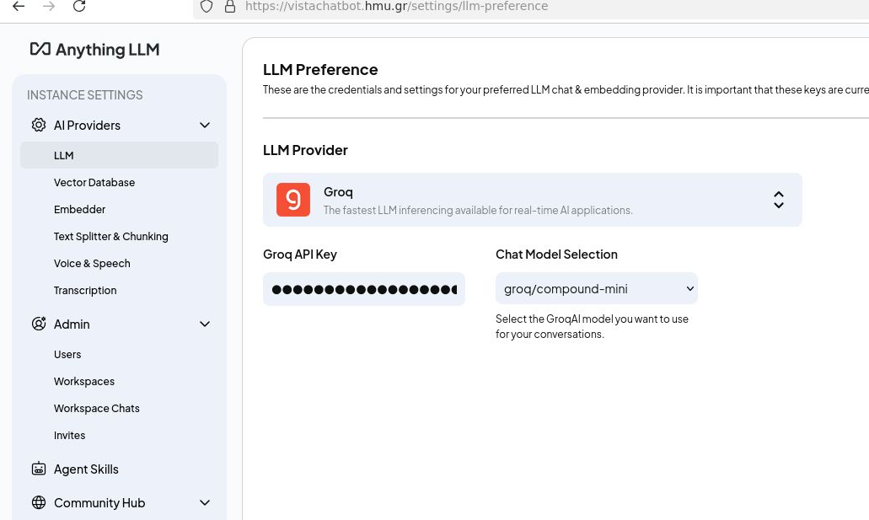

Technology Stack
The implementation relies on a robust, open-source technology stack selected for its maturity and compatibility with educational environments. The backend logic is developed in Python 3.10, utilizing the FastAPI framework to handle high-concurrency asynchronous requests. Data persistence is managed by PostgreSQL 14, providing a reliable relational structure for user-thread mappings.
Communication between services is secured via HTTP/2 over TLS 1.3, ensuring that all data in transit is encrypted. For the AI processing, the project integrates AnythingLLM, a specialized backend that combines a vector database for document storage with an API for context management. This stack ensures that the system is lightweight enough to be containerized via Docker, facilitating rapid deployment across the diverse server environments of the project consortium.

Component Layer | Technology / Tool | Version | Role in Architecture | Selection Rationale
Orchestration Logic | Python | 3.10+ | Core Programming Language | Extensive library support for AI/ML (PyTorch, LangChain) and rapid prototyping capabilities.
API Framework | FastAPI | 0.109+ | Web Server Interface (ASGI) | Native asynchronous support (async/await) allows handling concurrent SSE streams without blocking threads.
Cognitive Backend | AnythingLLM | Desktop/Docker | RAG & Vector Management | All-in-one solution that manages vector databases (LanceDB) and embeddings, removing the need to build a custom RAG pipeline from scratch.
Underlying Model | Grok | Cloud Provider | Large Language Model | State of the art model that is trained by XAI ensuring fairness and high quality responses.
Persistence | PostgreSQL | 14.1 | Relational Database | Maintains the critical mapping between Anonymized Thread UUIDs and VISTA-SL User IDs.
Transport | Uvicorn / Nginx | Standard | WSGI/Reverse Proxy | Handles SSL termination and forwards secure HTTP/2 traffic to the application container.
Containerization | Docker Compose | V2 | Deployment Orchestration | Encapsulates the entire middleware stack into a single artifact for consistent deployment across partner servers.

Core Platform Infrastructure Integration

User Management and Thread Resolution
A critical challenge in integrating AI into an educational platform is state management. The VISTA-SL architecture addresses this through a dedicated resolution mechanism implemented in the Middleware. When a user initiates a chat session, the system does not simply pass the message to the AI; instead, it performs a lookup in the local PostgreSQL database to determine if a conversation thread already exists.
If a thread exists, the system retrieves the unique thread_slug and appends the new message to the existing context. If the user is new, the system triggers a provisioning sequence, requesting the AI engine to instantiate a new isolated container (User-UUID) and recording this association in the local database. This approach ensures that learners experience a continuous, coherent conversation across multiple study sessions, while the backend maintains a strict separation of data between different users.

Pedagogical Context Injection (RAG)
To fulfill the requirement of "personalized learning," the architecture implements a Dynamic System Injection workflow. Standard chatbots lack awareness of the user's external context; however, the VISTA-SL Middleware actively bridges this gap.
Upon receiving a student query, the Platform Connector module executes a synchronous API call to the LMS endpoint (/api/v1/coach). This request utilizes the user’s session token to retrieve a structured JSON object containing the student’s current module, completion percentage, recent quiz scores, and the system-recommended next lesson. The Middleware then transforms this raw data into a natural language "System Persona" prompt. This enriched prompt is injected into the AI's context window invisibly to the user, instructing the model to tailor its explanation to the specific proficiency level and curriculum position of the student.

Operational Logic and Data Flow
This section details the end-to-end lifecycle of a learner interaction within the VISTA-SL ecosystem. The system operation is defined by a strictly orchestrated sequence of events managed by the Middleware, ensuring that every AI response is grounded in both the static curriculum knowledge and the dynamic user state.

Phase 1: Session Initialization and Thread Resolution
The process begins when the Middleware receives a POST /chat request containing the student’s unique platform identifier (userId), a session authentication token (token), and their natural language query (message).
Before any AI processing occurs, the system performs Thread Resolution using the persistence layer (database.py):
- Lookup: The orchestrator queries the internal PostgreSQL database to determine if a conversational context already exists for this specific userId.
- Provisioning: If no record is found (e.g., a first-time user), the system triggers the create_thread routine via the LLM Service. This commands the Cognitive Backend to instantiate a new, isolated conversation container.
- Mapping: The resulting unique identifier (the "Thread Slug") returned by the AI engine is permanently mapped to the userId in the local database. This ensures that subsequent requests resume the same conversational history, providing a sense of continuity.

Phase 2: Dynamic Context Retrieval (The "Coach" Protocol)
Once the communication channel (Thread Slug) is established, the system executes the Pedagogical Context Injection phase (platform_connector.py).
Unlike standard chatbots that rely solely on the immediate user prompt, the VISTA-SL Middleware pauses to consult the Core LMS Platform. Using the student’s provided authentication token, the Connector module executes a secure API call to the /api/v1/coach endpoint.
The system retrieves a comprehensive JSON object describing the learner's current status, which is parsed to extract:
- Identity Verification: The username and validity of the session.

- Curriculum Progress: The exact ratio of completed versus total lessons (e.g., "Progress: 3/64").
- Adaptive Recommendations: The specific lesson or unit the system algorithm has identified as the next optimal step (e.g., "Next Recommendation: Unit 4 - Syntax").

Phase 3: Knowledge Base Ingestion (Static Context)
Parallel to the dynamic user context, the system utilizes a pre-loaded Vector Knowledge Base managed by the LLM Service (llm_service.py).
To ensure the AI adheres to the VISTA-SL curriculum, physical documents (PDFs, text files) are ingested via a dedicated upload pipeline. When a document is uploaded, the service transmits the file to the Cognitive Backend, which performs two critical operations:
- Vectorization: The text is segmented and converted into mathematical vector embeddings.
- Indexing: These embeddings are stored in the workspace's vector database.
When a query is processed, the Cognitive Backend performs a semantic search against this index, retrieving only the specific paragraphs or rules relevant to the student’s question. This "Grounding" process ensures answers are derived from approved project materials rather than the model's general training data.

Phase 4: Prompt Synthesis and Streaming Delivery
The final phase involves the synthesis of all gathered data into a coherent response (server.py).
The Orchestrator constructs a Composite System Prompt that is invisible to the user. This prompt follows a strict template:
- SYSTEM INJECTION: {Student Profile & Progress Data} USER MESSAGE: {Original Question}
This composite payload is transmitted to the Cognitive Backend. The Middleware then initiates an asynchronous Server-Sent Events (SSE) stream. As the AI generates the response token-by-token, the Middleware intercepts these chunks and relays them instantly to the frontend client. This streaming architecture minimizes latency, allowing the student to see the answer forming in real-time, while the "Self-Healing" logic monitors the stream for errors or connection drops, ensuring robust performance during extended tutoring sessions.
An overview of the whole step process is shown in the Figure below.
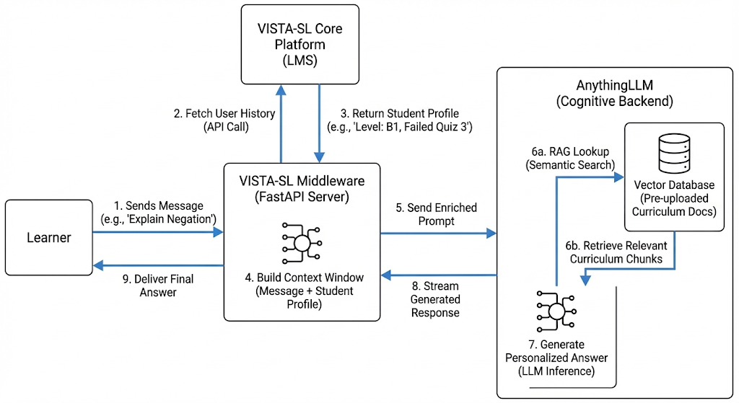
Figure 2: Complete pipeline from user message to application response.

Data Lifecycle and GDPR Compliance Interfaces

The "Right to be Forgotten" Protocols
In strict adherence to Article 17 of the GDPR (Right to Erasure), the VISTA-SL architecture includes dedicated technical mechanisms to permanently remove learner data. Unlike standard soft-deletion methods (which merely flag data as hidden), the Middleware implements a "Destructive Purge" protocol that targets both the relational mapping and the vector context.

Deletion Endpoints and Logic
The system exposes specific administrative routes designed to be triggered either by the Data Protection Officer (DPO) or automatically by the LMS upon a student’s account deletion. Context Destruction (The Cognitive Wipe). When a deletion request is received, the Middleware first executes a DELETE request to the Vector Engine’s endpoint (/api/v1/workspace/{slug}/thread). This operation instructs the AnythingLLM backend to physically remove the vector embeddings and chat history associated with that specific thread ID. Once this completes, the AI has no memory that the conversation ever took place.
Identity Decoupling (The Database Wipe) Following the successful response from the AI engine, the Middleware executes a SQL transaction to delete the corresponding row from the user_threads table. This removes the user_id-thread link. Even if the AI logs were theoretically recovered from a backup, they would exist as "orphan data" with no mathematical way to link them back to the specific student, satisfying the requirement for effective anonymization.
Administrative Log Purging To address the "residue" of metadata often left in system logs, the architecture includes a maintenance script (admin_tools.py) that targets the internal audit endpoint (/api/system/workspace-chats/-1). This command flushes the visual administrative logs, ensuring that no transient records of the user's interaction timestamps or message metadata remain in the system's operational view.

Deployment and Containerization Strategy

Containerization Rationale
To ensure consistency across the diverse technical infrastructures of the VISTA-SL consortium partners, the entire LLM Virtual Instructor module is delivered as a containerized microservice. This approach eliminates "dependency hell" by encapsulating the application code, python libraries, and system-level drivers into a single immutable artifact.

Docker Architecture
The deployment utilizes Docker technology, orchestrated via Docker Compose. The architecture is defined by two primary services communicating over a private, internal bridge network that is isolated from the public internet.
- Service A: The Middleware (vista-backend): Built on the official python:3.10-slim image, this container hosts the FastAPI application. It is stateless, meaning it can be stopped, destroyed, and redeployed without data loss, as long as the database remains intact.
- Service B: The Persistence Layer (vista-db): Built on the postgres:14-alpine image, this container holds the relational data. It utilizes a Docker Volume (postgres_data) to ensure that the mapping table persists even if the container itself is rebooted.

Deployment Configuration
The system uses environment variables to manage configuration, preventing sensitive credentials from being hardcoded into the source files. The docker-compose.yml manifest defines the startup order, ensuring the database is fully initialized and health-checked before the application attempts to connect. This robust startup sequence is essential for automated deployments in university server environments where manual intervention is limited.

Module Specification
Field | Description
Module | LLM Virtual Instructor Middleware & Orchestrator
Purpose | To function as an intelligent middleware layer that bridges the gap between the Core Learning Platform (LMS) and the Generative AI engine. It manages user session state, and implements pipeline to inject real-time pedagogical context into AI responses.
Inputs | 1. Student Interaction Data  • Description: The user's credentials and natural language query.  • Format: JSON {"userId": "string", "token": "string", "message": "string"}  • Source: Frontend Client (Student Interface)  • Frequency: Per Request (Real-time)  2. Learner Telemetry  • Description: Real-time academic status including completed lessons, quiz scores, and recommended next steps.  • Format: JSON Object (learnerProfile, progressSummary, recommendations)  • Source: VISTA-SL Core Platform (LMS Backend)  • Frequency: Per Request (Triggered internally before response generation)  3. Curriculum Documents  • Description: Static educational content (Sign Language syntax rules, glossaries).  • Format: Unstructured Text / PDF  • Source: Administrative Upload  • Frequency: Batch (Ad-hoc updates)
Outputs | 1. AI Response Stream  • Description: Natural language explanation generated by the AI.  • Format: Server-Sent Events (SSE) stream data: {"token": "..."}  • Destination: Frontend Client  • Frequency: Real-time (Streaming)  2. System Prompts  • Description: Context-enriched instructions sent to the cognitive engine.  • Format: JSON Payload (Context Window)  • Destination: AnythingLLM (Cognitive Backend)  • Frequency: Per Request  3. State Mapping  • Description: Association between Platform User ID and AI Thread ID.  • Format: Relational Record (user_id <-> thread_slug)  • Destination: Internal PostgreSQL Database  • Frequency: Once per new user session
Core Processing | 1. Thread Resolution: Checks internal database to resolve the incoming userId to an existing anonymous AI thread. If none exists, provisions a new container via API.  2. Dynamic Context Injection: Pauses execution to fetch learner stats from the LMS. Synthesizes a "System Persona" prompt (e.g., "User is Level B1, focus on Syntax").  3. RAG Orchestration: Transmits the enriched prompt to the Vector Engine. The engine performs a semantic search on curriculum docs and generates a response.  4. Stream Relay: Asynchronously intercepts tokens from the AI engine and pushes them to the client to minimize latency.  Computational Intensity: Low (I/O Bound). The heavy lifting is offloaded to the AI Backend.
Dependencies | Libraries & Frameworks:  • FastAPI (Web Server)  • Uvicorn (ASGI Runner)  • SQLAlchemy (ORM)  • Asyncpg (Async DB Driver)  • HTTPX (Async HTTP Client)  External Services:  • AnythingLLM: Required for Vector Database management and LLM inference.  • VISTA-SL Core API: Required for fetching user progress (/api/v1/coach).
Planned Technology | Language: Python 3.10+  Framework: FastAPI  Architecture: Asynchronous Microservice
Deployment Considerations | Hosting: Containerized (Docker).  Architecture: Runs in an internal bridge network, not exposed directly to the public internet (requires Reverse Proxy/Nginx).  GPU Needs: The Middleware itself requires CPU only. However, the connected AnythingLLM service requires GPU acceleration (NVIDIA CUDA) for optimal token generation speed if the model is hosted locally, else if the model is cloud based no GPU acceleration is necessary.  Scalability: Stateless design allows horizontal scaling via Docker Compose or Kubernetes.
Data Storage Needs | 1. Relational Database (PostgreSQL):  • Stores the user_threads table.  • minimal storage footprint (approx. 1KB per user).  2. Vector Database (Managed by AnythingLLM):  • Stores embeddings of the curriculum.  • Requires persistence volume for LanceDB or similar vector store.

