PIPELINE TO HOST GIT APPLICATION

Steps:

* Create a flask application
* Setup a git repository and push it
* A black rectangular object with white lines

  Description automatically generatedAdd a secret key to connect to EC2 instance let’s call it staging instance it would go something like this
* A screenshot of a computer

  Description automatically generatedNow that it’s been added go a head and create a workflow file to do a python test and host it on servers, we can do it in two ways
* Now Create an EC2 Instance
* Install java 21
* sudo apt update -y && sudo apt upgrade -y
* sudo apt install openjdk-21-jdk -y
* **Install Jenkins**

```

sudo wget -O /usr/share/keyrings/jenkins-keyring.asc \

https://pkg.jenkins.io/debian-stable/jenkins.io-2023.key

echo "deb [signed-by=/usr/share/keyrings/jenkins-keyring.asc]" \

https://pkg.jenkins.io/debian-stable binary/ | sudo tee \

/etc/apt/sources.list.d/jenkins.list > /dev/null

sudo apt-get update

sudo apt-get install Jenkins

```

* Enable and start Jenkins

```

sudo systemctl enable jenkins

```

```

sudo systemctl start Jenkins

```

NOTE: without installing java, Jenkins won’t work

* 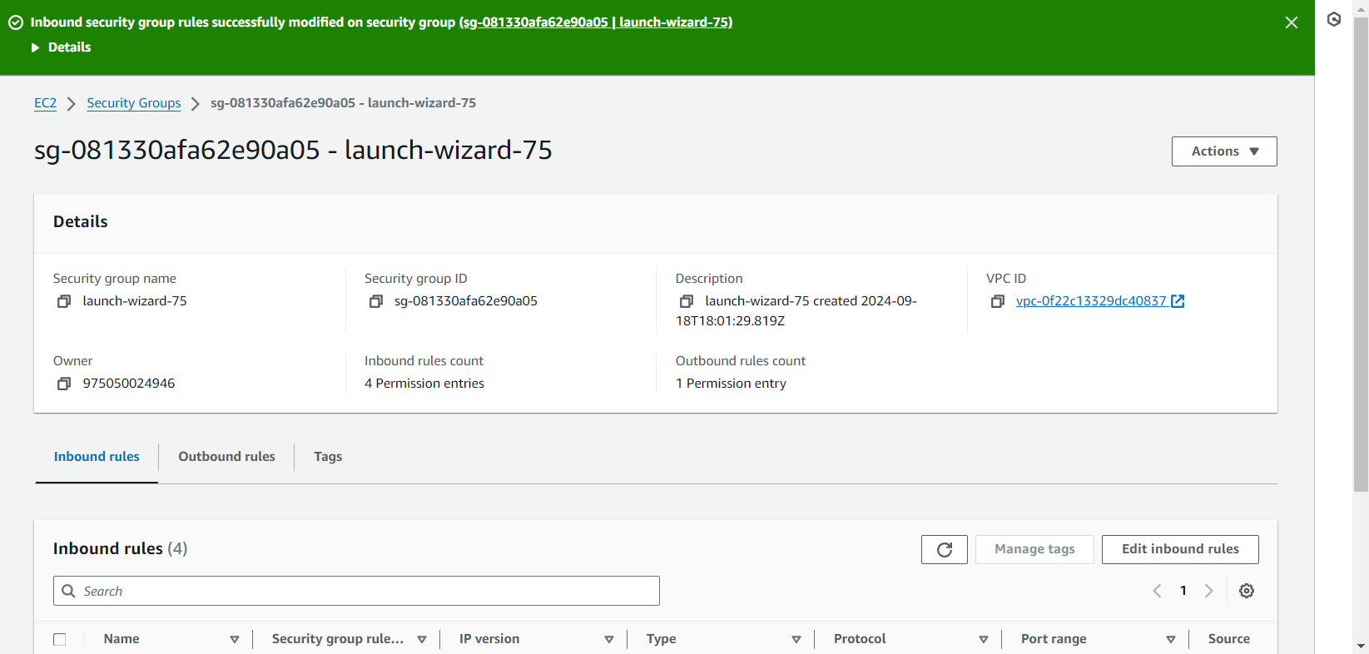It would be hosted on port 8080

Now go back to your instance settings and lookout for the security groups and allow tcp port of 8080

* After configuring Jenkins, it would look something like this
* Now go to manage Jenkins
* Click on plugins
* Click on available plugins
* A screenshot of a computer

  Description automatically generatedSearch of ssh-agent, pipeline stage view, publish over ssh
* A screenshot of a computer

  Description automatically generatedNow navigate back to dashboard
* Now click on manage Jenkins
* Click on System
* Scroll down until you see SSH Server
* 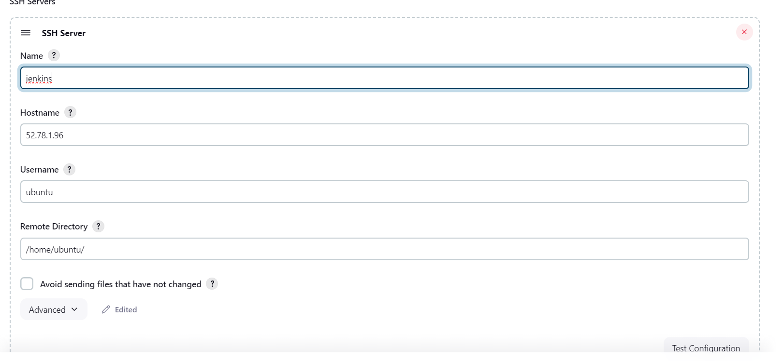Click on add ssh server
* A screenshot of a computer

  Description automatically generatedGo back to dash board
* Now click on new item
* Fill with any name
* Select -> pipeline and click on okay
* Fill SCM Polling to * * * * *
* 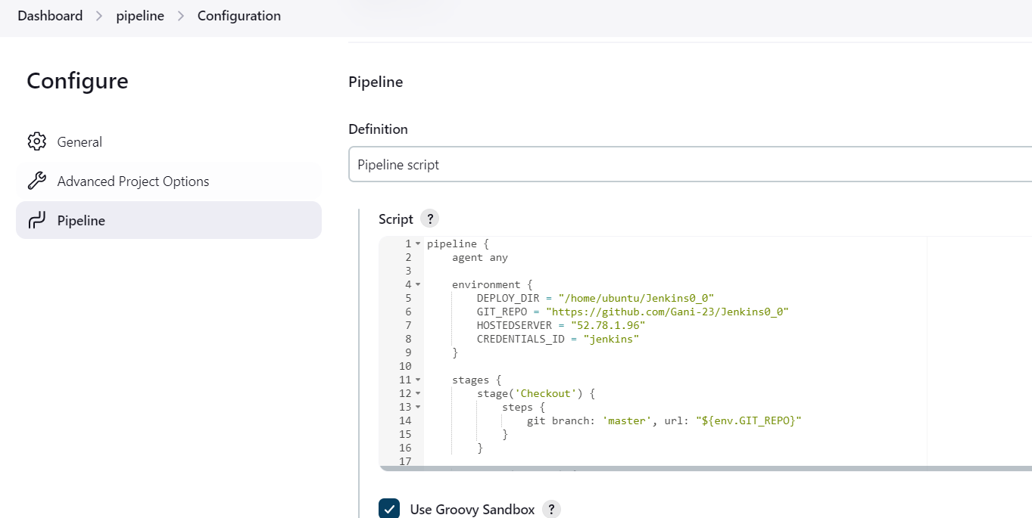Now paste the Jenkins file in here

Click on save or apply go to your repository dashboard in Jenkins dashboard press build now

The project gets deployed