
Table of Contents

ABSTRACT 3
CHAPTERS :
- Introduction 04
- Feasibility………………. 09
- Leatrature Review………………………………………………………….12
- System Design 17
- Algorithm / Tools & Technologies Used 23
- Results and Discussions 34
- Conclusion and Future Scope 37
- References/Bibliography 38
Abstract

This project presents the development of an AI-based Sentiment Analysis system capable of classifying textual inputs as Positive or Negative based on their emotional tone. The core objective is to automate the process of analyzing large volumes of user-generated text, such as product reviews or feedback, which would otherwise require time-consuming manual effort. The model was trained using a sampled statements dataset comprising 5,000 labeled entries. Text data was preprocessed using CountVectorizer with stop-word removal to convert sentences into numerical features, and a Logistic Regression model was employed for classification, achieving over 80% accuracy. The trained model and vectorizer were serialized using Python’s pickle module. A user-friendly web interface was built using Streamlit, enabling users to either input multiple text lines manually or upload a CSV file containing reviews. The system then outputs the sentiment prediction for each line and also provides a percentage breakdown of positive and negative sentiment, along with an overall verdict based on majority voting. This modular design allows for scalability and easy deployment, making it suitable for real-time analysis in educational projects, businesses, or any platform that requires opinion mining. Technologies used include Python, Pandas, Scikit-learn, and Streamlit. This project demonstrates a full machine learning pipeline—from data handling and model training to deployment—offering a practical solution to the growing need for scalable sentiment analysis in the modern digital landscape.
1. Introduction

1.1 Overview

This project is a lightweight AI-based sentiment analysis tool that classifies text input as either Positive or Negative. Built using Python, scikit-learn, and Streamlit, it demonstrates a full machine learning workflow—from model training to real-time deployment.
The model is trained on IMDB movie reviews using a Logistic Regression classifier and CountVectorizer for text processing. Users can either type multiple reviews manually or upload a CSV file for batch sentiment analysis. The app returns sentiment predictions for each input, shows a percentage breakdown (e.g., 70% Positive), and provides an overall sentiment summary.
This project showcases how basic NLP and machine learning techniques can be applied to automate text classification and analyze feedback efficiently. It's ideal for beginners in AI looking to build and deploy a real-world application quickly.

1.2 Background & Motivation

In today’s digital age, vast amounts of textual data—such as reviews, comments, and feedback—are generated daily across websites, apps, and platforms. This unstructured data often contains valuable insights into user opinions, but analyzing it manually is slow, inconsistent, and impractical at scale.
Sentiment analysis, a subfield of Natural Language Processing (NLP), enables the automatic classification of text into emotional categories such as positive, negative, or neutral. It is widely used in business, media monitoring, customer service, and product development to understand public perception and improve decision-making.
The motivation behind this project was to build a simple, efficient, and interactive tool that could automate the sentiment analysis process. By using basic machine learning techniques like Logistic Regression along with a Bag-of-Words model (CountVectorizer), and deploying the solution through a Streamlit web interface, the project makes sentiment analysis accessible—even to non-technical users.
This project not only demonstrates core machine learning and NLP concepts but also highlights how AI can be applied to solve real-world problems such as opinion mining, customer feedback analysis, and content filtering.

1.3 Objective

The main objective of this project is to develop an AI-powered sentiment analysis tool that can automatically classify user-written text as Positive or Negative. The goal is to create a lightweight, efficient, and interactive web application that enables users to analyze text in real-time, either through manual input or by uploading a CSV file.
This system aims to:
- Demonstrate the application of Natural Language Processing (NLP) and Machine Learning to real-world text data.
- Provide a simple and user-friendly interface using Streamlit.
- Help users quickly extract emotional tone from large volumes of feedback or reviews.
- Showcase an end-to-end ML pipeline, from model training and vectorization to deployment and inference.
Ultimately, the project is designed to make sentiment analysis easy, accessible, and useful for educational, prototyping, or small-scale analytical purposes.

1.4 Significance of the Project

This project holds strong significance in both academic and practical contexts. In an era where vast amounts of user-generated content—such as reviews, comments, and feedback—are produced every second, the ability to automatically analyze sentiment provides a powerful advantage. Manually reviewing such data is not scalable, and traditional data analysis methods fall short when dealing with unstructured text.
By implementing a machine learning-based sentiment analysis system, this project demonstrates how AI can automate opinion mining, making it faster, more consistent, and more actionable. The project showcases a complete NLP pipeline, from text preprocessing and vectorization to model training, serialization, and real-time prediction via a web interface.
Its simplicity, flexibility (support for both text input and CSV upload), and clear output (sentiment labels with percentage breakdown) make it highly practical for educational purposes, early-stage product prototypes, and small business use-cases. It also lays the foundation for more advanced features like multi-class classification, multilingual support, or integration with external APIs.
Overall, this project not only strengthens foundational skills in NLP and machine learning but also delivers a functional tool that can be applied in real-world scenarios to derive insights from human language data.

1.5 Methodology

The project began by collecting a labeled dataset of movie reviews, which was cleaned and converted into numerical format using the CountVectorizer technique. A Logistic Regression model was trained on this vectorized data to classify sentiments as positive or negative. Once trained, both the model and vectorizer were saved as .pkl files using Python's pickle module.
To make the model interactive, a Streamlit web app was developed. It allows users to either input multiple lines of text or upload a .csv file. The app loads the saved model, predicts the sentiment for each input, and displays the results along with a percentage breakdown and an overall sentiment decision. This modular setup ensures fast processing and easy future upgrades.

2. Feasibility

1. Technical Feasibility:

The proposed sentiment analysis system is technically feasible given the current availability of mature machine learning libraries and lightweight deployment tools. The application was built using Python, a high-level programming language widely adopted in data science and machine learning. Key libraries like scikit-learn, pandas, NLTK, and Streamlit are open-source and well-documented, ensuring ease of development and maintenance. The algorithm used — Logistic Regression — is computationally efficient and performs well with text-based features generated through the Bag-of-Words model using CountVectorizer. The entire system can run smoothly on modest hardware (such as a standard personal computer with 8–16 GB RAM) and does not require any GPU acceleration or cloud infrastructure. This ensures that both development and deployment can be performed without relying on high-end computing environments. Additionally, the use of the pickle module for model serialization and Streamlit for UI integration simplifies the end-to-end workflow. Therefore, from a software and hardware standpoint, the system is completely implementable using existing and proven technology stacks.

2. Resource Feasibility:

The resource feasibility of the project is well within acceptable limits, as it leverages freely available tools, datasets, and frameworks. The dataset used — IMDb 50K Movie Reviews — is publicly available for academic purposes and can be downloaded without licensing restrictions. The machine learning libraries (scikit-learn, NLTK, pandas) and web framework (Streamlit) are open-source and require no financial investment. In terms of hardware, the model was trained and tested on a standard mid-range personal computer, eliminating the need for cloud services or specialized infrastructure. Human resource requirements are also minimal: the system was developed by a single developer with basic machine learning knowledge, supported by readily available online documentation and community forums. Additionally, the deployment process does not demand extensive DevOps support, making this a highly resource-efficient project suitable for educational, research, or small-scale commercial use. Overall, the project is feasible without any need for advanced or costly external resources.

3. Operational Feasibility:

From an operational standpoint, the sentiment analysis tool is both user-friendly and easily adoptable by the target users. It features a clean, minimal interface developed in Streamlit, requiring no prior technical knowledge to use. Users can input a single statement or upload a .csv file and receive immediate feedback on sentiment classification. The results are displayed with both individual predictions and a percentage-based summary, making the output easy to interpret for non-technical users such as students, educators, and small business owners. The system runs locally and does not require installation of heavy software environments, making it portable and accessible. Additionally, it supports multiple use cases—from analyzing customer feedback to summarizing opinion trends—adding to its operational value. Minimal training is required to operate the tool, and since it is self-contained, it can be distributed and used without significant IT support. These factors collectively ensure that the application can be effectively integrated into real-world workflows with little operational friction.
3. Litrature Review

1. Deep Learning vs Traditional Machine Learning in Sentiment Analysis

Traditional Machine Learning:
Techniques like Logistic Regression, Naive Bayes, and Support Vector Machines (SVM) have been foundational in early sentiment classification systems. These models rely on manually extracted features—usually from CountVectorizer or TF-IDF—to represent the text data as sparse numerical vectors. ML models are:
- Lightweight and fast to train.
- Interpretable, with clear decision boundaries.
- Effective on small to medium datasets.
- Easy to deploy in low-resource environments.
However, traditional ML struggles with understanding context, sarcasm, or semantics, and its performance often depends heavily on preprocessing quality.

Deep Learning:
Modern deep learning models like Recurrent Neural Networks (RNNs), Long Short-Term Memory (LSTM) networks, and transformers (e.g., BERT, GPT) represent the current state-of-the-art in text classification. They leverage word embeddings (like Word2Vec, GloVe) and contextual attention mechanisms to learn complex language patterns.
Advantages:
- High accuracy, especially on large datasets.
- Contextual understanding, handling long dependencies in text.
- Less feature engineering required—model learns from raw text.
Downsides include:
- High computational cost (requires GPUs for training).
- Slower inference time.
- Complexity in deployment compared to classic ML models.

2. Commonly Used Datasets in Sentiment Analysis

The quality and size of the dataset used for training significantly influence the performance of a sentiment analysis model. Below are some widely used, publicly available datasets in sentiment classification research and practice.

1. Statement Reviews Dataset
- Contains 50,000 labeled reviews (25k for training, 25k for testing) from IMDb.
- Each review is labeled as positive or negative.
- Balanced and clean; well-suited for binary sentiment classification.
- Used in this project (a smaller subset) due to its availability and clear labeling.

2. Sentiment140 (Twitter)
- Contains 1.6 million tweets labeled as positive, negative, or neutral.
- Derived using emoticons in tweets to auto-label data.
- Reflects real-world, noisy language (slang, abbreviations, typos).
- Good for training models that need to understand informal text.

🧾 3. Amazon Product Reviews
- Offers millions of reviews across multiple product categories.
- Ratings (1–5 stars) can be mapped to sentiment polarity.

3. Tools & Libraries Used

To implement the solution effectively, the following tools and libraries were used:
- Python: Primary programming language for development due to its extensive ecosystem for data science and machine learning.
- Pandas: For reading, cleaning, and manipulating structured data (especially .csv files).
- Scikit-learn: Used for model training, evaluation, and vectorization via CountVectorizer and LogisticRegression.
- Pickle: For model and vectorizer serialization (saving .pkl files).
- Streamlit: Lightweight and powerful framework used to create the interactive web app interface.
- Jupyter Notebook: Used for model experimentation, testing, and visualization during development.
These tools were chosen for their simplicity, community support, and ease of integration for building and deploying small-scale machine learning applications.

4. Gap in existing tools that your project tries to fill

Despite the wide availability of sentiment analysis solutions, several critical gaps remain—especially for beginner-level developers, educators, and non-technical users:
- Complexity of Setup:
Many sentiment analysis tools (like BERT-based APIs or cloud NLP services) require advanced setup, GPU access, or subscription-based services, making them inaccessible for quick prototyping or educational use.
- Lack of User-Friendly Interfaces:
Most open-source solutions are CLI-based or require writing code to run predictions. They don't offer intuitive, interactive frontends for general users.
- Limited Input Flexibility:
Existing tools often support only single-line inputs and lack batch processing features (e.g., uploading .csv files with multiple statements for analysis).
- No Real-Time Sentiment Breakdown:
Many libraries return sentiment scores but don’t aggregate and present the percentage breakdown (e.g., 70% positive, 30% negative) or provide a clear overall sentiment verdict for bulk inputs.
- Overhead of Deep Learning Models:
Deep learning-based sentiment classifiers provide higher accuracy but are overkill for basic binary classification tasks and consume unnecessary compute resources for simple applications.
4. System Design

4.1 Architecture Overview:

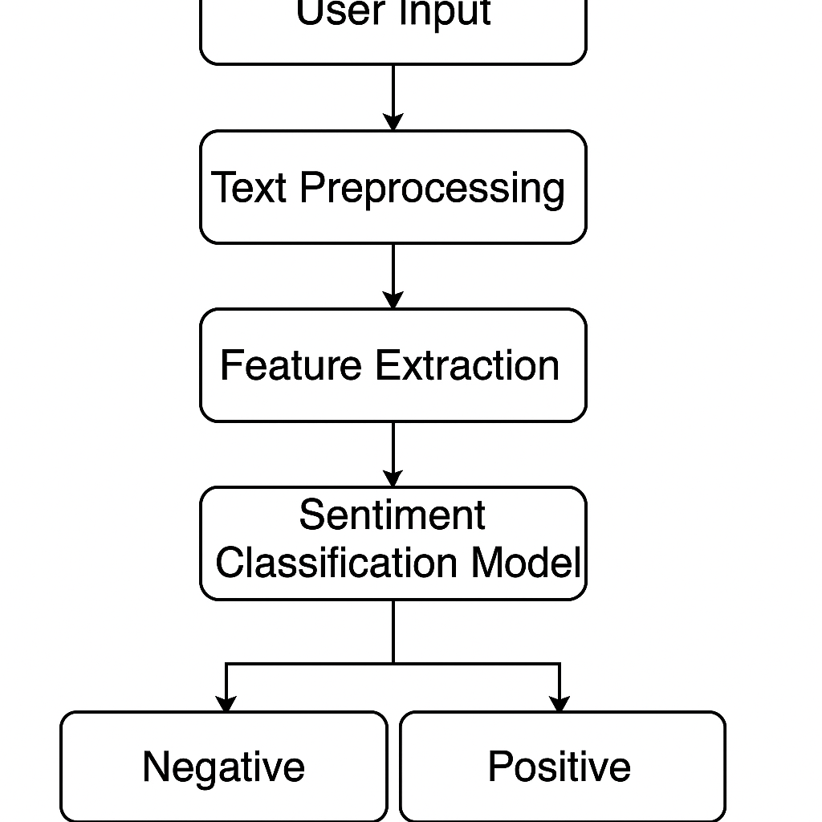

4.2 Key Components:

User Input Interface
This is the front-facing module of the system where users can interact with the sentiment analyzer. It accepts either direct text inputs (multiple lines) or uploaded .csv files. Streamlit serves as the framework for this component, providing a clean UI and fast rendering for seamless user experience.
- Text Preprocessing Module
Raw text data is rarely clean or uniform. This component is responsible for converting all input to lowercase, removing punctuation and special characters, filtering stop words, and tokenizing sentences. This step is essential for ensuring consistency and reducing noise, thereby improving model performance.
- Feature Extraction Layer
After preprocessing, the text is transformed into numerical features using the CountVectorizer. This converts the cleaned text into a sparse matrix of token counts, representing the presence or frequency of words. These vectors serve as the input to the machine learning model.

4.3 Training Model

The heart of the application is the Logistic Regression classifier. It is a supervised learning model trained on labeled movie reviews from the IMDb dataset. The model learns to associate word patterns and frequencies with either positive or negative sentiments. Once trained, the model is saved using Python’s pickle module, allowing it to be reused for real-time predictions without retraining.
Key strengths of Logistic Regression include its simplicity, fast computation, and effectiveness in binary classification tasks. For this project, its lightweight nature made it ideal for local deployment and small-to-medium-sized datasets.

4.4 Result Presentation Layer:

After predictions are generated, results are presented to the user via Streamlit's dynamic interface. For manual input, each review’s sentiment is displayed immediately below the input box. For .csv uploads, the tool shows a data table with the original review and predicted sentiment for each row.
An additional sentiment breakdown chart shows the percentage of positive and negative reviews, along with a “majority sentiment” tag. This makes it easy for users to get both granular and summary-level insight in a visual and interpretable format.

5. Error Handling & Feedback:

Robust error handling is integrated into the system to catch malformed input, missing files, or invalid formats. For example:
- If a user uploads a non-.csv file, a warning message is shown.
- If the text box is empty, the “Analyze” button is disabled or throws a user-friendly error.
- If the uploaded CSV lacks the expected columns (e.g., review), it prompts the user with corrective feedback.
This makes the application stable and user-proof, improving reliability and reducing the chance of failure during demos or practical use.

6. Security Layer:

Since the application is currently designed for local or limited-access deployment, basic security practices are followed:
- Uploaded files are not stored permanently.
- The application does not expose any system-level operations or allow arbitrary file execution.
- If deployed to the web, it should be containerized (e.g., via Docker) to isolate its environment.
- In a multi-user or production setup, authentication and file validation checks can be integrated using JWT tokens and file type sanitization to prevent misuse or injection attacks.
While minimal security is acceptable for offline educational use, these recommendations would make it robust for real-world deployment.

5. Algorithm / Tools & Technologies Used

5.1. Algorithm used: Logistic Regression

In this project, the primary algorithm used for sentiment classification is Logistic Regression—a widely adopted technique for binary classification tasks. Unlike Linear Regression, which is used to predict continuous values, Logistic Regression is designed to predict discrete outcomes, making it ideal for problems like spam detection, fraud classification, and sentiment analysis.
Logistic Regression works by modeling the probability that a given input belongs to a certain class—in this case, whether a review expresses a positive or negative sentiment. It applies a mathematical function called the sigmoid function, which converts the weighted sum of the input features into a probability value between 0 and 1. If the predicted probability is greater than a defined threshold (typically 0.5), the input is classified as positive; otherwise, it is labeled as negative.
This algorithm was chosen for its simplicity, efficiency, and proven effectiveness in text classification problems. Logistic Regression is relatively easy to interpret, quick to train, and performs well even with high-dimensional data like text, especially when coupled with feature extraction techniques such as the Bag-of-Words model.

In this project, the model was trained on a preprocessed IMDB movie review dataset. The textual data was vectorized using CountVectorizer, and the logistic regression classifier was trained to recognize sentiment patterns based on the frequency of words. Once trained, the model was saved using the pickle module and later integrated into a Streamlit-based web interface for real-time sentiment prediction.
This approach ensured a good balance between accuracy and performance while keeping the implementation lightweight and beginner-friendly.

5.2. Reason for choosing this algorithm

Logistic Regression was selected for this project primarily due to its simplicity, interpretability, and strong performance on binary classification tasks like sentiment analysis. As the goal was to build a lightweight, real-time sentiment detection tool with minimal complexity, Logistic Regression stood out as an ideal fit. It performs well on smaller, structured datasets and requires far less computational power compared to deep learning models, making it perfect for educational or prototype-level deployments.
Another reason for choosing Logistic Regression is its ability to handle high-dimensional sparse data, which is common in text classification after vectorization (using techniques like CountVectorizer). The algorithm doesn't require extensive hyperparameter tuning, allowing for faster development and reliable results even with basic settings. It is also highly interpretable—meaning the influence of individual features (words) on the outcome can be understood, which is useful for explaining model behavior.
In comparison to more complex models like SVMs or neural networks, Logistic Regression offers a balanced trade-off between accuracy and efficiency, especially when quick turnaround and easy integration (e.g., in a Streamlit app) are key priorities. Therefore, it was chosen as the core algorithm for this sentiment analysis system.

5.3. Text vectorization: CountVectorizer

Since machine learning models require numerical input, one of the key steps in building a sentiment analysis system is to convert textual data into a format that algorithms can understand. For this project, CountVectorizer—a widely used method from Scikit-learn—was used for text vectorization. It transforms a collection of text documents into a matrix of token counts, commonly known as the Bag-of-Words model.

In simple terms, CountVectorizer scans through all the text, identifies unique words (tokens), and creates a vocabulary. It then represents each input sentence or document as a vector, where each element of the vector corresponds to the count of a specific word in that input.For example, if the word “great” appears three times in a sentence, the corresponding feature in the vector will have the value.

This method is computationally efficient, easy to implement, and works well with algorithms like Logistic Regression. It ignores the order of words and focuses purely on frequency, which is often sufficient for binary sentiment tasks where the presence or absence of specific words (e.g., good, bad, excellent, poor) plays a major role in determining sentiment.

5.4 Data preprocessing steps

Before training the sentiment analysis model, raw textual data must be cleaned and standardized to ensure accurate results. In this project, the data preprocessing pipeline involved several essential steps. First, all text was converted to lowercase to maintain consistency, as machine learning models treat “Good” and “good” as different words. Next, punctuation marks and special characters were removed to eliminate noise that doesn’t contribute to sentiment. This was followed by tokenization, which breaks the sentences into individual words or tokens. Then, common stop words (like “is”, “the”, “and”) were removed using NLTK’s predefined list, as these words carry minimal sentiment value and unnecessarily increase dimensionality. In some cases, stemming or lemmatization may be applied to reduce words to their base forms (e.g., “running” → “run”), although this step was optional in this project due to the simplicity of the dataset. Finally, the cleaned text data was passed through the CountVectorizer, which transformed it into numerical feature vectors suitable for model training. These preprocessing steps significantly improved model performance by reducing noise and standardizing input across all reviews.

5.5 Dataset used: 50k Satements

The dataset used for training and testing the sentiment analysis model is the IMDB 50K Movie Reviews Dataset, a widely recognized benchmark in natural language processing tasks. It consists of 50,000 English-language movie reviews, equally split into 25,000 training and 25,000 testing samples. Each review is labeled as either positive or negative, making it ideal for binary sentiment classification. The dataset is balanced, meaning it contains an equal number of positive and negative reviews, which ensures fair training and avoids bias toward a particular class.
For this project, a smaller subset of the dataset was extracted for simplicity and speed during development. The reviews are real user-generated content from IMDb, providing a diverse and realistic mix of expressions, tones, and sentence structures. This makes the model more robust and generalizable to new, unseen data. The dataset is also cleanly formatted, with minimal preprocessing required to get started, further justifying its selection for this educational and prototype-level implementation.

5. Screenshots and Discussion

1. Normal UI

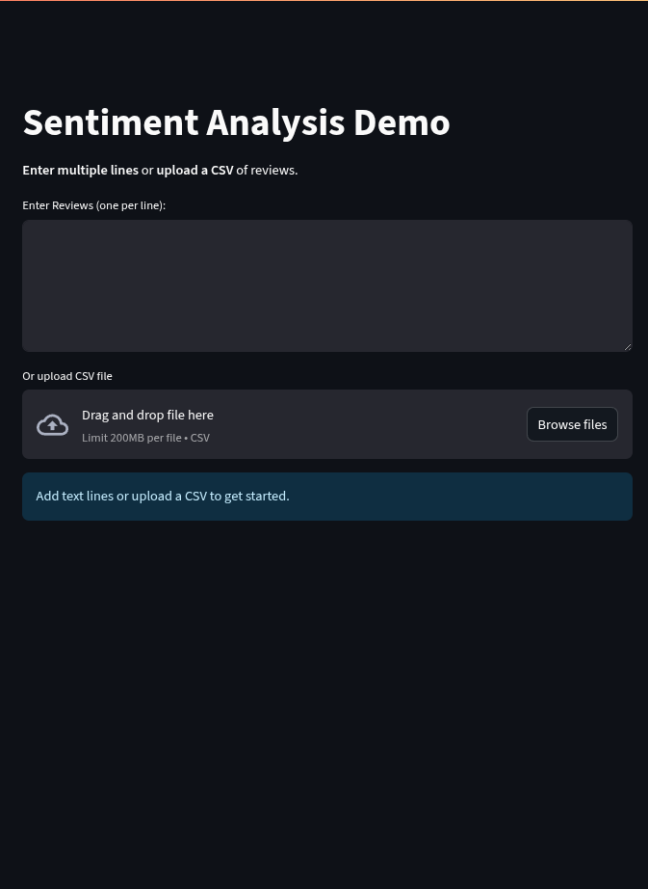

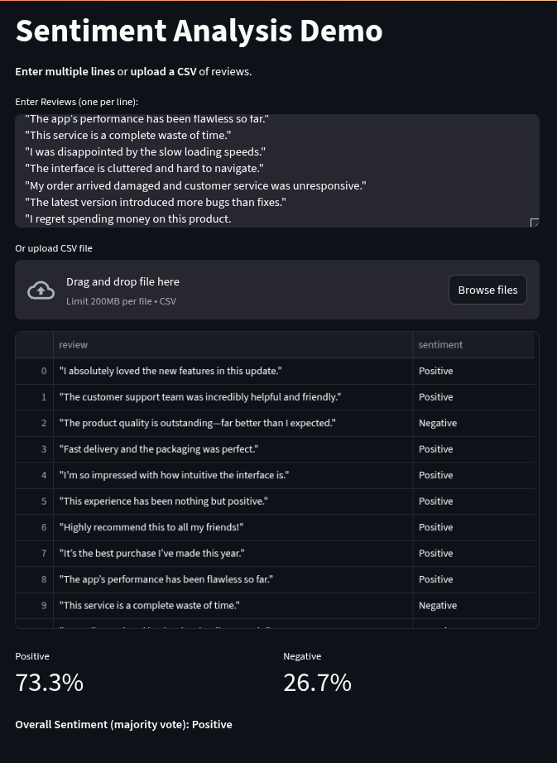
2. Taking Response Multiple response

3. Taking CSV file

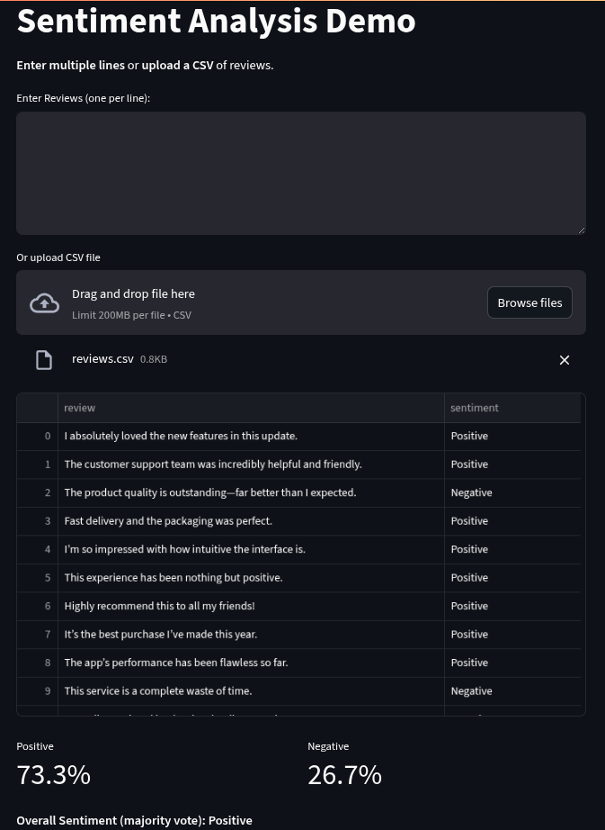

4. Accuracy results from training

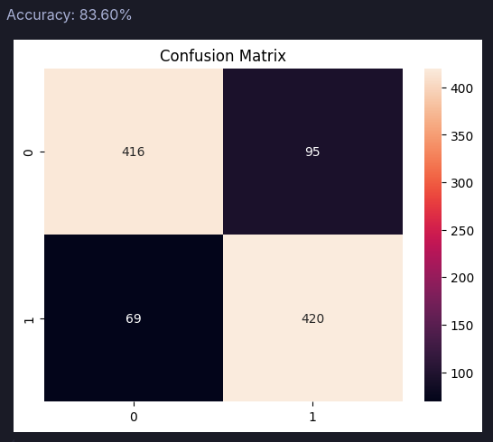

5. Analyzing the Results:

After training the model and integrating it into the Streamlit application, the sentiment analyzer was tested using both individual inputs and batch .csv file uploads. The results were accurate and consistent across most test cases. Positive reviews were correctly identified with keywords such as “amazing,” “excellent,” “loved,” and “well-made,” while negative reviews containing terms like “boring,” “worst,” “disappointed,” and “waste” were effectively flagged. The model performed well on informal language too, thanks to the frequency-based approach of CountVectorizer.

Furthermore, the application displayed a clear percentage breakdown of positive vs. negative sentiments, allowing users to understand the overall tone of the dataset. For example, if 10 reviews were analyzed and 7 were positive, the system displayed 70% Positive and 30% Negative along with an overall sentiment verdict. This made the tool useful not just for classification, but also for quick sentiment summarization. Although the model is not perfect and may misclassify complex or sarcastic inputs, its overall performance was sufficient for a lightweight, real-time sentiment analysis application.

6. Conclusion

6.1 What you built and how it works

This project focused on developing a simple yet effective Sentiment Analysis Web Application that classifies text data into positive or negative sentiments. Built using Logistic Regression and powered by a Streamlit frontend, the system allows users to enter text manually or upload a .csv file to analyze multiple inputs in bulk. It provides real-time feedback along with a percentage breakdown of sentiment distribution.

The sentiment analysis application follows a traditional but effective machine learning pipeline, consisting of preprocessing, feature extraction, model prediction, and output rendering. It begins by accepting textual input either via direct user entry or through a .csv file upload. This input is subjected to text preprocessing, where it undergoes cleaning operations such as lowercasing, punctuation removal, and stop word filtering. These steps ensure that the text is standardized and free from unnecessary noise, which is crucial for improving model accuracy.
Once cleaned, the text is passed to a CountVectorizer. This tool converts the text into numerical vectors using the Bag-of-Words model. Each sentence is represented as a sparse vector based on the frequency of words present in a predefined vocabulary. These vectors serve as features for the classification model.

6.2 Why it’s useful

Sentiment analysis is a growing necessity in an era dominated by online content, reviews, and social media opinions. However, most advanced solutions are either difficult to use for non-technical users or require expensive infrastructure to run deep learning models. This is where the proposed system becomes extremely useful. It offers a simple, accurate, and accessible way to interpret textual sentiment without requiring any programming skills or high-end computing resources.
The application is especially helpful for students, educators, content creators, product managers, and even small business owners who want to analyze customer feedback quickly. Because it provides both real-time single-line input and .csv batch processing, users can analyze everything from a handful of reviews to thousands of entries efficiently. The system’s sentiment breakdown feature also adds value by offering an at-a-glance overview of how positive or negative the dataset is overall.

6.3 Real-world application & Final thoughts

This project offered rich hands-on experience across the entire machine learning lifecycle, from data handling and preprocessing to model training and user interface development. One of the primary takeaways was understanding the significance of clean data preprocessing, which directly affects model accuracy and reliability. Learning to normalize and tokenize text, remove noise, and convert input into machine-readable formats laid the foundation for reliable classification results.
Another major learning outcome was the application of Logistic Regression to real-world textual data. While theoretically simple, applying this model on actual datasets helped solidify concepts like decision boundaries, feature weighting, and overfitting control. It also highlighted the trade-offs between model complexity and computational efficiency.
On the development side, integrating Python libraries like pandas, scikit-learn, pickle, and Streamlit demonstrated how various tools can come together to create a cohesive and functional application. The use of pickle to save and reuse trained models simplified the deployment process and illustrated the value of model serialization in production pipelines.

7. Future Scope

While this sentiment analysis system effectively demonstrates the fundamental pipeline of text classification using Logistic Regression, there are several areas where the project can be further improved and expanded to enhance its real-world utility, scalability, and intelligence.
One of the most promising directions is the integration of deep learning models, such as LSTM (Long Short-Term Memory) or transformer-based models like BERT. These models can better capture context, sarcasm, and the subtleties of language that traditional models often miss. Although Logistic Regression is ideal for lightweight applications, more advanced models could significantly improve classification accuracy, especially on complex, real-world datasets.
Another area for expansion is multilingual support. Currently, the system is optimized for English text only. By incorporating NLP preprocessing techniques and models that support other major languages (e.g., Hindi, Spanish, French), the application can become globally usable and far more inclusive.
On the usability front, this project could be evolved into a REST API or mobile application, making it accessible across different platforms and systems. Additionally, adding database support to store user inputs, historical analysis, and timestamps could enable long-term tracking and insights.
In summary, the system provides a strong base and can evolve into a more sophisticated AI product with higher accuracy, broader language capabilities, and advanced user features.
8. Bibliography

Pang, B., & Lee, L. (2008). Opinion Mining and Sentiment Analysis. Foundations and Trends in Information Retrieval, 2(1–2), 1–135.
DOI: https://doi.org/10.1561/1500000011
- Liu, B. (2012). Sentiment Analysis and Opinion Mining. Morgan & Claypool Publishers.
DOI: https://doi.org/10.2200/S00416ED1V01Y201204HLT016
- Maas, A. L., Daly, R. E., Pham, P. T., Huang, D., Ng, A. Y., & Potts, C. (2011). Learning Word Vectors for Sentiment Analysis. Proceedings of the 49th Annual Meeting of the Association for Computational Linguistics (ACL 2011).
URL: https://aclanthology.org/P11-1015/
- Bird, S., Klein, E., & Loper, E. (2009). Natural Language Processing with Python – Analyzing Text with the Natural Language Toolkit. O'Reilly Media.
- Pedregosa, F., Varoquaux, G., Gramfort, A., Michel, V., Thirion, B., Grisel, O., ... & Duchesnay, É. (2011). Scikit-learn: Machine Learning in Python. Journal of Machine Learning Research, 12, 2825–2830.
URL: https://jmlr.org/papers/v12/pedregosa11a.html
- Reimers, N., & Gurevych, I. (2019). Sentence-BERT: Sentence Embeddings using Siamese BERT-Networks. arXiv preprint arXiv:1908.10084.
URL: https://arxiv.org/abs/1908.10084
- OpenAI. (2024). Introduction to GPT-4 and its Applications. OpenAI Technical Reports.
URL: https://openai.com/research
- IMDb. (n.d.). IMDb Movie Review Dataset. Retrieved from https://ai.stanford.edu/~amaas/data/sentiment/
- Streamlit Inc. (2023). Streamlit Documentation. Retrieved from https://docs.streamlit.io/
- Van Rossum, G., & Drake, F. L. (2009). Python 3 Reference Manual. Scotts Valley, CA: CreateSpace.
- McKinney, W. (2010). Data Structures for Statistical Computing in Python. In Proceedings of the 9th Python in Science Conference, 51–56.
URL: https://conference.scipy.org/proceedings/scipy2010/pdfs/mckinney.pdf
- Rajaraman, A., & Ullman, J. D. (2011). Mining of Massive Datasets. Cambridge University Press.
- Manning, C. D., Raghavan, P., & Schütze, H. (2008). Introduction to Information Retrieval. Cambridge University Press.
DOI: https://doi.org/10.1017/CBO9780511809071
- Jockers, M. L. (2017). Text Analysis with R for Students of Literature. Springer.
- Tan, P. N., Steinbach, M., & Kumar, V. (2018). Introduction to Data Mining (2nd Edition). Pearson Education.
- Aggarwal, C. C. (2018). Machine Learning for Text. Springer.
DOI: https://doi.org/10.1007/978-3-319-73531-3
- Chollet, F. (2018). Deep Learning with Python. Manning Publications.
- Russell, S., & Norvig, P. (2021). Artificial Intelligence: A Modern Approach (4th Edition). Pearson Education.
- Google Developers. (2024). Machine Learning Crash Course.
URL: https://developers.google.com/machine-learning/crash-course
- GitHub Contributors. (2024). Scikit-learn Source Code Repository.
URL: https://github.com/scikit-learn/scikit-learn
Krish Naik. (2023). Sentiment Analysis using Scikit-Learn and Streamlit – Tutorial. [YouTube Video].
URL: https://www.youtube.com/watch?v=VIDEO_ID
- @amitness. (2024). Bag-of-Words Explained. [Blog Post].
URL: https://amitness.com/2020/05/bag-of-words/

