CYBER KILL CHAIN
Attack Lifecycle & SOC Analyst Analysis
Internship Main Points • Professional Learning Notes

1. Cyber Kill Chain – Overview
The Cyber Kill Chain is a framework for understanding the stages an adversary may move through during a cyberattack. The source material describes the Lockheed Martin Cyber Kill Chain as a framework established in 2011 and organized into seven phases.
- Helps security teams understand an attack as a sequence of stages.
- Useful for SOC Analysts, Security Researchers, Threat Hunters, and Incident Responders.
- Can support detection, investigation, response, and understanding of attacker progression.
- The framework is especially useful when analyzing ransomware, security breaches, and APT activity.

2. The Seven Cyber Kill Chain Phases
Phase | Main Purpose | Examples / Techniques | SOC Analyst Focus
1. Reconnaissance | Research and planning before an attack. | OSINT, employee information, exposed technologies, passive/active reconnaissance. | Understand what information and exposed infrastructure may be targeted; recognize reconnaissance activity and context.
2. Weaponization | Prepare the malicious components used in the attack. | Malware, exploits, payloads, malicious Office macros/VBA, backdoors, phishing/OAuth-related techniques. | Identify likely malicious payload characteristics and connect preparation activity with later delivery/exploitation.
3. Delivery | Transmit the weaponized content to the target. | Phishing, malicious email, USB drops, watering-hole attacks. | Review email, endpoint, web, or removable-media evidence associated with the delivery path.
4. Exploitation | Exploit a vulnerability or cause malicious code to execute. | Malicious macro execution, known CVEs, zero-days, privilege escalation. | Look for unexpected process spawning, registry changes, new services, and suspicious command-line arguments.
5. Installation | Establish persistence or continued access. | Web shells, backdoors, Windows services, Run Keys/Startup Folder, timestomping. | Identify persistence artifacts and suspicious changes that allow an attacker to remain on a system.
6. Command & Control (C2) | Maintain communication between attacker and compromised system. | Beaconing, HTTP/HTTPS communication, DNS tunneling. | Look for repeated outbound connections, unusual domains/IPs, beacon-like traffic, and suspicious DNS behavior.
7. Actions on Objectives | Carry out the attacker’s final goals. | Credential collection, privilege escalation, internal reconnaissance, lateral movement, exfiltration, backup/shadow-copy deletion, data corruption. | Determine scope and impact, identify attacker objectives, and support containment and incident response.

3. Key Concepts for an Internship
OSINT: Open-Source Intelligence; information gathered from publicly available sources.
Malware: Malicious software used to compromise or affect systems.
Exploit: Code or a technique used to take advantage of a vulnerability.
Payload: The component delivered or executed to perform the attacker’s intended malicious action.
Persistence: Techniques that allow an attacker to maintain access after initial compromise.
Beaconing: Repeated communication from a compromised system to command-and-control infrastructure.
C2: Command and Control; communication used to manage or interact with compromised systems.
Lateral Movement: Movement through internal systems after initial compromise.
Exfiltration: Unauthorized transfer of collected data out of the environment.
IOC: Indicator of Compromise; an observable artifact that may help identify malicious activity.

4. SOC Investigation View
- Identify which Kill Chain phase is supported by the available evidence.
- Correlate multiple indicators instead of relying on one artifact alone.
- During exploitation, examine unexpected process execution, registry changes, services, and command-line activity.
- During installation, investigate persistence mechanisms and suspicious system changes.
- During C2, examine recurring network connections, HTTP/HTTPS activity, and DNS tunneling indicators.
- During Actions on Objectives, focus on credentials, privilege escalation, lateral movement, data collection/exfiltration, and destructive activity.
- Use the framework to understand attacker progression and where defensive action can interrupt the chain.

5. High-Value Detection Indicators
Attack Stage | Important Indicators | Why It Matters
Exploitation | Unexpected process spawning; registry changes; new services; suspicious command-line arguments. | May indicate successful exploitation or execution.
Installation | Web shells; backdoors; unusual services; Run Keys/Startup Folder changes; timestomping. | May indicate persistence or efforts to hide activity.
C2 | Repeated outbound connections; HTTP/HTTPS beaconing; suspicious DNS behavior/tunneling. | May indicate ongoing communication with attacker infrastructure.
Actions on Objectives | Credential collection; lateral movement; data collection/exfiltration; backup/shadow-copy deletion. | Helps determine attacker goals, scope, and impact.

6. Cyber Kill Chain Limitations
- The traditional framework was designed around a particular attack model and does not represent every modern threat equally well.
- It can be less effective for insider threats.
- Adversaries can change tools, hashes, IP addresses, and techniques, so a simple linear model is not sufficient for every investigation.
- The source recommends using the Cyber Kill Chain alongside frameworks such as MITRE ATT&CK and Unified Kill Chain.

7. Internship Key Takeaways
- Learn the seven phases and understand the purpose of each phase.
- Map observable evidence to the most relevant attack phase.
- Pay particular attention to exploitation, persistence, C2, lateral movement, and data exfiltration indicators.
- Think in terms of attacker progression: Reconnaissance → Weaponization → Delivery → Exploitation → Installation → C2 → Actions on Objectives.
- Use the framework as an investigation aid, not as the only detection model.
- A SOC Analyst should focus on identifying evidence, understanding attack progression, and supporting timely response.

8. Practical Learning / Lab Relevance
The source material includes a Target breach case study intended to practice mapping observed artifacts to Cyber Kill Chain phases. For internship documentation, record the evidence observed, the phase it represents, the reasoning for the mapping, and the defensive lesson learned.

9. Quick Revision Sheet
- Reconnaissance → Research the target
- Weaponization → Prepare malicious capability
- Delivery → Send/deliver the capability
- Exploitation → Trigger vulnerability or execution
- Installation → Establish persistence
- Command & Control → Communicate with the compromised system
- Actions on Objectives → Achieve the attacker’s goal

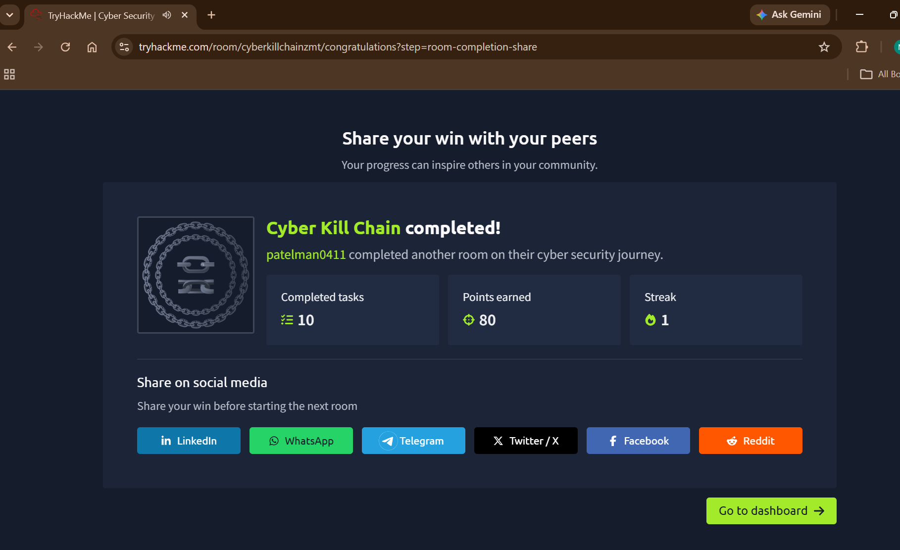

Internship Focus: Understand the attack lifecycle • identify evidence • map activity to phases • support detection and response

