SOC / CYBERSECURITY HANDS-ON LAB
Windows Event Log Investigation
Virtual Machine Lab Setup & Security Event Analysis

Student Name | Man Patel
Lab / Internship Task | Hands-On Task – Windows Event Logs
Primary Platform | Windows 10 Event Viewer
Required VMs | Windows 10 + Linux linux

1. Lab Objective
Objective: Build a small virtualized lab and practice identifying Windows security-related events using Event Viewer. The lab focuses on four important event types: successful logons, failed logons, process creation, and new local user creation.

2. Lab Requirements
- VirtualBox or VMware Workstation Player
- One Windows 10 virtual machine
- One Linux Server or Linux Desktop virtual machine
- At least 4 GB RAM recommended for the Windows VM and sufficient RAM for the Linux VM
- Windows administrator account for generating/inspecting relevant events
- Enough disk space for two VM installations
- Screenshot capability for documenting Event Viewer results

3. Recommended Lab Architecture
VM | Operating System | Purpose | Suggested Network
VM 01 | Windows 10 | Event generation & Event Viewer investigation | NAT / Host-only
VM 02 | Linux linux | Security lab / supporting system | NAT / Host-only

4. Build the Virtual Machine Lab

4.1 Install VirtualBox or VMware
- Install Oracle VirtualBox or VMware Workstation Player on the host computer.
- Create a new virtual machine for Windows 10. Attach a legitimate Windows 10 ISO and complete the installation.
- Create a second virtual machine using a Linux Server or Linux Desktop distribution such as Ubuntu.
- Install Guest Additions / VMware Tools where appropriate for better display, mouse, and integration support.
- Keep the lab isolated or use NAT/Host-only networking unless internet access is required.
- Take a snapshot of each VM after the base installation so the lab can be restored easily.
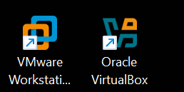
4.2 created kali Linux
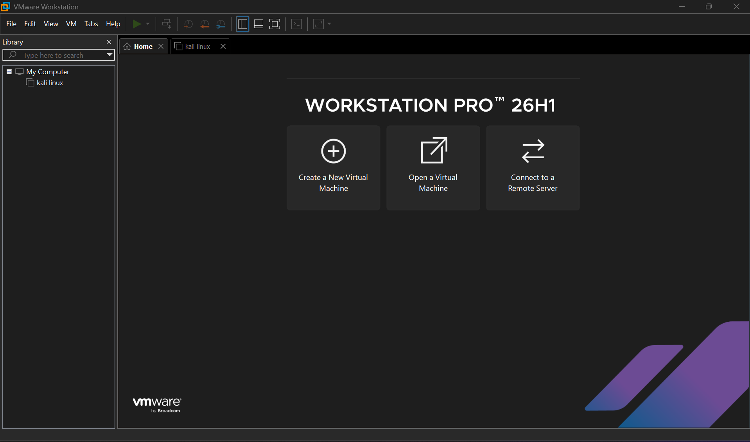
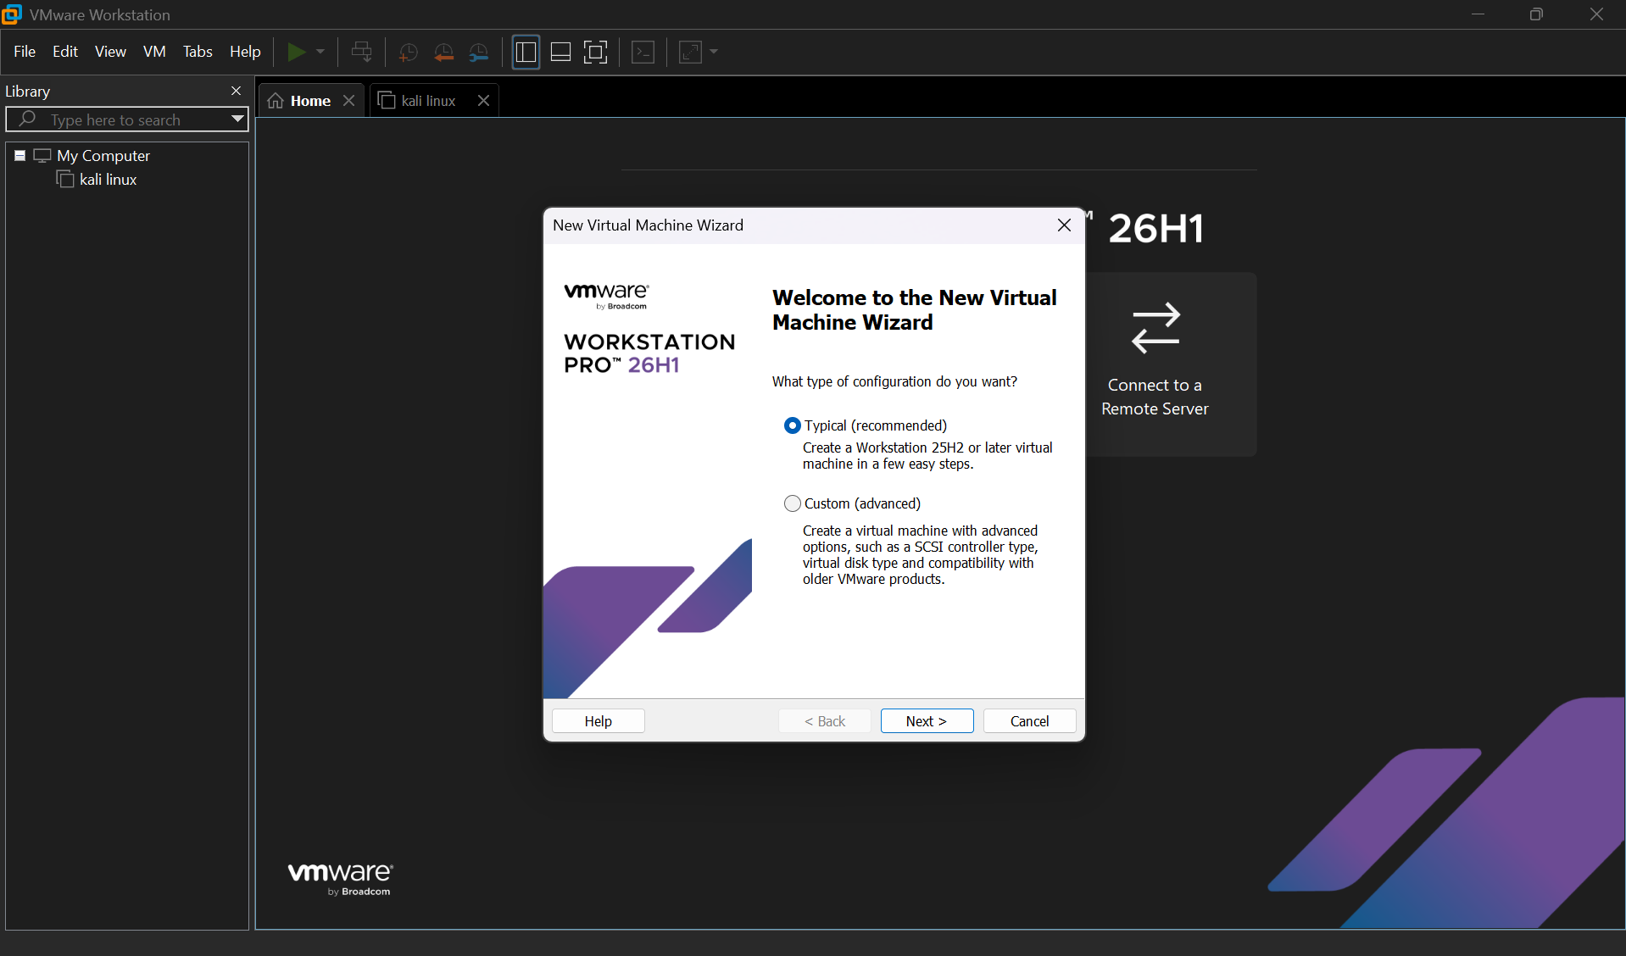
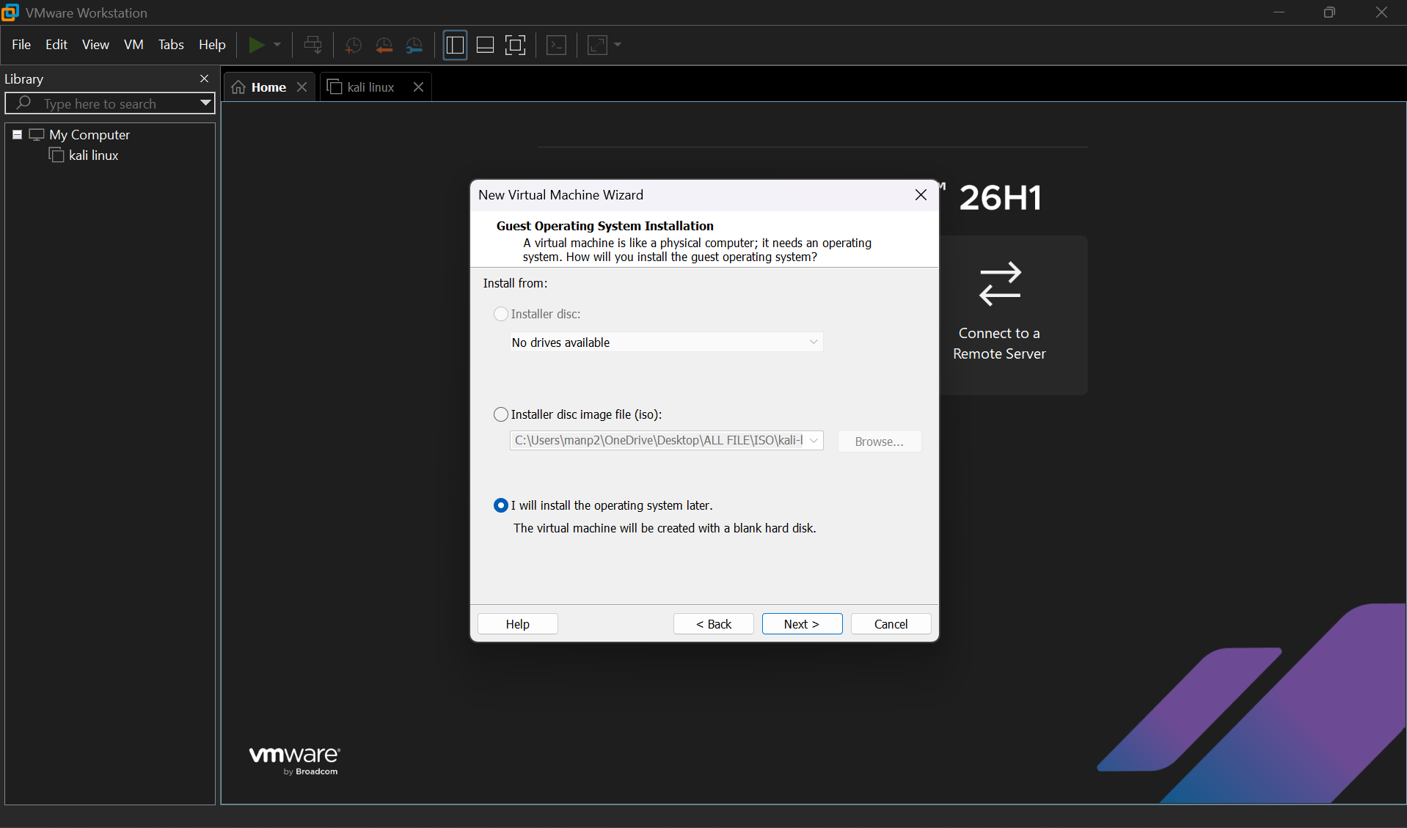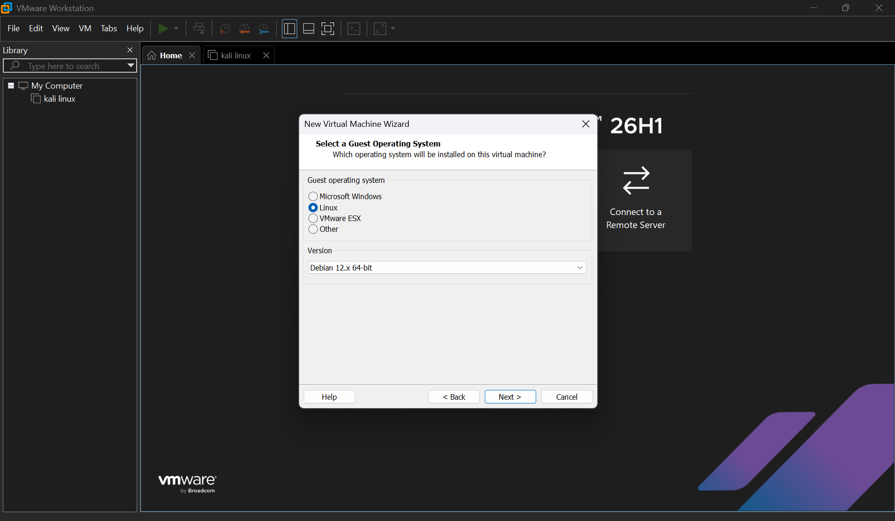
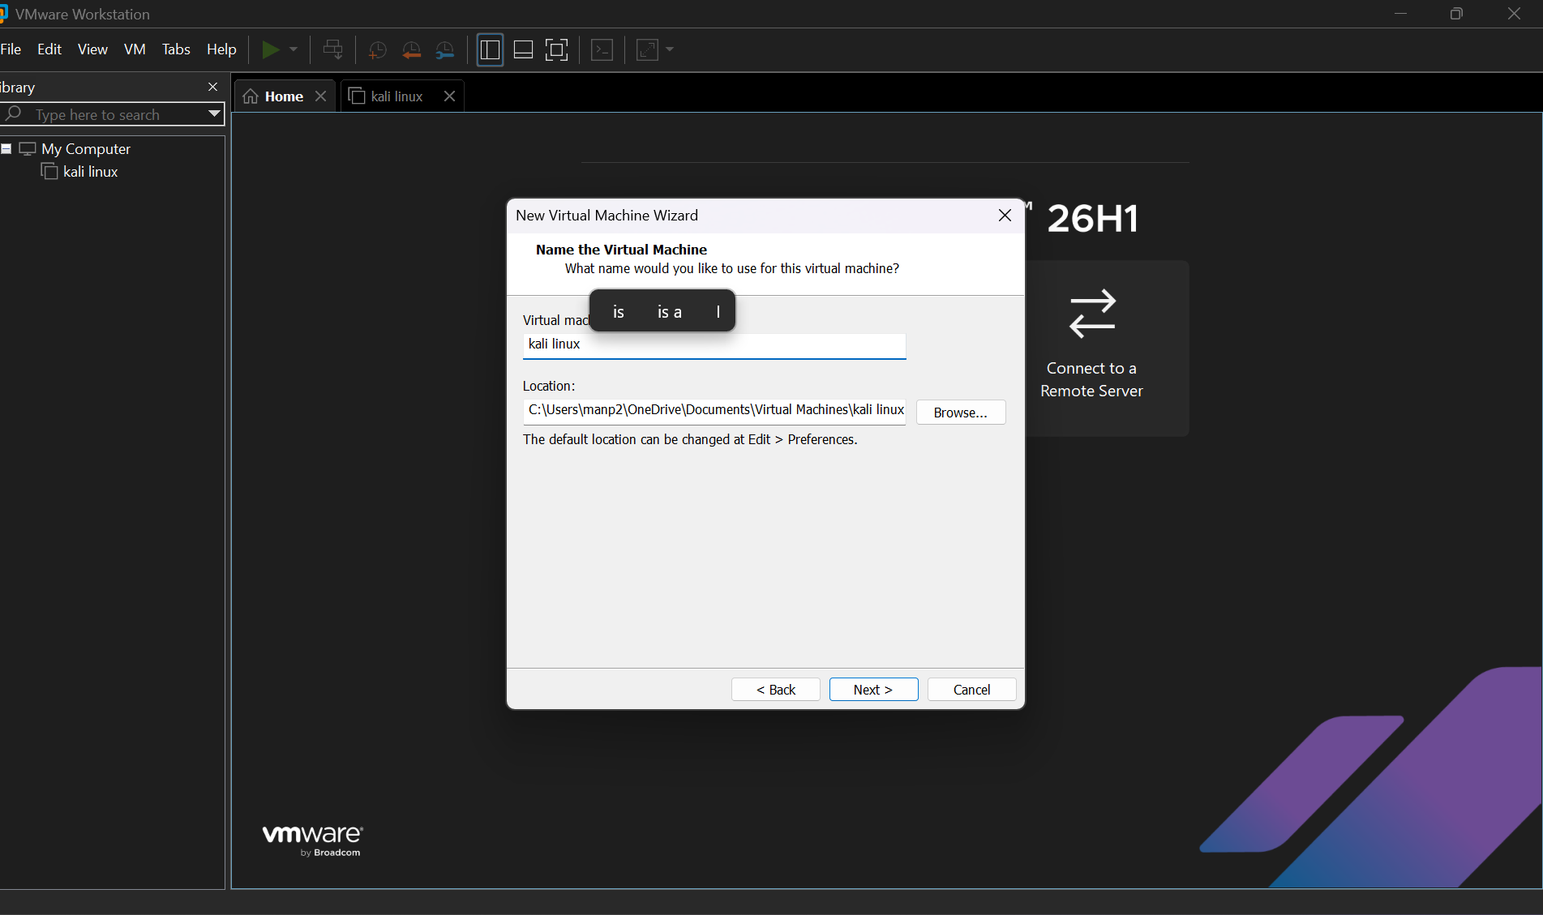
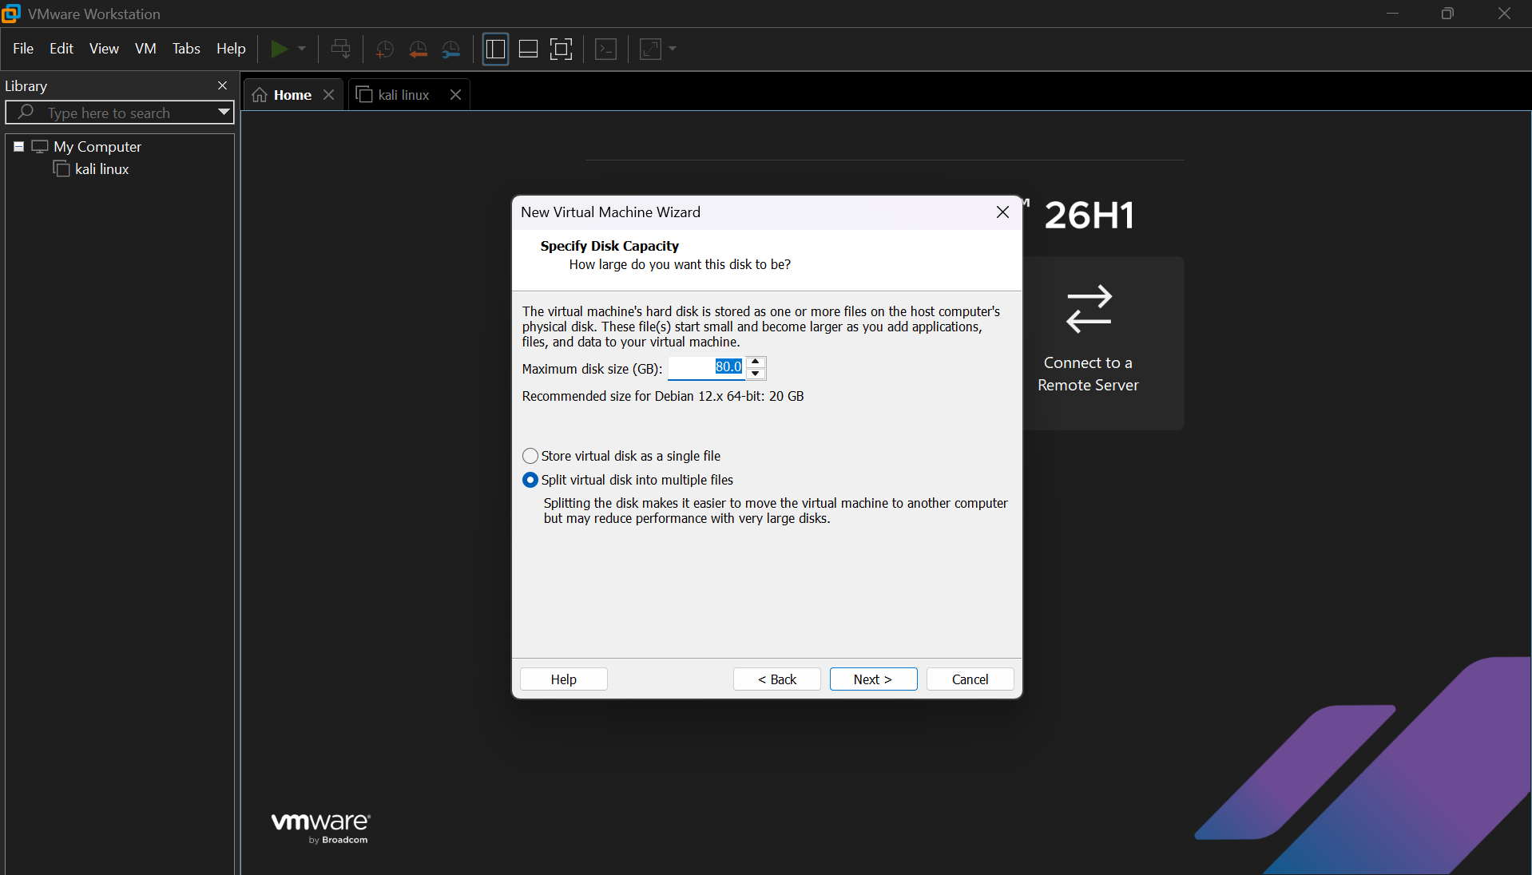
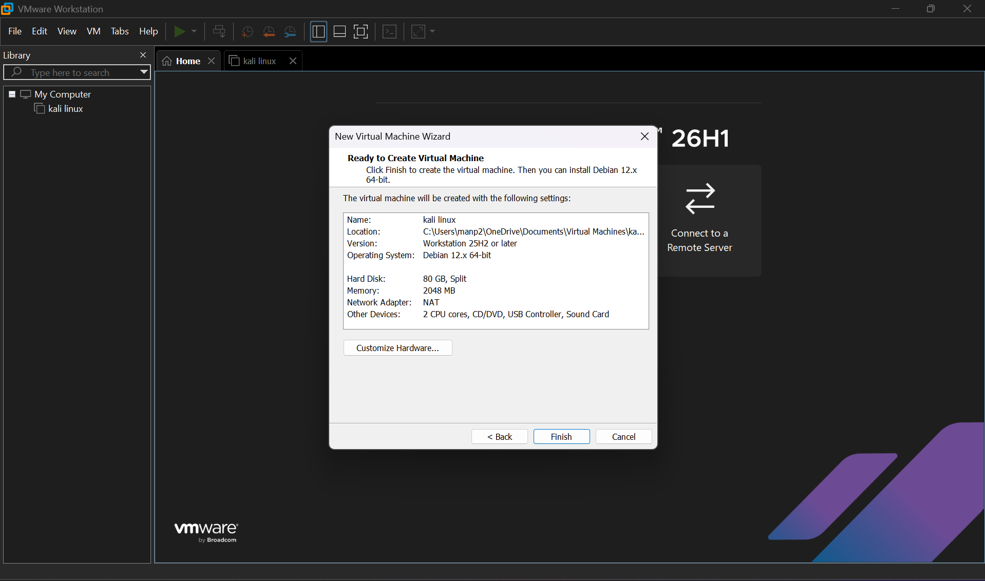
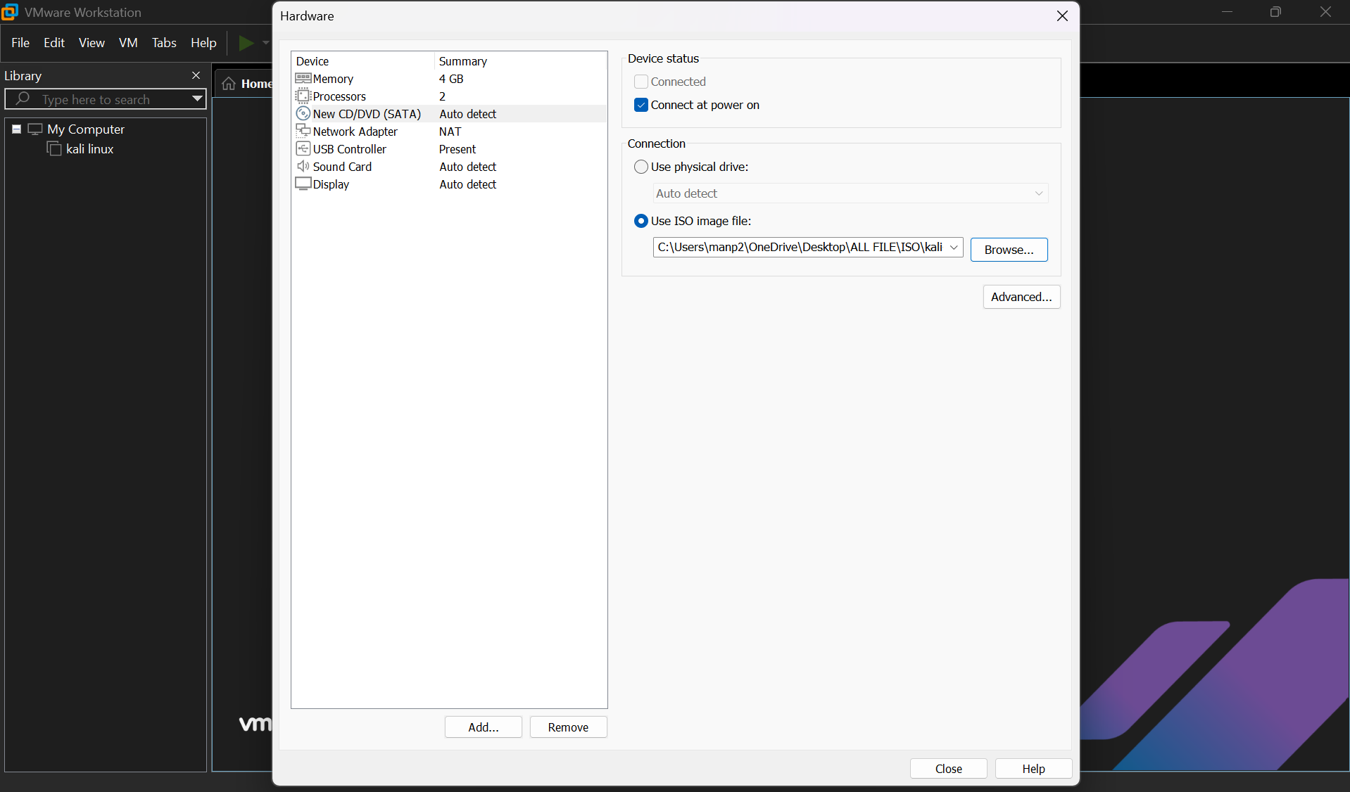
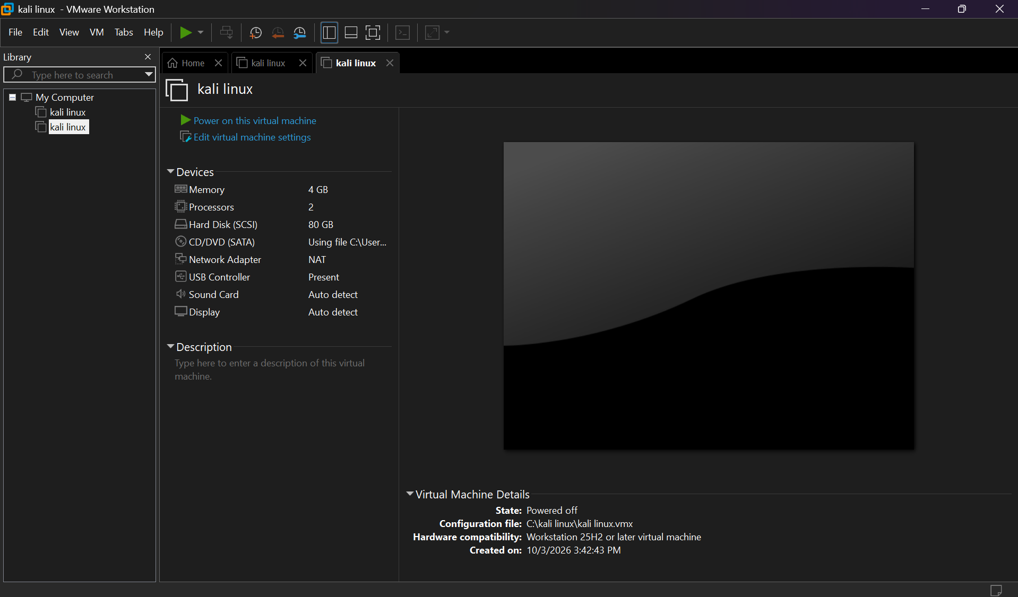
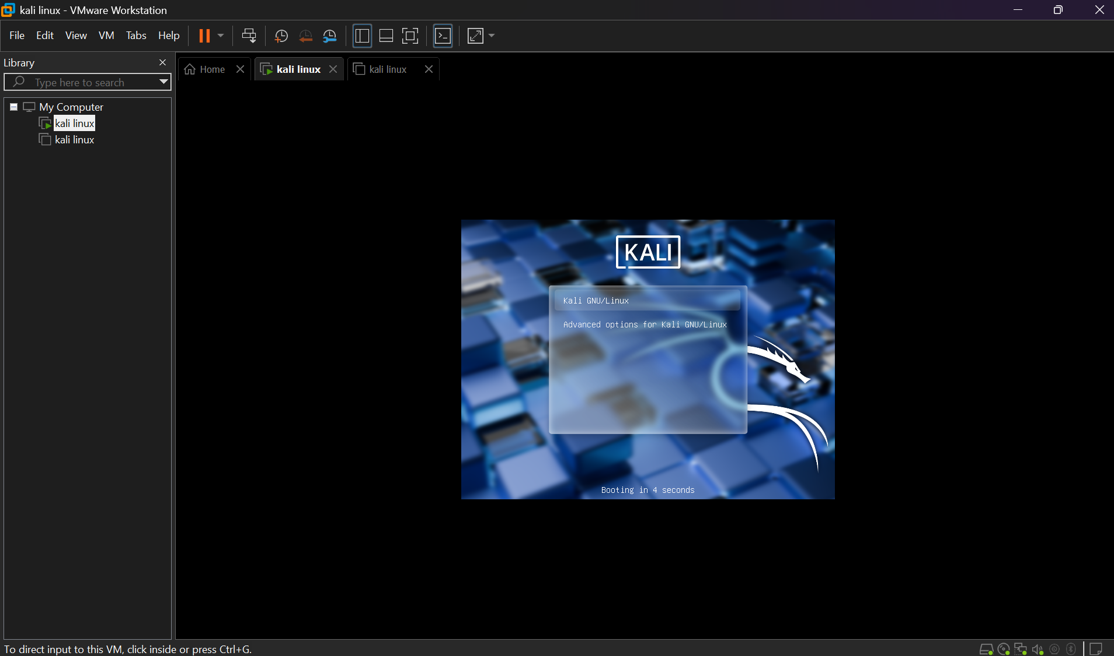
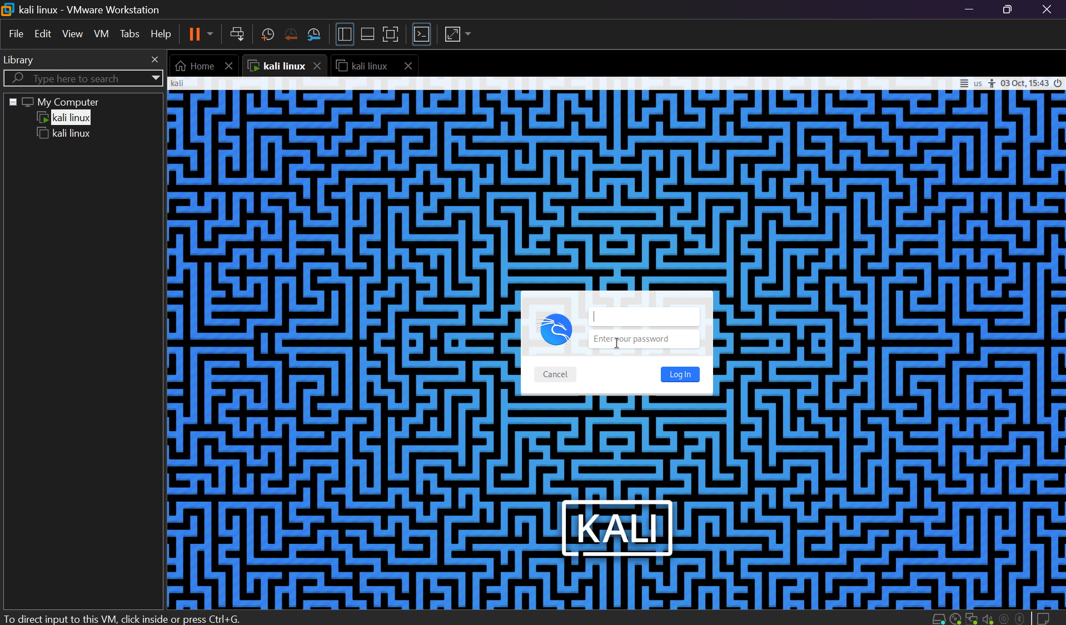
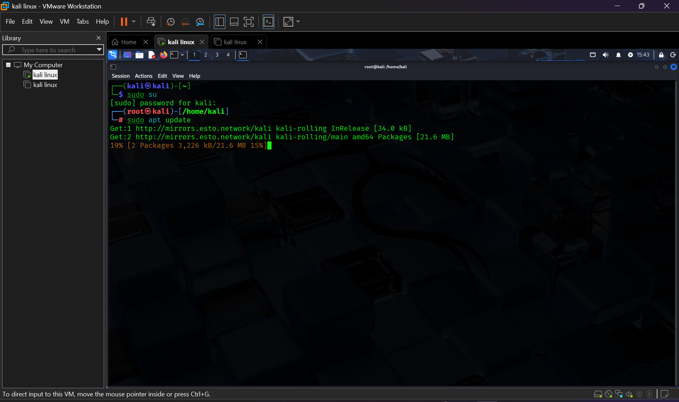

4.3 created windows 10
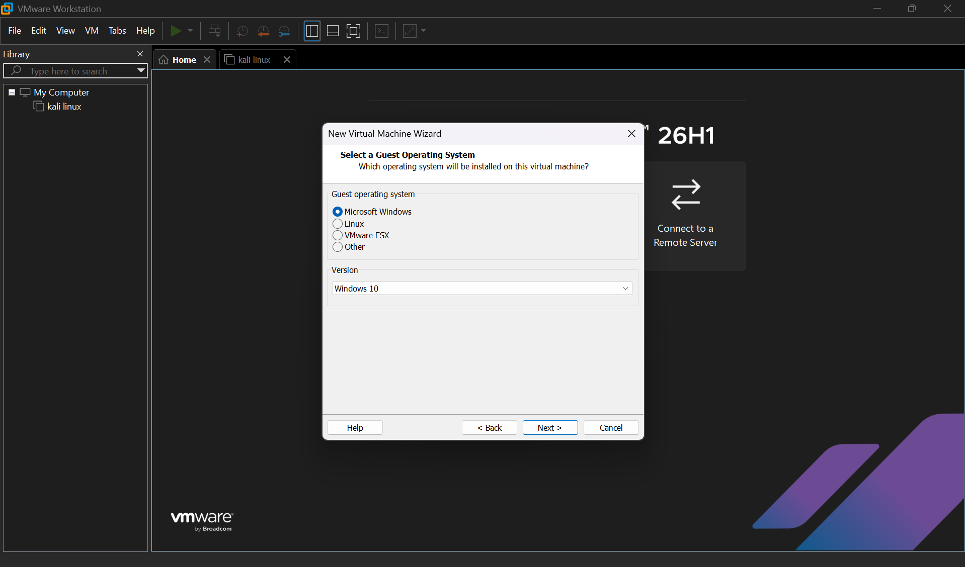
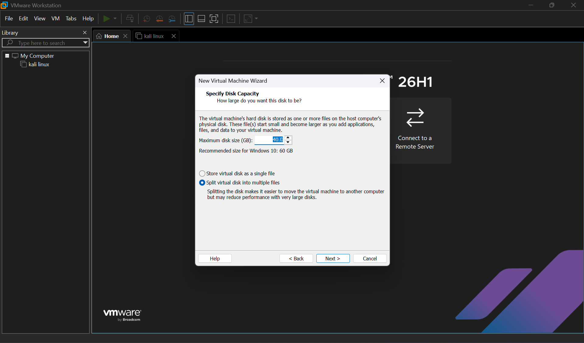
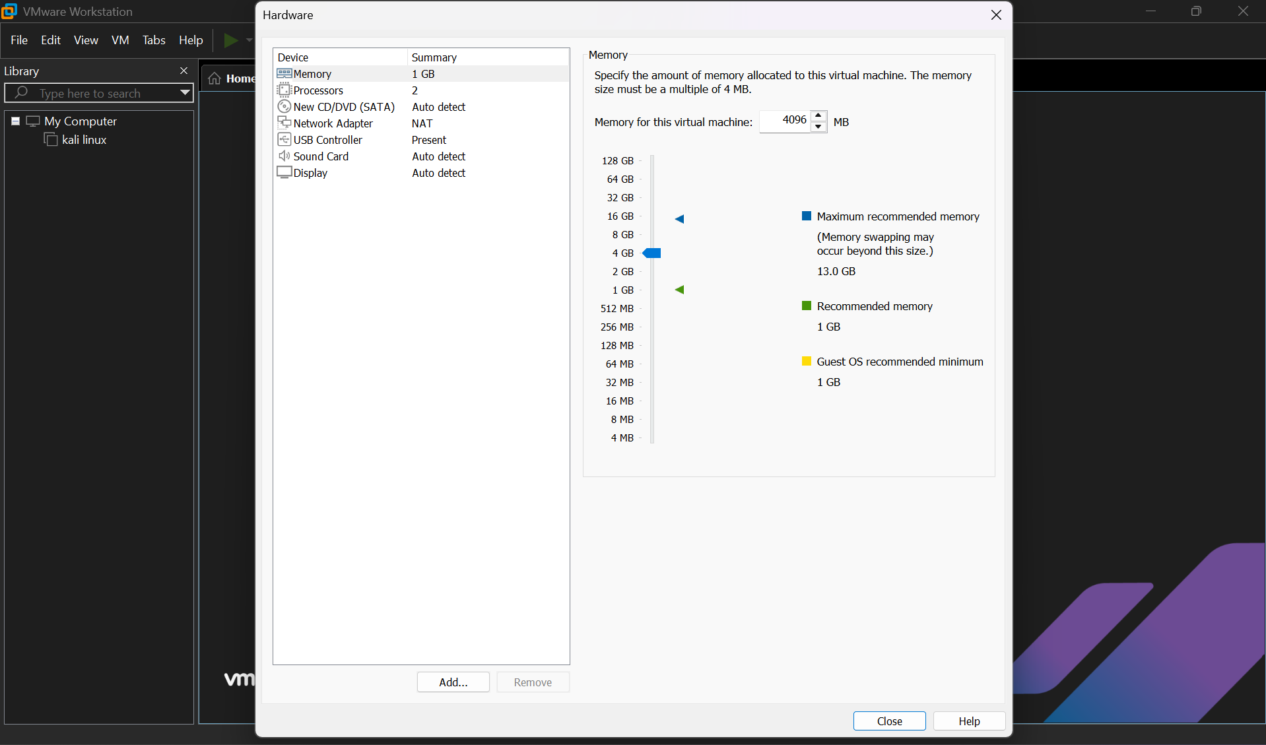
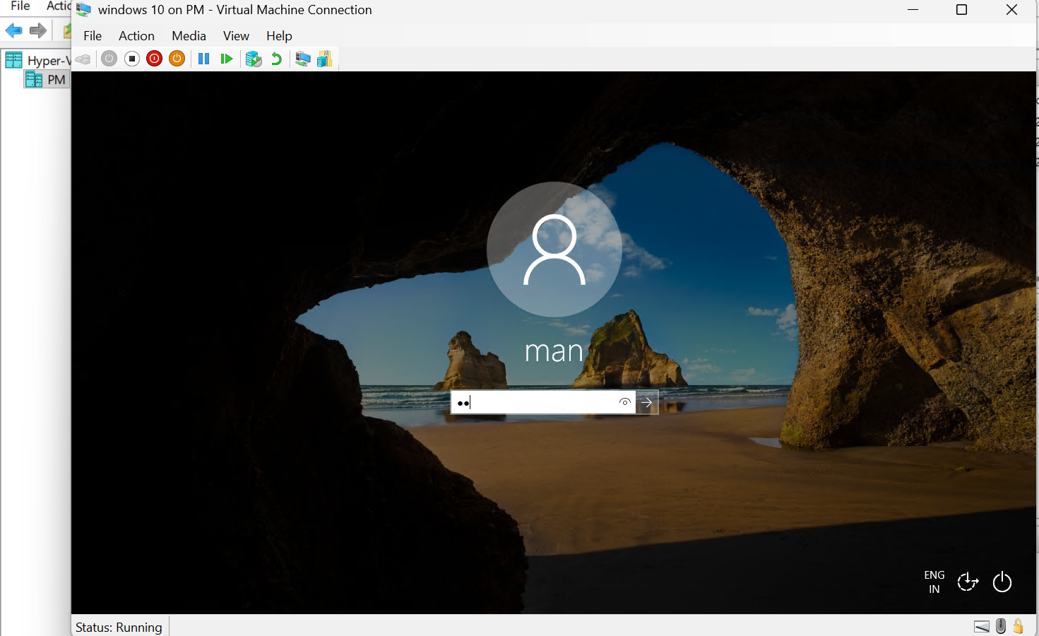
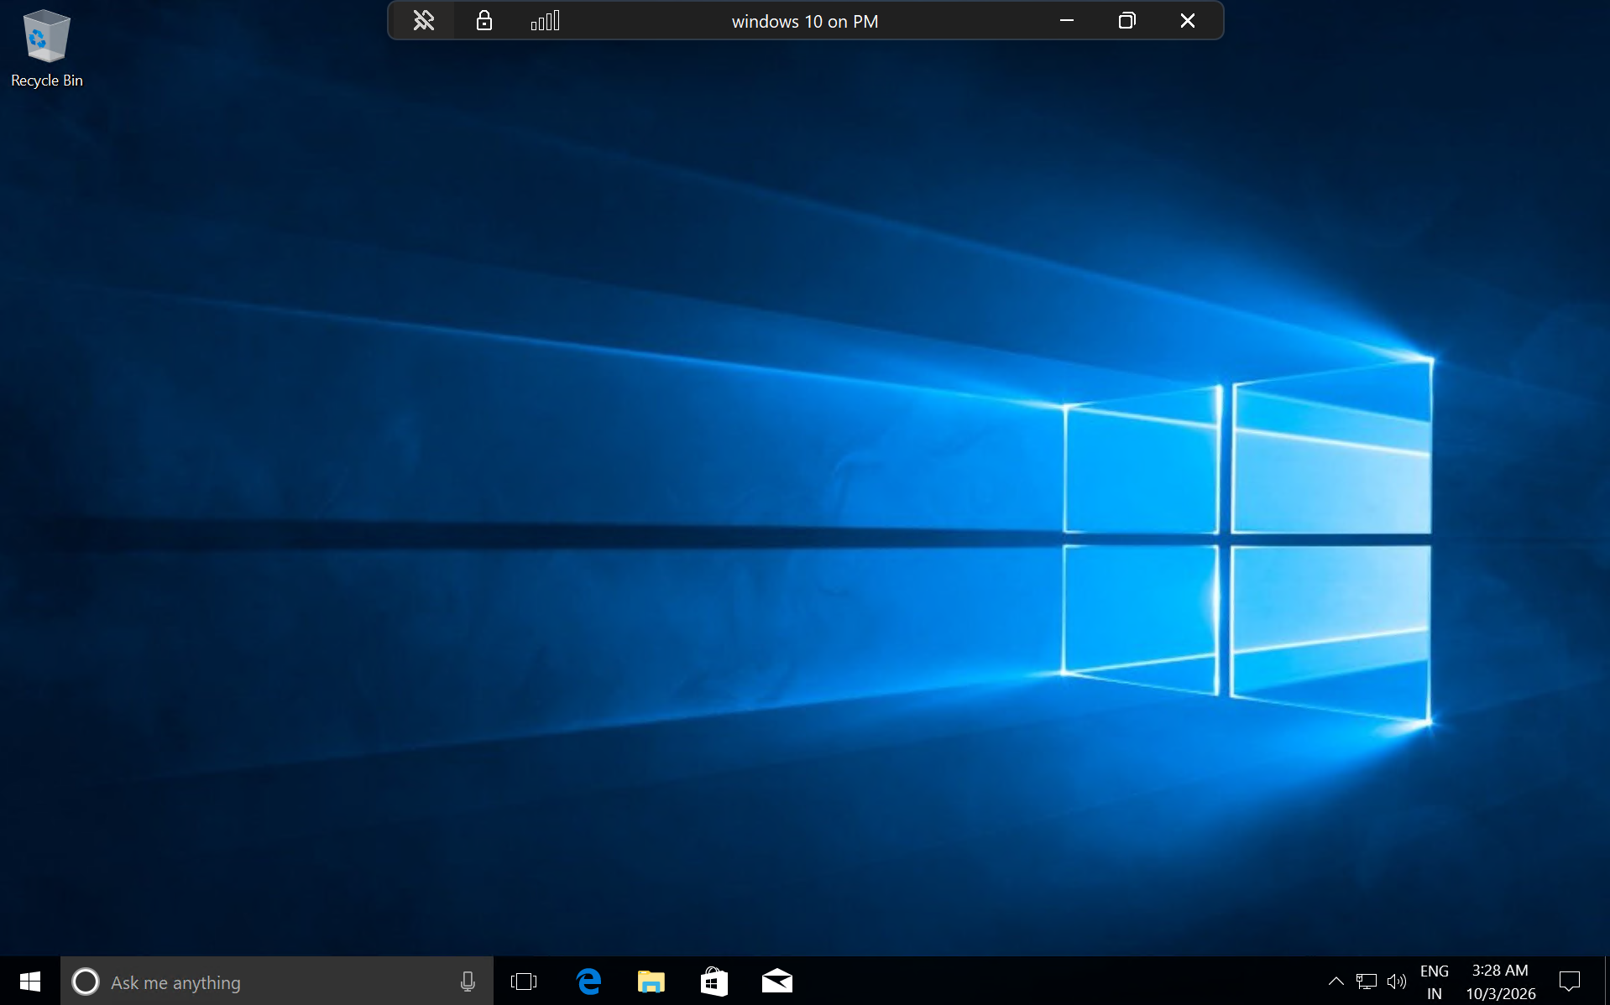

5. Windows Event Viewer Investigation
Open Event Viewer: Press Win + R, type eventvwr.msc, and press Enter. Navigate to Windows Logs → Security. If required, use Filter Current Log… and enter the required Event ID.
Important: Event availability depends on the audit policies enabled on the Windows VM. If an expected event does not appear, generate the corresponding activity and verify that the relevant Windows auditing policy is enabled.
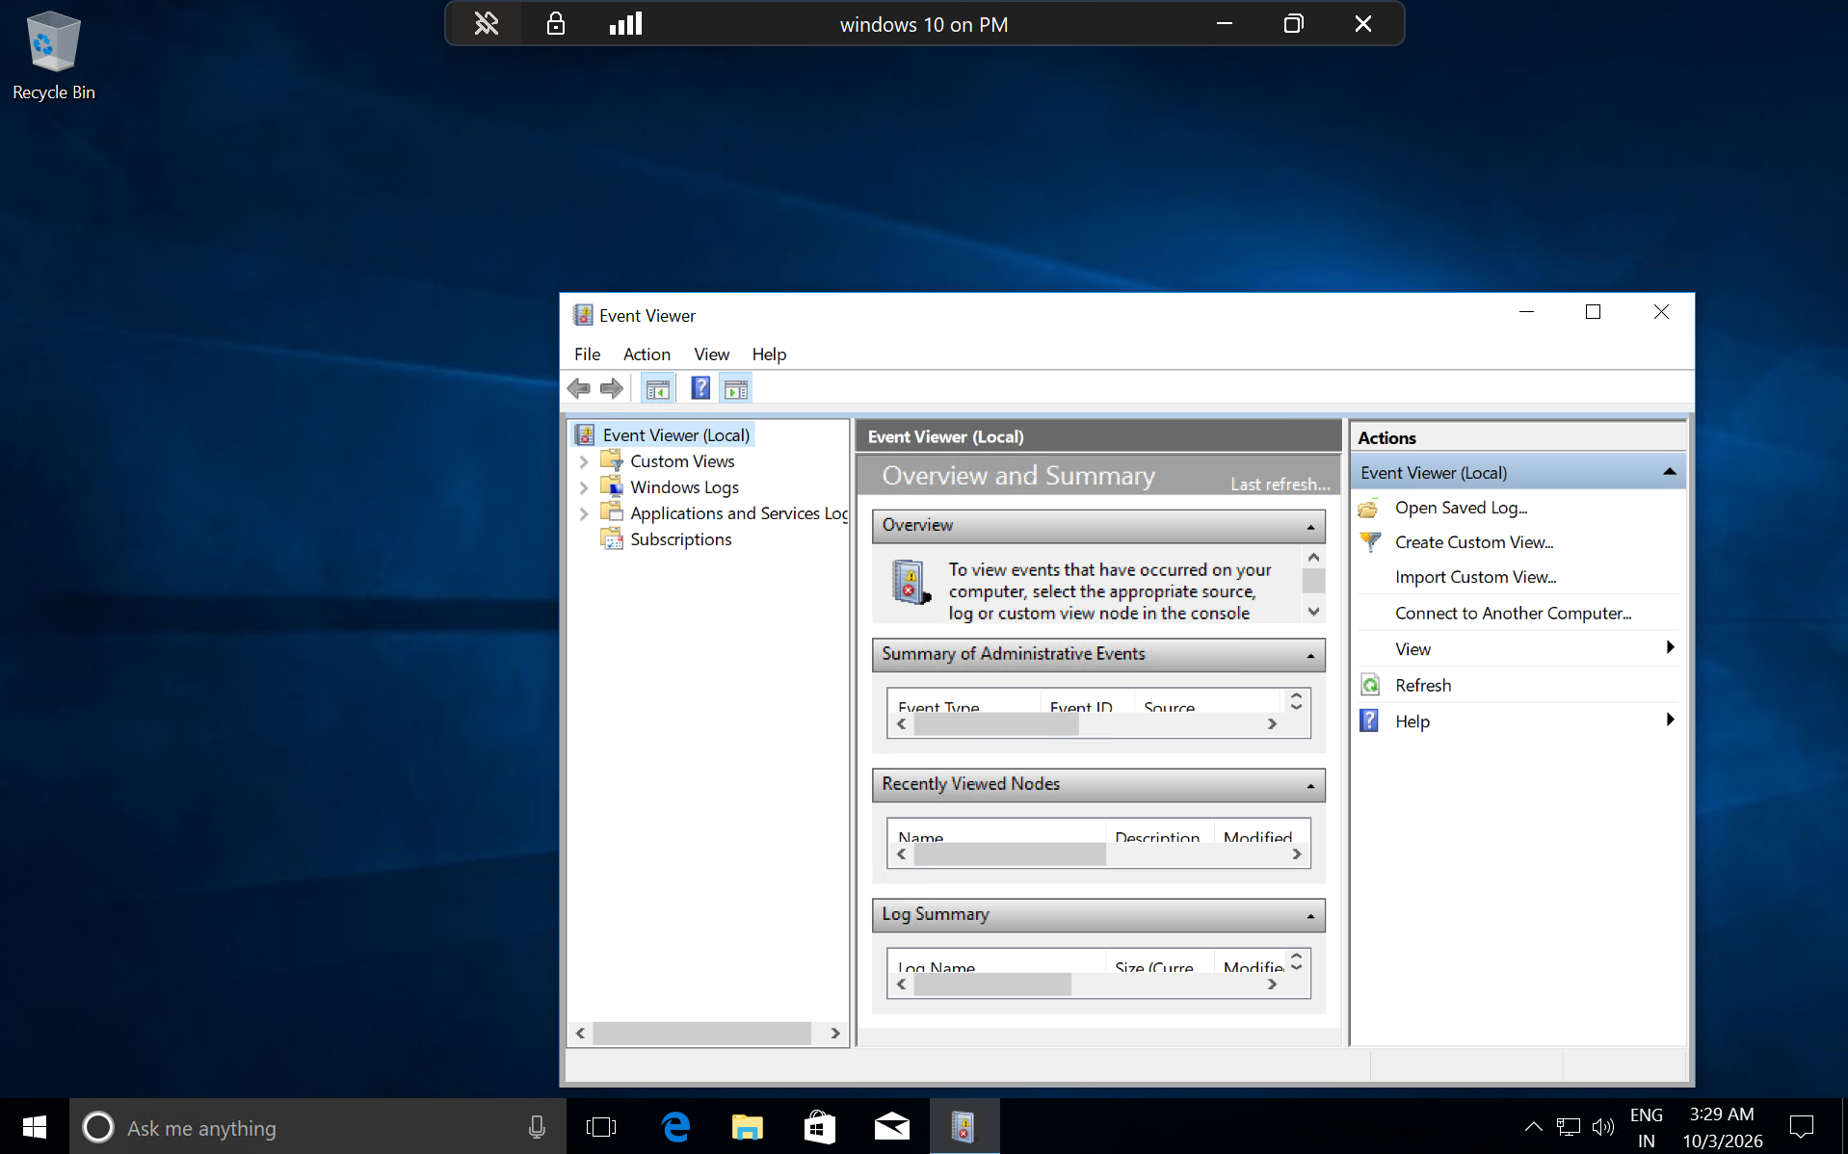

6. Required Event IDs
Event ID | Event Type | What It Indicates | Evidence to Capture
4624 | Successful logon | A logon to the Windows system completed successfully. | Event details showing Event ID 4624, time, account, and logon information.
4625 | Failed logon | A logon attempt failed. | Event details showing Event ID 4625, time, account, and failure information.
4688 | Process creation | A new process/program was started. | Event details showing Event ID 4688 and the process information.
4720 | User account created | A new user account was created. | Event details showing Event ID 4720 and the newly created account.

7. Event ID 4624 — Successful Logon
- Open Event Viewer → Windows Logs → Security.
- Select Filter Current Log… and enter Event ID 4624.
- Open a relevant 4624 event.
- Review the General tab and, when needed, the Details tab.
- Record the date/time, account name, Logon Type, and other useful fields visible in the event.
- Capture a screenshot where the Event ID and key evidence are readable.
- 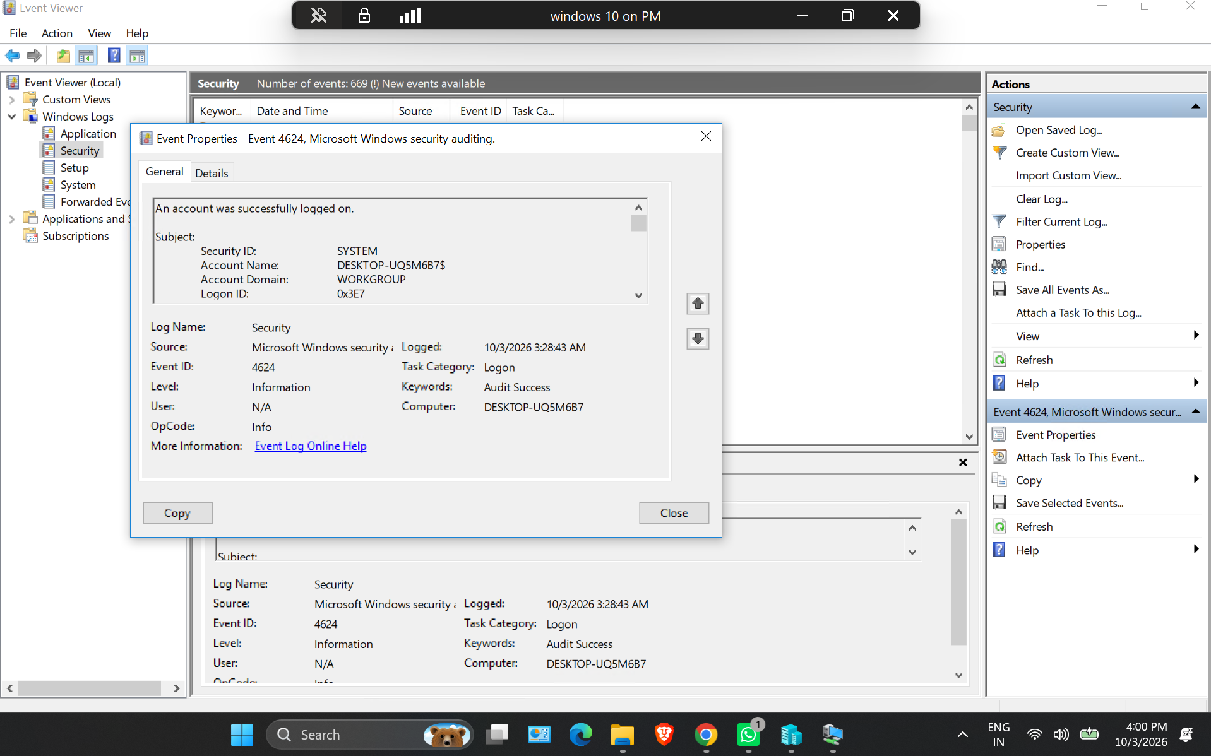

8. Event ID 4625 — Failed Logon
- In Security logs, use Filter Current Log… and enter Event ID 4625.
- Generate a controlled failed logon in the lab if necessary, using a test account or intentionally incorrect password.
- Open the resulting 4625 event.
- Review the account name, failure information, source/network information if present, and timestamp.
- Capture a screenshot showing Event ID 4625 and the relevant evidence.
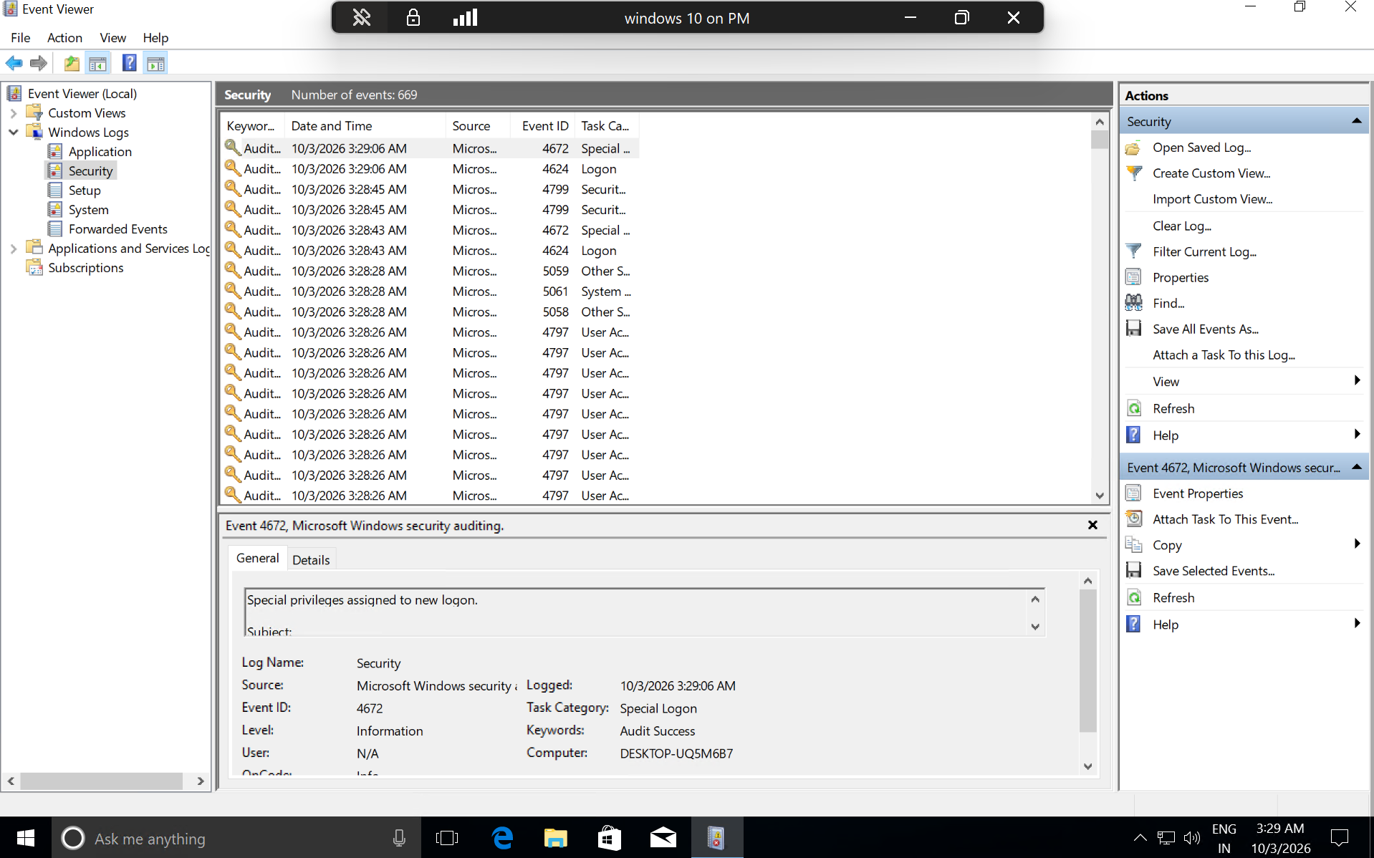

9. Event ID 4688 — Process Creation
- Filter the Security log for Event ID 4688.
- Start a harmless program in the Windows VM, such as Notepad, if necessary.
- Open the corresponding 4688 event.
- Review the new process name and other available process-creation fields.
- Capture a screenshot where Event ID 4688 and the process information are readable.
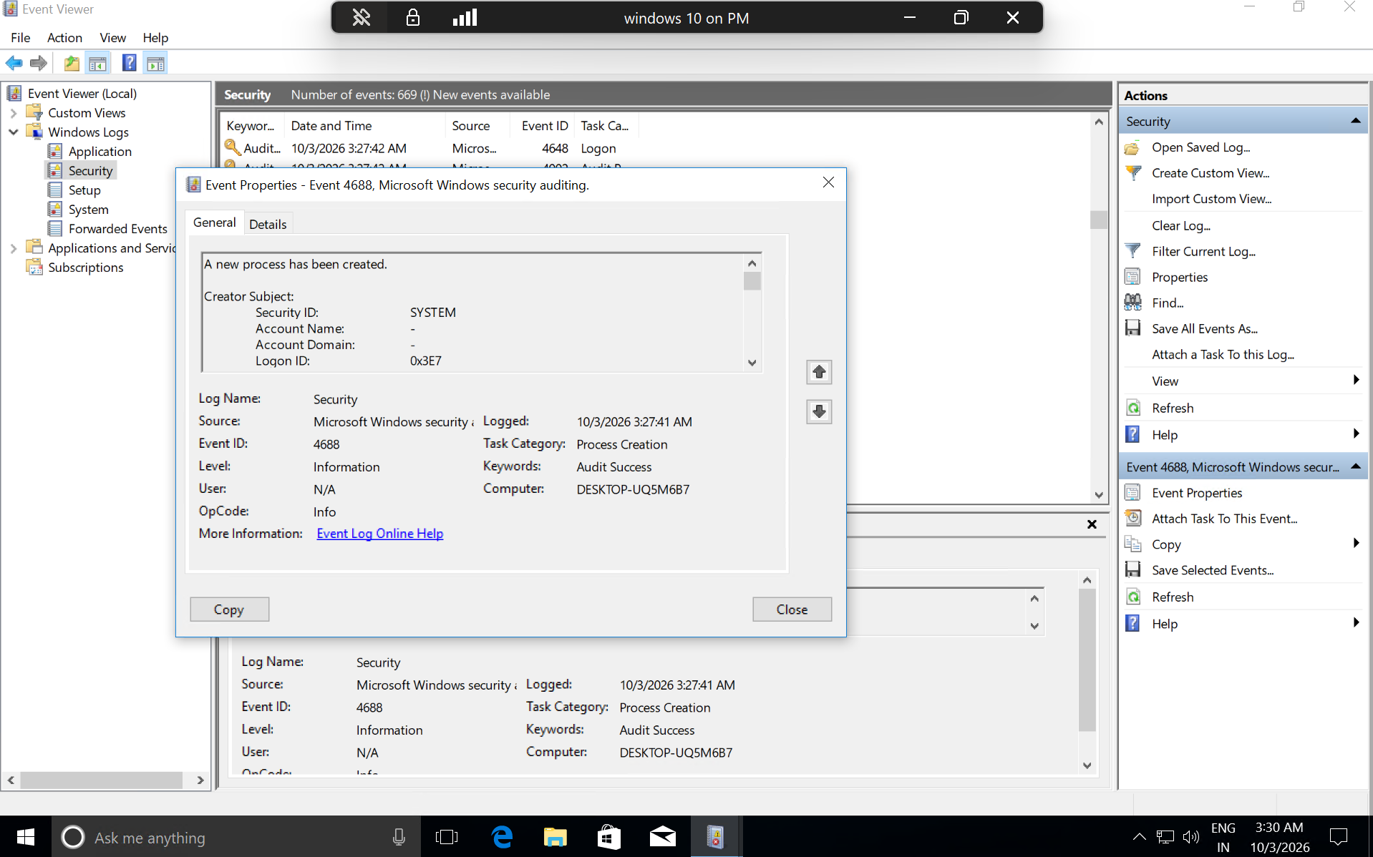

10. Event ID 4720 — New User Account Created
- Filter the Security log for Event ID 4720.
- Create a temporary local test user from Windows Settings or Computer Management using administrator privileges.
- Return to Event Viewer and open the corresponding 4720 event.
- Review the subject account and the newly created account information.
- Capture a screenshot showing Event ID 4720 and the account-creation evidence.
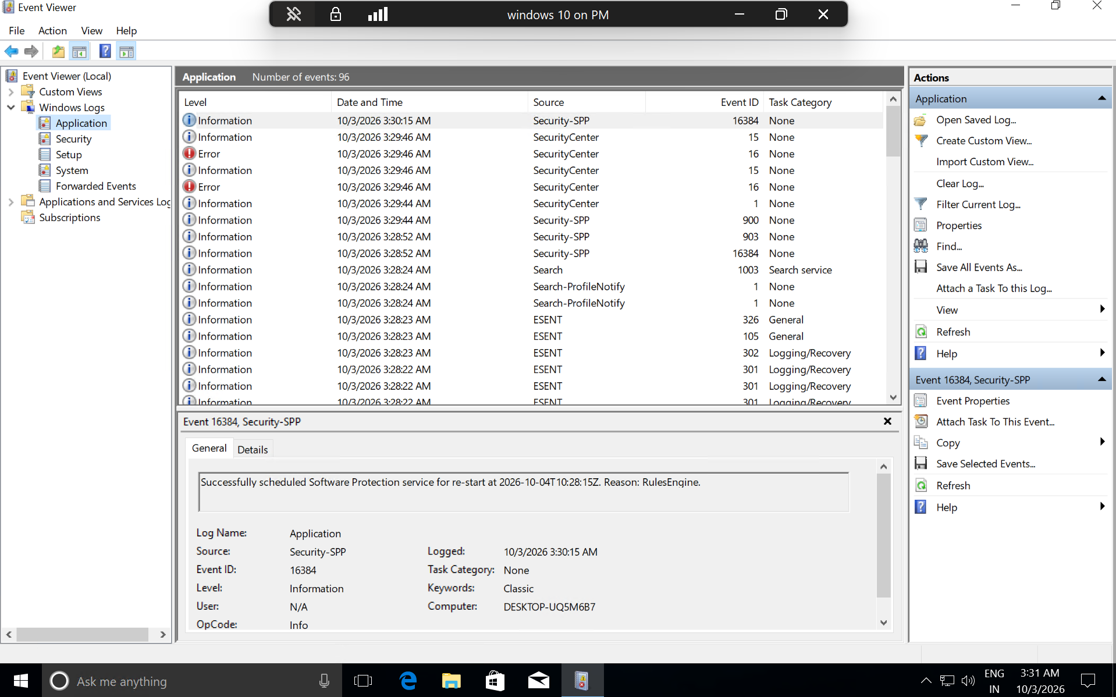

11. If the Events Are Not Appearing
Check auditing configuration. On the Windows VM, open Local Security Policy (where available) and review Advanced Audit Policy Configuration → System Audit Policies. Relevant auditing categories include account logon, logon/logoff, detailed tracking, and account management. After changing audit settings, reproduce the activity and check the Security log again

12. SOC Relevance
- Event 4624 can provide evidence of successful authentication and help analysts establish a user logon timeline.
- Event 4625 can provide evidence of unsuccessful authentication attempts and can be correlated with other telemetry.
- Event 4688 helps establish which processes were created and can support process-based investigations.
- Event 4720 can provide evidence that a local account was created and can be correlated with administrative activity.
- SOC analysts commonly correlate multiple events with timestamps, usernames, hostnames, source information, and other telemetry rather than relying on a single event.

13. Conclusion
This hands-on exercise builds practical experience with Windows Event Viewer and foundational SOC investigation workflows. By generating and identifying authentication, process-creation, and account-management events, the learner practices collecting host-based evidence that can later be correlated in SIEM platforms such as Splunk or Wazuh.

