1.What are the two values of the Boolean data type? How do you write them?

A variable of the primitive data type Boolean can have two values: **true and false**

2. What are the three different types of Boolean operators?

 Three Boolean operators are: **AND, OR, and NOT**

3. Make a list of each Boolean operator's truth tables (i.e. every possible combination of Boolean values for the operator and what it evaluate ).

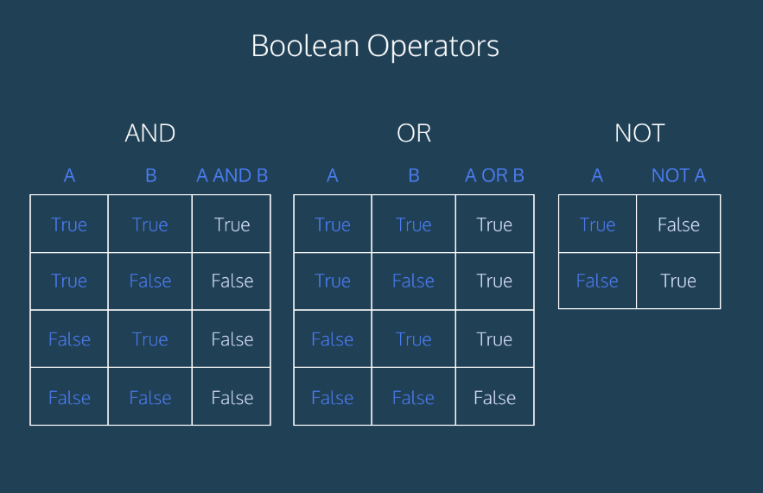

4. What are the values of the following expressions?

(5 > 4) and (3 == 5) False

not (5 > 4) False

(5 > 4) or (3 == 5) True

not ((5 > 4) or (3 == 5)) False

(True and True) and (True == False) False

(not False) or (not True) True

5. What are the six comparison operators?

Six comparison operators are : less than ( < ), less than or equal to ( <= ), greater than ( > ), greater than or equal to ( >= ), equal to ( == ), and not equal to ( != ).

6. How do you tell the difference between the equal to and assignment operators? Describe a condition and when you would use one.

The '=' is the so-called assignment operator and is used to assign the result of the expression on the right side of the operator to the variable on the left side. The '==' is the so-called equality comparison operator and is used to check whether the two expressions on both sides are equal or not.

7. Identify the three blocks in this code:

spam = 0

if spam == 10:

print('eggs')

if spam > 5:

print('bacon')

else:

print('ham')

print('spam')

print('spam')

Output :

ham

spam

spam

8. Write code that prints Hello if 1 is stored in spam, prints Howdy if 2 is stored in spam, and prints Greetings! if anything else is stored in spam.

def Input (spam):

If spam==1:

Print(“Hello”)

Elif spam==2:

Print(“Howdy”)

Else:

Print(“Greetings”)

Input(spam)

9.If your programme is stuck in an endless loop, what keys you’ll press?

**CTRL + C**

10. How can you tell the difference between break and continue?

The break statement terminates the whole iteration of a loop whereas continue skips the current iteration

11. In a for loop, what is the difference between range(10), range(0, 10), and range(0, 10, 1)?

Range(10) - 10 **indicates the stop value for the range function** and the 0 value is by default added as the starting value.

Range(0,10) - 10 **indicates the stop value for the range function** **which will go till 9 this time** and the 0 value is by default added as the starting value.

Range(0,10,1) - 10 **indicates the stop value for the range function** and the 0 value is by default added as the starting value and **it will increase at the rate of 1**.

12. Write a short program that prints the numbers 1 to 10 using a for loop. Then write an equivalent program that prints the numbers 1 to 10 using a while loop.

For counter in range(1,11):

Print(counter)

Counter =0

While(Counter <11):

Print(Counter)

Counter = Counter-1

13. If you had a function named bacon() inside a module named spam, how would you call it after importing spam?

**spam. bacon()**