Weather Application

For Searching Weather Anywhere

**Assignment: DSED-04 Group Assessment Course: Level 6 Diploma in Software Development**

|  |  |
| --- | --- |
| **Submitted By:** Manpreet Singh  Kanwar Singh  Avneet Singh  Jagdish Singh | **Submitted to:** Bikash Pokhrel Tutor ATC Vision College  East Tamaki, Auckland |

2021

.

.

1/1/2021

# Introduction:

This project is group project and is a part of our assessment for New Zealand Diploma in Software Development Diploma Level 6. This application is a health club application with that has ability to manage customers.

1. **Project Features:**
2. Login to View Weather
3. Search any City Weather in the worls
4. **Project Time Line**

|  |  |  |
| --- | --- | --- |
| SN | Item | Time |
| 1. | Discussion and First Meeting | 6 hours |
| 2. | Wireframe design | 1. hours |
| 3. | Final Design | 3 hours |
| 4. | Meetings on Scrum sprints | 20 minutes every day after Staring Project |
| 5. | Coding | 4 hours |
| 6. | Questions answers | 3 hours |
| 7. | Software documentation | 2 hour |
| 9. | Testing document | 1. hour |

**Loading Screen**

Wireframe:

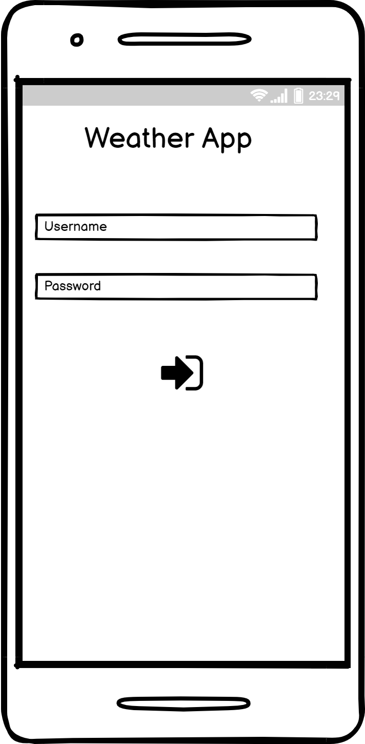

Final Design:

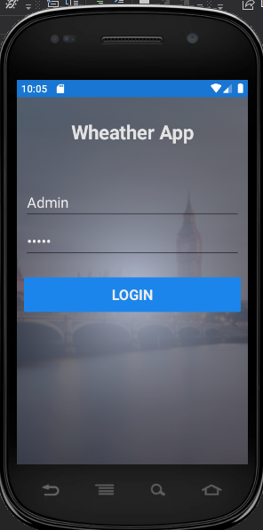

Main Screen

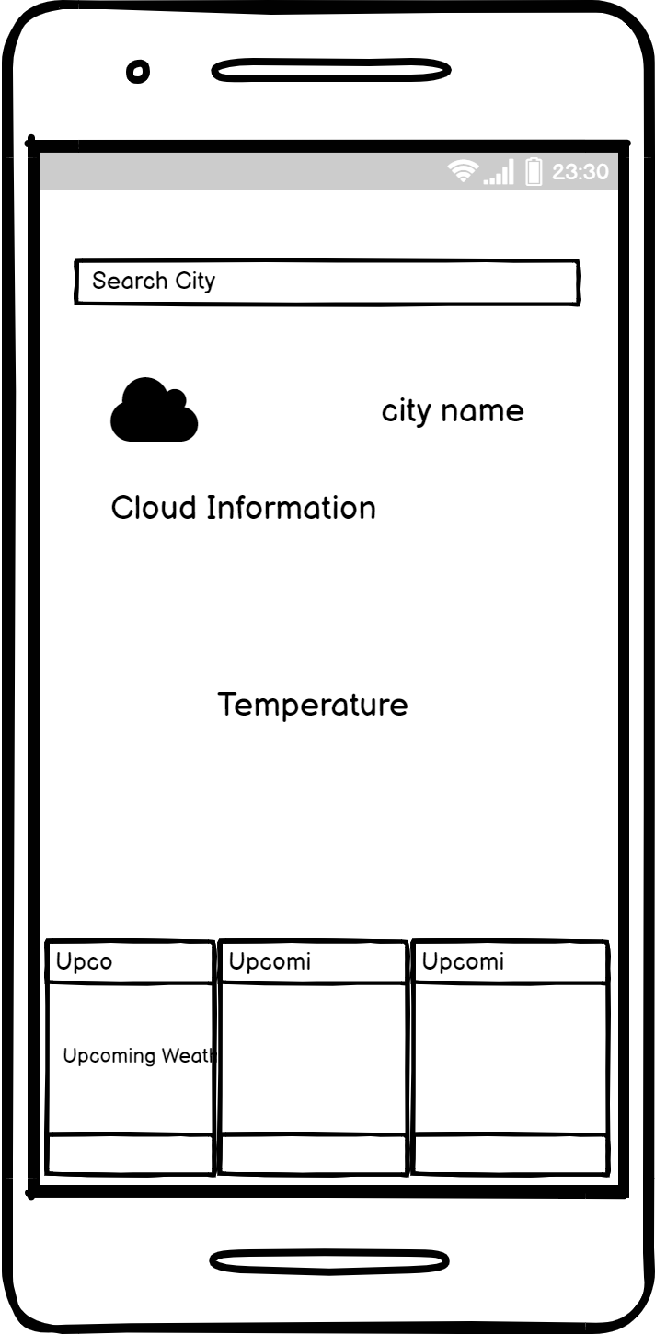

Final Design Upcoming Weather

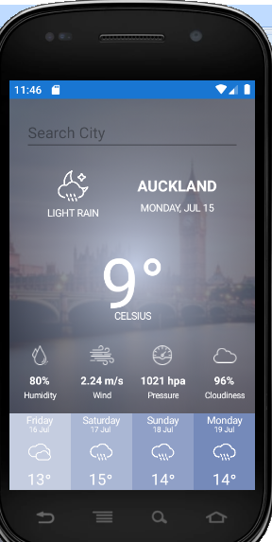

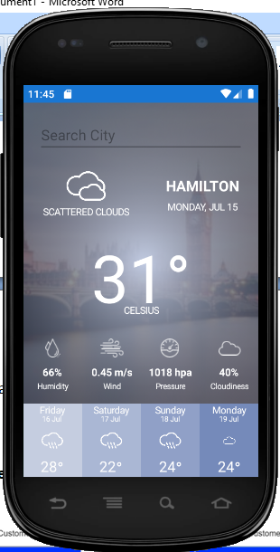

1. **Wireframe designs and their flow**

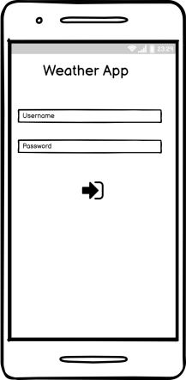 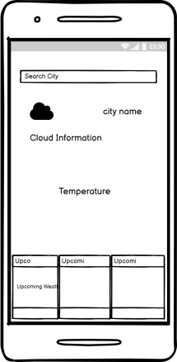

1. **Emulator Specification:**

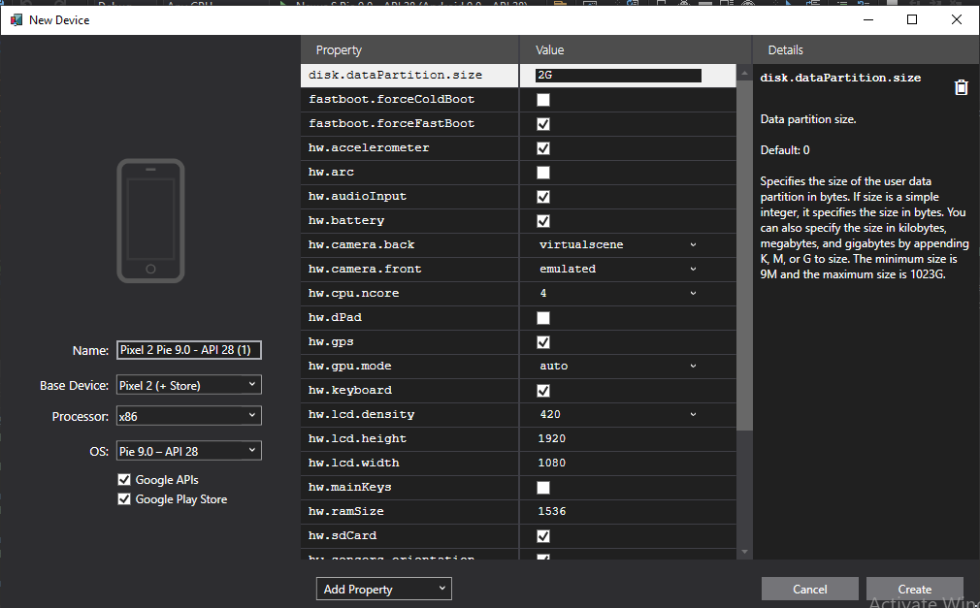

1. **Coding**

**Admin Login**

using System;

using System.Collections.Generic;

using System.ComponentModel;

using System.Linq;

using System.Text;

using System.Threading.Tasks;

using System.Windows.Input;

using Xamarin.Forms;

using Xamarin.Forms.Xaml;

namespace WeatherApp.Model

{

[XamlCompilation(XamlCompilationOptions.Compile)]

public partial class login : ContentPage

{

public event PropertyChangedEventHandler propertChanged;

public ICommand BaseCommand => new Command(CommandClicked);

public login()

{

InitializeComponent();

BindingContext = this;

}

public async void CommandClicked()

{

if (userTxt.Text == "Admin" && pswdTxt.Text == "12345")

{

await Navigation.PushAsync(new CurrentWeatherPage());

}

else

{

await DisplayAlert("Login Error", "Invalid Username / Password", "OK");

}

}

}

}