Consumer Credit Risk
PD, LGD and Simplified IFRS 9 ECL Model | LendingClub (Python)
Model Document
Scope: This is a simplified IFRS 9 illustration built for learning and portfolio purposes. It is not a production model and must not be used for provisioning, pricing or credit decisions.

1. Executive summary
This project estimates Probability of Default (PD), Loss Given Default (LGD) and Exposure at Default (EAD) from public LendingClub loan data and combines them into a simplified Expected Credit Loss (ECL) with a Stage 1/2/3 split, summarised by risk grade.
- PD model. The WoE logistic regression scorecard reaches an out-of-time AUC of 0.691 (Gini 0.382, KS 0.272). Gradient boosting reaches 0.714 (Gini 0.428, KS 0.307), a gain of 2.3 AUC points. The scorecard is kept as the primary model for transparency, with GBM as challenger.
- Calibration. Out of time, the scorecard under-predicts: mean PD 16.8% against an observed default rate of 21.5% (calibration intercept 0.33, slope 1.11). The ranking holds up, so a single intercept shift was applied before computing ECL.
- Stability. Score PSI between train and test is 0.002 (stable). One input, mort_acc, shows a significant shift (PSI 0.80), which comes from a data-availability gap rather than a change in borrowers (see section 4.3).
- LGD. Exposure-weighted LGD is 91.0%: net recoveries cover only about 9.0% of the balance outstanding at default, and LGD is almost flat across grades.
- ECL. Base-case ECL is $748.8m on EAD of $9.51bn (coverage 7.87%). Stage 3 is 2.6% of EAD but 29.7% of ECL. The adverse scenario gives $1,037.8m (+38.6%).

2. Data and default definition
- Source: LendingClub accepted loans (Kaggle, 2007 to 2018Q4). The file contains loan status, issue date, recoveries, total_rec_prncp and out_prncp, which allows PD, LGD and EAD to be estimated, not just PD.
- Default definition: Charged Off or Default = 1; Fully Paid = 0. Loans still in progress are excluded from model development (they are used later as the live book for ECL).
- Features: application-time only (loan amount, term, income, DTI, FICO, credit history, utilisation, account counts, etc.). LendingClub's own grade and interest rate are excluded from the PD model because they are the lender's own model output; grade is used only for reporting.
- Out-of-time split: train on loans issued up to 31 Dec 2014 (453,809 loans, default rate 17.03%); test on loans issued 2015 to 2016 (668,651 loans, default rate 21.54%). Later vintages are not used for testing because many loans have not yet had time to default.
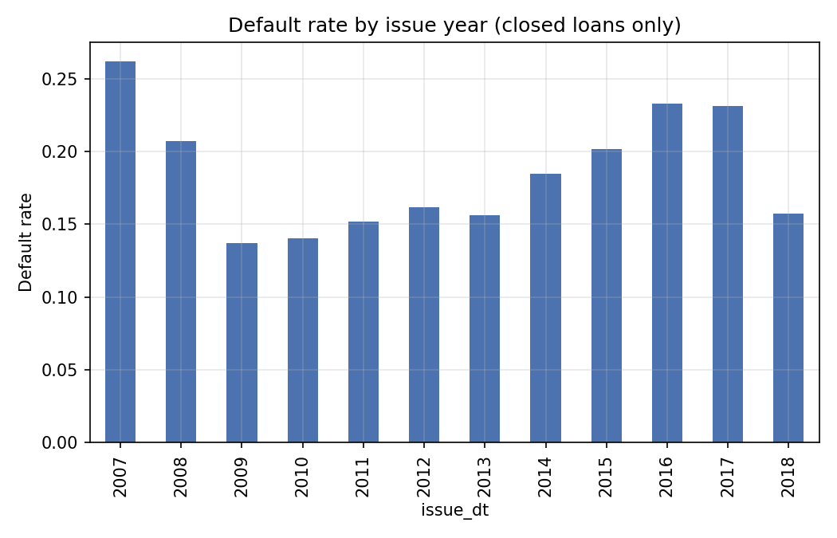
Figure 1. Default rate by issue year (closed loans only).

3. Methodology

3.1 PD
Numeric variables are quantile-binned (up to 8 bins, missing values in their own bin); rare categories are grouped. Each bin gets a Weight of Evidence, WoE = ln(%good / %bad). Variables are kept if Information Value is between 0.02 and 0.60 and, among correlated pairs (|r| >= 0.8), the higher-IV variable is retained. Eight variables enter the final logistic regression: term, loan_to_income, fico_avg, dti, verification_status, annual_inc, inq_last_6mths and mort_acc. Two further candidates were removed by automatic checks that refit the model until they pass: loan_amnt (a wrong-sign coefficient, meaning larger loans received more points) and revol_util (it moved the score by only 0.5 points). Every remaining coefficient is negative on WoE, so higher WoE always means lower risk, and every variable contributes at least 1 point of score spread. Scores are scaled to 600 points at 50:1 good:bad odds with 20 points to double the odds.
The challenger is a histogram-based gradient boosting classifier (depth 4, early stopping) trained on all candidate features.

3.2 LGD and EAD
- EAD at default: funded amount minus principal repaid (out_prncp is zero once a loan is charged off, so it cannot be used for defaulted loans).
- LGD: 1 minus net recoveries (recoveries less collection fees) divided by EAD, summed over defaulted loans and reported by grade.
- EAD on the live book: outstanding principal (out_prncp).

3.3 ECL and staging
- Portfolio: loans still in progress with outstanding principal.
- Stage 1 (current): 12-month PD. Stage 2 (in grace period or 16 to 30 days late): lifetime PD. Stage 3 (31 to 120 days late, used as a proxy for credit-impaired): PD of 100%.
- Term structure: scorecard PD is treated as default probability over the full term and converted to a horizon with a constant-hazard assumption, PD(h) = 1 - (1 - PD)^(h / term).
- ECL = PD x LGD x EAD, discounted at mid-horizon using the loan's interest rate as a proxy for the effective interest rate.
- Adverse scenario: PD odds multiplied by 1.5 and LGD multiplied by 1.15 (capped at 100%).

4. PD model validation

4.1 Discrimination
Model / sample | AUC | Gini | KS | Brier
Scorecard (train) | 0.682 | 0.364 | 0.264 | 0.133
Scorecard (OOT test) | 0.691 | 0.382 | 0.272 | 0.158
GBM (train) | 0.722 | 0.443 | 0.322 | 0.128
GBM (OOT test) | 0.714 | 0.428 | 0.307 | 0.154
Brier scores are higher out of time mainly because the default rate is higher in 2015 to 2016 than in the training period.
Both models rank risk well enough for a consumer unsecured portfolio. The scorecard does not overfit (out-of-time AUC 0.691 versus 0.682 in sample). GBM adds 2.3 AUC points.
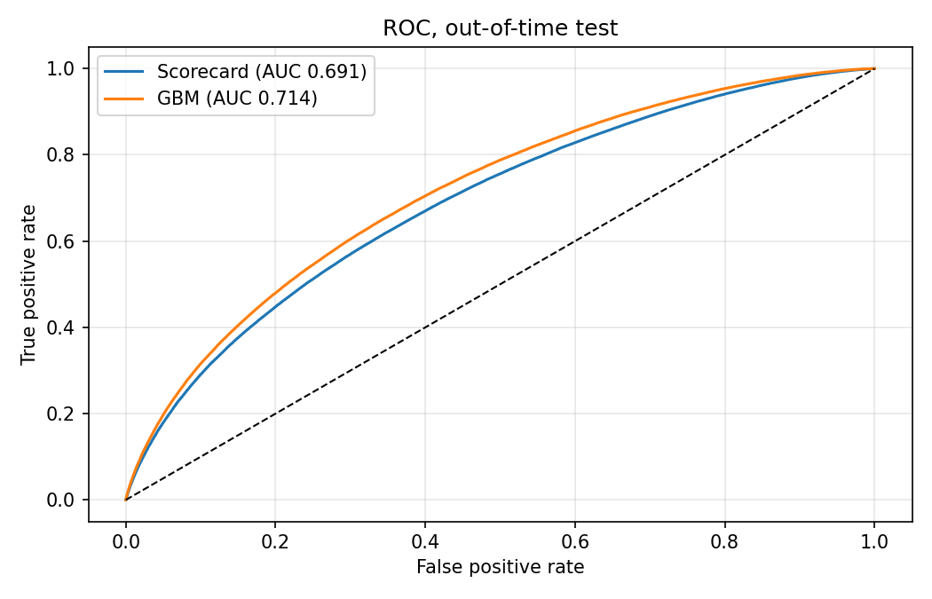
Figure 2. ROC curves on the out-of-time test set.
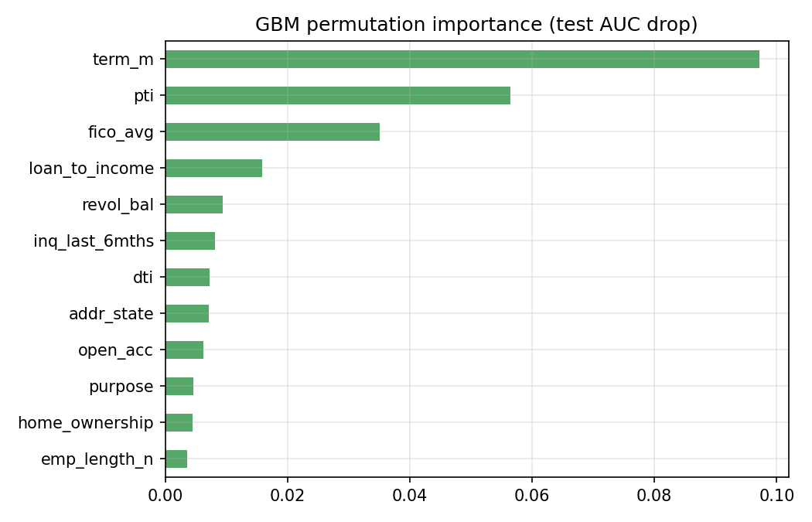
Figure 3. GBM permutation importance (drop in test AUC when a variable is shuffled).

4.2 Calibration
Model | Calibration slope | Intercept (CITL) | Mean predicted PD | Observed default rate
Scorecard | 1.107 | 0.328 | 16.81% | 21.54%
GBM | 1.061 | 0.313 | 17.11% | 21.54%
Intercept (CITL) is the shift in log-odds needed for the mean prediction to equal the observed default rate.
Both models under-predict the 2015 to 2016 default rate by roughly five percentage points. The decile table (before recalibration) shows observed defaults sit between 1.09 and 1.31 times predicted in every decile, i.e. the whole curve is shifted rather than mis-ranked. A single intercept adjustment is therefore a reasonable fix, and it is applied to the scorecard before the ECL calculation.
Decile | Loans | Avg PD | Observed DR | Observed / Predicted
1 | 66,866 | 5.42% | 5.92% | 1.09
2 | 66,865 | 8.24% | 10.25% | 1.24
3 | 66,865 | 10.26% | 13.29% | 1.30
4 | 66,865 | 12.06% | 15.40% | 1.28
5 | 66,865 | 13.85% | 17.86% | 1.29
6 | 66,865 | 15.77% | 20.60% | 1.31
7 | 66,864 | 18.01% | 23.32% | 1.29
8 | 66,866 | 21.02% | 27.37% | 1.30
9 | 66,865 | 26.10% | 33.82% | 1.30
10 | 66,865 | 37.43% | 47.61% | 1.27

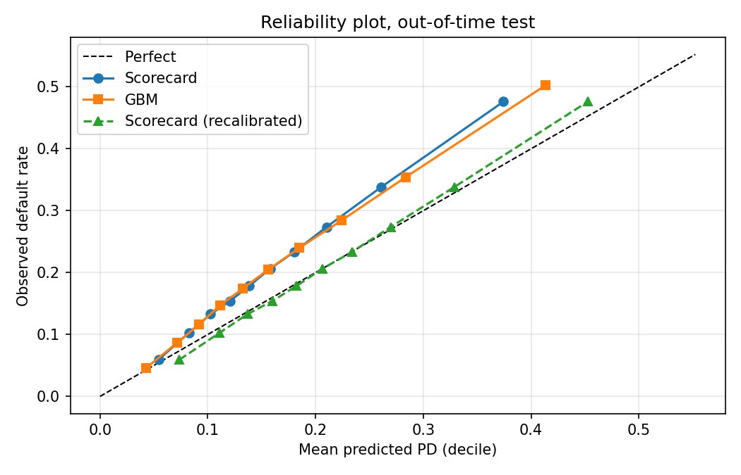
Figure 4. Reliability plot on the out-of-time test set, including the recalibrated scorecard.

4.3 Stability (PSI)
PSI compares the train and test distributions. The scorecard score has PSI 0.002, well under the 0.10 threshold, so the score distribution is stable. Of 23 input variables, one is flagged: mort_acc (PSI 0.80).
mort_acc is also one of the eight scorecard variables, so the shift was investigated. The field is blank for every loan issued from 2007 to 2011 and for 14% of 2012 loans, and fully populated from 2013 onward. That makes 11% of the training loans missing but 0% of the test loans. A bin that disappears entirely produces a PSI of about 0.77 on its own, which accounts for almost all of the 0.80 observed, so this is a data-availability effect and not a real change in the borrower population. A side effect is that the Missing bin works as a marker for the earliest vintages (2007 to 2011) and not as a borrower attribute. It receives a favourable score (about as many points as two to three mortgage accounts). The score PSI is still low (0.002) and the test set has no missing values, so ranking and ECL are unaffected here, but a cleaner design would train from 2012 onward or drop the variable.
Variable | PSI | Flag
mort_acc | 0.7982 | Significant shift
verification_status | 0.0516 | Stable
inq_last_6mths | 0.0484 | Stable
dti | 0.0447 | Stable
revol_util | 0.0396 | Stable
application_type | 0.0374 | Stable
addr_state | 0.0368 | Stable
pub_rec | 0.0290 | Stable
purpose | 0.0270 | Stable
pub_rec_bankruptcies | 0.0213 | Stable
Top 10 variables by PSI. The full list is in the Excel summary.
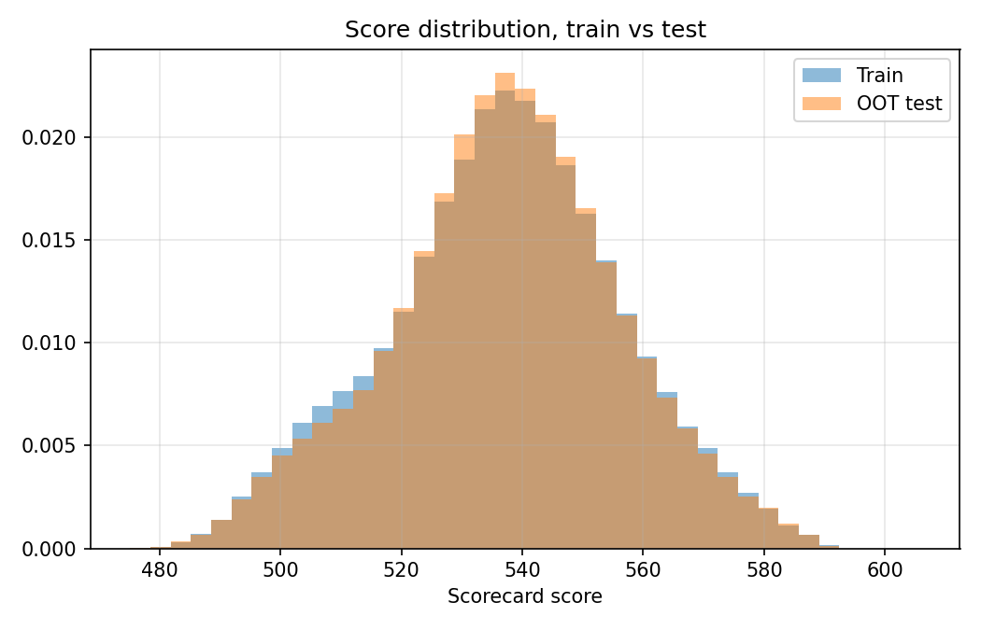
Figure 5. Scorecard score distribution, train versus out-of-time test.

5. Model choice: performance versus interpretability
GBM is 2.3 AUC points better out of time (Gini 0.428 versus 0.382). That is a meaningful but not decisive gain, and the calibration problem is the same for both models. For a provisioning setting the scorecard is the better primary model: its points table gives reason codes that can be audited, each variable's contribution is shown as points per bin and is easy to explain, and validation and governance are simpler. GBM is retained as a challenger. It could replace the scorecard only after adding monotonic constraints and SHAP-based explanations and showing that the gain persists on more recent data.
An initial version of the scorecard included loan_amnt with the wrong sign and revol_util with almost no effect. Both were removed by the automatic checks and the model was refit. Out-of-time AUC was essentially unchanged (0.6915 before, 0.6912 after), which is what you would expect when the dropped variables carry little independent information.

6. LGD and EAD
Grade | Defaults | EAD at default ($m) | Recoveries ($m) | LGD | EAD as % of funded
A | 14,213 | 115.0 | 9.6 | 91.6% | 58.9%
B | 52,652 | 455.0 | 39.5 | 91.3% | 63.8%
C | 85,801 | 883.9 | 78.3 | 91.1% | 69.9%
D | 61,259 | 723.8 | 65.0 | 91.0% | 73.9%
E | 36,196 | 512.0 | 48.3 | 90.6% | 78.2%
F | 14,585 | 234.4 | 22.8 | 90.3% | 82.3%
G | 4,632 | 80.8 | 7.7 | 90.5% | 85.7%

Across 269,338 defaulted loans, exposure-weighted LGD is 91.0%. LGD barely varies by grade (90.3% to 91.6%), so risk differentiation in ECL comes almost entirely from PD. Lower-grade loans tend to default earlier in their life, so less principal has been repaid and a larger share of the original balance is still outstanding at default (59% for grade A, 86% for grade G).
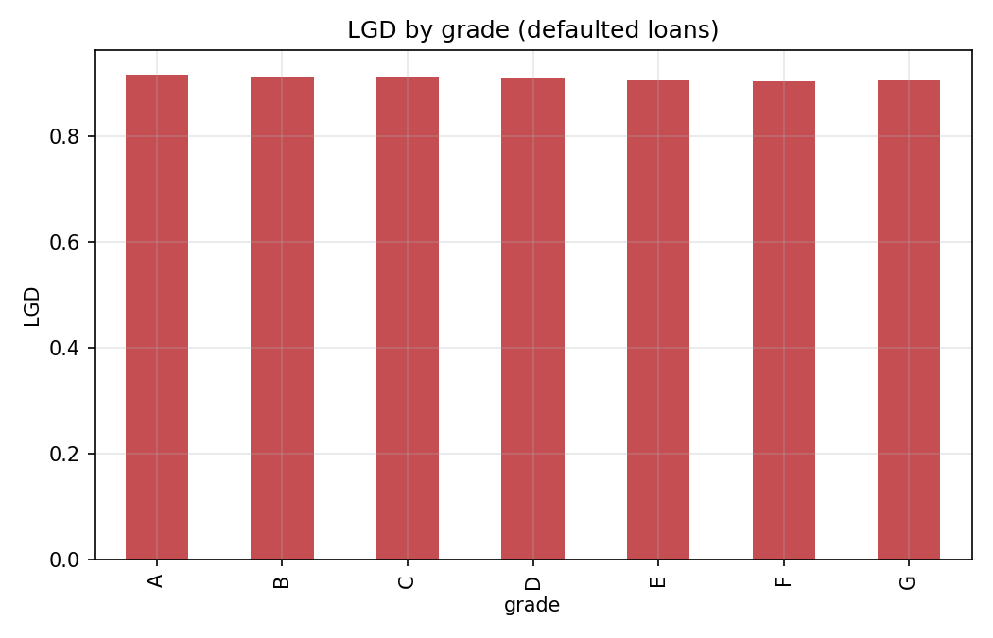
Figure 6. LGD by grade.

7. ECL results (base scenario)
Grade | Loans | EAD ($m) | Avg PD | Avg LGD | ECL ($m) | Coverage | Share of ECL
A | 196,642 | 2,002.6 | 4.8% | 91.6% | 85.0 | 4.24% | 11.3%
B | 268,973 | 2,675.9 | 7.6% | 91.3% | 177.5 | 6.63% | 23.7%
C | 266,530 | 2,847.2 | 10.4% | 91.1% | 255.2 | 8.96% | 34.1%
D | 122,202 | 1,368.5 | 12.8% | 91.0% | 149.0 | 10.89% | 19.9%
E | 41,237 | 455.3 | 15.1% | 90.6% | 57.7 | 12.68% | 7.7%
F | 9,450 | 120.2 | 17.9% | 90.3% | 17.9 | 14.89% | 2.4%
G | 2,830 | 40.2 | 19.5% | 90.5% | 6.5 | 16.20% | 0.9%
Total | 907,864 | 9,510.0 | 9.1% | 91.2% | 748.8 | 7.87% | 100.0%
Avg PD is the exposure-weighted PD over each loan's stage horizon (12 months for Stage 1, remaining life for Stage 2, 100% for Stage 3). Coverage = ECL / EAD.
Stage | Loans | EAD ($m) | Avg PD | Avg LGD | ECL ($m) | Coverage | Share of ECL
1 | 873,780 | 9,125.8 | 6.5% | 91.2% | 506.8 | 5.55% | 67.7%
2 | 12,643 | 140.0 | 20.1% | 91.1% | 19.6 | 13.99% | 2.6%
3 | 21,441 | 244.2 | 100.0% | 91.1% | 222.4 | 91.07% | 29.7%
Total | 907,864 | 9,510.0 | 9.1% | 91.2% | 748.8 | 7.87% | 100.0%

Total ECL is $748.8m on $9.51bn of exposure (7.87%). Coverage rises steadily from grade A to G because PD does and LGD does not. Stage 3 loans are only 2.6% of exposure but 29.7% of the allowance, because they carry a PD of 100% and an LGD above 90%. Stage 2 is small (1.5% of EAD) because it is defined by delinquency status only.

8. Base versus adverse sensitivity
Grade | EAD ($m) | ECL base ($m) | ECL adverse ($m) | Coverage base | Coverage adverse | Uplift
A | 2,002.6 | 85.0 | 126.7 | 4.24% | 6.33% | +49.1%
B | 2,675.9 | 177.5 | 252.2 | 6.63% | 9.42% | +42.0%
C | 2,847.2 | 255.2 | 351.2 | 8.96% | 12.34% | +37.6%
D | 1,368.5 | 149.0 | 200.4 | 10.89% | 14.64% | +34.5%
E | 455.3 | 57.7 | 76.0 | 12.68% | 16.68% | +31.6%
F | 120.2 | 17.9 | 23.1 | 14.89% | 19.22% | +29.1%
G | 40.2 | 6.5 | 8.3 | 16.20% | 20.61% | +27.2%
Total | 9,510.0 | 748.8 | 1,037.8 | 7.87% | 10.91% | +38.6%

Raising PD odds by 50% and LGD by 15% lifts total ECL by 38.6% to $1,037.8m. The uplift is similar across grades because the stress is applied uniformly. This is a simple multiplier, not a macro-economic scenario model.
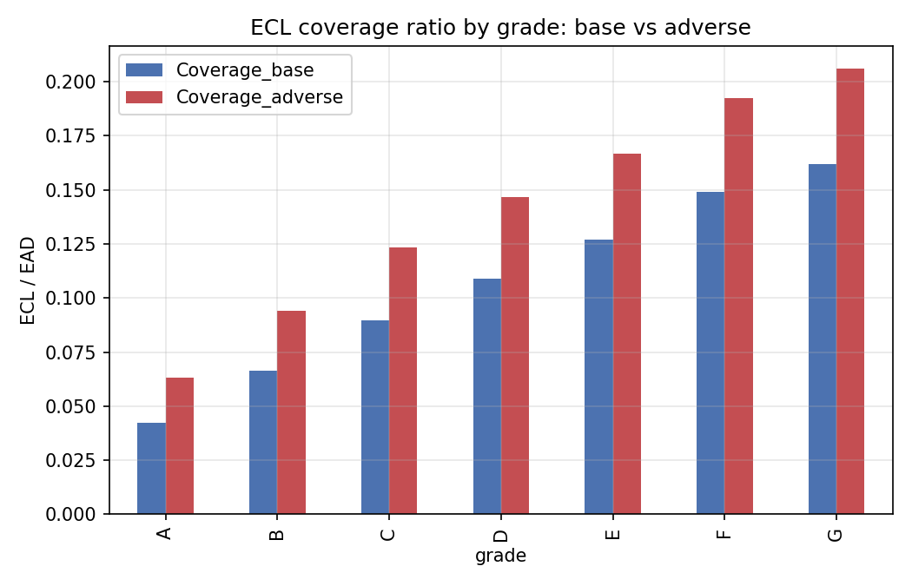
Figure 7. ECL coverage ratio by grade, base versus adverse.

9. Limitations
- Right-censoring: recent vintages show lower default rates because bad loans have not had time to default. The test window stops at 2016 for this reason, but 60-month loans from 2015 and 2016 are still partly unseasoned.
- Population drift: LendingClub underwriting changed over time. Calibration is adjusted on one window (2015 to 2016) and then applied to the live book, which includes later vintages.
- Staging uses delinquency status only. There is no PD-based test for a significant increase in credit risk and no forward-looking macro-economic scenarios or probability weighting, both of which IFRS 9 expects.
- Constant-hazard term structure; no prepayment modelling. Discounting uses the contract interest rate as a proxy for the effective interest rate.
- LGD is a grade-level average of cash recoveries, undiscounted and with no recovery-timing curve. It barely varies by grade, so it adds little risk differentiation.
- EAD is outstanding principal only (term loans, no undrawn commitments). Stage 3 is a proxy (31 to 120 days late) rather than a 90-days-past-due definition.
- mort_acc shows a significant distribution shift (PSI 0.80), explained by the field being blank for 2007 to 2011 loans (11% of training, 0% of test). Its Missing bin therefore acts as an early-vintage marker. It is kept for now; training from 2012 onward or dropping it would be cleaner.
- Variable selection is rule-based (IV band, correlation filter, sign and score-spread checks) and was done on a single training window; there is no stepwise or cross-validated selection.
- Only one out-of-time test window; no fairness or bias review of variables such as state or verification status.

10. Possible next steps
- Train from 2012 onward (when mort_acc is populated) or drop mort_acc, then refit and re-run the validation.
- Add a PD-based SICR test for Stage 2 and use a 90+ days past due definition for Stage 3.
- Replace the constant-hazard term structure with a survival or vintage-based curve.
- Add macro-economic scenarios (for example unemployment) with probability weights.
- Add monotonic constraints and SHAP explanations to the GBM to make it a viable replacement candidate.

11. Reproducibility
All results in this document come from the notebook lendingclub_ecl.ipynb in the same project folder. Detailed tables are in outputs/ecl_summary.xlsx (ECL by grade and stage, scenarios, LGD, deciles, PSI, scorecard points) and charts are in outputs/figures.

