**IN_CLASS_ASSIGNMENT – 1**

**Manpreet Kaur(C0752299)**

* Creating Twitter developer account and collecting data from Twitter using Twitter API.

**Open a Twitter developer account-** **Twitter Developer account—** Below is the screenshot of my Twitter Developer account console. Once I applied for the developer account console, it was approved in about 4-5 days.**Twitter Account:** @Manpree90360958

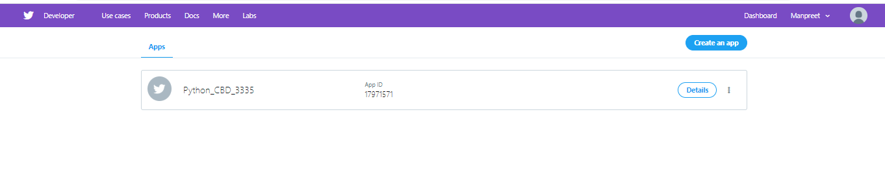

**Collect the latest 10 Tweets from your Twitter account: --** After Importing libraries, I used the access token and keys from my twitter developer account so that I can access the Twitter API and to access the API need to fetch access keys from Twitter app settings. These 4 keys should be confidential and unique for each account. *“tweet mode='extended'”* is used to print the output in full text and count() is used to print 10 tweets.

**Print the full text for these tweets:** Below are Screenshots from my Jupyter Notebook for your reference.

Output1- Collecting 10 latest tweets from a Timeline

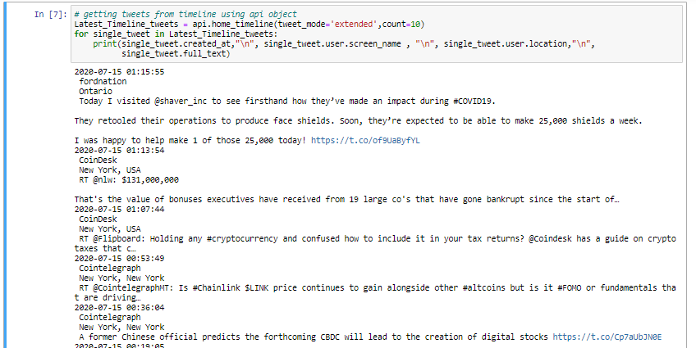

Output2- Collecting Tweets without removing “Retweets” using keyword “coinbase”

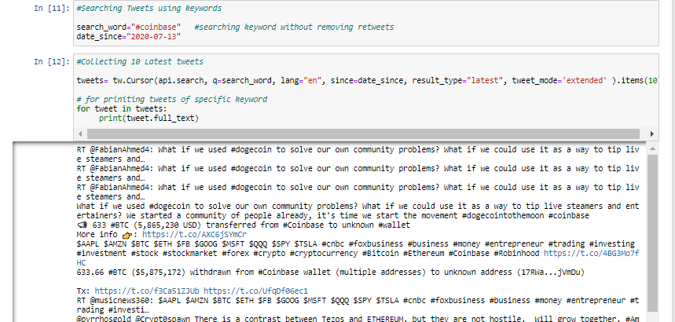

Output3- Collecting Tweets removing “Retweets” using Filter function

