# 1: Can you store different types in an array in c#?

Yes. By creating an array of type “object” we can store different types in an array. Like we create an array of type “int” we can only store int values int it. In array of type object we can store all values be it string int or even object of some class.

For ex: object[] arr = new object[2]; **Correct**

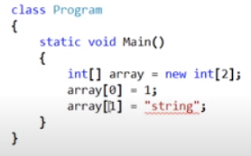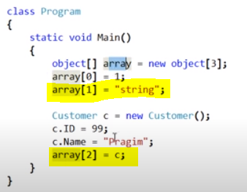

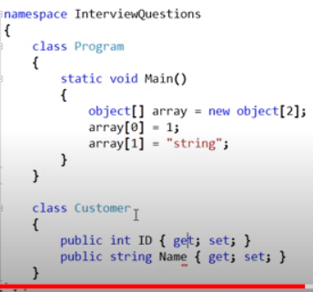

In snapshot 2 we have assigned string value and we have even assigned an object of class customer.

# 2. Why and when should we use an abstract class?

Ans: We would create an abstract class when we want to move the common functionality of two or more related classes to a base class and we do not want to instantiate that base class. We made it abstract as we do not want developers to accidentally be creating instances of that base employee abstract class.

Let’s understand this with help of an example. Let’s say an organization have to Employees.

1. **Fulltime Employee and Contract Employee. We created class for each of the two types of employee.**

# Now as you can see few variables and functions are common in both the classes.

# What we can do is we can add common functions to one base class and work with it. Here we have not yet made that base class as abstract. Let’s see what can be disadvantage of not making the base class as concrete and not the abstract class.

# 

# Here we created a concrete base class (non-abstract) which has the common variables and function od both classed. As you can see we have not yet made it abstract.

# 

# 

# Now Base class is available to devloper and they can create it’s instance.Where as the requirement is that common features should be added to base class and as the org has only two employees so the object should be created only for *Fulltime Employee and Contract Employee.*

# *But there is nothing stopping us from creating the object if base class.*

# So now if we make our bas class as abstract.:

# 

Important:

1. It does not allow us to create an instance of/object of base class. If we try **to create an object of abstract base class it will give compilation error.**
2. And by creating GetMonthly salary function as abstract we forced the derived classes to have a GetMonthly salary method in it. If they do not **have it will give error on compilation.**
3. The abstract class may or may not have abstract methods but If a class has even one abstract method then the class must be marked as abstract. Or the class is abstract.

# 3.What are the advantages of using interfaces?

# 

# 

# Abstract class virtual method

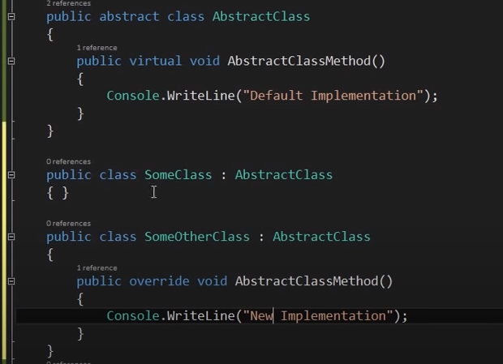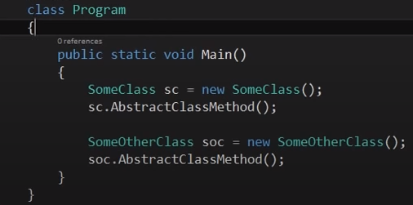

It is a standard that tells developer to redefine the function in some derived classes and no need to redefine in other.

# 5. Real time example of recursion

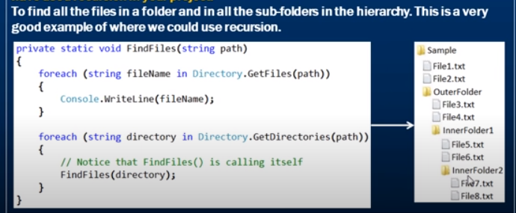

# 6. Storing different list types in a single generic list

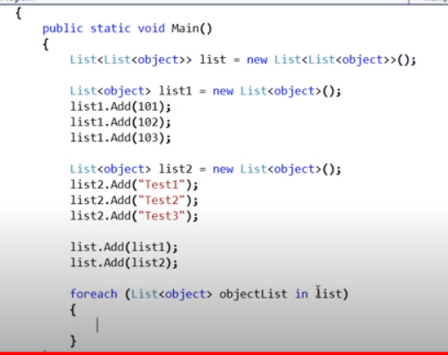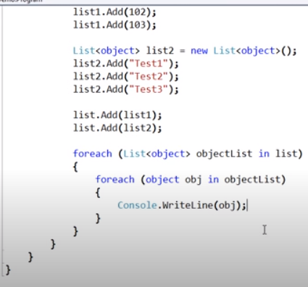

# 7. Can an abstract class have a constructor?

# 1. Yes, Abstract class can have a constructor. It helps to initialise the fields of the abstract class.

# 2. If we create the constructor of derived class on creating the object of derived class first the constructor of abstract class is called and then the constructor of derived class is called. (You can debug and see).Therefore we have the constructor for abstract class when we need certain fields of abstract class to be initialised even before the instantiation of child/derived class takes place.

# 3.Although we cannot create object of abstract class then why is the constructor of abstract class needed because when we create the object of derived class the constructor of base class is automatically called as stated in point2.

# 4. It’s good practice to mark the constructor in abstract class as protected as “public “ access control modifier doesn’t make any sense. (as we know we cannot make the object of abstract classes.)

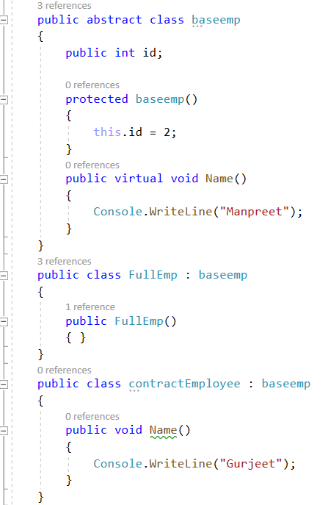

# 8. Call an abstract method from an abstract class constructor

# Yes.

# 

# 

# 9. What happens if finally block throws an exception? Or How to handle exceptions that occurs in finally block?

# 

# If the exception occurs in finally method it needs to be handled in main method as shown in pic 2,else the application will crash.

# The finally block execution stops where the exception is occurring, if there is any line of code statements after the int result = Convert.ToInt32(“Ten”); will not be executed.

# Third imp point is if any exception occurs before finally block say in try block and it is not handled then try block exception is lost.

# 

# 8. What is the difference between is and as keyword in c#.

# 1. is keyword works like equal to say if the emp is the object of type employee it returns true else it returns false.

# 2.

# 

# 9. What is the access modifier of default constructor?

# Ans: Public

# 10. Asyn and await in c#.

# When we used Thread.sleep our app became unresponsive till the processing of file was done.

# On using async and await the our application becomes responsive. Till the reading/processing of file is being done we can ,move the dialogue box resize it and all that we couldn’t use using thread.sleep.

# Await says it’s suspention point. The await operator signal that async method can’t continue past that point until that process is complete.

1. It can be achieved Using thread but code becomes complicated and painful.

# 

11. Output of this is // 1,3,5,7,9,11,13 PreIncreement

for (int i = 0; i < 13; i++)

{

Console.WriteLine(++i); // 1,3,5,7,9,11,13

}

12. Output of this is //0,2,4,6,8,10,12 PostIncreement

for (int i = 0; i < 13; i++)

{

Console.WriteLine(i++); // 1,3,5,7,9,11,13

}

13. Console.WriteLine(2+5+"7"); //77

Therefore + operator between tow integer add and between int and string concatenates.

14.