DATA ANALYTICS PROJECT
Retail Sales Performance
& Business Analytics
Project Report | Sales Transactions 2022–2025
━━━━━━━━━━━━━━━━━━━━━━━━━━━━━━━━
AUTHOR
Manpreet Jadon
PROJECT TYPE
Data Analytics Project
DATASET PERIOD
2022–2025

Executive Summary
This project analyzes the supplied Sales Transactions 2022–2025 CSV and its accompanying data dictionary. The source has 18,045 rows and 36 columns, covering 2022-01-01 through 2025-12-31. The completed notebook removes 45 exact duplicate rows from an analysis copy only, leaving 18,000 rows. On that copy, recorded sales total 8,234,090.60, recorded profit totals 1,645,439.40, and recorded cost totals 6,590,388.19. Overall profit divided by recorded sales is 19.98%. The source dictionary does not specify currency.
The highest annual recorded sales total in the period is 2,298,886.50 in 2025. From 2024 to 2025, sales increased 20.66%. Electronics is the leading product category by recorded sales; Online is the leading channel; and the United States is the leading country. These are descriptive, source-recorded measures and include all retained order statuses.
Headline measure | Notebook result
Source dataset | 18,045 rows × 36 fields
Analysis copy | 18,000 rows × 42 columns including derived date/time fields
Recorded sales / profit | 8,234,090.60 / 1,645,439.40
Profit margin (profit ÷ sales) | 19.98%
Distinct orders / customers | 14,541 / 4,882
Average recorded sales per order | 566.27

Business Problem Statement
Retail decision-makers need a reliable view of how recorded sales and profit vary across products, customers, channels, locations, and time. Duplicate transactions, incomplete values, inconsistent labels, and unusual measurements can distort these comparisons. This project documents a reproducible data-quality and analysis workflow so that business summaries can be interpreted with their definitions and limitations in view.

Project Objectives
- Establish the dataset's coverage, structure, data types, and data-quality limitations.
- Assess missing values, exact duplicates, label variants, and selected numeric range anomalies.
- Create a separate analysis copy while preserving the original input data.
- Describe recorded sales, profit, margin, order/customer activity, and flagged returns.
- Compare performance across available products, customer segments, channels, and geographic fields.
- Explore annual, quarterly, and monthly recorded-sales patterns using Order_Date.
- Screen relevant numeric measures for outliers and correlation, without treating correlation as causation.
- Translate observed patterns into cautious, evidence-based recommendations.

Dataset Overview
The transaction dataset supplied with this project is named Sales Transactions 2022–2025. No external source or data-collection method is documented in the files. The transaction CSV contains 18,045 rows and 36 source columns. Order_Date ranges from 2022-01-01 to 2025-12-31, covering the four calendar years in the dataset.

Important fields
Field group | Actual dataset fields
Identifiers | Transaction_ID, Order_ID, Customer_ID, Product_ID
Date and time | Order_Date, Order_Time, Order_Year
Sales and profit | Quantity, Unit_Price, Discount_Percentage, Sales_Amount, Cost_Amount, Profit
Product | Product_Name, Product_Category, Product_Subcategory
Customer | Customer_Name, Customer_Age, Customer_Gender, Customer_Segment
Channel and location | Sales_Channel, Store_ID, Store_Name, Country, Region, City
Operations and feedback | Order_Status, Shipping_Method, Delivery_Days, Return_Flag, Return_Reason, Payment_Method, Customer_Rating
Other measures | Sales_Representative, Promotion_Code, Inventory_Level

Data dictionary summary
The supplied sales_data_dictionary.csv documents all 36 transaction fields with a column name, description, declared data type, example value, and business meaning. The notebook verifies that the documented column set matches the transaction file. The dictionary identifies Transaction_ID as the transaction key, Order_ID as grouping order lines, Customer_ID as the repeat-customer key, and Order_Year as a convenience field that can be recalculated from Order_Date.

Field-by-field dictionary entries
Field | Dictionary type | Business meaning from dictionary
Transaction_ID | Text | Transaction-level key
Order_ID | Text | Groups order lines into orders
Customer_ID | Text | Supports repeat-customer analysis
Customer_Name | Text | Customer display/identification
Customer_Age | Integer | Demographic analysis; rare anomalies included
Customer_Gender | Text | Demographic segmentation
Customer_Segment | Text | Customer behavior and value analysis
Order_Date | Date | Time-series and seasonality analysis
Order_Time | Time | Hourly and anomaly analysis
Sales_Channel | Text | Channel performance
Store_ID | Text | Store-level analysis
Store_Name | Text | Store reporting
Country | Text | Geographic analysis
Region | Text | Regional analysis
City | Text | Geographic analysis
Product_ID | Text | Product key
Product_Name | Text | Product performance
Product_Category | Text | Category analysis
Product_Subcategory | Text | Subcategory analysis
Quantity | Integer | Volume/basket-size analysis
Unit_Price | Decimal | Pricing analysis
Discount_Percentage | Decimal | Promotion and margin analysis
Sales_Amount | Decimal | Revenue analysis
Cost_Amount | Decimal | Cost analysis
Profit | Decimal | Profitability analysis
Payment_Method | Text | Payment behavior
Order_Status | Text | Fulfillment analysis
Shipping_Method | Text | Delivery analysis
Delivery_Days | Integer | Service-level analysis
Return_Flag | Text | Return-rate analysis
Return_Reason | Text | Return root-cause analysis
Sales_Representative | Text | Rep performance
Promotion_Code | Text | Campaign analysis
Customer_Rating | Decimal | Satisfaction analysis
Inventory_Level | Integer | Inventory analysis
Order_Year | Integer | Convenience field; can be recalculated

Data Quality Assessment
The audit below uses the loaded source dataframe before the notebook's cleaning steps. Missing counts represent pandas-detected blank CSV fields in the source. The notebook reports missingness rather than imputing values or removing records because of missingness.

Missing value profile

Fields with observed missing values
Field | Missing source rows | Share of source rows
Return_Reason | 16,168 | 89.60%
Promotion_Code | 9,737 | 53.96%
Customer_Rating | 3,435 | 19.04%
Customer_Age | 218 | 1.21%
Inventory_Level | 198 | 1.10%
Delivery_Days | 162 | 0.90%
Customer_Gender | 162 | 0.90%
Payment_Method | 147 | 0.81%
Product_Name | 144 | 0.80%
Customer_Name | 108 | 0.60%

Duplicates, value checks, and data types
Quality check | Observed in source | Interpretation / handling
Exact duplicate records | 45 extra exact rows; 90 rows participate in repeated IDs | 45 repeated ID groups; 0 groups contain differing records
Loaded source types | 25 text, 9 float64, 2 int64 fields | Order_Date and Order_Time load as text; numeric fields with blanks can load as floating point.
Date checks | 0 unparseable Order_Date values | 0 Order_Year/date mismatches
Customer_Age | 1 value outside the notebook's 0–100 check (112) | Retained and flagged for review.
Quantity | 3 negative values (-1, -2, -3) | Retained; return/adjustment meaning is not documented.
Discount_Percentage | 1 value outside 0–100 (110) | Retained and flagged; not capped.
Customer_Rating | 0 values outside 1–5 | No out-of-range values flagged.
Categorical labels | Case-only variants and semantic aliases occur in the raw file. | Case-only variants are normalized; semantic aliases are not merged.

Observed label inconsistencies include case-only variants (for example, electronics / Electronics) and semantic/geographic variants (for example, DebitCard / Debit Card and NRW / North Rhine-Westphalia). The source also contains a visibly malformed region label, “�le-de-France”; it is retained and should be checked with the data owner.

Data Cleaning & Preprocessing
- Keep raw_df unchanged and create df as a separate copy.
- Remove only exact duplicate rows from df. This removes 45 extra rows; the analysis copy contains 18,000 transaction rows. No differing records share a Transaction_ID after this removal.
- Trim whitespace in text fields and convert empty strings to missing values in the working copy.
- Normalize case-only variants for selected categorical fields to the most frequently observed spelling; do not merge semantic aliases.
- Convert the specified numeric fields to numeric types and parse Order_Date; parse Order_Time to derive Order_Hour.
- Derive Order_Year_Calc, Order_Month, Order_Month_Name, Order_Quarter, and Order_Year_Month from Order_Date.
- Do not impute missing data, automatically correct flagged values, remove outliers, or recompute the recorded sales/cost/profit fields.
The completed notebook's analysis dataframe has 18,000 rows and 42 columns after adding six derived date/time features to the 36 source fields. The source files remain unchanged.

Exploratory Data Analysis
The notebook describes 18,000 transaction rows, 14,541 distinct orders, and 4,882 distinct customer IDs. It summarizes transaction counts and recorded sales/profit by order status, product category/product, customer ID/segment/gender, sales channel, country, region, and city. Time series use parsed Order_Date. Missing values, duplicate rows, numeric range flags, IQR outliers, and numeric correlations are also reviewed.

Sales Performance Analysis
Across the cleaned analysis copy, recorded Sales_Amount totals 8,234,090.60, Cost_Amount totals 6,590,388.19, and Profit totals 1,645,439.40. The overall profit-to-sales margin is 19.98%, defined as sum(Profit) divided by sum(Sales_Amount). Average recorded sales per order are 566.27, calculated by first summing sales lines within each Order_ID and then averaging across 14,541 distinct orders.
These totals include all retained rows regardless of Order_Status, including Returned, Cancelled, Processing, and Shipped. The notebook presents status-level totals separately; the supplied dictionary does not define a finance-approved revenue recognition policy.
Order status | Rows | Recorded sales | Recorded profit
Completed | 11,536 | 5,259,013.44 | 1,057,539.13
Shipped | 2,554 | 1,194,674.77 | 232,276.34
Returned | 1,597 | 711,969.75 | 142,411.34
Processing | 1,420 | 675,083.07 | 133,795.05
Cancelled | 893 | 393,349.57 | 79,417.54

Product Performance Analysis
Electronics leads product categories in recorded sales at 4,922,081.42, with recorded profit of 952,110.92. The highest-sales named product in the notebook's product table is AeroBook 14 Laptop (P001), at 1,382,381.54.
Product category | Rows | Recorded sales | Recorded profit | Units
Electronics | 8,188 | 4,922,081.42 | 952,110.92 | 18,061
Furniture | 3,303 | 1,986,144.85 | 420,015.02 | 6,288
Office Supplies | 4,524 | 741,774.85 | 144,728.13 | 10,043
Appliances | 1,985 | 584,089.48 | 128,585.33 | 3,885

Customer Analysis
Customer-level rankings use Customer_ID rather than Customer_Name. The dataset has 4,882 distinct customer IDs. Consumer is the highest-sales segment at 3,666,739.39 across 8,027 transaction rows. Segment totals are not customer lifetime value measures.
Customer segment | Rows | Recorded sales | Recorded profit
Consumer | 8,027 | 3,666,739.39 | 737,660.17
Small Business | 3,169 | 1,421,953.05 | 287,598.58
Returning Customer | 2,466 | 1,115,273.90 | 224,109.25
Corporate | 2,089 | 942,132.17 | 175,673.11
New Customer | 1,450 | 708,173.63 | 141,279.15
Premium | 799 | 379,818.46 | 79,119.14

Regional Analysis
The dataset includes Country, Region, and City. The United States is the highest-sales country at 3,503,885.80. Region comparisons are available in the notebook, but aliases and inconsistent region labels make direct regional aggregation less reliable until standardized.
Country | Rows | Recorded sales | Recorded profit
United States | 7,526 | 3,503,885.80 | 699,600.24
United Kingdom | 2,974 | 1,326,891.54 | 269,790.34
Canada | 2,680 | 1,199,510.15 | 240,793.71
Germany | 2,126 | 965,192.00 | 189,543.85
France | 1,581 | 725,734.88 | 144,662.55
Australia | 1,113 | 512,876.23 | 101,048.71

Time-Series Analysis
The notebook derives calendar year from parsed Order_Date and uses it for annual and year-over-year comparisons. Monthly sales are resampled to calendar-month starts, and quarterly sales are resampled by quarter start. Comparisons are descriptive and are not adjusted for inflation or other factors.
Calendar year | Rows | Recorded sales | Recorded profit | Sales YoY
2022 | 4,087 | 2,008,643.54 | 406,576.64 | —
2023 | 4,599 | 2,021,352.88 | 401,259.01 | 0.63%
2024 | 4,345 | 1,905,207.68 | 382,799.40 | -5.75%
2025 | 4,969 | 2,298,886.50 | 454,804.35 | 20.66%

Quarterly recorded sales
Quarter | Recorded sales
2022 Q1 | 360,742.91
2022 Q2 | 503,231.43
2022 Q3 | 475,399.25
2022 Q4 | 669,269.95
2023 Q1 | 427,002.44
2023 Q2 | 501,634.53
2023 Q3 | 440,898.68
2023 Q4 | 651,817.23
2024 Q1 | 404,629.16
2024 Q2 | 422,519.38
2024 Q3 | 457,954.73
2024 Q4 | 620,104.41
2025 Q1 | 517,970.18
2025 Q2 | 519,736.11
2025 Q3 | 504,835.03
2025 Q4 | 756,345.18

KPI Analysis
Sales channel | Rows | Recorded sales | Share | Profit margin
Online | 8,195 | 3,112,092.21 | 37.80% | 20.24%
Retail Store | 6,221 | 2,449,189.44 | 29.74% | 19.90%
B2B Portal | 2,124 | 2,121,499.06 | 25.76% | 19.79%
Phone Order | 1,460 | 551,309.89 | 6.70% | 19.67%

KPI | Value | Notebook definition
Recorded sales | 8,234,090.60 | Sum of Sales_Amount.
Recorded cost | 6,590,388.19 | Sum of Cost_Amount.
Recorded profit | 1,645,439.40 | Sum of Profit.
Overall profit margin | 19.98% | Total Profit ÷ total Sales_Amount.
Distinct orders | 14,541 | Distinct Order_ID values.
Distinct customers | 4,882 | Distinct Customer_ID values.
Average sales per order | 566.27 | Mean of summed Sales_Amount per Order_ID.
Return-flag row share | 1,873 / 18,000 (10.41%) | Rows where Return_Flag equals Yes divided by analysis rows.

Return_Flag = Yes is present on 1,873 rows (10.41%). Separately, 1,597 rows have Order_Status = Returned. These are distinct fields and are not treated as interchangeable measures.

Outlier and Correlation Analysis
IQR screening is applied to Sales_Amount, Profit, Quantity, and Customer_Age. It is a heuristic for review, not an error diagnosis; all flagged values remain in the analysis. Pearson correlation is calculated for available numeric fields and displayed as a heatmap; the correlations are not interpreted causally.
Field | IQR lower | IQR upper | Flagged rows | Share
Sales_Amount | -512.80 | 1,064.07 | 1,786 | 9.92%
Profit | -91.23 | 204.01 | 1,872 | 10.40%
Quantity | -2.00 | 6.00 | 694 | 3.86%
Customer_Age | 11.00 | 67.00 | 88 | 0.49%

The notebook's Pearson correlation between Sales_Amount and Profit is 0.917; this describes linear association in these records only and is not evidence that one measure causes the other.

Visualizations and their interpretation

Missing values by field
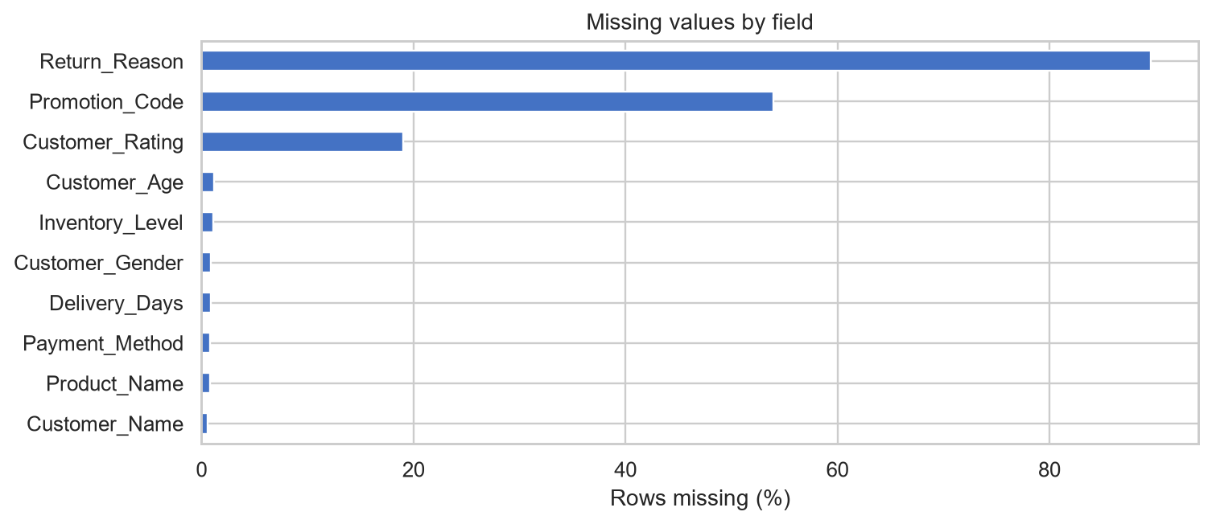
Figure 1. Missing values by field. Generated by the completed Jupyter Notebook.
The bar chart ranks source-field missingness; Return_Reason and Promotion_Code are the most incomplete fields. Missingness is reported, not filled.

Recorded sales by calendar year
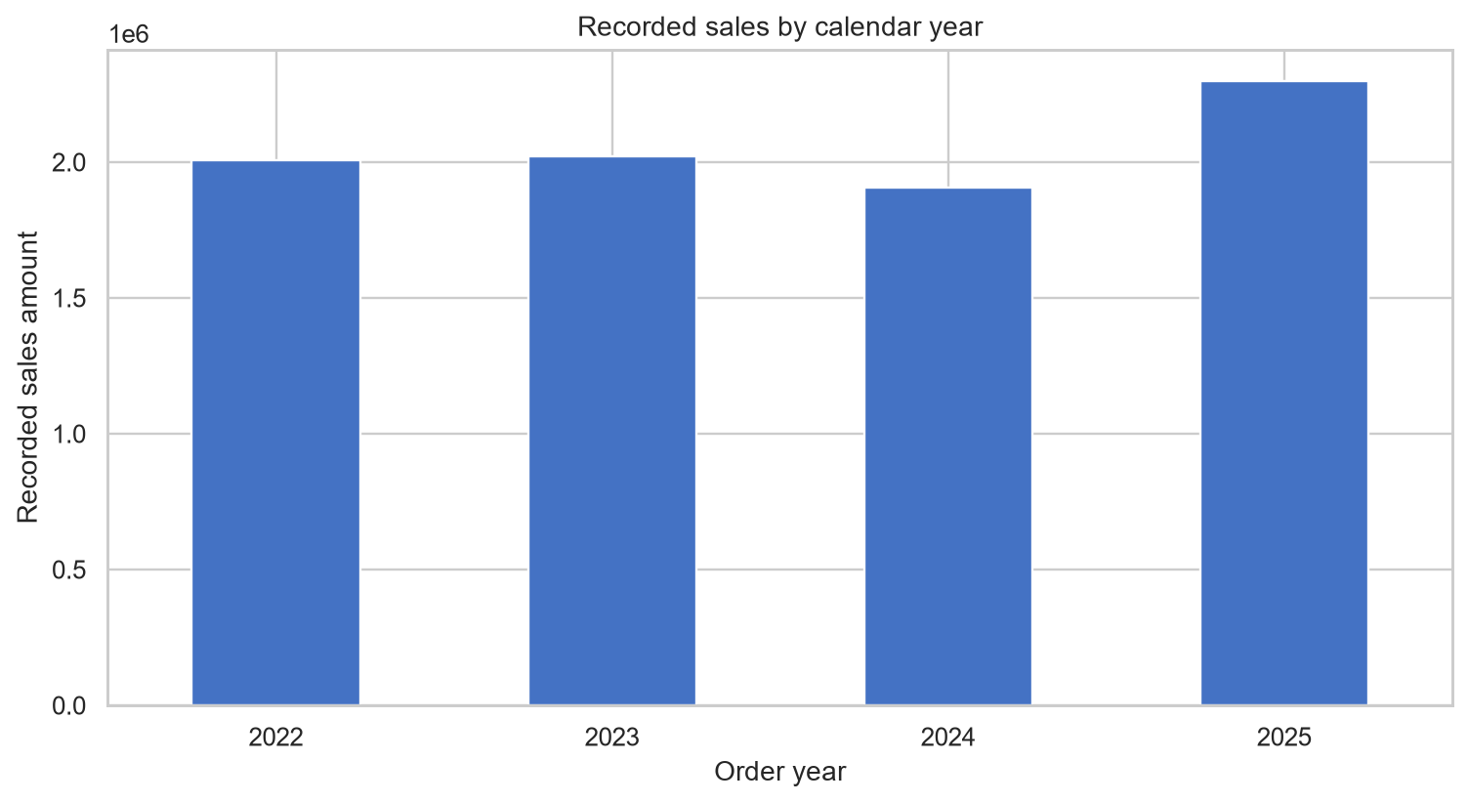
Figure 2. Recorded sales by calendar year. Generated by the completed Jupyter Notebook.
The annual chart shows the decline in 2024 and increase in 2025; the corresponding year-over-year changes are -5.75% and 20.66%.

Monthly recorded sales
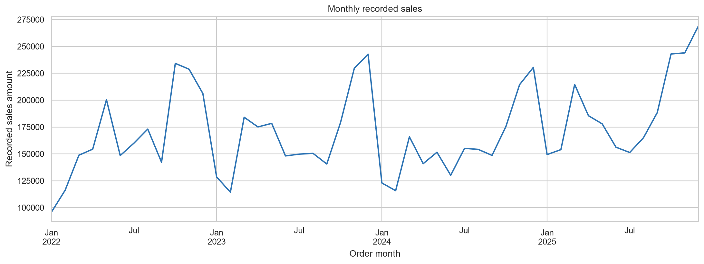
Figure 3. Monthly recorded sales. Generated by the completed Jupyter Notebook.
The monthly time series exposes variation across the observed period; the notebook does not claim that individual peaks establish a recurring seasonal cause.

Numeric box plots
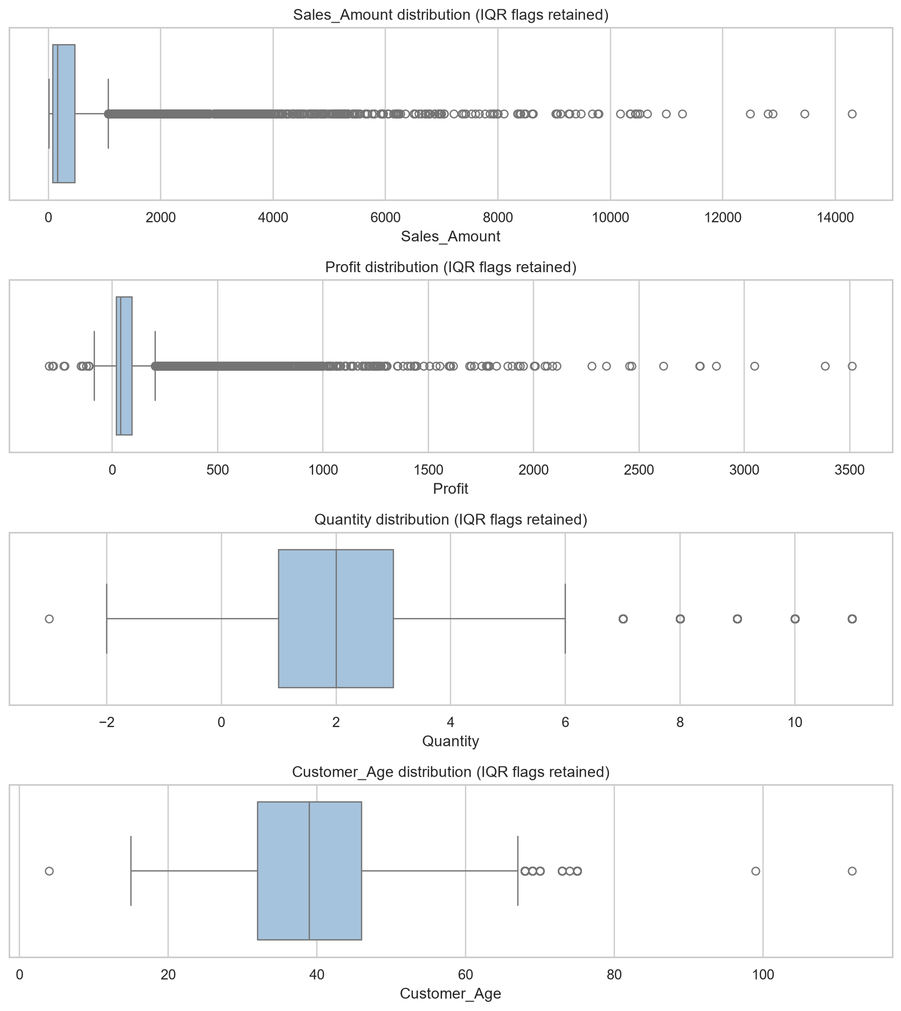
Figure 4. Numeric box plots. Generated by the completed Jupyter Notebook.
Box plots visualize selected distributions and IQR flags for Sales_Amount, Profit, Quantity, and Customer_Age. Flagged observations are retained.

Numeric correlation heatmap
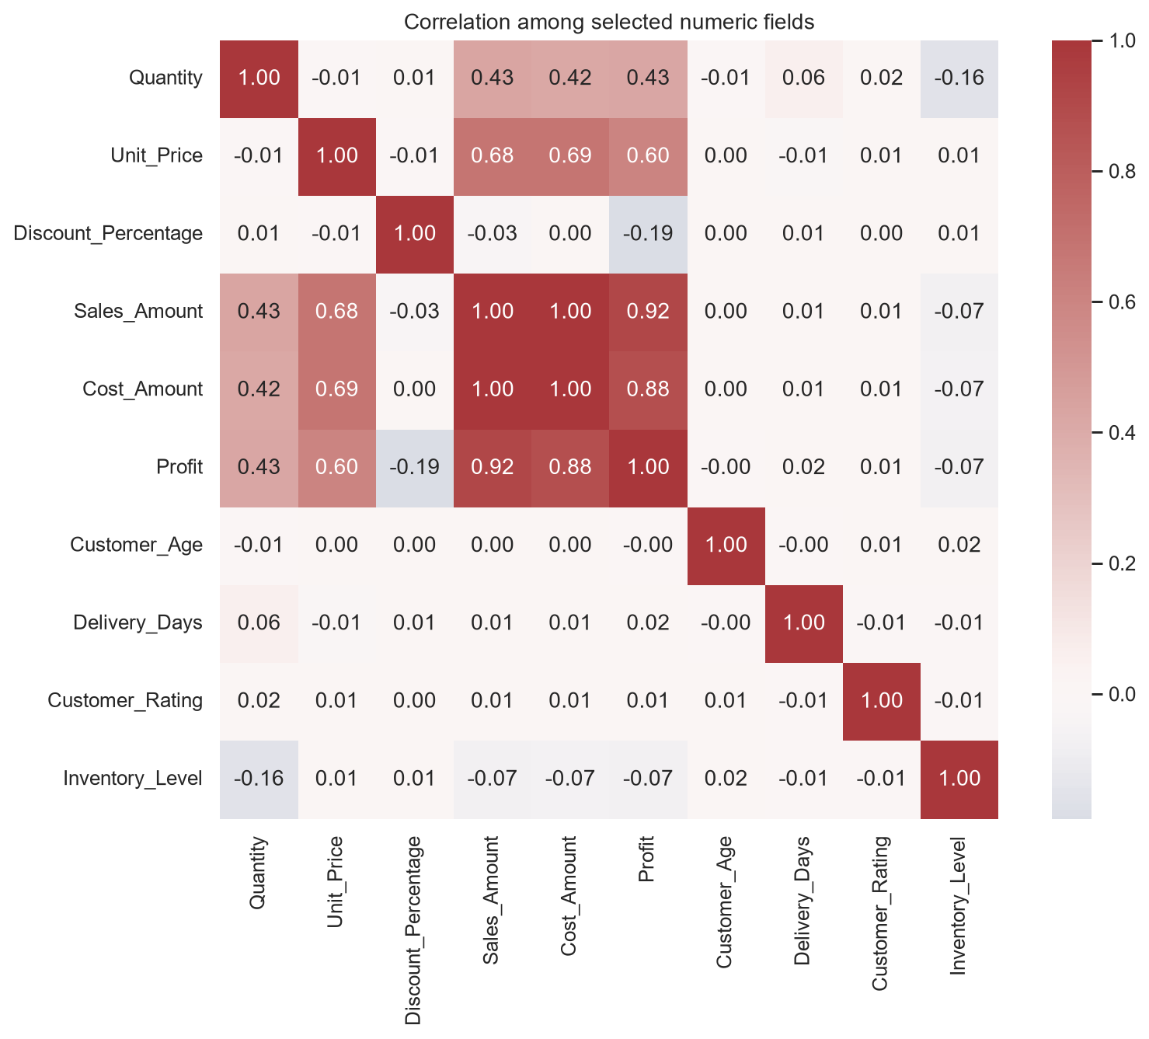
Figure 5. Numeric correlation heatmap. Generated by the completed Jupyter Notebook.
The heatmap displays pairwise Pearson correlations for selected numeric measures; correlations are descriptive and may be sensitive to outliers.

Sales by category, channel, country, and customer segment
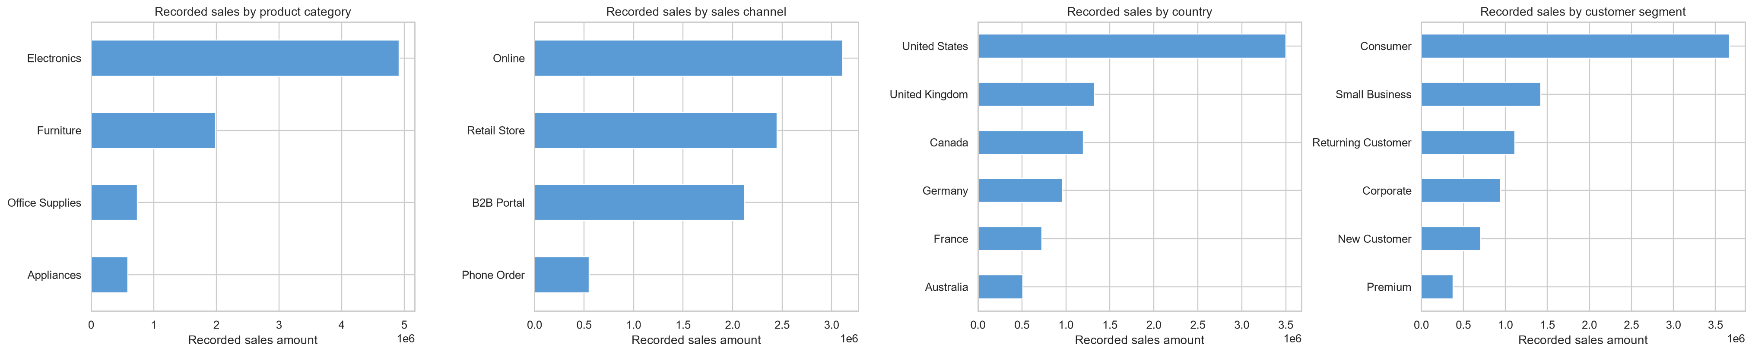
Figure 6. Sales by category, channel, country, and customer segment. Generated by the completed Jupyter Notebook.
The grouped horizontal bars compare recorded sales totals across business dimensions, without status-based financial adjustments.

Category sales by calendar year
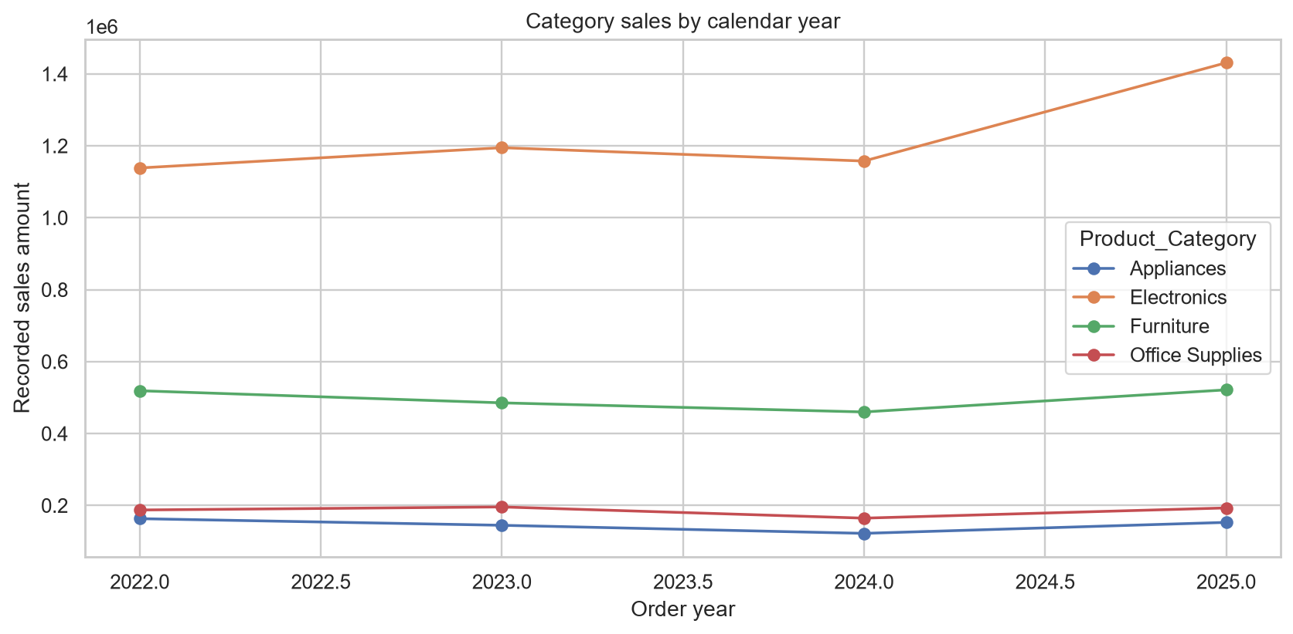
Figure 7. Category sales by calendar year. Generated by the completed Jupyter Notebook.
The line chart compares each available product category's recorded sales across the calendar years.

Key Business Insights
- The analysis copy contains 18,000 transaction rows with 14,541 distinct orders and 4,882 distinct customer IDs.
- Recorded sales total 8,234,090.60; recorded profit totals 1,645,439.40.
- From 2024 to 2025, recorded sales increased by 20.66% (+20.66%).
- The highest recorded annual sales total occurred in 2025.
- Electronics leads recorded sales by category, representing 59.8% of the named-group total.
- Online leads recorded sales by channel, representing 37.8% of the named-group total.
- United States leads recorded sales by country, representing 42.6% of the named-group total.
- 10.41% of analysis transaction rows are marked `Return_Flag = Yes`; this is a row-based rate, not an order- or value-based rate.
- Across the recorded amounts, the notebook-derived totals are 8,234,090.60 in sales, 1,645,439.40 in profit, and a 19.98% aggregate profit-to-sales ratio; these figures include all retained order statuses.
- At 10.41%, the share of rows marked Return_Flag = Yes is row-based, not an order-based or sales-value return rate.

Business Recommendations
The following actions reflect the completed notebook's recommendations and data caveats; validate them with source owners and finance before operational use.
- Investigate the upstream process responsible for 45 fully duplicated rows and enforce transaction-key uniqueness at ingestion.
- Review 1 discount value(s) outside 0–100 before using discount measures for promotion policy; do not silently cap them.
- Validate 1 age value(s) outside 0–100 with the source system; keep them flagged rather than imputing or deleting.
- Confirm whether 3 negative-quantity row(s) represent returns/adjustments or errors, then document the agreed treatment for volume reporting.
- Validate whether the 20.66% recorded-sales increase in 2025 is supported by comparable order status, volume, and product/channel mix.
- Agree a finance-approved inclusion rule for Completed, Returned, Cancelled, and in-progress orders before publishing an accounting revenue KPI.
- Standardize geographic aliases in the source system before using region-level rankings for resource allocation.
- Add a documented currency code and clarify whether Sales_Amount is net of returns/discounts; the supplied dictionary does not specify these conventions.

Limitations
- The supplied dictionary does not document the currency, financial recognition policy, fiscal calendar, or treatment of returns and order statuses for accounting revenue.
- Top-line sums include all retained rows and all Order_Status values; they are descriptive recorded totals, not audited net revenue.
- The dataset contains missing values and flagged measurements; no imputation or automatic correction is performed.
- Case normalization does not merge semantic aliases or validate the malformed region label; geographic comparisons should be interpreted with that limitation.
- IQR screening flags unusual observations but does not establish that they are erroneous. Negative quantity meaning is not documented.
- Year and quarter comparisons are descriptive, not inflation-adjusted, like-for-like, forecast, or causal analyses.
- The notebook contains no saved outputs; figures and summaries are generated when the notebook is executed. This report's figures were captured by executing its cells against the supplied files.

Future Improvements
- Confirm currency, revenue recognition, return, and order-status definitions with the data owner and finance team.
- Add source validation for Transaction_ID uniqueness, allowed discount/rating bounds, quantity policy, and Order_Year/date consistency.
- Create governed mapping tables for payment, region, and city aliases instead of relying on case-only normalization.
- Add order-based and value-based return KPIs after return definitions are approved.
- Build like-for-like reporting or forecasting only after coverage and seasonal definitions are validated.
- Re-run quality and KPI checks when refreshed transaction data is received.

Conclusion
The completed project provides a reproducible analysis of 18,045 source transaction rows across 2022–2025. The notebook preserves the source, removes 45 exact duplicate rows from its working copy, derives date/time features, and evaluates sales, product, customer, regional, KPI, outlier, and correlation patterns. Its analysis copy records 8,234,090.60 in sales and 1,645,439.40 in profit. The results offer descriptive business context; confirmed currency, revenue policy, and source-quality rules are needed before treating them as audited financial measures.

Technologies Used
Technology | Role in the completed analysis
Python | Notebook execution and analysis workflow.
Pandas | CSV loading, data cleaning, grouping, quality checks, and time-series summaries.
NumPy | Numerical operations and calculations.
Matplotlib | Notebook visualizations.
Seaborn | Box plots, correlation heatmap, and visualization styling.
Jupyter Notebook / IPython | Executable notebook, markdown narrative, and display output.
Python standard library (pathlib) | Input-file path handling in the notebook.

References
- Sales_transactions_2022_2025.csv — project-supplied source transaction file.
- sales_data_dictionary.csv — project-supplied field definitions, declared types, examples, and business meanings.
- ManpreetJadon_RetailSalesPerformanceAnalytics.ipynb — completed notebook; its cells were executed against the supplied data for this report.
- README.md — project overview, workflow, findings, and reproduction instructions.
- requirements.txt — pinned Python dependencies for the notebook.
No external business or market sources were used. All quantitative findings in this report are calculated from the supplied dataset using the completed notebook's documented preparation and metric definitions.

