DESIGN AXI-APB BRIDGE BASED ON AXI 4.0 AND APB 4.0 PROTOCOL
ABSTRACT
With the rapid development of technology in deep Submicron, the scale of integrated circuit (IC) grows increasingly. Intellectual property (IP) reuse has been taken popularly. This design method is widely applied in the system on chip (SoC) field. The on-chip bus design is most cared in IP-reused based SoC design. Several bus standards were proposed. Among those standards, the advanced microcontroller bus architecture (AMBA) is the most favored. ARM introduced the Advanced Microcontroller
Bus Architecture (AMBA) 4.0 specifications in March 2010, which includes Advanced eXtensible Interface (AXI) 4.0. This is very high-speed bus. AMBA bus protocol has
become the de facto standard SoC bus. That means more and more existing IPs must be able to communicate with AMBA 4.0 bus, we designed an Intellectual Property (IP) core of Advanced Peripheral Bus (APB) bridge, which translates the AXI4.0 transactions into APB 4.0 transactions. The bridge provides an interface between the high-performance AXI bus and low-power APB domain.
I.INTRODUCTION
Integrated circuits have entered the era of System-on-Chip (SoC), which refers to integrating all components of a computer or other electronic system into a single chip. It may contain digital, analog, mixed-signal, and often radio-frequency functions – all on a single chip substrate. With the increasing design size, IP is an inevitable choice for SoC design. And the widespread use of all kinds of IPs has changed the nature of the design flow, making On-Chip Buses (OCB) essential to the design. Of all OCBs existing in the market, the AMBA bus system is widely used as the de facto standard SoC bus.
On March 8, 2010, ARM announced availability of the AMBA 4.0 specifications. As the de facto standard SoC bus, AMBA bus is widely used in the high-performance SoC
designs. The AMBA specification defines on-chip communication standard for designing high-performance embedded microcontrollers. The AMBA 4.0 specification defines five buses/interfaces:
- Advanced eXtensible Interface (AXI)
- Advanced High-performance Bus (AHB)
- Advanced System Bus (ASB)
- Advanced Peripheral Bus (APB)
- Advanced Trace Bus (ATB)
AXI, the next generation of AMBA interface defined in the AMBA 4.0 specification, is targeted at high performance, high clock frequency system designs and includes features which make it very suitable for high-speed sub-micrometer interconnect.
- separate address/control and data phases
- support for unaligned data transfers using byte strobes
- burst based transactions with only start address issued
- issuing of multiple outstanding addresses
- easy addition of register stages to provide timing closure
II. PROPOSDE HARDWARE ARCHITECTURE OF AXI APB BRIDGE
II.1. APB PROTOCOL
APB belongs to the AMBA family and applicable for a single master and slave principle. It is optimized for low power, reduced complexity interface and low bandwidth operations which is unpipelined protocol. It is supported only for a single master and multiple slaves and contains only single channel to communicate between master and slave usually done by PSELx signal. PSELx signal is a master signal which is used to decide the number of slaves are used, PWRITE is a signal from master which decides Read or write operation if PWRITE =1, for write operation and 0 for Read operation. For any operation, PADDR and PWDATA are address and data signals set on the bus as well as PSEL is high, PENABLE must be high in the next clock cycle, when PREADY which is from Slave is high indicating data transfer is completed. PSLVERR which is a slave signal indicates an error condition on Read and Write operations. The transaction of APB is illustrated by the state machine and is shown in the Figure 1.
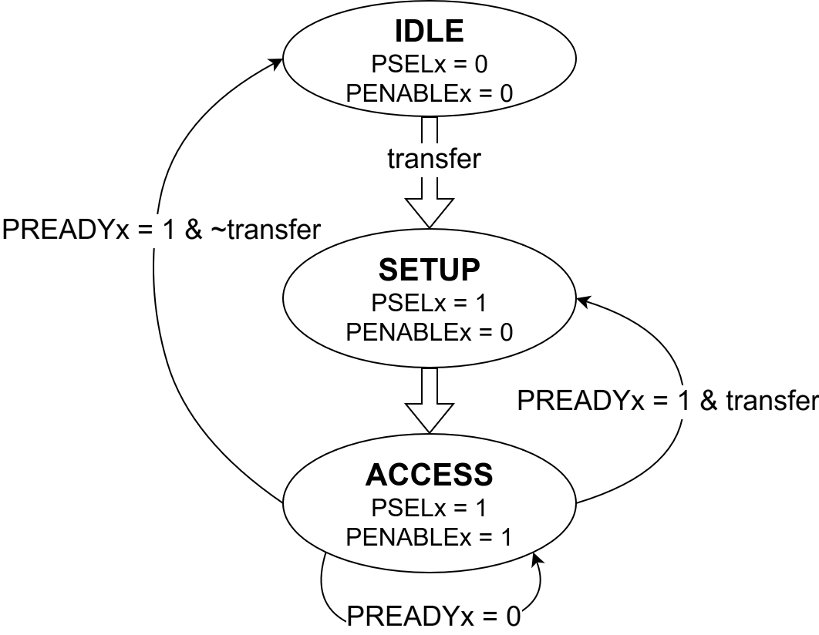
Figure 1: APB state machine for one transfer
II.2 AXI PROTOCOL
AXI4 refers to advanced extensible peripheral bus it supports for out of order response, multiple outstanding transactions, burst operations and disjoint operations along with advanced peripheral bus. It consists of five independent channels namely Address Write, Write Data, Address Read, Read and Write Response channel. The signal description of each channel is shown in Table 1.

Table 1: Signals of each AXI channel
Write Address  Channel | Write Data  Channel | Write Response  Channel | Read Address  Channel | Read Data  Channel
AWVALID | WVALID | BVALID | ARVALID | RVALID
AWREADY | WREADY | BREADY | ARREADY | RREADY
AWID[7:0] | WDATA[31:0] | BID[7:0] | ARID[7:0] | RDATA[31:0]
AWADDR[31:0] | WSTRB[3:0] | BRESP[1:0] | ARADDR[31:0] | RID[7:0]
AWLEN[7:0] | WLAST |  | ARLEN[7:0] | RRESP[1:0]
AWSIZE[2:0] |  |  | ARSIZE[2:0] | RLAST
AWBURST[1:0] |  |  | ARBURST[1:0]
AWPROT[2:0] |  |  | ARPROT[2:0]

Write transaction:
In the write transaction, address signal AWADDR and WDATA signal is set on the channel from the master and AWVALID signal which is master to slave goes high, and after one clock cycle a signal AWREADY from slave to master goes to high. Whenever a valid data is transmitted WVALID signal from master to slave goes high and after one clock cycle WREADY signal which is a slave to master signal goes high indicating that a successful transaction is completed. BRESP which is a signal from slave to master is set to OKAY after completion of data transfer. BVALID signal becomes high indicating successful transferring of data, and BREADY is a master to slave signal is high throughout the transaction. The architecture of write transaction is as shown in the Figure 2.
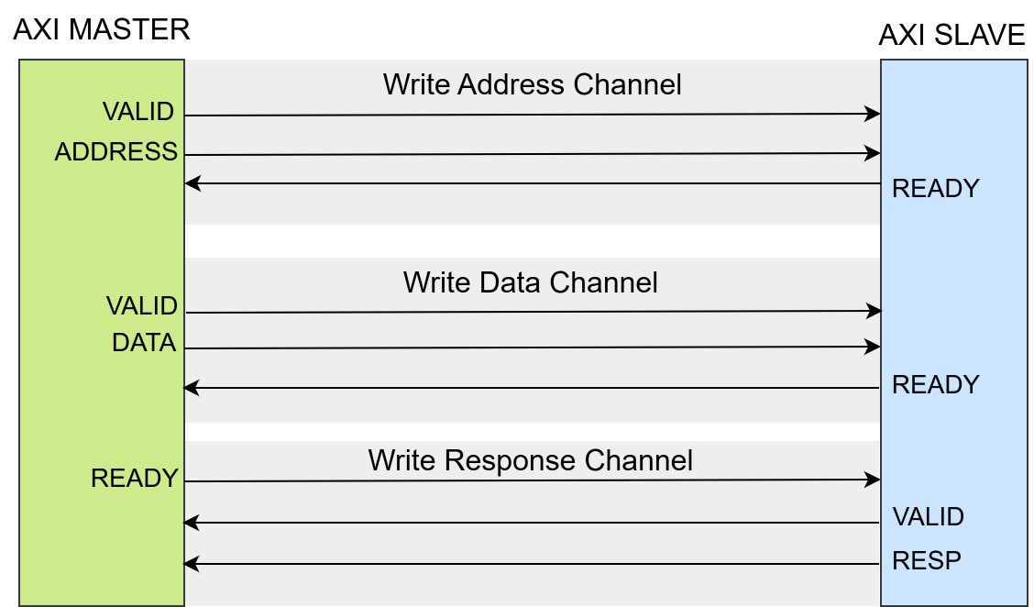
Figure 2: Write Transaction Diagram
Read Transaction:
In Read Transaction, read address signal ARADDR is set on channel, ARVALID signal which is master to slave becomes high, and in the next clock cycle ARREADY which is a master to slave signal becomes high indicating a valid address, and rad channel data signal RDATA which data presents that is to be read by master and RREADY is slave to master signal becomes high after completion of each transaction, RVALID is high which is a master to slave signal indicating successful read transaction, RLAST is a is high for last read burst , the mechanism for read transaction is as shown in the below Figure 3.
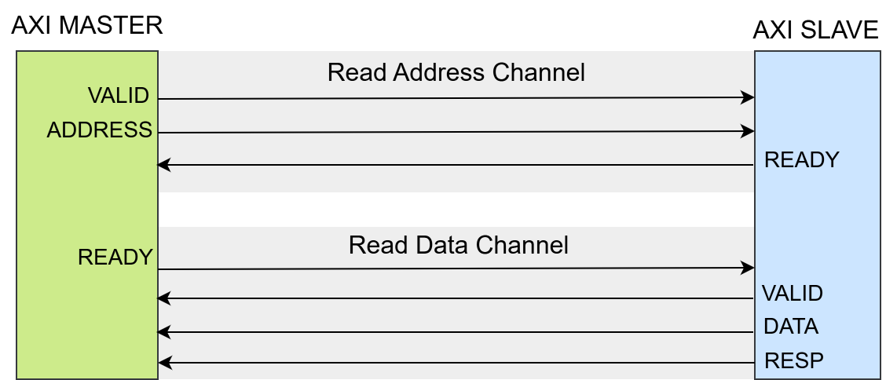
Figure 3: Read Transaction Diagram
II.3 PROPOSED HARDWARE ARCHITECTURE
In this section, we present the proposed hardware architecture of AXI2APB bridge that includes read request fifo (AR_SFIFO), read data fifo (RD_SFIFO), write request fifo (AW_SFIFO), write data fifo (WD_SFIFO), Decoder, Arbiter, Slave Addr Register and two protocol interfaces that are AXI slave interface and APB master interface. The architecture is described in Figure 4. Before diving into each component in detail, we outline several choices of our design.
The choices of design:
- Only supports 4-byte transfer
- Supports unaligned address
- Synchronous clock
- Supports 4 APB slaves (Table 2)
Table 2: Address Range of 16 APB slaves
APB Slave | Base Address | End Address
SLAVE0 | 32’h0000_1000 | 32’h0000_1FFF
SLAVE1 | 32’h0000_2000 | 32’h0000_2FFF
SLAVE2 | 32’h0000_3000 | 32’h0000_3FFF
SLAVE3 | 32’h0000_4000 | 32’h0000_4FFF

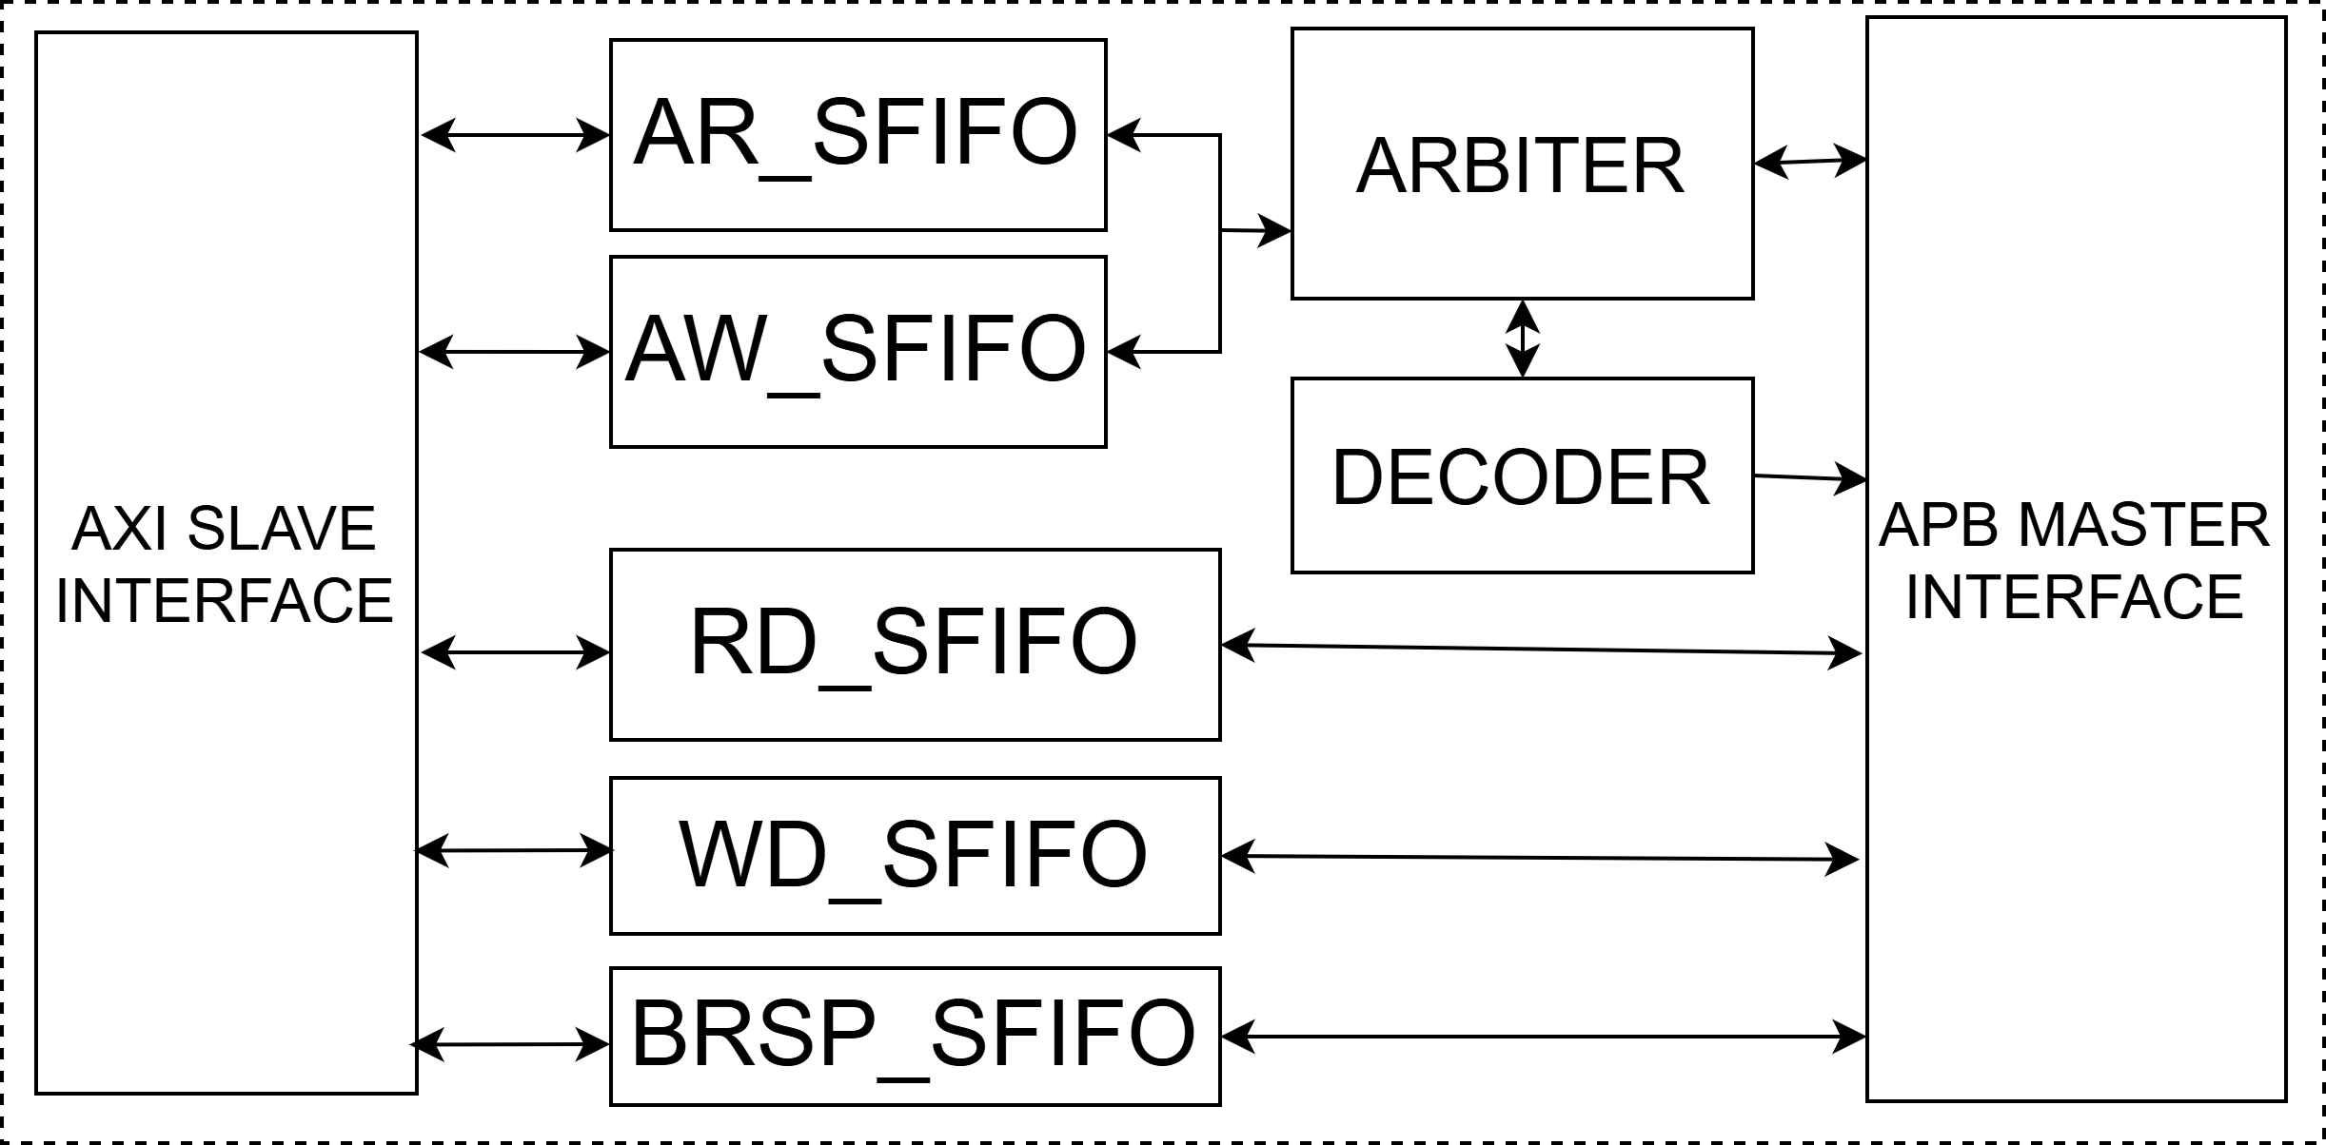
Figure 4: Proposed hardware architecture of AXI2APB Bridge
AR_SFIFO: this fifo stores information of read request channel that consists of ARADDR, ARID, ARLEN, ARSIZE, ARBURST and ARPROT; therefore, it also takes responsibility for handling ARVALID – ARREADY handshake.
AW_SFIFO: this fifo stores information of write request channel that consists of AWADDR, AWID, AWLEN, AWSIZE, AWBURST and AWPROT; therefore, it also takes responsibility for handling AWVALID – AWREADY handshake.
RD_SFIFO: this fifo stores information of read data channel that consists of RDATA, RID, RLAST, RRESP; therefore, it also takes responsibility for handling RVALID – RREADY handshake.
WD_SFIFO: this fifo stores information of write data channel that consists of WDATA, WSTRB, WLAST; therefore, it also takes responsibility for handling WVALID – WREADY handshake.
Note: all mentioned FIFOs are First-word fall-through (FWFT) FIFOs in our design
ARBITER: AXI protocol has pipeline operation and APB protocol has non-pipeline transferring, so we have to handle arbiter mechanics to ensure that there must be one request to be executed at any moment and it can be write transaction or read transaction. This block takes a role of it, described in figure 5 and figure 6.
This block has operation principle as follows:
- After reset, read request is prioritized
- On completion of any request or no transaction is progressing, there are such two cases:
- As write is granting, if read request is waiting, arbiter block prioritizes read in the next times otherwise write is continuously granted.
- As read is granting, if write request is waiting, arbiter block prioritizes write in the next times otherwise read is continuously granted.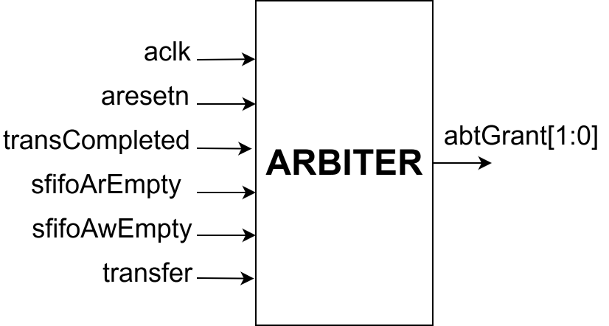
Figure 5: Block diagram of Arbiter block
Figure 5 shows the main signals of Arbiter block and their descriptions are discussed as follows:
- aclk, aresetn: AXI clock and low-level reset
- transCompleted: informs the completion of one AXI transaction as it asserts
- sfifoArEmpty: shows the empty status of AR_SFIFO(Figure 4) as it asserts
- sfifoAwEmpty: shows the empty status of AW_SFIFO(Figure 4) as it asserts
- transfer: one transaction is progressing as it is being high
- abtGrant[1:0]: indicates current higher priority of grant for write or read
- abtGrant[0] is equivalent to read is whether or not granted
- abtGrant[1] is equivalent to write is whether or not granted

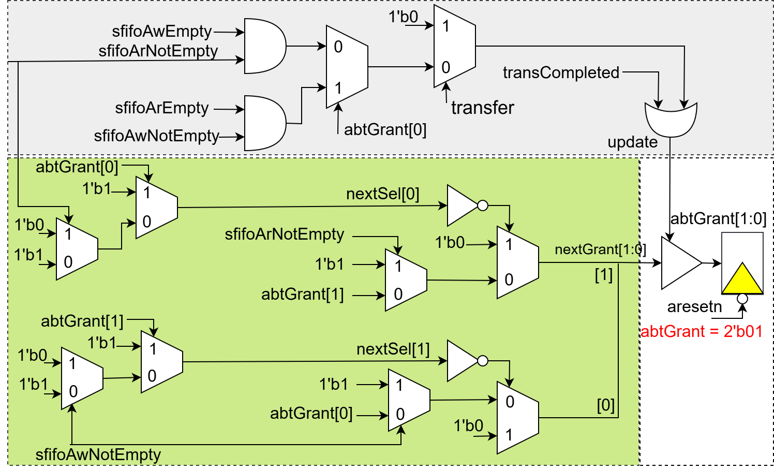
Figure 6: Logic Diagram of Arbiter Block
Figure 6 shows the three main functions of Arbiter block:
      - White color part illustrates the high priority to read after reset with value of abtGrant register is 2’b01 – abtGrant[0] represents read and abtGrant[1] controls write.
- Gray color region presents control signal that takes a role of updating value of Grant Register during run-time process. In addition, transCompleted informs one transaction done as being high logic while transfer has high logic that is equivalent to one transaction (read or write) is occurring.
- Green color domain describes the handling of arbiter logic that ensures only read or write to be implemented in any time.
DECODER: this block has block diagram described in Figure 7 and takes two main roles as follows:
- Decode ARADDR and AWADDR to determine which APB slave that master accesses to.
- Drive APB interface to implement transfer
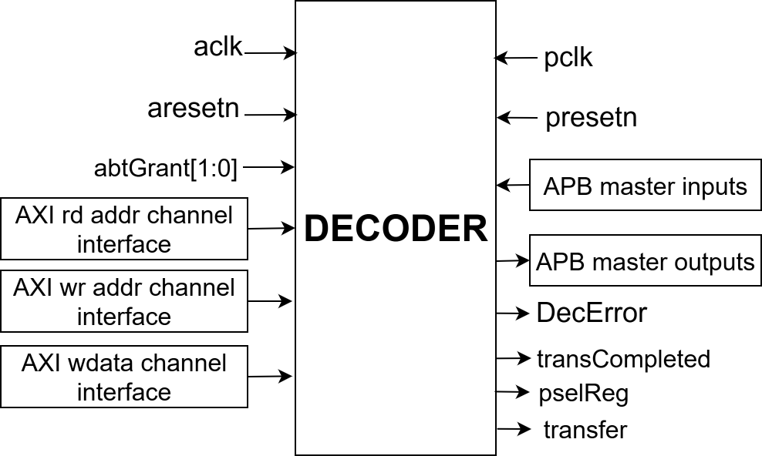
Figure 7: Block diagram of Decoder component
Figure 7 shows main signals of Decoder block and their descriptions are discussed as follows:
- aclk, aresetn: AXI clock and low-level reset
- abtGrant: shows current higher priority to read or write (described above)
- AXI rd addr channel interface: ARADDR, ARID, ARLEN, ARSIZE, ARBURST, and ARPROT that are read from AR_SFIFO (in Figure 4)
- AXI wr addr channel interface: AWADDR, AWID, AWLEN, AWSIZE, AWBURST, and AWPROT that are read from AW_SFIFO (in Figure 4)
- AXI wdata channel interface: WDATA, WSTRB, WLAST are read from WD_SFIFO(in Figure 4).
- pclk, present: APB clock, low-level reset
- APB master inputs: pslverr, pready, prdata
- APB master outputs: psel[SLAVE_CNT^{(*)}-1:0], penable, pwrite, pwdata, pstrb, pprot
- DecError: informs no existence of APB slave in design as asserting
- transCompleted: presents the completion of one transaction as this signal asserts
- pselReg: SLAVE ADDR REGISTER (figure 4) is selected as this signal asserts
- transfer: AXI transaction is progressing as this signal is being high
(*): SLAVE_CNT: shows the actual number of APB slaves used and this parameter is defined by user.
SLAVE ADDR REGISTER: this block is also an APB slave, and it belongs to address range from 32’h0000_0000 to 32’h0000_0FFF. In addition, it is accountable for storing base address and end address of 16 APB slaves with detailed information described in Table 2.

