CFJ User Guide
The Forge | WIL Part 2 | 18 October 2026
This guide explains the current website demo, Oracle profile page and Android preview. Screenshots show real browser sessions using sample data. They do not prove that the full system is finished or that a physical Android phone has been tested.

Choose the right version
- Website demo: open the project website or run npm start and visit http://127.0.0.1:8765. Accounts, bookings and payments here stay in that browser. Payments, QR scanning and messages are simulated.
- Oracle profile page: a separate local page at http://127.0.0.1:8788/profile-sync.html. It saves the synthetic member's name and goal through the API to Oracle. It does not sign you in to the main website.
- Android debug app: Home, Classes and Settings are available. Local preferences and development API panels exist. Physical-phone operation still needs verification. A website screenshot at a narrow width is not a phone-app screenshot.

Contents
2 Sign in and edit your profile
3 Book and cancel a class
4 Payments and training content
5 Staff and administrator views
6 Oracle profile connection
7 Android preview
8 Troubleshooting and support

Open the demonstration
Public demo: https://cfj-management-demo.mtungwamanqoba93.chatgpt.site/
Local preview: http://127.0.0.1:8765/ after the developer starts it. The new Help page is in the repository and local preview; public deployment has not been updated in this task.

Sign in and edit your profile
Open Home to browse programmes, memberships and visit information. Links labelled official open CFJ's separate website. For the member demo, open Member Login from the account page and use the prefilled sample account, then select Login As Member. Use fictional details and a password you do not use elsewhere if creating another demo account. Registration does not send a verification email or create a real gym membership. Sign in to the same browser to recover your demo records; clearing browser storage removes local changes.
On Members, scroll to Edit Profile and Preferences. Change your name, goal or other sample details and select Save Profile Changes. The profile shown on this page reflects browser data, not Oracle. Do not enter real health information. Select Logout on the profile card when finished.
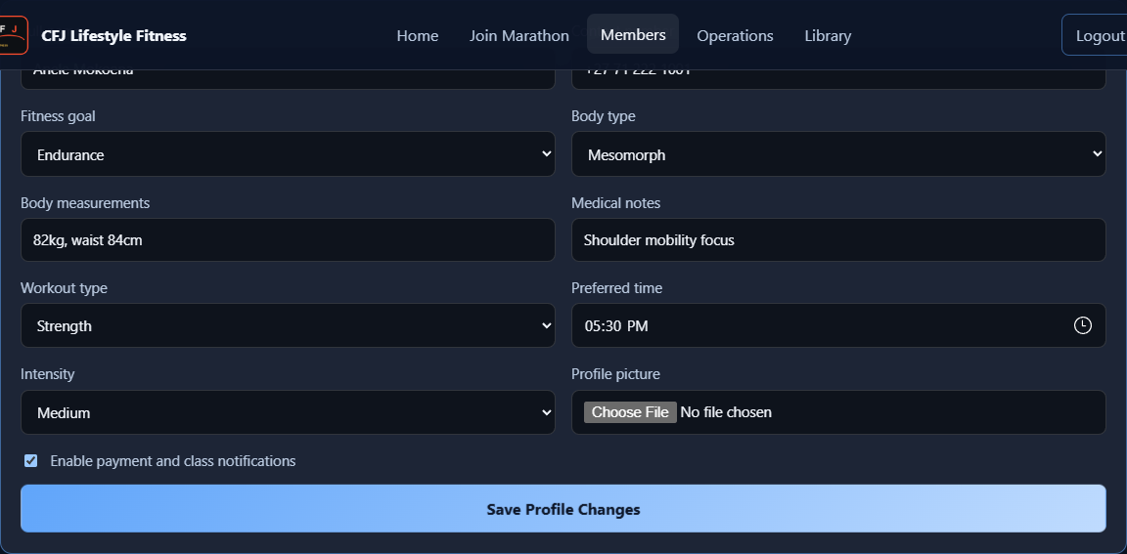
Figure 1 Browser demo profile fields after selecting Endurance.

Book and cancel a class
Open Operations as a member. Use the type, date and instructor filters under Class Booking. Choose Book on a class. Look under Your Bookings for its status. A full class offers Waitlist in this browser demo. Select Cancel on your booking to remove it and release its reserved place. These actions do not reserve places at the real gym. The server-side membership rules and the browser demo are separate implementations pending full integration.
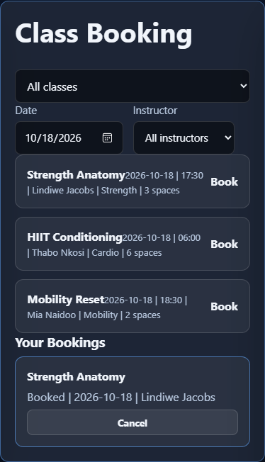
Figure 2 A class appears under Your Bookings after booking. Cancellation was also checked.
If no classes appear, choose All classes and All instructors and clear the date filter. A duplicate request means you should check the booking already listed.

Payments and training content
Operations also provides simulated Check In Now, Scan QR and Check Out actions, trainer requests and member connections. A trainer request is not a confirmed appointment. On Members, Pay Membership records a simulated payment and displays a confirmation; no money is charged and no email or SMS is delivered. Library shows sample training guides according to the selected goal and demo payment status. These are sample project flows, not a substitute for a trainer's advice.
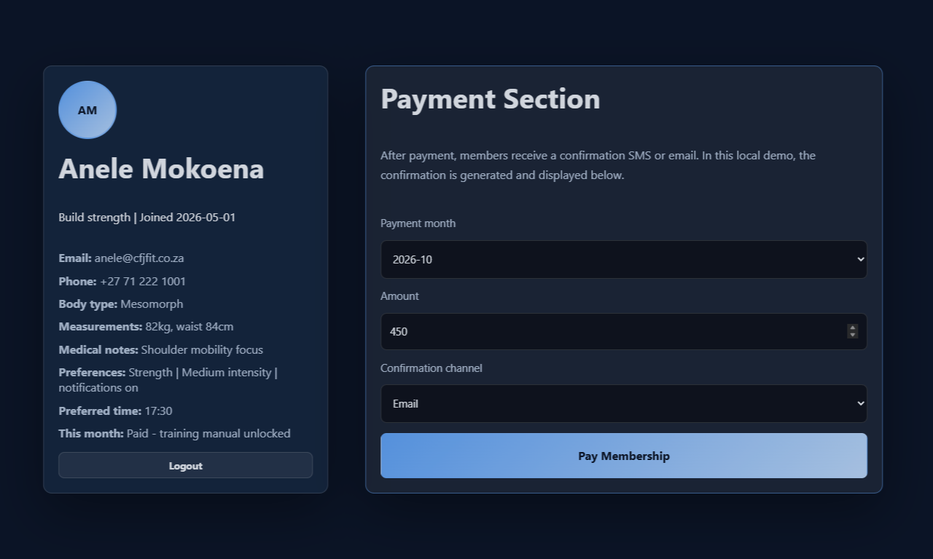
Figure 3 Member dashboard and simulated payment form. No real payment was made.
To explore the payment simulation, choose a month, sample amount and confirmation channel on Members, then select Pay Membership. Review Payment History for the sample confirmation. Open Library to see the available training content.

Staff and administrator views
Staff use Staff Login and administrators use Admin Login. The seeded local demonstration accounts are staff@cfjfit.co.za with staff123 and admin@cfjfit.co.za with admin123. These are public sample credentials in the source, not real gym accounts. Staff work in Staff Desk; administrators use Admin Reports. Generated totals refer to the demo data. Use Logout in the footer before switching roles. Client-side role navigation does not provide production access control.
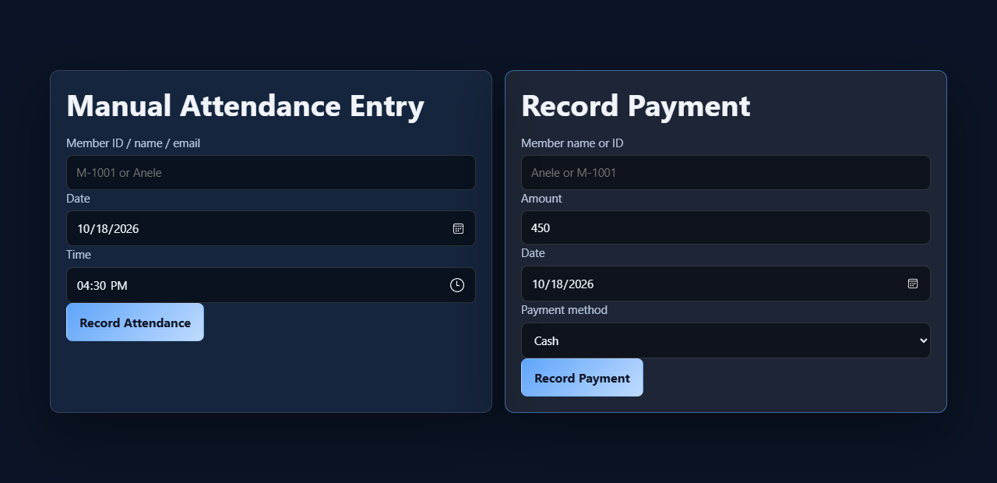
Figure 4 Staff workspace using the sample staff account.
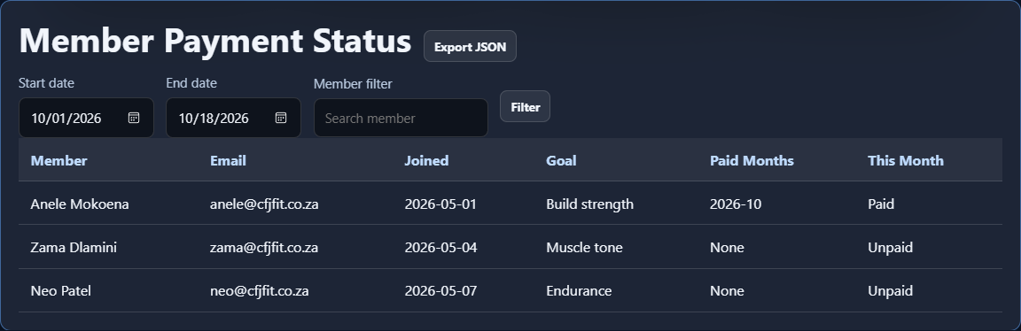
Figure 5 Administrator workspace using local demo records.

Oracle profile connection
The developer must first start Oracle and the profile API as described in database/README.md. Open http://127.0.0.1:8788/profile-sync.html. Enter the development token privately, select Load profile, edit the name or training goal, then select Save profile. Open another browser page and load the profile to see the committed change. If another client has edited it, reload before saving again. Never include the token in screenshots, Git or the report. This page currently uses one synthetic development identity.
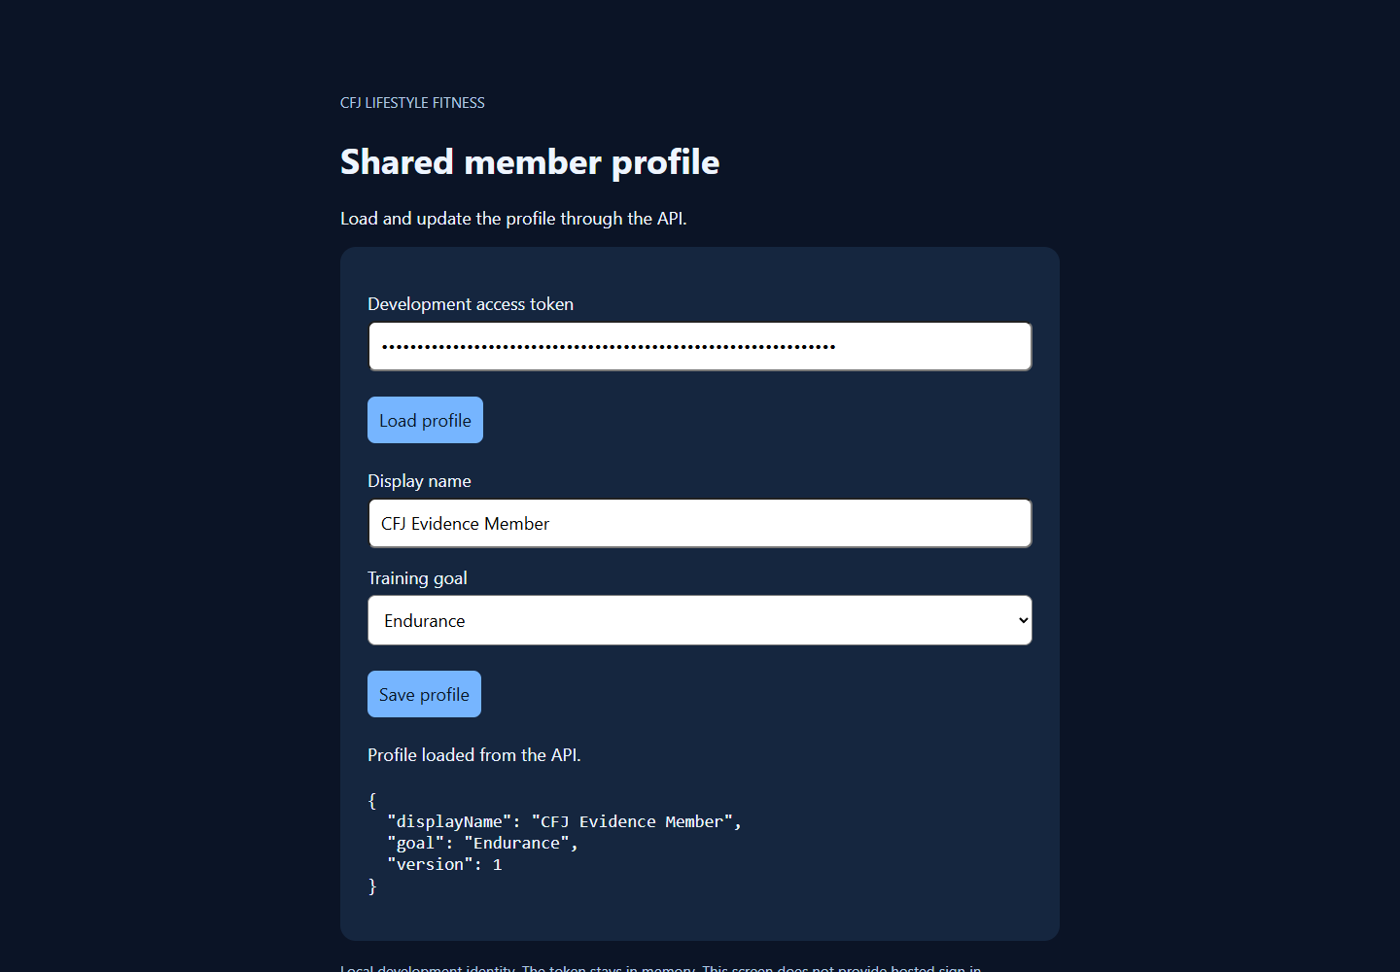
Figure 6 A second browser page reads the committed Oracle profile. Captured in the verified local integration session on 18 October.

Android preview
After the debug APK is installed on a compatible phone (Android 8 or newer), Home introduces the app, Classes links to the official timetable, and Settings lets you save a display name and training goal. Save preferences stores those settings locally; it is not an Oracle save. Reset preferences asks for confirmation and clears the local preferences. The debug Development profile sync section has separate Load from service and Save to service controls. For the local Oracle API, a developer forwards port 8788 over USB and supplies the service address http://127.0.0.1:8788 and a development token. Hosted sign-in and real app bookings are unfinished. These instructions come from the implemented screens; device execution remains to be checked.

Before the phone demonstration
- Connect and unlock a compatible Android phone, enable USB debugging and approve the computer on the phone.
- Have the developer start Oracle and the profile API, then configure USB port forwarding.
- Install the debug APK and test Home, Classes and Settings. Check local preference saving separately from API profile saving.
- Capture real phone screenshots and record the narrated demonstration after the required features work.
No Android phone screenshots are included here. On 18 October, 16 Android unit tests passed, the debug APK built, and lint completed with 10 warnings. The GitHub Android workflow passed too. Build results do not replace device testing.

Troubleshooting and support
Problem | What to do
Member login failed | Check the selected role and account details. A demo account created in another browser is not available here.
Invalid email or required field | Correct the highlighted field before submitting again.
No classes match | Clear the date and instructor filters and choose All classes.
Duplicate booking | Check Your Bookings instead of submitting again.
Profile changed elsewhere | Load the current profile, review it, then reapply your changes.
Access denied on profile service | Ask the developer to check the development token. Do not post it in chat or screenshots.
Service unavailable | Check Oracle is running and the API process is open. A public static website cannot reach a database running only on your computer.
Android cannot connect | Confirm USB debugging approval, port forwarding and the service address. The normal Save preferences button does not call the API.
Data differs between screens | The main website, local app preferences and Oracle profile demo are not yet fully integrated.

Getting help
Record the page or screen name, steps, expected result and actual result. Include a screenshot with passwords and tokens hidden, then log the issue for the team. Use synthetic data when reproducing problems. The team must still finish hosted authentication, the remaining relational data flows, physical-phone testing and the narrated assessment video.
Evidence scope: new screenshots came from an isolated local browser. The Oracle image comes from the earlier verified local integration check. The main public site was not redeployed in this task. Confirm the WIL deadline and final submission requirements against the official brief.

