PRASA CONNECT
Part 1 Research, Planning and Design Document
Module: OPSC6312 | App type: Android rail commuter application | Draft date: 21 August 2026
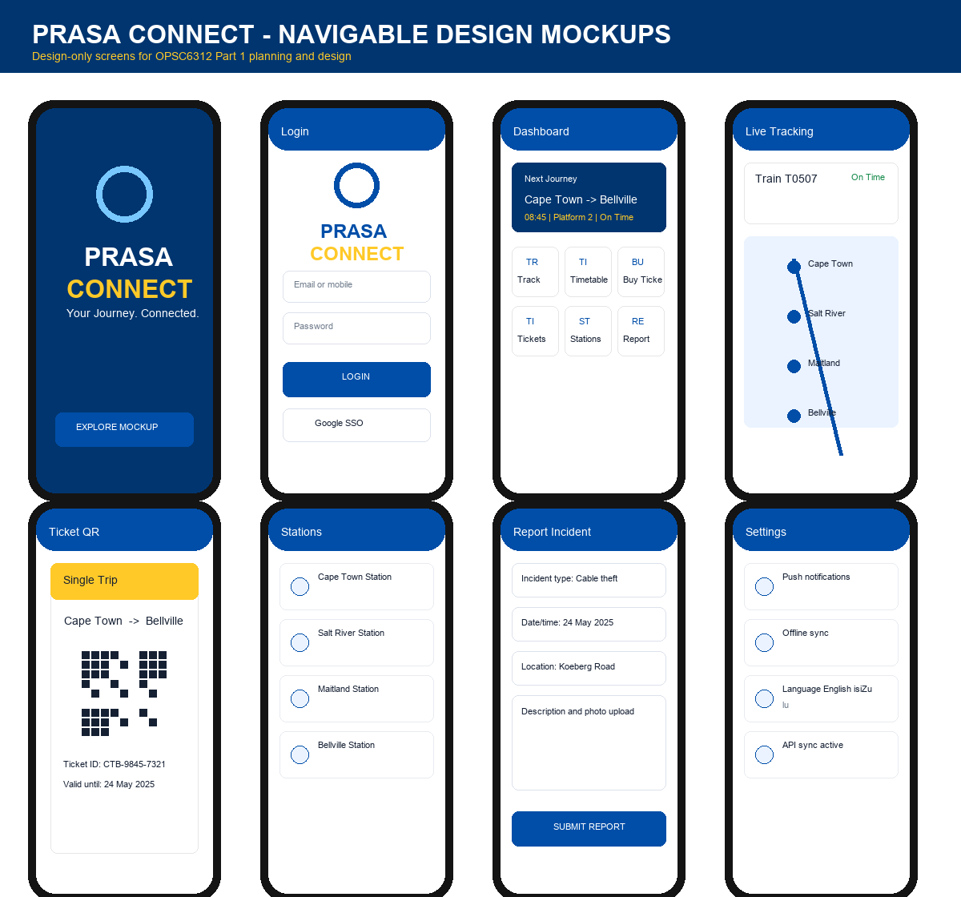
Figure 1: Generated PRASA Connect design mockups for the required app screens.

Clarifications Needed Before Final Submission
This draft uses reasonable assumptions so the group can continue working immediately. Please confirm the final student numbers, submission date, lecturer requirements for Harvard formatting, and whether the final app should use English plus isiZulu or English plus Afrikaans for the two South African languages. Also confirm whether the backend will be Firebase Cloud Functions, a Node/Express API, or another hosted REST API.

Role Allocation
Member | Role | Part 1 responsibility
Sanele | Team Leader and Researcher | Moovit research, research introduction, comparison, conclusion, app overview, final checking and combined PDF submission.
Nyito | Researcher and Designer | Trainline research, requirements, user interface mockups, screen descriptions and navigation diagram.
Nonhlanhla | Researcher and Planner | Gautrain research, references, REST API design, UML, data listing and Gantt chart.

Research Report

Introduction
Public transport is essential for many South African commuters, but rail users often struggle with uncertain train times, station information, ticket handling, service disruptions and safety reporting. PRASA Connect is proposed as an Android application that brings journey planning, train tracking, digital tickets, station information, incident reporting, offline access and real-time alerts into one commuter-focused service. The research compares Moovit, Trainline and the Gautrain app because they already solve parts of the same problem: they help users plan journeys, receive live transport information and manage tickets or travel accounts.

App 1: Moovit - Sanele
Moovit is a global urban mobility app that combines directions, real-time arrivals, service alerts, favourite stations and offline map access. Its strongest feature is the way it turns complex public transport networks into step-by-step journeys. The interface is easy to understand because the main tasks are separated into directions, stops and lines, and users can save frequently used places. A weakness for PRASA-style rail use is that Moovit depends heavily on available local data. In areas where agency feeds are incomplete, real-time predictions may be limited or unavailable. Some users may also find advertising and broad multimodal features distracting when they only need rail information.
From an Android development perspective, Moovit was likely implemented with location services, map SDKs, REST APIs for schedules and alerts, local caching for saved maps, push notifications and account/payment modules in selected cities. PRASA Connect should adopt Moovit ideas such as favourite stations, clear route options, offline timetable access and service alerts, but simplify the interface around PRASA rail journeys.

App 2: Trainline - Nyito
Trainline focuses on searching journeys, checking live train times, buying tickets and storing mobile barcodes. Its strength is the complete journey workflow: search, compare options, buy, track and present the ticket from the phone. It also gives platform information, disruption alerts and journey changes, which reduces uncertainty for commuters. A weakness is that it is built mainly around rail operators in Europe, so its payment rules, ticket types and station coverage do not directly match PRASA. The app may also feel transaction-heavy for users who only need free timetable and disruption information.
Technically, Trainline likely uses secure user authentication, payment SDKs, REST services for fares and live schedules, barcode ticket generation, cached ticket storage and notification services. PRASA Connect should adapt the mobile ticket pattern, live platform information and disruption alerts, while keeping ticket purchase simple and suitable for South African rail commuters.

App 3: Gautrain Mobile App - Nonhlanhla
The Gautrain app is the closest South African example because it provides journey planning, card balance management, fare products, travel history, nearby stations, real-time bus tracking and claims management. Its strengths are local relevance, profile-based travel information, card linking and the ability to manage travel products digitally. A weakness is that it serves a smaller, more controlled network than PRASA, so it does not solve the larger challenge of wider commuter rail disruptions, safety incidents and offline access across many stations.
The Gautrain app was likely implemented with user profiles, secure payment services, card-account APIs, location services, schedule APIs, database-backed travel history and push notifications. PRASA Connect can learn from its card and account management, but should add stronger incident reporting, saved offline timetables and multilingual support for broader accessibility.

Comparison and Best Features
All three apps show that commuters need trust, speed and clarity. Moovit is strongest for route discovery and favourite places. Trainline is strongest for ticket purchase, live trip tracking and barcode tickets. Gautrain is strongest for South African rail account management, card balances and local station guidance. PRASA Connect should combine the best parts of these apps: live tracking, simple route planning, favourite routes, QR tickets, service alerts, offline timetables, station details, secure user accounts and incident reporting. The design should avoid unnecessary complexity by presenting the most common commuter actions directly on the dashboard.

Research Conclusion
The research supports building PRASA Connect as a focused rail companion instead of a general transport app. The final application should help users know when their train is coming, where it is, what platform to use, whether there are disruptions, how to show a ticket and how to report safety concerns. The existing apps prove that these features are practical on Android when supported by APIs, local storage, notifications and clear mobile interface design.

Planning and Design Document

Overview of the App - Sanele
PRASA Connect is an Android application for PRASA commuters. The proposed icon uses the PRASA circular rail logo style with blue and light-blue radial lines and a gold accent to connect the brand to train movement. Innovative features include live train tracking, QR ticket storage, incident reporting with photo upload, offline timetable access with later sync, multilingual interface support, push alerts and a personal dashboard showing the next journey.

Detailed Requirements - Nyito
- Users must register and log in with encrypted password storage, and the final PoE version must also support Google single sign-on.
- Users must edit settings including language, notification preferences, offline sync and data usage.
- The app must connect to a hosted REST API that returns train schedules, station details, ticket records, alerts and incident status.
- Offline mode must cache saved tickets, favourite stations, recent timetables and unsent incident reports, then synchronise when the device reconnects.
- Push notifications must warn users about delays, platform changes, service disruptions and safety notices.
- The app must support at least two South African languages, proposed as English and isiZulu, with Afrikaans as an optional third language.
- The app must include PRASA-specific features: live train tracking, trip planning, station search, QR tickets, wallet, alerts and incident reporting.

User Interface Design - Nyito
The design prototype contains these screens: splash, login, register, dashboard, live train tracking, timetable, ticket QR, stations, Gauteng rail map, report incident, plan trip, wallet, alerts, profile and settings. The dashboard is the central hub and gives direct access to the most important commuter tasks, including a Rail Map tile that opens the official PRASA Gauteng rail network map. Bottom navigation keeps Home, Wallet, Plan Trip, Alerts and Profile available throughout the app.
Navigation diagram: Splash -> Login/Register -> Dashboard. From Dashboard users can open Live Tracking, Timetable, Buy Ticket/Wallet, My Tickets, Stations, Rail Map, Report Incident and Settings. Rail Map links onward to Plan Trip so users can inspect the Gauteng network first, then choose a journey. The bottom navigation also allows Dashboard <-> Wallet <-> Plan Trip <-> Alerts <-> Profile. Profile links to Settings, and Stations links to Report Incident for station safety reports.

REST API and Database Design - Nonhlanhla
The API will expose endpoints for authentication/profile lookup, schedules, stations, tickets, wallet transactions, alerts, incident reports and sync status. The recommended implementation is a Firebase-backed REST layer using Firebase Authentication, Cloud Firestore for NoSQL data, Firebase Storage for incident photos and Firebase Cloud Messaging for notifications. A Node/Express API hosted on Render or Firebase Cloud Functions can be used if the lecturer requires a custom API layer.

UML/System Connection Summary - Nonhlanhla
User -> Android UI -> ViewModel/state layer -> Repository -> REST API/Firebase services -> Firestore/Storage/FCM. The offline database sits beside the repository using Room or SQLite. When offline, the repository reads cached schedules and saves pending actions. When online, it sends unsynced records to the API and refreshes the local cache.

Data to Capture and Store - Nonhlanhla
Data entity | Fields and data types
User | userId:String, fullName:String, email:String, mobile:String, language:String, notificationEnabled:Boolean
Station | stationId:String, name:String, address:String, facilities:List<String>, latitude:Double, longitude:Double
TrainSchedule | scheduleId:String, trainNumber:String, origin:String, destination:String, departureTime:String, arrivalTime:String, platform:String, status:String
Ticket | ticketId:String, userId:String, route:String, fare:Double, qrCode:String, validUntil:DateTime, synced:Boolean
Incident | incidentId:String, userId:String, type:String, location:String, description:String, photoUrl:String, createdAt:DateTime, syncStatus:String
Alert | alertId:String, title:String, message:String, line:String, severity:String, createdAt:DateTime

Project Plan - Nonhlanhla
Milestone | Tasks
Week 1 | Confirm idea, roles, requirements and research sources
Week 2 | Complete app research and comparison
Week 3 | Create mockups, navigation diagram and design document
Week 4 | Set up Android project, Firebase/API plan and repository
Week 5 | Build login, dashboard, timetable and station screens
Week 6 | Build tickets, incident report, settings and offline cache
Week 7 | Add notifications, language support and unit tests
Week 8 | Bug fixing, video preparation, README and final submission checks

Planning Conclusion
PRASA Connect is planned as a practical commuter application that meets the POE requirements while addressing real rail-user pain points. The proposed design is clear enough for Part 2 implementation because it defines screens, navigation, required data, API responsibilities, offline behaviour, notifications and project milestones.

AI Use Write-up
AI assistance was used to draft a design-only Android mockup, structure the Part 1 document, summarise the supplied POE and roles documents, and generate a mockup sheet for the user interface section. The group must review all AI-assisted text, add their own screenshots or lecturer-required evidence where necessary, and cite AI use according to institutional guidance. AI was not used as a replacement for final student understanding; it supported drafting, design planning and formatting.

References
Gauteng Provincial Government. 2018. MEC Ismail Vadi launches new Gautrain website and mobile app. Available at: https://www.gov.za/news/media-statements/mec-ismail-vadi-launches-new-gautrain-website-and-mobile-app-01-feb-2018
Gautrain. 2026. Gautrain App listing and feature description. Available at: https://apps.apple.com/us/app/gautrain/id457863526
Moovit. 2026. Moovit App Features: One App, All Your Urban Mobility Options. Available at: https://moovit.com/features/
Moovit Support. 2026. Getting Started with Moovit. Available at: https://support.moovitapp.com/hc/en-us/articles/211391869-Getting-Started-with-Moovit
Trainline. 2026. Trainline app: check train times, book tickets, save time and money. Available at: https://www.thetrainline.com/information/apps
The Independent Institute of Education. 2026. OPSC6312 Portfolio of Evidence brief. Provided PDF.

Rail Map Design Addendum
The app now includes a dedicated Gauteng Rail Map screen using the official PRASA RailMap-Gauteng image. This supports route awareness, interchange discovery and trip planning before users open the Plan Trip screen.
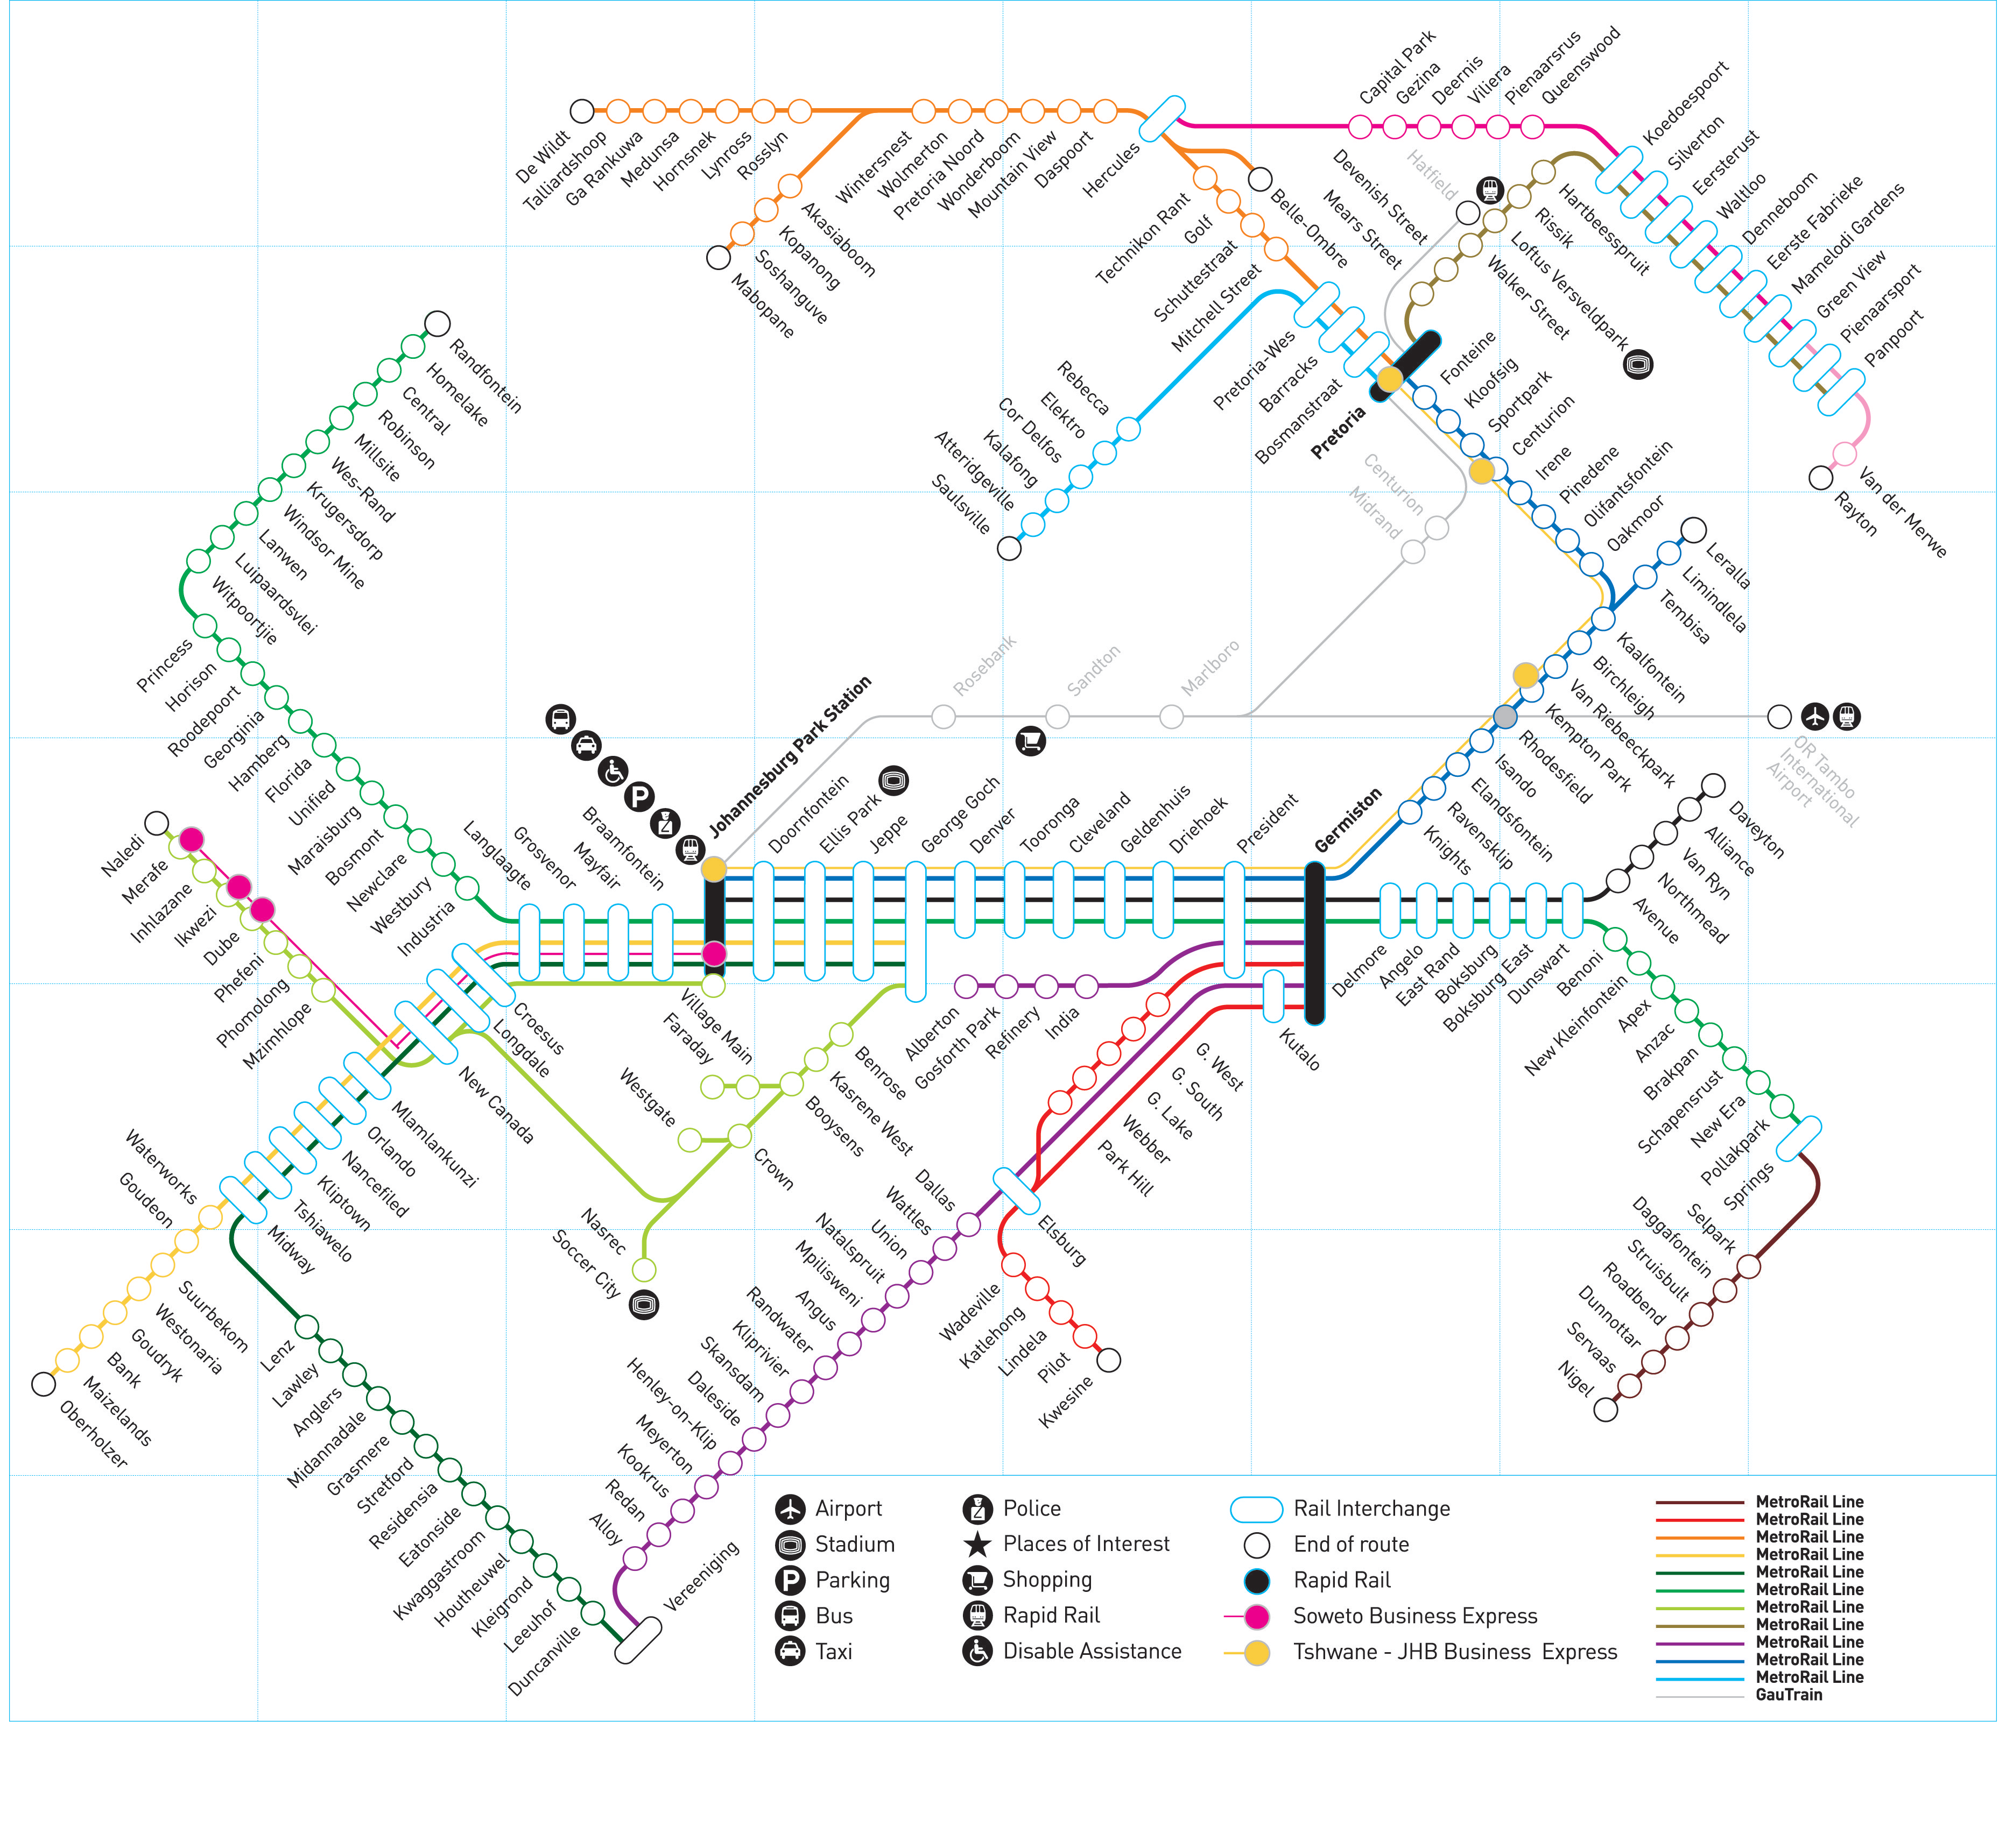
Figure: Official PRASA Gauteng RailMap added to the app mockup as a design-only resource.
PRASA. 2024. RailMap-Gauteng. Available at: https://www.prasa.com/admin/wp-content/uploads/2024/12/RailMap-Gauteng.png

Part 2 Prototype Rubric Readiness
Although the current Android work is design-only, the click-through prototype has been structured so that Part 2 can be built and demonstrated against the POE rubric. The prototype includes screens for registration, login, profile, settings, dashboard, timetable, live train tracking, QR ticket, wallet, stations, Gauteng rail map, incident reporting, alerts and a Part 2 readiness checklist.
Part 2 must show the working app performing: register/login with encrypted password handling, settings changes, REST API/database connection, invalid input handling, and the selected PRASA Connect features. The demonstration video should also show where data is stored in the authentication service, hosted API and database.
Rubric requirement | Where it appears in design | Part 2 implementation note
Register and login | Login and Register screens | Implement Firebase/Auth API; validate empty fields and weak passwords.
Encrypted password | Register screen security note | Use Firebase/Auth hashing or backend password hashing; never store plain text.
Settings | Settings screen | Persist language, notifications, offline sync and mobile data preferences.
REST API with database | Settings sync status, timetable, tickets, alerts | Connect Android repository to hosted Node/Express or Firebase API and database.
User-selected app features | Dashboard, tracking, tickets, stations, rail map, report incident | Build the main PRASA commuter workflows from the mockups.
Invalid input handling | Login validation cue and report form | Show error messages and prevent crashes.
GitHub, tests and README | Part 2 readiness screen | Add unit tests and GitHub Actions before submission.
Demo video | Part 2 readiness screen | Record on a device/emulator with voice-over and backend evidence.
Updated mockup sheet:
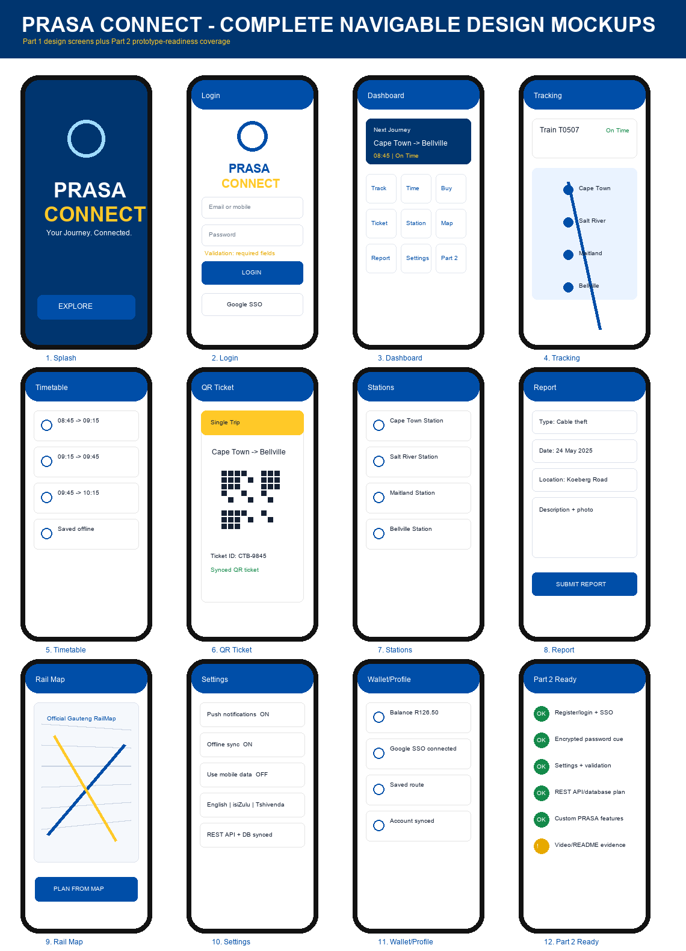
Clarifications still needed: confirm final language pair/list, final hosted API choice, student details for cover page, and whether the lecturer wants the Part 1 document exported as one combined PDF or separate PDFs.

Proper PRASA Background Information
The Passenger Rail Agency of South Africa (PRASA) is South Africa?s public passenger rail agency. It is a national government business enterprise/state-owned entity that reports through the transport portfolio and is responsible for passenger rail services in the public interest. PRASA is important to commuters because affordable rail transport connects people to work, education, public services and economic hubs.
PRASA services include urban commuter rail through Metrorail and long-distance passenger rail services through its main-line passenger rail operations. Metrorail serves major metropolitan commuter corridors, including Gauteng routes such as Johannesburg, Pretoria, Ekurhuleni and surrounding areas. This is why the PRASA Connect design includes a Gauteng rail map, stations, route planning, timetable access and live tracking.
The app concept responds to real commuter needs: users need accurate train information, simple route planning, saved offline travel information, digital ticket access, service disruption notices and a safe way to report incidents such as cable theft, vandalism and hazards at stations. These needs link directly to the POE requirements for authentication, settings, REST API/database access, offline mode with sync, notifications and multilingual support.

How This Information Was Added to the Design
PRASA information | Design response
PRASA provides passenger rail in the public interest. | The app focuses on practical commuter tasks instead of entertainment or unrelated features.
Metrorail supports urban commuter corridors. | Timetable, live tracking, stations and Gauteng RailMap screens are included.
Commuters need reliability and safety information. | Alerts, offline saved information and incident reporting are included.
The POE requires settings, API/database, offline sync, notifications and languages. | Settings and Part 2 readiness screens show these requirements clearly.
Updated mockup sheet including the About PRASA screen:
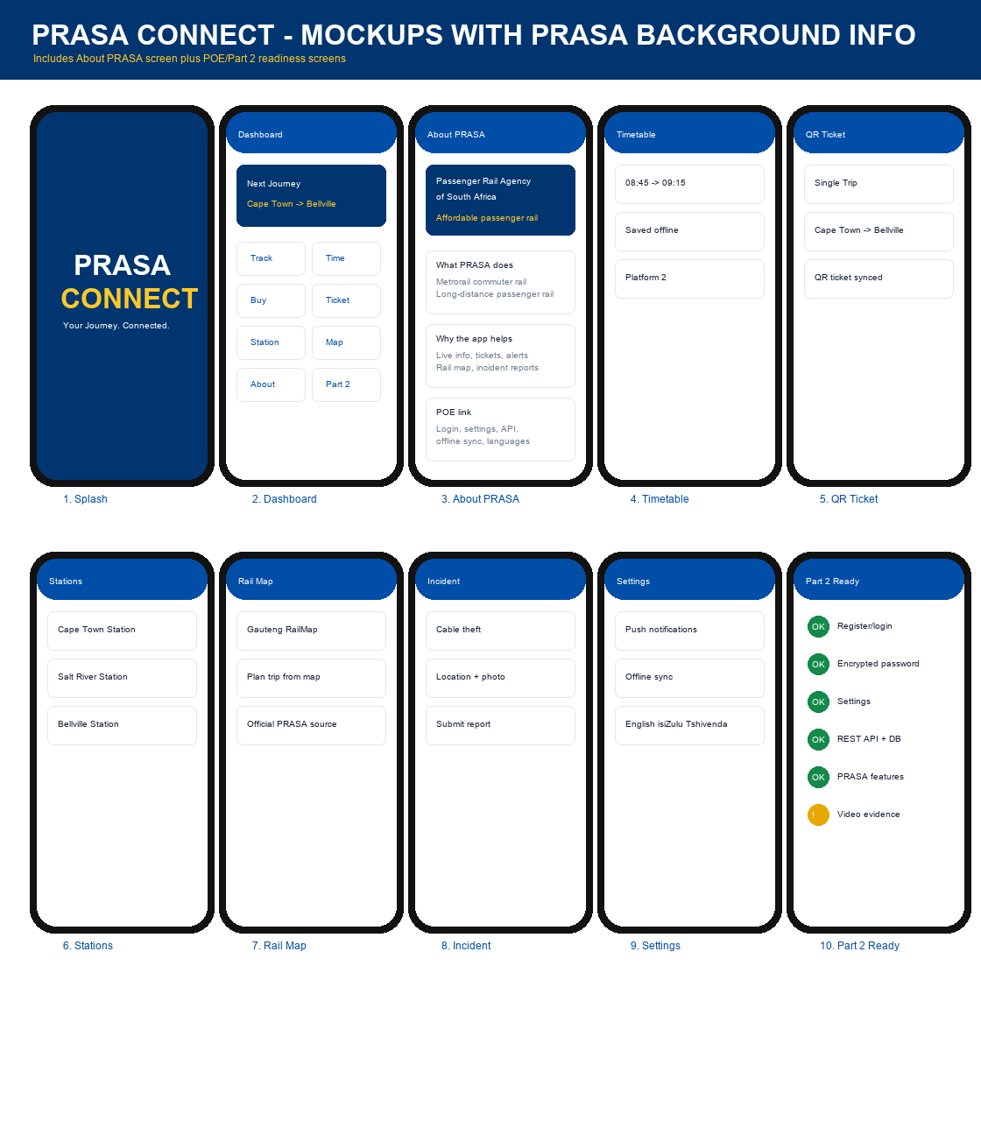

Additional PRASA References
South African Government. 2026. Transport: Passenger Rail Agency of South Africa mandate. Available at: https://www.gov.za/about-sa/transport
Passenger Rail Agency of South Africa. 2024. RailMap-Gauteng. Available at: https://www.prasa.com/admin/wp-content/uploads/2024/12/RailMap-Gauteng.png
SARCC/PRASA. 2026. About PRASA. Available at: https://sarcc.co.za/About_d-1

Response to Part 2 Grading Feedback
The original graded feedback stated that the app could not register, log in, show real interaction with data, use an API, make bookings, or log out. The prototype has therefore been updated from a static design-only mockup into a functional in-app prototype.

Corrections Added
Feedback issue | Correction made
Register | A working registration form was added with required-field validation, duplicate email checking, and password hashing.
Login | A working login form was added with a demo account and validation for incorrect credentials.
Logout | A Logout action was added to the top app bar after authentication.
API/data interaction | A local API-style repository called PrasaApi was added to simulate REST endpoints and store users, schedules, tickets and incidents.
Bookings | Users can select a timetable row and create a booking, which generates a ticket.
Tickets | Created bookings appear as QR-style tickets under My Tickets.
Incident reports | Users can submit incidents, which are saved into the data layer.
Settings | Users can update language, notification and offline-sync preferences.
Evidence screen | An API screen shows request/response logs and stored data counts for demonstration.

Remaining Final POE Work
The current implementation compiles and demonstrates working prototype behaviour locally. For the final POE, the local PrasaApi repository should be replaced with a hosted REST API and database, and the repository should include GitHub Actions, automated tests and a video demonstration link.

