MANRAJ SINGH PARMAR

100371004

DR.ABHIJIT SEN

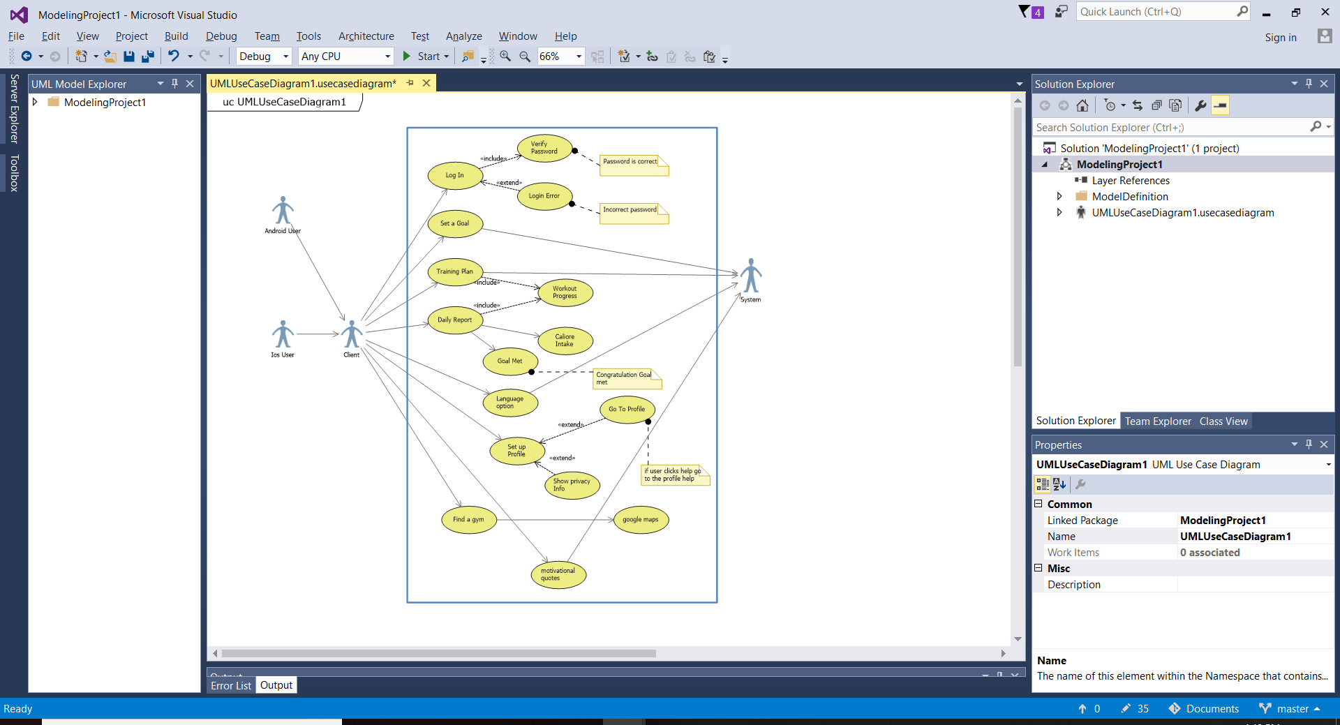

|  |  |
| --- | --- |
| **Use case title:** | Motivation quotes |
| **Primary actor** | user |
| **Level:** | Kite |
| **Stakeholder:** | User |
| **Preconditions:** | curiosity to get fit |
| **Minimal guarantee:** | Influence on mind |
| **Success guarantee:** | Good motivation quotes and other sources |
| **trigger** | Influential mind |
| **Main success scenario** | 1. Gets determined and dedicated to get fit |
| **Extension:** | Try other motivation. |