Exempel : Körning 1: Lr = 0.002 , aktivering = relu, 4 lager, optomizer = adam , loss = cross entropy, epoch = 15, KOPIERA IN HELA CNN.SEQUIENCIAL HÄR, Val_loss, train_loss, val_acc, accuracy, f1 score, pasta in classification report

## Model 1:

### Original

* Lr = ReduceLROnPlateau(monitor='val_loss', patience=2, verbose=1, factor=0.3, min_lr=0.000001).
* Aktivering = ReLU
* 15 lager
* optimizer = adam
* loss = binary crossentropy
* epoch = 25, ended at 7 epoch = EarlyStopping(monitor='val_loss', mode='min', patience=3)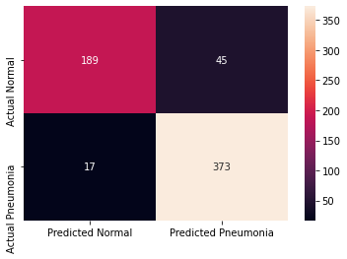

Epoch 00006: ReduceLROnPlateau reducing learning rate to 0.0003000000142492354.

Epoch 7/25

326/326 [==============================] - 133s 408ms/step - loss: 0.1275 - accuracy: 0.9531 - val_loss: 0.8370 - val_accuracy: 0.6875

precision recall f1-score support

NORMAL 0.92 0.81 0.86 234

PNEUMONIA 0.89 0.96 0.92 390

accuracy 0.90 624

macro avg 0.90 0.88 0.89 624

weighted avg 0.90 0.90 0.90 624

Model: "sequential"

_________________________________________________________________

Layer (type) Output Shape Param #

=================================================================

conv2d (Conv2D) (None, 500, 500, 32) 320

_________________________________________________________________

max_pooling2d (MaxPooling2D) (None, 250, 250, 32) 0

_________________________________________________________________

conv2d_1 (Conv2D) (None, 250, 250, 32) 9248

_________________________________________________________________

max_pooling2d_1 (MaxPooling2 (None, 125, 125, 32) 0

_________________________________________________________________

conv2d_2 (Conv2D) (None, 125, 125, 32) 9248

_________________________________________________________________

max_pooling2d_2 (MaxPooling2 (None, 62, 62, 32) 0

_________________________________________________________________

conv2d_3 (Conv2D) (None, 62, 62, 64) 18496

_________________________________________________________________

max_pooling2d_3 (MaxPooling2 (None, 31, 31, 64) 0

_________________________________________________________________

conv2d_4 (Conv2D) (None, 31, 31, 64) 36928

_________________________________________________________________

max_pooling2d_4 (MaxPooling2 (None, 15, 15, 64) 0

_________________________________________________________________

flatten (Flatten) (None, 14400) 0

_________________________________________________________________

dense (Dense) (None, 128) 1843328

_________________________________________________________________

dense_1 (Dense) (None, 64) 8256

_________________________________________________________________

dense_2 (Dense) (None, 1) 65

=================================================================

Total params: 1,925,889

Trainable params: 1,925,889

Non-trainable params: 0

_________________________________________________________________

## Model 2:

Like model 1

Changed optimizer to SGD:

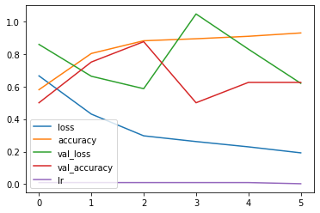

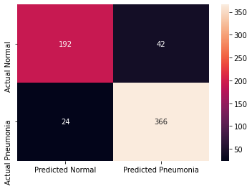

The testing accuracy is : 89.42307829856873 %

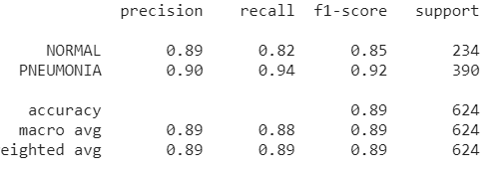

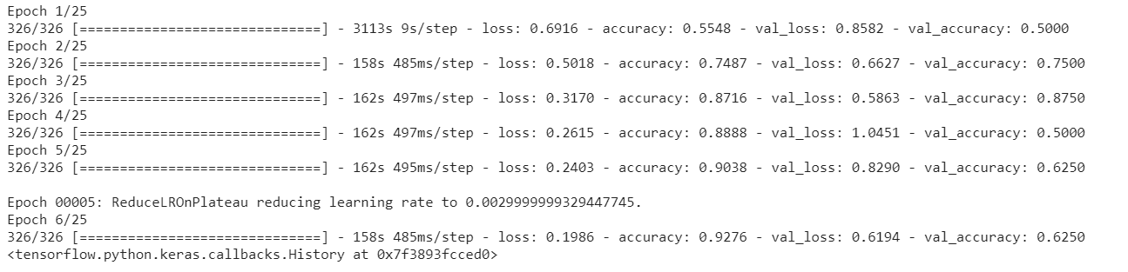

## Model 3:

Like model 2

Changed lossfunction to mean squared error:

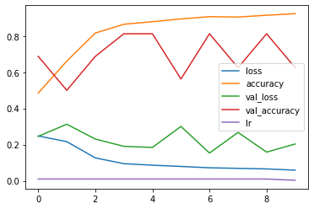

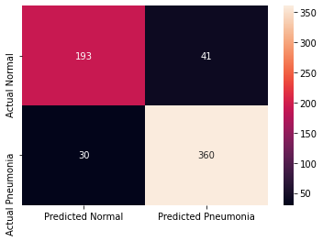

The testing accuracy is : 88.62179517745972 %

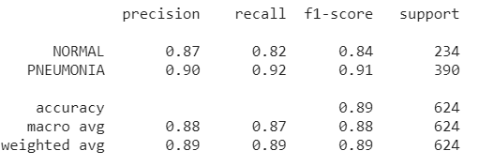

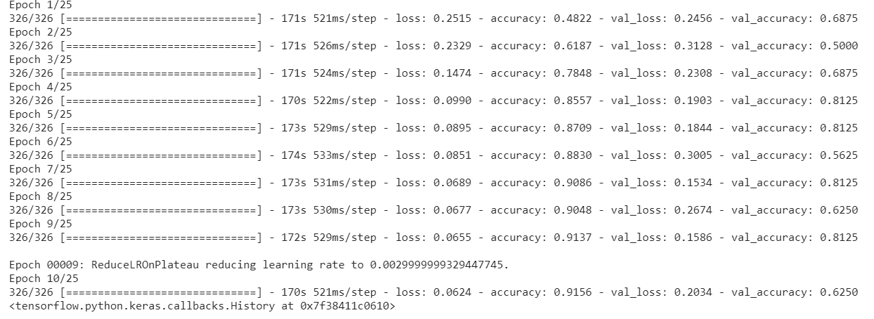

## Model 4:

Like model 1.

Optimizer Adam and mean squared error

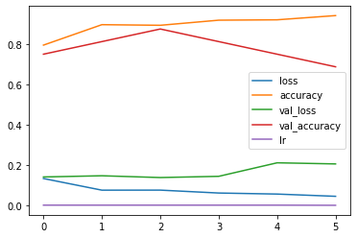

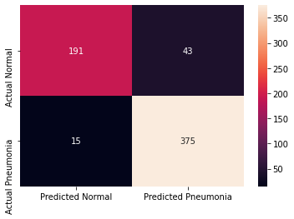

The testing accuracy is : 90.70512652397156 %

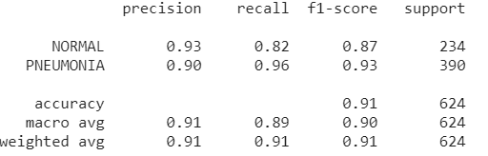

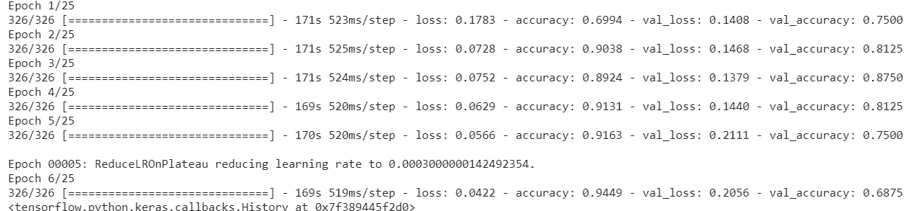

**Training plot Epoch 1-10**

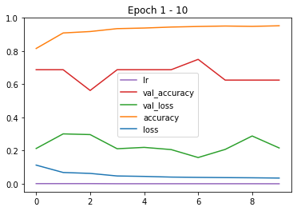

**Training plot Epoch 10 - 25**

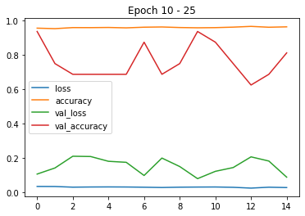

## Model 5:

Removed max pooling and added conv2d layers and a linear layer

_________________________________________________________________

Layer (type) Output Shape Param #

=================================================================

conv2d_20 (Conv2D) (None, 500, 500, 32) 320

_________________________________________________________________

conv2d_21 (Conv2D) (None, 500, 500, 32) 9248

_________________________________________________________________

max_pooling2d_12 (MaxPooling (None, 250, 250, 32) 0

_________________________________________________________________

conv2d_22 (Conv2D) (None, 250, 250, 32) 9248

_________________________________________________________________

max_pooling2d_13 (MaxPooling (None, 125, 125, 32) 0

_________________________________________________________________

conv2d_23 (Conv2D) (None, 125, 125, 64) 18496

_________________________________________________________________

conv2d_24 (Conv2D) (None, 125, 125, 64) 36928

_________________________________________________________________

conv2d_25 (Conv2D) (None, 125, 125, 64) 36928

_________________________________________________________________

conv2d_26 (Conv2D) (None, 125, 125, 64) 36928

_________________________________________________________________

max_pooling2d_14 (MaxPooling (None, 62, 62, 64) 0

_________________________________________________________________

flatten_4 (Flatten) (None, 246016) 0

_________________________________________________________________

dense_15 (Dense) (None, 128) 31490176

_________________________________________________________________

dense_16 (Dense) (None, 128) 16512

_________________________________________________________________

dense_17 (Dense) (None, 64) 8256

_________________________________________________________________

dense_18 (Dense) (None, 32) 2080

_________________________________________________________________

dense_19 (Dense) (None, 1) 33

=================================================================

Total params: 31,665,153

Trainable params: 31,665,153

Non-trainable params: 0

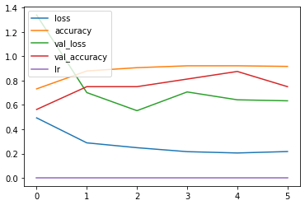

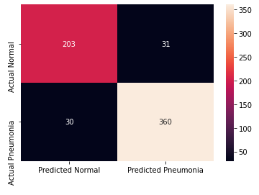

The testing accuracy is : 88.78205418586731 %

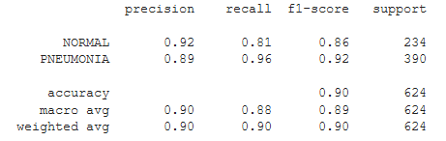

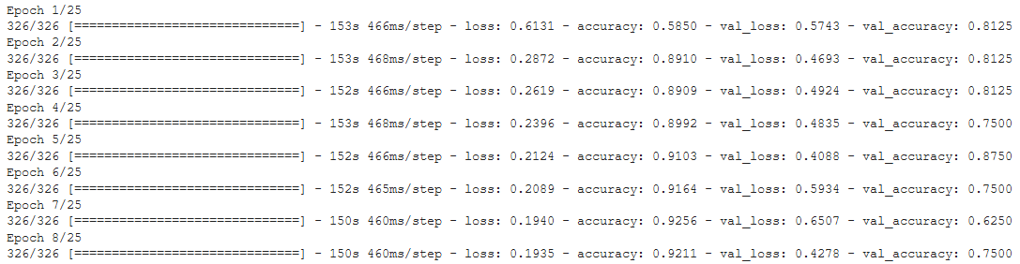

## Model 6:

Like model 1.

Optimizer Adam and mean squared error

_________________________________________________________________

Layer (type) Output Shape Param #

=================================================================

conv2d_7 (Conv2D) (None, 500, 500, 32) 320

_________________________________________________________________

max_pooling2d_3 (MaxPooling2 (None, 250, 250, 32) 0

_________________________________________________________________

conv2d_8 (Conv2D) (None, 250, 250, 32) 9248

_________________________________________________________________

max_pooling2d_4 (MaxPooling2 (None, 125, 125, 32) 0

_________________________________________________________________

conv2d_9 (Conv2D) (None, 125, 125, 32) 9248

_________________________________________________________________

max_pooling2d_5 (MaxPooling2 (None, 62, 62, 32) 0

_________________________________________________________________

conv2d_10 (Conv2D) (None, 62, 62, 64) 18496

_________________________________________________________________

max_pooling2d_6 (MaxPooling2 (None, 31, 31, 64) 0

_________________________________________________________________

flatten_1 (Flatten) (None, 61504) 0

_________________________________________________________________

dense_5 (Dense) (None, 128) 7872640

_________________________________________________________________

dense_6 (Dense) (None, 64) 8256

_________________________________________________________________

dense_7 (Dense) (None, 1) 65

=================================================================

Total params: 7,918,273

Trainable params: 7,918,273

Non-trainable params: 0

_________________________________________________________________

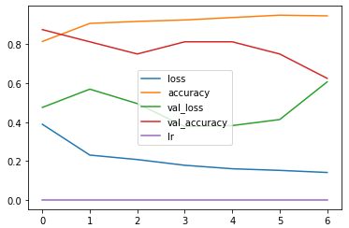

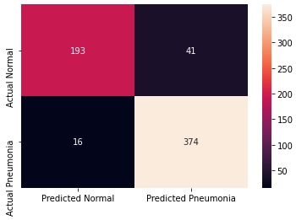

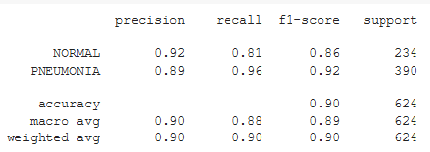

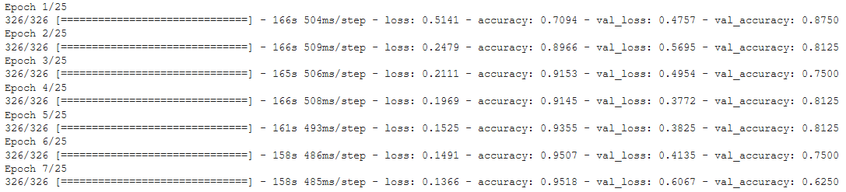

## Model 7:

Transfer learning: feature extraction on ResNet-50 (pretrained on ImageNet dataset).

Optimizer Adam with learning rate 0.003 and Binary Cross Entropy loss.

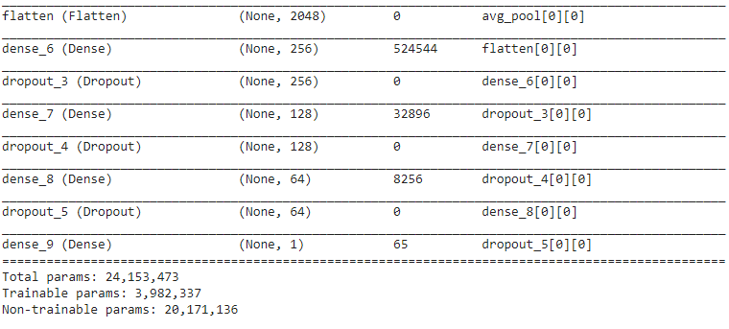

Fig.: Fully connected layer on top of the ResNet50 model.

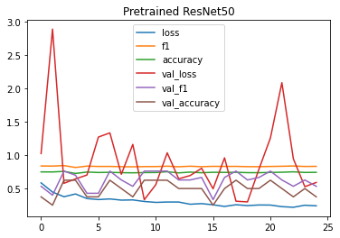

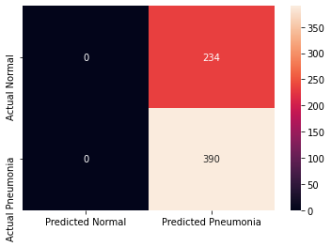

precision recall f1-score support

NORMAL 0.00 0.00 0.00 234

PNEUMONIA 0.62 1.00 0.77 390

accuracy 0.62 624

macro avg 0.31 0.50 0.38 624

weighted avg 0.39 0.62 0.48 624