WEEK-6

3.select emp_name from employee where emp_no =(select mgr_no from employee group by mgr_no having count(emp_no)=

( select count(emp_no) from employee group by mgr_no order by count(emp_no) desc limit 1));

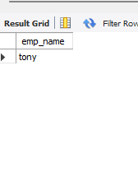

4.select a.emp_name from employee a where a.sal> (select avg(e.sal) from employee e where e.mgr_no=a.emp_no group by e.mgr_no);

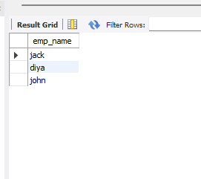

5.select emp_name from employee where emp_no in (select distinct mgr_no from employee

where emp_no in (select distinct mgr_no from employee ));

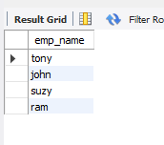

6. SELECT * from employee e,incentives i

where e.emp_no=i.emp_no and 2=(select count(*)

from incentives j

where i.incentive_amt=j.incentive_amt);

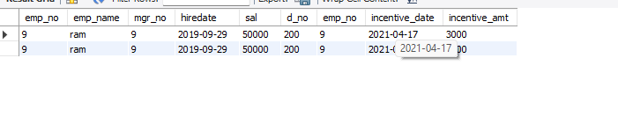select e.emp_name from employee e where e.dept_no=(select dept_no from employee where e.mgr_no=emp_no);

7.