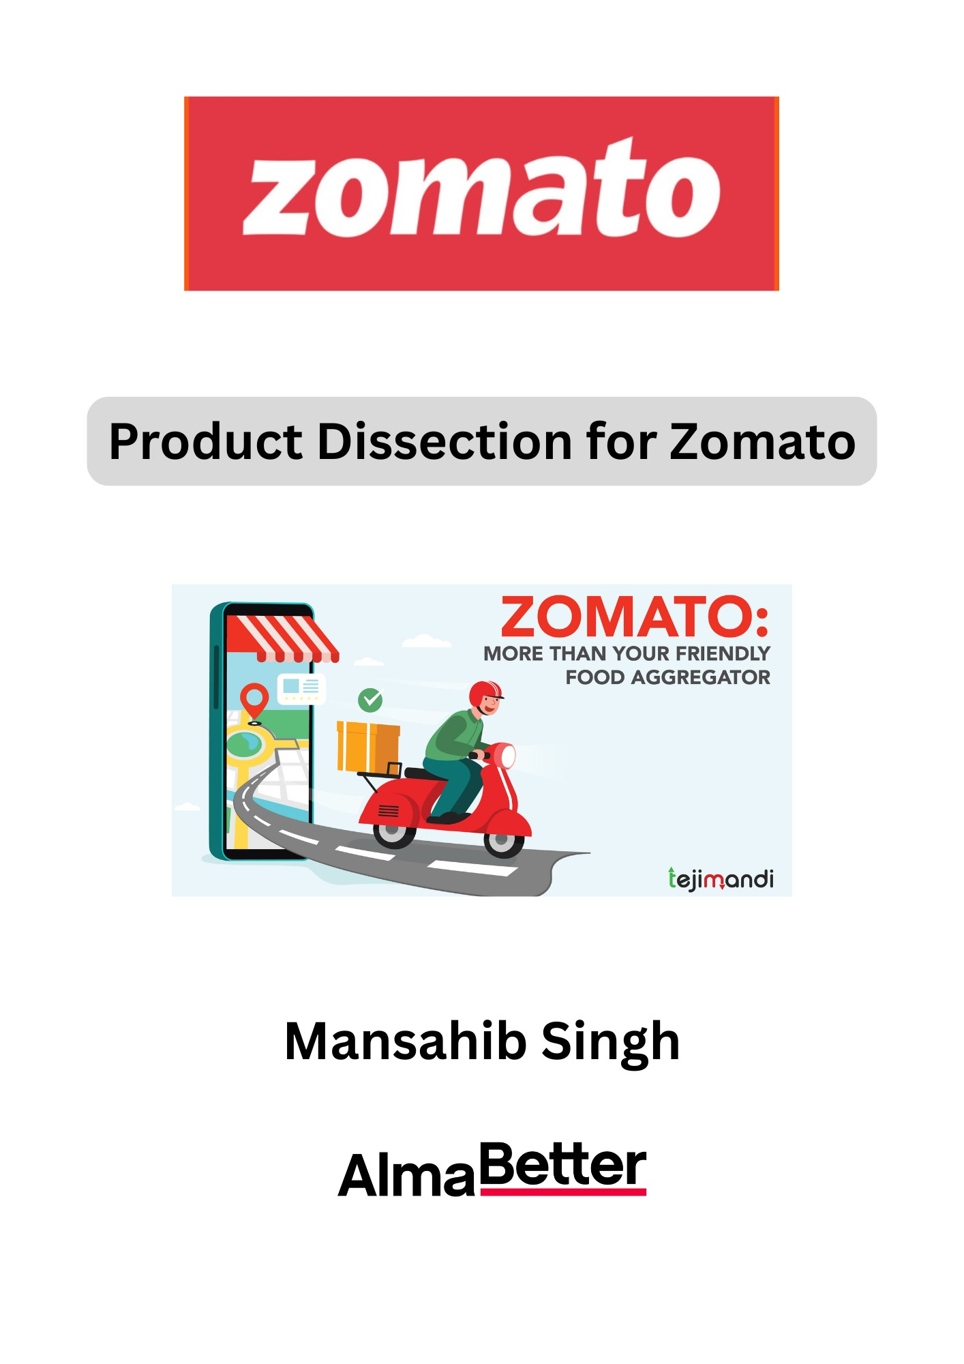

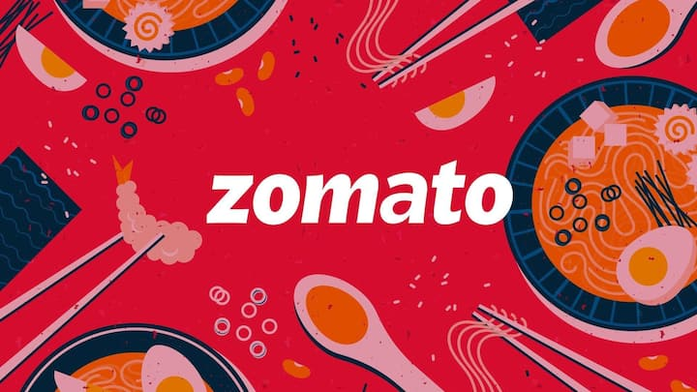

**Product Dissection for Zomato**

### **Company Overview:**

Zomato is a leading Indian multinational technology platform specializing in food delivery, restaurant discovery, and dining services. Founded in 2008 by Deepinder Goyal and Pankaj Chaddah, and headquartered in Gurugram, Haryana, Zomato connects millions of users with restaurants through its easy-to-use app and website. Over the years, the company has expanded its services to include online ordering, table reservations, and restaurant supply chain management through its Hyperpure platform. Listed on the Indian stock exchanges in 2021, Zomato continues to strengthen its position in the highly competitive food-tech sector, focusing on customer experience, innovation, and sustainable growth.

### **Product Dissection and Real-World Problems Solved by Zomato:**

Zomato’s platform offers a comprehensive food experience by seamlessly integrating restaurant discovery, food delivery, and user engagement features. Through its discovery tool, users can explore restaurants based on location, cuisine, price, and user ratings. Detailed menus, photos, and authentic customer reviews help users make informed dining choices quickly and confidently. The platform saves users considerable time and effort by highlighting popular restaurants with positive feedback, while the real-time order tracking system enhances transparency by allowing users to monitor their food’s journey from preparation to delivery. Additionally, Zomato’s premium membership programs like Zomato Pro and Zomato Pro Plus provide exclusive discounts, faster deliveries, and prioritized customer support for loyal users..

Beyond food ordering, Zomato has diversified its offerings to support both consumers and restaurant partners. With its Hyperpure platform, Zomato supplies high-quality ingredients directly to restaurants, solving critical supply chain challenges and ensuring consistent food quality. Its expansion into quick commerce through the acquisition of Blinkit has further positioned Zomato as a provider of instant grocery and daily essential deliveries. Offline initiatives such as Zomaland food festivals strengthen community engagement and reinforce brand loyalty. Altogether, Zomato’s product ecosystem addresses real-world needs by combining convenience, reliability, and experience, transforming the way people discover, order, and enjoy food.

Zomato’s product design effectively solves real-life problems by creating a platform where users can easily explore food options, share their experiences, and satisfy their culinary needs with greater convenience. By blending digital innovation with real-world food experiences, Zomato has redefined modern dining habits and established itself as an essential part of the food-tech landscape.+.

### **Case Study: Real-World Problems and Zomato’s Innovative Solutions**

Zomato, a leading food-tech platform, has not only transformed the way we explore and order food, but has also addressed significant real-world challenges through its innovative services. By offering a seamless platform that combines convenience, accessibility, personalization, and social responsibility, Zomato has elevated the dining experience while solving broader societal problems.

#### **Problem 1: Busy Lifestyle**

**Real-World Challenge:** In today’s fast-paced world, working professionals and elderly individuals often struggle to find time to cook or dine out due to their busy schedules and lifestyle constraints.

**Zomato’s Solution:** Zomato provides a convenient platform where users can easily order meals from a wide range of restaurants without leaving their homes. With just a few clicks, customers can have their favorite dishes delivered to their doorstep, saving significant time and effort. Additionally, users can order food for family members and friends residing in different cities, thereby fostering care and connection across distances.

#### **Problem 2: Food Waste Reduction**

**Real-World Challenge:** Restaurants often face the issue of food wastage due to overproduction or unsold inventory, contributing to unnecessary resource depletion and hunger issues.

**Zomato’s Solution:** Through its **Feeding India** initiative, Zomato partners with restaurants to collect surplus food and distribute it to local charities and shelters. This not only helps reduce food wastage but also addresses hunger, demonstrating Zomato’s commitment to social responsibility and sustainable practices.

#### **Problem 3: User Preferences and Limited Options**

**Real-World Challenge:** Users with specific dietary restrictions, such as veganism, gluten intolerance, or kid-friendly needs, often face difficulties finding appropriate dining options.

**Zomato’s Solution:** Zomato offers advanced search and filter options that allow users to easily locate restaurants catering to their specific dietary requirements. The platform’s partnerships with diverse restaurants enable greater customization and personalization of orders, ensuring that all users have an inclusive and satisfying experience.

#### **Problem 4: Hygiene and Quality Assurance**

**Real-World Challenge:** Concerns about restaurant hygiene and food safety are common among users, with fears related to foodborne illnesses like food poisoning or diarrhea.

**Zomato’s Solution:** Zomato has incorporated user-generated reviews and ratings specifically focused on hygiene standards. Additionally, it provides inspection reports and other detailed information, empowering customers to make informed dining decisions and encouraging restaurants to maintain high cleanliness standards.

|  |  |  |
| --- | --- | --- |
| **Problem** | **Real-World Challenge** | **Zomato’s Innovative Solution** |
| Busy Lifestyle | Lack of time for cooking or dining out | Doorstep food delivery through an easy-to-use platform; ability to order for others across different cities |
| Food Waste Reduction | Overproduction and wastage of food at restaurants | *Feeding India* initiative for surplus food donation to local charities and shelters |
| User Preferences and Limited Options | Difficulty in finding restaurants meeting specific dietary needs (vegan, gluten-free, etc.) | Advanced filters and search options; customizable menu options based on dietary preferences |
| Hygiene and Quality Assurance | Concerns about restaurant hygiene and food safety | User reviews on hygiene, availability of inspection reports to promote transparency and safer dining |

#### **Conclusion:**

Zomato’s innovative solutions directly tackle some of the most pressing challenges faced by modern consumers and the food service industry. By creating a platform that emphasizes convenience, sustainability, personalization, and transparency, Zomato has redefined the dining experience for millions. Its initiatives not only serve customers’ everyday needs but also contribute positively to the larger social fabric by reducing food waste, promoting hygiene, and fostering inclusivity.

### 

### **Top Features of Zomato:**

### **Restaurant Discovery:** Allows users to explore restaurants based on location, cuisine, cost, ratings, and popularity. Menus, photos, and detailed reviews enhance decision-making.

### **Online Food Ordering and Delivery:** Enables users to order food from their favorite restaurants with real-time tracking and estimated delivery times.

### **Table Reservation:** Provides the ability to book tables at restaurants in advance, reducing wait times and ensuring a smoother dining experience.

### **User Reviews and Ratings:** Authentic user-generated content helps others choose restaurants based on quality, service, hygiene, and value for money.

### **Personalized Recommendations:** Uses AI to offer suggestions based on user preferences, past orders, search history, and location trends.

### **Advanced Search and Filters:** Users can filter by dietary needs (e.g., vegan, gluten-free), food types, distance, ratings, cost for two, and special features like outdoor seating or alcohol availability.

### **Zomato Gold/Zomato Pro *(now merged as Zomato Pro Plus):*** Offers members exclusive discounts on dining out and food delivery, making eating more affordable.

### **Feeding India Initiative:** Zomato’s CSR effort to combat hunger and reduce food waste by facilitating donations of surplus food to the needy.

### **Restaurant Hygiene Ratings:** Introduced hygiene audits and certifications to help users identify safe, clean dining spaces based on verified health and safety standards.

### **Multi-City Ordering:** Allows users to order food for someone living in a different city — great for sending meals to family or friends.

### **In-App Payments:**Seamless payment options with integrated wallets, credit/debit card payments, UPI support, and reward points system.

### **Schema Description:**

The schema for **Zomato** consists of multiple entities representing different aspects of the platform. These entities include **users**, **restaurants**, **menu items**, **orders**, **payments**, **deliveries**, and **reviews**.

Each entity has specific attributes that define its properties and establish relationships with other entities.

**User Entity:**

The **User** entity stores information about individual users registered on the platform.

* **User_id** **(*Primary Key*):** A unique identifier for each user.
* **Name:** Full name of the user.
* **Email:** Email address for account authentication and communication.
* **Phone_number:** Registered contact number of the user.
* **Password:** Encrypted password for secure login.
* **Address:** The saved delivery address or billing address of the user.

**Restaurant Entity:**

The **Restaurant** entity represents the dining outlets listed on Zomato.

* **Restaurant_id (*Primary Key*):** A unique identifier for each restaurant.
* **Name:** Name of the restaurant.
* **Address:** Physical address of the restaurant.
* **Phone_number:** Contact number for reservations and inquiries.
* **Cuisine_type:** Categories of cuisine offered by the restaurant.
* **Average_rating:** The restaurant’s average rating based on user reviews.

**Menu Item Entity:**

The **Menu Item** entity details the individual dishes offered by restaurants.

* **Item_id (*Primary Key*):** A unique identifier for each menu item.
* **Restaurant_id (*Foreign Key*):** Links menu items to their respective restaurant.
* **Item_name:** Name of the menu item.
* **Description:** Brief description of the dish.
* **Price:** Price of the menu item.

**Order Entity:**

The **Order** entity represents a purchase request initiated by a user.

* **Order_id (*Primary Key*):** A unique identifier for each order.
* **User_id (*Foreign Key*):** References the user placing the order.
* **Restaurant_id (*Foreign Key*)**: References the restaurant fulfilling the order.
* **Order_status:** The current status of the order (e.g., pending, confirmed, delivered).
* **Order_date:** The timestamp of when the order was placed.

**Payment Entity:**

The **Payment** entity manages transaction details for user orders.

* **Payment_id (*Primary Key*):** A unique identifier for each payment transaction.
* **Order_id (*Foreign Key*):** References the associated order.
* **Payment_method:** Mode of payment used (e.g., credit card, UPI, wallet).
* **Payment_status:** Status of the payment (e.g., successful, pending, failed).

**Delivery Entity:**

The **Delivery** entity manages the logistics and status of order deliveries.

* **Delivery_id (*Primary Key*):** A unique identifier for each delivery.
* **Order_id (*Foreign Key*):** References the associated order.
* **Delivery_status:** Status of the delivery (e.g., out for delivery, delivered, canceled).
* **Expected_delivery_time:** Estimated time for delivery completion..

**Review Entity:**

The **Review** entity captures feedback and ratings provided by users.

* **Review_id (*Primary Key*):** A unique identifier for each review.
* **User_id (*Foreign Key***): References the user who posted the review.
* **Restaurant_id (*Foreign Key*):** References the reviewed restaurant.
* **Rating:** User’s rating (usually on a scale of 1 to 5).
* **Comment:** User’s detailed feedback or remarks.

**Relationships are:**

* **Users place orders** – Each user can place multiple orders, and each order is associated with a single user.
* **Restaurants receive orders** – Each restaurant can receive multiple orders, with each order linked to one specific restaurant.
* **Payment on order** – Each order is associated with exactly one payment, and each payment corresponds to a single order.
* **Delivery on order** – Each order is linked to one delivery instance, and each delivery is associated with a single order.
* **Restaurants have reviews** – Each restaurant can have multiple reviews, with each review posted by different users.
* **Restaurants have menu items** – Each restaurant offers multiple menu items, and each item belongs to a single restaurant.
* **Orders contain items** – Each order can include multiple menu items, with each item associated with one order.
* **Users post reviews** – Each user can write multiple reviews, with each review linked to one user and one restaurant.

**ER Diagram:**

Let's create on ERdiagram that visually represents the relationships and attributes of the entities within the Zomato schema. This diagram will provide a clear understanding of how different parts of Zomato's system are connected and interact with others.

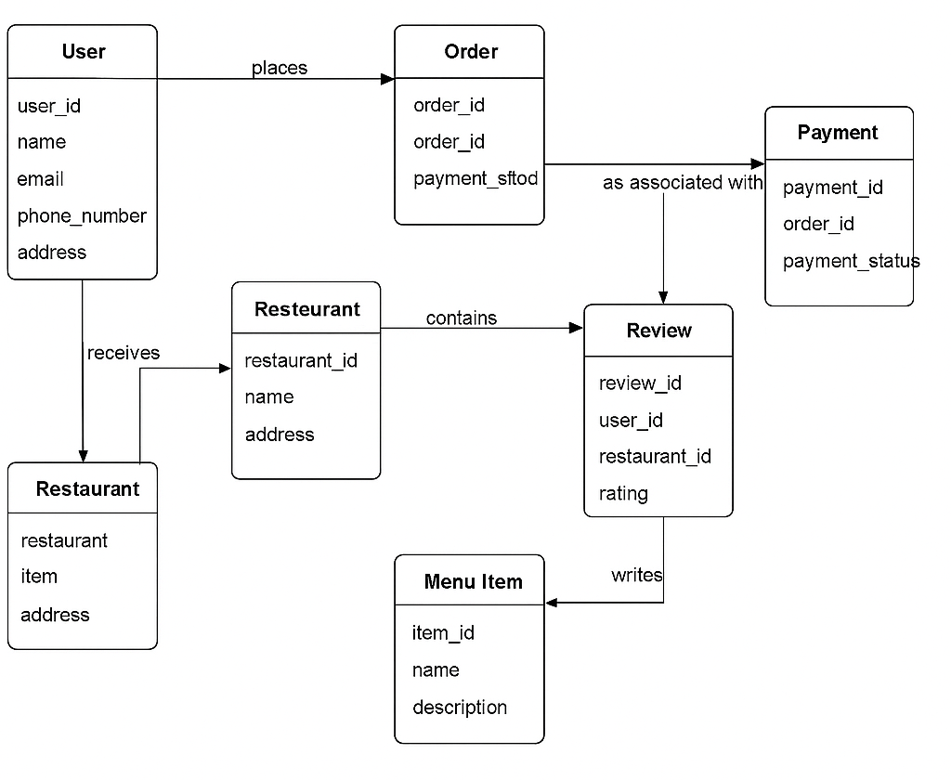

### **Conclusion:**

In this case study, we've looked at how Zomato's database and diagram are set up. Zomato is like a digital hub where you can find restaurants, order food, and connect with others. Think of it like Instagram, but for food. Zomato keeps track of users, restaurants, reviews,orders, payments, and menus.Zomato's smart technology has helped it become a big player in the food delivery world.