**Sales Performance Dashboard using Power BI Milestone-1**

**Abstract**

This project utilizes a sales dataset to analyze business performance through Power BI dashboards. By leveraging data on orders, customers, products, profits, and returns, the dashboard offers insights into sales trends, customer behavior, product profitability, and return patterns. The findings help businesses optimize discount strategies, improve profitability, and enhance customer satisfaction by identifying key patterns and trends across regions and segments.

**Introduction**

The dataset provided focuses on order, sales, and returns data, capturing detailed transactional information such as order dates, customer segments, product categories, profits, returns, and payment modes. The goal of this project could be to analyse sales performance, customer behaviour, product profitability, and return patterns. This data is rich with potential insights for improving business processes, such as identifying trends in sales and returns, optimising discount strategies, and enhancing customer satisfaction.

**Objective**

* Analyze sales performance across different regions and time periods.
* Evaluate customer behavior by understanding purchase trends and segment contributions.
* Assess product profitability to detect high-performing and low-performing items.
* Identify return patterns and their impact on profits.
* Optimize discount strategies to balance sales growth with profitability.

**Project Goal**

The primary goal of this project is to analyse sales performance, customer behaviour, product profitability, and return patterns. By leveraging this dataset, the objective is to uncover actionable insights that can help improve business processes through:

* Identifying trends in sales and returns over time.
* Optimizing discount strategies to boost revenue.
* Enhancing customer satisfaction by understanding behaviour and reducing product returns.
* Evaluating profitability by product categories, regions, and customer segments to optimise marketing efforts.

**Data Schema: Structure of the Dataset**

The data schema involves organizing the dataset into logical tables with clear relationships, primary keys, and foreign keys to ensure efficient querying and analysis. Below is a recommended structure based on your dataset.

**Tables and Keys**

1. **Orders Table**

**Columns:**

* + - Order ID (Primary Key)
    - Order Date
    - Customer ID (Foreign Key)
    - Product ID (Foreign Key)
    - Sales Amount
    - Profit
    - Discount Applied
    - Shipping Mode
    - Region

1. **Customers Table**

**Columns:**

* + - Customer ID (Primary Key)
    - Customer Name
    - Segment (e.g., Consumer, Corporate)
    - Region

1. **Products Table**

**Columns:**

* + - Product ID (Primary Key)
    - Product Name
    - Category (e.g., Furniture, Office Supplies)
    - Sub-Category

1. **Returns Table**

**Columns:**

* + - Return ID (Primary Key)
    - Order ID (Foreign Key)
    - Return Status (Returned/Not Returned)
    - Return Date

**Relationships**

* **Orders Table** → **Customers Table**:

**Foreign Key:** Customer ID

**Relationship:** One customer can have many orders.

* **Orders Table** → **Products Table**:

**Foreign Key:** Product ID

**Relationship:** One product can appear in multiple orders.

* **Orders Table** → **Returns Table**:

**Foreign Key:** Order ID

**Relationship:** One order can have one return status (if applicable).

**Schema Diagram (Concept)**

* **Orders**: Central fact table linking **Customers**, **Products**, and **Returns**.
* **One-to-Many Relationships**: Customers ↔ Orders, Products ↔ Orders.
* **One-to-One or Optional Relationship**: Orders ↔ Returns (optional based on return status).

**Methodology**

* Data Collection: Organize transactional data, including orders, customers, products, and returns.
* Data Structuring: Develop a schema with logical relationships between orders, customers, products, and returns using primary and foreign keys.
* Data Analysis in Power BI:
* Create dashboards for sales performance, profit margins, and return patterns.
* Use DAX formulas to compute key metrics like Average Order Value (AOV) and profit by category.
* Implement correlation analysis to assess the relationship between discounts and profits.
* Visualization: Develop dynamic reports to present insights using graphs, filters, and cards.

**Analysis Plan**

**1. Sales Performance Analysis**

Goal: Assess the overall revenue and profit generated across different regions, categories, and time periods.

Total Sales: Measure total sales across all products.

Profit Margin: Evaluate profitability by product categories and segments.

DAX FORMULA:

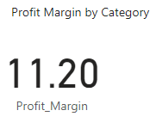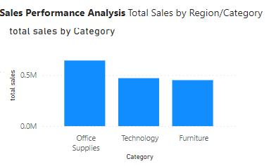

**2. Customer Behavior Analysis**

Goal: Understand how different customer segments contribute to sales and profits.

DAX FORMULA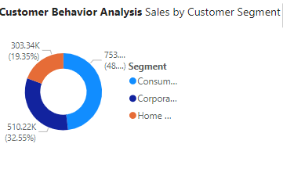: 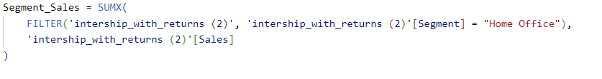

Average Order Value (AOV):

DAX FORMULA:

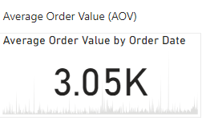

**3. Product Profitability Analysis**

Goal: Identify the most profitable products and categories, and detect low-performing items.

Profit by Product and Category:

DAX FORMULA:



**4. Return Patterns Analysis**

Goal: Identify products, regions, or segments with the highest return rates, which can impact profit margins.

DAX FORMULA



Profit Impact of Returns:

DAX FORMULA



**5. Discount Optimization Analysis**

Goal: Analyze how discounts affect sales volume and profit margins to determine optimal discount levels.

Sales Increase with Discounts:

DAX FORMULA



Profit vs. Discount Relationship:

DAX FORMULA:

Profit_vs_Discount = CORRELATION('Data'[Profit], 'Data'[Discount Applied])

**Future Work**

* Using External Data:

Add more data from outside sources (like competitor information) to make better decisions and get deeper insights.

* Forecasting Sales:

Use tools to predict future sales trends, so businesses can plan ahead more effectively.

* Understanding Customer Behavior:

Use smart analytics to find out which customers might stop buying and how to keep them interested.

* Making the Dashboard Bigger and Better:

Add more important business metrics to track things like performance and profits more thoroughly.

* Moving to the Cloud:

Shift the dashboard online (cloud) so people can access it from anywhere and work on it together in real-time.

**Conclusion**

This project provided key insights into sales trends, customer behaviour, product profitability, and returns. It identified peak sales periods, profitable products, and high-return areas, helping optimize operations. The analysis of discounts and returns offers actionable strategies to balance profitability and customer satisfaction.

## 

## 

# 