## ABSTRACT

This report provides an in-depth analysis of the Super Store dataset using Power BI, aiming to uncover actionable insights into customer behavior, sales trends, and regional performance. The analysis explores customer segments, product performance, regional sales differences, and operational metrics, with a goal of supporting data-driven strategic decision-making to boost profitability and optimize resource allocation. ppppppppppppppppppppppppppppppppppppppppppp

# CONTENTS

### ABSTRACT i

### CONTENTS ii

### CHAPTER 1: INTRODUCTION 1-3

* 1. Introduction
  2. Objectives
  3. Future Scope

CHAPTER 3: METHODOLOGY 8-10

CHAPTER 4: IMPLEMENTATION 11-14

CHAPTER 5: RESULTS 15-16

CONCLUSION 17

**iii**

**CHAPTER 1**

**INTRODUCTION**

* 1. **Introduction**

The "Comprehensive Sales Analysis of SuperStore Dataset" project leverages Power BI to transform raw sales data into valuable insights that inform decision-making and strategic planning. By analyzing key metrics across customer behavior, product performance, regional sales, and operational efficiency, this project seeks to optimize revenue growth and customer satisfaction.

The SuperStore dataset contains a range of data points, including customer information, product categories, sales amounts, discounts, shipping times, and regional information. Through Power BI's data modeling, DAX calculations, and interactive visualizations, the report provides an in-depth analysis of sales trends, profitability, and customer segmentation. This analysis highlights opportunities to enhance revenue through targeted customer engagement, identify high-value products and regions, and streamline operational processes.

With comprehensive insights into customer lifetime value, year-over-year growth, and shipping efficiency, the report serves as a data-driven foundation for strategic recommendations that enhance overall business performance.

**1.2 Objectives**

1. **Analyze Sales Performance**:
   * Calculate and visualize key metrics like Total Sales, Total Profit, and Gross Profit Margin to understand revenue drivers and profitability.
2. **Customer Segmentation and Value**:
   * Segment customers based on spending patterns (e.g., Platinum, Gold, Silver) and calculate Customer Lifetime Value (CLV) to identify high-value customers for targeted engagement and retention.
3. **Regional Sales Insights**:
   * Assess sales performance across regions, highlighting top-performing areas and potential markets for expansion.
4. **Product Profitability Analysis**:
   * Evaluate product performance by calculating metrics like Sales per Unit and Profit Margin by Product, identifying the most and least profitable products to guide inventory and marketing strategies.
5. **Track Growth Trends**:
   * Measure Year-over-Year Sales Growth to identify seasonal patterns, growth trends, and potential market opportunities.

**1.3 Future Scope**

1. **Real-Time Data Integration**
   * **Objective**: Enable real-time data connectivity to provide live insights, helping stakeholders respond quickly to changes in sales, inventory, and customer trends.
   * **Implementation**: Connect Power BI to a live data source, such as an SQL database or cloud storage (Azure, AWS), to support automatic refreshes and ensure that data is always current.
2. **Predictive Analytics and Machine Learning**
   * **Objective**: Introduce forecasting models to anticipate future sales trends, customer behaviors, and inventory needs.
   * **Implementation**: Use Power BI’s AI capabilities or integrate with Python/R scripts to create predictive models for Customer Lifetime Value (CLV), churn probability, and seasonal demand, supporting proactive decision-making.
3. **Enhanced Customer Segmentation**
   * **Objective**: Develop more granular customer segments to provide deeper insights into customer behavior, allowing for targeted marketing.
   * **Implementation**: Use clustering techniques or custom calculated columns to group customers by metrics beyond spending, such as purchase frequency and product preferences, identifying high-value segments for focused engagement.
4. **Mobile-Optimized Dashboards**
   * **Objective**: Make insights accessible to users on mobile devices, allowing stakeholders to access key metrics anytime, anywhere.
   * **Implementation**: Configure a mobile-friendly version of the Power BI report, ensuring that key visuals are adapted to fit smaller screens and maintaining an interactive experience on mobile devices.
5. **Dashboard Alerts and Notifications**
   * **Objective**: Set up alerts for critical metrics to enable proactive monitoring of business performance.
   * **Implementation**: In Power BI service, configure alerts for important KPIs, such as sales and profit thresholds, to notify stakeholders of significant changes in real-time, allowing for immediate actions.

## CHAPTER 3

**METHODOLOGY**

The methodology for this Power BI project involves a systematic approach to data processing, modeling, analysis, and visualization, aiming to convert raw data into actionable insights. Key steps include data import, cleaning, creating DAX measures and calculated columns, and designing interactive visualizations.

1. **Data Import and Preparation**
   * Data Import: Imported the SuperStore dataset into Power BI, ensuring all necessary tables, such as sales, customer, and product information, were available for analysis.
   * Data Cleaning: Utilized Power Query for data cleaning, addressing missing values, ensuring data type consistency (e.g., converting dates to Date format), and removing unnecessary columns to improve performance.
   * Date Table Creation: Created a custom Date table to support time-based analysis. Columns for Year, Month, Quarter, and Day were added to enable dynamic date filtering and comparisons over time.
2. **Data Modeling**
   * Relationships: Established relationships between tables (e.g., linking Customer ID between customer and sales tables) to create a unified data model that supports cross-table analysis.
   * Data Hierarchy: Built hierarchies within the Date table (Year > Quarter > Month) to support time-based drill-downs in visuals and enable monthly, quarterly, and yearly comparisons.
3. **DAX Measures**
   * Calculation of Key Metrics: Created DAX measures for essential metrics, such as Total Sales, Total Profit, Gross Profit Margin, Customer Lifetime Value (CLV), and Year-over-Year Sales Growth. These measures allowed for flexible, context-aware calculations in response to slicers and filters.
   * Advanced Measures: Developed more complex measures for region-specific and product-specific insights, such as Sales by Region and Top 5 Products by Sales, to drive deeper analysis.
4. **Calculated Columns**
   * Customer Segmentation: Added calculated columns to segment customers (e.g., Platinum, Gold, Silver) based on spending, allowing targeted insights for customer engagement.

* Operational Metrics: Calculated Days to Ship as a measure of shipping efficiency and Discounted Sales to reflect actual revenue post-discounts.

1. **Visualization Design**
   * Visual Selection: Selected visualizations to align with the insights required, including bar charts for CLV, maps for regional sales, KPI cards for high-level metrics, and line charts for sales trends.
   * Interactivity: Added slicers for time, region, and customer segment, allowing users to drill down into specific segments and time frames for focused analysis.
   * Report Layout: Structured the report into sections (e.g., Sales Overview, Customer Analysis, Regional Performance, and Operational Insights) to enhance readability and facilitate data exploration.

## CHAPTER 4

**IMPLEMENTATION**

The implementation of this Power BI project involved data loading and cleaning, creating DAX measures and calculated columns, and designing visualizations that provide actionable insights into customer behavior, sales trends, and operational metrics.

**1. Data Import and Cleaning**

- Dataset Import : The SuperStore dataset was loaded into Power BI, and relevant tables were linked based on common keys, such as `Customer ID` and `Product ID`.

- Data Cleaning in Power Query:

- Data Type Correctio: Ensured that columns like `Order Date`, `Sales`, and `Profit` were correctly formatted as Date and Currency types.

- Missing Values and Duplicates: Removed any duplicate records and handled missing values in columns critical for analysis.

- Date Table Creation: Created a custom Date table with columns for Year, Month, Quarter, and Day to support time-based analysis. This table was linked to the dataset’s `Order Date` column for consistent time filtering across visualizations.

**2. DAX Measures**

DAX measures were used to calculate key metrics dynamically, responding to filters and slicers to give a flexible analysis view.

1. Total Sales :

Calculates overall revenue from sales transactions.

**Total Sales = SUM(SuperStore_Sales_Dataset[Sales])**

2. Total Profit :

Calculates the total profit by summing up profit across all transactions.

**Total Profit = SUM(SuperStore_Sales_Dataset[Profit])**

3. Gross Profit Margin :

Measures profitability as a percentage of total sales, giving insight into financial efficiency.

**Gross Profit Margin = DIVIDE([Total Profit], [Total Sales], 0)**

4. Sales by Region :

Aggregates sales data for each region to enable comparative analysis.

**Sales by Region = CALCULATE([Total Sales], ALLEXCEPT(SuperStore_Sales_Dataset, SuperStore_Sales_Dataset[Region]))**

**3. Calculated Columns**

Row-level calculated columns were created to provide granular details, such as customer segmentation and profitability per unit.

1. Sales per Unit :

Calculates the revenue generated per unit sold, providing insights into product value.

**Sales per Unit = DIVIDE(SuperStore_Sales_Dataset[Sales], SuperStore_Sales_Dataset[Quantity], 0)**

2. Days to Ship :

Calculates the number of days taken to ship each order, which helps analyze shipping efficiency.

**Days to Ship = DATEDIFF(SuperStore_Sales_Dataset[Order Date], SuperStore_Sales_Dataset[Ship Date], DAY)**

3. Customer Segment :

Segments customers based on their total spending into Platinum, Gold, and Silver categories.

**Customer Segment = IF([CLV] > 3800, "Platinum", IF([CLV] > 1000, "Gold", "Silver"))**

4. Discounted Sales :

Applies the discount to sales, showing the actual revenue after discounts.

**Discounted Sales = SuperStore_Sales_Dataset[Sales] * (1 - SuperStore_Sales_Dataset[Discount])**

**4. Visualization Creation**

Power BI visuals were designed to provide insights into the SuperStore dataset’s various facets, ensuring an interactive and user-friendly report.

**1. KPI Cards:**

- Total Sales and Total Profit: Key Performance Indicator (KPI) visuals for Total Sales and Total Profit were added to give a high-level overview.

Gross Profit Margin: A gauge visual was used to display the Gross Profit Margin, helping users quickly assess profitability.

**2. Sales and Customer Analysis:**

- Customer Lifetime Value (CLV) Bar Chart: A bar chart shows the CLV for each customer, highlighting high-value clients for targeted retention.

- Customer Segmentation Pie Chart: Displays the proportion of customer segments (Platinum, Gold, Silver) to guide marketing and loyalty efforts.

**3. Regional Performance:**

- Sales by Region Map: A geographic map visual shows sales distribution across regions, with color-coding to highlight high-performing areas.

- Year-over-Year Sales Growth Line Chart: A line chart visualizes YoY growth trends, identifying seasonal patterns and sales increases or decreases.

**4. Product Performance:**

- Top 5 Products by Sales Column Chart: A column chart highlights the top-selling products, which helps in inventory and promotional planning.

- Return Rate Donut Chart: A donut chart displays the percentage of returns, pointing to quality or satisfaction issues.

**5. Operational Insights:**

- Days to Ship Histogram: Displays the distribution of shipping times across orders, highlighting delays and supply chain issues.

- Cumulative Sales Line Chart: Shows the accumulation of sales over time, helping to observe peaks and low-sales periods.

**5. Dashboard Layout and Interactivity**

- Report Layout: The report layout was designed with sections for Sales Overview, Customer Analysis, Regional Performance, and Operational Insights to enhance readability and user navigation.

- Filters and Slicers: Filters and slicers for time periods, regions, and customer segments were added to allow users to drill down into specific data points.

- Custom Themes: Consistent themes and color schemes were applied to create a cohesive and professional look, enhancing interpretability.

## CHAPTER 5

**RESULTS AND SNAPSHOTS**

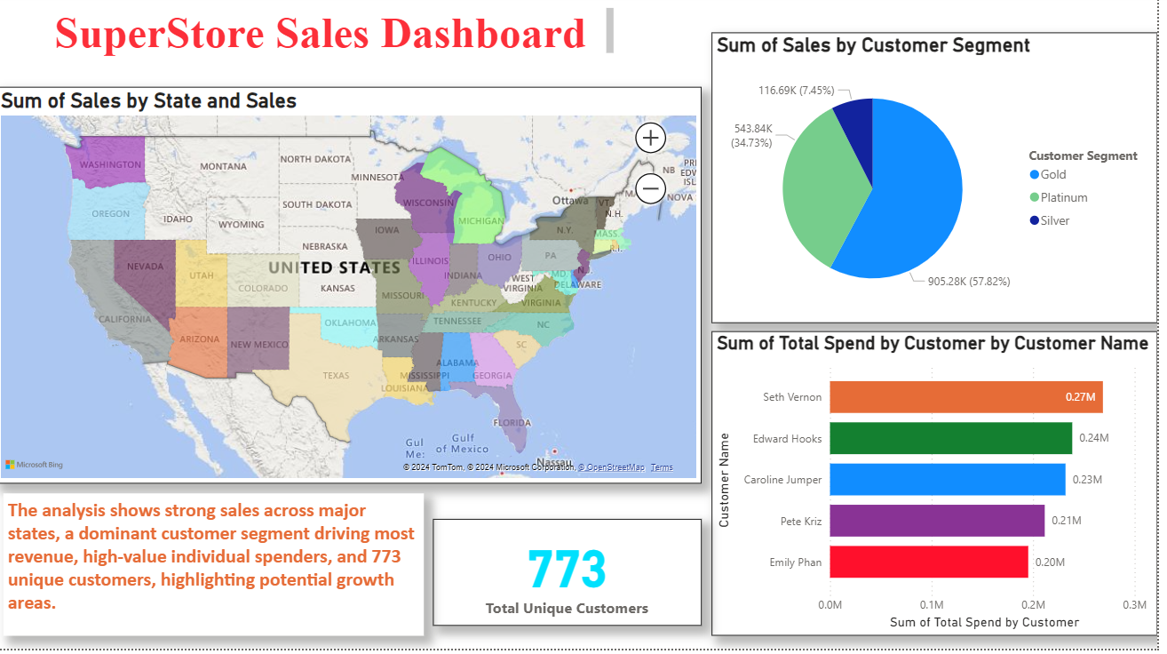

**Figure 1.1 - Visualization**

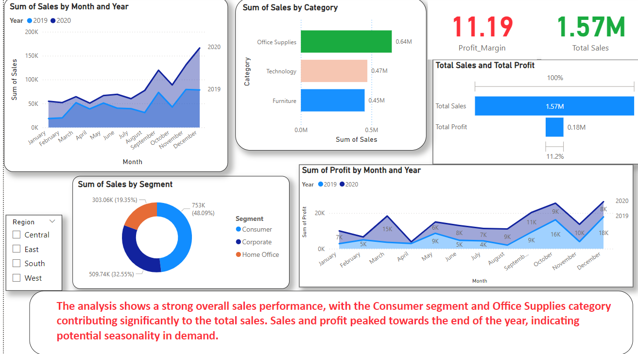

**Figure 1.2 - Visualization**

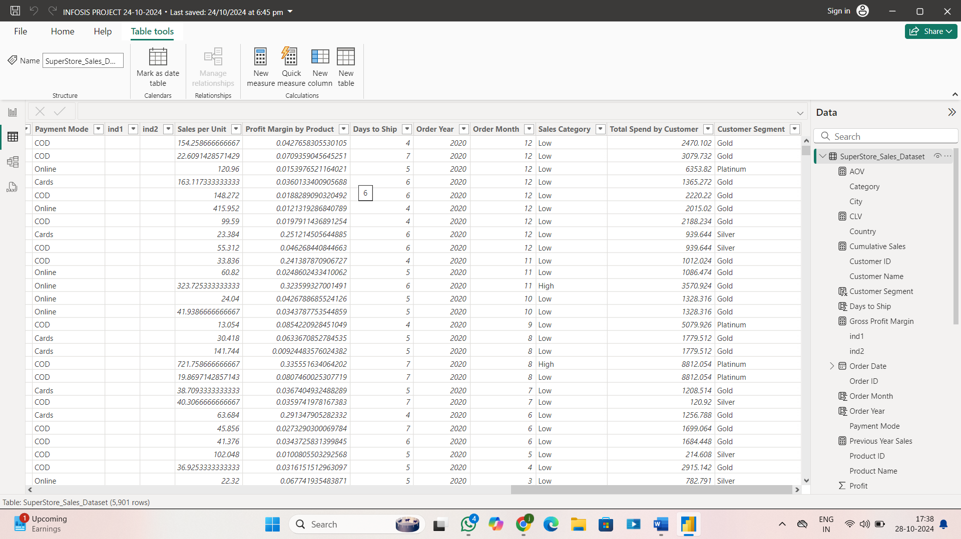

**Figure 1.3 – Data transformation**

## CONCLUSION

The SuperStore dataset analysis in Power BI provided valuable insights into sales performance, customer segmentation, regional sales differences, and product profitability. Key findings highlight the importance of high-value customer segments, such as Platinum customers, who contribute significantly to overall revenue and warrant targeted retention efforts. Additionally, regional analysis reveals high-performing areas, guiding potential resource allocation and marketing focus. Product-level insights identify top-selling items and highlight areas for inventory management, while operational metrics, like shipping times, point to opportunities for logistics optimization. Overall, the analysis equips the organization with data-driven strategies to enhance profitability, streamline operations, and improve customer satisfaction.

## 