# Major Project Report

Sales Performance Analysis Using Power BI

Submitted by: TREND TRACKERS

Team Members :

Kiran M  
Jeevan M  
 Gauri Shinde  
 Mansee Dakhole

Under the Guidance of: Pavithra Kannan

Year: 2024-2025

# Table of Contents

1. Abstract  
2. Introduction  
 2.1 Overview  
 2.2 Objectives  
 2.3 Future Scope  
3. About the Dataset  
 3.1 Key Attributes  
 3.2 Significance  
4. Methodology  
 4.1 Data Preparation  
 4.2 Data Modeling  
 4.3 Visualization Design  
5. Implementation  
 5.1 Data Analysis Process  
 5.2 Dashboard Development  
6. Results  
 6.1 Insights Gained  
 6.2 Snapshots  
7. Conclusion  
 7.1 Summary  
 7.2 Future Recommendations

# Abstract

This report provides a comprehensive analysis of sales performance using the SuperStore dataset, leveraging the advanced capabilities of Power BI. The project focuses on extracting actionable insights from data related to customer behavior, sales trends, regional performance, and product profitability. The study aims to guide decision-makers in optimizing their strategies for revenue growth and operational efficiency. By utilizing data modeling techniques, DAX measures, and interactive dashboards, the analysis delivers a detailed understanding of various performance metrics that are crucial for business growth.

# 1. Introduction

## 1.1 Overview

In today’s competitive business landscape, data-driven decision-making is crucial for staying ahead. This project seeks to transform raw sales data from the SuperStore dataset into valuable insights using Power BI. The focus is on analyzing key metrics such as sales performance, customer segmentation, regional differences, and product profitability. By adopting a structured approach to data analysis, this project provides the tools necessary for organizations to identify opportunities, address challenges, and implement effective strategies.

## 1.2 Objectives

The primary objectives of this project are centered around achieving a comprehensive understanding of sales performance. These include:  
- Analyzing sales and profitability trends to identify growth opportunities.  
- Segmenting customers based on their spending behavior to enable targeted engagement.  
- Assessing regional sales performance to identify top-performing areas and underperforming regions.  
- Evaluating product profitability to guide inventory management and marketing efforts.  
- Tracking growth trends to uncover seasonal patterns and emerging market opportunities.

1. Analyze sales and profitability trends.  
2. Segment customers for targeted strategies.  
3. Assess regional sales performance.  
4. Evaluate product profitability.  
5. Identify growth trends to optimize strategies.

## 1.3 future Scope

The future scope of this project involves integrating advanced features and technologies to further enhance its utility. This includes real-time data integration, which allows for immediate insights and rapid response to changing trends. Predictive analytics, powered by machine learning models, can forecast future sales trends, customer behaviors, and inventory needs. Additionally, advanced customer segmentation techniques can provide even deeper insights, enabling highly targeted marketing campaigns. Mobile-optimized dashboards and alerts for critical KPIs ensure that stakeholders have access to insights anytime and anywhere.

1. Real-time analytics integration.  
2. Predictive modeling for trends and customer behaviors.  
3. Enhanced customer segmentation for detailed targeting.  
4. Mobile-optimized dashboards and proactive KPI alerts.

# 2. About the Dataset

## 2.1 Key Attributes

The Super Store dataset serves as a rich source of information for comprehensive sales analysis. Key attributes of the dataset include transaction details, customer information, product specifications, and operational metrics. Transaction details such as Order ID, Order Date, and Ship Date provide insights into sales timelines, while customer information, including names, regions, and segments, helps in identifying key demographics. Product-related data, like categories and sub-categories, allows for detailed profitability analyses, and operational metrics such as shipping times and discounts offer insights into efficiency and revenue impacts.

- Sales Details: Order ID, Sales, Profit.  
- Customer Info: Name, Region, Segment.  
- Product Info: Categories, Sub-categories.  
- Operational Metrics: Discounts, Shipping Times.

## 2.2 Significance

This dataset is significant because it encapsulates a wide array of business data points, making it an ideal candidate for a holistic sales analysis. By focusing on multiple dimensions of business performance, it helps uncover trends that are not immediately apparent. The insights gained from this dataset can directly inform strategic decisions related to customer engagement, regional marketing, and inventory management, ultimately driving business success.

The dataset was selected for its rich details enabling sales, profitability, and operational analyses. It aids in uncovering trends for data-driven decisions.

# 3. Methodology

The methodology section details the structured approach employed to transform raw sales data into actionable insights using Power BI. This process involves multiple stages, including data preparation, data modeling, and visualization design. Each step plays a crucial role in ensuring that the analysis is accurate, insightful, and effectively communicates key findings.

## 3.1 Data Preparation

Data cleaning using Power Query addressed missing values, duplicates, and standardized formats. Integration of relevant tables and creation of a Date table supported time-based analysis.

## 3.2 Data Modeling

Relationships and hierarchies (e.g., Year > Quarter > Month) were built. DAX measures were created for dynamic metrics like Total Sales, Profit Margins, and Customer Lifetime Value.

## 3.3 Visualization Design

Key visuals included KPI cards, bar charts, line charts, maps, and slicers for interactivity. The layout was structured into thematic sections: Sales Overview, Regional Performance, etc.

# 4. Implementation

The implementation phase focuses on translating the methodology into practical steps within Power BI. This involves data importation, cleaning, and preparation, followed by creating measures and calculated columns using DAX, and finally designing and assembling the visualizations into an interactive dashboard. This stage is where theoretical planning materializes into actionable insights.

## 4.1 Data Analysis Process

1. Imported the SuperStore dataset.  
2. Created calculated columns for metrics like Days to Ship, CLV, and Sales per Unit.  
3. Designed DAX measures for profitability, sales trends, and growth analysis.

## 4.2 Dashboard Development

Developed dashboards with filters and slicers for detailed explorations. Integrated advanced visuals like YoY growth trends, CLV segmentation, and sales by region.

# 5. Results

The results section presents the outcomes derived from the comprehensive analysis of the SuperStore dataset using Power BI. By applying the data preparation, modeling, and visualization steps outlined previously, the analysis uncovered valuable insights into sales performance, customer segmentation, regional trends, and product profitability. These insights provide a clear picture of the business's strengths, weaknesses, and areas for potential growth.

## 5.1 Insights Gained

- Sales Trends: Identified peak seasons and consistent growth areas.  
- Customer Segmentation: High-value customer categories driving major revenue.  
- Regional Analysis: Pinpointed top-performing and underperforming regions.  
- Operational Insights: Improved understanding of shipping delays and their impact.

## 5.2 Snapshots

Visual dashboards showcased trends, profitability, and customer data. Metrics like Total Sales, Return Rates, and Profit by Region were visualized for clarity.

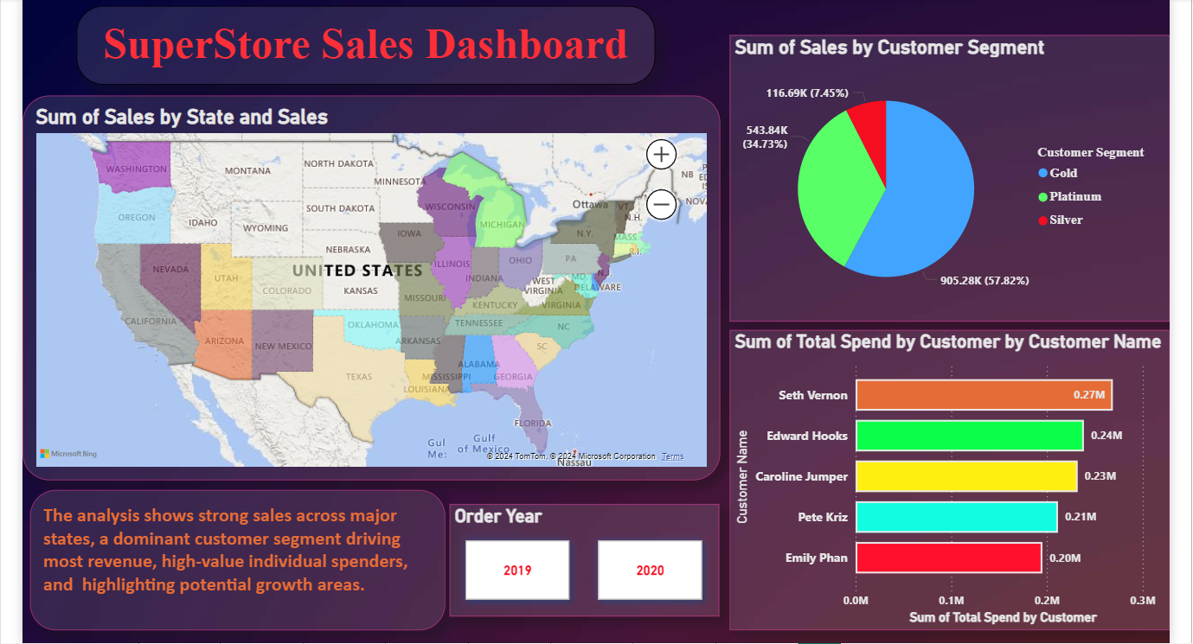

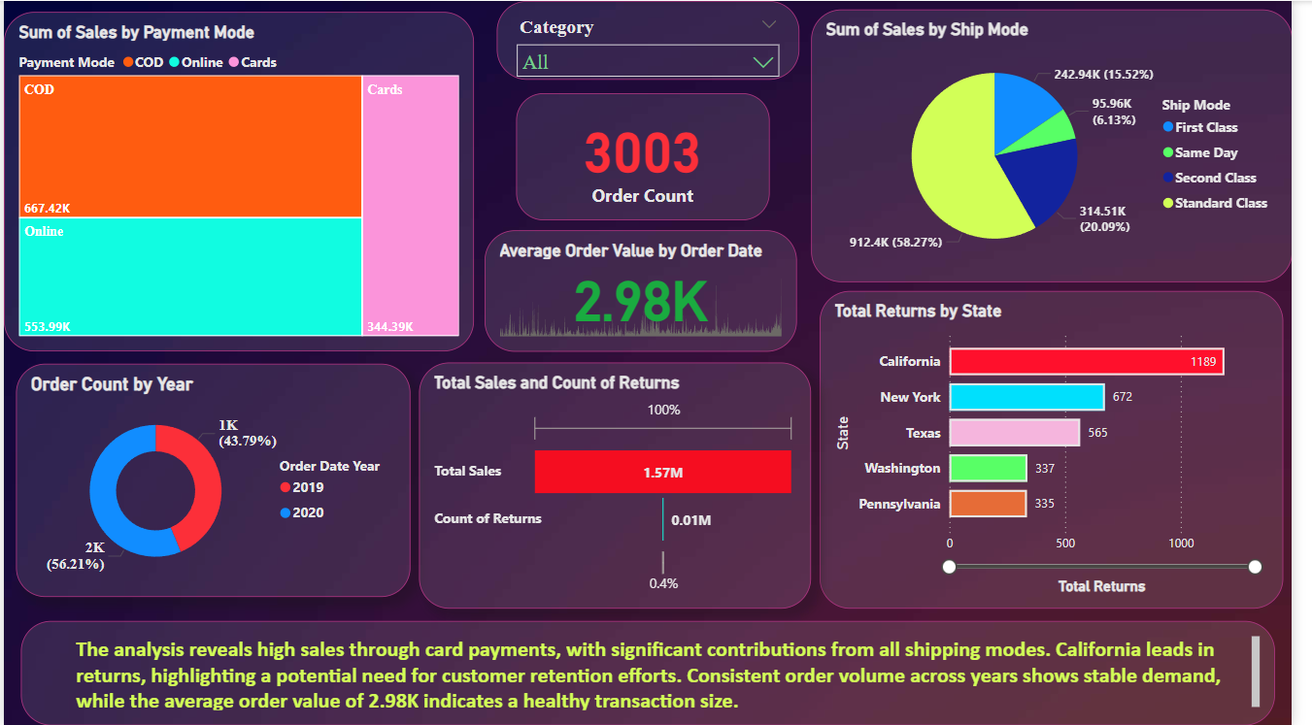

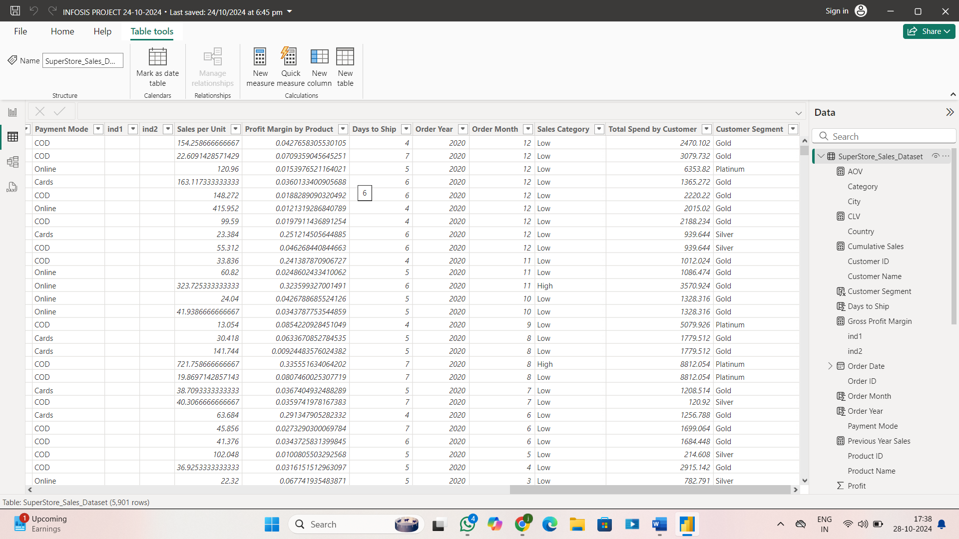

# 6. Conclusion

The results section presents the outcomes derived from the comprehensive analysis of the SuperStore dataset using Power BI. By applying the data preparation, modeling, and visualization steps outlined previously, the analysis uncovered valuable insights into sales performance, customer segmentation, regional trends, and product profitability. These insights provide a clear picture of the business's strengths, weaknesses, and areas for potential growth.

## 6.1 Summary

Power BI’s capabilities turned raw sales data into actionable insights. Strategic recommendations included targeted customer engagement, optimizing regional strategies, and enhancing operational efficiency.

## 6.2 Future Enhancement

1. Leverage predictive analytics for proactive decision-making.  
2. Expand geospatial analyses for deeper regional insights.  
3. Adopt real-time dashboard updates for timely interventions.