**PURBANCHAL UNIVERSITY**



**DEPARTMENT OF COMPUTER ENGINEERING**

**KHWOPA ENGINEERING COLLEGE**  
**LIBALI-8, BHAKTAPUR**

**PROJECT REPORT**

**ON**

**GYM E-COMMERCE**

 Project work proposal in partial fulfillment of requirements for the award of the degree of Bachelor of Engineering in Computer Engineering

**SUBMITTED BY**

Manseez Bahadur Pradhan (780320)

**SUBMITTED TO**

Department of Computer Engineering

Er. Jagdish Duwal

APRIL 22, 2024

# ACKNOWLEDGEMENT

I wish to express my sincere gratitude to all the individuals who have contributed to the fruition of this project proposal. Their unwavering guidance, support, and invaluable insights have been instrumental in driving this project forward.

Special appreciation is extended to **Er. Siddhant Sharma** for his guidance and I am also sincerely thankful to **Er. Jagdish Duwal**. The resources and facilities provided by the organization have been indispensable in facilitating our research endeavors and the development of a comprehensive proposal. Furthermore, I would like to extend my gratitude to Khwopa Engineering College and the Department of Computer Engineering for incorporating this project into our curriculum.

This project has been a solo endeavor, and I am profoundly grateful for the opportunity to embark on this journey. Each contribution, whether big or small, has been invaluable in shaping the outcome of this proposal. Thank you all for your unwavering support and belief in this endeavor.

Warm regards,

Manseez Bahadur Pradhan

# ABSTRACT

This report describes the creation of a Gym Online Store using Django, with separate areas for gym owners and shoppers. The website helps gym owners manage their products, and shoppers can easily browse and buy gym gear. With a user-friendly design, the site makes gym shopping easier and more accessible. This report explains how the website works, what users can do, and why it's helpful for modernizing gym shopping and making better use of resources.

Keywords: Gym Online Store, Owners, Shoppers, Features, Ease of Use.

**TABLE OF CONTENTS**

ACKNOWLEDGEMENT i

ABSTRACT ii

CHAPTER 1 1

INTRODUCTION 1

1.1 Background 1

1.2 Statement of Problems 1

1.3 Objective 2

1.4 Application and Scope 2

CHAPTER 2 3

METHODOLOGY 3

2.1 Features 3

2.2 Tools and Platform: 3

2.3 Algorithm 4

2.4 Flowchart 5

2.5 Relational Schema 6

2.6 Entity-Relationship Diagram 7

CHAPTER 3 8

RESULTS AND DISCUSSION 8

CHAPTER 4 13

CONCLUSION AND RECOMMENDATION 13

4.1 Conclusion 13

4.2 Recommendation 13

REFERENCES 14

**LIST OF FIGURES**

Figure 2.4 Flowchart 5

Figure 2.5 Relational Schema 6

Figure 2.6 ER Diagram 7

Figure 3.1. Login Page 8

Figure 3.2. Home Page 8

Figure 3.3. Cart Page 9

Figure 3.4. Checkout Page 9

Figure 535. Complete Transaction 10

Figure 3.6. Customer details 10

Figure 3.7. Item Ordering 11

Figure 3.8. Order Placed 11

Figure 3.9. Products 12

Figure 3.10. Shipping details 12

# CHAPTER 1

# INTRODUCTION

## Background

The fitness industry's shift towards digital platforms has brought convenience but also challenges like complex user interfaces. To tackle this, we're developing a Gym E-commerce Website using Django and frontend technologies. Our aim is to simplify gym equipment purchasing for both owners and enthusiasts.

We're prioritizing simplicity and efficiency, ensuring an intuitive interface for easy navigation. Our platform will offer a seamless shopping experience, allowing users to quickly find what they need without unnecessary complications.

Through our project, we're addressing the hurdles faced by gym owners and enthusiasts in online shopping. By offering a user-friendly platform, we're enhancing accessibility and convenience in gym product procurement. Our project represents a step forward in modernizing the fitness industry's digital landscape.

## Statement of Problems

Traditional methods of managing gym retail operations, like paper records and manual processes, are causing headaches for gym owners. It's challenging to keep track of gym equipment inventory and for customers to find what they need, leading to errors and delays. Without a modern Gym E-commerce Website, gym owners struggle to meet customer needs and provide a smooth shopping experience.

Key problems with traditional gym commerce include:

* Existing Gym E-commerce Websites often lack a proper user login system, limiting user engagement and personalization. This absence hinders the ability to provide tailored recommendations and restricts access to essential features.
* The heavy reliance on admin functionalities in the backend complicates the user journey, leading to confusion and frustration among both gym owners and customers.
* This complexity undermines the user experience and impedes the seamless interaction between stakeholders.
* Furthermore, the absence of a streamlined checkout process and inefficient product management systems contribute to a disjointed and cumbersome shopping experience.
* This lack of efficiency undermines the potential for growth and profitability for gym owners and hampers customer satisfaction.

## Objective

The objective of the Gym Ecommerce is to develop a seamless interaction between gym owners and customers without the need for a formal user login system.

## Application and Scope

The Application and Scopes of the Gym E-Commerce Websites are:

* Suitable for all types of gyms, including commercial gyms, home gyms, and fitness centers.
* Helps gym owners organize equipment and products efficiently.
* Enables customers to find and purchase gym gear quickly and easily.
* Can handle both physical gym equipment and digital resources like workout plans and fitness apps.
* Customizable to fit the needs of different gym sizes and user preferences.
* Improves customer engagement by offering personalized recommendations and fitness programs.
* Streamlines administrative tasks, freeing up gym owners' time to focus on providing quality services and support.

# CHAPTER 2

# METHODOLOGY

## 2.1 Features

In a streamlined gym e-commerce website, the emphasis lies on essential features that enhance user interaction and facilitate efficient operations. Here are the key features that such a platform might offer:

* Product Showcase: Provides users with a visually appealing display of available gym equipment and accessories for easy browsing and selection.
* Guest Checkout: Allows users to make purchases without the need for registration, streamlining the buying process and enhancing accessibility.
* User Registration: Enables customers to create accounts securely, providing them with personalized recommendations and order tracking.
* Order Management: Allows users to track their orders, view order history, and manage shipping details for a seamless purchasing experience.
* Admin Dashboard: Grants administrators access to system management tools and features for efficient inventory management and order processing.

System Requirements:

* User Authentication: Registered users can log in securely using their credentials to access personalized features and services.
* Admin Authentication: Administrators can log in securely using their credentials to access the admin dashboard and perform backend tasks.
* Products Management: Administrators can add new products to the system, update existing ones, and manage inventory levels to ensure a comprehensive and up-to-date product catalog.

## 2.2 Tools and Platform:

Programming Language: Python, JavaScript

Framework: Django

Database: db.sqlite3

Platform: Windows

## 2.3 Algorithm

Algorithm for Gym E-commerce Website Management:

1. Start
2. Verify Identity of the person using the system
3. If (Identity is of an Admin) Then

Display Admin Panel

Provide continuous options until an exit condition is met:

1. Add Product
2. Add Customer
3. Update Product
4. View Shipment
5. See Transaction
6. Manage Inventory

If (Exit condition is met) Then

Exit Admin Panel

End If

Else If (Identity is of a customer) Then

Display User Panel

Provide continuous options until an exit condition is met:

1. Browse Products

2. Add to Cart

3. View Cart

4. Proceed to Checkout

If (Exit condition is met) Then

Exit User Panel

End If

Else

Display an error message indicating unrecognized identity

End If

End

End

## 2.4 Flowchart

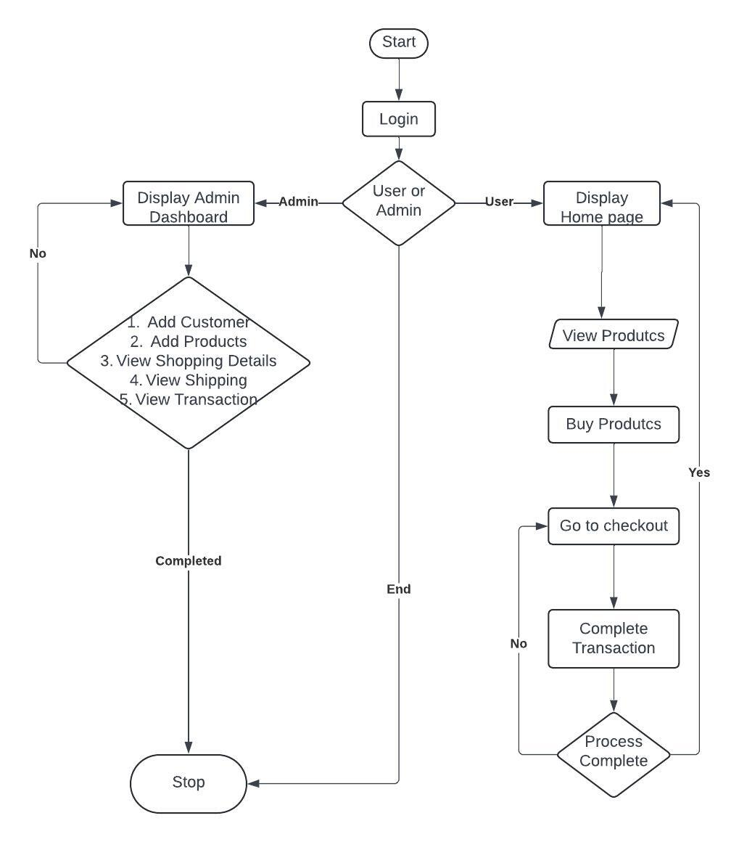Figure 2.4 Flowchart

## 2.5 Relational Schema

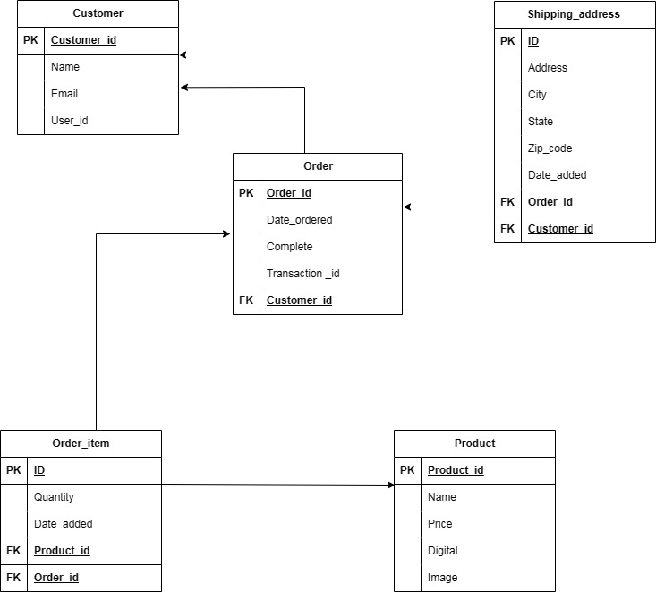

Figure 2.5 Relational Schema

## 2.6 Entity-Relationship Diagram

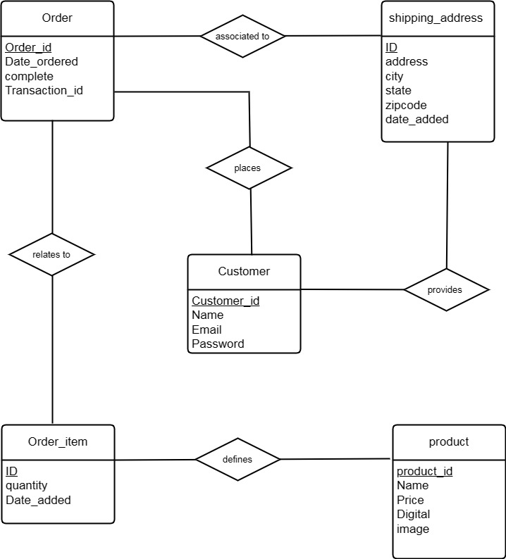Figure 2.6 ER Diagram

# CHAPTER 3

# RESULTS AND DISCUSSION

The outputs of the project are briefly described with the respective images;

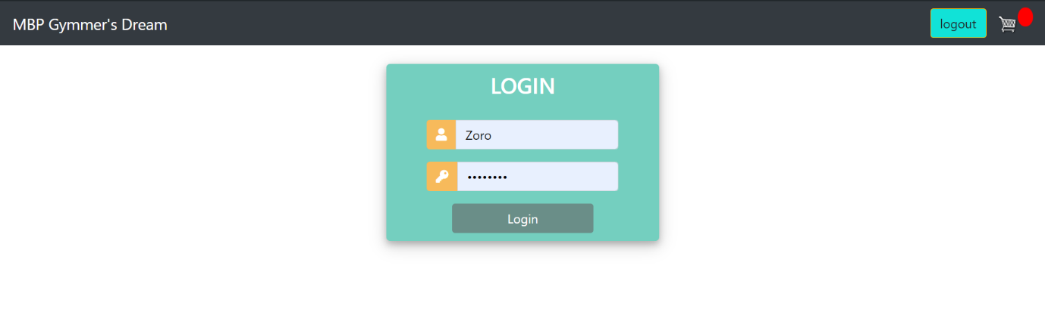Figure 3.1. Login Page

This is where the user is able to login

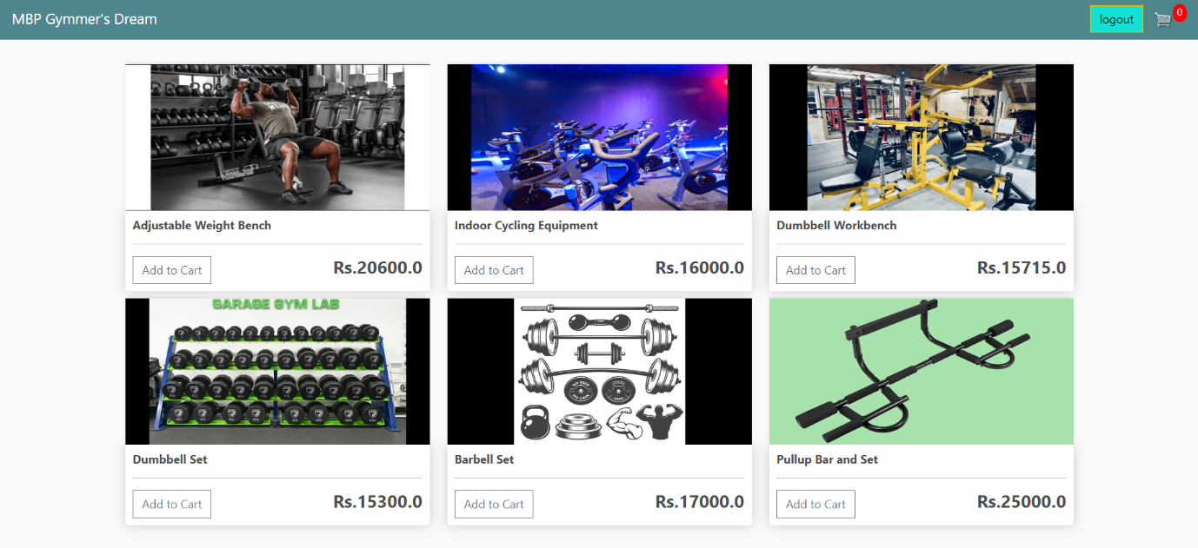Figure 3.2. Home Page

In this page the user is able to add the products to the cart

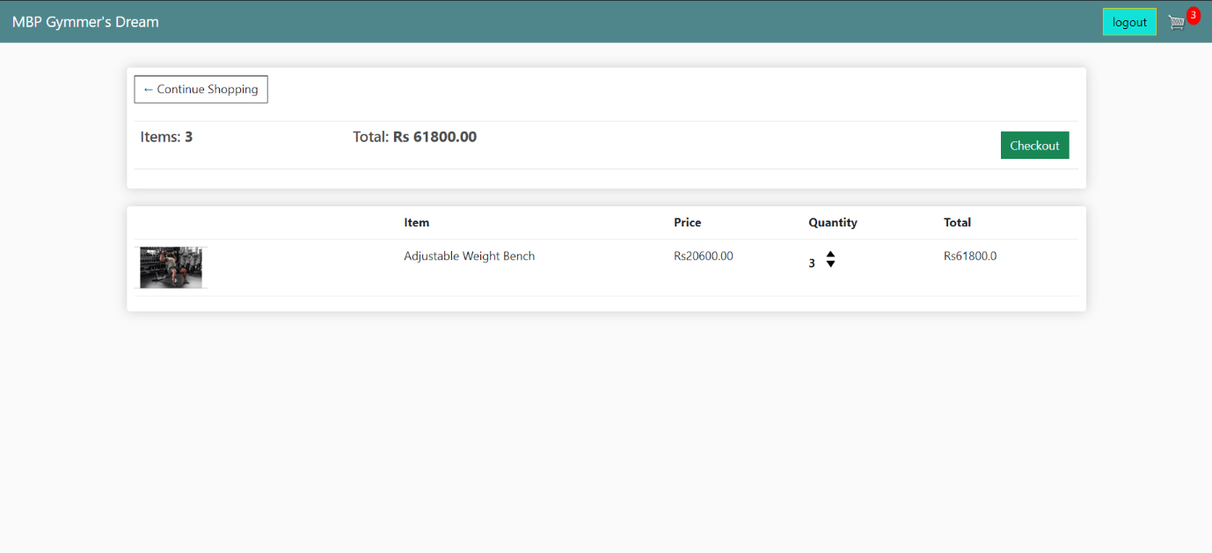

Figure 3.3. Cart Page

The products bought will be shown here with the quantity and the total amount

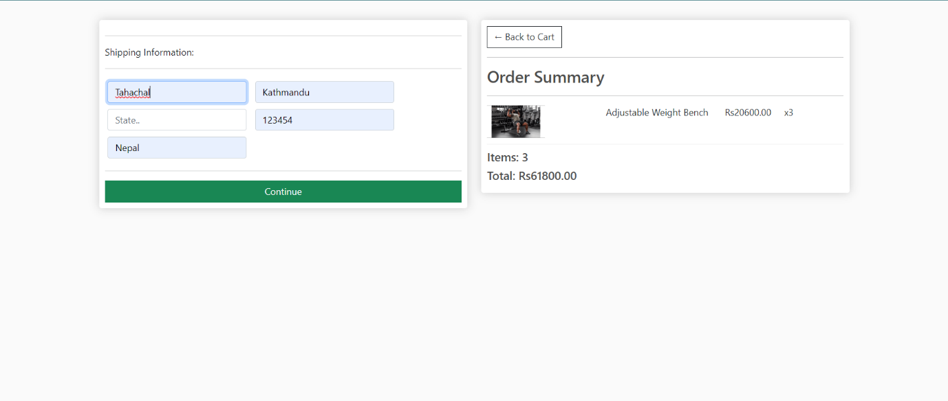Figure 3.4. Checkout Page

The checkout transaction will be carried out here

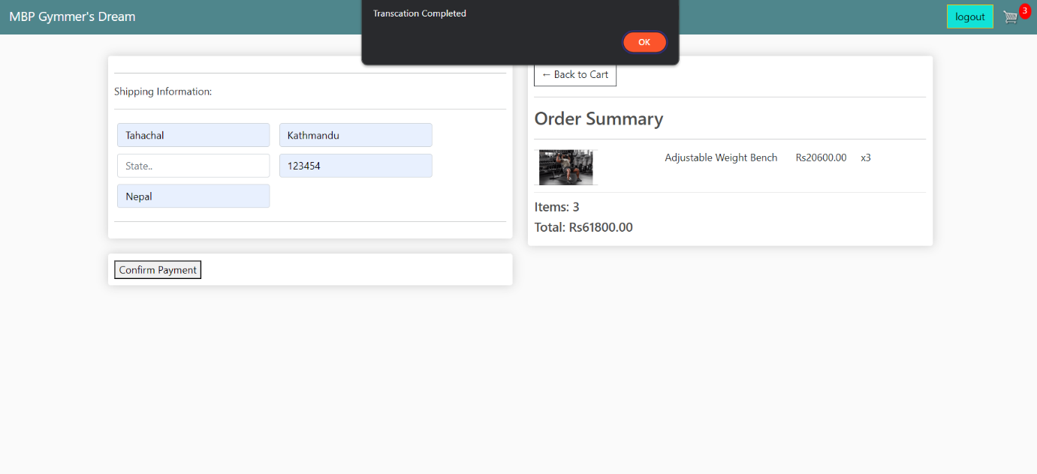

Figure 535. Complete Transaction

After the checkout the user fill in the needed details and the payment is done



Figure 3.6. Customer details

The details of the customer are shown here

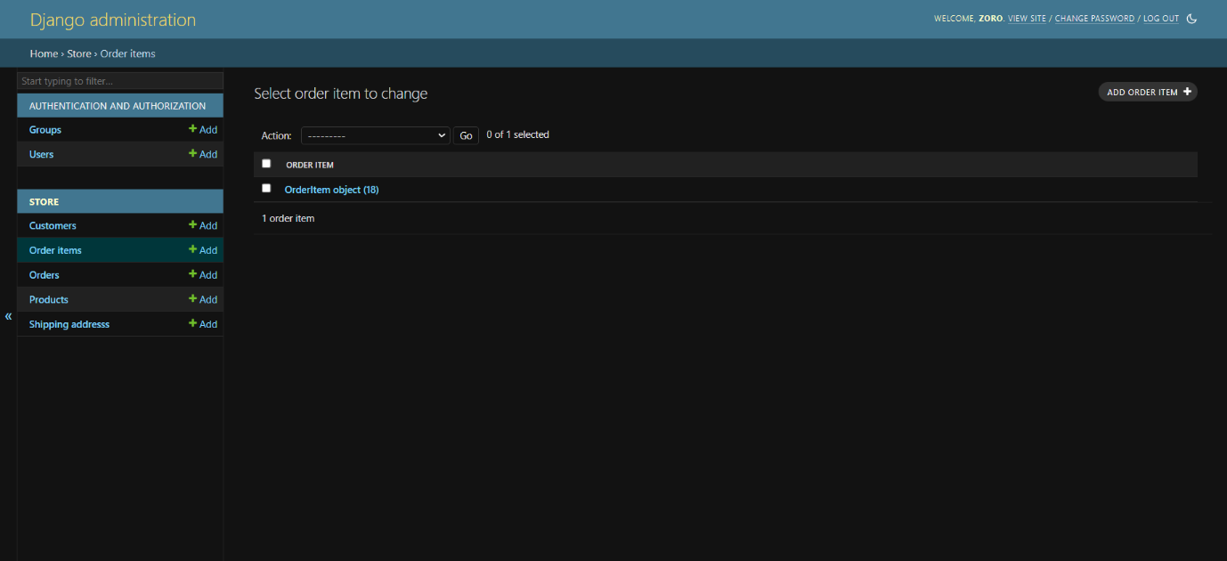

Figure 3.7. Item Ordering

The ordered items will be shown here

Figure 3.8. Order Placed

The orders that have been place will appear here

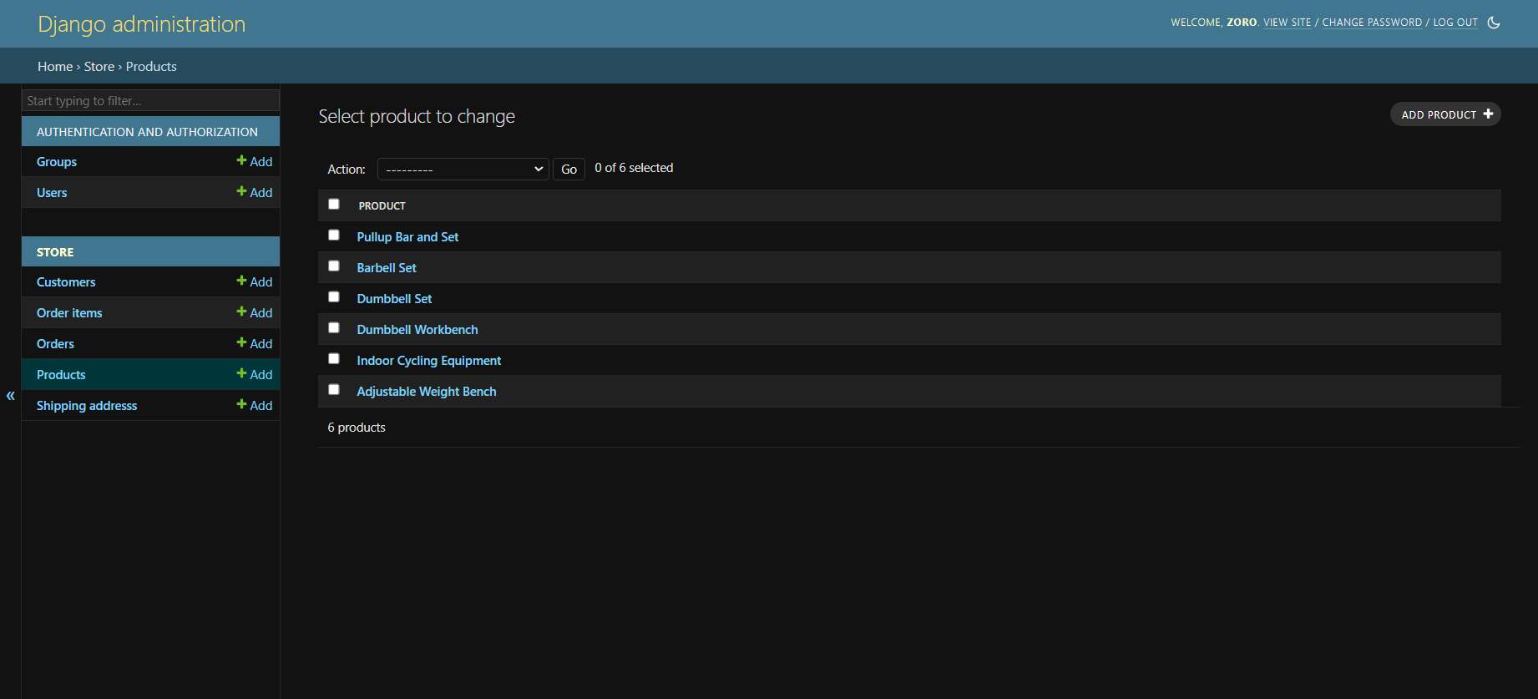

Figure 3.9. Products

The products in the shop are available here and can be added according to need

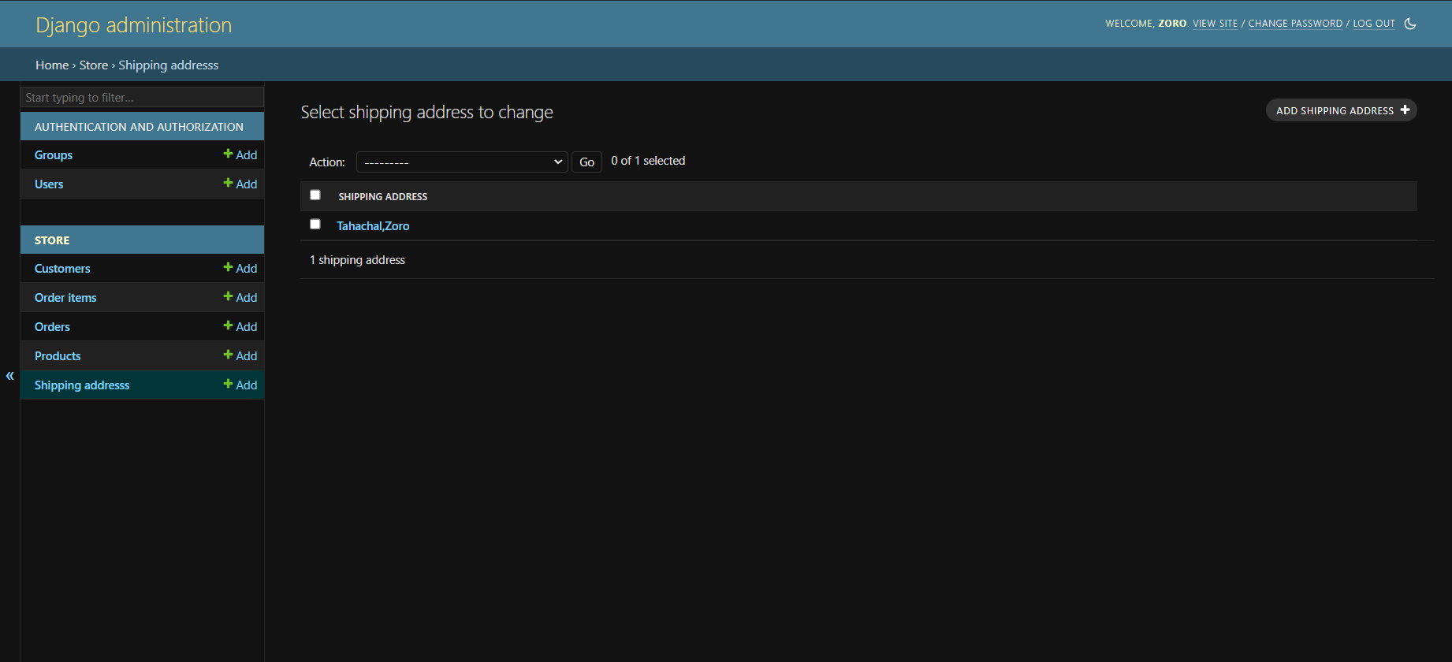

Figure 3.10. Shipping details

The order that has been paid and checked out has the sipping address

# CHAPTER 4

# CONCLUSION AND RECOMMENDATION

## 4.1 Conclusion

In conclusion, our Gym E-commerce Website, featuring dual interfaces for administrators and customers, represents a significant advancement in streamlining gym retail operations. With intuitive interfaces tailored to the needs of both stakeholders, we have simplified product management processes and enhanced the overall shopping experience. Through functionalities such as product addition, updating, browsing, and checkout, our system improves efficiency and accessibility for gym owners and customers alike. Looking ahead, we are committed to refining and expanding our platform to meet the dynamic demands of the fitness industry, ensuring a seamless and satisfying experience for all users.

## 4.2 Recommendation

For future I would do the following enhancements as:

* Add a proper payment gateway for online payment transaction.
* Develop location and searching delivery live tracking with use of API.

# REFERENCES

[1] "Django Official Website" by Django Software Foundation.

* [Django (djangoproject.com)](https://www.djangoproject.com/)

[2] "Django Packages" by Django Packages.

* [Django Packages: Reusable apps, sites and tools directory for Django](https://djangopackages.org/)

[3] “Django Tutorials” by w3 school.

* [Django Tutorial (w3schools.com)](https://www.w3schools.com/django/index.php)

[4] “Django Tutorials” by GeeksforGeeks

* [Django Tutorial | Learn Django Framework - GeeksforGeeks](https://www.geeksforgeeks.org/django-tutorial/)

[5]” Python Django Tutorials” by Code with Harry.

* [Python Django Tutorials in Hindi - YouTube](https://www.youtube.com/playlist?list=PLu0W_9lII9ah7DDtYtflgwMwpT3xmjXY9)

[6] “Django Ecommerce Website” by Dennis Ivy.

* [[Django Ecommerce Website - YouTube](https://www.youtube.com/playlist?list=PL-51WBLyFTg0omnamUjL1TCVov7yDTRng)](https://www.youtube.com/playlist?list=PL-51WBLyFTg0omnamUjL1TCVov7yDTRng)