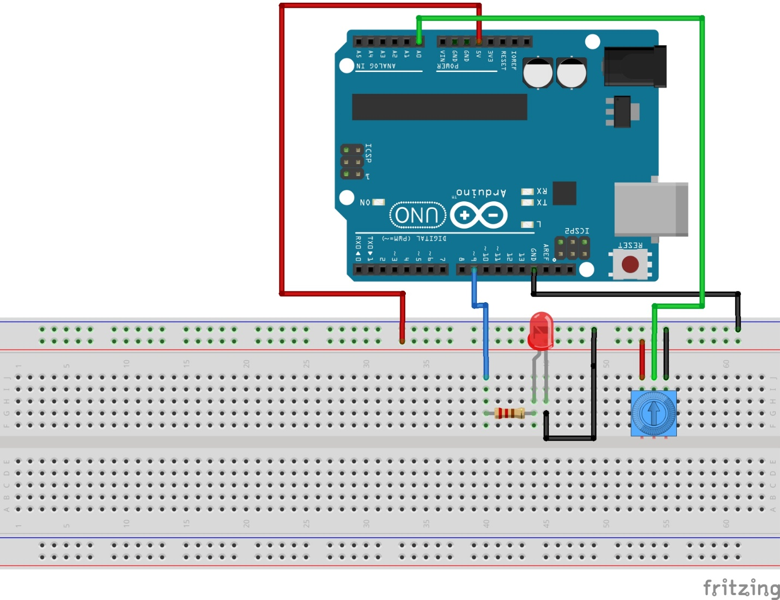

Source: http://www.toptechboy.com/arduino/lesson-11-arduino-circuit-to-dim-led-with-potentiometer/oi98u7