# PROJECT TITLE:

**AUTOMATED TOLL COLLECTION SYSTEM**

Submitted By:

|  |  |
| --- | --- |
| **Roll No** | **Name of Students** |
| 4075 | Mitaxi S. Vaddoriya |
| 4077 | Gunjan A. Vaghasiya |
| 4082 | Mansi R. Vavadiya |
| 4144 | Preet N. Patel |

Submitted To:

**K.S. School of Business Management and Information Technology**

M. Sc. – Computer Application and Information Technology



Contents

PROJECT TITLE: 1

1.Project Overview 3

**Project Goals and Objectives :** 3

2. Requirements Analysis 4

**Functional Requirements:** 4

**Non-Functional Requirements :** 4

**User Requirements:** 4

**System Requirements:** 4

3. System Architecture and Design 5

**System Overview** 5

**Hardware Design** 5

**Component List** 5

**System Design :** 5

**Data Flow Diagrams** 6

4. IMPLEMENTATION DETAILS 7

**Hardware Setup** 7

**Software Development** 7

**Integration Techniques** 7

**Code Snippets** 7

5. Testing and Validation 14

**Test Plans** 14

**Test Cases** 14

**Performance Metrics** 14

6. CONCLUSION 15

**Summary of Findings** 15

**Limitations of the Project** 15

**Future Work** 15

7. REFERENCES 16

**Books:** 16

**Websites:** 16

# 1.Project Overview

In this project, we will introduce you to the **Automatic Smart Toll Tax Collection System** designed using **RFID Module** and **Arduino**. Nowadays there is a huge rush in toll plazas for paying the **toll tax**. Therefore, in order to reduce traffic and save time, an **automatic toll collector**can be used.

This project is a demo of a **Smart Toll Tax Collection System**. Consider there are n numbers of vehicles at Toll Plaza. When these vehicles cross the **IR Sensor**, the gate will be closed. At the same time, the **LCD** will display to put the Card to the reader for scanning. Then you can put your card on **RFID** and pay your bill. When the bill is successfully paid, then you can go towards the 2nd Gate. When a vehicle crosses the 2nd IR Sensor, the gate will be opened and you can go. In case the card doesn’t have a balance, you can **recharge** the card using this RFID and **Keypad** by entering the amount.

**Project Goals and Objectives :**

* At present, FASTags, an electronic toll collection system, is used in which 'Radio Frequency Identification' (RFID) technology is employed to make toll payments. The RFID passive tag on the vehicles is used for making payments directly from the customers linked to account.
* Develop an automated, toll collection system that can collect toll automatic and open automatically when it is paid.
* An automatic toll collection system is introduced to eliminate the need for manual toll ticketing, reduce traffic congestion, and improve traffic flow on expressways

# 2. Requirements Analysis

## **Functional Requirements:**

* Tag distribution
* Identification and matching of vehicle owner’s bank account
* Automatic toll amount debit from Card
* Optimize waiting time at toll plaza

## **Non-Functional Requirements :**

* Durability: All components must be robust and suitable for high usage environments.

## **User Requirements:**

* Ease of Use: No manual interaction should be needed

## **System Requirements:**

Hardware: Arduino board, IR sensors, RFID system , servo motor, and LCD screen.

Software: Code to manage sensor data and control the motor.

# 3. System Architecture and Design

## **System Overview**

Electronic toll collection systems rely on three major components: automated vehicle identification, automated vehicle classification, transaction processing.

## **Hardware Design**

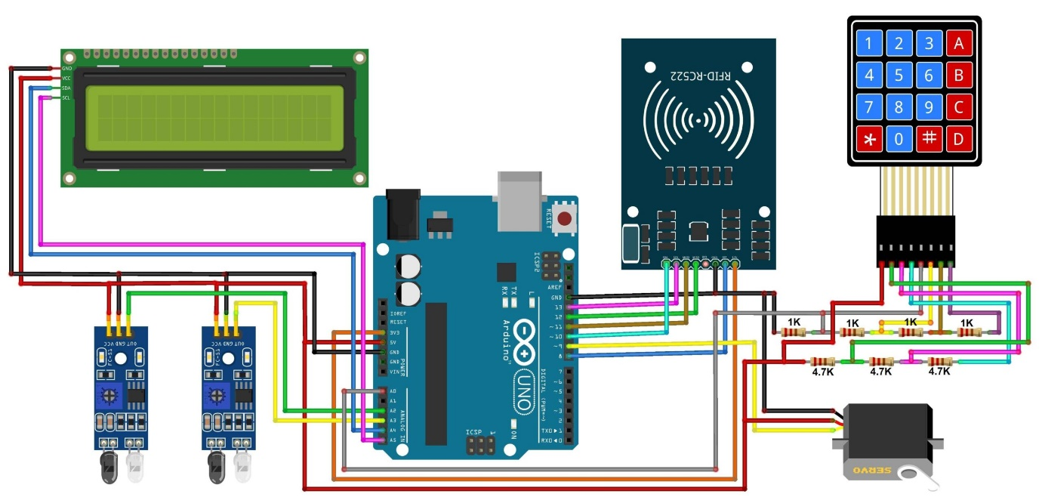

## **Component List**

|  |  |
| --- | --- |
| 1 | Arduino UNO Board |
| 2 | RC522 RFID Reader |
| 3 | 13.56 MHz RFID Card |
| 5 | I2C LCD Display |
| 6 | 4x4 Keypad Module |
| 7 | IR Sensor Module E18-D80NK |
| 8 | Servo Motor MG995 |
| 9 | Resistor 1K |
| 10 | Resistor 4.7K |

## **System Design :**

* **Programming Languages and Tools:** The system is programmed using C++ in the Arduino development environment.

## **Data Flow Diagrams**

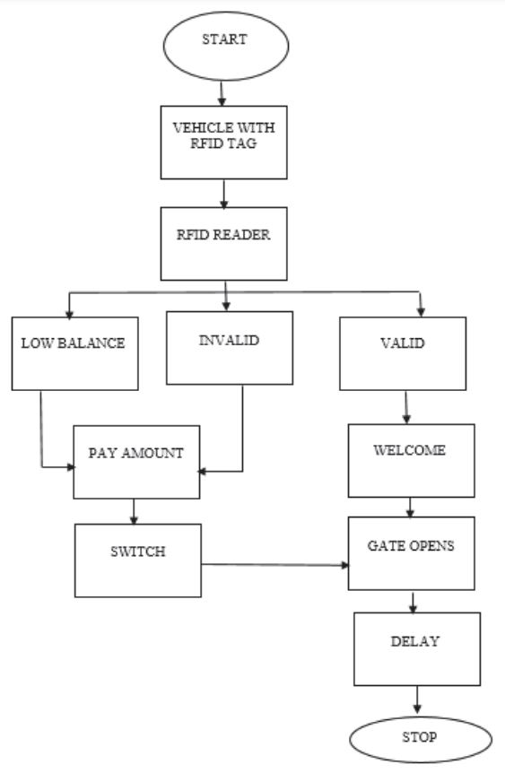

# 4. IMPLEMENTATION DETAILS

## **Hardware Setup**

* Attach the IR sensor to the toll booth to help detect the vehicle and valid user by RFID.
* Connect the servo motor to the Fastag to enable automatic opening and closing.

## **Software Development**

* Set up the Arduino IDE, write code to detect vehicle from the IR sensor.
* Code to open the Fastag using the servo motor when a user paid bill.

## **Integration Techniques**

* Testing the interaction between the IR sensor ,RFID and the servo motor to ensure the Fastag opens at the correct times.

## **Code Snippets**

**1. RC522 Library:    
2. One Wire Keypad Library   
3. Liquid Crystal I2C Library**

void setup () {

 lcd.begin();

  lcd.backlight();

  Serial.begin(9600);

  servo.attach(9);

  servo.write(90);

  pinMode(sensorPin1, INPUT);

  pinMode(sensorPin2, INPUT);

  pinMode(buzzerPin, OUTPUT);

  KP2.SetKeypadVoltage(5.0);

  SPI.begin();

  mfrc522.PCD_Init();

  lcd.setCursor(0, 0);

  lcd.print(" Automatic toll");

  lcd.setCursor(0, 1);

  lcd.print("colection system");

  delay(3000);

  lcd.clear();

}

void loop()

{

  if (recharge == 0){

    reCharge();

  }

  else{

    lcd.setCursor(0, 0);

    lcd.print("   Welcome!!!");

    sensorRead();

    rfid();

    KeyPad();

    if (senVal1 == 0){

      servoDown();

      lcd.clear();

      lcd.setCursor(0, 0);

      lcd.print("Vehicle detected");

      delay(1000);

      lcd.clear();

      lcd.setCursor(0, 0);

      lcd.print("Put your card to");

      lcd.setCursor(0, 1);

      lcd.print("the reader......");

      delay(2000);

      lcd.clear();

    }

    else if (senVal2 == 0 && state == 1){

      servoUp();

      lcd.clear();

      lcd.setCursor(0, 0);

      lcd.print("Have a safe");

      lcd.setCursor(0, 1);

      lcd.print("journey");

      delay(1000);

      lcd.clear();

      state = 0;

    }

  }

}

void servoDown(){

  servo.attach(9);

  for (servoPos = 30; servoPos <= 120; servoPos += 1)

  {

    servo.write(servoPos);

    delay(5);

  }

}

void servoUp(){

  servo.attach(9);

  for (servoPos = 120; servoPos >= 30; servoPos -= 1)

  {

    servo.write(servoPos);

    delay(5);

  }

}

void sensorRead(){

  senVal1 = digitalRead(sensorPin1);

  senVal2 = digitalRead(sensorPin2);

}

void rfid(){

  if ( ! mfrc522.PICC_IsNewCardPresent()){

    return;

  }

  if ( ! mfrc522.PICC_ReadCardSerial()){

    return;

  }

  String content = "";

  for (byte i = 0; i < mfrc522.uid.size; i++){

    content.concat(String(mfrc522.uid.uidByte[i] < 0x10 ? " 0" : " "));

    content.concat(String(mfrc522.uid.uidByte[i], HEX));

  }

  content.toUpperCase();

  if (content.substring(1) == "8A 4A 1A B3"){

    if (card1Balance >= 500){

      lcdPrint();

      card1Balance = card1Balance - 500;

      lcd.setCursor(9, 1);

      lcd.print(card1Balance);

      delay(2000);

      lcd.clear();

      state = 1;

    }

    else{

      card = content.substring(1);

      LcdPrint();

      lcd.setCursor(9, 1);

      lcd.print(card1Balance);

      lcd.print(" Tk");

      delay(2000);

      lcd.clear();

      lcd.setCursor(0, 0);

      lcd.print("Please Recharge");

      delay(1000);

      lcd.clear();

      state = 0;

    }

  else{

    digitalWrite(buzzerPin, HIGH);

    lcd.setCursor(0, 0);

    lcd.print("Unknown Vehicle");

    lcd.setCursor(0, 1);

    lcd.print("Access denied");

    delay(1500);

    lcd.clear();

    digitalWrite(buzzerPin, LOW);

  }

}

void KeyPad(){

  byte KState = KP2.Key_State();

  if (KState == PRESSED){

    Key = KP2.Getkey();

      if (Key == 'A'){

        lcd.clear();

        lcd.setCursor(0, 0);

        lcd.print("Recharging Mode.");

        lcd.setCursor(0, 1);

        lcd.print("................");

        delay(1500);

        lcd.clear();

        recharge = 0;

    }}}

void clearData(){

  while (data_count != 0){

    Data[data_count--] = 0;

  }

  return;

}

void reCharge(){

  lcd.setCursor(0, 0);

  lcd.print ("Enter the amount");

  byte KState = KP2.Key_State();

  if (KState == PRESSED){

    Key = KP2.Getkey();

      if (Key == 'D'){

        if (card == “8A 4A 1A B3"){

          num1 = Data;

          card1Balance = num1.toInt() + card1Balance;

          lcd.clear();

          lcd.setCursor(0, 0);

          lcd.print("Your current");

          lcd.setCursor(0, 1);

          lcd.print("balance: ");

          lcd.setCursor(9, 1);

          lcd.print (card1Balance);

          lcd.print(" Tk");

          delay(3000);

          clearData();

          lcd.clear();

          recharge = 1;

        }

        else if (card == "DC A4 3E 17"){

          num2 = Data;

          card2Balance = num2.toInt() + card2Balance;

          lcd.clear();

          lcd.setCursor(0, 0);

          lcd.print("Your current");

          lcd.setCursor(0, 1);

          lcd.print("balance: ");

          lcd.setCursor(9, 1);

          lcd.print (card2Balance);

          lcd.print(" Tk");

          delay(3000);

          clearData();

          lcd.clear();

          recharge = 1;

        }}

      else {

        Data[data_count] = Key;

        lcd.setCursor(data_count, 1);

        lcd.print(Data[data_count]);

        data_count++;

      }}}

void lcdPrint(){

  digitalWrite(buzzerPin, HIGH);

  delay(200);

  digitalWrite(buzzerPin, LOW);

  delay(100);

  lcd.clear();

  lcd.setCursor(0, 0);

  lcd.print("  Successfully");

  lcd.setCursor(0, 1);

  lcd.print(" paid your bill");

  delay(1500);

  lcd.clear();

  lcd.setCursor(0, 0);

  lcd.print("Your Remaining");

  lcd.setCursor(0, 1);

  lcd.print("balance: ");

}

void LcdPrint(){

  digitalWrite(buzzerPin, HIGH);

  delay(200);

  digitalWrite(buzzerPin, LOW);

  delay(100);

  lcd.clear();

  lcd.setCursor(0, 0);

  lcd.print("  Your balance");

  lcd.setCursor(0, 1);

  lcd.print(" is insufficent");

  delay(1500);

  lcd.clear();

  lcd.setCursor(0, 0);

  lcd.print("Your Remaining");

  lcd.setCursor(0, 1);

  lcd.print("balance: ");

}

# 5. Testing and Validation

## **Test Plans**

* Develop an automated, toll collection system that can collect toll automatic and open automatically when it is paid.

## **Test Cases**

* **Test Case 1:** Verify that the Fastag closes when a user enter in system.
* **Test Case 2:** Confirm that the RFID card is valid and would pay the bill successfully.
* **Test Case 3:** Verify that the Fastag open when bill is paid.

## **Performance Metrics**

* **Test Case 1 Results:** Fastag opened and closed successfully in 99% of trials.
* **Test Case 2 Results:** RFID reader was accurate in 99% trials.

# 6. CONCLUSION

## **Summary of Findings**

* This new system is aimed at reducing congestion at toll booths by completely eliminating physical toll booths across the country in the future, and preventing vehicle owners from paying unnecessary toll fee.

## **Limitations of the Project**

* More complex systems use a variety of sensors.
* fully automatic recognition has a significant error rate, leading to billing errors and the cost of transaction processing

## **Future Work**

* We can give a static QR code which can be attached to vehicles, when vehicle pass from the toll booth the scanner automatically scan that QR code and open the gate.
* If in future some higher functionality scanner is introduced then we can directly scan the number plate of vehicles instead of QR code which will require even lesser time and payment will be deducted from the user’s bank account linked with that vehicle.

# 7. REFERENCES

## **Books:**

* Peter Waher, “Learning Internet Of Things”
* Vijay Madisetti, Arshdeep Bahga, “Learning Internet Of Things : A Hands-On Approach”

## **Websites:**

<https://how2electronics.com/>

<https://www.youtube.com/>