Supermarket Sales Analysis
Project Report
AICTE | IBM SkillsBuild Data Analytics with AI Academic Internship 2026
Conducted by BharatCares in association with AICTE
Submitted by: Mansi

Abstract
This project analyzes a supermarket sales dataset of 500 transactions to uncover insights about product and category performance, branch/city sales patterns, customer segmentation, payment-method usage, and customer satisfaction ratings. Exploratory data analysis was carried out using Python (pandas, matplotlib, seaborn), followed by a lightweight predictive-analytics extension using scikit-learn to model transaction sales value from transaction attributes. The analysis identifies Beverages, Personal Care, and Grocery as the top revenue categories, Member customers as higher-value spenders than Normal customers, and digital payment methods (UPI, Net Banking) as the dominant payment choice, while customer ratings remain consistently high (~4/5) across branches and payment types.

1. Introduction
Retail businesses generate large volumes of transactional data every day, and extracting actionable insight from this data is central to improving operations, targeting promotions, and understanding customer behaviour. This project applies data analytics techniques to a supermarket's sales records to answer practical business questions about which products and categories drive revenue, how different branches perform, how customer segments differ in spending behaviour, which payment methods are preferred, and how satisfied customers are with their purchases.

2. Problem Statement
The aim of this project is to analyze supermarket sales data and find useful information about products, branches, categories, customers, payments, and ratings.

3. Objectives
- Load, clean, and inspect the supermarket sales dataset for consistency and completeness.
- Identify top-performing products and categories by revenue and volume.
- Compare sales performance across branches and cities.
- Analyze customer segments by membership type and gender, and their spending patterns.
- Examine payment-method usage and customer rating patterns.
- Build a simple predictive model as an AI extension to the core analytics.
- Summarize findings into actionable business recommendations.

4. Dataset Description
The dataset consists of 500 sales transactions from a supermarket chain operating across four Indian cities. Each row represents one invoice with the following fields:
Column | Description
Invoice ID | Unique transaction identifier
Date | Date of transaction (Jan–Jul 2026)
Branch / City | Branch code (A–D) and its city (Jaipur, Delhi, Mumbai, Bengaluru)
Customer Type | Member or Normal
Gender | Customer gender
Product / Category | Item purchased and its product category
Quantity | Units purchased
Unit Price | Price per unit (₹)
Payment | UPI, Net Banking, Card, or Cash
Rating | Customer satisfaction rating (out of 5)
Sales | Total transaction value (Quantity × Unit Price)

5. Methodology
- Data loading and inspection: shape, data types, and summary statistics.
- Data cleaning: checked for missing values, duplicate invoices, and verified that Sales equals Quantity × Unit Price for every row.
- Exploratory Data Analysis: category/product revenue analysis, branch/city comparisons, customer segmentation, payment and rating distributions.
- Correlation analysis among numeric features (Quantity, Unit Price, Rating, Sales).
- Predictive-analytics extension: Linear Regression and Random Forest models trained to predict Sales value from transaction attributes, evaluated with MAE and R².

6. Exploratory Data Analysis & Findings

6.1 Products & Categories
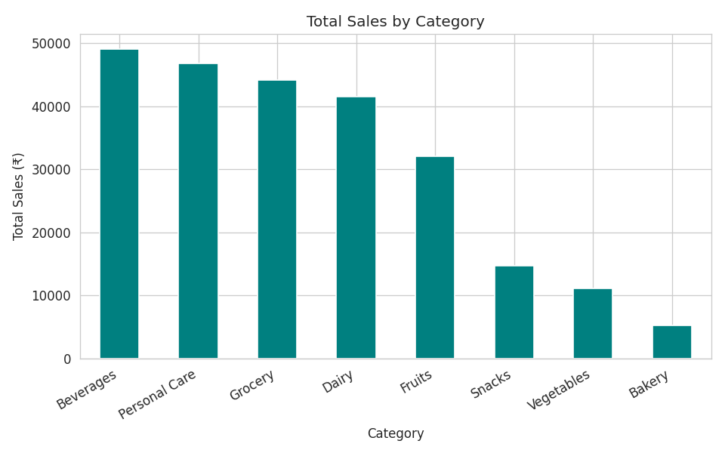
Figure 1: Total sales by product category.
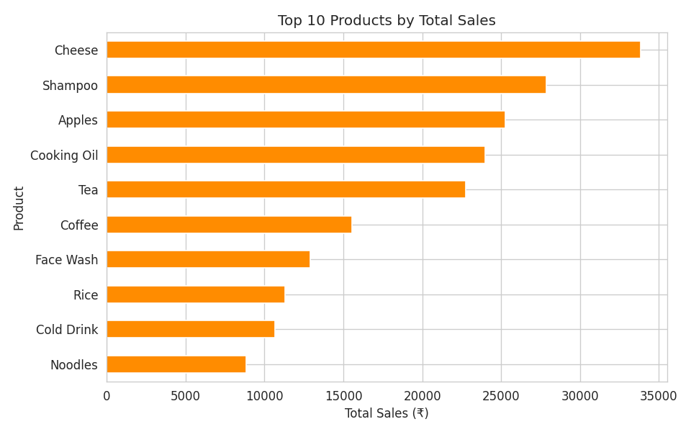
Figure 2: Top 10 products by total sales.
Beverages, Personal Care, and Grocery are the highest-revenue categories, while Bakery contributes the least — useful for stocking and promotional prioritization.

6.2 Branches & Cities
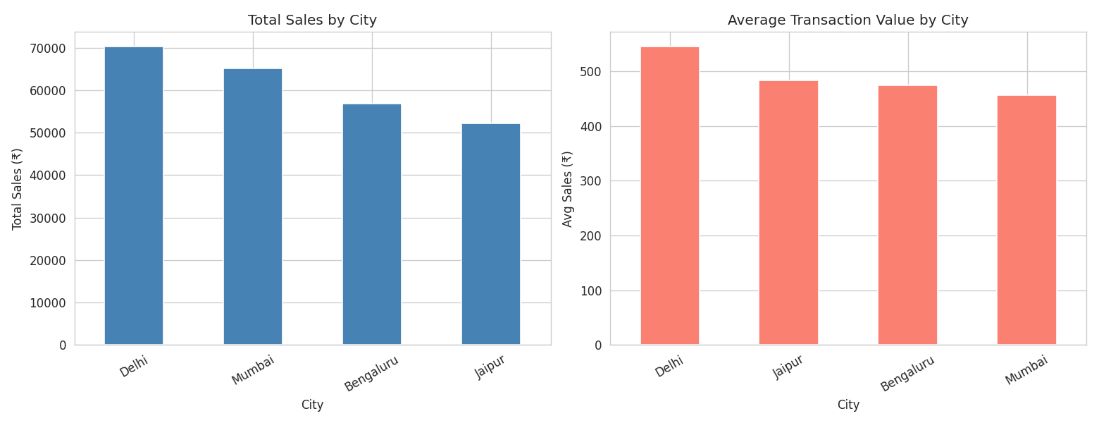
Figure 3: Total sales and average transaction value by city.
Total sales and average transaction value differ noticeably across the four branches, with the Mumbai branch (Branch C) recording the highest transaction volume — relevant for staffing and inventory allocation decisions.

6.3 Customers
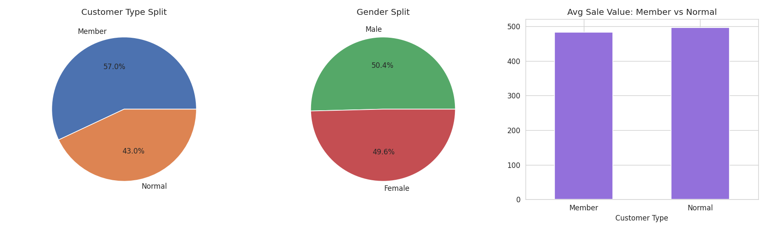
Figure 4: Customer type split, gender split, and average sale value by customer type.
Member customers account for 57% of transactions, but their average transaction value is close to that of Normal customers (only a marginal difference). This suggests that, in this dataset, the loyalty program is associated with higher visit frequency rather than a larger basket size per visit.

6.4 Payments & Ratings
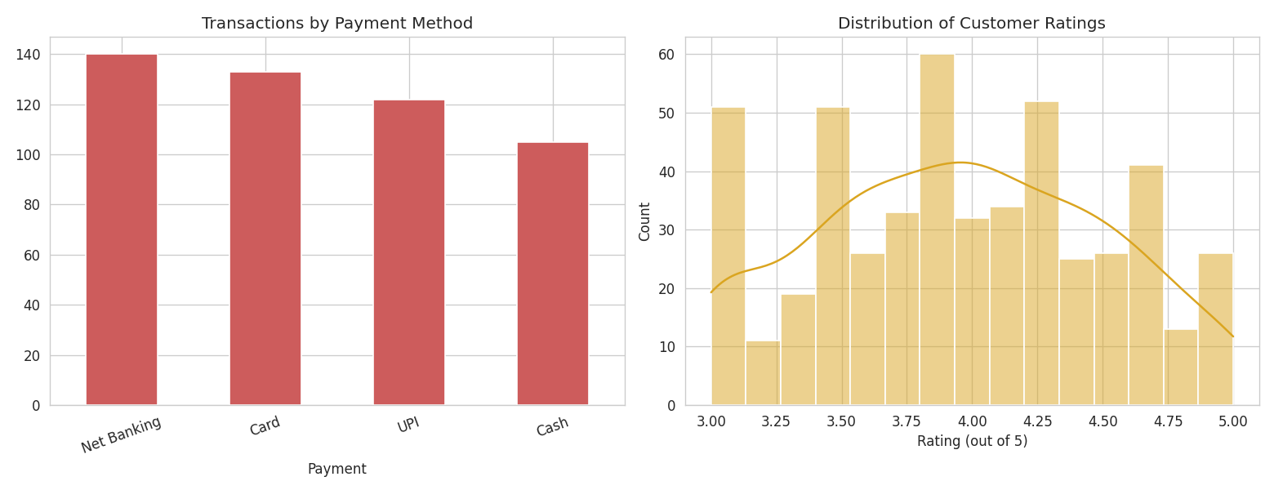
Figure 5: Transactions by payment method (left) and distribution of customer ratings (right).
UPI and Net Banking are the most-used payment methods, reflecting a shift toward digital payments. Customer ratings cluster around 4 out of 5 with a roughly normal spread, and average ratings remain consistent (~3.9–4.0) across branches and payment methods, indicating steady service quality with no clear weak point.

6.5 Correlation Analysis
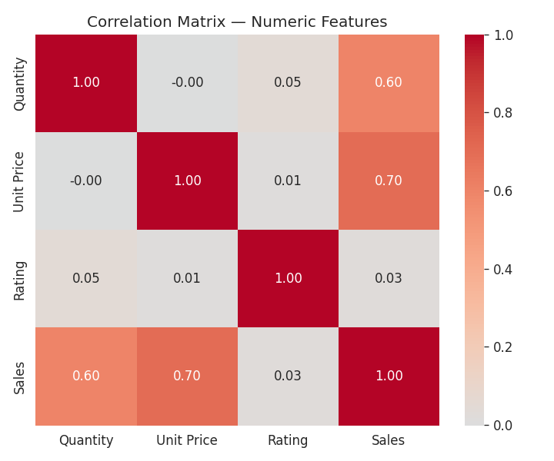
Figure 6: Correlation matrix of numeric features.
Sales is strongly correlated with Unit Price and moderately with Quantity, as expected since Sales is their product. Rating shows negligible correlation with Sales, indicating transaction size does not systematically influence how customers rate their experience.

7. Predictive Analytics (AI) Component
As an AI extension to the core analytics, Linear Regression and Random Forest models were trained to predict a transaction's Sales value from its Branch, Category, Customer Type, Gender, Payment method, Quantity, and Unit Price, using an 80/20 train-test split.
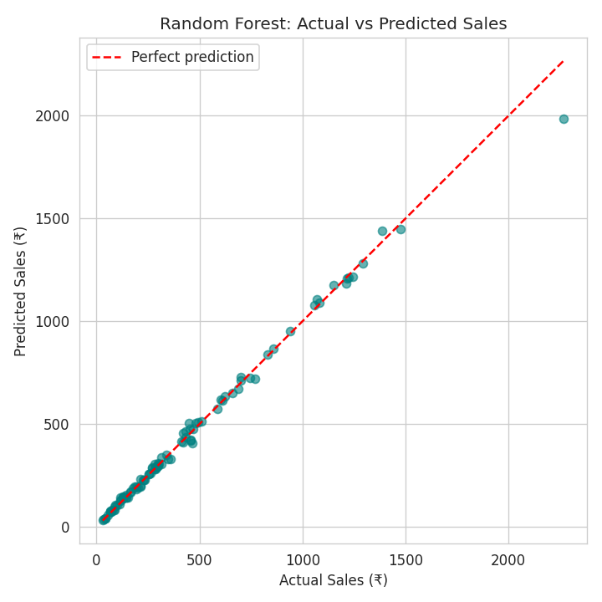
Figure 7: Random Forest — actual vs. predicted sales on the test set.
Both models achieve very high accuracy, since Sales is deterministically Quantity × Unit Price and both are included as input features. This exercise primarily demonstrates the end-to-end modeling pipeline (encoding categorical features, train-test splitting, model comparison, and evaluation with MAE/R²) rather than solving a genuinely uncertain prediction problem. A more realistic extension — noted in the Future Scope below — would predict Rating instead, since it is not a deterministic function of the other columns.

8. Conclusion
This analysis of 500 supermarket transactions surfaced clear patterns across products, branches, customers, payments, and ratings. Beverages, Personal Care, and Grocery lead in revenue; the Mumbai branch leads in transaction volume; Member and Normal customers spend similarly per transaction, with membership instead driving a higher share of overall transactions; UPI and Net Banking dominate payment choice; and customer satisfaction is consistently high across the board. These findings translate directly into actionable recommendations for inventory, marketing, and loyalty-program strategy.

9. Recommendations
- Promote top-selling categories (Beverages, Personal Care, Grocery) with bundled offers, while running targeted promotions to lift under-performing categories like Bakery.
- Investigate ways to increase average basket size for Member customers, since membership currently drives visit frequency more than spend per visit.
- Continue incentivizing digital payments (UPI/Net Banking), which are already the preferred methods.
- Investigate any branch or product line with below-average ratings for targeted service improvements, even though overall satisfaction is currently consistent.
- Use branch-level sales patterns to guide staffing and inventory allocation, particularly for higher-volume branches.

10. Future Scope
- Predict customer Rating (a non-deterministic target) from transaction and customer attributes to uncover satisfaction drivers.
- Add time-series forecasting of weekly/monthly sales per branch or category.
- Perform RFM (Recency, Frequency, Monetary) customer segmentation to identify high-value customers.
- Deploy the analysis as an interactive dashboard (e.g. Streamlit or Power BI) for ongoing business use.

11. References
Supermarket sales dataset — provided Master Class practice material (BharatCares / IBM SkillsBuild internship program).
pandas documentation — https://pandas.pydata.org
scikit-learn documentation — https://scikit-learn.org
seaborn documentation — https://seaborn.pydata.org

