AMAZON SALES DASHBOARD
Business Intelligence & Sales Performance Report
Prepared by: Mansi Jain
Tool Used: Microsoft Power BI
Project Report

1. Executive Summary
This report presents an analysis of an Amazon sales dataset using an interactive Microsoft Power BI dashboard. The dashboard is designed to examine sales, profit, quantity, shipping cost, market performance, regional contribution, customer order priorities, shipping modes, and geographic trends.
The report contains four dashboard views: an overall sales report, profit analysis, regional analysis, and sales analysis. Together, these views provide a consolidated understanding of business performance and help identify high-performing markets, regions, cities, countries, and shipping categories.
2. Project Objectives
- To transform raw Amazon sales data into meaningful visual insights.
- To monitor important business KPIs such as sales, profit, quantity, and shipping cost.
- To compare performance across markets, regions, countries, cities, and states.
- To understand the relationship between shipping modes, order priority, and business performance.
- To create an interactive dashboard that supports filtering and data-driven decision-making.
3. Dataset and Tools Used
Component | Description
Dataset | Amazon sales transaction dataset
File format | Excel workbook (.xlsx)
Visualization tool | Microsoft Power BI
Main measures | Sales, Profit, Quantity, Shipping Cost, Discount
Main dimensions | Country, Region, Market, City, State, Category, Ship Mode, Order Priority
Dashboard pages | 4 analytical pages
4. Dashboard Overview
The dashboard uses a consistent purple-themed layout with KPI cards, slicers, bar charts, area charts, a donut chart, a waterfall chart, a funnel chart, and a treemap. These visual elements allow users to explore the data at different levels of detail while maintaining a clear and organized presentation.
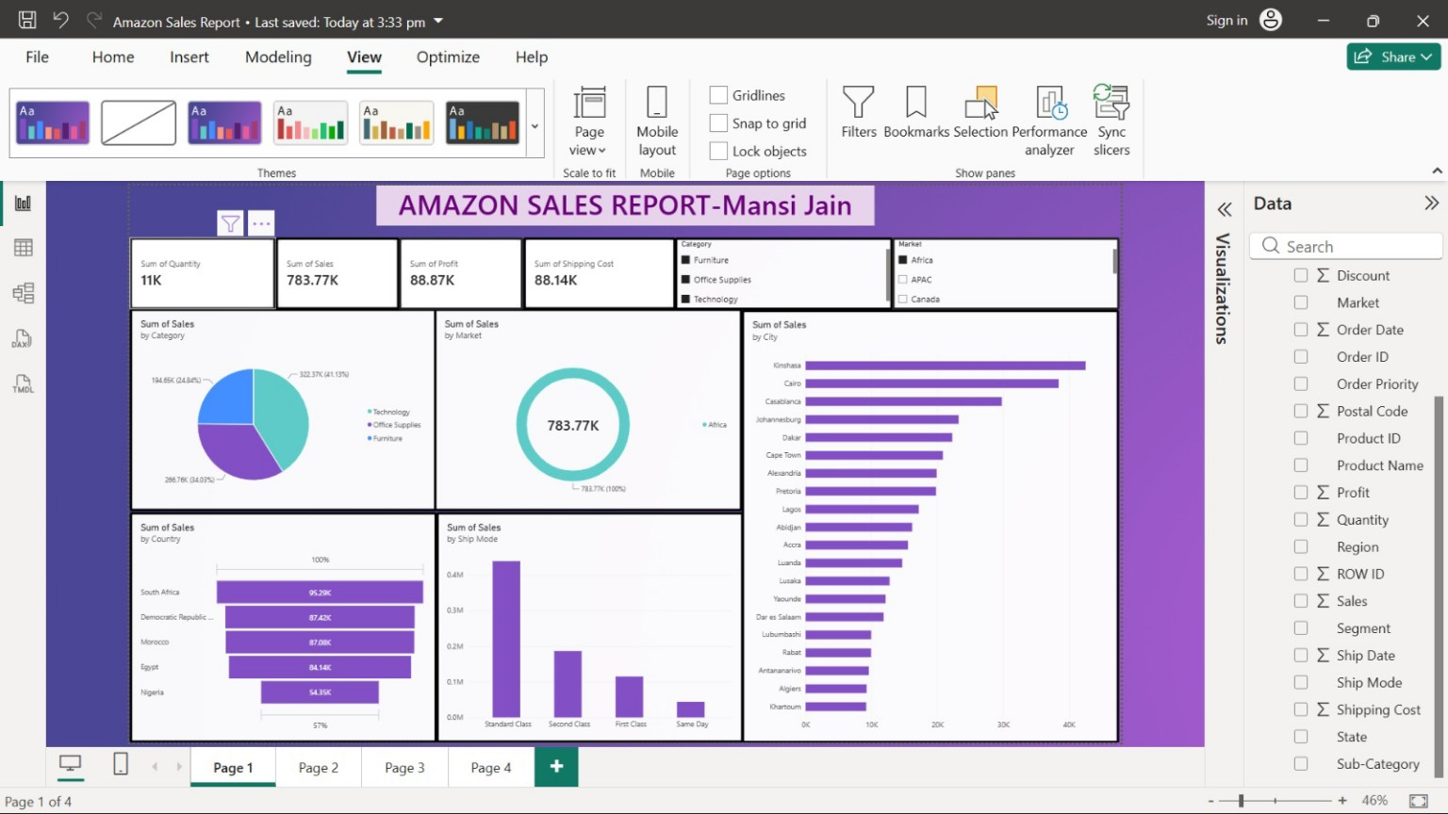
Figure 1. Overall Amazon Sales Report dashboard

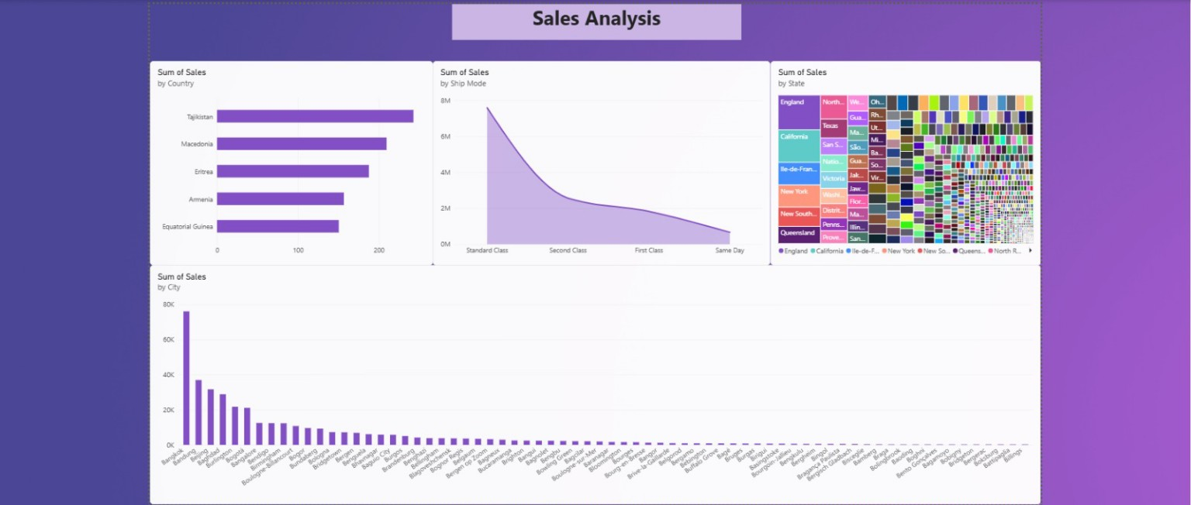
Figure 3. Sales Analysis dashboard

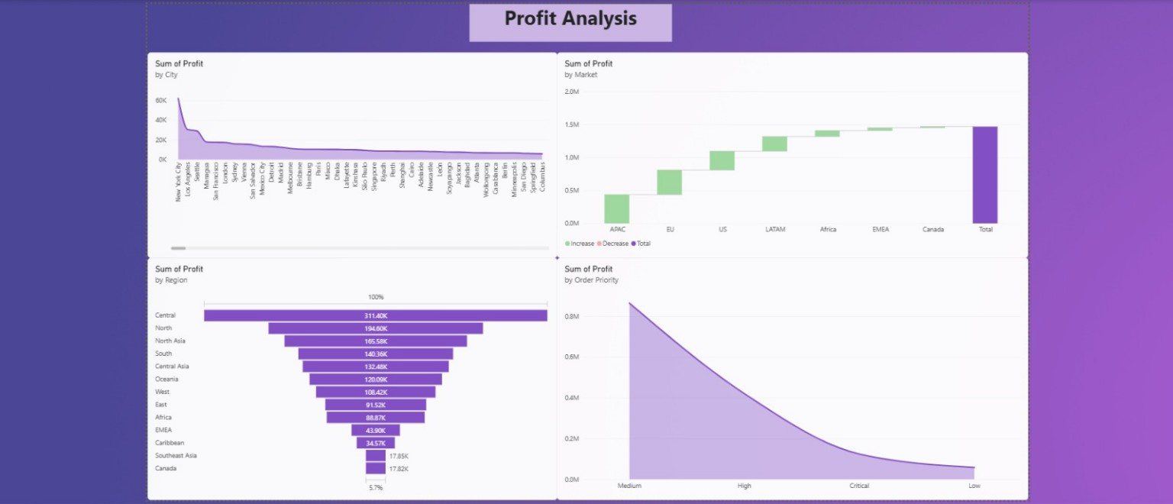
Figure 2. Profit Analysis dashboard

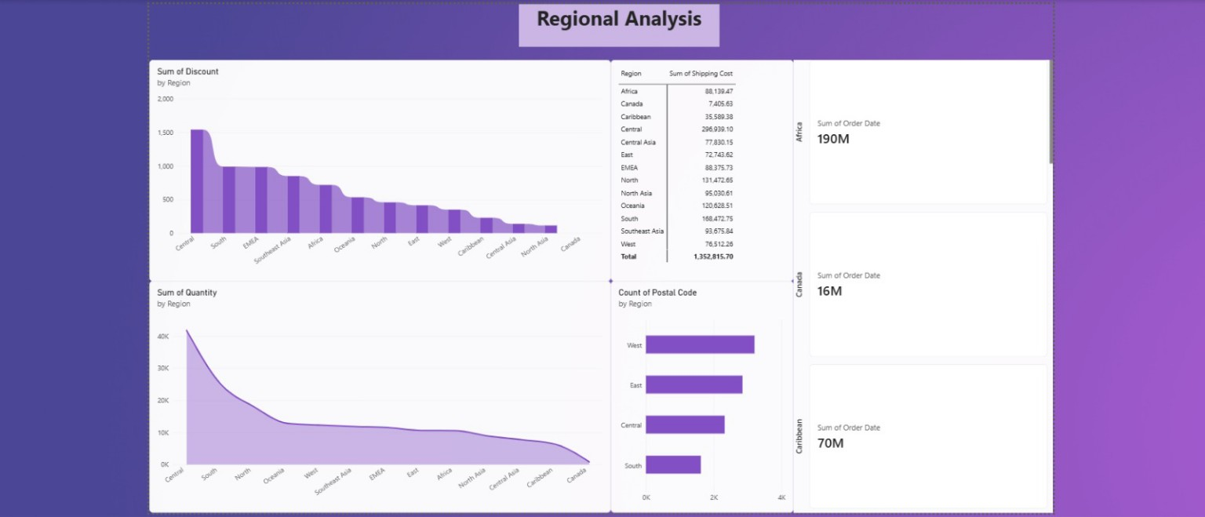
Figure 4. Regional Analysis dashboard

5. Key Performance Indicators
The overall dashboard displays the following high-level indicators based on the visible report summary:
KPI | Displayed Value | Interpretation
Total Quantity | Approximately 11K | Indicates the volume of units sold.
Total Sales | Approximately 783.77K | Represents the total sales value shown in the report view.
Total Profit | Approximately 88.87K | Shows the profit contribution in the selected dashboard context.
Shipping Cost | Approximately 88.14K | Highlights the cost associated with fulfilling orders.
6. Page-wise Analysis
6.1 Overall Sales Report
The first page provides a summary of the business using KPI cards and interactive filters. The category chart indicates that Technology, Office Supplies, and Furniture contribute to the overall sales mix. The market visual and country/city charts allow users to examine how sales are distributed geographically.
The shipping-mode chart compares Standard Class, Second Class, First Class, and Same Day delivery. In the displayed view, Standard Class contributes the largest share of sales, while Same Day represents the smallest share among the shown shipping modes.
6.2 Sales Analysis
The Sales Analysis page presents sales by country, shipping mode, state, and city. The country chart identifies the leading countries in the displayed selection, while the shipping-mode chart again shows Standard Class as the dominant category.
The state treemap provides a compact view of sales distribution across states. The city chart demonstrates that sales are unevenly distributed, with a few cities contributing substantially more than the remaining locations.
6.3 Profit Analysis
The Profit Analysis page focuses on the distribution of profit across cities, markets, regions, and order priorities. The city chart shows that profit is concentrated among a small number of leading cities, followed by a long tail of cities with smaller contributions.
The market waterfall visual presents the cumulative contribution of different markets to total profit. The regional funnel visual highlights differences among regions, with Central appearing as the largest contributor in the displayed chart. The order-priority chart compares Medium, High, Critical, and Low priorities and shows that Medium-priority orders account for the largest displayed profit contribution.
6.4 Regional Analysis
The Regional Analysis page examines discount, shipping cost, quantity, postal-code counts, and selected regional figures. The discount chart compares regions and indicates that discount levels vary considerably across the business.
The shipping-cost table provides a region-level breakdown. In the displayed table, Central has the highest shipping cost, while Canada has one of the lowest. The quantity chart shows Central and South among the largest contributors to units sold. The regional cards on the right provide additional selected-region figures for quick reference.
7. Major Insights
- Sales and profit are geographically concentrated; a limited number of cities and regions contribute a significant portion of the totals.
- Standard Class is the most prominent shipping mode in the displayed sales analysis, suggesting that it is the primary fulfillment option in the dataset.
- Central is shown as a leading region for both profit and shipping cost, which makes it important for further operational analysis.
- The three product categories—Technology, Office Supplies, and Furniture—form the main category structure used for sales comparison.
- Order priority can be examined alongside profit to understand whether urgent or critical orders are associated with different profitability patterns.
- Shipping cost should be monitored together with sales and profit because higher sales volume does not automatically imply higher profitability.
- The treemap and city-level charts can help identify locations that may require targeted marketing, inventory planning, or logistics optimization.
8. Suggested Business Actions
- Investigate the reasons behind strong performance in the highest-contributing regions and cities.
- Review shipping expenses in high-cost regions and evaluate whether delivery options can be optimized.
- Compare profit margins by category, country, and shipping mode before making pricing or promotional decisions.
- Use slicers to examine performance by time period, market, product category, and order priority.
- Track low-performing cities and categories over time to determine whether the pattern is temporary or persistent.
- Add time-based visuals, such as monthly sales and profit trends, in a future dashboard version for stronger forecasting and monitoring.
9. Limitations
- The report is based on the available dataset and the figures displayed in the Power BI dashboard.
- The dashboard screenshots show selected views; some values may change when filters or slicers are applied.
- The analysis describes patterns in the data and does not establish the causes of those patterns.
- Additional fields such as customer segments, returns, inventory levels, and product-level margins could improve the depth of analysis.
10. Conclusion
The Amazon Sales Dashboard converts a large sales dataset into an accessible business intelligence report. It brings together sales, profit, quantity, shipping cost, geography, category, shipping mode, and order priority in one interactive environment.
The analysis indicates that performance varies across regions and locations, Standard Class is the dominant shipping mode in the displayed view, and a small number of geographic areas contribute strongly to overall results. The dashboard can be used as a foundation for more detailed profitability, logistics, and time-series analysis.

