DB Schema :

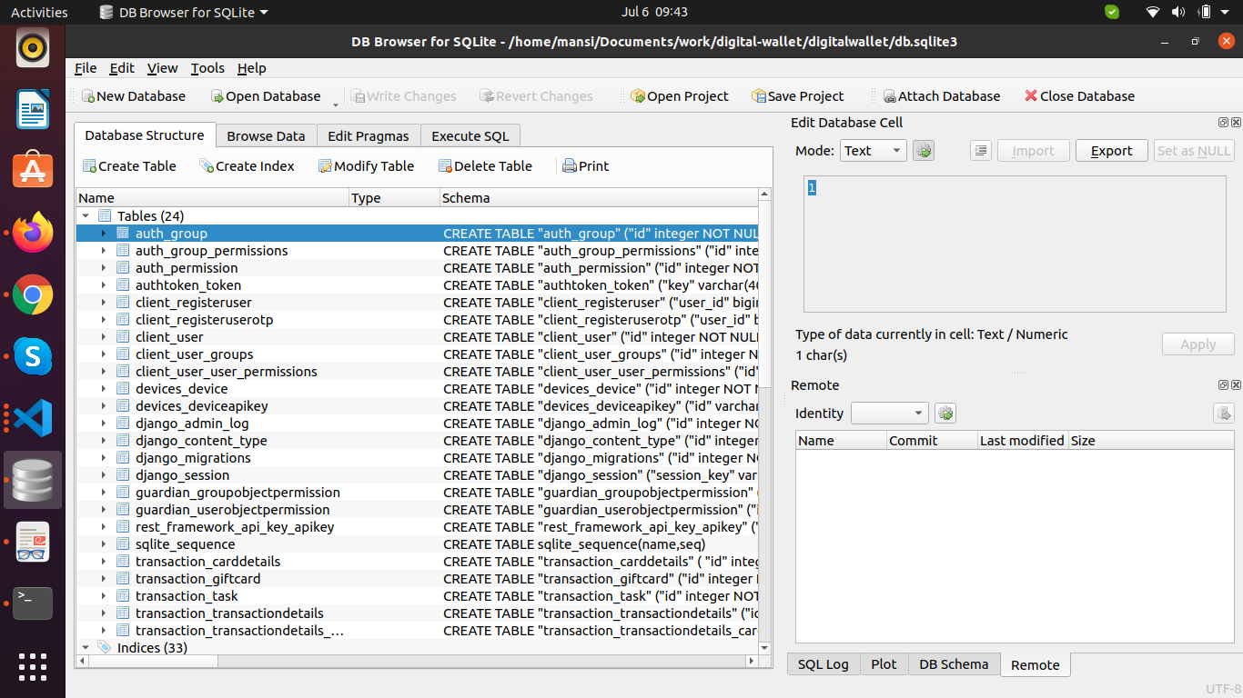

client_registeruserotp -> to store generated otp.
client_registeruser -> extra table, will be deleted.(was created for demo purpose)
client_user -> to store user details.
devices_device -> to store all the devices
devices_deviceapikey -> to store apikey for the device.
transaction_carddetails -> details of the card assigned to user.
transaction_giftcard -> to store details of the gift card.
transaction_transactiondetails -> to store transaction details like amount credited etc.
transaction_transactiondetails_cardetails -> to store mapping of trasaction associated with card.

