Movie Recommendation System: Technical Report

1. Problem Understanding
This project builds a Netflix movie recommendation system from user-movie rating data. The system has two goals:

- Predict how a user may rate an unseen movie.
- Generate a ranked top-k list of unseen movies for each user.

The final user-facing task is ranking, so the project evaluates both rating-prediction accuracy and top-k recommendation quality. The full workflow is in main.ipynb; reproducible scripts are provided for preprocessing, training, evaluation, recommendation generation, and report figures.

2. Data and Preprocessing
The project uses Netflix ratings and movie metadata.

File | Purpose
combined_data_1.txt | Raw Netflix ratings in movie-header format
netflix_ratings_1.csv | Parsed ratings with UserID, MovieID, Rating, and Date
movie_titles.csv | Movie metadata with MovieID, Year, and Title

Preprocessing steps:

1. Parse the raw Netflix file if the parsed CSV is not already present.
2. Load movie metadata using Latin-1 encoding to handle title characters.
3. Sample 3,000,000 ratings with random_state=42 for reproducibility.
4. Keep users with at least 10 ratings to reduce user sparsity.
5. Keep movies with at least 50 ratings to ensure enough item-level signal.
6. Use UserID, MovieID, and Rating for modeling.
7. Create an 80:20 train/test split.

Final modeling dataset after filtering:

Quantity | Value
Ratings | 1,968,136
Users | 100,209
Movies | 2,208
Training ratings | 1,574,508
Test ratings | 393,628

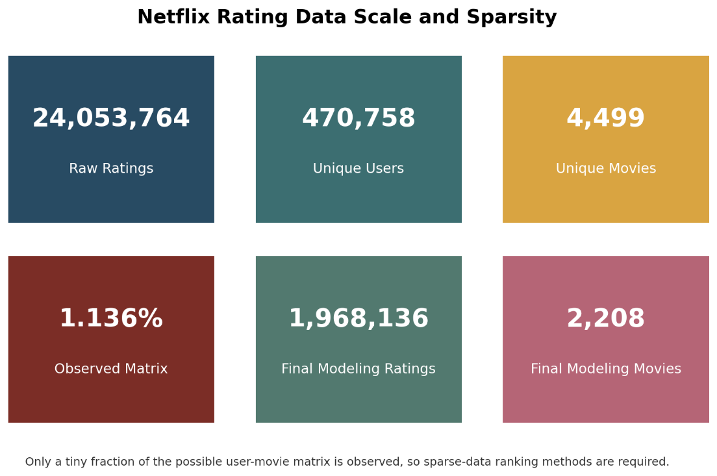
Figure 1. The raw data is large, but the user-movie matrix is still highly sparse. This justifies filtering and collaborative ranking methods.

3. Exploratory Data Analysis
EDA examined rating behavior, user activity, movie popularity, sparsity, temporal patterns, and popularity versus average rating.

Key findings:

- Ratings are positively biased, with most ratings concentrated around 3 and 4 stars.
- User behavior is imbalanced: many users rate only a small number of movies, while a smaller group is highly active.
- Movie popularity is strongly long-tailed: a small set of movies receives most ratings.
- Popularity and quality are not equivalent. The popularity-vs-average-rating correlation is weak, around 0.237.
- Because the matrix is sparse and popularity is imbalanced, a personalized recommender is more appropriate than a popularity-only list.
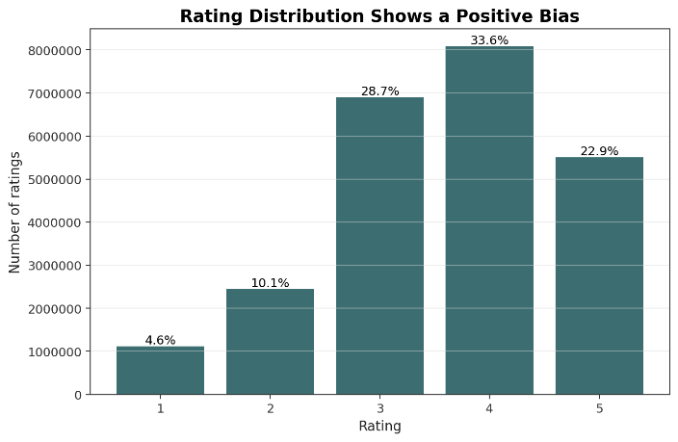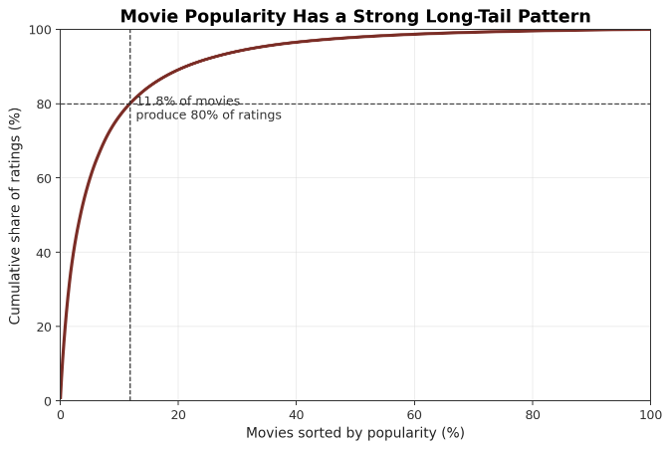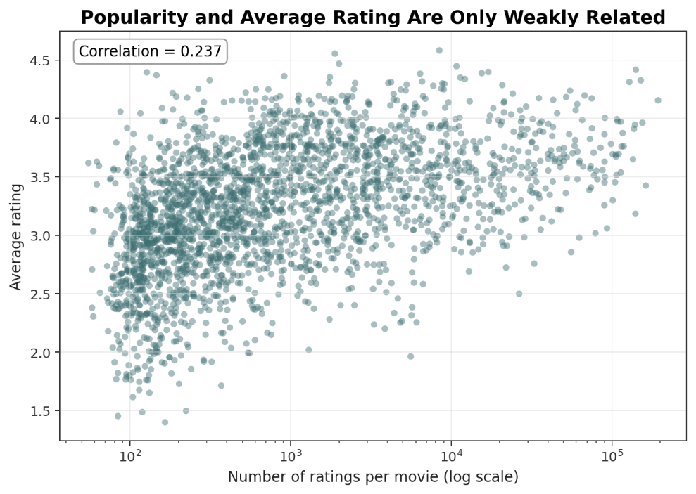

Figure 2. EDA summary: ratings are positively biased, movie popularity is long-tailed, and popularity has only weak relationship with average rating.

4. Methodology and Model Design
The methodology follows a complete recommendation workflow: preprocess and filter sparse Netflix ratings, explore user/item behavior, train rating-prediction models, build a ranking-focused hybrid recommender, evaluate using held-out data, and generate top-k recommendations.

4.1 Item-Based Collaborative Filtering
This model builds a movie-user rating matrix, fills missing values with zero for cosine similarity, and predicts ratings from the user's ratings on similar movies.

Neighborhood size K was tuned using K = 5, 10, 20, 30, 50, 100. The best value was K = 20, with RMSE approximately 1.0163 and MAE 0.8075.

This approach is interpretable and directly models movie similarity, but it is limited by sparse rating overlap.

4.2 SVD Matrix Factorization
The SVD model from Surprise learns latent user and item factors, capturing hidden preference patterns beyond direct item overlap.

Selected hyperparameters:

Parameter | Value
n_factors | 20
n_epochs | 20
reg_all | 0.05
lr_all | 0.005
random_state | 42

Final SVD rating-prediction result: RMSE 0.9294, MAE 0.7332.

4.3 Implicit Item-Based Hybrid Recommender
Strong rating prediction did not automatically produce the best top-k ranking, so the final recommender was designed directly for ranking.

The hybrid model treats ratings of 4 or 5 as positive interactions and scores unseen movies using:

final_score = alpha * item_similarity_score + (1 - alpha) * popularity_score

Signals used:

- Popularity score: promotes movies liked by many users.
- Item-similarity score: promotes movies similar to the user's liked movies.
- Rated-movie filtering: removes movies already rated by the user.

The hybrid weight alpha was tuned using MAP@10. The best result was alpha = 0.50 with MAP@10 approximately 0.03080, showing that both popularity and item similarity contributed useful ranking signal.

5. Evaluation Metrics and Experimental Results
The project uses rating and ranking metrics because prediction accuracy and recommendation quality are different objectives.

Metric | Purpose | Better Direction
RMSE | Penalizes large numeric rating errors | Lower
MAE | Measures average absolute rating error | Lower
Precision@10 | Share of top-10 recommendations that are relevant | Higher
Recall@10 | Share of held-out relevant movies recovered in top 10 | Higher
Hit Rate@10 | Share of users with at least one top-10 hit | Higher
MAP@10 | Rewards relevant movies appearing higher in the ranking | Higher

For ranking evaluation, movies rated 4 or 5 in the test set are treated as relevant.

Experimental results:

Model | RMSE | MAE | MAP@10 | Main Conclusion
Item-Based CF | 1.0163 | 0.8075 | - | Interpretable baseline, weaker under sparsity
Tuned SVD | 0.9294 | 0.7332 | 0.00818 | Best rating prediction, weak ranking
Popularity Baseline | - | - | 0.02346 | Strong non-personalized ranking baseline
Implicit Hybrid | - | - | 0.03080 | Best final top-k recommender

Final hybrid quality: Precision@10 0.02160, Recall@10 0.09582, Hit Rate@10 0.19767, MAP@10 0.03080.

Practical model comparison:

Model | Recommendation Quality | Training Complexity | Computational Efficiency | Practical Usability
Item-Based CF | Moderate; sparse overlap hurts | Medium | Fast after similarity build; memory grows with movies | Interpretable baseline
Tuned SVD | Best RMSE, weak ranking | Medium-high | Efficient after training | Good for rating prediction
Popularity Baseline | Strong but generic | Low | Very fast | Robust, not personalized
Implicit Hybrid | Best MAP@10 | Medium | Efficient top-k scoring on sampled set | Best balance of personalization, popularity, explainability

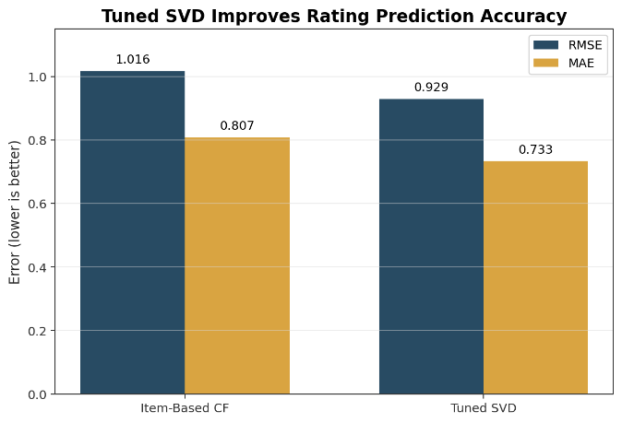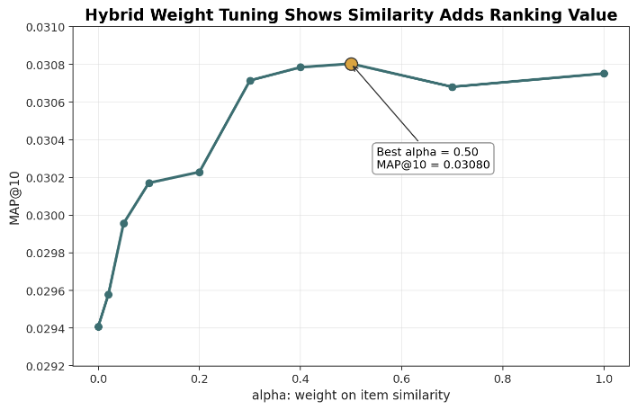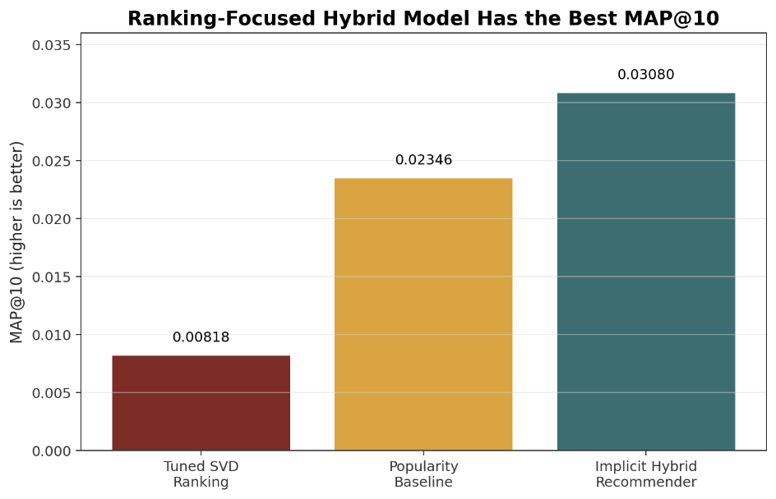

Figure 3. Model results summary: SVD is best for rating prediction, while the implicit hybrid recommender is best for top-k ranking. Hybrid tuning selects `alpha = 0.50`.

6. Recommendation Examples
recommendation_generation.py finds a user's rated movies, scores unseen candidates, removes already-rated movies, sorts by hybrid score, and returns top-k titles with release years.

Example recommendations for user 305344:

Rank | Movie | Year | Hybrid Score
1 | The Sixth Sense | 1999 | 0.9843
2 | The Silence of the Lambs | 1991 | 0.9715
3 | Pirates of the Caribbean: The Curse of the Black Pearl | 2003 | 0.9436
4 | Lord of the Rings: The Fellowship of the Ring | 2001 | 0.9397
5 | Braveheart | 1995 | 0.9280
6 | Lethal Weapon | 1987 | 0.9169
7 | Finding Nemo (Widescreen) | 2003 | 0.9085
8 | Jaws | 1975 | 0.9080
9 | Shrek 2 | 2004 | 0.8979
10 | The Wizard of Oz: Collector's Edition | 1939 | 0.8885

The full top-10 list demonstrates readable user-facing output. Already-rated movies are removed before ranking.

7. Success and Failure Cases
A success case is a user for whom at least one held-out positive test movie appears in the top-10 recommendations. The notebook generated recommendations for sampled evaluation users and compared them against held-out positive test movies.

Representative success cases:

UserID | Hits@10 | AP@10 | Matched held-out positive movies
84748 | 3 | 0.3778 | Lord of the Rings: The Fellowship of the Ring; Pirates of the Caribbean: The Curse of the Black Pearl; X2: X-Men United
373913 | 3 | 0.3417 | American Beauty; Pirates of the Caribbean: The Curse of the Black Pearl; Reservoir Dogs
253991 | 3 | 0.2667 | Finding Nemo (Widescreen); The Silence of the Lambs; Shrek 2

These cases confirm that the model can recover movies users actually liked but that were hidden during training. MAP@10 remains modest because the task is sparse and each user has few held-out positive movies.

Failure cases and causes:

Failure Case | Likely Cause | Improvement
No held-out hit in top 10 | Sparse user history or few positive test movies | Train on more data; add content features
Popular movies dominate recommendations | Long-tail imbalance and popularity signal | Add diversity/novelty constraints
Similarity misses niche taste | Limited overlap between niche movies | Use genre/cast/director metadata

8. Reproducibility

Step | Command
Install dependencies | pip install -r requirements.txt
Preprocess data | python data_preprocessing.py --data-dir . --output-dir processed
Train models | python model_training.py --processed-dir processed --artifacts-dir artifacts
Evaluate recommender | python evaluation.py --processed-dir processed --artifacts-dir artifacts --top-k 10
Generate recommendations | python recommendation_generation.py --artifacts-dir artifacts --user-id 305344 --top-k 10
Generate report figures | python generate_report_figures.py

Generated directories:

Directory | Contents
processed/ | Processed data and train/test splits
artifacts/ | Saved SVD model, hybrid recommender, metrics, and tuning results
report_images/ | Figures used in this report

9. Key Insights and Future Work
Key insights:

- The Netflix rating data is large but sparse, so filtering and sparse-aware models are necessary.
- Ratings are positively biased and movie popularity is long-tailed.
- Popularity is a useful signal but does not fully represent movie quality or user preference.
- Tuned SVD is best for numeric rating prediction.
- The implicit item-based hybrid recommender is best for top-k ranking.
- Rating-prediction accuracy and recommendation-ranking quality are different objectives.

Future improvements:

- Train on a larger sample or the full Netflix dataset to improve collaborative coverage.
- Add content features such as genre, cast, director, language, and synopsis.
- Use temporal train/test splitting to better simulate future recommendations.
- Add ranking metrics such as NDCG@10, coverage, diversity, and novelty.
- Save and deploy model artifacts behind a simple API or web interface.

10. Conclusion
This project implements a complete movie recommendation workflow: data parsing, preprocessing, EDA, model training, hyperparameter tuning, evaluation, recommendation generation, success-case analysis, and reproducible scripts.

The tuned SVD model achieved the best rating-prediction performance with RMSE 0.9294 and MAE 0.7332. However, the final goal is ranked recommendation, and the implicit item-based hybrid recommender achieved the best top-k result with MAP@10 0.03080 at alpha = 0.50. Therefore, the hybrid recommender was selected as the final recommendation model.

