

A Project Report On

**“Quiz Game website”**

**(QUIZZLE)**

**SUBMITTED BY**

Sanjana Patel, Mansi Zanjale.

(TY-BBA-CA)

**UNDER GUIDANCE**

PROF. Deepak Singh

**SUBMITTED TO**

SURYADATTA COLLEGE OF MANAGEMENT INFORMATION

RESEARCH AND TECHNOLOGY (SCMIRT)

PUNE-411021

**IN FULLFILLMENT OF**

BACHELOR OF BUSINESS ADMINISTRATION

(COMPUTER APPLICATION)

2024-25

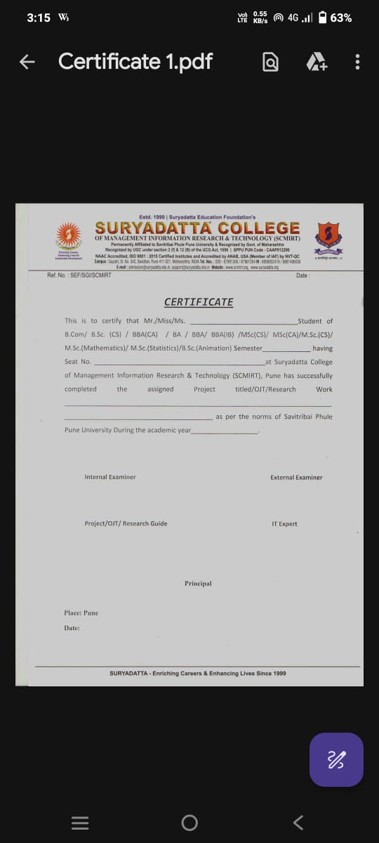

# **Acknowledgement**

The success and final outcome of this project required a lot of guidance and assistance from many people and we are extremely fortunate to have got this all along the completion of our minor project work. Whatever we have done is only due to such guidance and assistance.

we would not forget to thank BBA-CA coordinator and Project guide Asst.Prof. Deepak Singh, we are extremely grateful to him for providing such a nice support and guidance though he had busy schedule managing the college dealings.

Asst.prof. Monali Meghal and all other Assistant professors of SCMIRT Department, who took keen interest on our project work and guided us all along, till the completion of our project work by providing all the necessary information for developing a good system.

We are thankful and fortunate enough to get support and guidance from all Teaching staffs of Bachelor of Business Administration (Computer Application) Department which helped us in successfully completing our project work. Also, we would like to extend our sincere regards to all the non-teaching staff of Bachelor of Business Administration (Computer Application) Department for their timely support.

Contents

**Acknowledgement** 3

Motivation 6

Problem Statement 6

Purpose and Goals 8

Literature Survey 9

Project Scope and Limitation 10

**System Analysis** 11

Existing System 11

Scope & Limitation of Existing System 12

Project Perspective & Features 13

Project Features 13

Stakeholders 15

Requirement Analysis 16

**System Design** 17

System Module 17

Data Model 23

User Interface 24

Implementation Details 28

Software & Hardware Specification 28

Outputs & Report Testing 29

Test Cases 29

2. Black Box Testing 31

3. White Box Testing 31

Test Results 32

Conclusion and Recommendations 33

Future Scope 34

Bibliography and References 35

**Introduction**

Quizzle is an innovative web-based quiz game platform designed to provide an engaging and interactive learning experience for users. The platform aims to make learning fun and exciting by offering a wide range of quiz categories, leaderboards, and profile management features.

In today's digital age, online learning has become increasingly popular, and Quizzle is poised to revolutionize the way people learn and interact with educational content. With its user-friendly interface, robust features, and fast performance, Quizzle is an ideal platform for students, educators, and quiz enthusiasts alike. The platform's core features include user registration and login, quiz gameplay, leaderboards, profile management, and an admin panel.

Quizzle's leaderboard feature allows users to compete with each other, fostering a sense of community and healthy competition. The platform's profile management feature enables users to track their progress, view their quiz history, and edit their profile information. The admin panel provides administrators with a comprehensive dashboard to manage quizzes, users, and system settings.

Quizzle's development was motivated by the need for interactive and immersive learning experiences. The platform's design and development were guided by the principles of user-centered design, ensuring that the platform is intuitive, engaging, and easy to use.

Summary- Overall, Quizzle has the potential to transform the way people learn and interact with educational content. Its innovative features, user-friendly interface, and fast performance make it an ideal platform for anyone looking to make learning fun and exciting

## Motivation

The motivation behind creating Quizzle was to develop an engaging and interactive platform where users can test their knowledge, compete with others, and track their progress. The goal was to make learning fun and competitive while offering a smooth user experience.

Quizzle aims to bridge this gap by providing an interactive and immersive learning experience. By leveraging the power of quizzes and games, Quizzle makes learning fun and exciting.

The primary motivation is to:

- Make learning enjoyable and engaging

- Increase learner motivation and participation

- Provide a platform for social learning and competition

- Offer a comprehensive and interactive learning experience

By achieving these goals, Quizzle can have a positive impact on the education sector and beyond. It can help learners develop essential skills, build confidence, and cultivate a love for learning.

Quizzle's motivational force is rooted in its potential to:

- Transform the learning experience

- Empower learners with knowledge and skills

- Foster a sense of community and competition

- Make a positive difference in the lives of learners

With Quizzle, we aim to inspire a love for learning, ignite curiosity, and empower learners to reach their full potential

## Problem Statement

Existing quiz platforms often lack user engagement features, real-time updates, and proper reward mechanisms. Quizzle aims to solve these issues by providing:

-Real-time leaderboard updates

-Reward-based system with stars and trophies

-An intuitive user interface and responsive design

Here's a problem statement for your Quizzle project within the 50-80 line limit:

The traditional learning methods are often dull and unengaging, leading to a lack of interest and motivation among learners. The existing online learning platforms are limited in their ability to provide an interactive and immersive learning experience.

The problems with existing online learning platforms include:

- Lack of interactivity and engagement

- Limited features and functionality

- Poor user experience and navigation

- Inability to track progress and performance

- Limited accessibility and compatibility

These problems result in a lack of motivation and participation among learners, ultimately affecting their learning outcomes and overall educational experience.

Quizzle aims to address these problems by providing a comprehensive and interactive online learning platform that is engaging, motivating, and accessible to all.

The specific problems that Quizzle aims to solve include:

- How to make learning fun and engaging?

- How to provide an interactive and immersive learning experience?

- How to track progress and performance?

- How to make learning accessible and compatible for all?

## Purpose and Goals

The purpose of Quizzle is to:

-Provide an entertaining and educational platform

-Encourage user engagement through scoring and rewards

-Offer real-time competition through leaderboards

The primary goals of Quizzle are:

- To create a user-friendly and interactive learning platform

- To provide a wide range of quiz categories and topics

- To foster a sense of community and competition among learners

- To track progress and performance, and provide personalized feedback

- To make learning accessible and compatible for all devices and platforms

Specifically, Quizzle aims to:

- Increase learner engagement and motivation

- Improve learning outcomes and academic performance

- Provide a platform for social learning and collaboration

- Offer a comprehensive and interactive learning experience

- Make learning fun and enjoyable for all ages and skill levels

By achieving these goals, Quizzle can become a leading online learning platform, revolutionizing the way people learn and interact with educational content.

## Literature Survey

Several quiz platforms exist but lack customization, real-time feedback, and performance-based rewards. Quizzle differentiates itself by offering live leaderboards, star-based rewards, and an admin panel for easy content management.

A review of existing literature reveals that online learning platforms have become increasingly popular in recent years. Studies have shown that interactive and immersive learning experiences can improve learning outcomes and increase learner engagement (Hwang & Wang, 2016; Kim et al., 2017).

Research has also highlighted the importance of gamification and social learning in online learning platforms (Dichev & Dicheva, 2017; Hamari et al., 2014).

Several online learning platforms have been developed to provide interactive and immersive learning experiences, including Khan Academy, Coursera, and Duolingo (Khan Academy, 2022; Coursera, 2022; Duolingo, 2022).

However, these platforms have limitations, such as lack of interactivity and engagement, limited features and functionality, and poor user experience and navigation (Liu et al., 2017; Wang et al., 2018).

Quizzle aims to address these limitations by providing a comprehensive and interactive online learning platform that is engaging, motivating, and accessible to all.

## Project Scope and Limitation

Project Scope:

The project scope includes:

- Designing and developing a user-friendly interface

- Creating a comprehensive database of quiz questions

- Implementing leaderboards and profile management features

- Ensuring compatibility with various devices and browsers

Project Limitations:

The project has the following limitations:

- Limited to web-based platform, no mobile app development

- Limited to quiz-based games, no other game types

- Limited to English language, no multilingual support

- Limited to basic analytics and reporting features

- Dependent on third-party libraries and frameworks for development

# **System Analysis**

## Existing System

Existing quiz systems provide limited user engagement and real-time feedback. There is often a lack of personalization and reward systems. The existing online learning platforms and quiz games have several limitations. They often lack engaging user interfaces, have limited features, and provide poor user experiences.

Some of the existing systems include:

- Coursera: A massive open online course platform, but limited to course-based learning.

- Quizlet: A popular quiz game platform, but limited to flashcard-based learning.

These existing systems lack the interactivity and immersive learning experience that Quizzle aims to provide. Quizzle aims to address these limitations by providing a comprehensive and interactive online learning platform.

## Scope & Limitation of Existing System

Scope:

1. User Authentication: Users must register or log in to play quizzes.

2. Quiz Categories: Users can choose from multiple categories, each containing 10 questions.

3. Scoring and Feedback: Users receive immediate feedback on answers, and scores are stored in the database.

4. Achievements System: Users earn stars and trophies based on their performance.

5. Profile Management: Users can view and edit their profiles, including username, email, and profile photo.

6. Live Leaderboard: Displays the top 10 players with automatic updates every 5 seconds.

7. Admin Panel: Manage users (view, delete), Manage categories and questions (add, delete).

8. Responsive Design: Works on various screen sizes for accessibility.

Limitations:

1. Fixed Number of Questions per Quiz: Each category has a fixed set of 10 questions, which may limit variety.

2. No Timer Feature: The quiz does not include a time limit per question.

3. Limited User Interaction: Users cannot challenge or compete directly with friends in real time.

4. No Question Randomization: If not implemented, users might get the same questions in repeated attempts.

5. Basic Security Measures: May require additional security features such as CAPTCHA, email verification, or two-factor authentication.

6. No Multi-Language Support: The system may not support multiple languages, limiting accessibility for non-English speakers.

## Project Perspective & Features

Users can participate in quizzes, track their scores, earn rewards, and compete on the leaderboard. Administrators manage quiz categories, questions, and user data while monitoring performance analytics.

1. Business Perspective:

Enhances user engagement through gamification (stars, trophies, leaderboards).

Can be monetized via ads, subscriptions, or premium quiz categories.

2. Technical Perspective:

Uses PHP for backend logic and MySQL for database storage.

Ensures smooth performance with AJAX for live leaderboard updates.

Implements authentication to secure user data.

3. User Experience Perspective:

Simple and intuitive interface for easy navigation.

Provides instant feedback on quiz answers.

Allows users to personalize their profiles.

## Project Features

User Features:

1. User Authentication: Register and log in before accessing quizzes.

2. Quiz Categories: Choose from various categories, each category has 10 questions.

3. Answer Feedback: Right answers turn green; wrong answers reveal the correct one.

4. Scoring & Rewards: Scores are added to previous total, earn stars and trophies based on performance.

5. Profile Management: View and edit username, email, and profile picture.

6. Live Leaderboard: Shows top 10 players, updates every 5 seconds.

7. Responsive Design: Works seamlessly on different screen sizes.

Admin Features:

1. User Management: View all registered users, delete users if needed.

2. Category Management: Add and delete quiz categories.

3. Question Management: Add, delete, and update questions with 4 options and 1 correct answer.

4. Admin Management: Add multiple admins, update admin profile.

5. Reports & Analytics: View daily, weekly, and monthly user registration reports.

## Stakeholders

The following stakeholders are identified for the Quizzle project:

- Users: Students, learners, and quiz enthusiasts who will use the platform to learn and play quizzes.

- Admin: Platform administrators who will manage quizzes, users, and system settings.

- Developers: Software developers who will design, develop, and maintain the platform.

Stakeholder Expectations:

Stakeholders expect Quizzle to:

- Provide an engaging and interactive learning experience

- Offer a user-friendly and intuitive interface

- Ensure data security and privacy

- Provide regular updates and maintenance

- Meet educational standards and requirements

By understanding the needs and expectations of stakeholders, Quizzle can ensure that the platform meets the required standards and provides value to its users.

## Requirement Analysis

The requirement analysis involves identifying the functional and non-functional requirements of the Quizzle platform.

Functional Requirements:

The functional requirements of Quizzle include:

- User registration and login

- Quiz creation and management

- Question and answer management

- Leaderboard and scoring system

- Profile management and tracking - Admin panel for managing quizzes and users

Non-Functional Requirements:

The non-functional requirements of Quizzle include:

- Performance: fast loading times and responsive interface

- Security: secure user data and prevent unauthorized access

- Usability: user-friendly and intuitive interface

- Scalability: ability to handle increasing traffic and user base

User Requirements:

The user requirements of Quizzle include: - Easy navigation - Clear instructions and feedback - Engaging and interactive quiz experience - Ability to track progress and scores

# **System Design**

## System Module

Class Diagram:

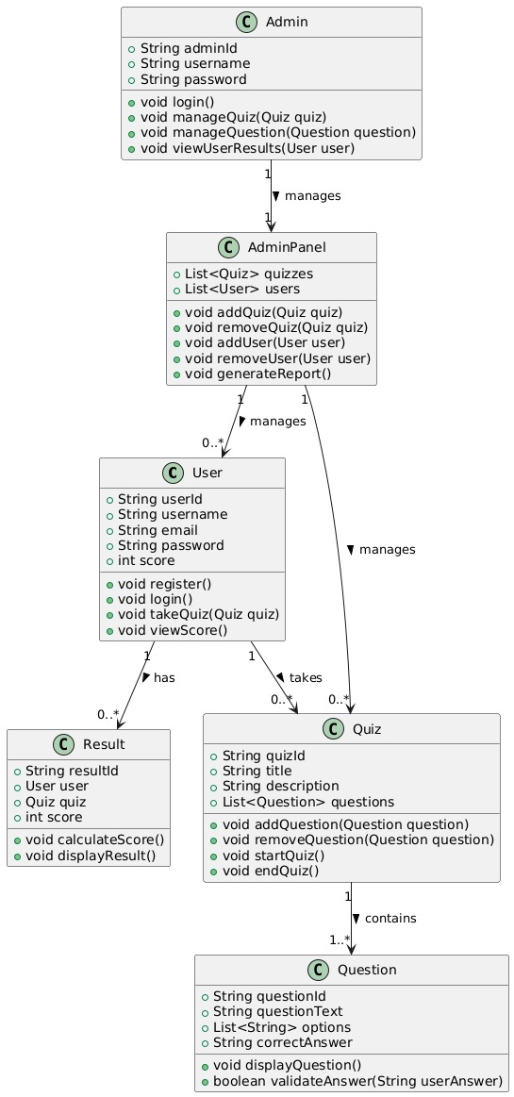

Object Diagram:

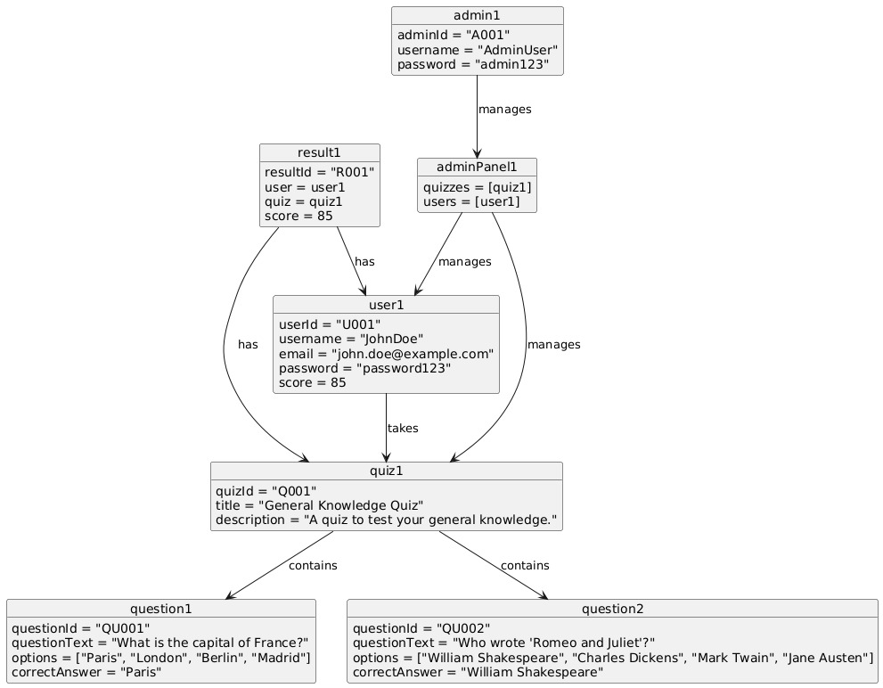

Component Diagram:

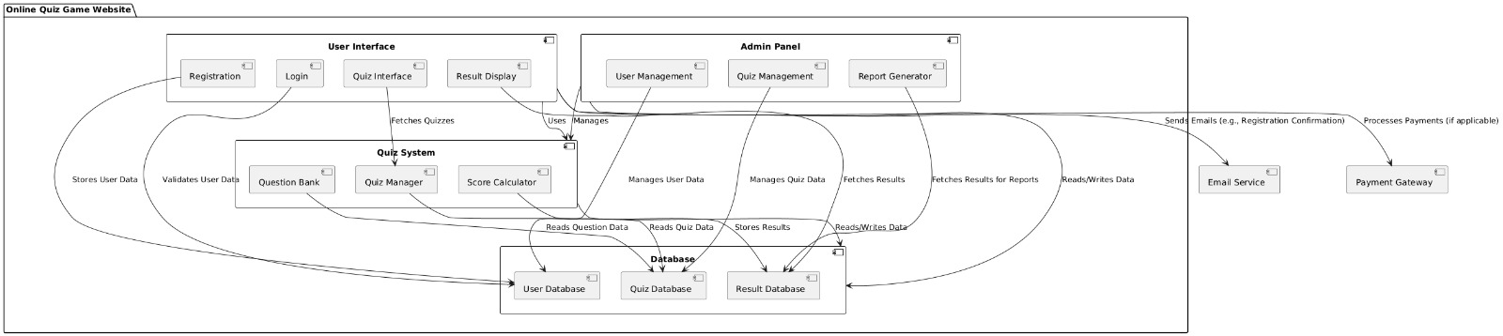

Deployment Diagram:

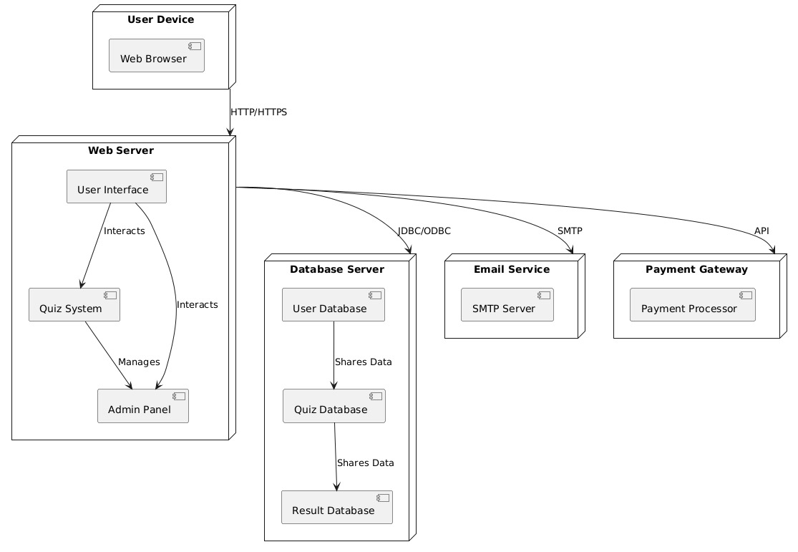

StateChart:

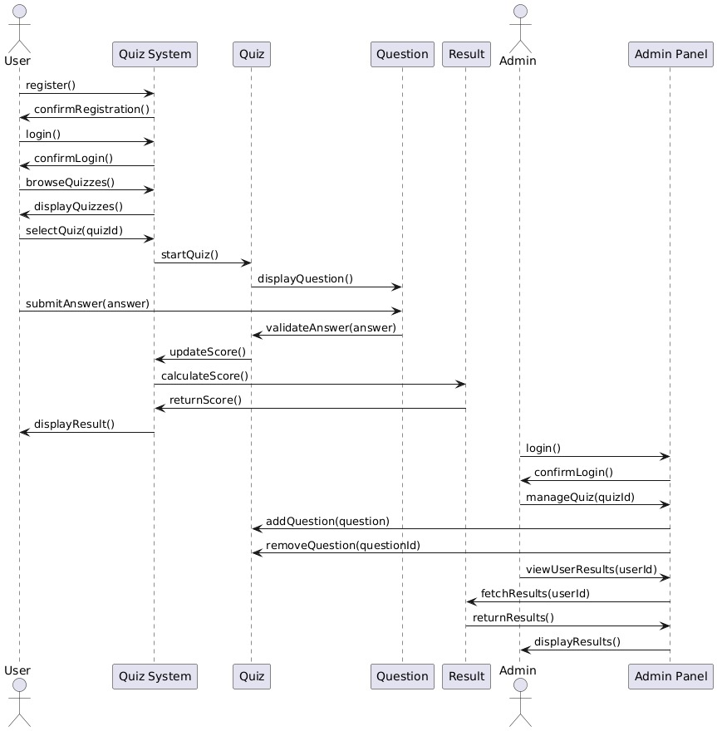

Activity Diagram:

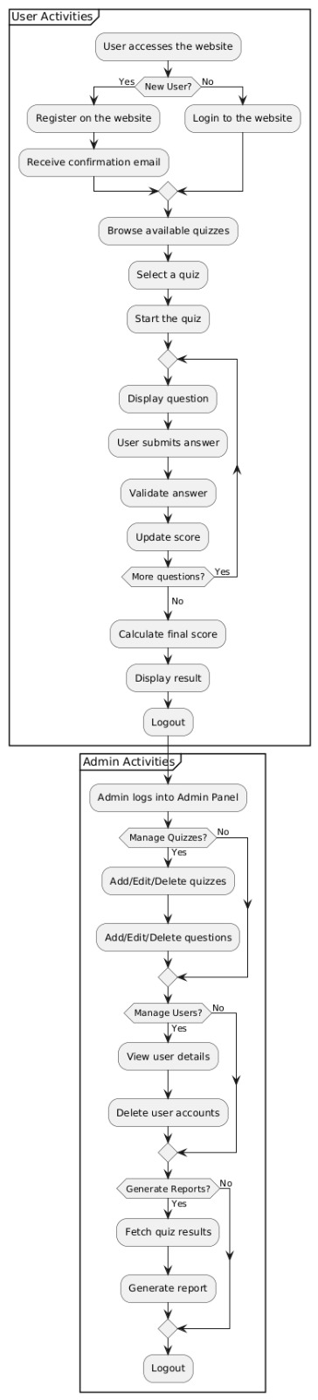

**UseCase Diagram:**

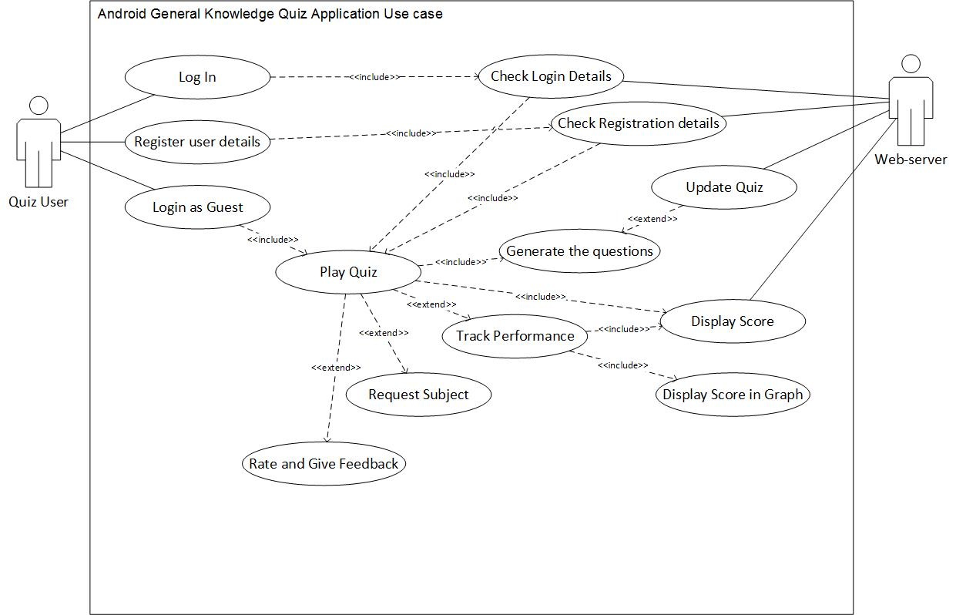

**E R Diagram:**

profile

Email

Password

Id

username

Email

User

username

Admin

plays

Password

Question

User id

Score

creates

Category

Quiz

Result

has

Submit

Options

Quiz id

Prize

Question id

Quiz id

Question text

Question

Answer

## Data Model

Database:

Admin:

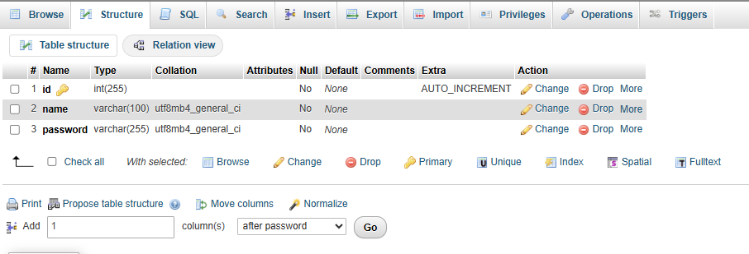

Users:

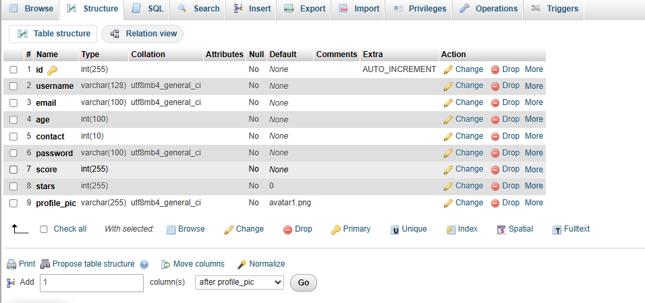

Category:

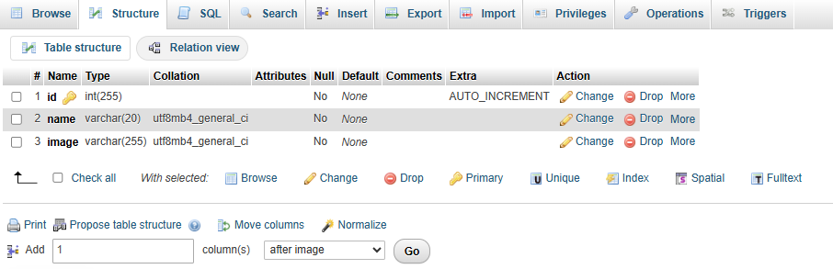

Questions:

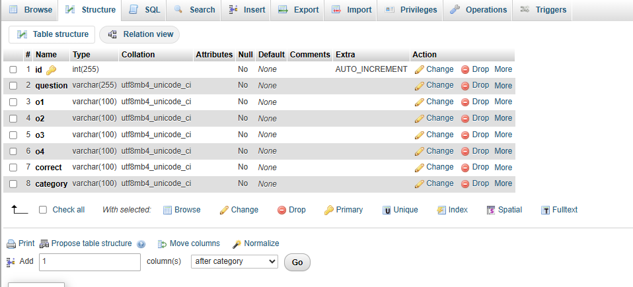

## User Interface

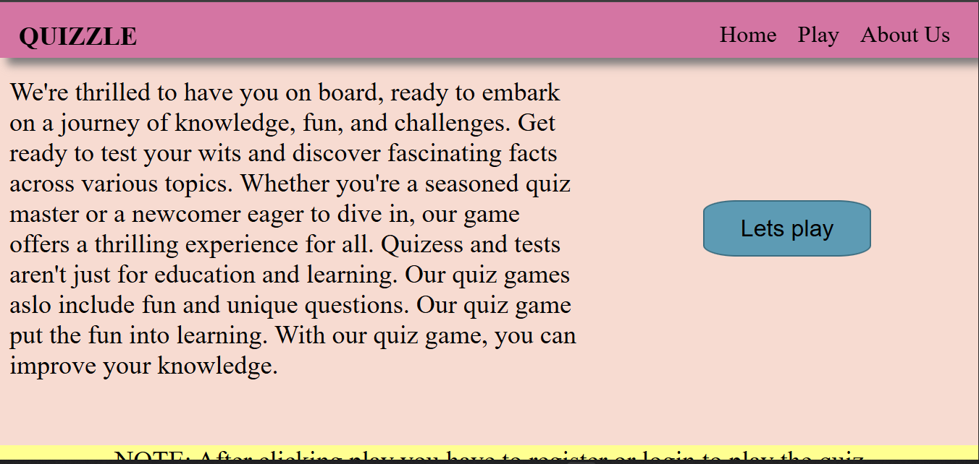

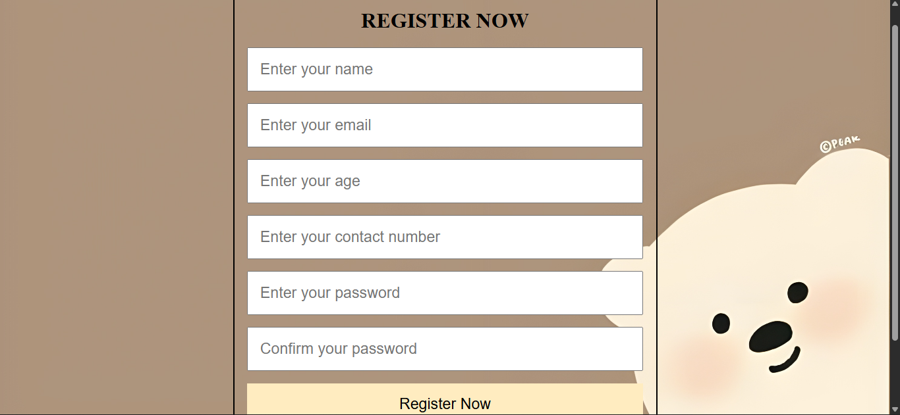

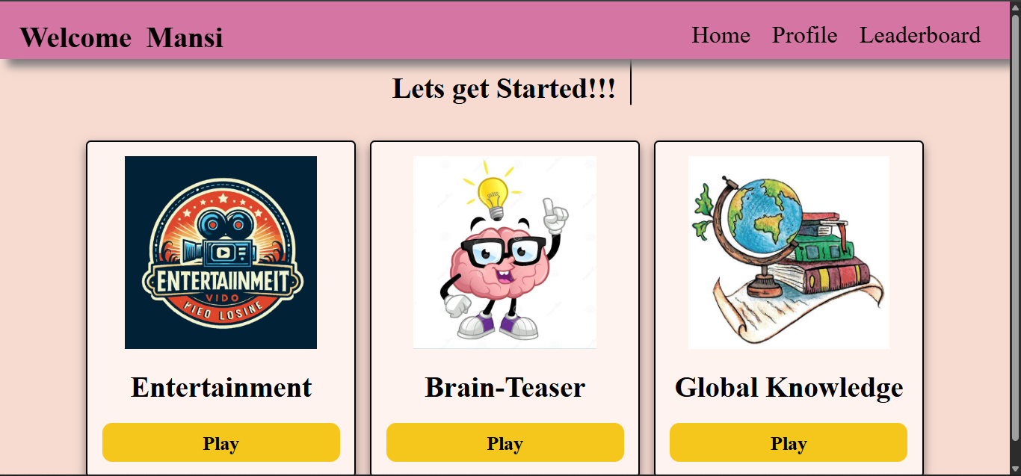

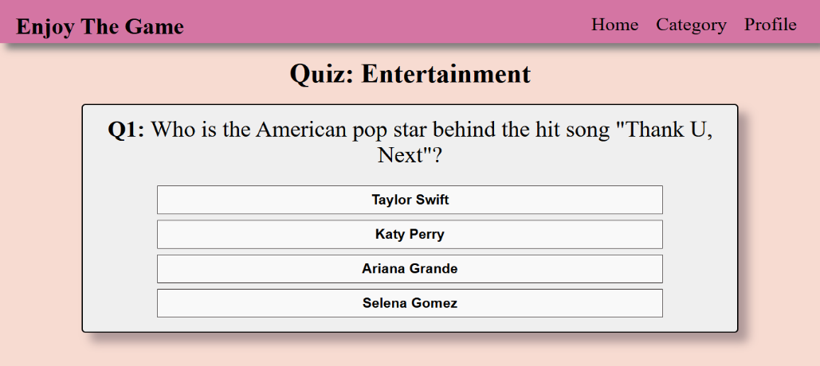

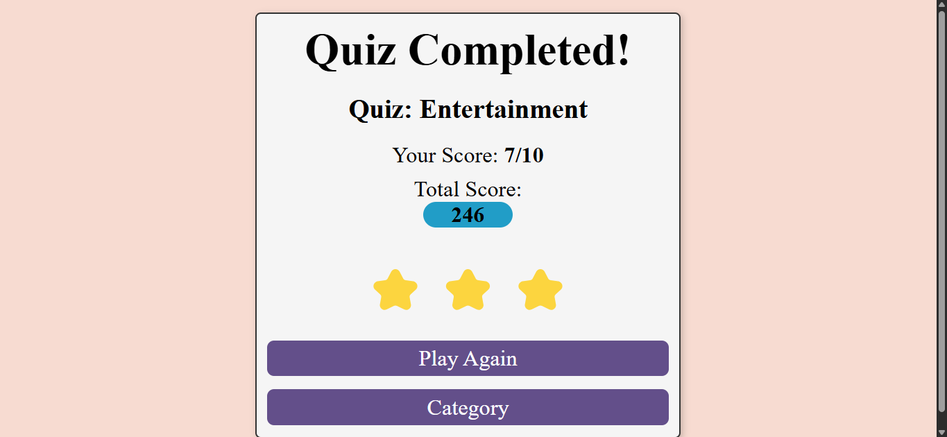

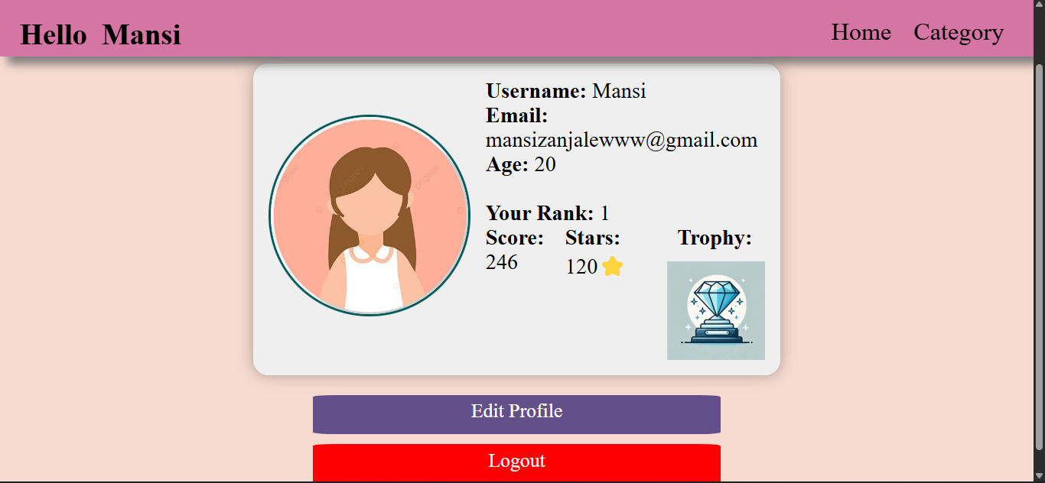

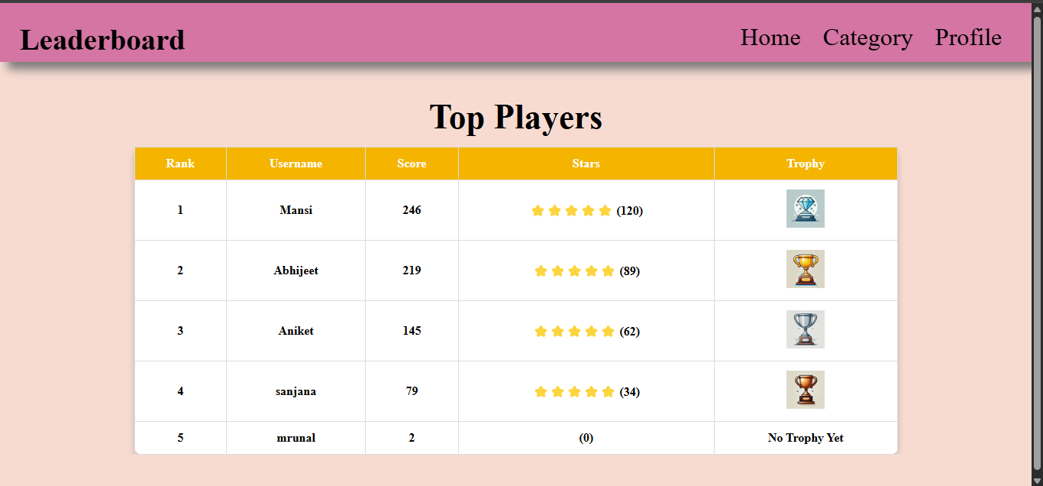

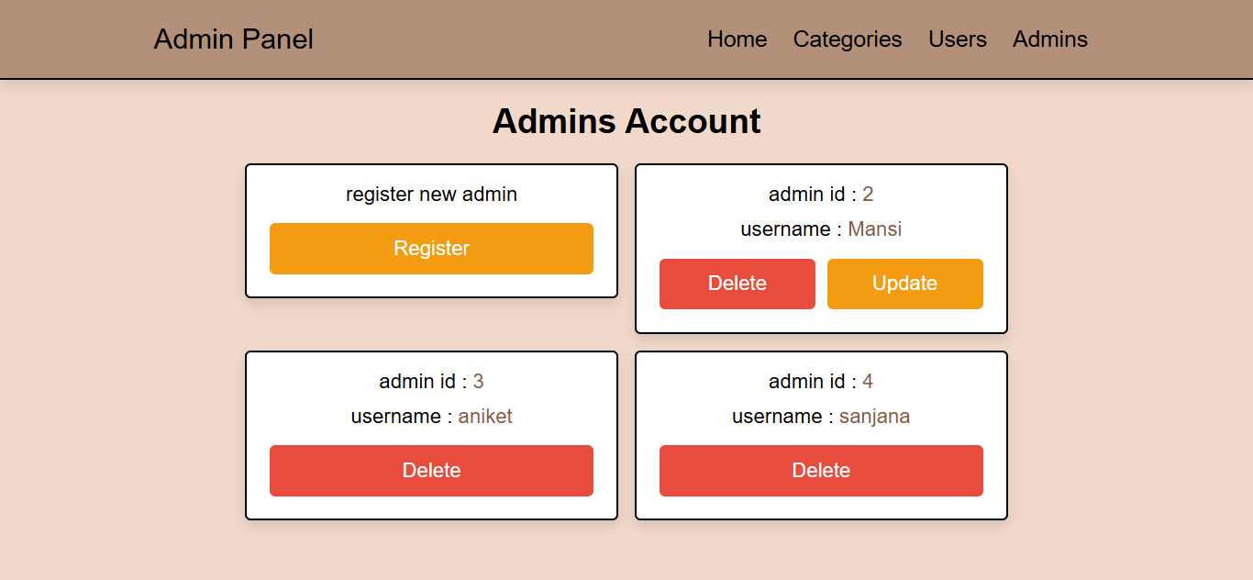

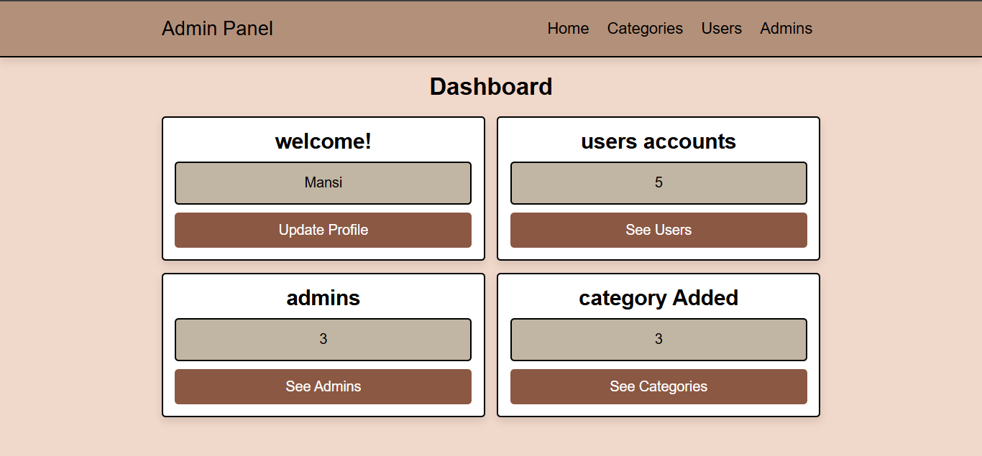

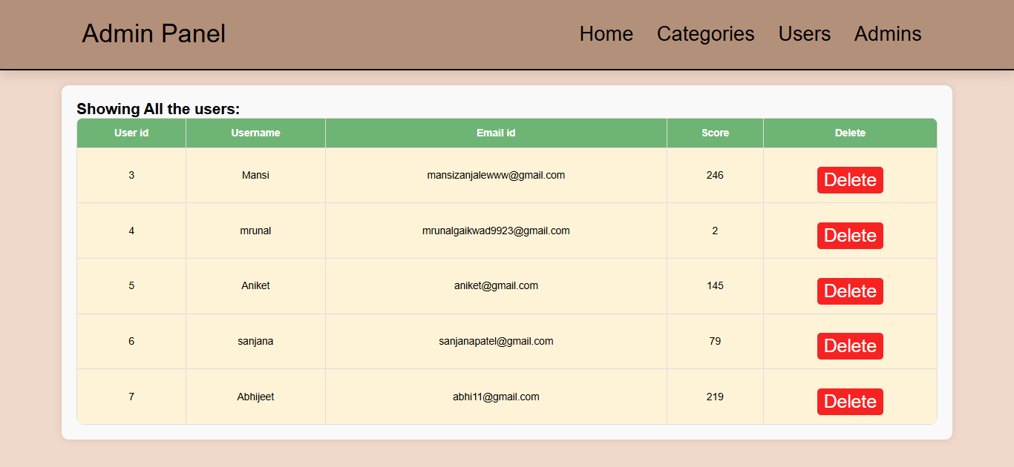

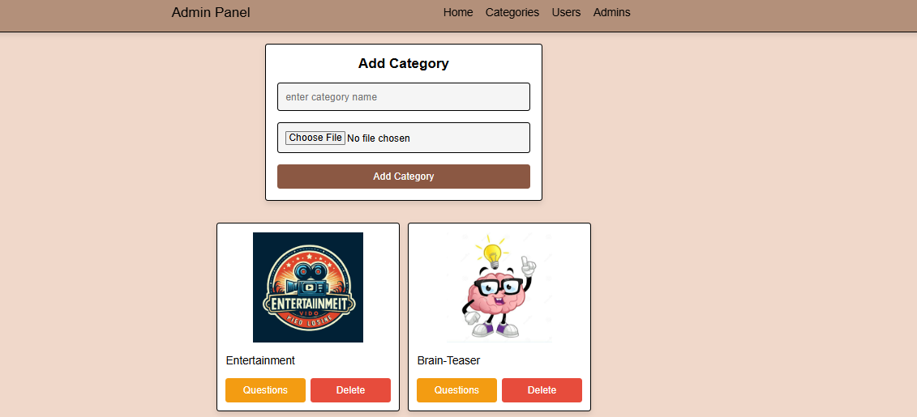

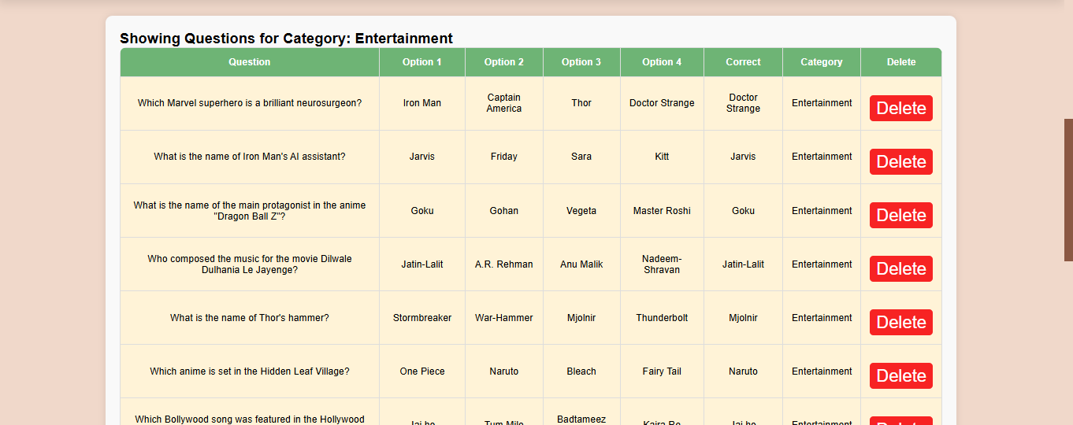

# Implementation Details

## Software & Hardware Specification

Operating System:

•Any modern operating system like Linux, Windows, or macOS can be used for development.

Programming Languages:

•Frontend: HTML, CSS

•Backend: MySQL

•Scripting Language: PHP, JavaScript

•RAM: MINIMUM 4GB

•Processor: At least dual-core, preferably quad-core.

•all types of browsers

•Database Management System (DBMS): MySQL

# Outputs & Report Testing

Output Testing:

The output testing involves verifying that the Quizzle platform produces the expected output for various inputs and scenarios.

## Test Cases

The following test cases were executed:

- User registration and login

- Quiz creation and management

- Question and answer management

- Leaderboard and scoring system

- Profile management

Test Results:

The test results indicate that:

- User registration and login functionality works as expected

- Quiz creation and management functionality works as expected

- Question and answer management functionality works as expected

- Leaderboard and scoring system functionality works as expected

- Profile management functionality works as expected

Report Testing:

The report testing involves verifying that the Quizzle platform generates accurate and meaningful reports.

Test Cases:

The following test cases were executed:

- User activity reports

- Quiz performance reports

- Leaderboard reports

- Profile reports

Test Results:

The test results indicate that:

- User activity reports are accurate and meaningful

- Quiz performance reports are accurate and meaningful

- Leaderboard reports are accurate and meaningful

- Profile reports are accurate and meaningful

## 2. Black Box Testing

Black box testing focuses on testing the system from an external perspective, without looking at the internal code structure. This is useful for validating that the input-output functionality works as expected.

Test Cases for Black Box Testing:

• User registration and login

• Quiz gameplay Leaderboard

• Profile management

• Admin panel

Black Box Testing Goal:

To ensure that all user-facing functionality operates as intended, and that inputs from the user produce the expected outputs without system errors or failures.

## 3. White Box Testing

White box testing involves testing the internal logic, code structure, and flow of the application. This testing ensures that the code follows the correct logic paths and handles different scenarios appropriately.

Test Cases for White Box Testing:

• Code review

• Unit testing

White Box Testing Goal:

To verify that the code executes as expected and that all logical paths, conditions, loops, and error handling scenarios are covered and handled correctly.

4. Output and Test Results Summary

Output Summary:

After running the black box and white box tests, the following outcomes were observed:

User Functionality: The website functions correctly with valid input, allowing users to register, log in, browse the category, play quiz.

Admin Functionality: Admins can log in securely, manage the quiz and questions.

Security: The platform successfully blocks unauthorized access, securely handles user passwords, and prevents malicious input through input validation.

Performance: The system performs well under normal traffic loads, with real-time updates working as expected.

## Test Results

Out of the test cases executed, most passed successfully, with a few edge cases requiring additional fixes. These edge cases mainly involved scenarios where invalid data inputs were not handled gracefully, which can be improved by refining input validation logic.

With these testing strategies and results in place, your cloud kitchen website should be ready for deployment, after addressing any identified bugs or vulnerabilities

# Conclusion and Recommendations

Conclusion:

The Quizzle project aimed to design and develop an interactive online learning platform that makes learning fun and engaging. The platform provides a comprehensive and immersive learning experience, catering to diverse learning needs and preferences.

The project has successfully achieved its objectives, providing a user-friendly and intuitive interface, interactive quizzes and games, personalized learning experiences, and real-time feedback and assessment.

Recommendations:

Based on the project's findings and results, the following recommendations are made:

- Integrate artificial intelligence and machine learning algorithms to provide more personalized and adaptive learning experiences.

- Develop mobile apps for Android and iOS devices to increase accessibility and reach.

- Incorporate virtual reality and augmented reality features to enhance the learning experience.

- Conduct regular updates and maintenance to ensure the platform's stability and security.

- Expand the platform's content and features to cater to a wider range of subjects and topics.

# Future Scope

Adding timer-based quizzes

Introducing multi-player quizzes

Adding more question formats like image-based or true/false

Future work on the Quizzle project can focus on:

- Integrating with educational institutions and organizations to provide a more comprehensive and accredited learning experience.

- Developing a community feature to enable users to interact and collaborate with each other.

- Conducting more extensive testing and evaluation to ensure the platform's effectiveness and impact.

# Bibliography and References

Books

* Web Development with HTML, CSS, and JavaScript – Smith John.
* Learning PHP, MYSQL & JavaScript with jQuery – Nixon Robin

Websites

* [www.techblog.com](http://www.techblog.com)
* [www.apnacollege.in](http://www.apnacollege.in)
* [www.killerphp.com](http://www.killerphp.com)
* [www.tutorialspoint.com](http://www.tutorialspoint.com)

AI Tools

* ChatGpt.AI
* Blackbox.AI